**INPUT**

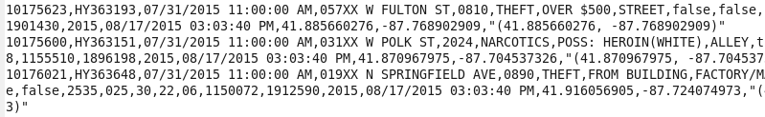

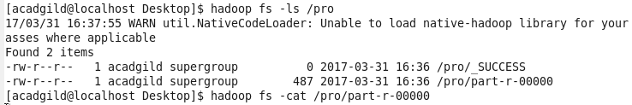

**1. Write a mapreduce and pig program to calculate the number of cases investigated under FBI**

**USING MAP REDUCE**

**MAPPER** 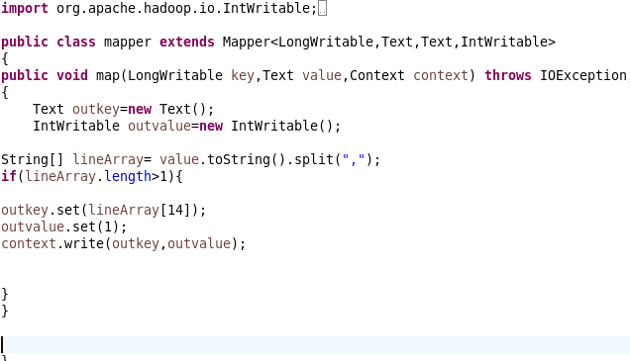

**REDUCER**

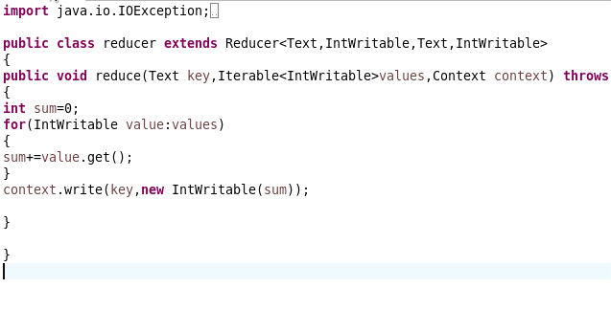

**DRIVER**

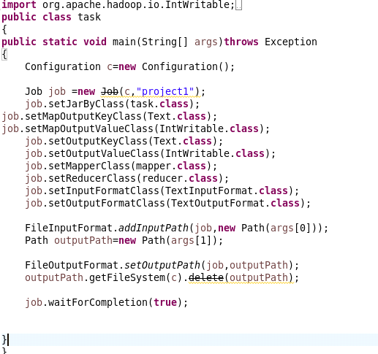

**OUTPUT**

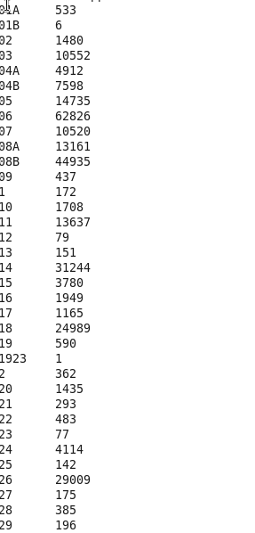

**USING PIG**



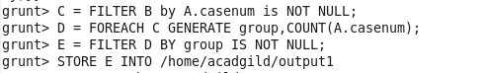

**OUTPUT**

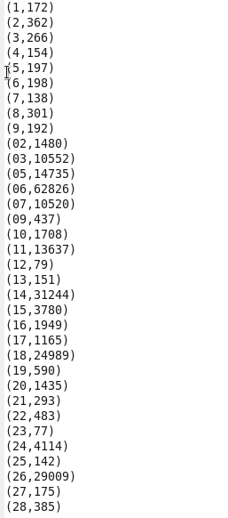

**2. Write a mapreduce and pig program to calculate the number of cases investigated undereach FBI code 32.**

**USING MAP REDUCE**

**MAPPER**



**REDUCER**



**DRIVER**



**OUTPUT**



**USING PIG**



**OUTPUT**



**3. Write a mapreduce and pig program to calculate the number of arrests in theft district wise.**

**USING MAP REDUCE**

**MAPPER**



**REDUCER**



**DRIVER**



**OUTPUT**

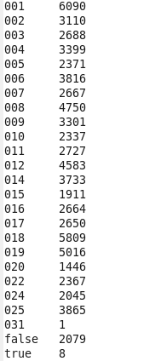

**USING PIG**



**OUTPUT**

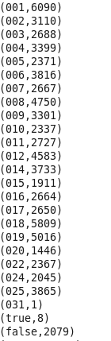

**4. Write a mapreduce and pig program to calculate the number of arrests done between October 2014 and October 2015.**

**USING MAP REDUCE**

**MAPPER**

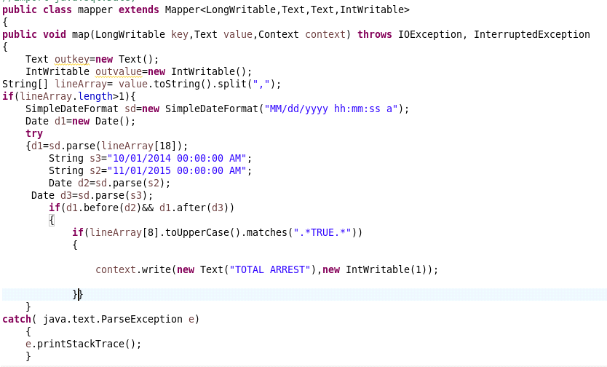

**REDUCER**



**DRIVER**



**OUTPUT**



**USING PIG**



grunt> O = FOREACH N GENERATE ToDate(SUBSTRING(upd,0,10),'MM/dd/yyyy') AS(U_Date:datetime);







**OUTPUT**

