**PIG**

**1. Write a pig script to find no of complaints which got timely response**

**INPUT**

**LOAD THE DATA**







**OUTPUT**



**2. Write a pig script to find no of complaints where consumer forum forwarded the complaint same day they received to respective company**







**OUTPUT**



**3. Write a pig script to find list of companies topping in complaint chart (companies with maximum number of complaints)**



**OUTPUT**

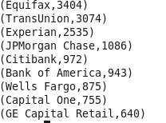

**4. Write a pig script to find no of complaints filed with product type has "Debt collection" for the year 2015**



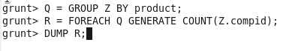

**OUTPUT**



**MAP REDUCE**

**1. Write a mapreduce program to remove commas present inside the double quotes.**



