BMS INSTITUTE OF TECHNOLOGY & MANAGEMENT

YELAHANKA, BENGALURU - 560064



**DEPARTMENT OF ARTIFICIAL INTELLIEGNCE AND MACHINE LEARNING**

**PROJECT BASED LEARNING**

2020-21 Odd Semesters

***“*QUARANTINE WRISTBAND”**

*Submitted By*

**Puja S** USN: 1BY19AI040

**Putluru Yashwanth** USN: 1BY19AI041

**Rahul Srivastava** USN: 1BY19AI042

**Dhananjay Kumar Singh** USN: 1BY19CV008

*Under the guidance of*

Dr. Anupama H S

Associate Professor, Dept of AI&ML

2020-2021

**INSTITUTE VISION**

To emerge as one of the finest technical institutions of higher learning, to develop engineering professionals who are technically competent, ethical and environment friendly for betterment of the society.

**INSTITUTE MISSION**

Accomplish stimulating learning environment through high quality academic instruction, innovation and industry-institute interface.

**DEPARTMENT VISION**

To develop professionals equipped to build sustainable and intelligent solutions that effectively interact with the natural intelligence towards creating a digitally empowered environment for future generations, safeguarding social ethics.

**DEPARTMENT MISSION**

* To enable students with the spirit and power of interdisciplinary acumen by integrating a world of knowledge into a world of intelligent systems and subsystems.
* Boost academic outcome through place-based education and collaborations with established research labs and industries.
* Encourage entrepreneurship efforts among students and develop them into great leaders.

|  |  |
| --- | --- |
| **Maths– 18MAT31 - Course Outcomes (COs) w.r.t this PBL** | |
| 1 | CO for MATH |
|  | **Evaluate Engineering/real world problems using various concepts of Mathematics.** |

|  |  |
| --- | --- |
| **Data Structures and Applications– 18CS32 - Course Outcomes (COs) w.r.t this PBL** | |
| 2 | CO for DSA |
|  |  |

|  |  |
| --- | --- |
| **Analog and Digital Electronics– 18CS33 - Course Outcomes (COs) w.r.t this PBL** | |
| 3 | CO for ADE |
| CO1 | **Demonstrate analog circuits and devices with their physical operation.** |
| CO2 | **Apply various simplifying techniques for digital circuits designing.** |
| CO3 | **Analyze digital operations in digital circuits.** |
| CO4 | **Design and stimulate simple HDL programs.** |
| CO5 | **Analyze and design various real time applications in analog and digital electronic.** |

|  |  |
| --- | --- |
| **Computer Organization– 18CS34 - Course Outcomes (COs) w.r.t this PBL** | |
| 4 | CO for CO |
| CO1 | **Explain the basic organization of a computer system** |
| CO2 | **Demonstrate functioning of different sub systems, such as processor, Input/output, and memory.** |
| CO3 | **Illustrate hardwired control and micro programmed control, pipelining, embedded and other computing systems.** |
| CO4 | **Design and analyze simple arithmetic and logical units.** |

|  |  |
| --- | --- |
| **SE– 18CS35 - Course Outcomes (COs) w.r.t this PBL** | |
| 5 | CO for SE |
|  | Summarize the Software Engineering tools, techniques and methods for effectively relating to various social and environmental systems. |

|  |  |
| --- | --- |
| **Discrete Mathematical Structures– 18CS36 - Course Outcomes (COs)**  **w.r.t this PBL** | |
| 6 | CO for DMS |
|  | **Evaluate solutions for different problems in various mathematical techniques**. |

|  |  |  |  |  |  |  |  |  |  |  |  |  |
| --- | --- | --- | --- | --- | --- | --- | --- | --- | --- | --- | --- | --- |
| **COURSE** | **PO1** | **PO2** | **PO3** | **PO4** | **PO5** | **PO6** | **PO7** | **PO8** | **PO9** | **PO10** | **PO11** | **PO12** |
| Math | ✓ | ✓ |  | ✓ |  |  |  |  | ✓ | ✓ |  |  |
| Data structures and Applications | ✓ | ✓ | ✓ | ✓ | ✓ |  |  | ✓ | ✓ | ✓ | ✓ | ✓ |
| Analog and Digital Electronics | ✓ | ✓ | ✓ | ✓ | ✓ |  |  | ✓ | ✓ | ✓ | ✓ | ✓ |
| Computer Organization | ✓ | ✓ | ✓ | ✓ | ✓ | ✓ | ✓ | ✓ | ✓ | ✓ | ✓ | ✓ |
| Software Engineering |  |  |  |  |  |  |  | ✓ | ✓ |  |  |  |
| Discrete Mathematical Structures | ✓ | ✓ | ✓ | ✓ | ✓ | ✓ | ✓ |  | ✓ | ✓ |  | ✓ |

**Project to Program Outcomes (PO) Mapping**

**Project name: Quarantine Wristband**

|  |  |
| --- | --- |
| **Program outcomes (POs):** | |
| **PO1** | **Engineering knowledge:** Apply the knowledge of Mathematics, Science, Engineering fundamentals and an engineering specialization to the solution of complex engineering problems |
| **PO2** | **Problem analysis:** Identify, formulate, review research literature, and analyse complex Engineering problems reaching substantiated conclusions using first principles of mathematics, Natural sciences and engineering sciences |
| **PO3** | **Design/development of solutions:** Design solutions for complex engineering problems and design system components or processes that meet the specified needs with appropriate consideration for the public health and safety, and the cultural, societal, and environmental considerations. |
| **PO4** | **Conduct investigations of complex problems**: Use research-based knowledge and research methods including design of experiments, analysis and interpretation of data, and synthesis of the Information to provide valid conclusions |
| **PO5** | **Modern tool usage**: Create, select, and apply appropriate techniques, resources, and modern Engineering and IT tools including prediction and modelling to complex engineering activities with an understanding of the limitations. |
| **PO6** | **The engineer and society:** Apply reasoning informed by the contextual knowledge to assess societal, health, safety, legal and cultural issues and the consequent responsibilities relevant to the professional engineering practice. |
| **PO7** | **Environment and sustainability:** Understand the impact of the professional engineering solutions in societal and environmental contexts, and demonstrate the knowledge of, and need for Sustainable development |
| **PO8** | **Ethics:** Apply ethical principles and commit to professional ethics and responsibilities and norms of the engineering practice. |
| **PO9** | **Individual and team work:** Function effectively as an individual, and as a member or leader in diverse teams, and in multidisciplinary settings |
| **PO10** | **Communication:** Communicate effectively on complex engineering activities with the engineering Community and with society at large, such as, being able to comprehend and write effective reports And design documentation, make effective presentations, and give and receive clear instructions. |
| **PO11** | **Project management and finance:** Demonstrate knowledge and understanding of the Engineering and management principles and apply these to one’s own work, as a member and Leader in a team, to manage projects and in multidisciplinary environments. |
| **PO12** | **Life-long learning:** Recognize the need for, and have the preparation and ability to engage in independent and life-long learning in the broadest context of technological change. |

**Abstract:**

The world health organization (WHO) has declared the novel coronavirus disease (COVID-19 or 2019-nCoV) outbreak a pandemic, and quarantines are playing a vital role in containing its spread. But globally, the defections of the quarantined patients are raising serious concerns. If COVID-19 positive, the absconding quarantine patients can infect more people, which makes their timely detection vital. As the literature suggests, a wearable device is more complex towards healthcare routines/restrictions; thus, in this work, we have designed an IoT based wearable quarantine band (safety band) to detect the absconding. While designing it, we kept in mind the cost, global supply chain disruption, and COVID-19 quarantine duration, which the WHO recommends. This wearable prototype, with the bundled mobile app, reports and tracks the absconding quarantine subjects in real-time. Quarantine-Band is an economical solution that could benefit low income regions to prevent the spread of COVID-19.

**Introduction:**

In the diagram given below, User 1 is a person wearing the Quarantine-Band, and User 2 is a person/authority monitoring the quarantined subjects. wearable band is meant only to be taken off when a pre-determined quarantine period is over. Concerned medical authorities have control of the tracking system and responsible for the initial subject registration, which reduces the privacy concerns of the quarantine subjects as well as ensures the legitimacy of the data. Using the global positioning satellite (GPS) based geofencing, the tracking system generates real-time alerts and allows the authorities to detect the absconding quarantine patients in real-time. The mobile app also reports about any disembarkation or tampering of the wearable band during an active quarantine. As the COVID-19 pandemic and associated lockdowns have disrupted the global supply chain primarily of medical and electronics components, we have designed our prototype judiciously minimalist so that it requires fewer parts. Keeping in mind the WHO recommendation of a 14-day quarantine for a person who was exposed to a COVID-19 positive patient, we have selected the wearable band components and their mode of operation so that the included battery would be enough for the entire quarantine period. Since the reuse of the contaminated devices in epidemic scenarios are largely avoided, we also tried to keep the device cost low, so that the device could be incinerated after its use and still be mass-produced.

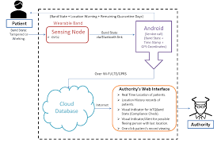

**Literature Survey:**

The papers referred while developing this product were EAI Endorsed Transactions, How to Electronics, News India Express, Electronics Forum, SVS Embedded

**Motivation:**

According to the World Health Organization (WHO), a pandemic is “the worldwide spread of a new disease”. Another descriptive definition of a pandemic says: “an epidemic occurring worldwide, or over a vast area, crossing international boundaries and usually affecting a large number of people”. On March 11, 2020, the WHO has marked the outbreak of novel coronavirus disease (nCoV or COVID-19 or SARS-CoV-2) a pandemic and as of April 21, 2020 5:00 PM Indian standard time, there has been more than 2.1 million confirmed infections, 135 thousand confirmed deaths and spread across 213 countries, areas or territories. Thus an explosion of coronavirus infections may occur in real if the measures like quarantine and isolation of the infected or exposed persons are not applied. To mitigate the growth of infections, quarantine (along with the isolation and social distancing) plays a pivotal role which according to the WHO is defined as, “the quarantine of persons is the restriction of activities of or the separation of persons who are not ill but who may be exposed to an infectious agent or disease, to monitor their symptoms and ensure the early detection of cases”. Introducing quarantine measures early in a disease outbreak delay the disease outbreak and delay the peak of an epidemic in a country. The success of the quarantine measures is primarily dependent on the patient’s compliance, which is influenced by the sense of civic duty or the social responsibility of a person and varies over countries and cultures. During the COVID-19 outbreak, various reports emerge of people absconding from the quarantines and hospitals. The tracking of COVID-19 positive patients is carried out mostly through mobile applications, e.g., Aarogya Setu. As of April 21, 2020, Aarogya Setu works on the concept of crowdsourcing. As per this app’s user reviews, the functionality of alerts to nearby users is limited, since it assumes that every person that has a smartphone have this application installed. The users have also shown concerns about the legitimacy of data entered in the app, suggesting a need for verifying or approving authority. Though the mobile app-based tracking seems inadequate, a visual indicator- based tracking method (e.g., medical authorities stamping on the hands with a non-washable ink), is most successful in detecting the absconding COVID19 quarantine subjects. But as in each case, the absconding subjects were caught far away from their quarantine location, and reported through the common public; the timely alert to the authorities would have proved more worthy. Thus, to detect the absconding subjects on time, none of the two mentioned schemes seems to work effectively and somehow violates the privacy of subjects as well. Various healthcare studies suggests the use of wearable device make a patient more compliant to medical routines and restrictions; thus a wearable band would be a right solution for this case. Thus, we have designed a wearable band bundled with a mobile application, would detect and track the absconding quarantine subjects in real-time.

**Existing System**:

Hong Kong designed a wristband for those people who had a foreign travel and it had a QR code which would enable the respective medical team to trace the person violating the rules/restrictions. Once the band is received, the person’s information gets registered on the database and a message is given to their respective phone numbers. Upon reaching their house the person is required to walk around his/her entire house so that the bandcantrace the radius of the house. After two weeks of complete isolation the band send a signal informing him/her the completion of the quarantine period.

An IT manager from Abu Dhabi wanted to do something for the society so she came up with an idea of developing her very own band called THE QUARANTINE BAND.

South Korea took inspiration from Hong Kong to develop a wristband for its overseas travelers to prevent the spread of the virus.

Finally, three students from Karnataka developed a wristband to prevent the absconding patients and prevent the spread.

**Limitations of Existing System:**

* Most of the travelers didn’t receive a message.
* While letting the device trace the radius of the house, some people couldn’t cover their entire house due to technical faults in a few of them.
* It could be tampered very easily.

**Proposed System:**

* It gets activated once worn.
* A radius of 100 meters is fixed.
* It can’t be tampered very easily. If the lock is tampered a warning is given to the respective team.

**System Requirement Specifications**

**Functional Part:**

In this section, we list out the components and their mode of operation, which makes the Quarantine-Band.

* ESP32: It is a popular, and widely studied development kit, deployed in a variety of internet of things (IoT) applications. The compact form factor of the ESP32 (length width-thickness: 52 x 27 x 10mm) makes it suitable for use in a wearable device. In the Quarantine-Band, ESP32 is responsible for sensing the wearable band’s tampering and reporting this incident to the mobile application wirelessly through a Bluetooth link. Our wearable device keeps the connection alive with the mobile application and transmits wearable band status at specific time intervals. For this reason, the ESP32 operates in Modem Sleep mode, where CPU is always on, and the Bluetooth baseband and radio are disabled when not transmitting. To reduce the current consumption of Quarantine-Band, we set the ESP32’s CPU clock speed to 80 MHz and set a low transmission duty cycle (1 byte in 2 minutes). In addition to this, we have disabled the ESP32’s power light-emitting diode (LED) as well.
* Tampering detection wire: A conducting cable (20 centimeters in length) is connected between the ground pin and a general-purpose input/output (GPIO) pin of the ESP32 to detect any disembarkation or tampering of the wearable band.
* MAX30100: The MAX30100 is an integrated pulse oximetry and heartrate monitor sensor solution. It combines two LEDs, a photodetector, optimized optics, and low-noise analog signal processing to detect pulse oximetry and heart-rate signals. The MAX30100 operates from 1.8V and 3.3V power supply.
* DHT22: Temperature-Humidity Sensor
* USB Cable: The ESP32 is powered up, using a male universal serial bus (USB) A to a male micro USB cable, 10 centimeters in length.
* Battery: Depending on the duration of the quarantine, as set by the authority, the battery capacity could be chosen. We have chosen a USB battery or power bank to power up the Quarantine-Band.

**Non-Functional Part:**

This product was developed mainly for the low-income families along with this the other advantages are that the data stored is secure, accurate, real time detection of the absconding patients, historical data, cannot be tampered and waterproof.

**Proposed Methodology:**

**CIRCIUT CONNECTION:**

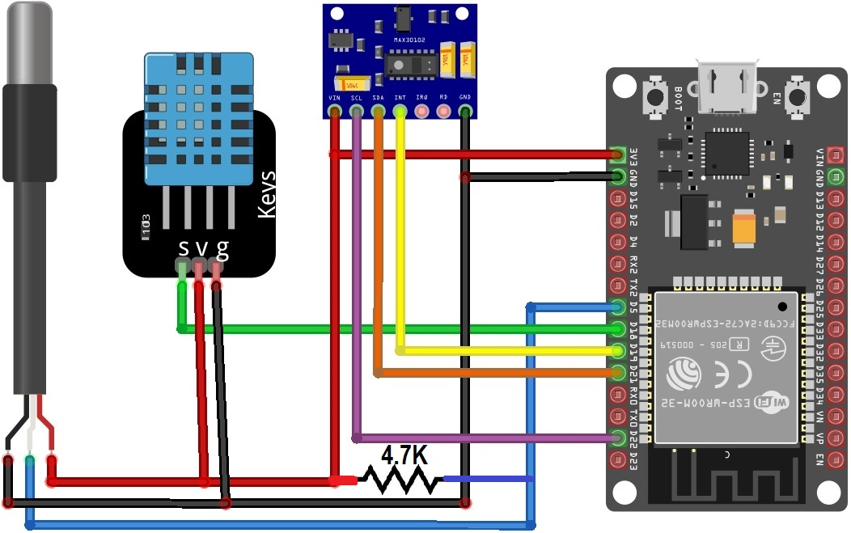

**ALGORITHM:**

Step1: Input SSID and wi-fi password

Step2: Print wi-fi connected

Step3: Set up the HTTP server

Step4: Print Initializing pulse oximeter

Step5: If (!pox.begin())

{

     Serial.println("FAILED");

     for (;;);

   }

Else

{

     Serial.println("SUCCESS");

     pox.setOnBeatDetectedCallback(onBeatDetected);

   }

Step6: Register a callback for beat detection

Step7: if (millis() - tsLastReport > REPORTING_PERIOD_MS)

   {

    Serial.print("Room Temperature: ");

    Serial.print(DHT.temperature);

    Serial.println("°C");

    Serial.print("Room Humidity: ");

    Serial.print(DHT.humidity);

{

 Serial.println("%");

    Serial.print("BPM: ");

    Serial.println(BPM);

    Serial.print("SpO2: ");

    Serial.print(SpO2);

    Serial.println("%");

    Serial.print("Body Temperature: ");

    Serial.print(bodytemperature);

    Serial.println("°C");

{

Serial.println("******************************");

     Serial.println();

tsLastReport = millis();

}

}

}

**Implementation:**

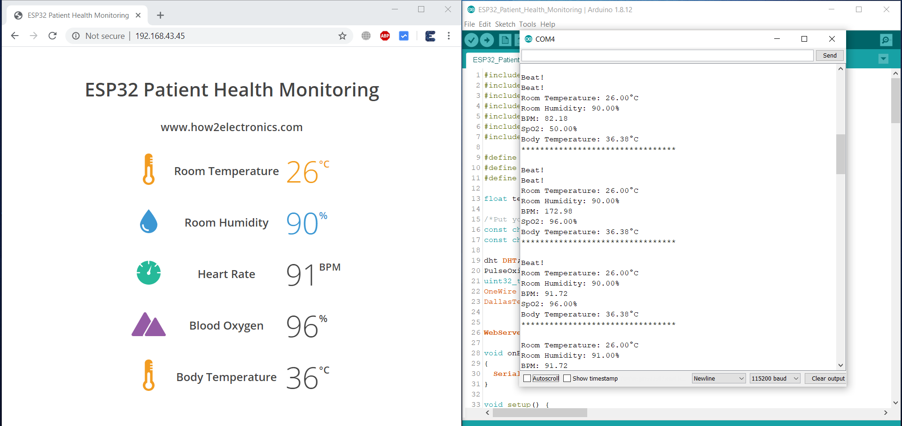

The output is shown on the left picture. The IP address given on the output screen can be viewed on any browser.

**Conclusion:**

The Quarantine-Band presents a minimalist design, keeping in mind the cost, global supply chain disruption, and the WHO’s recommended average quarantine period in mind. The Quarantine-Band, with the bundled mobile application and cloud-based monitoring system, provides a scalable, low-cost solution to detect the absconding COVID-19 quarantine subjects and track them in real-time. The components of the wearable band, their mode of operation, and the battery are chosen such that they stay operational throughout the quarantine period, also validated via the current consumption analysis. Due to the possibility of contamination, the reuse of Quarantine-Band could be avoided; thus, the cost of this prototype is kept less by reusing several smartphone’s features. As an economical solution, the Quarantine-Band could benefit low income areas of the world where it could be used to keep track of quarantined patients.

**Future Enhancement:**

The current state of the prototype opens multiple new opportunities for researchers. One of the precise directions would be to predict the probability of a person to abscond a quarantine using biosensor data fitted over the Quarantine Band and machine learning. Device power optimization and adequate battery research is also a direction to follow. Last but not least, for making the wearable comfortable enough to be worn over arms, we have used the clothing as a possible skeleton for the device, which could be alternatively 3D printed with a variety of materials.

**References:**

[**https://www.who.int/emergencies/diseases/novel-coronavirus-2019/question-and-answers-hub/q-a-detail/coronavirus-disease-covid-19**](https://www.who.int/emergencies/diseases/novel-coronavirus-2019/question-and-answers-hub/q-a-detail/coronavirus-disease-covid-19)

[**https://www.who.int/health-topics/coronavirus#tab=tab_1**](https://www.who.int/health-topics/coronavirus#tab=tab_1)

[**https://en.wikipedia.org/wiki/ESP32**](https://en.wikipedia.org/wiki/ESP32)

[**https://learn.sparkfun.com/tutorials/max30105-particle-and-pulse-ox-sensor-hookup-guide/all**](https://learn.sparkfun.com/tutorials/max30105-particle-and-pulse-ox-sensor-hookup-guide/all)

**https://www.sparkfun.com/datasheets/Sensors/Temperature/DHT22.pdf**

[**https://eudl.eu/pdf/10.4108/eai.13-7-2018.163997**](https://eudl.eu/pdf/10.4108/eai.13-7-2018.163997)

**https://www.emerson.com/documents/automation/white-paper-deltav-system-health-monitoring-networking-security-whitepaper-en-67960.pdf**

[**https://www.youtube.com/watch?v=6nR1b5bhwg0**](https://www.youtube.com/watch?v=6nR1b5bhwg0)

[**https://www.electronicsforu.com/electronics-projects/prototypes/coronasecure-covid-19-heath-band**](https://www.electronicsforu.com/electronics-projects/prototypes/coronasecure-covid-19-heath-band)

[**https://www.newindianexpress.com/states/karnataka/2020/apr/02/goaway-bands---a-smart-band-to-the-people-under-quarantine-2124767.html**](https://www.newindianexpress.com/states/karnataka/2020/apr/02/goaway-bands---a-smart-band-to-the-people-under-quarantine-2124767.html)

[**https://how2electronics.com/iot-based-patient-health-monitoring-esp32-web-server/**](https://how2electronics.com/iot-based-patient-health-monitoring-esp32-web-server/)