Models can be used to predict how much different houses are worth.
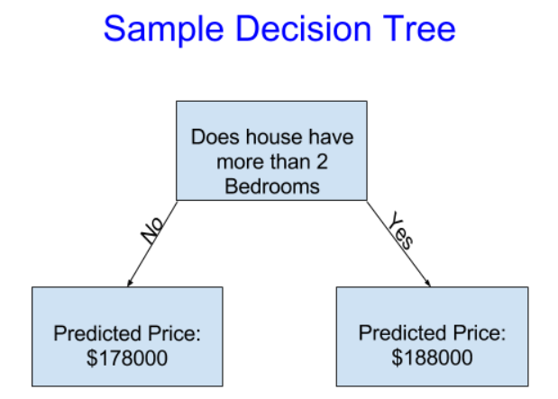
Simple decision tree:

Fitting/training model = capturing patterns from the data.
Training data = data used to fit the model.
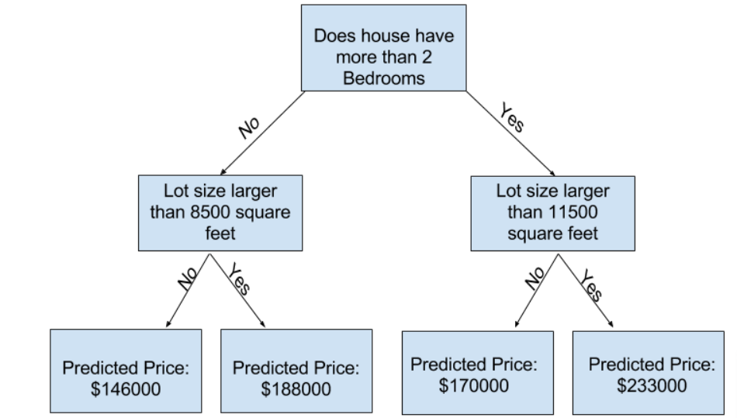
Capturing more factors = more splits (deeper trees).

Point at bottom where we make the prediction is called the ‘leaf’.

Prediction target:
y = melbourne_data.Price

Features (columns used to make predictions):
melbourne_features = ['Rooms', 'Bathroom', 'Landsize', 'Lattitude', 'Longtitude']
X = melbourne_data[melbourne_features]

Running first decision tree model:
from sklearn.tree import DecisionTreeRegressor
# Define model. Specify a number for random_state to ensure same results each run
melbourne_model = DecisionTreeRegressor(random_state=1)
# Fit model
melbourne_model.fit(X, y)
predictions = melbourne_model.predict(X)
print(predictions)
Summarizing model quality- Mean Absolute Error (error=actual−predicted)

We can split the dataset into training and validation data:
from sklearn.model_selection import train_test_split
# split data into training and validation data, for both features and target
# The split is based on a random number generator. Supplying a numeric value to
# the random_state argument guarantees we get the same split every time we
# run this script.
train_X, val_X, train_y, val_y = train_test_split(X, y, random_state = 0)
# Define model
melbourne_model = DecisionTreeRegressor()
# Fit model
melbourne_model.fit(train_X, train_y)
# get predicted prices on validation data
val_predictions = melbourne_model.predict(val_X)
print(mean_absolute_error(val_y, val_predictions))
Overfitting/underfitting
As we add more splits to the decision tree, each leaf (bottom layer) will have less houses in each of them and their predicted prices will be closer to the actual value. However, they will make unreliable predictions for validation data and new data- this is called overfitting. The model matches the training data perfectly but does poorly for validation and other data. It is capturing spurious (fake) patterns which will not occur in the future.
On the other hand, if we don’t have enough splits, the model will fail to capture important distinctions and patterns in the data- this is called underfitting.
We want to find the sweet spot where MAE for the validation data is at a minimum
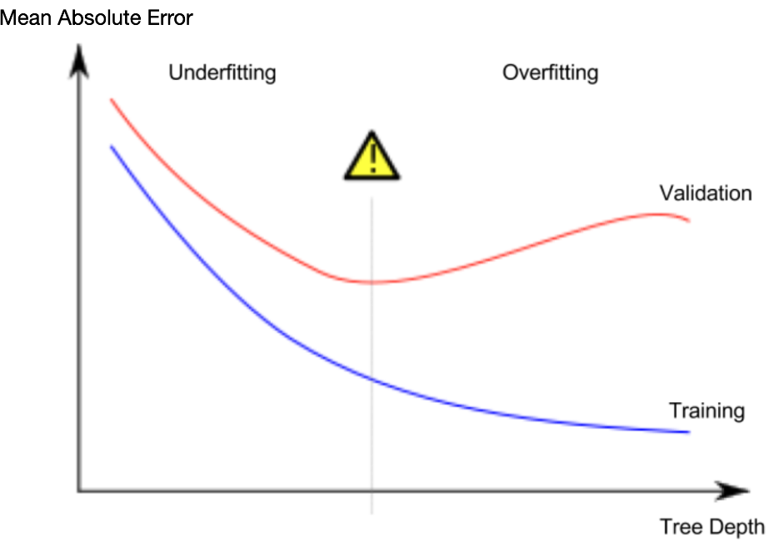
We can alter the ‘max_leaf_nodes’ variables and find the MAE to identify the optimal number of leaves.
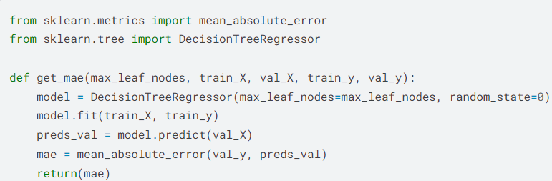

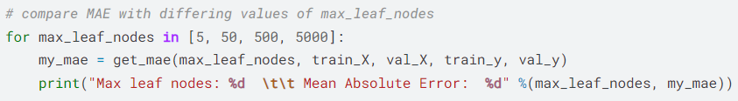
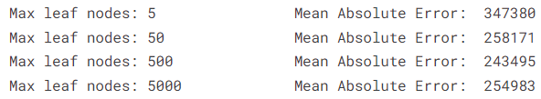

Random Forest
This takes multiple decision trees and finds the average of each of the individual trees.
Missing values
Drop columns with missing values entirely.
Imputation (filling with mean or most frequent value of column or 0)
However, imputed values may be very different from actual value. Or a specific row may be unique in some way.
Instead, we can still use imputation but add another column with ‘missing values’ which is filled with ‘True’ or ‘False’.
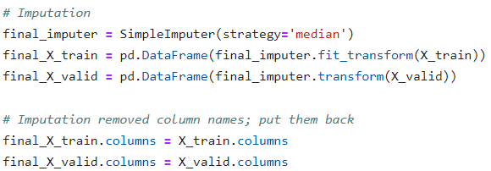
Categorical data
Machine Learning models cannot handle ‘categorical data’.
These columns can either be dropped (if the data is unimportant).
Convert to ordinal data (e.g. 0 = never, 3 = everyday).
One-hot-encoding which creates new columns to indicate the presence or absence of a category. This will not assume there is an ordering to the categories unlike ordinal data, this is called nominal data.
