**FILE MANAGEMENT SYSTEM**

Pujan Talukder

Reg No: 11916253

Roll No: 10

**Introduction**: A file management system. Used for storing and managing files. This application is implemented with authentication system. A login and signup module is implemented with MYSQL database. User can store files after login with credentials. A user can also download files from the server which they have already uploaded and can delete files also.

**Screenshots:**

**Login.html (login page)**

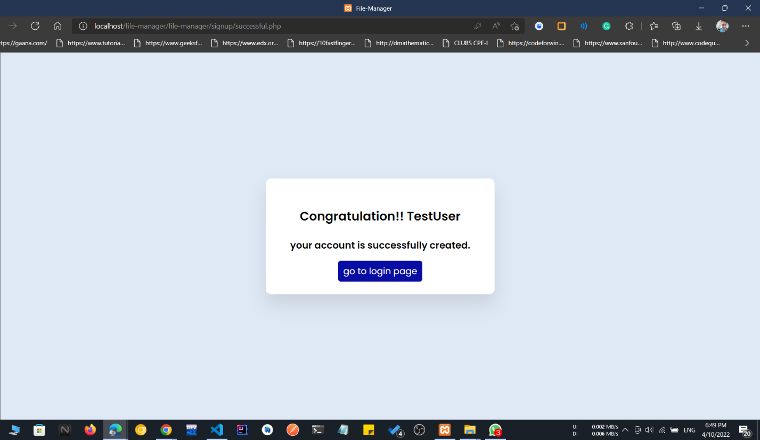**signup.html (create new account)** 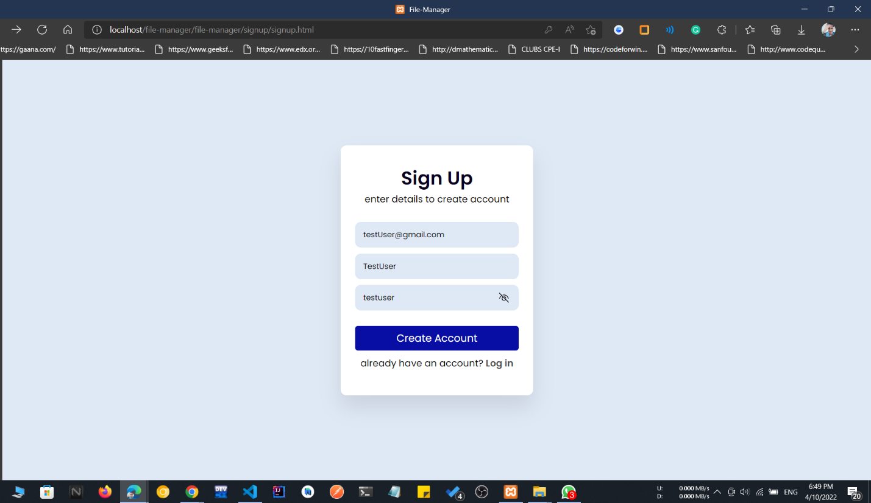

**successful creation of new account**

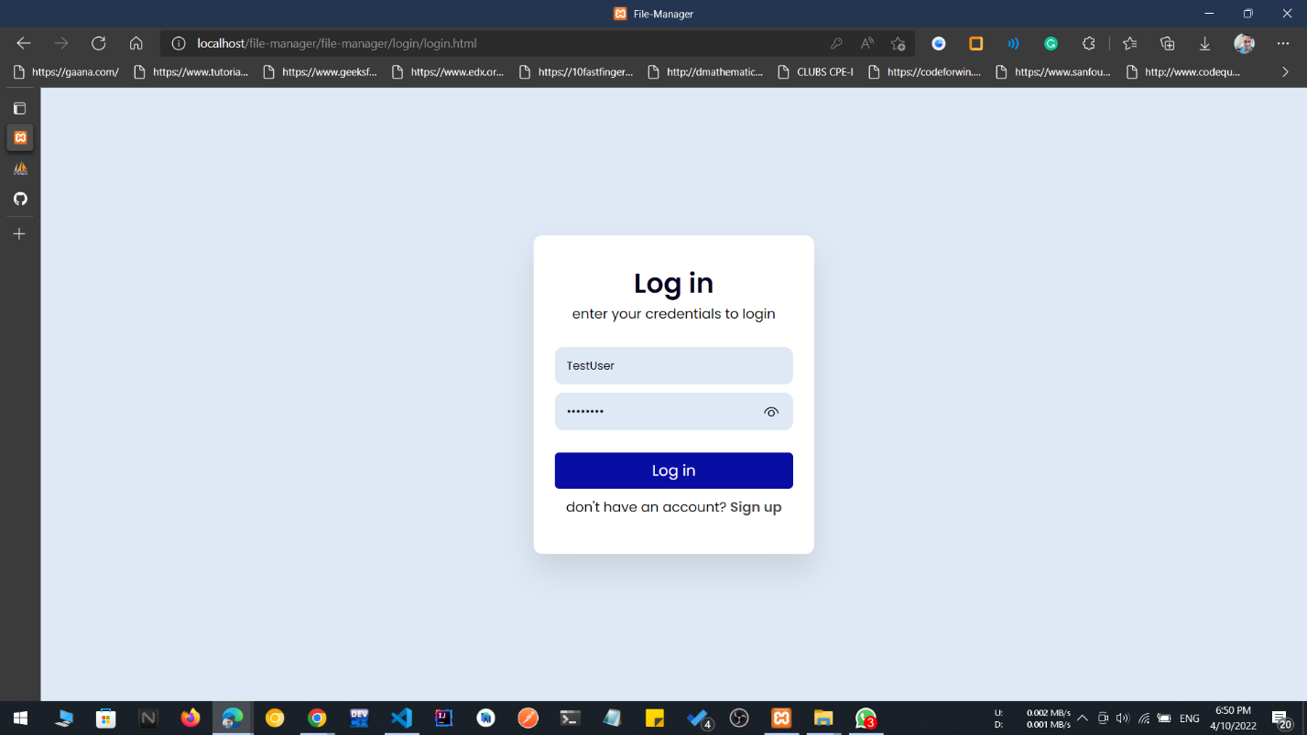**login with created account**

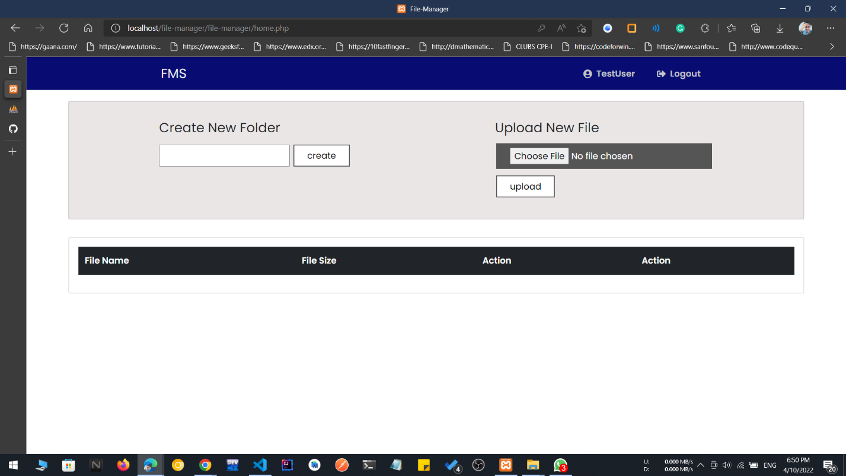

**home.php(before uploading files)**

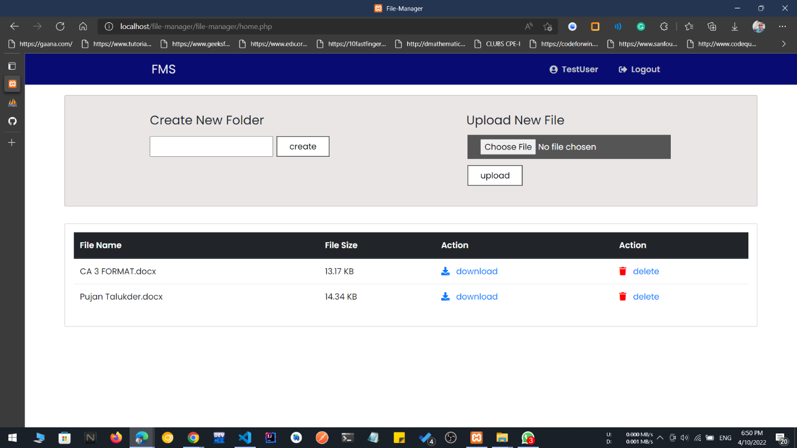**home.php(after uploading files)**

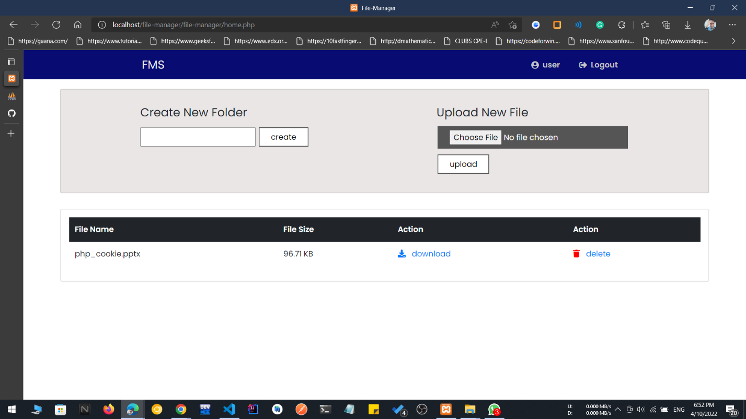

**home.php(session of a different user)**

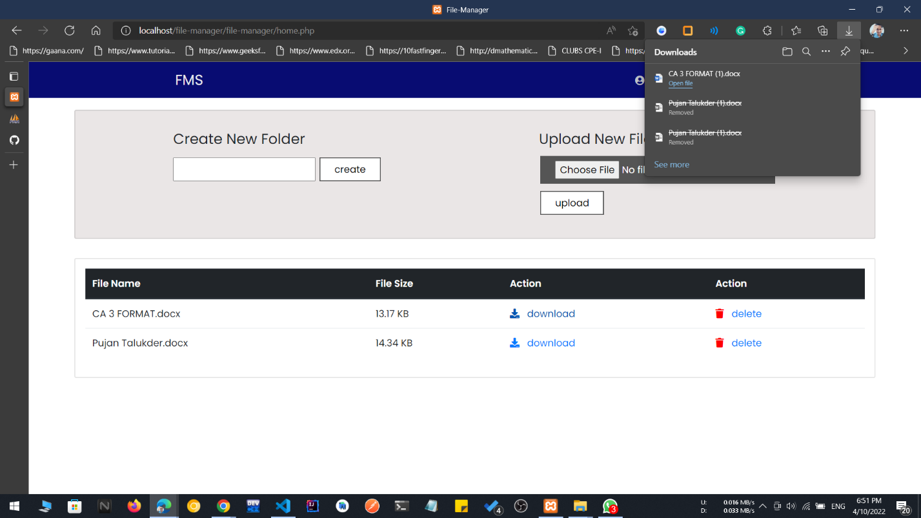**downloading file**

**Learning Outcome:**

1. **Working with php**
2. **Implementing relational database**
3. **Working with mysql**
4. **Working with UI framework Bootstrap**

**GitHub Link :** <https://github.com/PujanTalukder/file-manager.git>