** **

**JYOTHY INSTITUTE OF TECHNOLOGY**

TATAGUNI, BENGALURU

AFFILIATED TO VTU, BELAGAVI

**DEPARTMENT OF INFORMATION SCIENCE AND TECHNOLOGY**

In Association With

**CIIRC and Quantech Origin and Unacademy**

**TEAM CONSENT FORM**

The team, Alpha Clan­­­­­­­­­­ of Sri Sairam College of Engineering (+91)8217091124, do hereby undertake on this day (24/11/2022) the following;

1. We hereby declare that, the entries submitted by us in the Application Form are complete and true to the best of our knowledge, and based on official records.
2. We hereby declare that we are willing to participate in Gameathon 2022 with the best of our intentions and interest.
3. We hereby declare that we will not resort to any malpractice by copying our code or downloading any assets from the internet.
4. We hereby agree to share our screens and present proof of our work when asked for by the judge or mentors during the event.
5. We hereby declare that our team may be disqualified, at any stage, if found ineligible and/or the information provided by us is found to be incorrect.

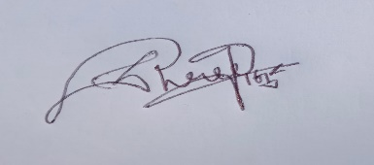 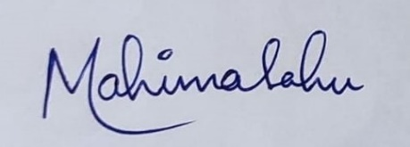

**Pujashree V | Mahima Sahu**

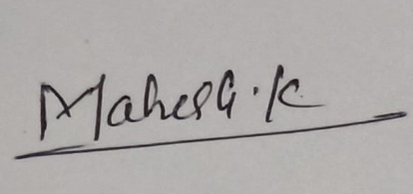 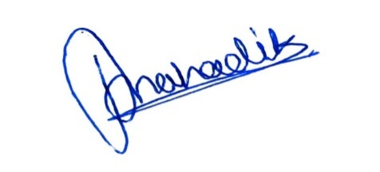

**Mahesh Kumar Chaudhary | Pratik Mahadik**

**Signature of team members**

**Date:25/11/2022**

**Place:** JIT Bangalore