1.ReactJS-HOL
Creating React App : npx create-react-app myfirstreact
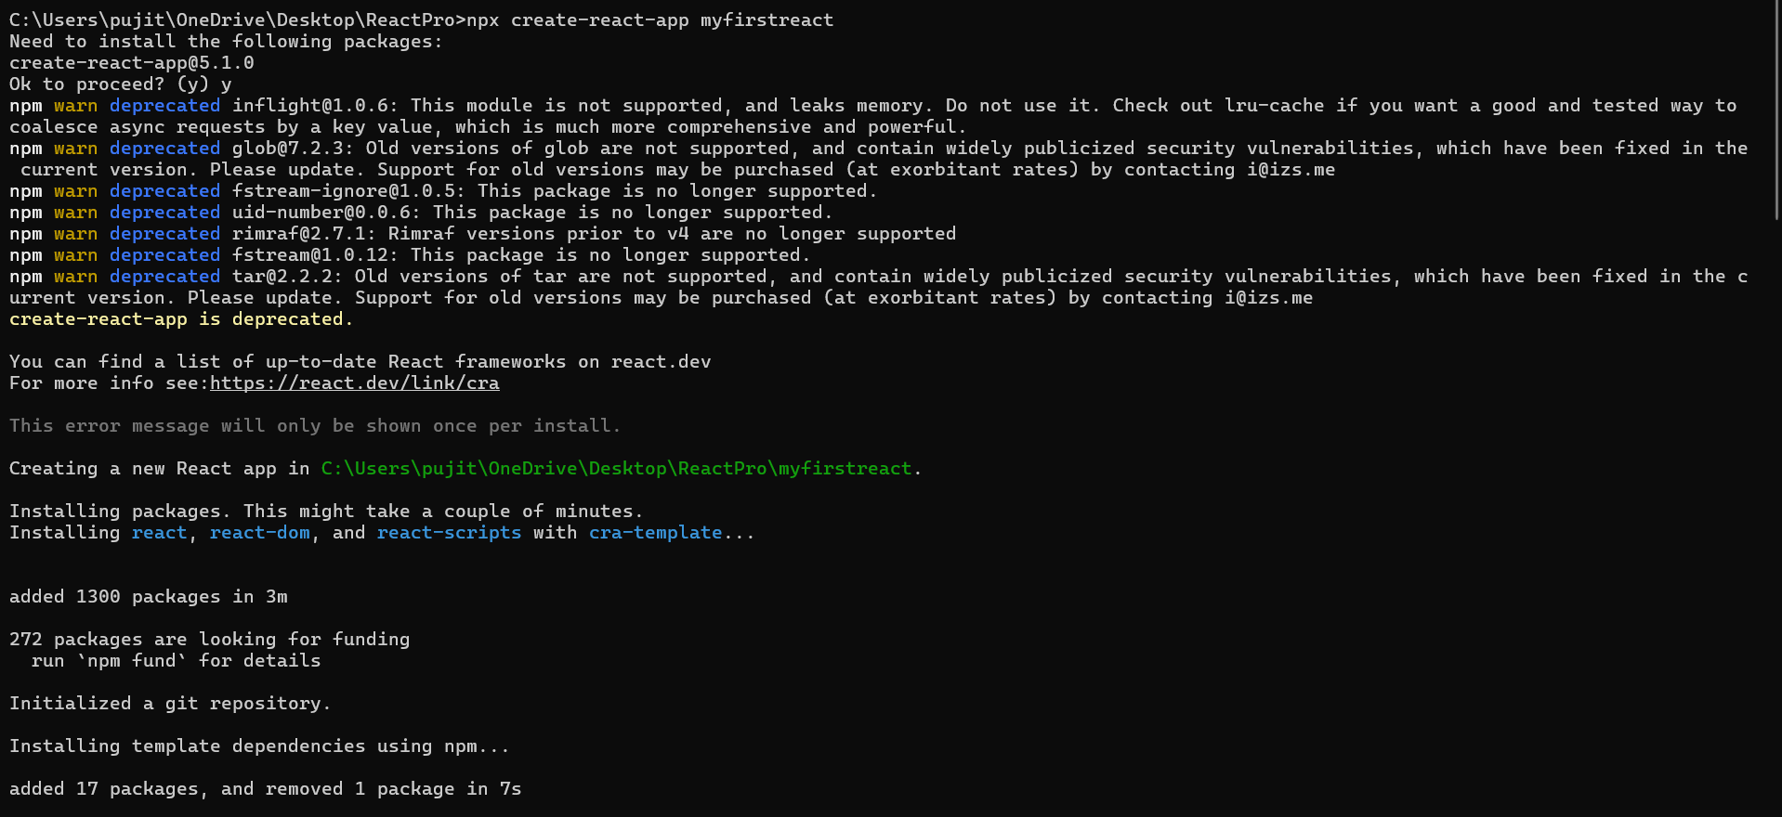

App.js :
import React from 'react';
function App() {
return (
<div style={{ textAlign: 'center', marginTop: '50px' }}>
<h1>welcome to the first session of React</h1>
</div>
);
}
export default App;

Running on localhost 3000 :

