Module 5 - Spring Core and Maven
Exercise 1: Configuring a Basic Spring Application
Program Code:
Project Structure:
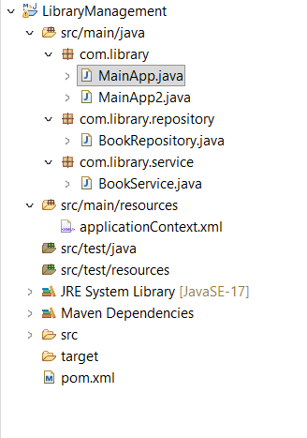
pom.xml:
<project xmlns="http://maven.apache.org/POM/4.0.0"
xmlns:xsi="http://www.w3.org/2001/XMLSchema-instance"
xsi:schemaLocation="http://maven.apache.org/POM/4.0.0 https://maven.apache.org/xsd/maven-4.0.0.xsd">
<modelVersion>4.0.0</modelVersion>
<groupId>com.library</groupId>
<artifactId>LibraryManagement</artifactId>
<version>0.0.1-SNAPSHOT</version>

<dependencies>
<dependency>
<groupId>org.springframework</groupId>
<artifactId>spring-context</artifactId>
<version>6.1.10</version> </dependency>
</dependencies>

<build>
<plugins>
<plugin>
<groupId>org.apache.maven.plugins</groupId>
<artifactId>maven-compiler-plugin</artifactId>
<version>3.11.0</version>
<configuration>
<source>17</source>
<target>17</target>
</configuration>
</plugin>
</plugins>
</build>
</project>

applicationContext.xml :
<bean id="bookRepository" class="com.library.repository.BookRepository" />
<bean id="bookService" class="com.library.service.BookService" />

BookRepository class :
package com.library.repository;

public class BookRepository {
public void saveData() {
System.out.println("Book data saved successfully to the database!");
}
}

BookService class :

package com.library.service;

import com.library.repository.BookRepository;

public class BookService {
private BookRepository bookRepository;

// Setter method for Spring to inject BookRepository
public void setBookRepository(BookRepository bookRepository) {
this.bookRepository = bookRepository;
}

public void addBook() {
System.out.println("Service: Attempting to add a book...");
bookRepository.saveData();
}
}

MainApp.java:
package com.library;

import org.springframework.context.ApplicationContext;
import org.springframework.context.support.ClassPathXmlApplicationContext;
import com.library.repository.BookRepository;

public class MainApp {
public static void main(String[] args) {
System.out.println("--- Exercise 1: Initializing Spring Context ---");

// 1. Load the Spring XML configuration file to start the IoC Container
ApplicationContext context = new ClassPathXmlApplicationContext("applicationContext.xml");

System.out.println("Spring Context loaded successfully!");

// 2. Retrieve the BookRepository bean directly from the container to test configuration
BookRepository bookRepository = (BookRepository) context.getBean("bookRepository");

// 3. Call a method to verify the bean works
bookRepository.saveData();

// Close the context resource
((ClassPathXmlApplicationContext) context).close();
}
}

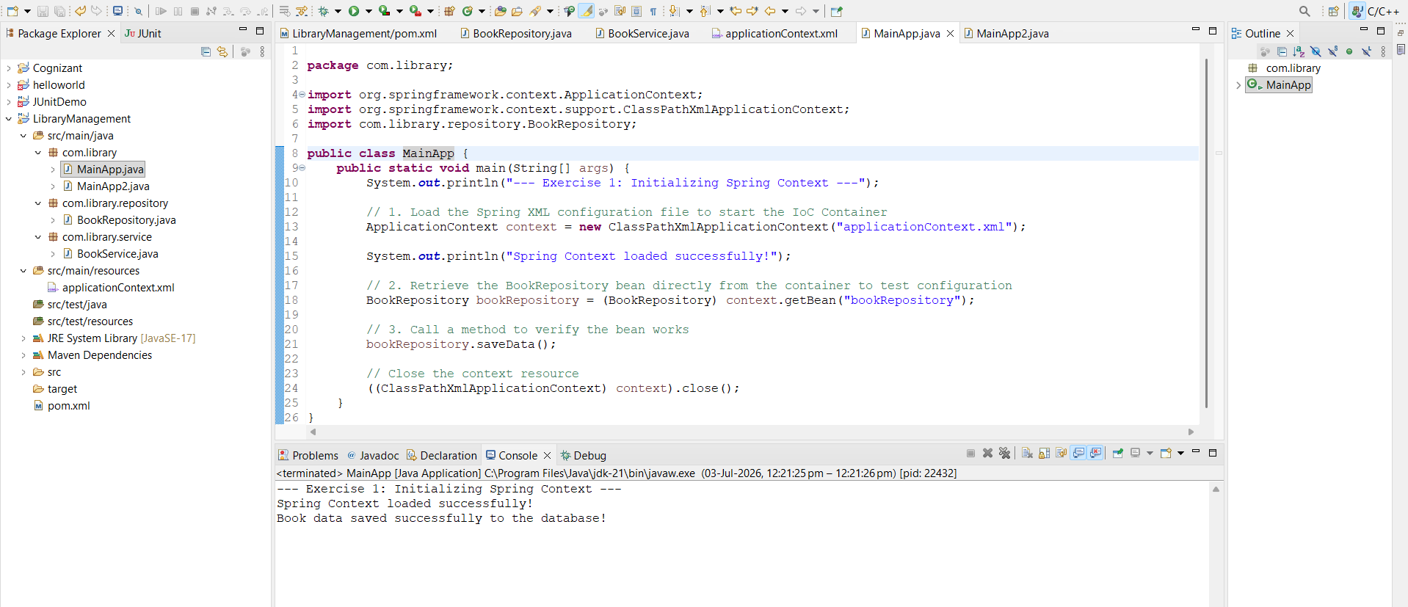

Exercise 2 - Implementing Dependency Injection:
Program :
applicationContext.xml :
<?xml version="1.0" encoding="UTF-8"?>
<beans xmlns="http://www.springframework.org/schema/beans"
xmlns:xsi="http://www.w3.org/2001/XMLSchema-instance"
xsi:schemaLocation="http://www.springframework.org/schema/beans
https://www.springframework.org/schema/beans/spring-beans.xsd">

<bean id="bookRepository" class="com.library.repository.BookRepository" />

<bean id="bookService" class="com.library.service.BookService">
<property name="bookRepository" ref="bookRepository" />
</bean>

</beans>

MainApp.java :

package com.library;

import org.springframework.context.ApplicationContext;
import org.springframework.context.support.ClassPathXmlApplicationContext;
import com.library.service.BookService;

public class MainApp {
public static void main(String[] args) {
// 1. Load the Spring XML configuration file
ApplicationContext context = new ClassPathXmlApplicationContext("applicationContext.xml");

// 2. Retrieve the configured BookService bean from the container
BookService bookService = (BookService) context.getBean("bookService");

// 3. Call the method to test if dependency injection succeeded
bookService.addBook();

// Close the context resource
((ClassPathXmlApplicationContext) context).close();
}
}
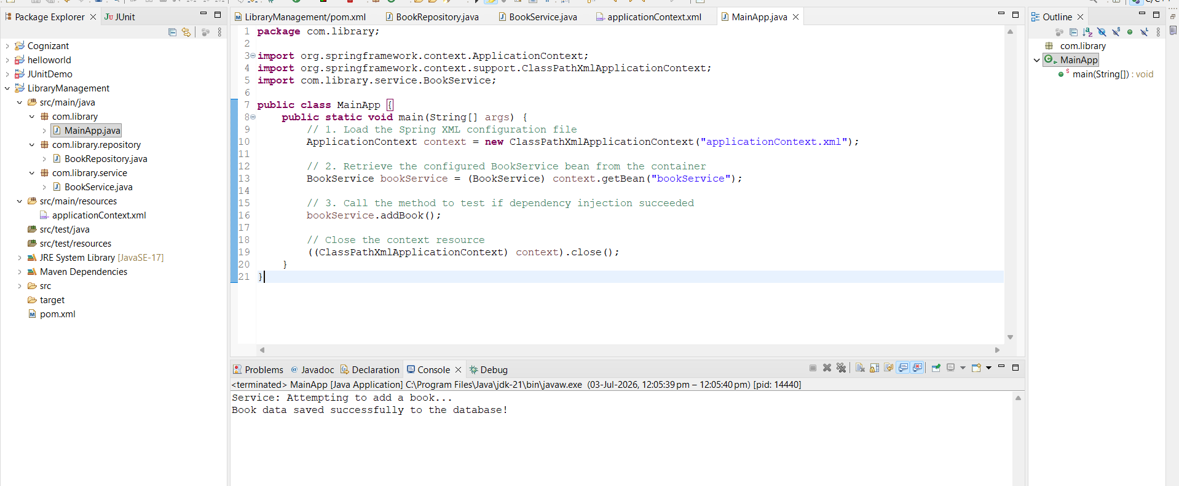

Exercise 4: Creating and Configuring a Maven Project
pom.xml :
<project xmlns="http://maven.apache.org/POM/4.0.0"
xmlns:xsi="http://www.w3.org/2001/XMLSchema-instance"
xsi:schemaLocation="http://maven.apache.org/POM/4.0.0 https://maven.apache.org/xsd/maven-4.0.0.xsd">
<modelVersion>4.0.0</modelVersion>
<groupId>com.library</groupId>
<artifactId>LibraryManagement</artifactId>
<version>0.0.1-SNAPSHOT</version>
<packaging>war</packaging> <properties>
<spring.version>5.3.31</spring.version>
</properties>

<dependencies>
<dependency>
<groupId>org.springframework</groupId>
<artifactId>spring-context</artifactId>
<version>${spring.version}</version>
</dependency>

<dependency>
<groupId>org.springframework</groupId>
<artifactId>spring-aop</artifactId>
<version>${spring.version}</version>
</dependency>

<dependency>
<groupId>org.springframework</groupId>
<artifactId>spring-webmvc</artifactId>
<version>${spring.version}</version>
</dependency>
</dependencies>

<build>
<plugins>
<plugin>
<groupId>org.apache.maven.plugins</groupId>
<artifactId>maven-compiler-plugin</artifactId>
<version>3.11.0</version>
<configuration>
<source>1.8</source>
<target>1.8</target>
</configuration>
</plugin>
</plugins>
</build>
</project>

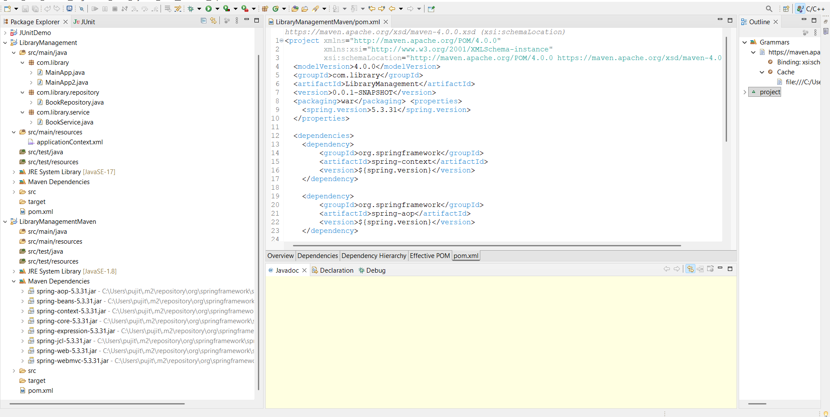
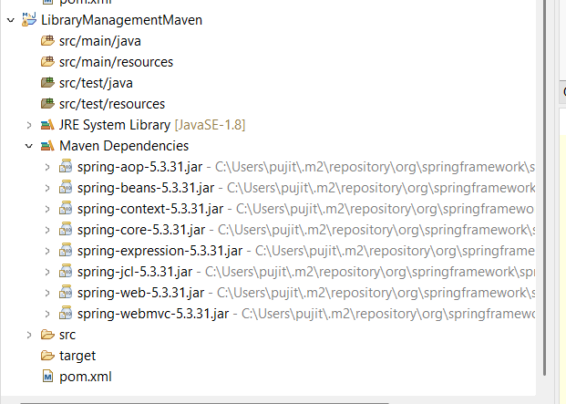

Exercise 5: Configuring the Spring IoC Container
applicationContext.xml :
<?xml version="1.0" encoding="UTF-8"?>
<beans xmlns="http://www.springframework.org/schema/beans"
xmlns:xsi="http://www.w3.org/2001/XMLSchema-instance"
xsi:schemaLocation="http://www.springframework.org/schema/beans
https://www.springframework.org/schema/beans/spring-beans.xsd">

<bean id="bookRepository" class="com.library.repository.BookRepository" />

<bean id="bookService" class="com.library.service.BookService">
<property name="bookRepository" ref="bookRepository" />
</bean>

</beans>

BookRepository.java :
package com.library.repository;

public class BookRepository {
public void saveData() {
System.out.println("Database: Book record successfully saved!");
}
}

BookService.java :
package com.library.service;

import com.library.repository.BookRepository;

public class BookService {
private BookRepository bookRepository;

// Setter method used by Spring IoC container for dependency injection
public void setBookRepository(BookRepository bookRepository) {
this.bookRepository = bookRepository;
}

public void addBook() {
System.out.println("Service: Delegating book addition to Repository...");
bookRepository.saveData();
}
}

LibraryManagementApplication.java :
package com.library;

import org.springframework.context.ApplicationContext;
import org.springframework.context.support.ClassPathXmlApplicationContext;
import com.library.service.BookService;

public class LibraryManagementApplication {
public static void main(String[] args) {
System.out.println("=== Exercise 5: Bootstrapping IoC Container ===");

// 1. Load configuration metadata into the ApplicationContext
ApplicationContext context = new ClassPathXmlApplicationContext("applicationContext.xml");

// 2. Retrieve the fully wired bean container instance
BookService bookService = (BookService) context.getBean("bookService");

// 3. Invoke methods to verify configuration success
bookService.addBook();

// 4. Close the context context channel safely
((ClassPathXmlApplicationContext) context).close();
}
}

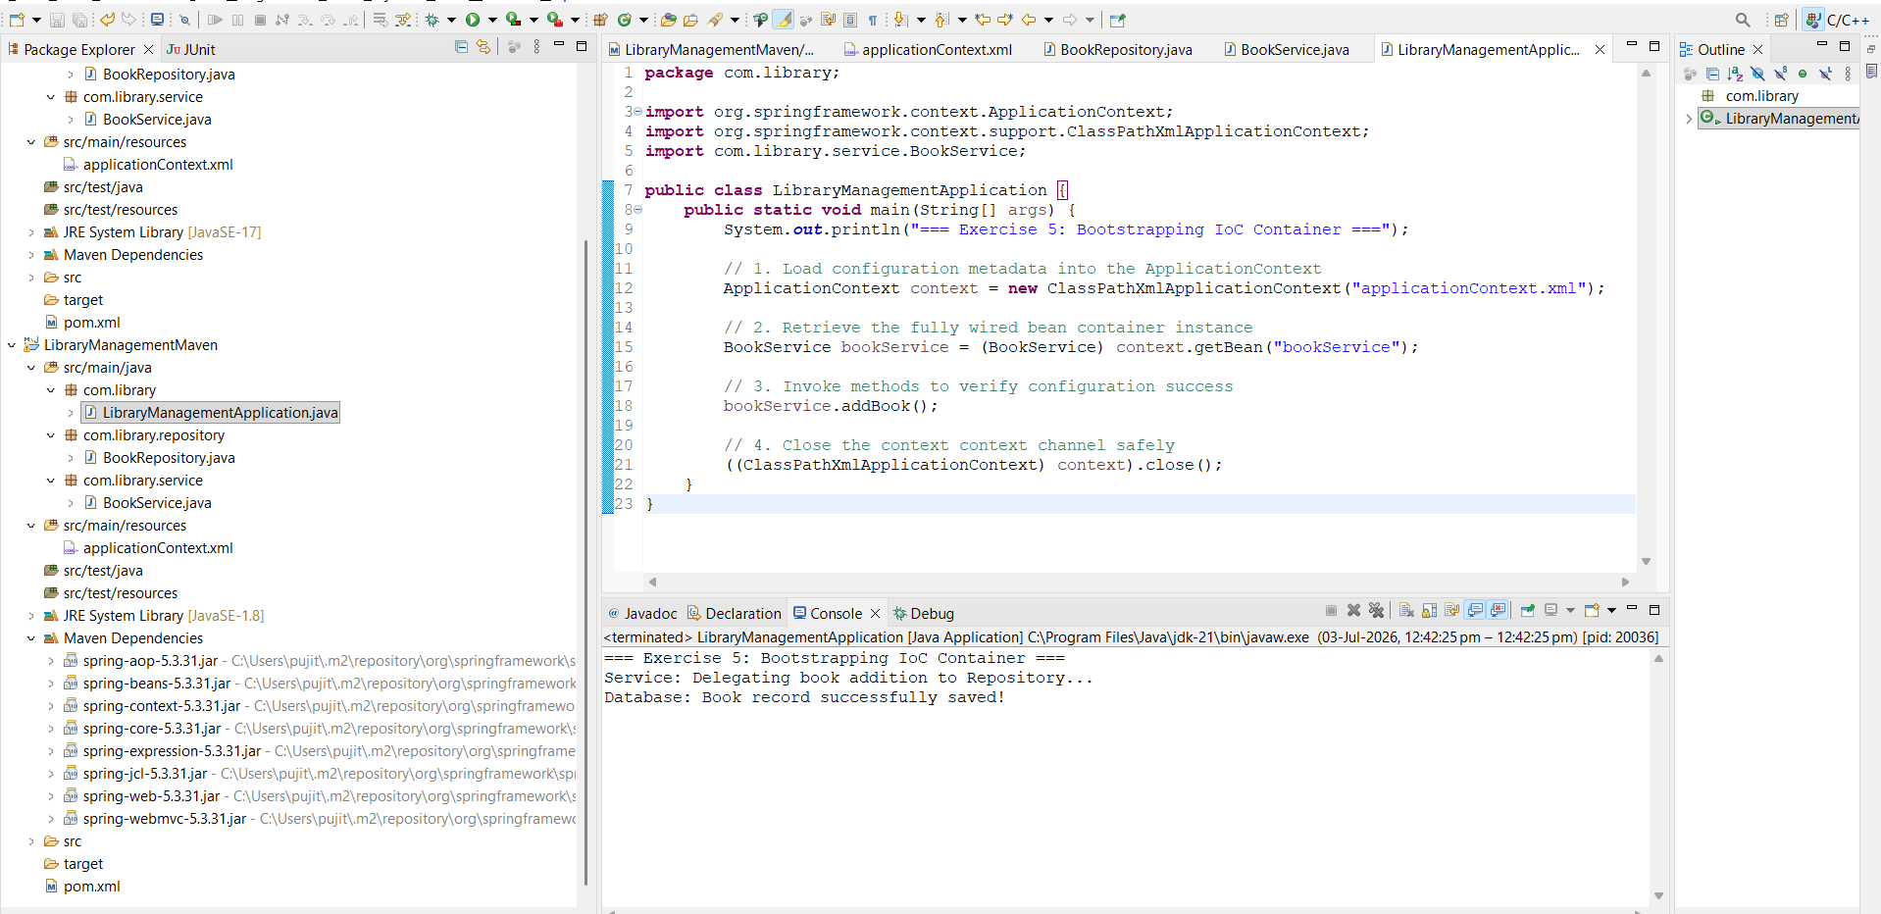

Exercise 7: Implementing Constructor and Setter Injection
NotificationService.java :
package com.library.service;

public class NotificationService {
public void sendNotification(String message) {
System.out.println("Notification: " + message);
}
}

BookService.java :
package com.library.service;

import com.library.repository.BookRepository;

public class BookService {
private BookRepository bookRepository;
private NotificationService notificationService;

// 1. CONSTRUCTOR INJECTION: For NotificationService
public BookService(NotificationService notificationService) {
this.notificationService = notificationService;
System.out.println("-> Constructor Injection: NotificationService injected.");
}

// 2. SETTER INJECTION: For BookRepository
public void setBookRepository(BookRepository bookRepository) {
this.bookRepository = bookRepository;
System.out.println("-> Setter Injection: BookRepository injected.");
}

public void addBook() {
System.out.println("Service: Adding a new book record...");
bookRepository.saveData();
notificationService.sendNotification("Book added successfully!");
}
}

applicationContext.xml :
<?xml version="1.0" encoding="UTF-8"?>
<beans xmlns="http://www.springframework.org/schema/beans"
xmlns:xsi="http://www.w3.org/2001/XMLSchema-instance"
xsi:schemaLocation="http://www.springframework.org/schema/beans
https://www.springframework.org/schema/beans/spring-beans.xsd">

<bean id="bookRepository" class="com.library.repository.BookRepository" />
<bean id="notificationService" class="com.library.service.NotificationService" />

<bean id="bookService" class="com.library.service.BookService">

<constructor-arg ref="notificationService" />

<property name="bookRepository" ref="bookRepository" />

</bean>

</beans>

LibraryManagementApplication
package com.library;

import org.springframework.context.ApplicationContext;
import org.springframework.context.support.ClassPathXmlApplicationContext;
import com.library.service.BookService;

public class LibraryManagementApplication {
public static void main(String[] args) {
System.out.println("=== Exercise 5: Bootstrapping IoC Container ===");

// 1. Load configuration metadata into the ApplicationContext
ApplicationContext context = new ClassPathXmlApplicationContext("applicationContext.xml");

// 2. Retrieve the fully wired bean container instance
BookService bookService = (BookService) context.getBean("bookService");

// 3. Invoke methods to verify configuration success
bookService.addBook();

// 4. Close the context context channel safely
((ClassPathXmlApplicationContext) context).close();
}
}

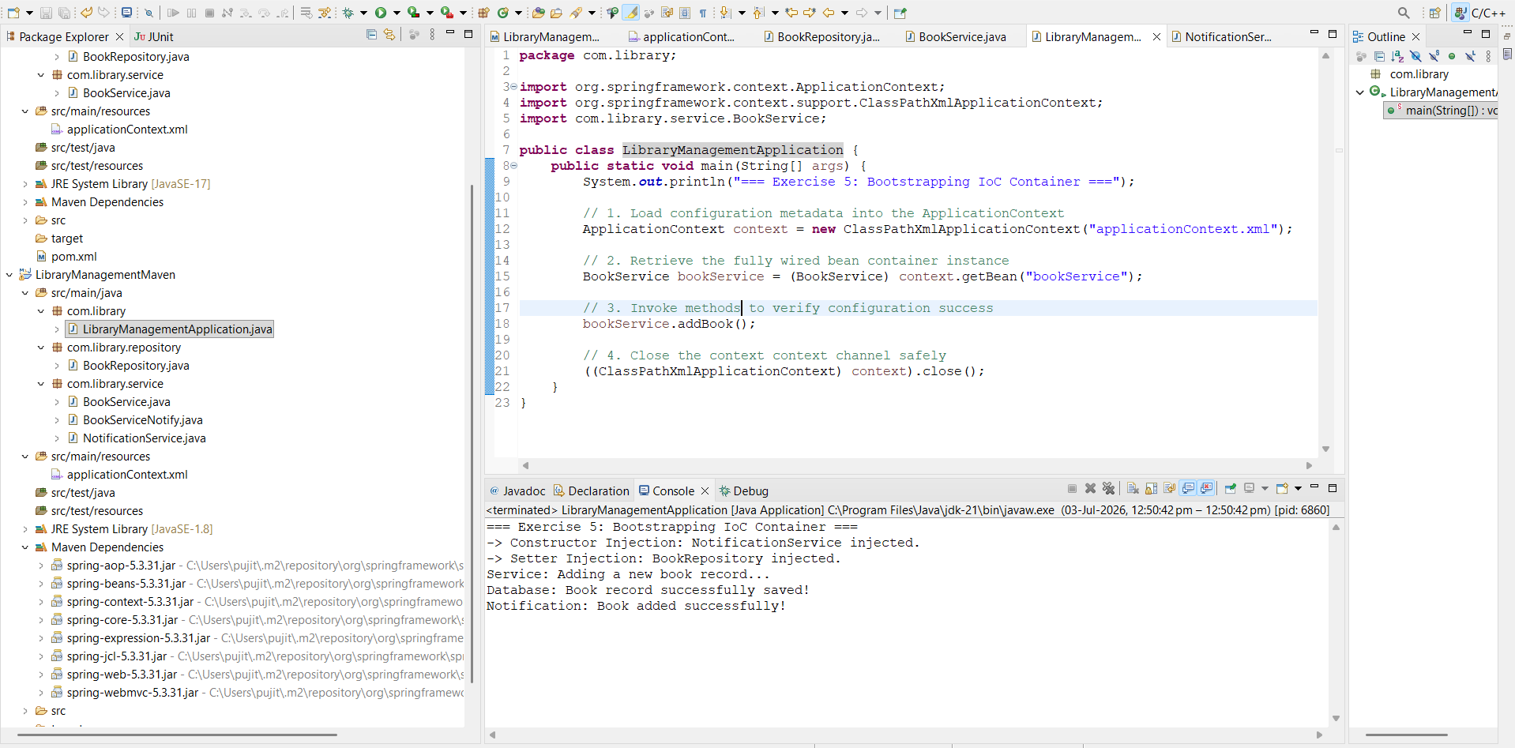

Exercise 9: Creating a Spring Boot Application
Updated pom.xml :
<?xml version="1.0" encoding="UTF-8"?>
<project xmlns="http://maven.apache.org/POM/4.0.0"
xmlns:xsi="http://www.w3.org/2001/XMLSchema-instance"
xsi:schemaLocation="http://maven.apache.org/POM/4.0.0 https://maven.apache.org/xsd/maven-4.0.0.xsd">
<modelVersion>4.0.0</modelVersion>

<parent>
<groupId>org.springframework.boot</groupId>
<artifactId>spring-boot-starter-parent</artifactId>
<version>3.2.5</version>
<relativePath/>
</parent>

<groupId>com.library</groupId>
<artifactId>LibraryManagement</artifactId>
<version>0.0.1-SNAPSHOT</version>

<properties>
<java.version>17</java.version>
</properties>

<dependencies>
<dependency>
<groupId>org.springframework.boot</groupId>
<artifactId>spring-boot-starter-web</artifactId>
</dependency>

<dependency>
<groupId>org.springframework.boot</groupId>
<artifactId>spring-boot-starter-data-jpa</artifactId>
</dependency>

<dependency>
<groupId>com.h2database</groupId>
<artifactId>h2</artifactId>
<scope>runtime</scope>
</dependency>
</dependencies>

<build>
<plugins>
<plugin>
<groupId>org.springframework.boot</groupId>
<artifactId>spring-boot-maven-plugin</artifactId>
</plugin>
</plugins>
</build>
</project>

Application. Properties :
spring.datasource.url=jdbc:h2:mem:librarydb
spring.datasource.driverClassName=org.h2.Driver
spring.datasource.username=sa
spring.datasource.password=

spring.h2.console.enabled=true
spring.h2.console.path=/h2-console

spring.jpa.show-sql=true
spring.jpa.hibernate.ddl-auto=update

Book.java :
package com.library.model;
import jakarta.persistence.Entity;
import jakarta.persistence.GeneratedValue;
import jakarta.persistence.GenerationType;
import jakarta.persistence.Id;
@Entity
public class Book {
@Id
@GeneratedValue(strategy = GenerationType.IDENTITY)
private Long id;
private String title;
private String author;

public Book() {}

public Book(String title, String author) {
this.title = title;
this.author = author;
}

public Long getId() { return id; }
public void setId(Long id) { this.id = id; }
public String getTitle() { return title; }
public void setTitle(String title) { this.title = title; }
public String getAuthor() { return author; }
public void setAuthor(String author) { this.author = author; }
}
BookRepository1.java :

package com.library.repository;

import com.library.model.Book;
import org.springframework.data.jpa.repository.JpaRepository;
import org.springframework.stereotype.Repository;

@Repository
public interface BookRepository1 extends JpaRepository<Book, Long> {
// This gives you access to built-in methods like findAll() and save()
}

BookController.java :

package com.library.controller;

import com.library.model.Book;
import com.library.repository.BookRepository1;
import org.springframework.beans.factory.annotation.Autowired;
import org.springframework.web.bind.annotation.*;

import java.util.List;

@RestController
@RequestMapping("/api/books")
public class BookController {

@Autowired
private BookRepository1 bookRepository;

// 1. GET Endpoint to fetch all books
@GetMapping
public List<Book> getAllBooks() {
return bookRepository.findAll();
}

// 2. POST Endpoint to add a new book
@PostMapping
public Book createBook(@RequestBody Book book) {
return bookRepository.save(book);
}
}

LibraryManagementApplication

package com.library;

import org.springframework.boot.SpringApplication;
import org.springframework.boot.autoconfigure.SpringBootApplication;

@SpringBootApplication
public class LibraryManagementApplication {
public static void main(String[] args) {
SpringApplication.run(LibraryManagementApplication.class, args);
}
}

