Angular Hands on:
1.Node.js & npm commands :
node -v
npm -v
2. Angular CLI (v20)
- Install Globally: Open terminal and execute: npm install -g @angular/cli
- Verify Installation: ng version
3.Visual Studio Code & Extensions
Extensions: Angular Language Service
4.Chrome DevTools & Angular DevTools
Extension: Install Angular DevTools from the Chrome Web Store
5. JSON Server (Mock Backend) : npm install -g json-server

HANDS-ON 1: Environment Setup, Project Structure & First Component
Task 1: Scaffold and Explore the Project
ng new student-course-portal --routing --style=css
cd student-course-portal

notes.txt :
angular.json: Workspace configuration file for CLI build tools, assets, and project settings.
tsconfig.json: Global TypeScript compiler configuration for the workspace.
tsconfig.app.json: Application-specific TypeScript compiler configuration.
package.json: Manages project dependencies, scripts, and package metadata.
src/main.ts: Application entry point that bootstraps the Angular application.
src/app/app.module.ts / app.config.ts: Application root module/standalone configuration file.
src/app/app.component.ts: Root component logic handling the top-level view.
src/index.html: Main HTML file that hosts the Angular application.

Run Application: ng serve
Opening local host : http://localhost:4200
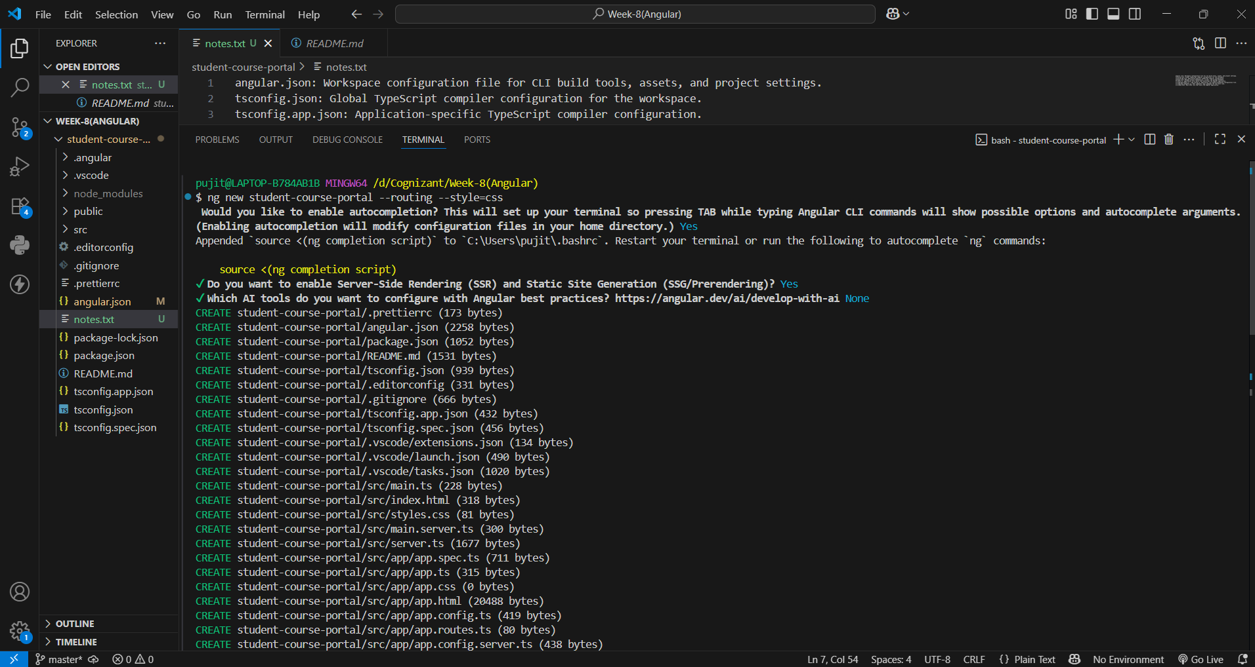

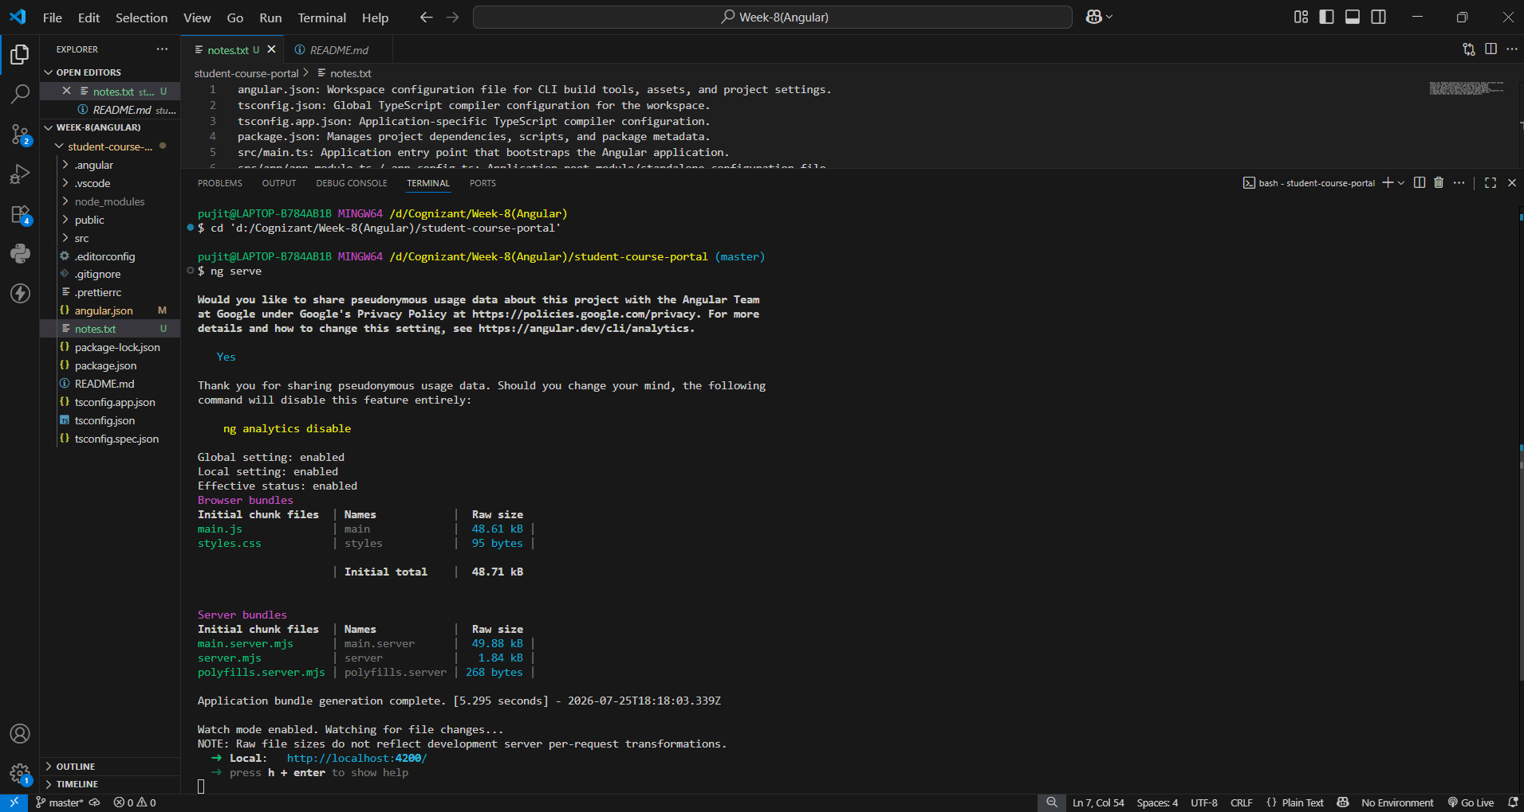
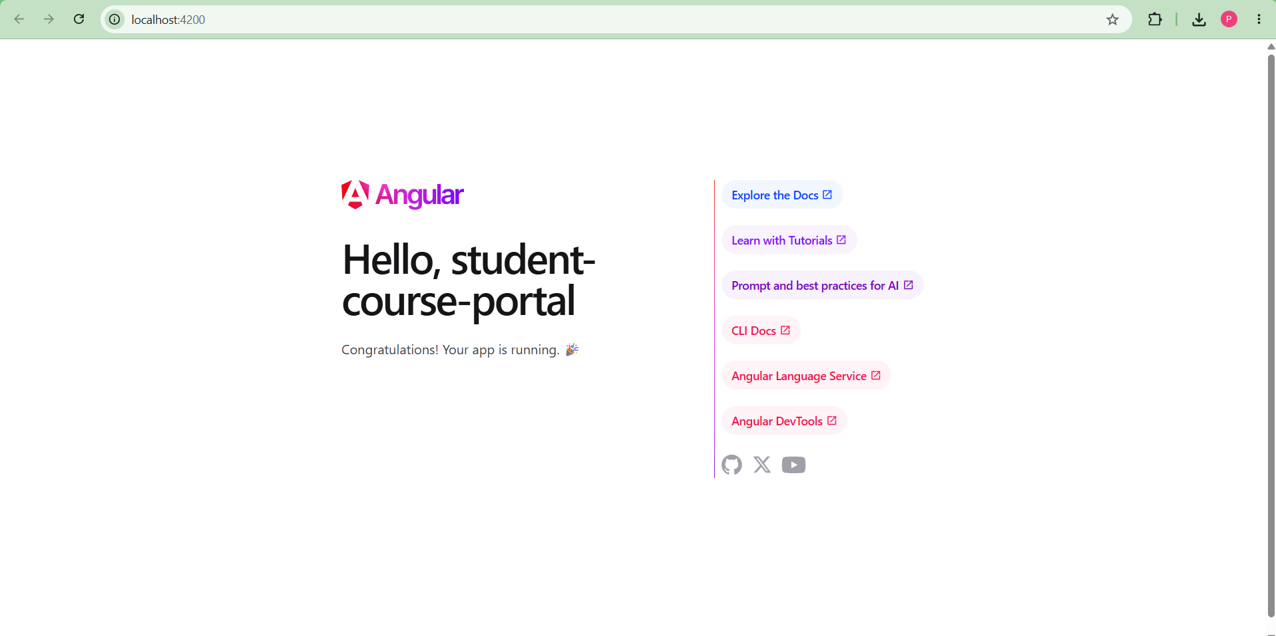

Task 2: Create and Organise Components
Commands:
ng generate component components/header
ng generate component pages/home
ng generate component pages/course-list
ng generate component pages/student-profile

home.html:
<section class="home-container">
<h1>Welcome to the Student Course Portal</h1>
<p>Manage your enrolled courses, check academic grades, and browse available offerings.</p>

<div class="stats-row">
<div class="stat-card">
<h3>Courses Available</h3>
<p>12</p>
</div>
<div class="stat-card">
<h3>Enrolled</h3>
<p>3</p>
</div>
<div class="stat-card">
<h3>GPA</h3>
<p>3.8</p>
</div>
</div>
</section>

app.html:
<app-header></app-header>
<main>
<app-home></app-home>
<router-outlet></router-outlet>
</main>

app.ts:
import { Component } from '@angular/core';
import { RouterOutlet } from '@angular/router';
import { Header } from './components/header/header';
import { Home } from './pages/home/home';

@Component({
selector: 'app-root',
standalone: true,
imports: [RouterOutlet, Header, Home],
templateUrl: './app.html',
styleUrl: './app.css'
})
export class App {
title = 'student-course-portal';
}

header.ts :
import { Component } from '@angular/core';

@Component({
selector: 'app-header',
imports: [],
templateUrl: './header.html',
styleUrl: './header.css',
})
export class Header {}

home.ts:
import { Component } from '@angular/core';

@Component({
selector: 'app-header',
imports: [],
templateUrl: './header.html',
styleUrl: './header.css',
})
export class Header {}

