HANDS-ON 2 : Data Binding, Lifecycle Hooks & Component Communication
Task 1: All Four Binding Types
home.ts :
import { Component } from '@angular/core';
import { FormsModule } from '@angular/forms'; // Required for ngModel
@Component({
selector: 'app-home',
standalone: true,
imports: [FormsModule], // Add FormsModule here
templateUrl: './home.html',
styleUrl: './home.css',
})
export class Home {
// Step 11: Interpolation property
portalName: string = 'Student Course Portal';

// Step 12: Property binding property
isPortalActive: boolean = true;

// Step 13: Event binding property
message: string = '';

// Step 14: Two-way data binding property
searchTerm: string = '';

// Step 13: Event handler method
onEnrollClick(): void {
this.message = 'Enrollment opened!';
}
}
home.html :
<div class="home-container">
<!-- Step 11: String Interpolation (Component -> DOM) -->
<h1>{{ portalName }}</h1>

<!-- Step 12 & 13: Property Binding [disabled] and Event Binding (click) -->
<button [disabled]="!isPortalActive" (click)="onEnrollClick()">
Enroll Now
</button>

<!-- Displays the message updated by onEnrollClick() -->
<p *ngIf="message">{{ message }}</p>

<hr />

<!-- Step 14: Two-Way Data Binding [(ngModel)] (DOM <-> Component) -->
<div class="search-box">
<label for="search">Search Course: </label>
<input id="search" type="text" [(ngModel)]="searchTerm" placeholder="Type here..." />

<!-- Live display of the search term using string interpolation -->
<p>Searching for: {{ searchTerm }}</p>
</div>

<!-- Step 15: Explanation Comment -->
<!--
[property] binding is ONE-WAY (Component -> DOM). It sends data from TypeScript to the template, but changes in the DOM won't update the TS variable.
[(ngModel)] binding is TWO-WAY (DOM <-> Component). It continuously synchronizes data between the template input and the TS variable in real time.
-->
</div>

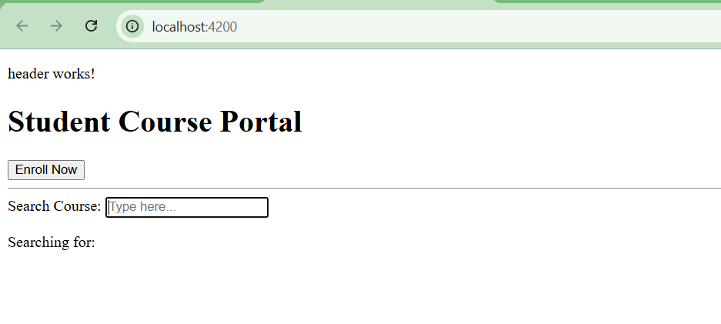

Task 2: Lifecycle Hooks
home.ts:
import { Component, OnInit, OnDestroy } from '@angular/core';
import { FormsModule } from '@angular/forms';

@Component({
selector: 'app-home',
standalone: true,
imports: [FormsModule],
templateUrl: './home.html',
styleUrl: './home.css',
})
export class Home implements OnInit, OnDestroy {
portalName: string = 'Student Course Portal';
isPortalActive: boolean = true;
message: string = '';
searchTerm: string = '';

onEnrollClick(): void {
this.message = 'Enrollment opened!';
}

// Step 16: ngOnInit hook fires once when component initializes
ngOnInit(): void {
console.log('HomeComponent initialised — courses loaded');
}

// Step 17: ngOnDestroy hook fires right before component is removed from DOM
ngOnDestroy(): void {
console.log('HomeComponent destroyed');
}
}
Command:
ng generate component components/course-card

course-card.ts :
import { Component, Input, OnChanges, SimpleChanges } from '@angular/core';

@Component({
selector: 'app-course-card',
standalone: true,
imports: [],
templateUrl: './course-card.html',
styleUrl: './course-card.css'
})
export class CourseCard implements OnChanges {
// Step 18: Input property to receive data from parent
@Input() course: any;

// Step 18: ngOnChanges hook fires whenever an @Input value changes
ngOnChanges(changes: SimpleChanges): void {
if (changes['course']) {
console.log('Course input changed:');
console.log(' Previous Value:', changes['course'].previousValue);
console.log(' Current Value:', changes['course'].currentValue);
}
}
}

Course-list.ts:
import { Component } from '@angular/core';
import { CourseCard } from '../../components/course-card/course-card';

@Component({
selector: 'app-course-list',
standalone: true,
imports: [CourseCard],
templateUrl: './course-list.html',
styleUrl: './course-list.css'
})
export class CourseList {
// Step 19: Hardcoded courses array
courses = [
{ id: 101, name: 'Angular Fundamentals', code: 'CS101', credits: 3 },
{ id: 102, name: 'Web Development Basics', code: 'CS102', credits: 4 },
{ id: 103, name: 'Cloud Computing Essentials', code: 'CS103', credits: 3 }
];
}
Course-list.html:
<h2>Course List</h2>
<div class="course-list">
<!-- Step 19: Rendering 3 cards -->
<app-course-card [course]="courses[0]"></app-course-card>
<app-course-card [course]="courses[1]"></app-course-card>
<app-course-card [course]="courses[2]"></app-course-card>
</div>
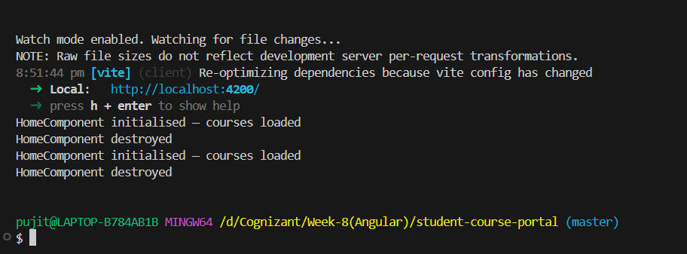

Task 3: @Input and @Output — Parent-Child Communication
course-card.ts:
import { Component, Input, Output, EventEmitter } from '@angular/core';
import { CommonModule } from '@angular/common';

@Component({
selector: 'app-course-card',
standalone: true,
imports: [CommonModule],
templateUrl: './course-card.html',
styleUrl: './course-card.css'
})
export class CourseCard {
// Step 20: Receive the course object from parent
@Input() course!: { id: number; name: string; code: string; credits: number };

// Step 21: Define event emitter to send the course ID back up to parent
@Output() enrollRequested = new EventEmitter<number>();
}
course-card.html:
<div class="card">
<!-- Step 20: Render all four fields -->
<h3>{{ course.name }}</h3>
<p><strong>Code:</strong> {{ course.code }}</p>
<p><strong>Credits:</strong> {{ course.credits }}</p>
<p><strong>ID:</strong> {{ course.id }}</p>

<!-- Step 21: Trigger event emission when clicked -->
<button (click)="enrollRequested.emit(course.id)">Enroll</button>
</div>

course-list.ts:
import { Component } from '@angular/core';
import { CommonModule } from '@angular/common';
import { CourseCard } from '../../components/course-card/course-card';

@Component({
selector: 'app-course-list',
standalone: true,
imports: [CommonModule, CourseCard],
templateUrl: './course-list.html',
styleUrl: './course-list.css'
})
export class CourseList {
// Step 22: Define array with 5 course objects
courses = [
{ id: 101, name: 'Angular Fundamentals', code: 'CS101', credits: 3 },
{ id: 102, name: 'Web Development Basics', code: 'CS102', credits: 4 },
{ id: 103, name: 'Cloud Computing Essentials', code: 'CS103', credits: 3 },
{ id: 104, name: 'Database Management Systems', code: 'CS104', credits: 4 },
{ id: 105, name: 'Data Structures & Algorithms', code: 'CS105', credits: 3 }
];

selectedCourseId: number | null = null;

// Step 23: Handle event sent by child card
onEnroll(courseId: number): void {
console.log('Enrolling in course: ' + courseId);
this.selectedCourseId = courseId;
}
}

course-list.html
<h2>Course List</h2>

<div class="course-list">
<!-- Step 22: Loop through 5 courses, pass each into child [course], listen for (enrollRequested) -->
<app-course-card
*ngFor="let c of courses"
[course]="c"
(enrollRequested)="onEnroll($event)">
</app-course-card>
</div>

<!-- Step 24: Display selected course ID below the list -->
<p *ngIf="selectedCourseId">Selected course ID: {{ selectedCourseId }}</p>

