MicroServices :
Creating Microservices for account and loan
In command prompt: mvnw clean package
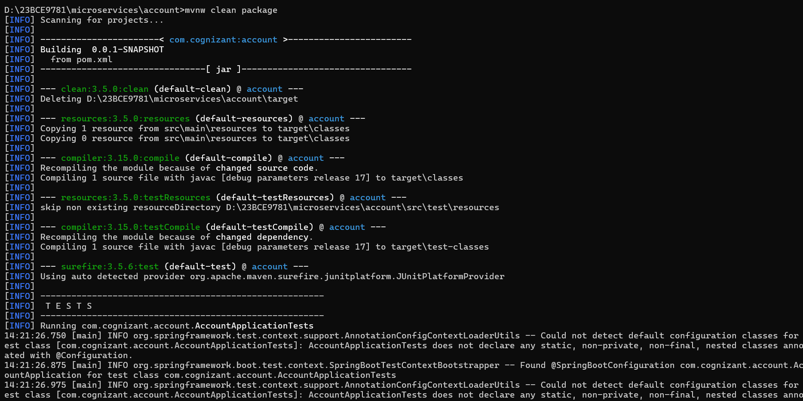

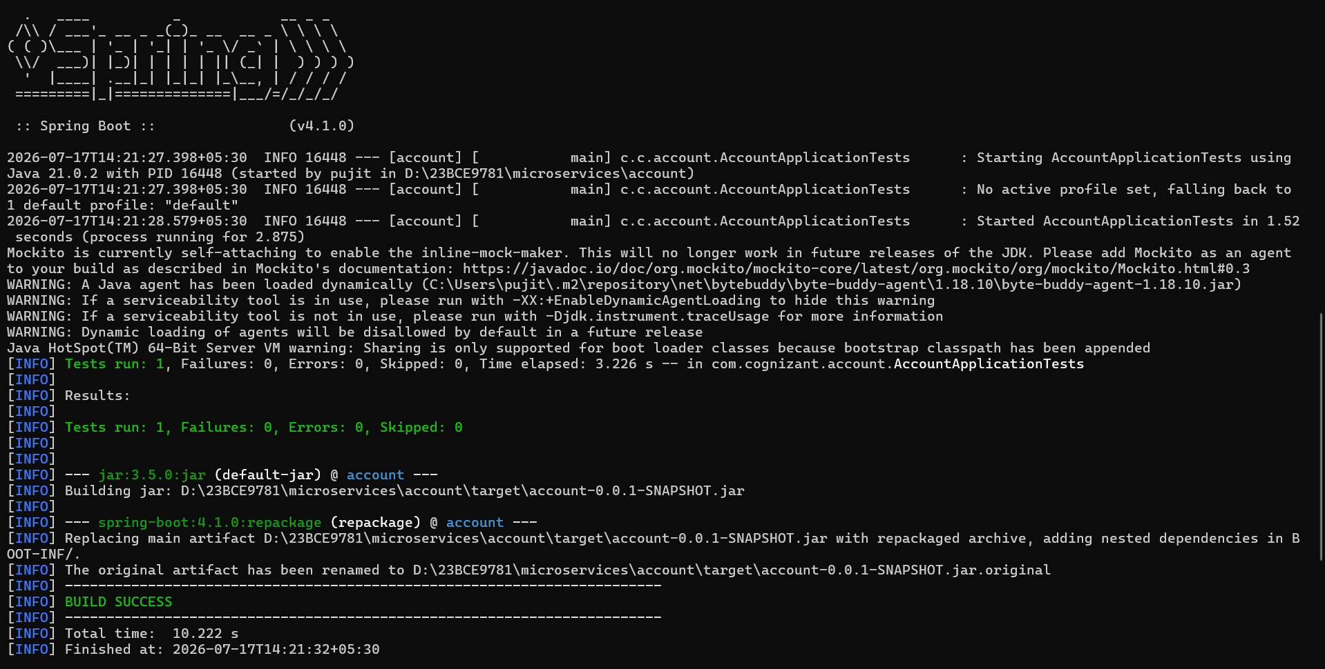

Account :
AccountController.java :
package com.cognizant.account;

import java.util.HashMap;
import java.util.Map;
import org.springframework.web.bind.annotation.GetMapping;
import org.springframework.web.bind.annotation.PathVariable;
import org.springframework.web.bind.annotation.RestController;

@RestController
public class AccountController {

@GetMapping("/accounts/{number}")
public Map<String, Object> getAccountDetails(@PathVariable String number) {
Map<String, Object> account = new HashMap<>();
account.put("number", number); // Dynamic based on URL
account.put("type", "savings");
account.put("balance", 234343);
return account;
}
}

AccountApplication.java:
package com.cognizant.account;
import org.springframework.boot.SpringApplication;
import org.springframework.boot.autoconfigure.SpringBootApplication;
@SpringBootApplication
public class AccountApplication {
public static void main(String[] args) {
SpringApplication.run(AccountApplication.class, args);
}
}

Running AccountApplication.java on port 8080:

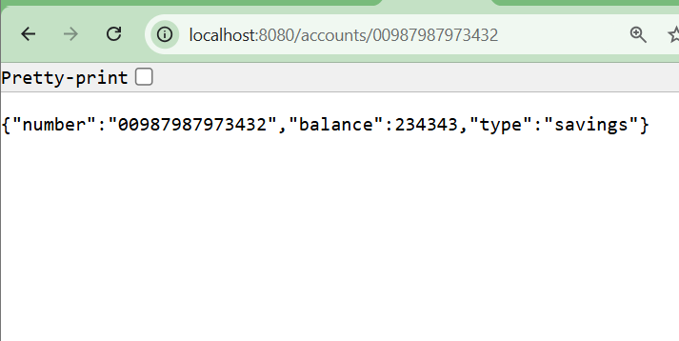

Loan :
LoanController.java :
package com.cognizant.loan;

import java.util.HashMap;
import java.util.Map;
import org.springframework.web.bind.annotation.GetMapping;
import org.springframework.web.bind.annotation.PathVariable;
import org.springframework.web.bind.annotation.RestController;

@RestController
public class LoanController {

@GetMapping("/loans/{number}")
public Map<String, Object> getLoanDetails(@PathVariable String number) {
Map<String, Object> loan = new HashMap<>();
loan.put("number", number);
loan.put("type", "car");
loan.put("loan", 400000);
loan.put("emi", 3258);
loan.put("tenure", 18);
return loan;
}
}

LoanApplication.java:
package com.cognizant.loan;
import org.springframework.boot.SpringApplication;
import org.springframework.boot.autoconfigure.SpringBootApplication;

@SpringBootApplication
public class LoanApplication {
public static void main(String[] args) {
SpringApplication.run(LoanApplication.class, args);
}
}
Running LoanApplication.java on port 8081:

