Week – 1:
Module 1 - Design principles & Patterns:
Exercise 1 - Implementing the Singleton Pattern:
Program Code:
package Module_1;
import java.util.*;
class Logger{
private static Logger instance;
private Logger() {
System.out.println("Instance Created");
}
public static Logger getInstance() {
if(instance==null) {
instance = new Logger();
}
return instance;
}
public void log(String message) {
System.out.println("LOG: "+message);
}
}
public class Sigleton {

public static void main(String[] args) {
Logger logger1 = Logger.getInstance();
logger1.log("First Message");
Logger logger2 = Logger.getInstance();
logger2.log("Second message");
if (logger1 == logger2) {
System.out.println("Only one Logger instance exists.");
} else {
System.out.println("Multiple Logger instances exist.");
}

}

}

Output:

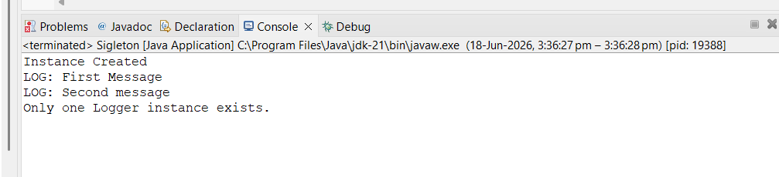

Exercise 2: Implementing the Factory Method Pattern:
Create a project named FactoryMethodPatternExample with the following structure:
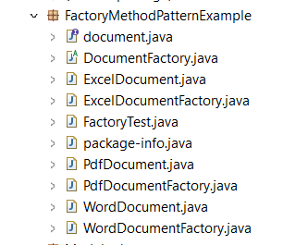

1.Document Interface
document.java:
package FactoryMethodPatternExample;

public interface document {
void open();

}

2. Concrete Document Classes:
WordDocument.java:
package FactoryMethodPatternExample;

public class WordDocument implements document{
public void open() {
System.out.println("Openeing Word Document");
}

}

PdfDocument.java:
package FactoryMethodPatternExample;

public class PdfDocument implements document{
public void open() {
System.out.println("Openeing PDF Document");
}

}
ExcelDocument.java:
package FactoryMethodPatternExample;

public class ExcelDocument implements document{
public void open() {
System.out.println("Openeing Excel Document");
}
}

3.Abstract Factory
DocumentFactory.java:
package FactoryMethodPatternExample;

public abstract class DocumentFactory {
public abstract document createDocument();

}

4.Concrete Factories
WordDocumentFactory.java:
package FactoryMethodPatternExample;

public class WordDocumentFactory extends DocumentFactory{
public document createDocument() {
return new WordDocument();
}

}

PdfDocumentFactory.java:
package FactoryMethodPatternExample;

public class PdfDocumentFactory extends DocumentFactory{
public document createDocument() {
return new PdfDocument();
}

}

ExcelDocumentFactory.java:
package FactoryMethodPatternExample;

public class ExcelDocumentFactory extends DocumentFactory{
public document createDocument() {
return new ExcelDocument();
}

}

5. Test Class
FactoryTest.java:
package FactoryMethodPatternExample;
public class FactoryTest {
public static void main(String[] args) {

DocumentFactory wordFactory = new WordDocumentFactory();
document wordDoc = wordFactory.createDocument();
wordDoc.open();

DocumentFactory pdfFactory = new PdfDocumentFactory();
document pdfDoc = pdfFactory.createDocument();
pdfDoc.open();

DocumentFactory excelFactory = new ExcelDocumentFactory();
document excelDoc = excelFactory.createDocument();
excelDoc.open();
}
}

Output:
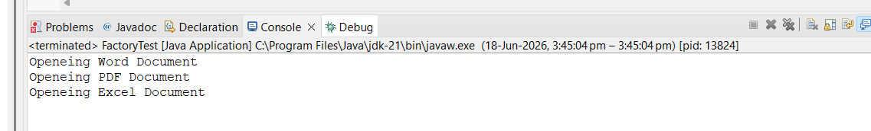

Module 2 - Data structures and Algorithms
Exercise 2: E-commerce Platform Search Function

i)Understanding Asymptotic Notation:
- Big O Notation:
Big O notation describes how the running time of an algorithm grows as the input size (n) increases. It helps compare algorithms based on efficiency.

Examples:
- O(1) → Constant time
- O(log n) → Logarithmic time
- O(n) → Linear time
- O(n²) → Quadratic time

ii)Search Operation Cases:

Case | Linear Search |  | Binary Search
Best Case | O(1) |  | O(1)
Average Case | O(n) |  | O(log n)
Worst Case | O(n) |  | O(log n)
- Best Case: Element found at the beginning or middle immediately.
- Average Case: Element found after several comparisons.
- Worst Case: Element is last or absent.

Program Code:
Product Class:
package Ecommerce_Platform;

class Product {
int productId;
String productName;
String category;

Product(int productId, String productName, String category) {
this.productId = productId;
this.productName = productName;
this.category = category;
}

void display() {
System.out.println(productId + " " + productName + " " + category);
}
Linear Search:

package Ecommerce_Platform;

public class LinearSearch {

public static Product linearSearch(Product[] products, int key) {
for (Product p : products) {
if (p.productId == key) {
return p;
}
}
return null;
}

public static void main(String[] args) {

Product[] products = {
new Product(101, "Laptop", "Electronics"),
new Product(102, "Shoes", "Fashion"),
new Product(103, "Phone", "Electronics"),
new Product(104, "Watch", "Accessories")
};

Product result = linearSearch(products, 103);

if (result != null)
result.display();
else
System.out.println("Product not found");
}
}

Output:

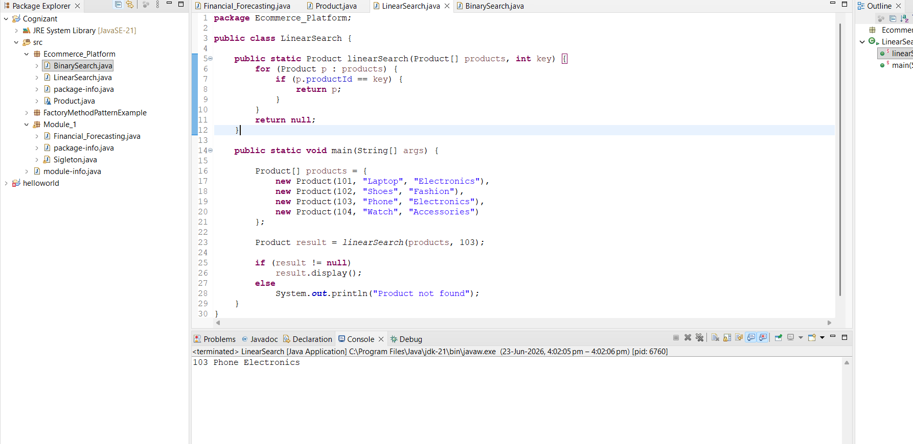

Binary Search :

package Ecommerce_Platform;

public class BinarySearch {

public static Product binarySearch(Product[] products, int key) {
int low = 0;
int high = products.length - 1;

while (low <= high) {
int mid = (low + high) / 2;

if (products[mid].productId == key)
return products[mid];
else if (products[mid].productId < key)
low = mid + 1;
else
high = mid - 1;
}

return null;
}

public static void main(String[] args) {

Product[] products = {
new Product(101, "Laptop", "Electronics"),
new Product(102, "Shoes", "Fashion"),
new Product(103, "Phone", "Electronics"),
new Product(104, "Watch", "Accessories")
};

Product result = binarySearch(products, 103);

if (result != null)
result.display();
else
System.out.println("Product not found");
}
}

Output:

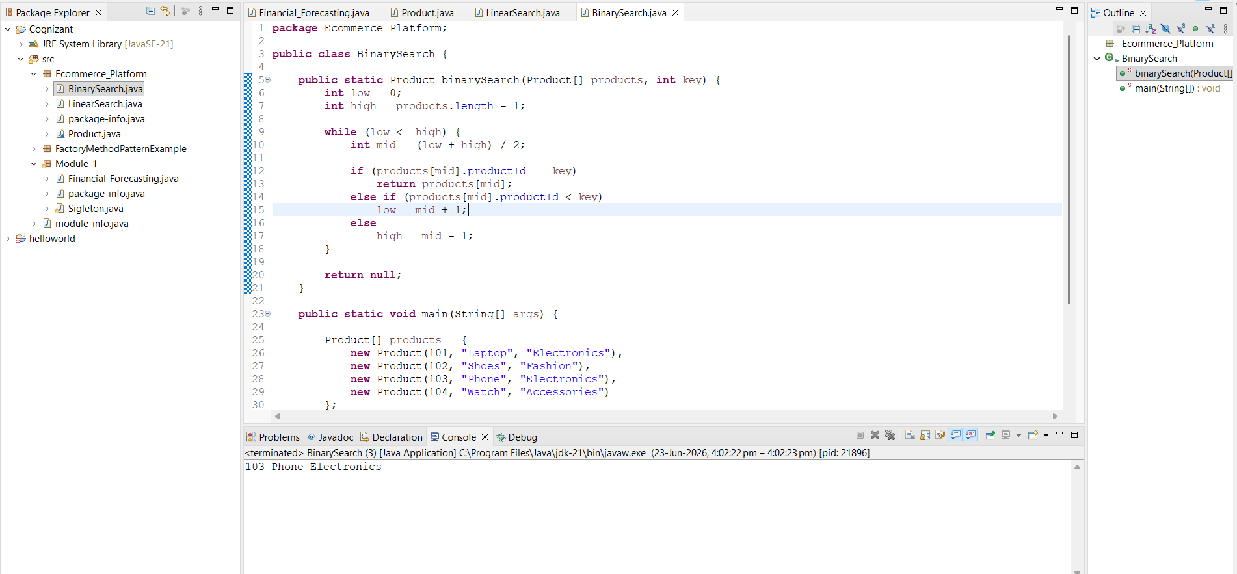
Exercise 7: Financial Forecasting
Recursion:
Recursion is a technique where a method calls itself to solve smaller instances of the same problem. It simplifies problems that can be broken down into repetitive subproblems.
Program Code:
package Module_1;

public class Financial_Forecasting {

public static double forecast(double initialValue,
double growthRate,
int years) {

if (years == 0)
return initialValue;

return (1 + growthRate) *
forecast(initialValue, growthRate, years - 1);
}

public static void main(String[] args) {

double initialValue = 10000;
double growthRate = 0.10;
int years = 5;

double futureValue = forecast(initialValue, growthRate, years);

System.out.println("Future Value after "
+ years + " years = " + futureValue);
}
}

Output:

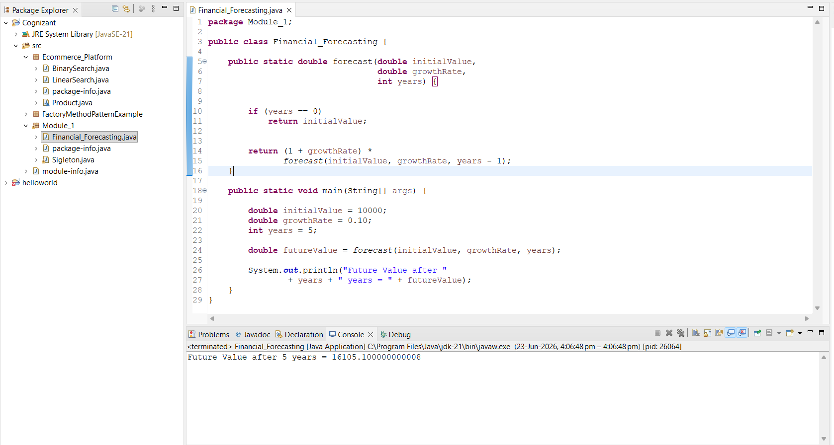

Module 3 - PL/SQL Programming
Exercise 1: Control Structures

Creating Tables:

Customers Table:

CREATE TABLE Customers (
CustomerID NUMBER PRIMARY KEY,
Name VARCHAR2(50),
Age NUMBER,
Balance NUMBER,
IsVIP VARCHAR2(5)
);

Loans Table:

CREATE TABLE Loans (
LoanID NUMBER PRIMARY KEY,
CustomerID NUMBER,
InterestRate NUMBER(5,2),
DueDate DATE,
FOREIGN KEY (CustomerID) REFERENCES Customers(CustomerID)
);

Inseting data:

Customers Table:

INSERT INTO Customers VALUES (101, 'Ravi', 65, 15000, 'FALSE');
INSERT INTO Customers VALUES (102, 'Priya', 45, 8000, 'FALSE');
INSERT INTO Customers VALUES (103, 'Amit', 70, 20000, 'FALSE');
INSERT INTO Customers VALUES (104, 'Neha', 30, 5000, 'FALSE');

Loans Table:

INSERT INTO Loans VALUES (201, 101, 8.5, SYSDATE + 15);
INSERT INTO Loans VALUES (202, 102, 9.0, SYSDATE + 45);
INSERT INTO Loans VALUES (203, 103, 7.5, SYSDATE + 20);
INSERT INTO Loans VALUES (204, 104, 8.0, SYSDATE + 10);

COMMIT;

Scenario 1: The bank wants to apply a discount to loan interest rates for customers above 60 years old.
- Question: Write a PL/SQL block that loops through all customers, checks their age, and if they are above 60, apply a 1% discount to their current loan interest rates.

Program Code:
DECLARE
v_age CUSTOMERS.AGE%TYPE;
BEGIN
FOR cust IN (SELECT CustomerID, Age FROM Customers) LOOP
v_age := cust.Age;
IF v_age > 60 THEN
UPDATE Loans
SET InterestRate = InterestRate - 1
WHERE CustomerID = cust.CustomerID;
DBMS_OUTPUT.PUT_LINE(
'1% discount applied for Customer ID: ' ||
cust.CustomerID
);
END IF;
END LOOP;
COMMIT;
END;
/
Output:
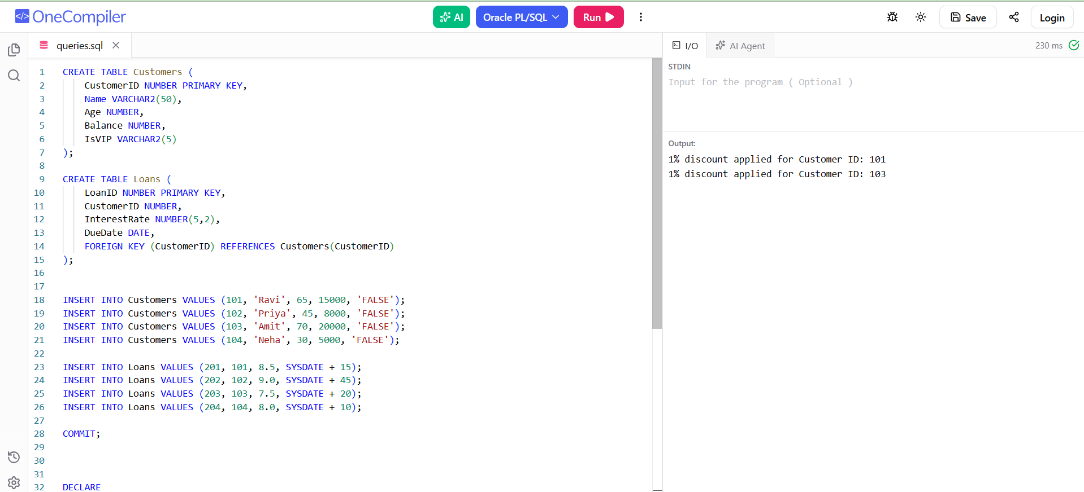

Scenario 2: A customer can be promoted to VIP status based on their balance.
- Question: Write a PL/SQL block that iterates through all customers and sets a flag IsVIP to TRUE for those with a balance over $10,000.
Program Code:
DECLARE
BEGIN
FOR cust IN (
SELECT CustomerID, Balance
FROM Customers
) LOOP
IF cust.Balance > 10000 THEN
UPDATE Customers
SET IsVIP = 'TRUE'
WHERE CustomerID = cust.CustomerID;
DBMS_OUTPUT.PUT_LINE(
'Customer ID ' || cust.CustomerID ||
' promoted to VIP.'
);
END IF;
END LOOP;
COMMIT;
END;
/
Output:
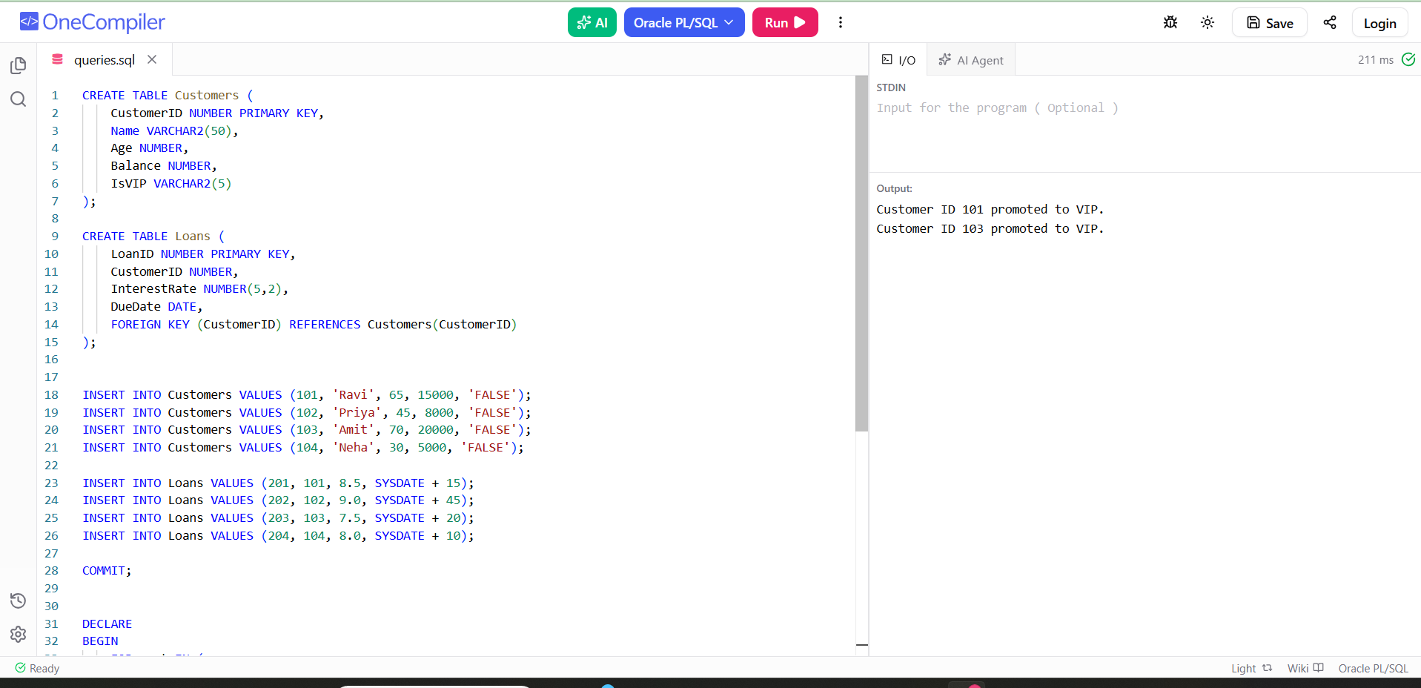

Scenario 3: The bank wants to send reminders to customers whose loans are due within the next 30 days.
  - Question: Write a PL/SQL block that fetches all loans due in the next 30 days and prints a reminder message for each customer.
Program Code:
DECLARE
BEGIN
FOR loan_rec IN (
SELECT c.CustomerID,
c.Name,
l.LoanID,
l.DueDate
FROM Customers c
JOIN Loans l
ON c.CustomerID = l.CustomerID
WHERE l.DueDate BETWEEN SYSDATE AND SYSDATE + 30
) LOOP
DBMS_OUTPUT.PUT_LINE(
'Reminder: Customer ' || loan_rec.Name ||
' (ID: ' || loan_rec.CustomerID || ')' ||
' has Loan ID ' || loan_rec.LoanID ||
' due on ' ||
TO_CHAR(loan_rec.DueDate, 'DD-MON-YYYY')
);
END LOOP;
END;
/
Output:
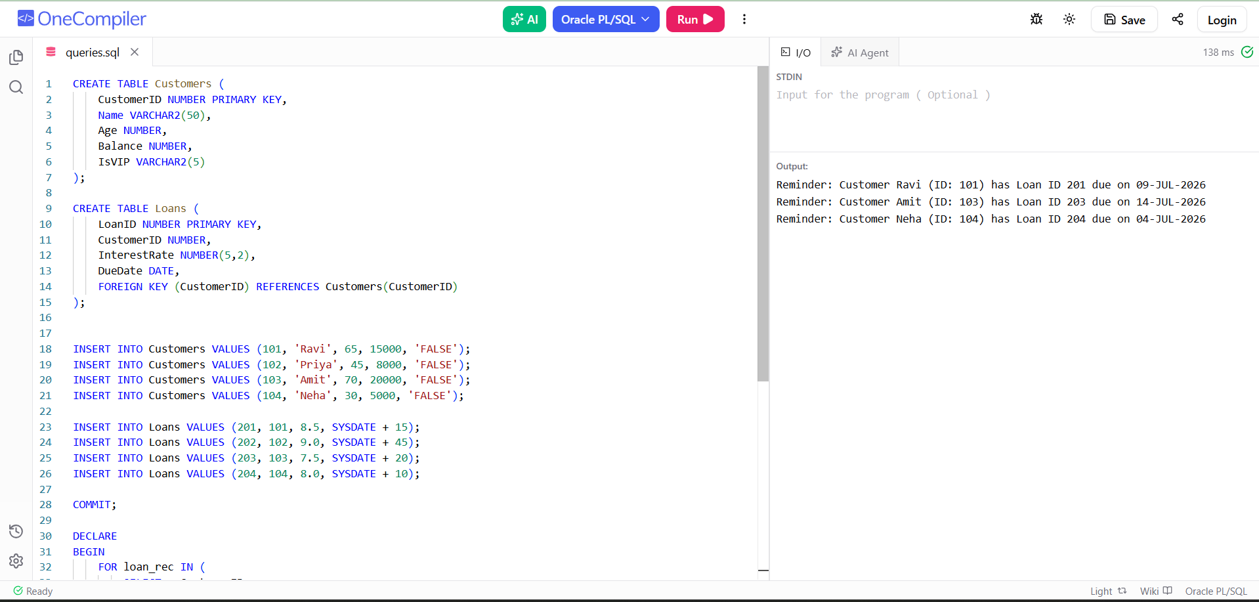

Exercise 3: Stored Procedures
Creating Tables:

Accounts Table:

CREATE TABLE Accounts (
AccountID NUMBER PRIMARY KEY,
CustomerName VARCHAR2(50),
AccountType VARCHAR2(20),
Balance NUMBER(10,2)
);

Employees Table:

CREATE TABLE Employees (
EmployeeID NUMBER PRIMARY KEY,
EmployeeName VARCHAR2(50),
Department VARCHAR2(30),
Salary NUMBER(10,2)
);

Inseting data:

Accounts Table:

INSERT INTO Accounts VALUES (101, 'Ravi', 'Savings', 10000);
INSERT INTO Accounts VALUES (102, 'Priya', 'Savings', 15000);
INSERT INTO Accounts VALUES (103, 'Amit', 'Current', 20000);
INSERT INTO Accounts VALUES (104, 'Neha', 'Savings', 12000);

COMMIT;

Employees Table:

INSERT INTO Employees VALUES (1, 'John', 'IT', 50000);
INSERT INTO Employees VALUES (2, 'Alice', 'IT', 60000);
INSERT INTO Employees VALUES (3, 'Bob', 'HR', 45000);
INSERT INTO Employees VALUES (4, 'Emma', 'HR', 55000);

COMMIT;

Scenario 1: The bank needs to process monthly interest for all savings accounts.
  - Question: Write a stored procedure ProcessMonthlyInterest that calculates and updates the balance of all savings accounts by applying an interest rate of 1% to the current balance.

Program Code:
CREATE OR REPLACE PROCEDURE ProcessMonthlyInterest
IS
BEGIN
UPDATE Accounts
SET Balance = Balance + (Balance * 0.01)
WHERE AccountType = 'Savings';

COMMIT;

DBMS_OUTPUT.PUT_LINE('=================================');
DBMS_OUTPUT.PUT_LINE(' MONTHLY INTEREST PROCESSING ');
DBMS_OUTPUT.PUT_LINE('=================================');
DBMS_OUTPUT.PUT_LINE('1% interest applied to all Savings Accounts.');
DBMS_OUTPUT.PUT_LINE('Balances updated successfully.');
DBMS_OUTPUT.PUT_LINE('Transaction Completed.');
END;
/

SET SERVEROUTPUT ON;

EXEC ProcessMonthlyInterest;

Output:

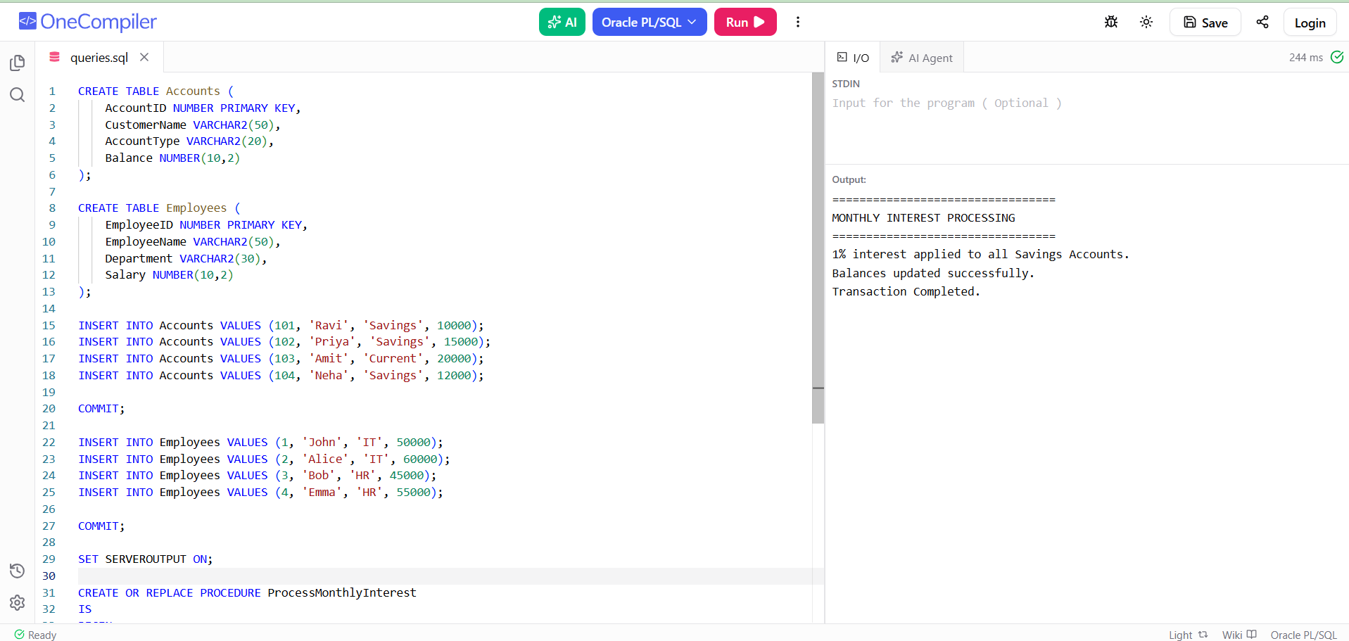

Scenario 2: The bank wants to implement a bonus scheme for employees based on their performance.
  - Question: Write a stored procedure UpdateEmployeeBonus that updates the salary of employees in a given department by adding a bonus percentage passed as a parameter.

Program Code:
CREATE OR REPLACE PROCEDURE UpdateEmployeeBonus(
p_department IN VARCHAR2,
p_bonus_percent IN NUMBER
)
IS
BEGIN
UPDATE Employees
SET Salary = Salary + (Salary * p_bonus_percent / 100)
WHERE Department = p_department;

COMMIT;

DBMS_OUTPUT.PUT_LINE('=================================');
DBMS_OUTPUT.PUT_LINE(' EMPLOYEE BONUS UPDATE ');
DBMS_OUTPUT.PUT_LINE('=================================');
DBMS_OUTPUT.PUT_LINE('Department : ' || p_department);
DBMS_OUTPUT.PUT_LINE('Bonus Added : ' || p_bonus_percent || '%');
DBMS_OUTPUT.PUT_LINE('Salary Updated Successfully.');
END;
/

EXEC UpdateEmployeeBonus('IT',10);

Output:

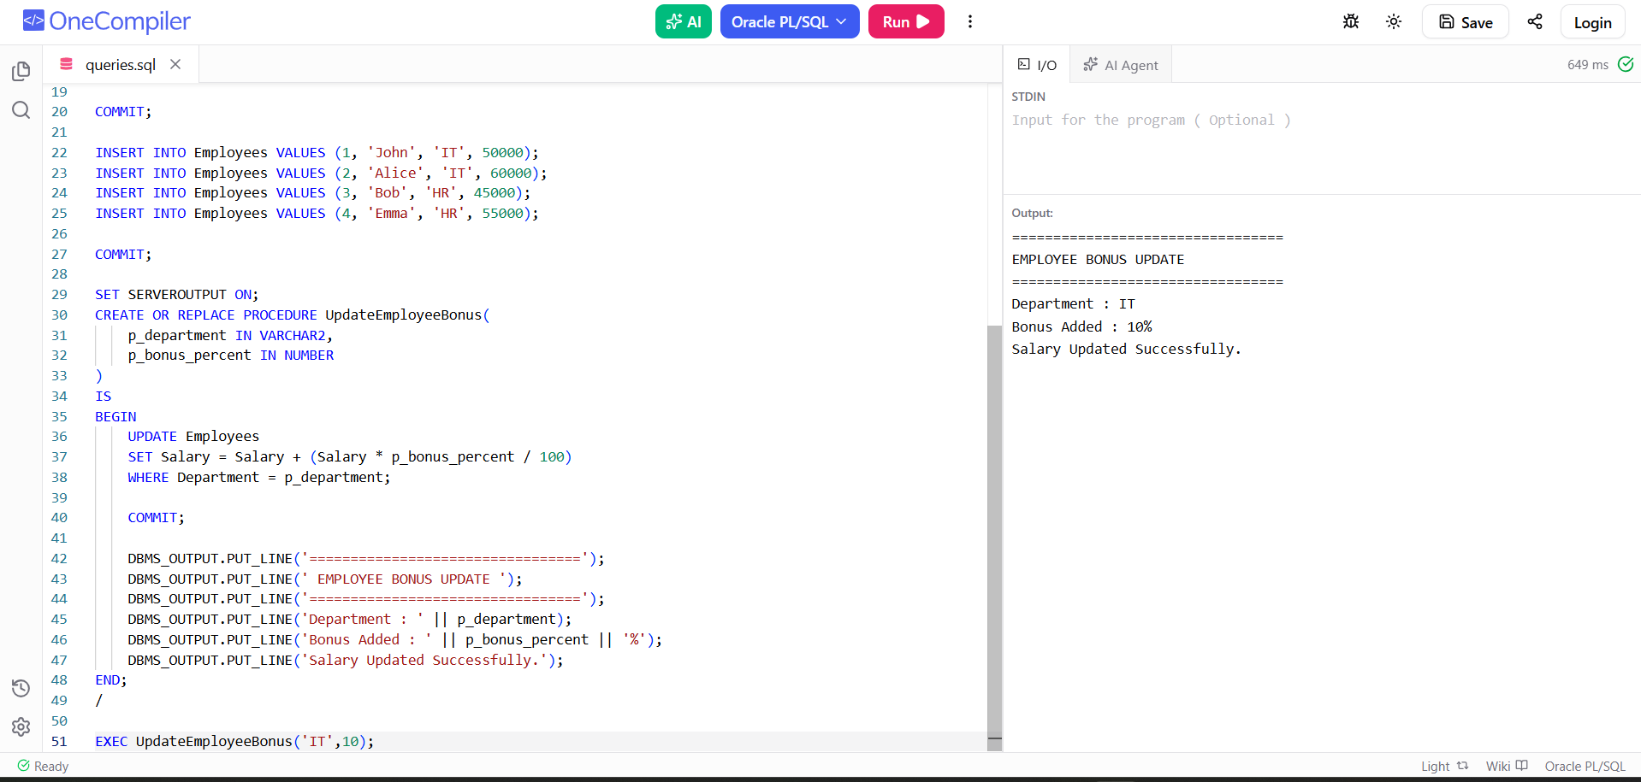

Scenario 3: Customers should be able to transfer funds between their accounts.
  - Question: Write a stored procedure TransferFunds that transfers a specified amount from one account to another, checking that the source account has sufficient balance before making the transfer.

Program Code:
CREATE OR REPLACE PROCEDURE TransferFunds(
p_from_account IN NUMBER,
p_to_account IN NUMBER,
p_amount IN NUMBER
)
IS
v_balance NUMBER;
BEGIN
SELECT Balance
INTO v_balance
FROM Accounts
WHERE AccountID = p_from_account;

IF v_balance >= p_amount THEN

UPDATE Accounts
SET Balance = Balance - p_amount
WHERE AccountID = p_from_account;

UPDATE Accounts
SET Balance = Balance + p_amount
WHERE AccountID = p_to_account;

COMMIT;

DBMS_OUTPUT.PUT_LINE('=================================');
DBMS_OUTPUT.PUT_LINE(' FUND TRANSFER SUCCESSFUL ');
DBMS_OUTPUT.PUT_LINE('=================================');
DBMS_OUTPUT.PUT_LINE('From Account : ' || p_from_account);
DBMS_OUTPUT.PUT_LINE('To Account : ' || p_to_account);
DBMS_OUTPUT.PUT_LINE('Amount : $' || p_amount);
DBMS_OUTPUT.PUT_LINE('Transfer Completed.');

ELSE
DBMS_OUTPUT.PUT_LINE('=================================');
DBMS_OUTPUT.PUT_LINE(' TRANSACTION FAILED ');
DBMS_OUTPUT.PUT_LINE('=================================');
DBMS_OUTPUT.PUT_LINE('Insufficient Balance.');
END IF;

EXCEPTION
WHEN NO_DATA_FOUND THEN
DBMS_OUTPUT.PUT_LINE('Invalid Account Number.');
END;
/

EXEC TransferFunds(101,102,2000);

Output:

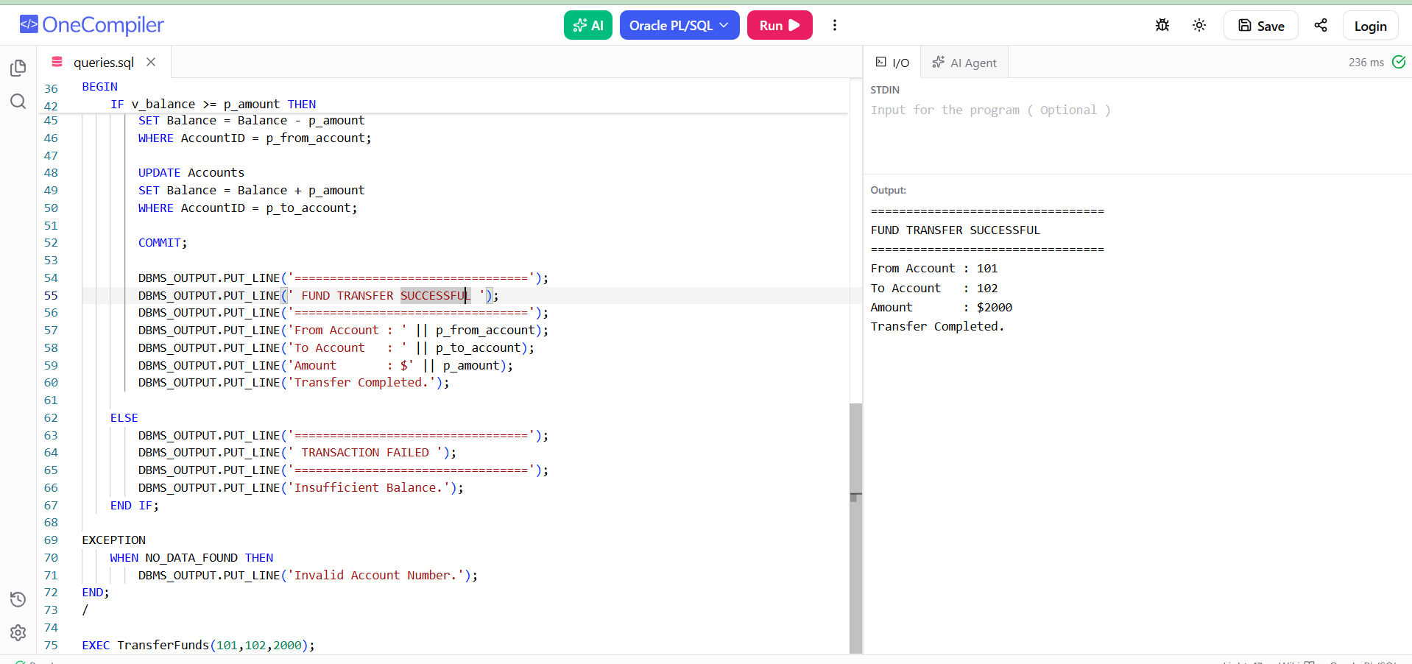

Module 4 - Test driven development and Logging framework

JUnit_Basic Testing Exercises:

Exercise 1: Setting Up Junit
Program Code:

package com.example.JUnitDemo;

import static org.junit.Assert.assertEquals;
import org.junit.Test;

public class CalculatorTest {

@Test
public void testAddition() {
assertEquals(5, 2 + 3);
}
}

Output:
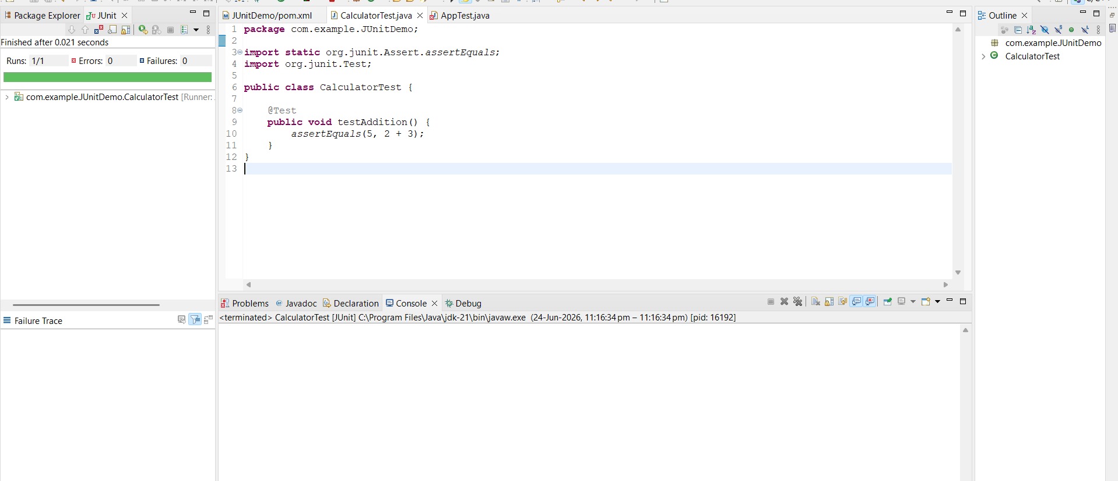

Exercise 3: Assertions in Junit:
Program Code:

package com.example.JUnitDemo;
import static org.junit.Assert.*;
import org.junit.Test;

public class AssertionsTest {

@Test
public void testAssertions() {

// Assert Equals
assertEquals(5, 2 + 3);

// Assert True
assertTrue(5 > 3);

// Assert False
assertFalse(5 < 3);

// Assert Null
assertNull(null);

// Assert Not Null
assertNotNull(new Object());
}
}

Output:
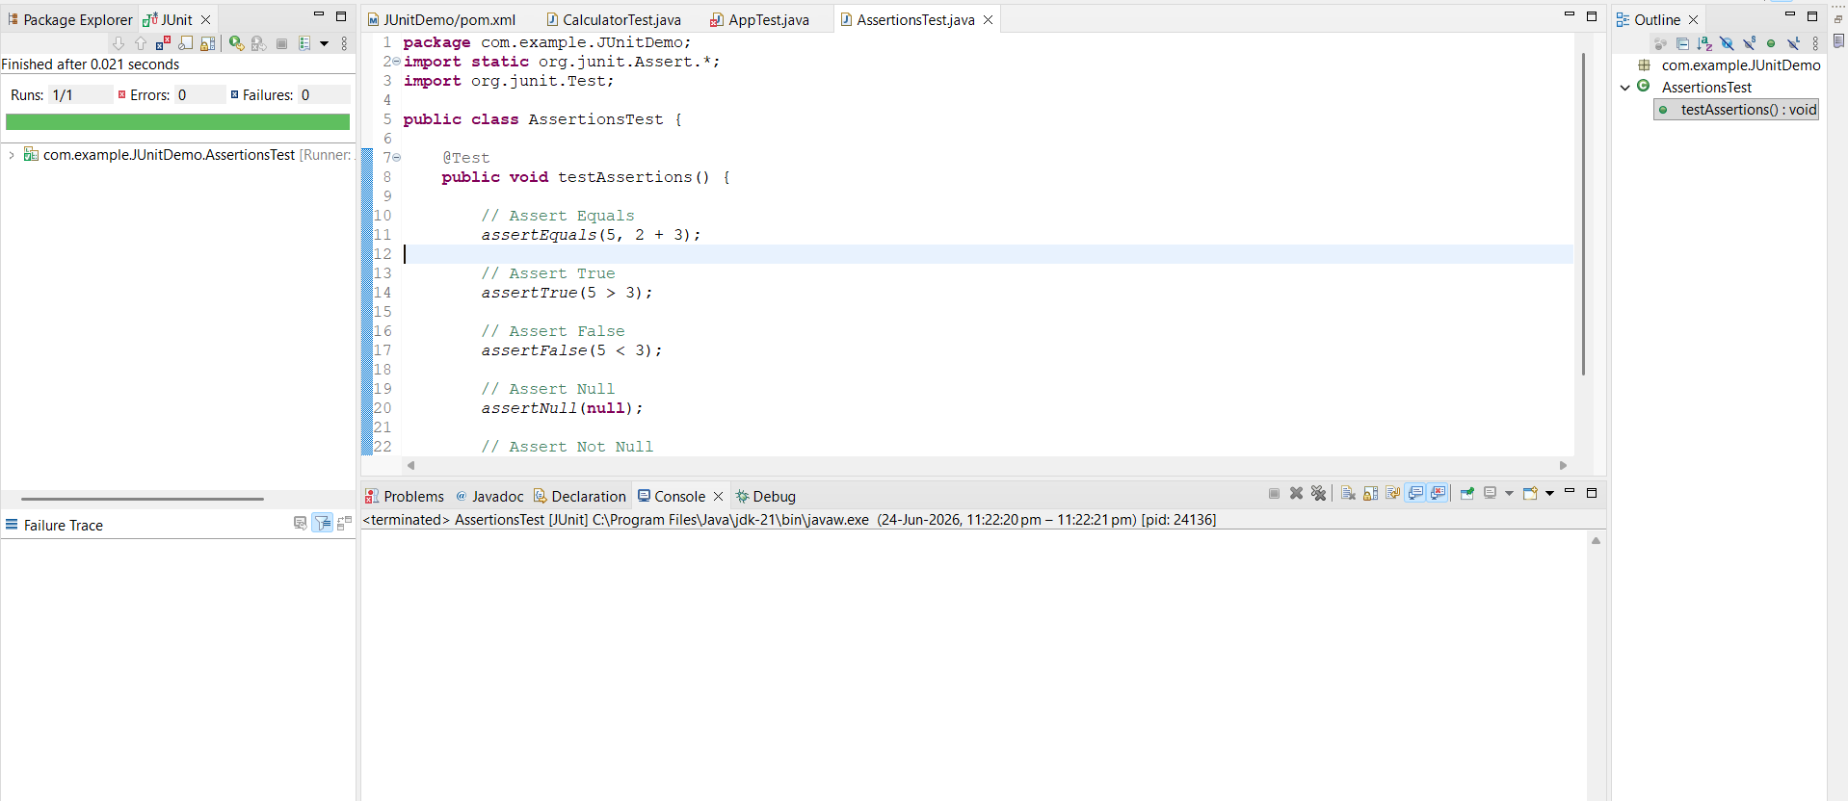

Exercise 4: Arrange-Act-Assert (AAA) Pattern, Test Fixtures, Setup and Teardown Methods in JUnit
Program Code:

package com.example.JUnitDemo;

import static org.junit.Assert.assertEquals;
import org.junit.After;
import org.junit.Before;
import org.junit.Test;

public class AAATest {

private int num1;
private int num2;

@Before
public void setUp() {
num1 = 10;
num2 = 20;
System.out.println("Setup Method Executed");
}

@Test
public void testAddition() {

// Arrange
int expected = 30;

// Act
int actual = num1 + num2;

// Assert
assertEquals(expected, actual);

System.out.println("Test Method Executed");
}

@After
public void tearDown() {
System.out.println("Teardown Method Executed");
}
}

Output:
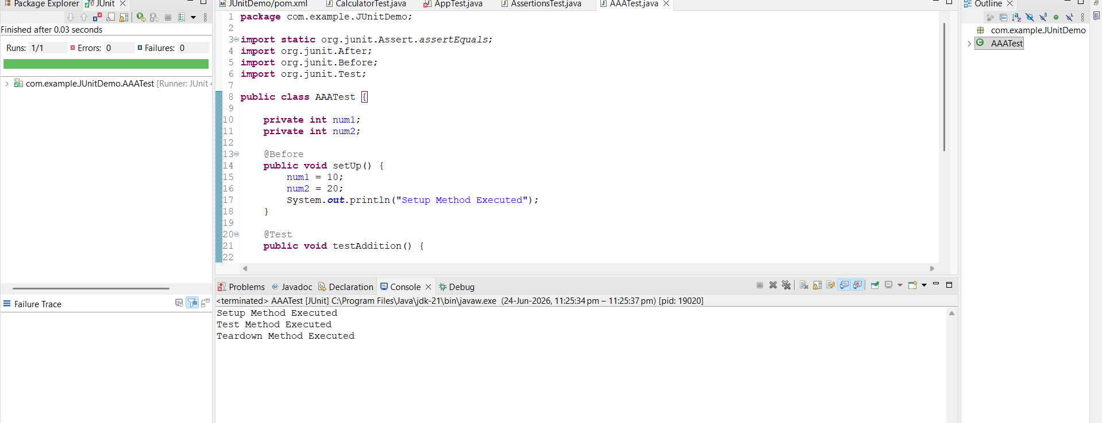

Mockito exercises:
Exercise 1: Mocking and Stubbing
Program Code:

ExternalApi.java
package com.example.JUnitDemo;

public interface ExternalApi {
String getData();
}

MyService.java:
package com.example.JUnitDemo;

public class MyService {

private ExternalApi api;

public MyService(ExternalApi api) {
this.api = api;
}

public String fetchData() {
return api.getData();
}
}

MyServiceTest.java
package com.example.JUnitDemo;

import static org.junit.jupiter.api.Assertions.assertEquals;
import static org.mockito.Mockito.when;

import org.junit.jupiter.api.Test;
import org.mockito.Mockito;

public class MyServiceTest {

@Test
public void testExternalApi() {

// Create mock object
ExternalApi mockApi = Mockito.mock(ExternalApi.class);

// Stub method
when(mockApi.getData()).thenReturn("Mock Data");

// Inject mock into service
MyService service = new MyService(mockApi);

// Call method
String result = service.fetchData();

System.out.println(result);

assertEquals("Mock Data", result);

// Verify result
assertEquals("Mock Data", result);
}
}

Output:

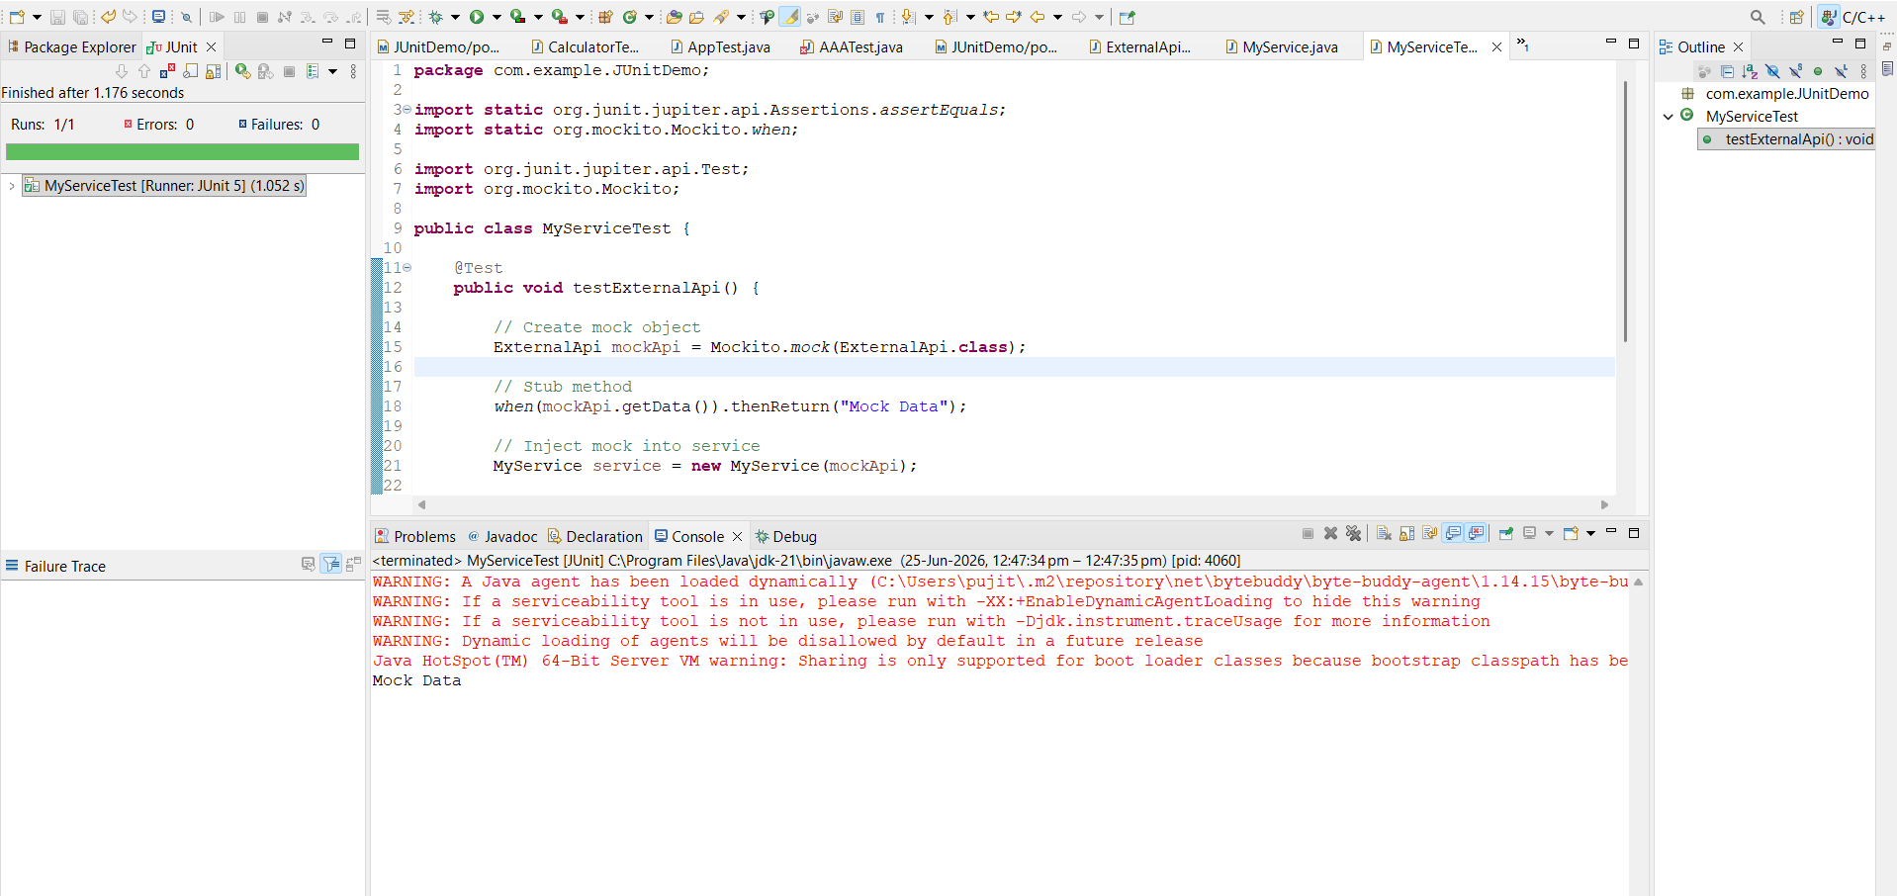

Exercise 2: Verifying Interactions
Program Code:

Test Class:
package com.example.JUnitDemo;

import static org.mockito.Mockito.verify;

import org.junit.jupiter.api.Test;
import org.mockito.Mockito;

public class MyServiceTest1 {

@Test
public void testVerifyInteraction() {

// Create mock object
ExternalApi mockApi = Mockito.mock(ExternalApi.class);

// Create service
MyService service = new MyService(mockApi);

// Call method
service.fetchData();

// Verify interaction
verify(mockApi).getData();
}
}

Output:
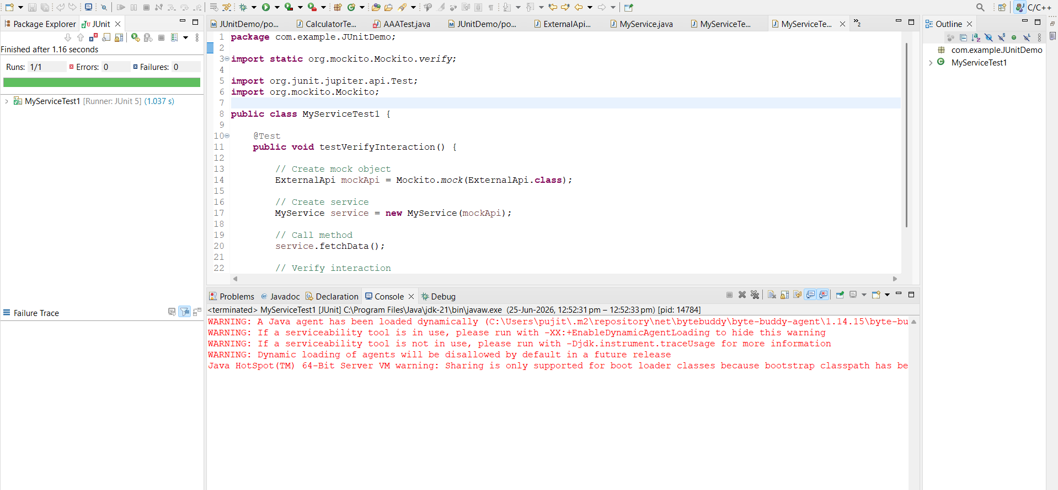

SL4J Logging exercises
Exercise 1: Logging Error Messages and Warning Levels
Program Code:

LoggingExample.java
package com.example.JUnitDemo;

import org.slf4j.Logger;
import org.slf4j.LoggerFactory;

public class LoggingExample {

private static final Logger logger =
LoggerFactory.getLogger(LoggingExample.class);

public static void main(String[] args) {

logger.error("This is an error message");

logger.warn("This is a warning message");

}
}

Output:
