Week – 3:
Module – 7
Spring REST using Spring Boot 3
1. spring-rest-handson:
i) Create a Spring Web Project using Maven
Spring initializer:
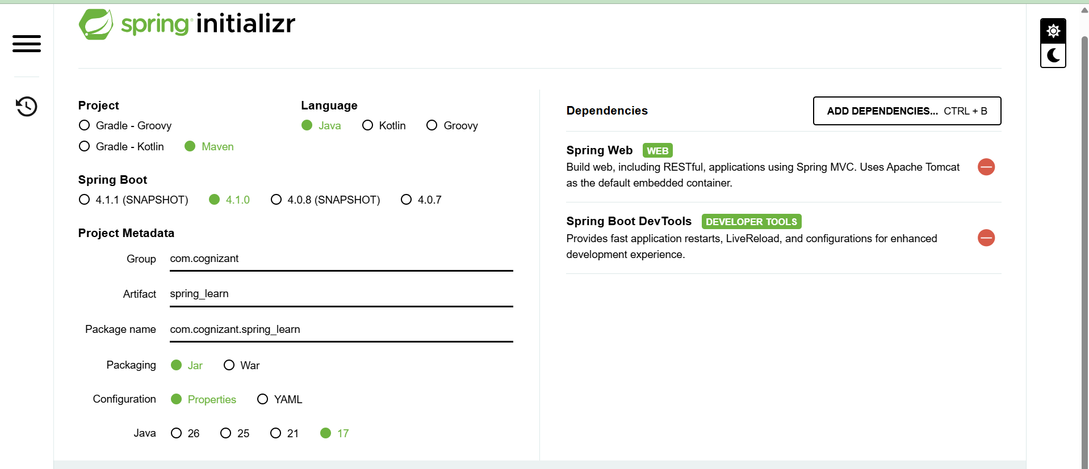
pom.xml :
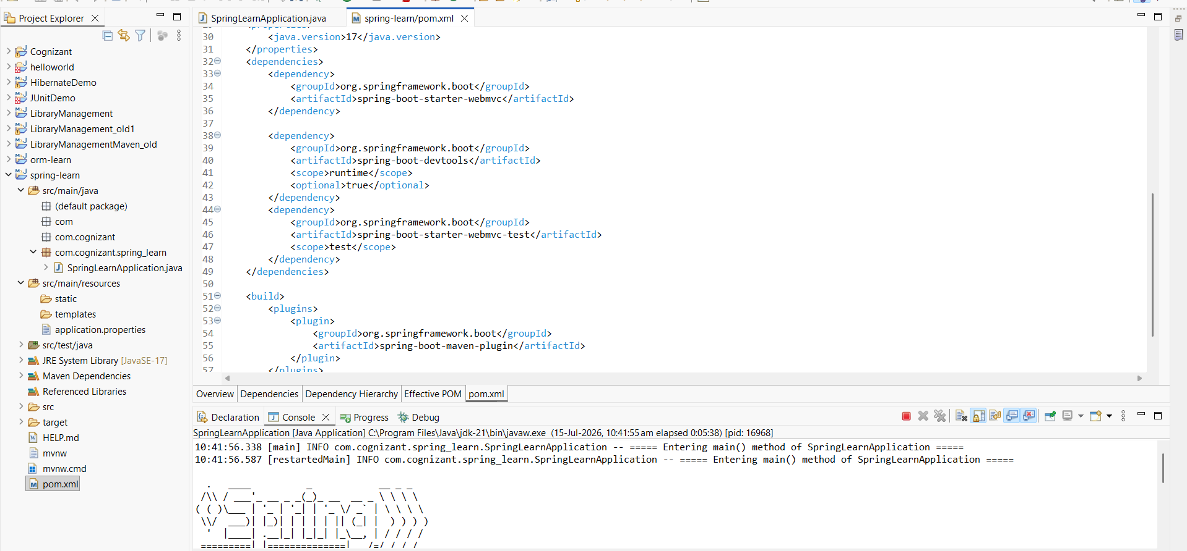

SpringLearnApplication.java :
package com.cognizant.spring_learn;

import org.slf4j.Logger;
import org.slf4j.LoggerFactory;
import org.springframework.boot.SpringApplication;
import org.springframework.boot.autoconfigure.SpringBootApplication;

@SpringBootApplication
public class SpringLearnApplication {

private static final Logger logger = LoggerFactory.getLogger(SpringLearnApplication.class);

public static void main(String[] args) {
logger.info("===== Entering main() method of SpringLearnApplication =====");
SpringApplication.run(SpringLearnApplication.class, args);
logger.info("===== SpringLearnApplication started successfully =====");
}
}

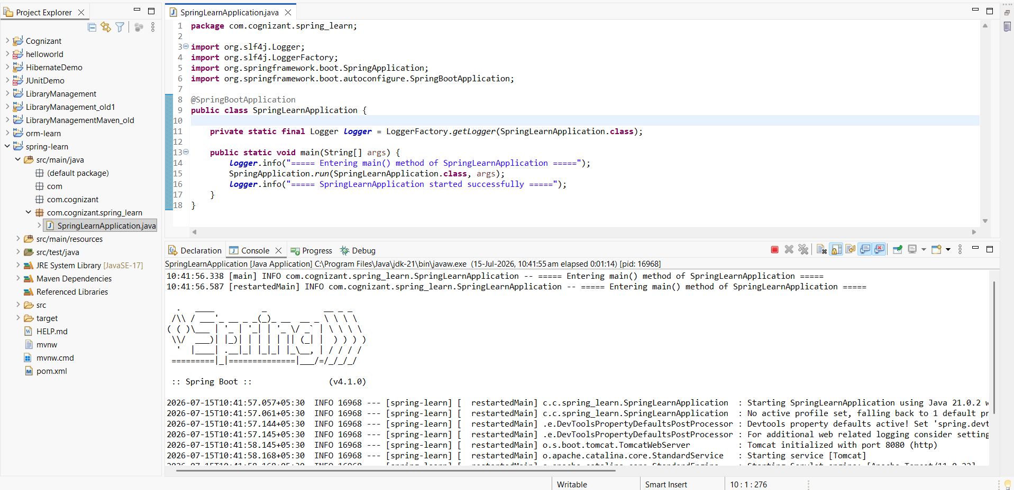

ii) Spring Core – Load Country from Spring Configuration XML :
dataformat.xml :
<?xml version="1.0" encoding="UTF-8"?>
<beans xmlns="http://www.springframework.org/schema/beans"
xmlns:xsi="http://www.w3.org/2001/XMLSchema-instance"
xsi:schemaLocation="http://www.springframework.org/schema/beans
https://www.springframework.org/schema/beans/spring-beans.xsd">

<bean id="dateFormat" class="java.text.SimpleDateFormat">
<constructor-arg value="dd/MM/yyyy" />
</bean>

</beans>

SpringLearnApplication.java:
package com.cognizant.spring_learn;
import java.text.ParseException;
import java.text.SimpleDateFormat;
import java.util.Date;

import org.springframework.context.ApplicationContext;
import org.springframework.context.support.ClassPathXmlApplicationContext;

import org.slf4j.Logger;
import org.slf4j.LoggerFactory;
import org.springframework.boot.SpringApplication;
import org.springframework.boot.autoconfigure.SpringBootApplication;

@SpringBootApplication
public class SpringLearnApplication {

private static final Logger logger = LoggerFactory.getLogger(SpringLearnApplication.class);

public static void main(String[] args) {
logger.info("===== Entering main() method of SpringLearnApplication =====");
SpringApplication.run(SpringLearnApplication.class, args);
logger.info("===== SpringLearnApplication started successfully =====");
displayDate();
}
private static void displayDate() {
ApplicationContext context = new ClassPathXmlApplicationContext("date-format.xml");

SimpleDateFormat format = context.getBean("dateFormat", SimpleDateFormat.class);

try {
Date date = format.parse("31/12/2018");
System.out.println("Parsed date: " + date);
} catch (ParseException e) {
e.printStackTrace();
}
}
}

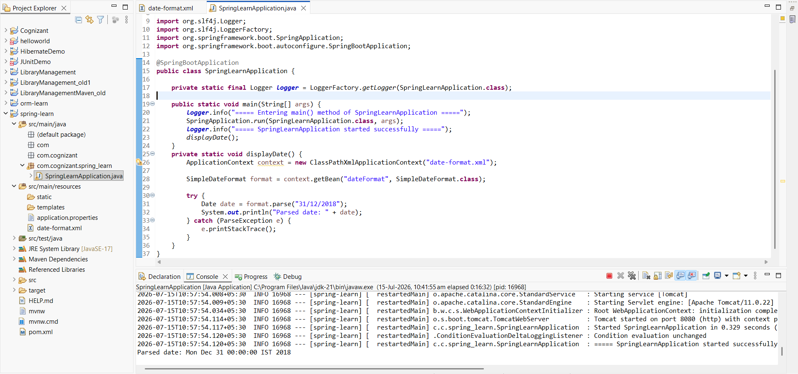

2. spring-rest-handson
i) Hello World RESTful Web Service
HelloController :
package com.cognizant.springlearn.controller;

import org.slf4j.Logger;
import org.slf4j.LoggerFactory;
import org.springframework.web.bind.annotation.GetMapping;
import org.springframework.web.bind.annotation.RestController;

@RestController
public class HelloController {

private static final Logger LOGGER = LoggerFactory.getLogger(HelloController.class);

@GetMapping("/hello")
public String sayHello() {
LOGGER.info("START - sayHello()");

String response = "Hello World!!";

LOGGER.info("END - sayHello()");
return response;
}
}

SpringLearnApplication.java :
package com.cognizant.spring_learn;
import java.text.ParseException;
import java.text.SimpleDateFormat;
import java.util.Date;

import org.springframework.context.ApplicationContext;
import org.springframework.context.support.ClassPathXmlApplicationContext;

import org.slf4j.Logger;
import org.slf4j.LoggerFactory;
import org.springframework.boot.SpringApplication;
import org.springframework.boot.autoconfigure.SpringBootApplication;

@SpringBootApplication(scanBasePackages = {"com.cognizant.springlearn", "com.cognizant.springlearn.controller"})
public class SpringLearnApplication {

private static final Logger logger = LoggerFactory.getLogger(SpringLearnApplication.class);

public static void main(String[] args) {
logger.info("===== Entering main() method of SpringLearnApplication =====");
SpringApplication.run(SpringLearnApplication.class, args);
logger.info("===== SpringLearnApplication started successfully =====");
displayDate();
}
private static void displayDate() {
ApplicationContext context = new ClassPathXmlApplicationContext("date-format.xml");

SimpleDateFormat format = context.getBean("dateFormat", SimpleDateFormat.class);

try {
Date date = format.parse("31/12/2018");
System.out.println("Parsed date: " + date);
} catch (ParseException e) {
e.printStackTrace();
}
}
}
Applications.properties: Running in port 8083
spring.application.name=spring-learn
server.port=8083

In Browser :

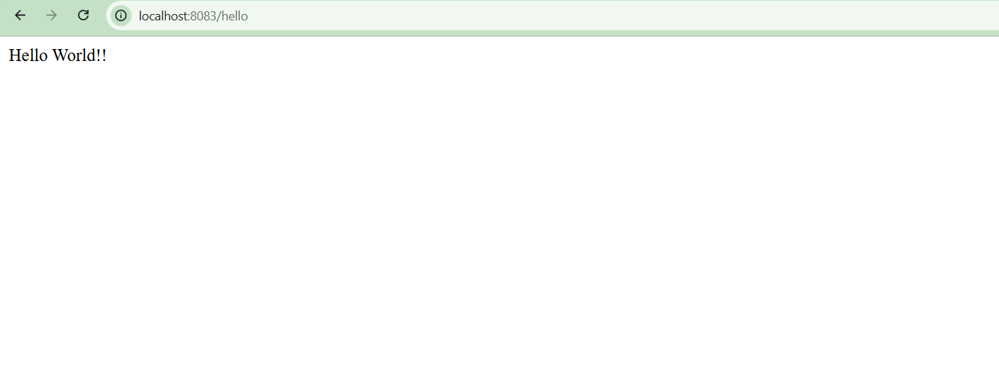

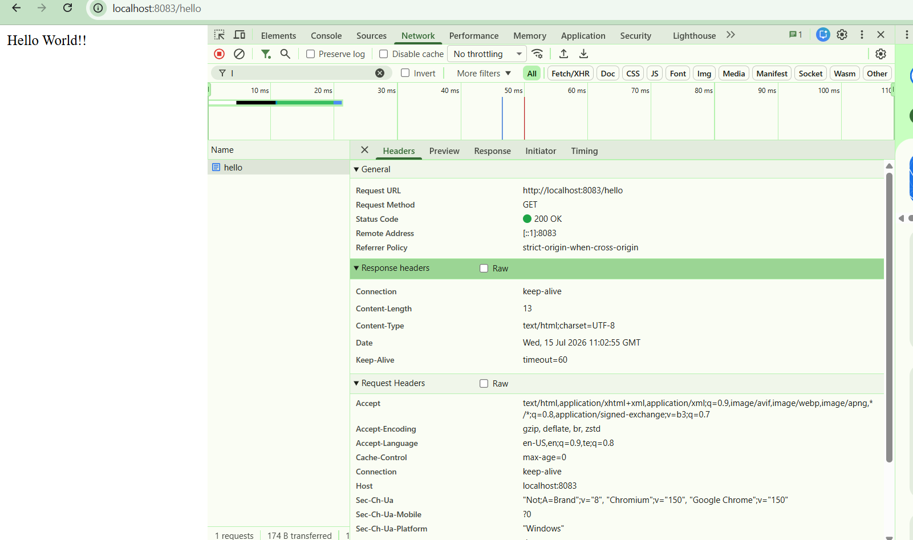

In Postman :
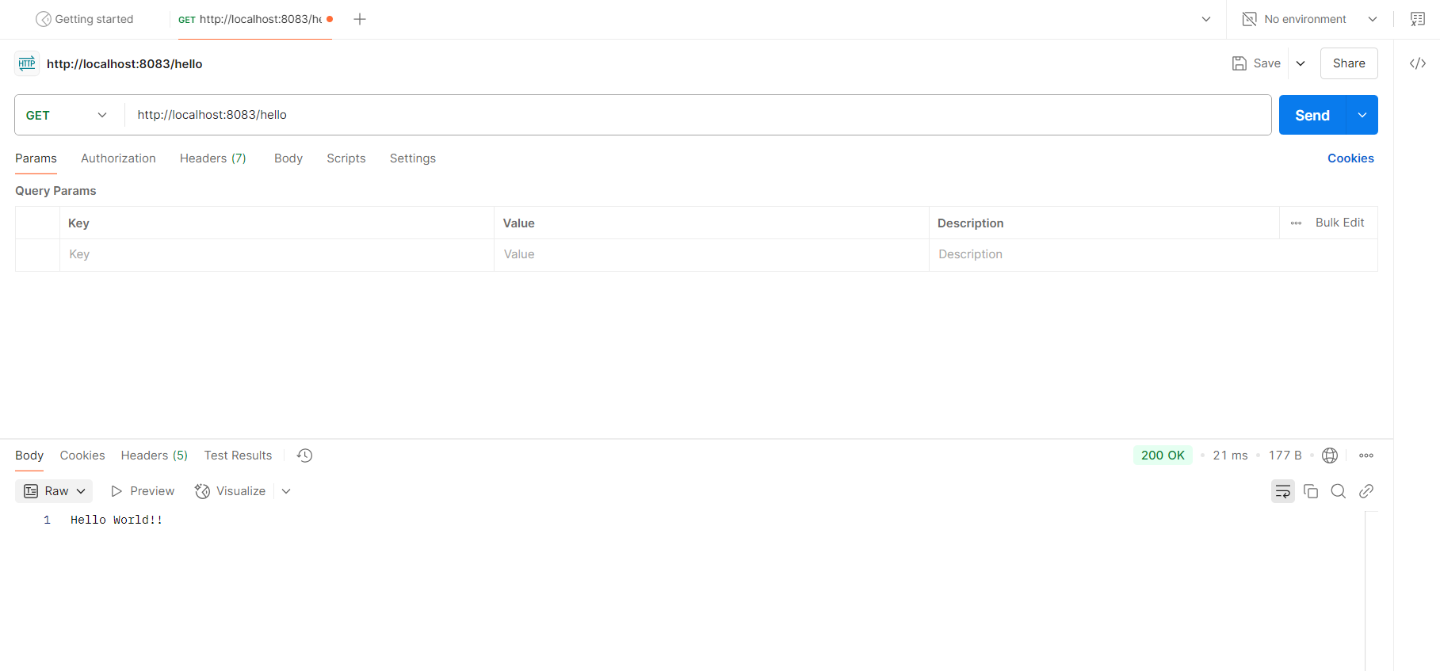

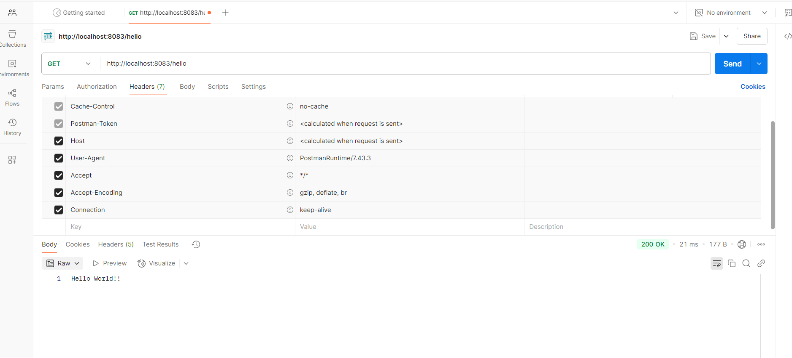

ii)REST - Country Web Service:
Country.java:
package com.cognizant.springlearn.model;

public class Country {

private String code;
private String name;

public Country() {
}

public Country(String code, String name) {
this.code = code;
this.name = name;
}

public String getCode() {
return code;
}

public void setCode(String code) {
this.code = code;
}

public String getName() {
return name;
}

public void setName(String name) {
this.name = name;
}

}

country-config.xml:
<?xml version="1.0" encoding="UTF-8"?>
<beans xmlns="http://www.springframework.org/schema/beans"
xmlns:xsi="http://www.w3.org/2001/XMLSchema-instance"
xsi:schemaLocation="http://www.springframework.org/schema/beans
https://www.springframework.org/schema/beans/spring-beans.xsd">

<bean id="india" class="com.cognizant.springlearn.model.Country">
<property name="code" value="IN" />
<property name="name" value="India" />
</bean>

</beans>

CountryController.java:
package com.cognizant.springlearn.controller;

import org.slf4j.Logger;
import org.slf4j.LoggerFactory;
import org.springframework.context.ApplicationContext;
import org.springframework.context.support.ClassPathXmlApplicationContext;
import org.springframework.web.bind.annotation.RequestMapping;
import org.springframework.web.bind.annotation.RequestMethod;
import org.springframework.web.bind.annotation.RestController;

import com.cognizant.springlearn.model.Country;

@RestController
public class CountryController {

private static final Logger logger = LoggerFactory.getLogger(CountryController.class);

@RequestMapping(value = "/country", method = RequestMethod.GET)
public Country getCountryIndia() {
logger.info("===== Entering getCountryIndia() method =====");

ApplicationContext context = new ClassPathXmlApplicationContext("country-config.xml");
Country india = context.getBean("india", Country.class);
((ClassPathXmlApplicationContext) context).close();

logger.info("===== Exiting getCountryIndia() method =====");
return india;
}

}

Running SpringLearnApplication.java :
package com.cognizant.spring_learn;
import java.text.ParseException;
import java.text.SimpleDateFormat;
import java.util.Date;

import org.springframework.context.ApplicationContext;
import org.springframework.context.support.ClassPathXmlApplicationContext;

import org.slf4j.Logger;
import org.slf4j.LoggerFactory;
import org.springframework.boot.SpringApplication;
import org.springframework.boot.autoconfigure.SpringBootApplication;

@SpringBootApplication(scanBasePackages = {"com.cognizant.springlearn", "com.cognizant.springlearn.controller"})
public class SpringLearnApplication {

private static final Logger logger = LoggerFactory.getLogger(SpringLearnApplication.class);

public static void main(String[] args) {
logger.info("===== Entering main() method of SpringLearnApplication =====");
SpringApplication.run(SpringLearnApplication.class, args);
logger.info("===== SpringLearnApplication started successfully =====");
displayDate();
}
private static void displayDate() {
ApplicationContext context = new ClassPathXmlApplicationContext("date-format.xml");

SimpleDateFormat format = context.getBean("dateFormat", SimpleDateFormat.class);

try {
Date date = format.parse("31/12/2018");
System.out.println("Parsed date: " + date);
} catch (ParseException e) {
e.printStackTrace();
}
}
}

In Browser:
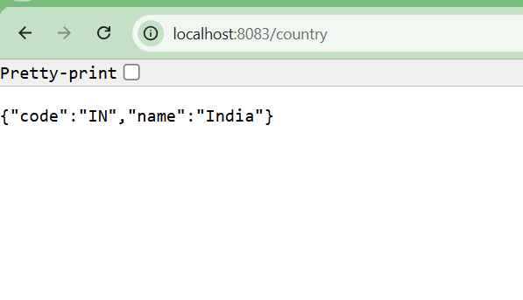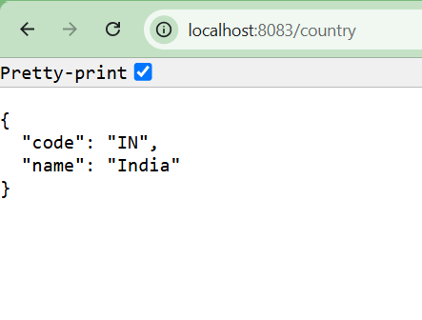
In Postman :
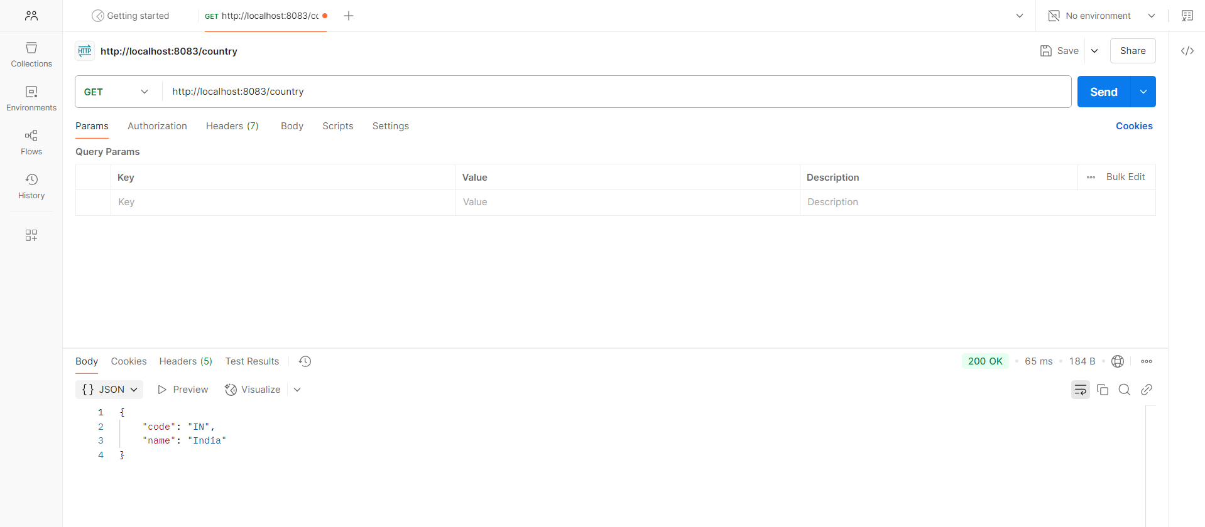

iii) REST - Get country based on country code
country.xml:
<?xml version="1.0" encoding="UTF-8"?>
<beans xmlns="http://www.springframework.org/schema/beans"
xmlns:xsi="http://www.w3.org/2001/XMLSchema-instance"
xsi:schemaLocation="http://www.springframework.org/schema/beans
https://www.springframework.org/schema/beans/spring-beans.xsd">

<bean id="countryList" class="java.util.ArrayList">
<constructor-arg>
<list>
<bean class="com.cognizant.springlearn.model.Country">
<property name="code" value="IN" />
<property name="name" value="India" />
</bean>
<bean class="com.cognizant.springlearn.model.Country">
<property name="code" value="US" />
<property name="name" value="United States" />
</bean>
<bean class="com.cognizant.springlearn.model.Country">
<property name="code" value="UK" />
<property name="name" value="United Kingdom" />
</bean>
<bean class="com.cognizant.springlearn.model.Country">
<property name="code" value="AU" />
<property name="name" value="Australia" />
</bean>
</list>
</constructor-arg>
</bean>

</beans>

CountryService interface :
package com.cognizant.springlearn.service;

import com.cognizant.springlearn.model.Country;

public interface CountryService {

Country getCountry(String code);

}

CountryServiceImpl :
package com.cognizant.springlearn.service;

import java.util.List;

import org.slf4j.Logger;
import org.slf4j.LoggerFactory;
import org.springframework.context.ApplicationContext;
import org.springframework.context.support.ClassPathXmlApplicationContext;
import org.springframework.stereotype.Service;

import com.cognizant.springlearn.model.Country;

@Service
public class CountryServiceImpl implements CountryService {

private static final Logger logger = LoggerFactory.getLogger(CountryServiceImpl.class);

@Override
@SuppressWarnings("unchecked")
public Country getCountry(String code) {
logger.info("===== Entering getCountry() method =====");

ApplicationContext context = new ClassPathXmlApplicationContext("country.xml");
List<Country> countryList = (List<Country>) context.getBean("countryList");
((ClassPathXmlApplicationContext) context).close();

Country matchedCountry = countryList.stream()
.filter(country -> country.getCode().equalsIgnoreCase(code))
.findFirst()
.orElse(null);

logger.info("===== Exiting getCountry() method =====");
return matchedCountry;
}

}

CountryController.java :
package com.cognizant.springlearn.controller;

import org.slf4j.Logger;
import org.slf4j.LoggerFactory;
import org.springframework.beans.factory.annotation.Autowired;
import org.springframework.context.ApplicationContext;
import org.springframework.context.support.ClassPathXmlApplicationContext;
import org.springframework.web.bind.annotation.GetMapping;
import org.springframework.web.bind.annotation.PathVariable;
import org.springframework.web.bind.annotation.RequestMapping;
import org.springframework.web.bind.annotation.RequestMethod;
import org.springframework.web.bind.annotation.RestController;

import com.cognizant.springlearn.model.Country;
import com.cognizant.springlearn.service.CountryService;

@RestController
public class CountryController {

private static final Logger logger = LoggerFactory.getLogger(CountryController.class);

@Autowired
private CountryService countryService;

@RequestMapping(value = "/country", method = RequestMethod.GET)
public Country getCountryIndia() {
logger.info("===== Entering getCountryIndia() method =====");

ApplicationContext context = new ClassPathXmlApplicationContext("country-config.xml");
Country india = context.getBean("india", Country.class);
((ClassPathXmlApplicationContext) context).close();

logger.info("===== Exiting getCountryIndia() method =====");
return india;
}

@GetMapping("/countries/{code}")
public Country getCountry(@PathVariable String code) {
logger.info("===== Entering getCountry() method =====");

Country country = countryService.getCountry(code);

logger.info("===== Exiting getCountry() method =====");
return country;
}

}

Running SpringLearnApplication.java :
package com.cognizant.spring_learn;
import java.text.ParseException;
import java.text.SimpleDateFormat;
import java.util.Date;

import org.springframework.context.ApplicationContext;
import org.springframework.context.support.ClassPathXmlApplicationContext;

import org.slf4j.Logger;
import org.slf4j.LoggerFactory;
import org.springframework.boot.SpringApplication;
import org.springframework.boot.autoconfigure.SpringBootApplication;

@SpringBootApplication(scanBasePackages = {"com.cognizant.springlearn", "com.cognizant.springlearn.controller"})
public class SpringLearnApplication {

private static final Logger logger = LoggerFactory.getLogger(SpringLearnApplication.class);

public static void main(String[] args) {
logger.info("===== Entering main() method of SpringLearnApplication =====");
SpringApplication.run(SpringLearnApplication.class, args);
logger.info("===== SpringLearnApplication started successfully =====");
displayDate();
}
private static void displayDate() {
ApplicationContext context = new ClassPathXmlApplicationContext("date-format.xml");

SimpleDateFormat format = context.getBean("dateFormat", SimpleDateFormat.class);

try {
Date date = format.parse("31/12/2018");
System.out.println("Parsed date: " + date);
} catch (ParseException e) {
e.printStackTrace();
}
}
}
Browser Output:
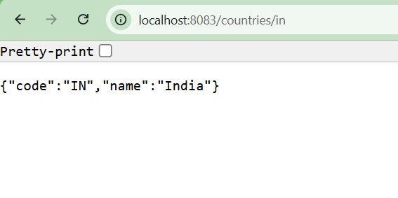 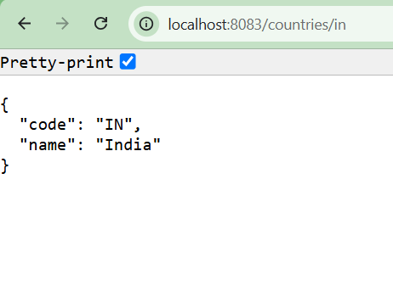Postman Output:
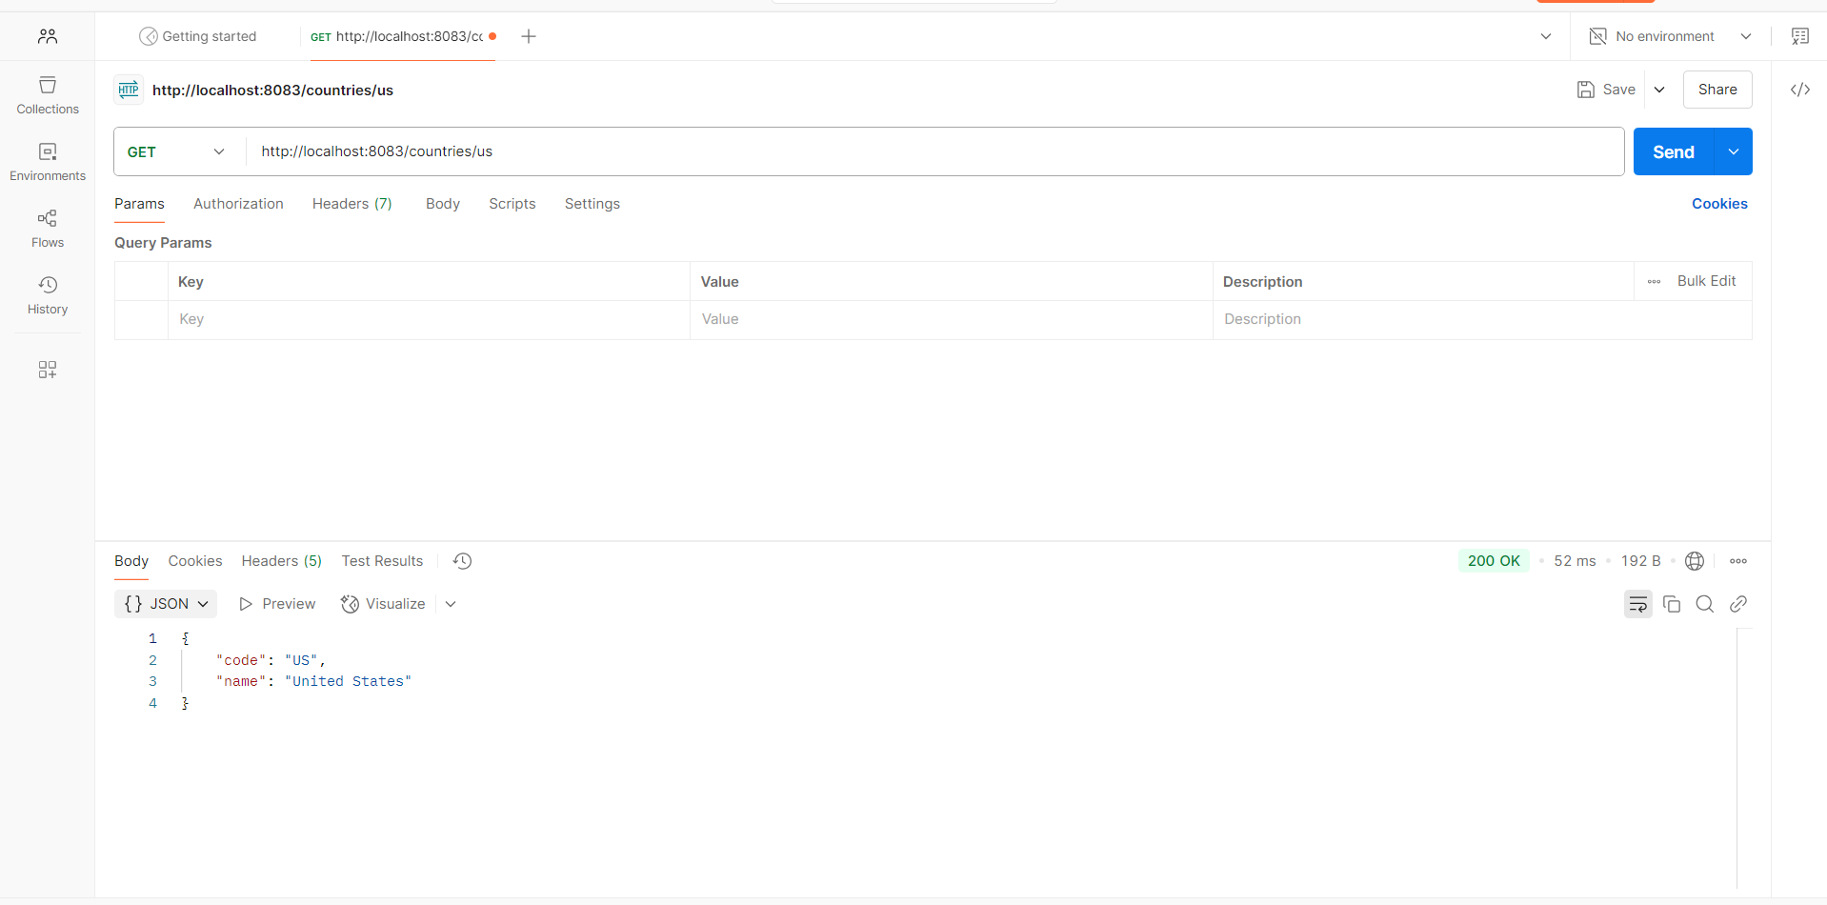

5. JWT-handson:
Create authentication service that returns JWT
BasicAuthDecoder.java:
package com.example.my_auth_service.security;

import java.nio.charset.StandardCharsets;
import java.util.Base64;

public class BasicAuthDecoder {

public static String[] decode(String authHeader) {
if (authHeader == null || !authHeader.startsWith("Basic ")) {
throw new IllegalArgumentException("Invalid Authorization header format");
}
String base64Credentials = authHeader.substring(6).trim();
byte[] decodedBytes = Base64.getDecoder().decode(base64Credentials);
String credentials = new String(decodedBytes, StandardCharsets.UTF_8);
return credentials.split(":", 2);
}
}

JwtTokenProvider.java:
package com.example.my_auth_service.security;

import io.jsonwebtoken.Jwts;
import io.jsonwebtoken.SignatureAlgorithm;
import io.jsonwebtoken.security.Keys;
import org.springframework.stereotype.Component;
import java.security.Key;
import java.util.Date;

@Component
public class JwtTokenProvider {

private final Key key = Keys.secretKeyFor(SignatureAlgorithm.HS256);
private final long validityInMilliseconds = 3600000;

public String createToken(String username) {
Date now = new Date();
Date validity = new Date(now.getTime() + validityInMilliseconds);

return Jwts.builder()
.setSubject(username)
.setIssuedAt(now)
.setExpiration(validity)
.signWith(key)
.compact();
}
}

SecurityConfig.java:
package com.example.my_auth_service.config;

import org.springframework.context.annotation.Bean;
import org.springframework.context.annotation.Configuration;
import org.springframework.security.config.annotation.web.builders.HttpSecurity;
import org.springframework.security.config.annotation.web.configuration.EnableWebSecurity;
import org.springframework.security.web.SecurityFilterChain;

@Configuration
@EnableWebSecurity
public class SecurityConfig {

@Bean
public SecurityFilterChain securityFilterChain(HttpSecurity http) throws Exception {
http
.csrf(csrf -> csrf.disable())
.authorizeHttpRequests(auth -> auth
.requestMatchers("/authenticate").permitAll()
.anyRequest().authenticated()
);
return http.build();
}
}

AuthController.java:
package com.example.my_auth_service.controller;

import com.example.my_auth_service.security.BasicAuthDecoder;
import com.example.my_auth_service.security.JwtTokenProvider;
import org.springframework.http.HttpStatus;
import org.springframework.http.ResponseEntity;
import org.springframework.web.bind.annotation.PostMapping;
import org.springframework.web.bind.annotation.RequestHeader;
import org.springframework.web.bind.annotation.RestController;
import java.util.Map;

@RestController
public class AuthController {

private final JwtTokenProvider jwtTokenProvider;

public AuthController(JwtTokenProvider jwtTokenProvider) {
this.jwtTokenProvider = jwtTokenProvider;
}

@PostMapping("/authenticate")
public ResponseEntity<?> authenticate(@RequestHeader("Authorization") String authHeader) {
try {
String[] credentials = BasicAuthDecoder.decode(authHeader);
String username = credentials[0];
String password = credentials[1];

if ("user".equals(username) && "pwd".equals(password)) {
String token = jwtTokenProvider.createToken(username);
return ResponseEntity.ok(Map.of("token", token));
} else {
return ResponseEntity.status(HttpStatus.UNAUTHORIZED).body(Map.of("error", "Invalid username or password"));
}
} catch (IllegalArgumentException e) {
return ResponseEntity.status(HttpStatus.BAD_REQUEST).body(Map.of("error", e.getMessage()));
}
}
}

MyAuthServiceApplication :
package com.example.my_auth_service;

import org.springframework.boot.SpringApplication;
import org.springframework.boot.autoconfigure.SpringBootApplication;

@SpringBootApplication
public class MyAuthServiceApplication {

public static void main(String[] args) {
SpringApplication.run(MyAuthServiceApplication.class, args);
}

}

