Week – 2 :

Module 5 - Spring Core and Maven
Exercise 1: Configuring a Basic Spring Application
Program Code:
Project Structure:
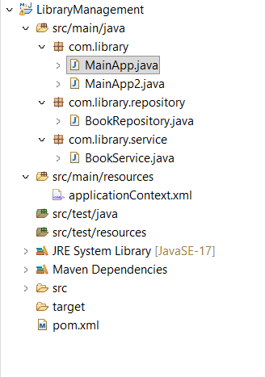
pom.xml:
<project xmlns="http://maven.apache.org/POM/4.0.0"
xmlns:xsi="http://www.w3.org/2001/XMLSchema-instance"
xsi:schemaLocation="http://maven.apache.org/POM/4.0.0 https://maven.apache.org/xsd/maven-4.0.0.xsd">
<modelVersion>4.0.0</modelVersion>
<groupId>com.library</groupId>
<artifactId>LibraryManagement</artifactId>
<version>0.0.1-SNAPSHOT</version>

<dependencies>
<dependency>
<groupId>org.springframework</groupId>
<artifactId>spring-context</artifactId>
<version>6.1.10</version> </dependency>
</dependencies>

<build>
<plugins>
<plugin>
<groupId>org.apache.maven.plugins</groupId>
<artifactId>maven-compiler-plugin</artifactId>
<version>3.11.0</version>
<configuration>
<source>17</source>
<target>17</target>
</configuration>
</plugin>
</plugins>
</build>
</project>

applicationContext.xml :
<bean id="bookRepository" class="com.library.repository.BookRepository" />
<bean id="bookService" class="com.library.service.BookService" />

BookRepository class :
package com.library.repository;

public class BookRepository {
public void saveData() {
System.out.println("Book data saved successfully to the database!");
}
}

BookService class :

package com.library.service;

import com.library.repository.BookRepository;

public class BookService {
private BookRepository bookRepository;

// Setter method for Spring to inject BookRepository
public void setBookRepository(BookRepository bookRepository) {
this.bookRepository = bookRepository;
}

public void addBook() {
System.out.println("Service: Attempting to add a book...");
bookRepository.saveData();
}
}

MainApp.java:
package com.library;

import org.springframework.context.ApplicationContext;
import org.springframework.context.support.ClassPathXmlApplicationContext;
import com.library.repository.BookRepository;

public class MainApp {
public static void main(String[] args) {
System.out.println("--- Exercise 1: Initializing Spring Context ---");

// 1. Load the Spring XML configuration file to start the IoC Container
ApplicationContext context = new ClassPathXmlApplicationContext("applicationContext.xml");

System.out.println("Spring Context loaded successfully!");

// 2. Retrieve the BookRepository bean directly from the container to test configuration
BookRepository bookRepository = (BookRepository) context.getBean("bookRepository");

// 3. Call a method to verify the bean works
bookRepository.saveData();

// Close the context resource
((ClassPathXmlApplicationContext) context).close();
}
}

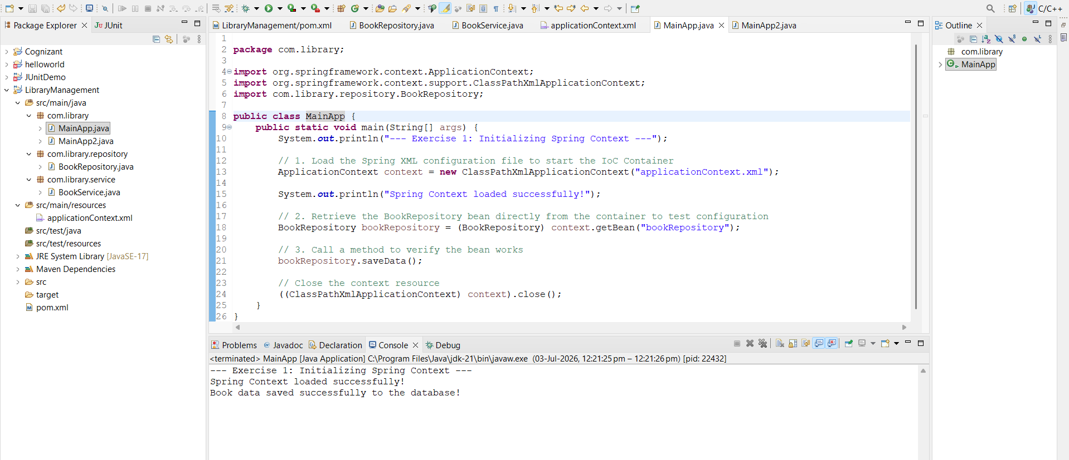

Exercise 2 - Implementing Dependency Injection:
Program :
applicationContext.xml :
<?xml version="1.0" encoding="UTF-8"?>
<beans xmlns="http://www.springframework.org/schema/beans"
xmlns:xsi="http://www.w3.org/2001/XMLSchema-instance"
xsi:schemaLocation="http://www.springframework.org/schema/beans
https://www.springframework.org/schema/beans/spring-beans.xsd">

<bean id="bookRepository" class="com.library.repository.BookRepository" />

<bean id="bookService" class="com.library.service.BookService">
<property name="bookRepository" ref="bookRepository" />
</bean>

</beans>

MainApp.java :

package com.library;

import org.springframework.context.ApplicationContext;
import org.springframework.context.support.ClassPathXmlApplicationContext;
import com.library.service.BookService;

public class MainApp {
public static void main(String[] args) {
// 1. Load the Spring XML configuration file
ApplicationContext context = new ClassPathXmlApplicationContext("applicationContext.xml");

// 2. Retrieve the configured BookService bean from the container
BookService bookService = (BookService) context.getBean("bookService");

// 3. Call the method to test if dependency injection succeeded
bookService.addBook();

// Close the context resource
((ClassPathXmlApplicationContext) context).close();
}
}
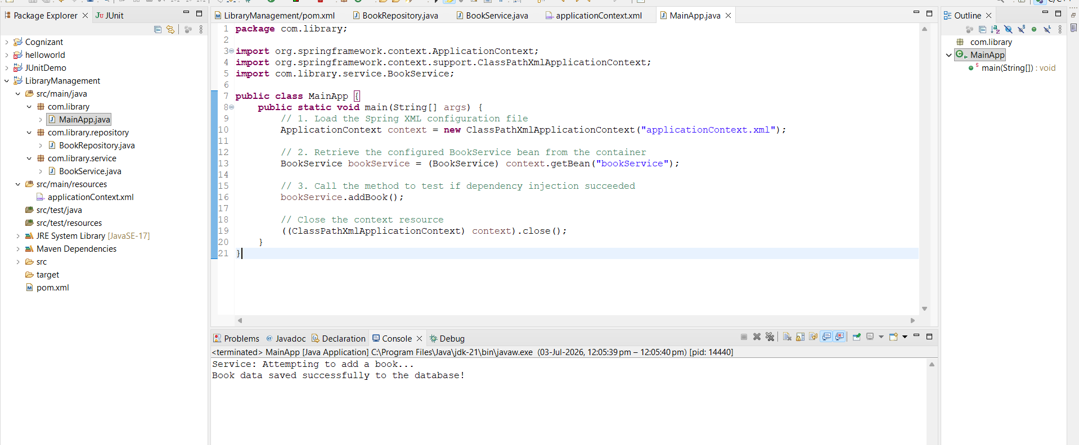

Exercise 4: Creating and Configuring a Maven Project
pom.xml :
<project xmlns="http://maven.apache.org/POM/4.0.0"
xmlns:xsi="http://www.w3.org/2001/XMLSchema-instance"
xsi:schemaLocation="http://maven.apache.org/POM/4.0.0 https://maven.apache.org/xsd/maven-4.0.0.xsd">
<modelVersion>4.0.0</modelVersion>
<groupId>com.library</groupId>
<artifactId>LibraryManagement</artifactId>
<version>0.0.1-SNAPSHOT</version>
<packaging>war</packaging> <properties>
<spring.version>5.3.31</spring.version>
</properties>

<dependencies>
<dependency>
<groupId>org.springframework</groupId>
<artifactId>spring-context</artifactId>
<version>${spring.version}</version>
</dependency>

<dependency>
<groupId>org.springframework</groupId>
<artifactId>spring-aop</artifactId>
<version>${spring.version}</version>
</dependency>

<dependency>
<groupId>org.springframework</groupId>
<artifactId>spring-webmvc</artifactId>
<version>${spring.version}</version>
</dependency>
</dependencies>

<build>
<plugins>
<plugin>
<groupId>org.apache.maven.plugins</groupId>
<artifactId>maven-compiler-plugin</artifactId>
<version>3.11.0</version>
<configuration>
<source>1.8</source>
<target>1.8</target>
</configuration>
</plugin>
</plugins>
</build>
</project>

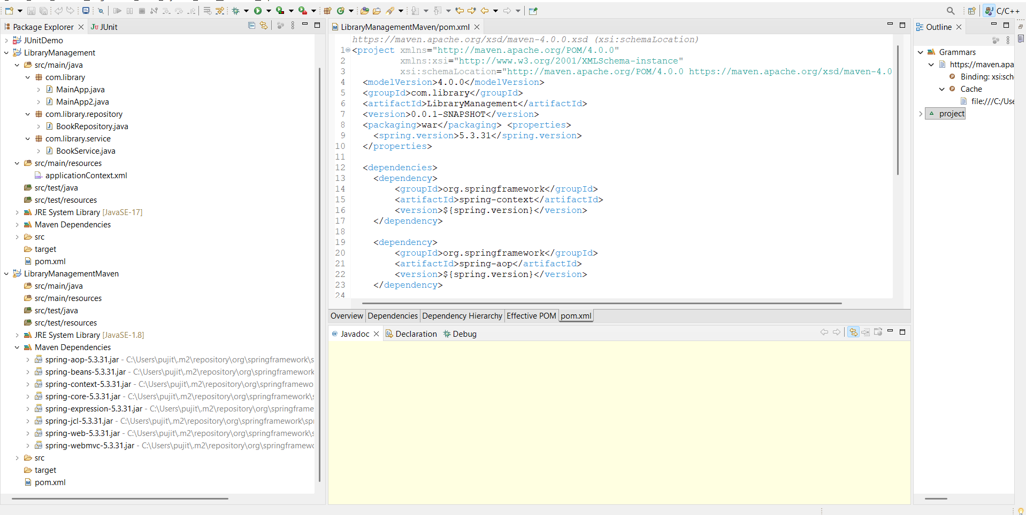
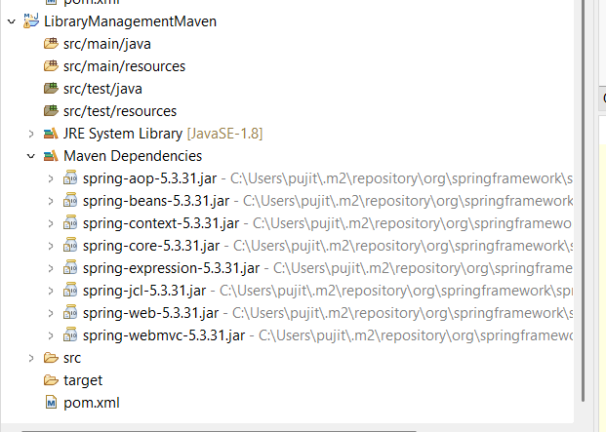

Exercise 5: Configuring the Spring IoC Container
applicationContext.xml :
<?xml version="1.0" encoding="UTF-8"?>
<beans xmlns="http://www.springframework.org/schema/beans"
xmlns:xsi="http://www.w3.org/2001/XMLSchema-instance"
xsi:schemaLocation="http://www.springframework.org/schema/beans
https://www.springframework.org/schema/beans/spring-beans.xsd">

<bean id="bookRepository" class="com.library.repository.BookRepository" />

<bean id="bookService" class="com.library.service.BookService">
<property name="bookRepository" ref="bookRepository" />
</bean>

</beans>

BookRepository.java :
package com.library.repository;

public class BookRepository {
public void saveData() {
System.out.println("Database: Book record successfully saved!");
}
}

BookService.java :
package com.library.service;

import com.library.repository.BookRepository;

public class BookService {
private BookRepository bookRepository;

// Setter method used by Spring IoC container for dependency injection
public void setBookRepository(BookRepository bookRepository) {
this.bookRepository = bookRepository;
}

public void addBook() {
System.out.println("Service: Delegating book addition to Repository...");
bookRepository.saveData();
}
}

LibraryManagementApplication.java :
package com.library;

import org.springframework.context.ApplicationContext;
import org.springframework.context.support.ClassPathXmlApplicationContext;
import com.library.service.BookService;

public class LibraryManagementApplication {
public static void main(String[] args) {
System.out.println("=== Exercise 5: Bootstrapping IoC Container ===");

// 1. Load configuration metadata into the ApplicationContext
ApplicationContext context = new ClassPathXmlApplicationContext("applicationContext.xml");

// 2. Retrieve the fully wired bean container instance
BookService bookService = (BookService) context.getBean("bookService");

// 3. Invoke methods to verify configuration success
bookService.addBook();

// 4. Close the context context channel safely
((ClassPathXmlApplicationContext) context).close();
}
}

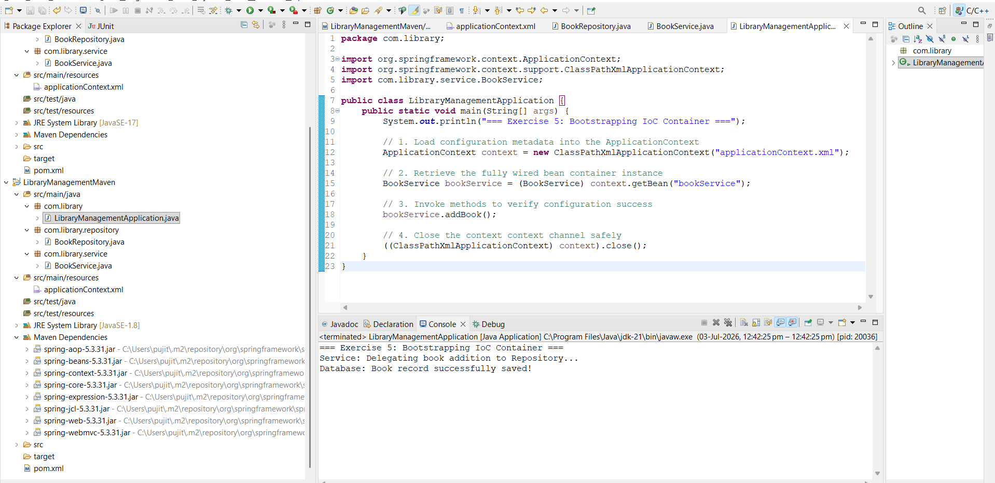

Exercise 7: Implementing Constructor and Setter Injection
NotificationService.java :
package com.library.service;

public class NotificationService {
public void sendNotification(String message) {
System.out.println("Notification: " + message);
}
}

BookService.java :
package com.library.service;

import com.library.repository.BookRepository;

public class BookService {
private BookRepository bookRepository;
private NotificationService notificationService;

// 1. CONSTRUCTOR INJECTION: For NotificationService
public BookService(NotificationService notificationService) {
this.notificationService = notificationService;
System.out.println("-> Constructor Injection: NotificationService injected.");
}

// 2. SETTER INJECTION: For BookRepository
public void setBookRepository(BookRepository bookRepository) {
this.bookRepository = bookRepository;
System.out.println("-> Setter Injection: BookRepository injected.");
}

public void addBook() {
System.out.println("Service: Adding a new book record...");
bookRepository.saveData();
notificationService.sendNotification("Book added successfully!");
}
}

applicationContext.xml :
<?xml version="1.0" encoding="UTF-8"?>
<beans xmlns="http://www.springframework.org/schema/beans"
xmlns:xsi="http://www.w3.org/2001/XMLSchema-instance"
xsi:schemaLocation="http://www.springframework.org/schema/beans
https://www.springframework.org/schema/beans/spring-beans.xsd">

<bean id="bookRepository" class="com.library.repository.BookRepository" />
<bean id="notificationService" class="com.library.service.NotificationService" />

<bean id="bookService" class="com.library.service.BookService">

<constructor-arg ref="notificationService" />

<property name="bookRepository" ref="bookRepository" />

</bean>

</beans>

LibraryManagementApplication
package com.library;

import org.springframework.context.ApplicationContext;
import org.springframework.context.support.ClassPathXmlApplicationContext;
import com.library.service.BookService;

public class LibraryManagementApplication {
public static void main(String[] args) {
System.out.println("=== Exercise 5: Bootstrapping IoC Container ===");

// 1. Load configuration metadata into the ApplicationContext
ApplicationContext context = new ClassPathXmlApplicationContext("applicationContext.xml");

// 2. Retrieve the fully wired bean container instance
BookService bookService = (BookService) context.getBean("bookService");

// 3. Invoke methods to verify configuration success
bookService.addBook();

// 4. Close the context context channel safely
((ClassPathXmlApplicationContext) context).close();
}
}

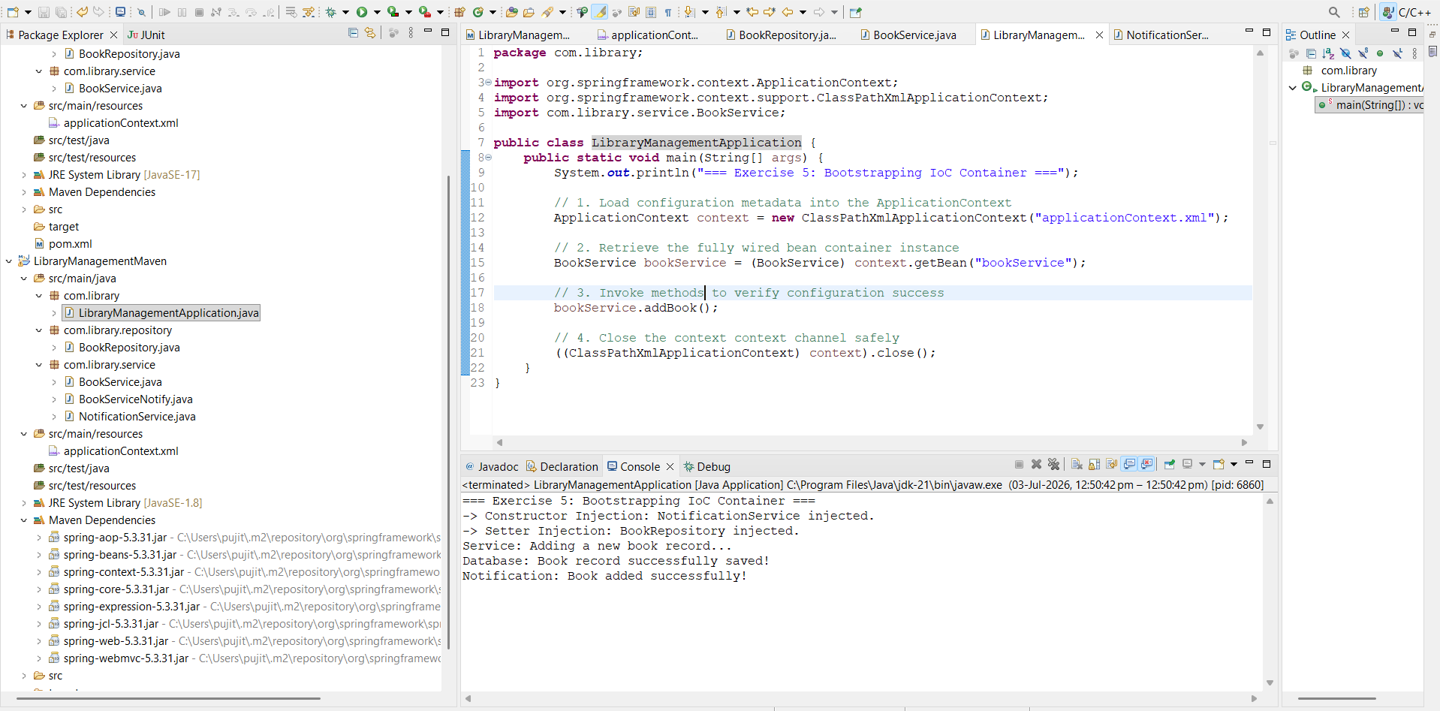

Exercise 9: Creating a Spring Boot Application
Updated pom.xml :
<?xml version="1.0" encoding="UTF-8"?>
<project xmlns="http://maven.apache.org/POM/4.0.0"
xmlns:xsi="http://www.w3.org/2001/XMLSchema-instance"
xsi:schemaLocation="http://maven.apache.org/POM/4.0.0 https://maven.apache.org/xsd/maven-4.0.0.xsd">
<modelVersion>4.0.0</modelVersion>

<parent>
<groupId>org.springframework.boot</groupId>
<artifactId>spring-boot-starter-parent</artifactId>
<version>3.2.5</version>
<relativePath/>
</parent>

<groupId>com.library</groupId>
<artifactId>LibraryManagement</artifactId>
<version>0.0.1-SNAPSHOT</version>

<properties>
<java.version>17</java.version>
</properties>

<dependencies>
<dependency>
<groupId>org.springframework.boot</groupId>
<artifactId>spring-boot-starter-web</artifactId>
</dependency>

<dependency>
<groupId>org.springframework.boot</groupId>
<artifactId>spring-boot-starter-data-jpa</artifactId>
</dependency>

<dependency>
<groupId>com.h2database</groupId>
<artifactId>h2</artifactId>
<scope>runtime</scope>
</dependency>
</dependencies>

<build>
<plugins>
<plugin>
<groupId>org.springframework.boot</groupId>
<artifactId>spring-boot-maven-plugin</artifactId>
</plugin>
</plugins>
</build>
</project>

Application. Properties :
spring.datasource.url=jdbc:h2:mem:librarydb
spring.datasource.driverClassName=org.h2.Driver
spring.datasource.username=sa
spring.datasource.password=

spring.h2.console.enabled=true
spring.h2.console.path=/h2-console

spring.jpa.show-sql=true
spring.jpa.hibernate.ddl-auto=update

Book.java :
package com.library.model;
import jakarta.persistence.Entity;
import jakarta.persistence.GeneratedValue;
import jakarta.persistence.GenerationType;
import jakarta.persistence.Id;
@Entity
public class Book {
@Id
@GeneratedValue(strategy = GenerationType.IDENTITY)
private Long id;
private String title;
private String author;

public Book() {}

public Book(String title, String author) {
this.title = title;
this.author = author;
}

public Long getId() { return id; }
public void setId(Long id) { this.id = id; }
public String getTitle() { return title; }
public void setTitle(String title) { this.title = title; }
public String getAuthor() { return author; }
public void setAuthor(String author) { this.author = author; }
}
BookRepository1.java :

package com.library.repository;

import com.library.model.Book;
import org.springframework.data.jpa.repository.JpaRepository;
import org.springframework.stereotype.Repository;

@Repository
public interface BookRepository1 extends JpaRepository<Book, Long> {
// This gives you access to built-in methods like findAll() and save()
}

BookController.java :

package com.library.controller;

import com.library.model.Book;
import com.library.repository.BookRepository1;
import org.springframework.beans.factory.annotation.Autowired;
import org.springframework.web.bind.annotation.*;

import java.util.List;

@RestController
@RequestMapping("/api/books")
public class BookController {

@Autowired
private BookRepository1 bookRepository;

// 1. GET Endpoint to fetch all books
@GetMapping
public List<Book> getAllBooks() {
return bookRepository.findAll();
}

// 2. POST Endpoint to add a new book
@PostMapping
public Book createBook(@RequestBody Book book) {
return bookRepository.save(book);
}
}

LibraryManagementApplication

package com.library;

import org.springframework.boot.SpringApplication;
import org.springframework.boot.autoconfigure.SpringBootApplication;

@SpringBootApplication
public class LibraryManagementApplication {
public static void main(String[] args) {
SpringApplication.run(LibraryManagementApplication.class, args);
}
}

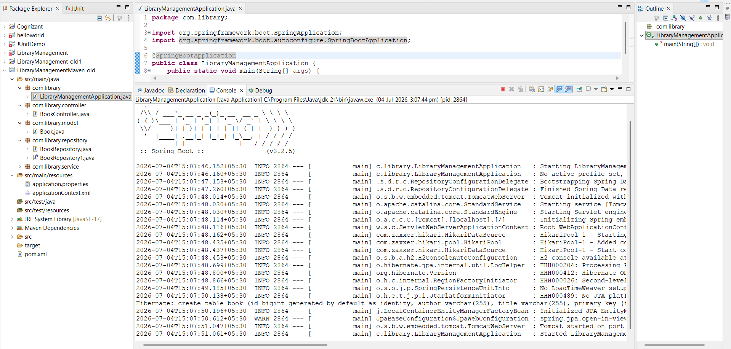

Module 6 - Spring Data JPA with Spring Boot, Hibernate
1)Spring Data JPA - Quick Example
pom.xml :
<?xml version="1.0" encoding="UTF-8"?>
<project xmlns="http://maven.apache.org/POM/4.0.0" xmlns:xsi="http://www.w3.org/2001/XMLSchema-instance"
xsi:schemaLocation="http://maven.apache.org/POM/4.0.0 https://maven.apache.org/xsd/maven-4.0.0.xsd">
<modelVersion>4.0.0</modelVersion>

<parent>
<groupId>org.springframework.boot</groupId>
<artifactId>spring-boot-starter-parent</artifactId>
<version>4.1.0</version>
<relativePath/> </parent>

<groupId>com.cognizant</groupId>
<artifactId>orm-learn</artifactId>
<version>0.0.1-SNAPSHOT</version>
<name>orm-learn</name>
<description>Demo project for Spring Data JPA and Hibernate</description>

<properties>
<java.version>17</java.version>
</properties>

<dependencies>
<dependency>
<groupId>org.springframework.boot</groupId>
<artifactId>spring-boot-starter-data-jpa</artifactId>
</dependency>

<dependency>
<groupId>org.springframework.boot</groupId>
<artifactId>spring-boot-devtools</artifactId>
<scope>runtime</scope>
<optional>true</optional>
</dependency>

<dependency>
<groupId>com.h2database</groupId>
<artifactId>h2</artifactId>
<scope>runtime</scope>
</dependency>

<dependency>
<groupId>org.springframework.boot</groupId>
<artifactId>spring-boot-starter-test</artifactId>
<scope>test</scope>
</dependency>
</dependencies>

<build>
<plugins>
<plugin>
<groupId>org.springframework.boot</groupId>
<artifactId>spring-boot-maven-plugin</artifactId>
</plugin>
</plugins>
</build>

</project>

application.properties :
# Logging Configuration
logging.level.org.springframework=info
logging.level.com.cognizant=debug
logging.level.org.hibernate.SQL=trace
logging.level.org.hibernate.type.descriptor.sql=trace
logging.pattern.console=%d{dd-MM-yy} %d{HH:mm:ss.SSS} %-20.20thread %5p %-25.25logger{25} %25M %4L %m%n

# Embedded H2 Database Configuration
spring.datasource.url=jdbc:h2:mem:orm_learn;DB_CLOSE_DELAY=-1
spring.datasource.driverClassName=org.h2.Driver
spring.datasource.username=sa
spring.datasource.password=

# Hibernate Setup
spring.jpa.hibernate.ddl-auto=update
spring.jpa.properties.hibernate.dialect=org.hibernate.dialect.H2Dialect

country.java :
# Logging Configuration
logging.level.org.springframework=info
logging.level.com.cognizant=debug
logging.level.org.hibernate.SQL=trace
logging.level.org.hibernate.type.descriptor.sql=trace
logging.pattern.console=%d{dd-MM-yy} %d{HH:mm:ss.SSS} %-20.20thread %5p %-25.25logger{25} %25M %4L %m%n

# Embedded H2 Database Configuration
spring.datasource.url=jdbc:h2:mem:orm_learn;DB_CLOSE_DELAY=-1
spring.datasource.driverClassName=org.h2.Driver
spring.datasource.username=sa
spring.datasource.password=

# Hibernate Setup
spring.jpa.hibernate.ddl-auto=update
spring.jpa.properties.hibernate.dialect=org.hibernate.dialect.H2Dialect

CountryService.java :

package com.cognizant.orm_learn.service;

import java.util.List;
import org.springframework.beans.factory.annotation.Autowired;
import org.springframework.stereotype.Service;
import org.springframework.transaction.annotation.Transactional;
import com.cognizant.orm_learn.model.Country;
import com.cognizant.orm_learn.repository.CountryRepository;

@Service
public class CountryService {

@Autowired
private CountryRepository countryRepository;

@Transactional(readOnly = true)
public List<Country> getAllCountries() {
return countryRepository.findAll();
}
}
CountryRepository.java:
package com.cognizant.orm_learn.repository;

import org.springframework.data.jpa.repository.JpaRepository;
import org.springframework.stereotype.Repository;
import com.cognizant.orm_learn.model.Country;

@Repository
public interface CountryRepository extends JpaRepository<Country, String> {
}

OrmLearnApplication.java :
package com.cognizant.orm_learn;

import java.util.List;
import org.slf4j.Logger;
import org.slf4j.LoggerFactory;
import org.springframework.boot.SpringApplication;
import org.springframework.boot.autoconfigure.SpringBootApplication;
import org.springframework.context.ApplicationContext;
import com.cognizant.orm_learn.model.Country;
import com.cognizant.orm_learn.service.CountryService;

@SpringBootApplication
public class OrmLearnApplication {

private static final Logger LOGGER = LoggerFactory.getLogger(OrmLearnApplication.class);
private static CountryService countryService;

public static void main(String[] args) {
ApplicationContext context = SpringApplication.run(OrmLearnApplication.class, args);

countryService = context.getBean(CountryService.class);

LOGGER.info("Inside main");
testGetAllCountries();
}

private static void testGetAllCountries() {
LOGGER.info("Start");
List<Country> countries = countryService.getAllCountries();
LOGGER.debug("countries={}", countries);
LOGGER.info("End");
}
}

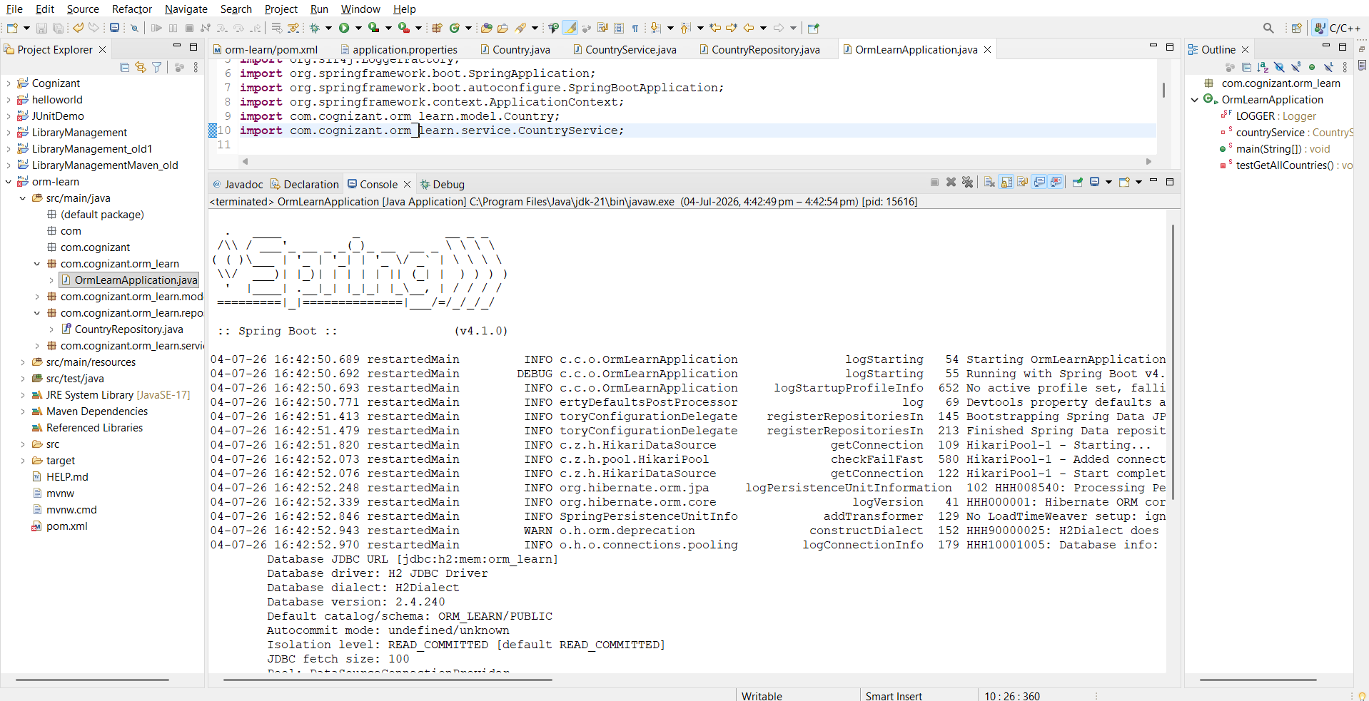

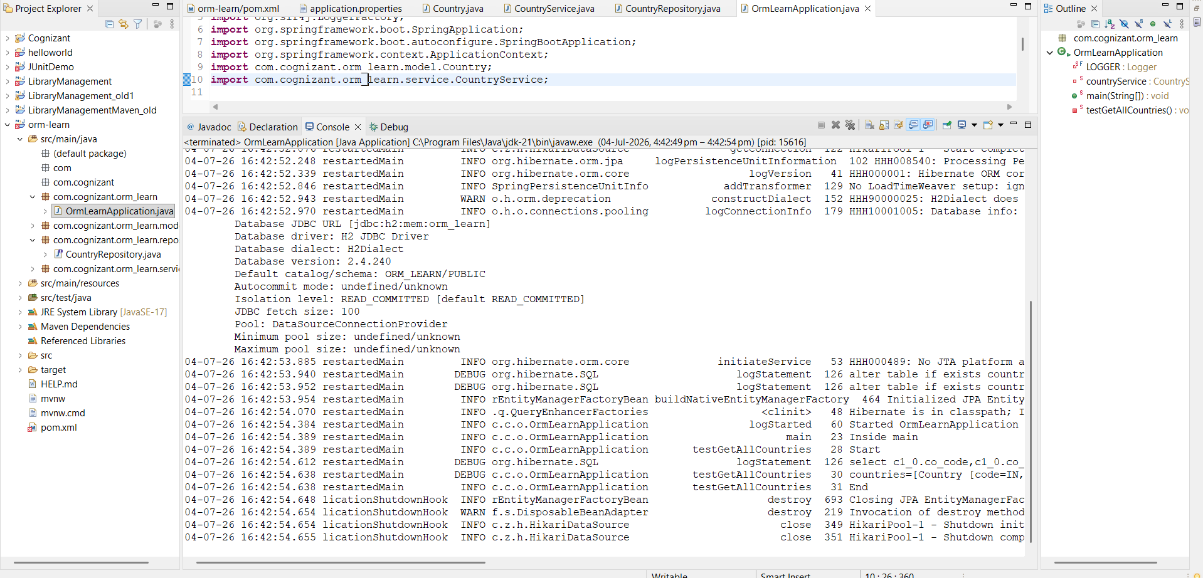

2)Difference between JPA, Hibernate and Spring Data JPA
Hibernate.cfg.xml :
<?xml version="1.0"?>

<!DOCTYPE hibernate-configuration PUBLIC
"-//Hibernate/Hibernate Configuration DTD 3.0//EN"
"http://hibernate.sourceforge.net/hibernate-configuration-3.0.dtd">

<hibernate-configuration>

<session-factory>

<property name="hibernate.connection.driver_class">
org.h2.Driver
</property>

<property name="hibernate.connection.url">
jdbc:h2:mem:testdb
</property>

<property name="hibernate.connection.username">
sa
</property>

<property name="hibernate.connection.password">
</property>

<property name="hibernate.dialect">
org.hibernate.dialect.H2Dialect
</property>

<property name="hibernate.hbm2ddl.auto">
update
</property>

<property name="hibernate.show_sql">
true
</property>

<mapping class="com.example.Employee"/>

</session-factory>

</hibernate-configuration>

Employee.java:
package com.example;

import javax.persistence.*;

@Entity
@Table(name="employee")
public class Employee {

@Id
@GeneratedValue(strategy=GenerationType.IDENTITY)
private int id;

private String name;

private double salary;

public Employee() {
}

public Employee(String name,double salary){
this.name=name;
this.salary=salary;
}

public int getId() {
return id;
}

public void setId(int id) {
this.id=id;
}

public String getName() {
return name;
}

public void setName(String name) {
this.name=name;
}

public double getSalary() {
return salary;
}

public void setSalary(double salary) {
this.salary=salary;
}
}

EmployeeDAO.java :
package com.example;

public class Main {

public static void main(String[] args) {

EmployeeDAO dao = new EmployeeDAO();

Employee emp =
new Employee("Pujitha",45000);

dao.addEmployee(emp);

System.out.println("Employee Saved");

}

}

HibernateUtil.java:
package com.example;

import org.hibernate.SessionFactory;
import org.hibernate.cfg.Configuration;

public class HibernateUtil {

private static SessionFactory factory;

static{
factory = new Configuration()
.configure()
.buildSessionFactory();
}

public static SessionFactory getFactory(){
return factory;
}
}

Main.java:
package com.example;

public class Main {

public static void main(String[] args) {

EmployeeDAO dao = new EmployeeDAO();

Employee emp =
new Employee("Pujitha",45000);

dao.addEmployee(emp);

System.out.println("Employee Saved");

}

}

