AI-Driven Network Traffic Analysis and Intrusion Detection System
Technical report - Megaminds IT Services, Cybersecurity Research Intern assessment (Round 1)

1. Problem overview
Signature-based detection catches attacks someone already wrote a rule for; it struggles with variants and novel behaviour. Behavioural and ML approaches look at how a host acts instead. The task is to build a prototype that ingests network traffic, extracts features, detects intrusions, and presents results an analyst can act on. I built a hybrid detector: an auditable rule layer for known attack behaviours plus an unsupervised anomaly model for everything the rules do not describe.

2. Objectives
- Obtain traffic containing benign behaviour, reconnaissance, DoS and one further attack.
- Extract features that separate those behaviours.
- Detect them with a justified method.
- Explain every alert (what, why, how severe/confident).
- Provide a runnable CLI and dashboard.
- Evaluate honestly, including failures, and state limitations.

3. Traffic data
Choice: a seeded synthetic LAN, written as real pcap files. Attacks may only be run against systems one owns, and a multi-host lab was not available for this assignment; a deterministic generator also makes every number here reproducible (python generate_traffic.py). The frames are valid Ethernet/IPv4/TCP/UDP/ICMP/ARP with correct checksums, open in Wireshark, and can be replayed in a lab with tcpreplay. The reader also accepts real classic-pcap captures.
Topology: one /24 with a gateway, web, SSH and DNS server, 12 benign clients and one attacker. Benign behaviour is a Poisson mix per client: HTTP(S) sessions (55 %), DNS (30 %), interactive SSH (7 %), ping (8 %), plus ARP bootstrap and refresh. Eight captures:
Capture | Purpose
train_benign (300 s), val_benign (300 s) | fit the anomaly model / calibrate its threshold
s1_normal | Scenario 1 - benign baseline
s2_portscan | nmap-style SYN scan, 1,000 ports at ~100/s
s3_dos | hping3-style SYN flood, ~400 SYN/s for 30 s; legitimate clients degrade (generator models 25 % success and 40x slower handshakes during the flood; the measured value from the pcap is in Section 7)
s4a_bruteforce / s4b_arpspoof | SSH password guessing ~6/s; ARP cache poisoning of victim and gateway at 1 Hz
s5_ambiguous | a low-and-slow scan (one port every 2-4 s) and a benign flash crowd (12 clients x 25 successful HTTP connections in 6 s)
Each capture has a .labels.json ground truth (attacker, interval, victims). Important caveat: because I wrote both the generator and the detector, results are an optimistic functional test, not evidence of real-world accuracy (Section 9).

4. System architecture
pcap -> parser -> flow tracker + windowed feature extraction -> {rule layer, Isolation Forest} -> hybrid merge -> alerts (CLI / JSON / HTML / Streamlit). Modules are in idslib/; ids.py is the CLI, evaluate.py the evaluation harness. The unit of analysis is a (5-second window, source host) row.

5. Feature extraction
All four attacks are behaviours of one host over a short time, so each window summarises what each source did. A TCP flow tracker records, per connection, whether the handshake completed, was refused (RST) or never answered - this is what separates a scan or flood (handshakes fail) from a legitimate surge (they succeed).
Feature | Why it is useful
pps, bytes_per_s, avg_pkt_size | volume; floods are high-rate tiny packets, bulk transfers are large
unique_dst_ips | fan-out / host sweeps
max_ports_per_target | distinct ports on one target - the scan signature (a normal client uses 1-3 ports per host)
new_conns, max_conns_per_target | connection rate to one (ip, port) - flood and brute-force signature
fail_ratio | share of connections never established - scan/flood vs. legitimate bursts
max_auth_conns | connections to one auth service (SSH/FTP/Telnet/RDP/VNC) in a window
arp_unsolicited | ARP replies with no matching request
ARP binding table (rules) | IP->MAC mapping; a change is the definition of ARP poisoning
Choices that matter: ARP alerts are attributed to the Ethernet sender, never the claimed IP (the attacker spoofs the claimed IP); a MAC is mapped to an IP only when unambiguous (a router MAC carries many IPs). Per-target features (not totals) stop a busy but legitimate client from looking like a scanner.

6. Detection methodology
Rule layer (one rule per behaviour; thresholds chosen from benign behaviour in the training data, not tuned on test captures): - PORT_SCAN: >= 15 distinct ports on one target within a window. - SYN_FLOOD: >= 50 connection attempts/s to one (ip, port) and >= 80 % never complete. The completion condition is deliberate: a flash crowd completes its handshakes. - BRUTE_FORCE: >= 8 connections to one authentication service in a window. - ARP_SPOOF: an IP already bound to MAC A is claimed by MAC B (bindings learned on first sight or supplied statically).
ML layer: an Isolation Forest (300 trees) fitted on benign windows only, so “anomalous” means “unlike normal behaviour”. The alert threshold is the 99.8th percentile of scores on a separate benign validation capture (+ small margin), which bounds the false-positive rate before any attack is seen.
Hybrid merge: a rule alert keeps its specific category and reason; if the ML layer also flags that window, it becomes rule+ml with higher confidence. An ML-only flag is reported as ANOMALY - “unusual, type unknown” - with severity capped at Medium.
Explainability: every alert states the rule and thresholds matched with the observed values, e.g. “466 distinct destination ports probed on 192.168.10.10 in 5s (rule: >= 15); 100 % of connections failed or never completed”. ML alerts list the three features deviating most from the benign median (robust z-score). Severity scales with the margin over the threshold; confidence is a heuristic (0.6 at the threshold, rising with margin), not a calibrated probability.

7. Testing and evaluation
Metrics are per (window, source) row; victim servers during an attack are excluded because a server answering a flood legitimately looks busy (these are counted separately as “victim-side alerts”).
Scenarios S1-S4 (1,777 rows, 27 attack rows)
Mode | TP | FP | FN | Precision | Recall | F1 | Accuracy
Rules | 27 | 0 | 0 | 100 % | 100 % | 100 % | 100 %
ML only | 18 | 1 | 9 | 94.7 % | 66.7 % | 78.3 % | 99.4 %
Hybrid | 27 | 1 | 0 | 96.4 % | 100 % | 98.2 % | 99.9 %
Including the S5 stress test (50 attack rows, 2,137 rows total): rules 100 % precision / 54 % recall; ML 50 % / 36 %; hybrid 60 % / 54 %. These aggregates are dominated by a deliberately hard case, so per-scenario results matter more.
Scenario results.
- S1 (normal): zero alerts in all modes.
- S2 (port scan): found in the first window (466 ports in 5 s).
- S3 (SYN flood): found in the first window (~400 conn/s, 100 % unfinished); impact below.
- S4a (brute force): found in all 10 windows.
- S4b (ARP spoofing): all 8 windows flagged, attributed to the attacker MAC/IP, not the spoofed gateway IP.
- Detection latency equals one window (5 s) in every case - a design trade-off between speed and statistical stability.
S3 - impact of the flood on the web server (legitimate clients only):
Phase | LAN pkts/s | SYN/s at server | Legit handshake success | Median SYN->SYN-ACK
Before | 50 | 1.1 | 100 % | 0.9 ms
During | 558 | 368 | 13 % | 39.9 ms
After | 57 | 1.6 | 100 % | 0.8 ms
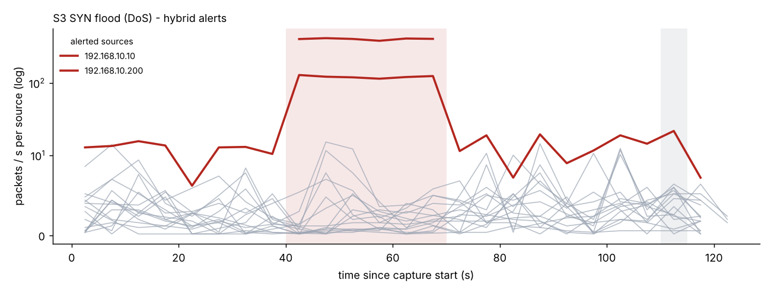
Figure 1 - S3 SYN flood: per-source packet rate; the attacker (192.168.10.200) and the victim server stand out during the shaded alert windows.
(Server degradation is modelled by the generator - success probability and latency multiplier during the flood - then measured from the pcap; it is an illustration of the metric pipeline, not an empirical server result.)
Errors and difficult cases.
- False positive (S3, ML only): the web server at t = 110 s scored 0.697 vs. a 0.696 threshold - a marginal, Low-severity alert on a normal busy window.
- S5 flash crowd (false positives): the ML layer raised 17 Low/Medium ANOMALY alerts on benign clients (e.g. max_conns_per_target = 25, benign median 1). Rules stayed silent because the handshakes completed. This is the central lesson: volume alone is not malice. Hybrid does not remove these ML-only alerts; it labels them as uncategorised, low-severity anomalies that an analyst can triage in seconds.
- S5 slow scan (false negative): all 23 attack windows missed by every mode. One port every ~3 s is 1-2 ports per window - below the scan rule, and indistinguishable from a normal client to the Isolation Forest.
- ARP spoofing is invisible to the ML layer alone (0/8). In benign training data arp_unsolicited is always 0, so the trees have no split point on it - an Isolation Forest cannot learn from a feature that never varied. The rule layer catches it; this is the strongest argument for the hybrid design.
- Rule layer precision of 100 % partly reflects that the benign data contains no scanner-like benign hosts (vulnerability scanners, monitoring, backup jobs); real networks do.
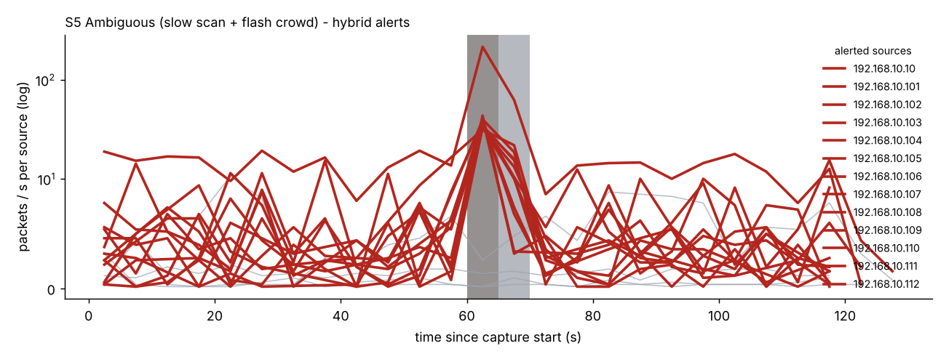
Figure 2 - S5 ambiguous capture: the flash crowd at t = 60-70 s raises many low-severity anomaly alerts; the slow scan never appears.

8. Network and security considerations
- Performance / inline use. This is an offline, windowed analyser: ~135,000 packets/s parse + feature extraction and 168 ms for rule + model scoring once features exist, on a 21,872-packet capture (single core, Python). Inline (IPS) deployment would add latency and a failure mode on the data path; I would deploy passively on a SPAN/TAP port. Windowing means alerts lag by at least one window.
- Completeness of capture. Drops under load, asymmetric routing (seeing only one direction) and encryption break flow tracking: a missed SYN-ACK looks like a failed connection and inflates fail_ratio. Encrypted payloads are irrelevant here because only headers and timing are used.
- Evasion. Low-and-slow scans (demonstrated), distributed scans from many sources, spoofed-source SYN floods (per-source features see each source once; a per-destination SYN/SYN-ACK imbalance rule is needed), mimicking benign rates, and slowly poisoning an ML baseline if training data is attacker-influenced.
- False-positive cost. Alerts that block (IPS) can cut off a legitimate flash crowd - exactly the S5 case. I therefore keep ML-only alerts non-blocking, low-severity, and explained.
- Scalability. Memory scales with distinct (window, source, flow) state; for 10 Gbit/s links this should move to Zeek/NetFlow-style sampled or hardware-assisted telemetry with the same per-source features, and the model scored in batch.

9. Limitations
Synthetic data written by the same author as the detector is the main weakness: thresholds and features fit attacks I know how I generated. The traffic is far simpler than a real network (one subnet, no IPv6, no VPN, no real application diversity), attack intensity is fixed, ML training uses ~880 benign rows, and the evaluation set is small (27 attack rows in S1-S4). Metrics here show that the pipeline works and where it breaks, not how it would perform in production. IPv6/ND spoofing, TCP stealth scans (FIN/NULL/Xmas), UDP floods and application-layer attacks are out of scope.

10. Future improvements
- Validate on CICIDS2017 and on live lab captures (Mininet + nmap/hping3/hydra/arpspoof).
- Multi-timescale features (5 s and 5 min) to catch slow scans.
- Per-destination SYN/SYN-ACK imbalance for spoofed floods.
- A supervised classifier or calibrated confidence once labelled real data exists.
- Allow-listing known scanners/monitors and a feedback loop from analyst verdicts.
- Streaming ingestion (Zeek logs / live capture) and IPv6 support.

Reproducing
python generate_traffic.py && python ids.py train && python evaluate.py regenerates every number and figure in this report (see README.md).

