Illuminating Autonomy: Federated Learning for Object Detection in Autonomous Vehicles under Low-Light Conditions
In this project we have trained Yolov5 algorithm on vehicles dataset which contains high and low light images and this dataset contains 5 different classes such as ‘Bus, Car, Motorbike, Truck and Person’. This model will work on both high and low light images. Model will be trained and load locally and then send to centralized server to update or save model.
To train yolov5 we have used below images
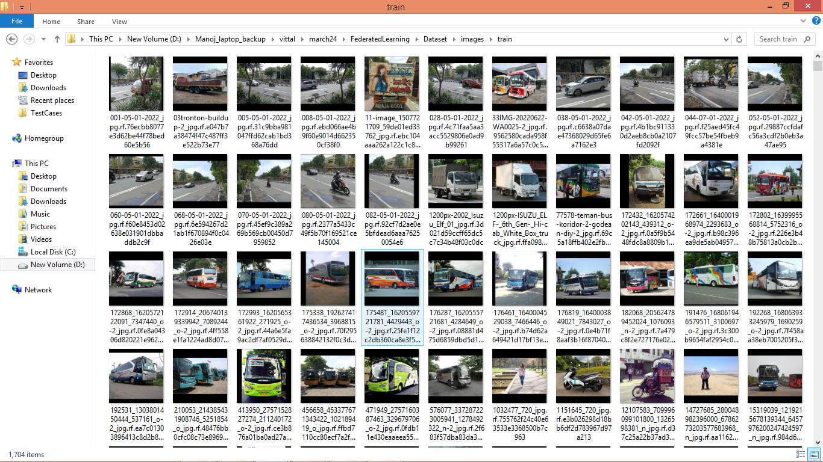
In below screen showing Yolov5 training performance details
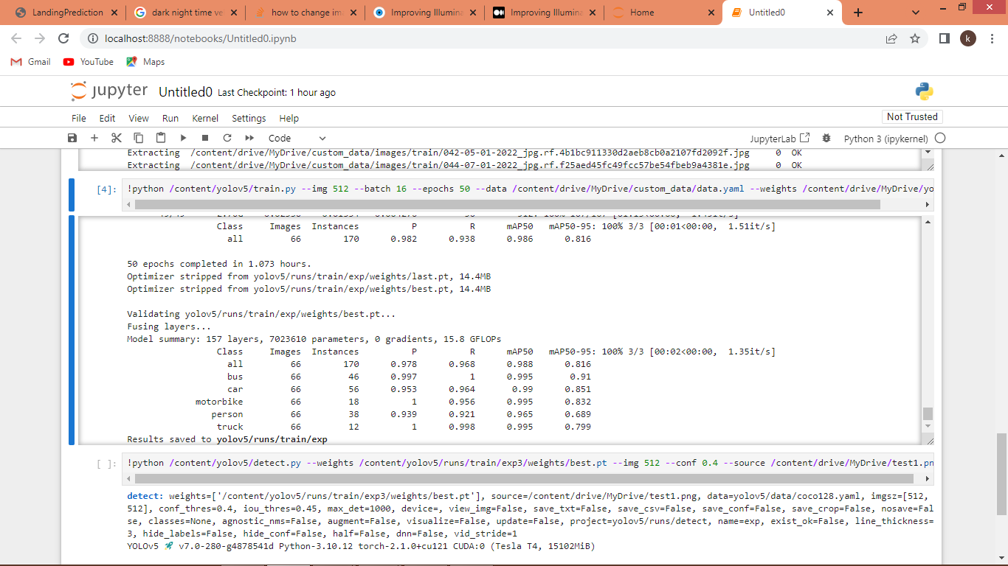
In above screen can see Yolov5 training performance result on all 5 classes.
To implement this project we have designed following modules
- Upload Vehicle Dataset: using this module will upload dataset to application
- Generate & Load Yolov5 Model: this module will generate and load Yolov5 model using loaded dataset images
- Federated Update Model to Server: this module can send generated Yolov5 model to centralized server
- Low Light Vehicle Detection: this module can load test image of high or low light and then illuminate given image and then Yolov5 will detect vehicles from loaded image
- Yolov5 Performance Graph: this module will display yolov5 training graph on precision, recall etc.
SCREEN SHOTS
To run project double click on ‘runServer.bat’ file to start centralized server and get below page
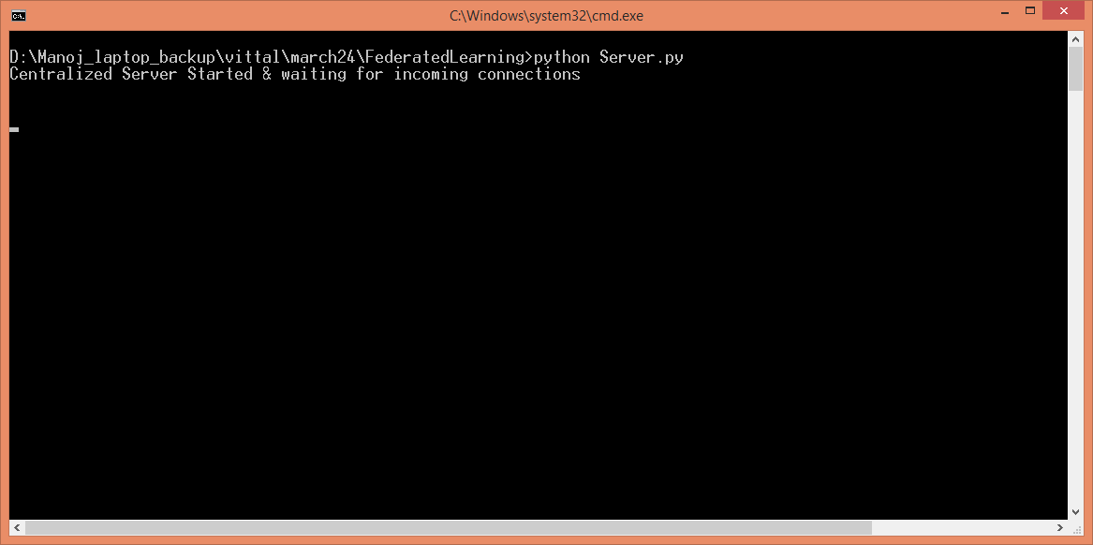
In above screen centralized server started which will receive models from local client and update model in its memory and now double click on ‘run.bat’ file to start client application
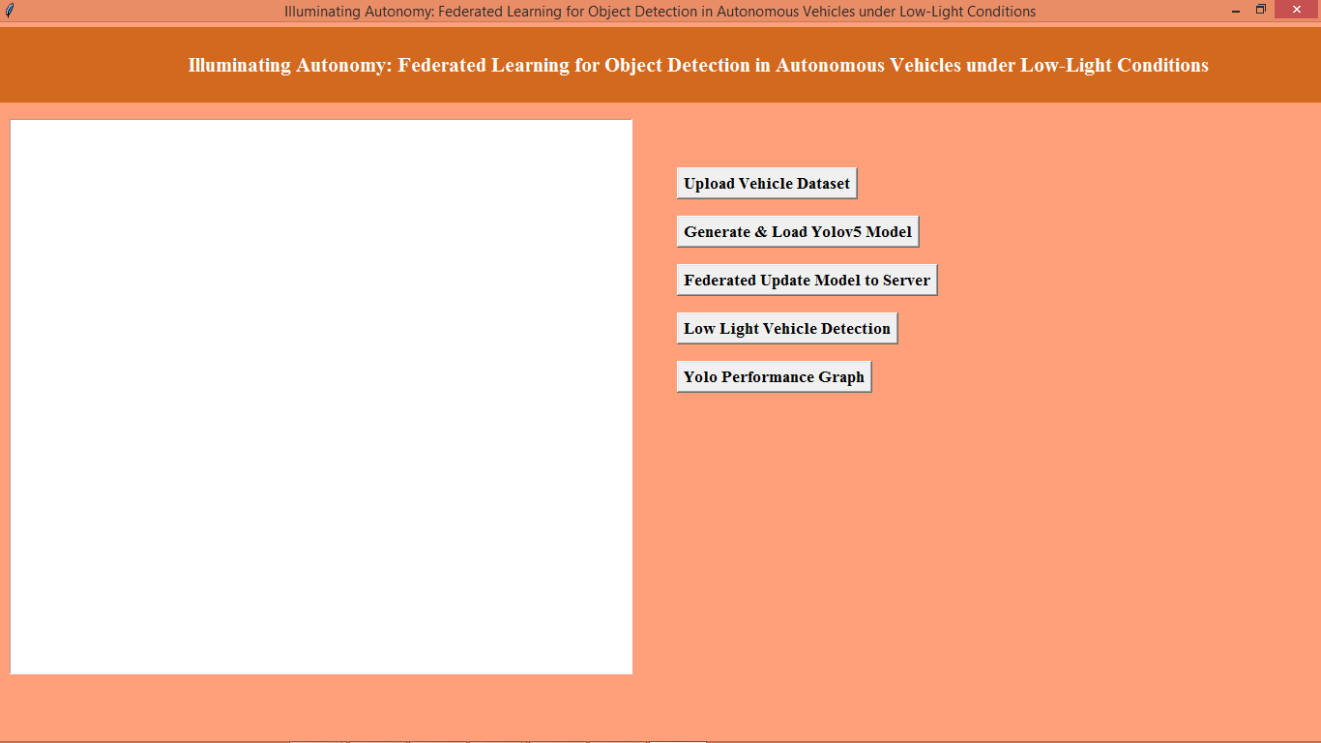
In above screen user can click on ‘Upload Vehicle Dataset’ button to load dataset and get below page
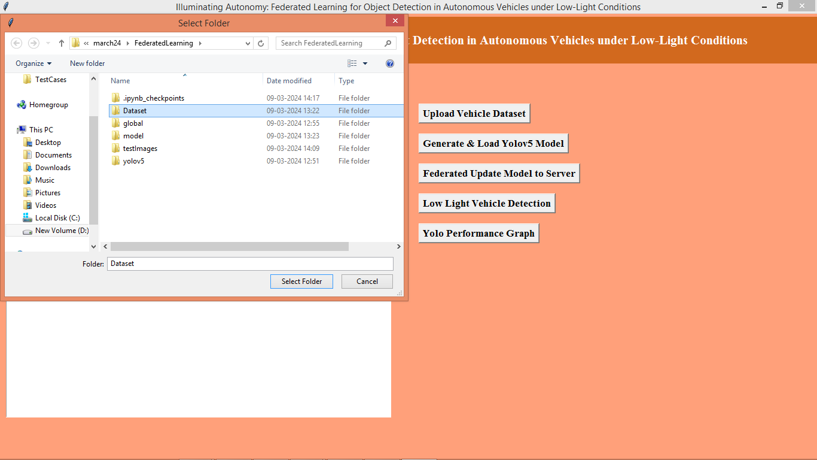
In above screen selecting and uploading ‘Dataset’ folder and then click on ‘Select Folder’ button to load dataset and get below page
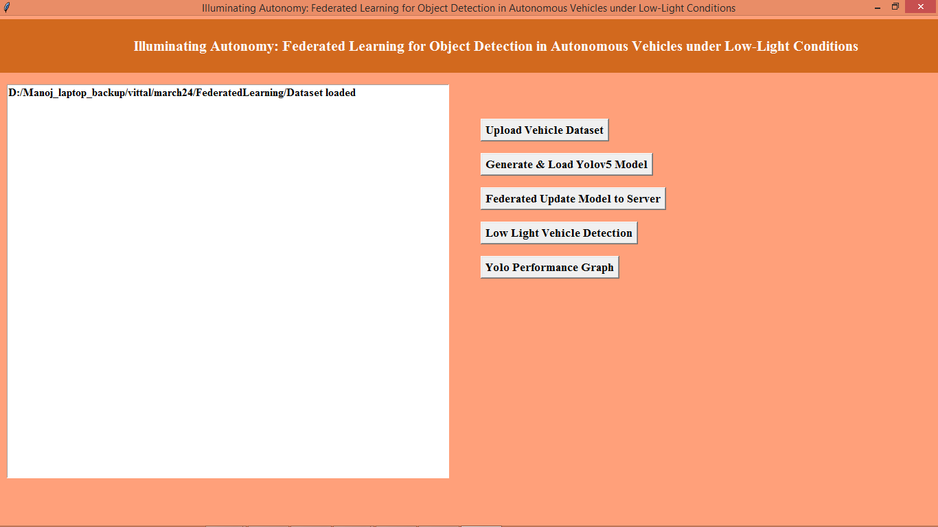
In above screen dataset loaded and now click on ‘Generate & Load YoloV5 Model’ button to load dataset and get below page
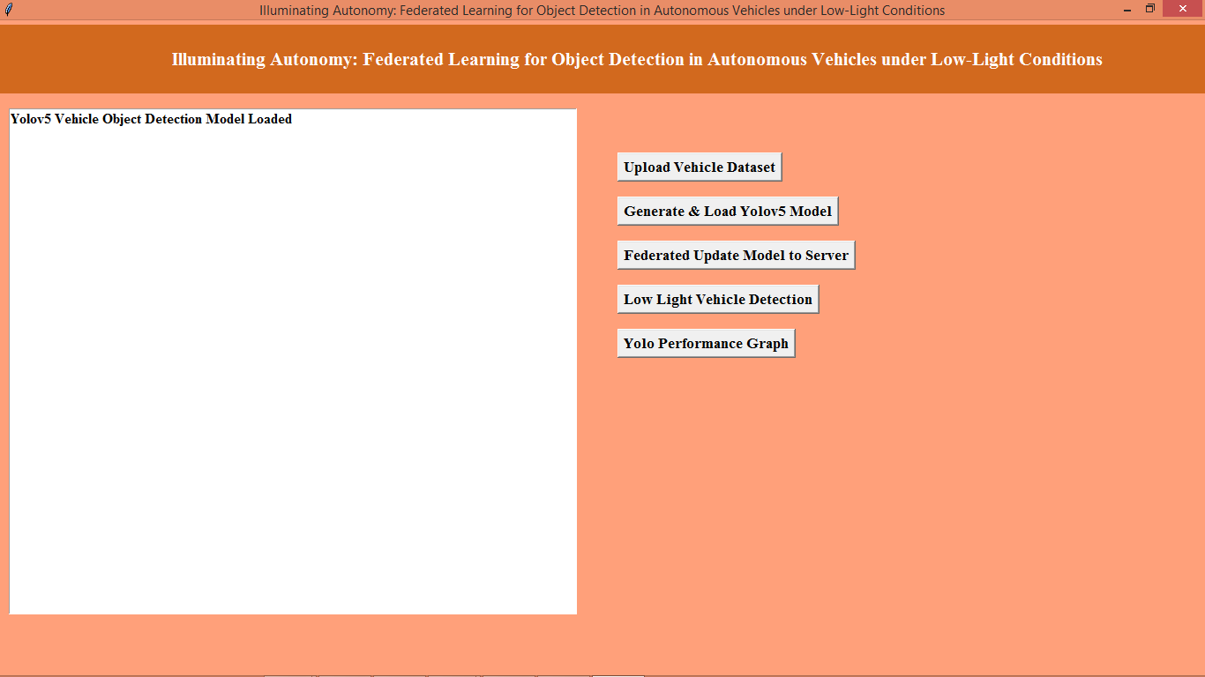
In above screen Yolov5 model loaded and now clicks on ‘Federated Update Model to Server’ button to sent model to server
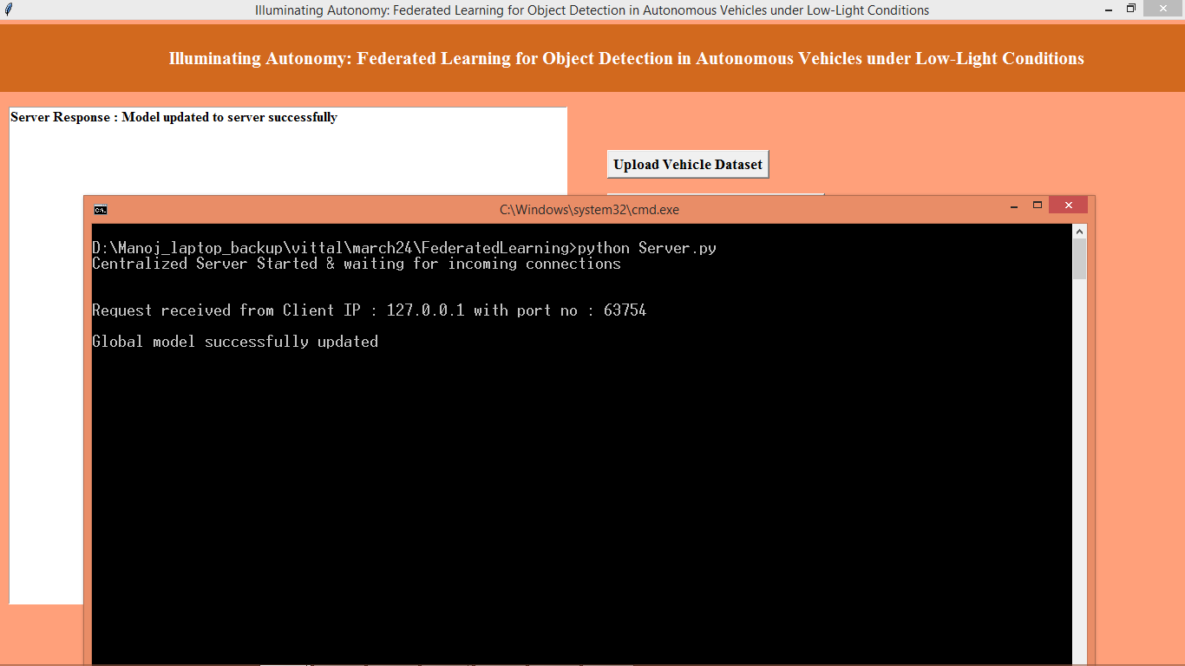
In above screen at client and server side can see model is updated successfully and now click on ‘Low Light Vehicle Detection’ button to upload test image and get below output
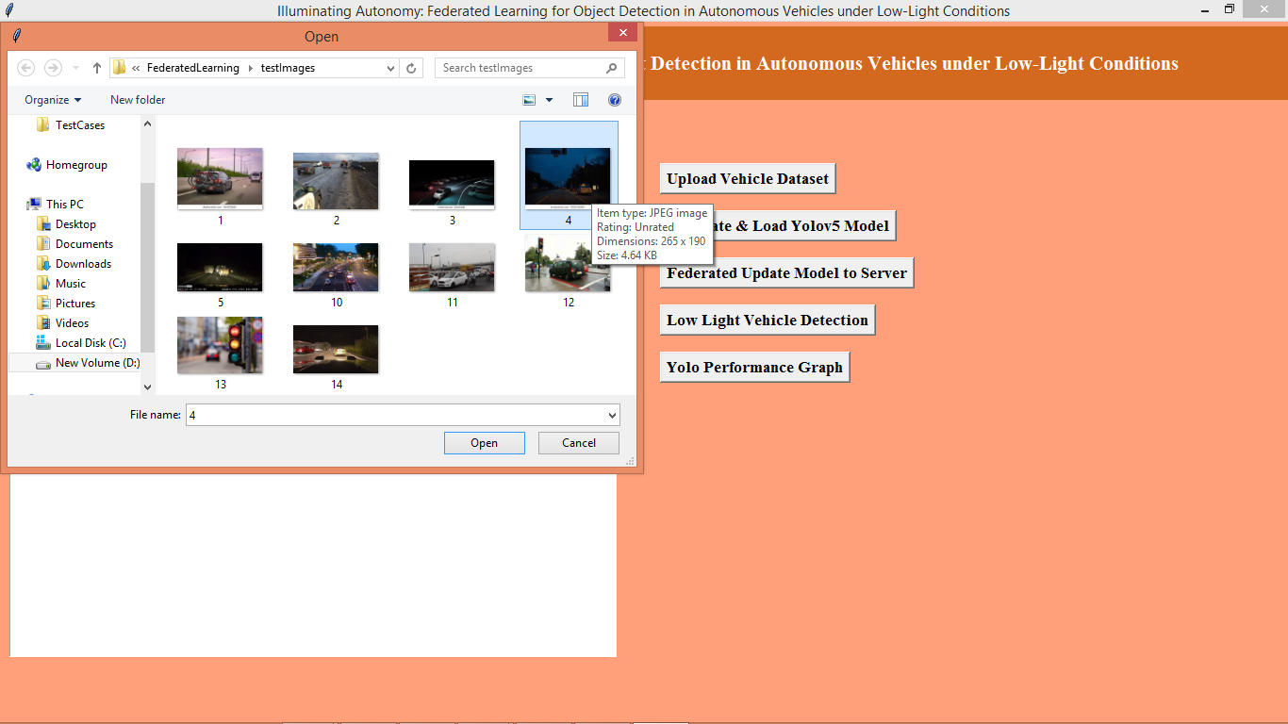
In above screen selecting and uploading 4.jpg and then click on ‘Open’ button to load image and get below output
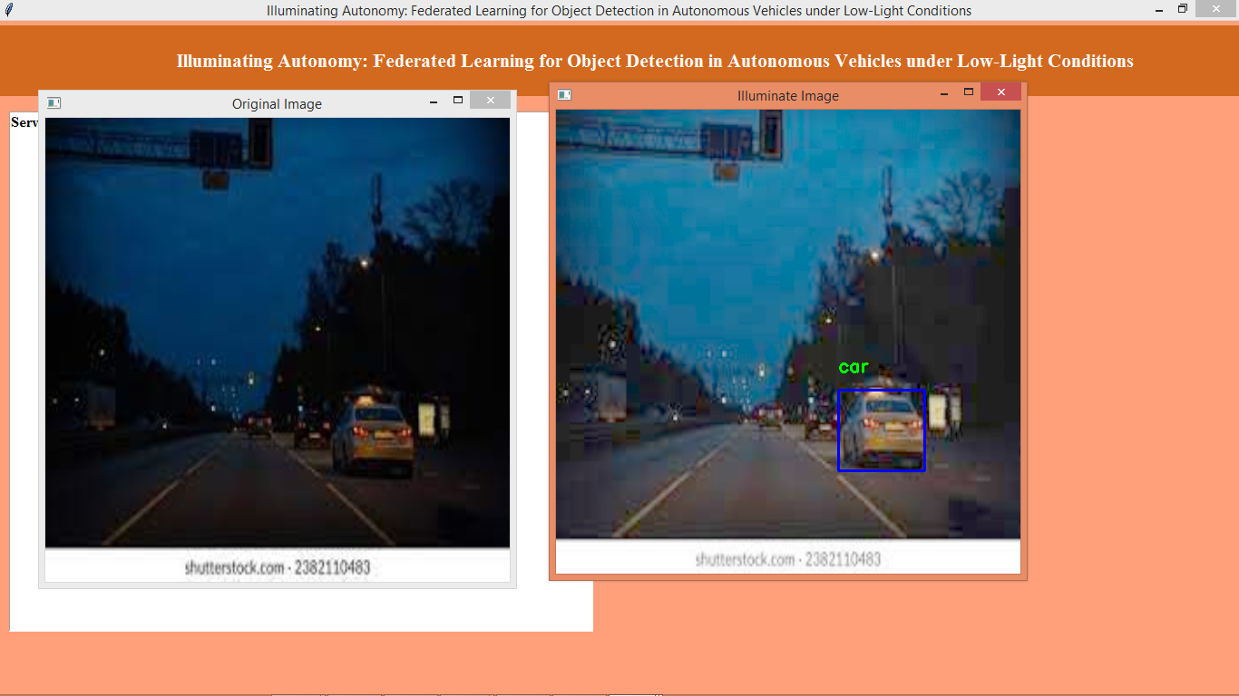
In above screen first image is the original low light image and second is the illuminated image where yolov5 detected and showing vehicle as ‘car’ in green and blue colour bounding box and similarly you can upload and test other images
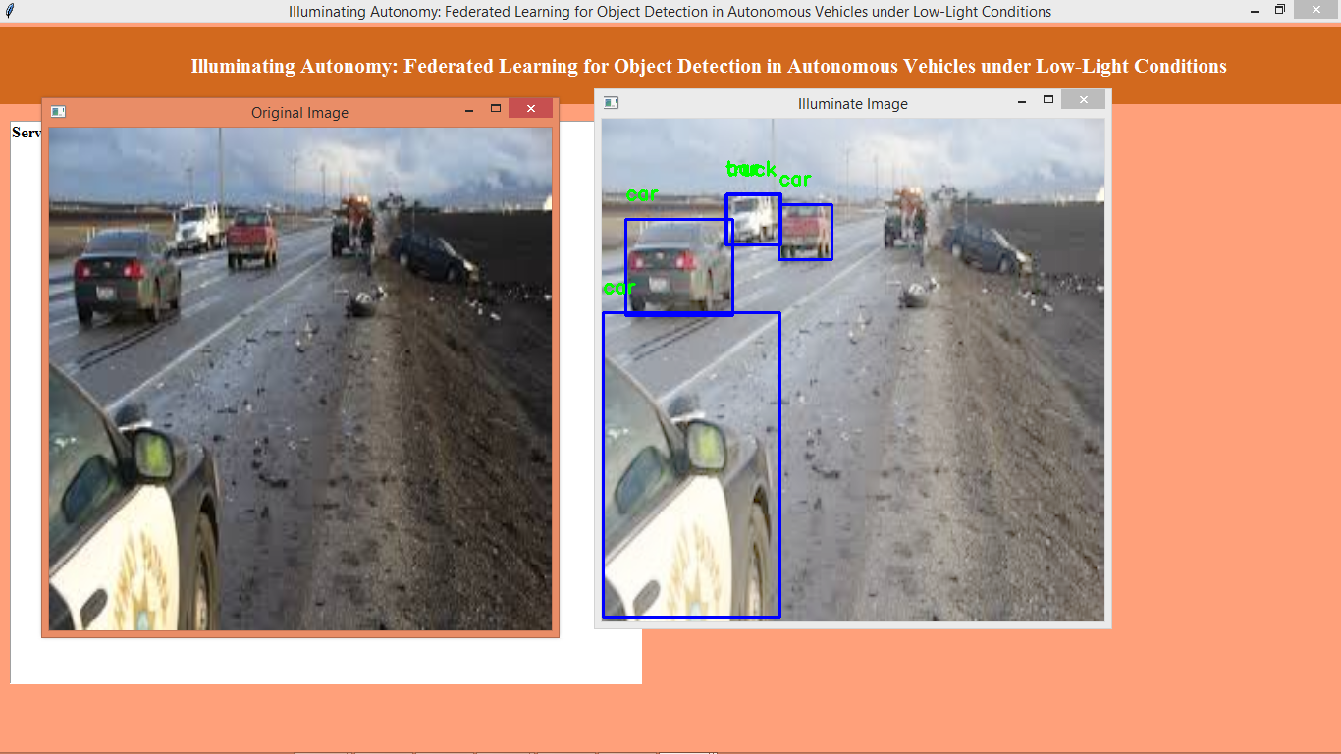
In above screen can see output from other image
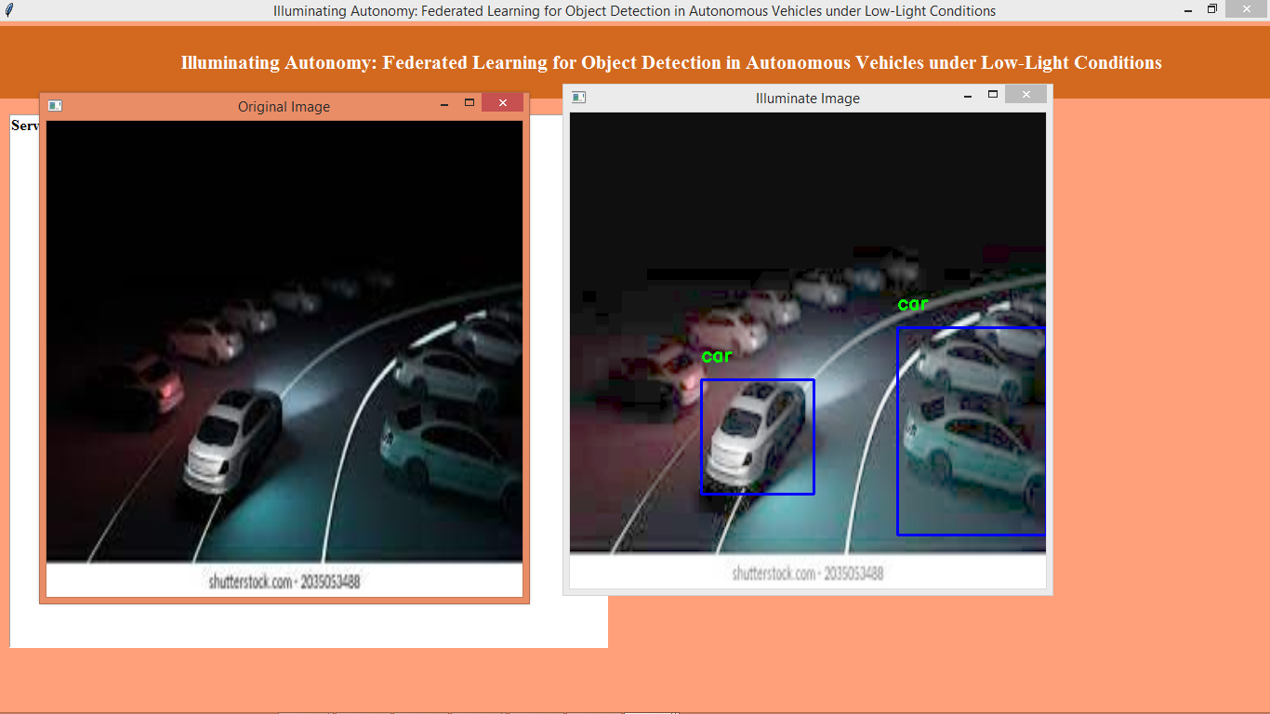
In above screen output from other image
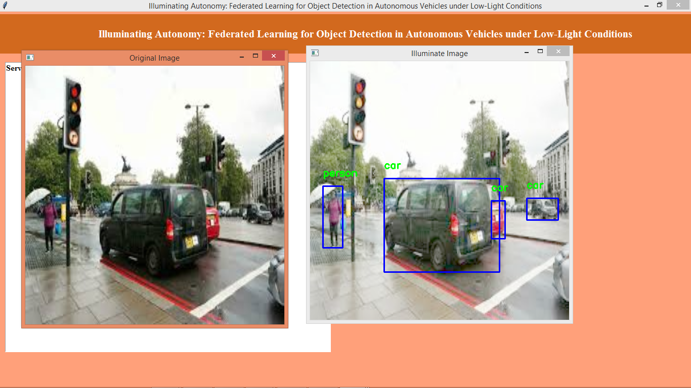
In above screen can see other output
Note: some objects may not be detected or detect wrongly as no algorithms are 100% accurate and now click on ‘Yolov5 Performance Graph’ button to get below graph
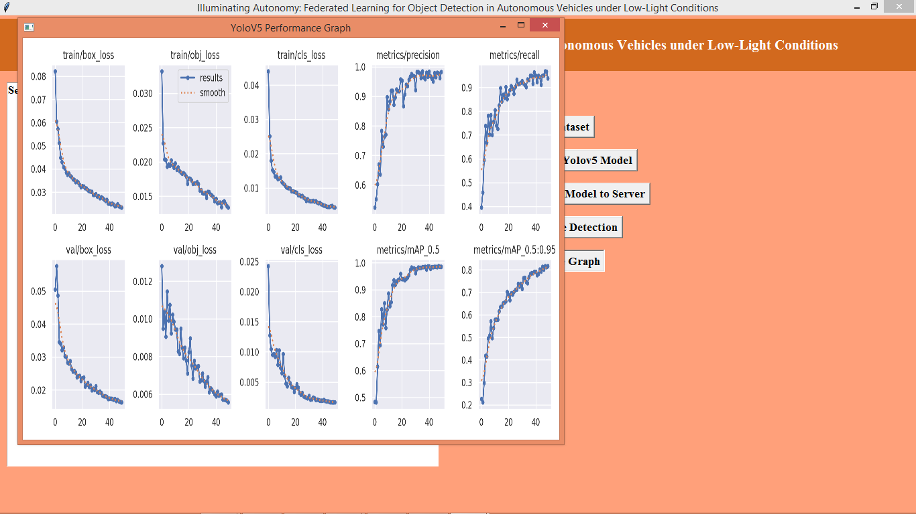
In above yolov5 graphs can see with each increasing epoch LOSS got decrease and precision, recall got increase.

