Normalization
Observe the structure of the given EMPLOYEE table below and suggest if this table can be further normalized.
EMPLOYEE (EMPNO, ENAME, SAL, DEPTNO, DNAME, LOC)
Explain what normal form this table is in and how you can make this into the next normal form.
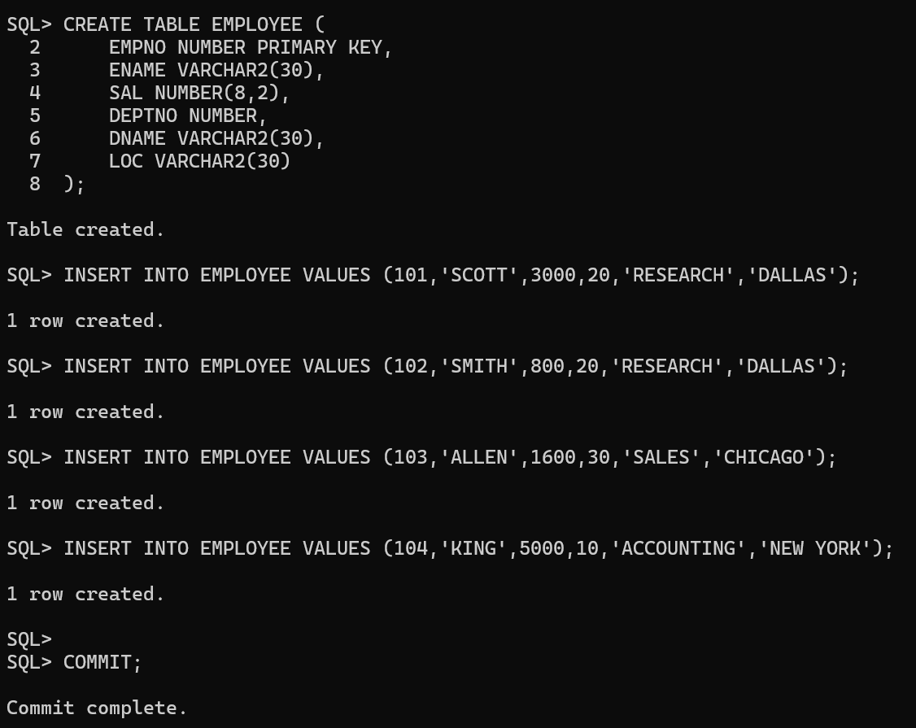
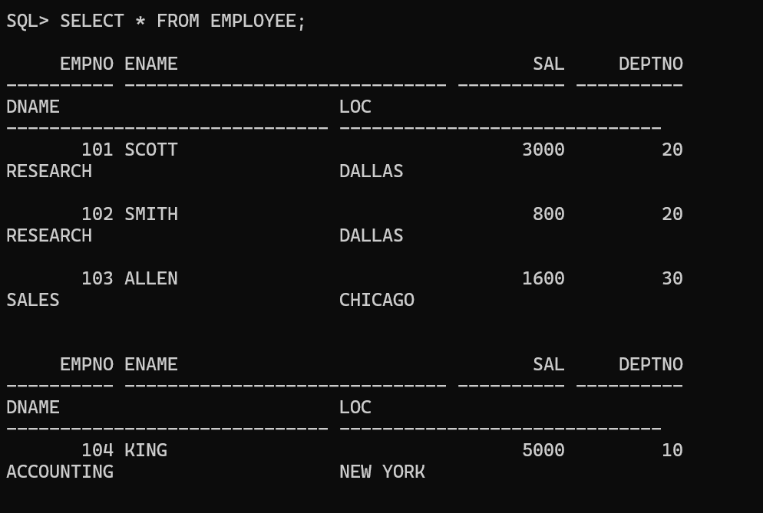

Normalized to 3NF
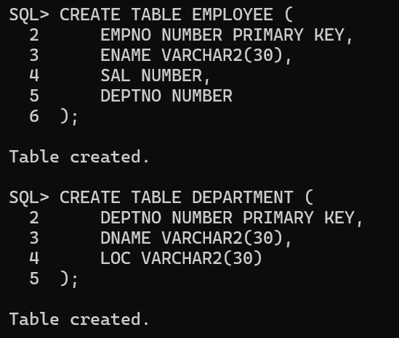

Observe the structure of the given STUDENT table below and suggest if this table can be further normalized.
STUDENT (ROLLNO, NAME, AGE, EXAM, MARKS, GRADE)
Explain what normal form this table is in and how you can make this into the next normal form.
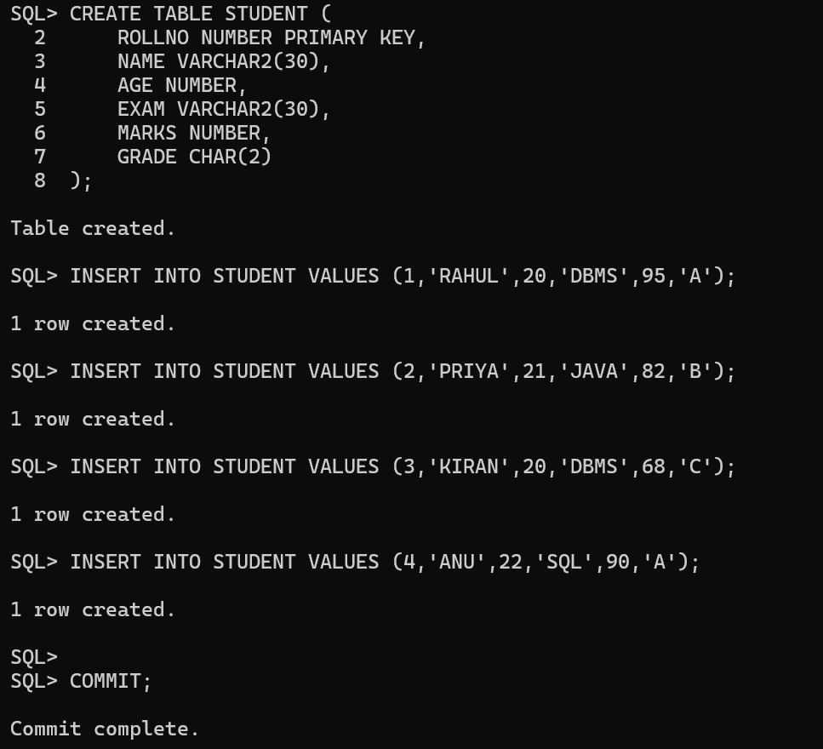

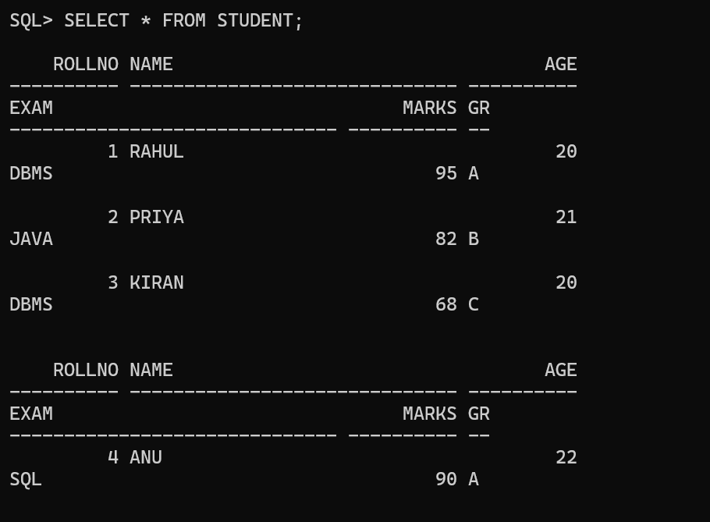

Normalized to 3NF
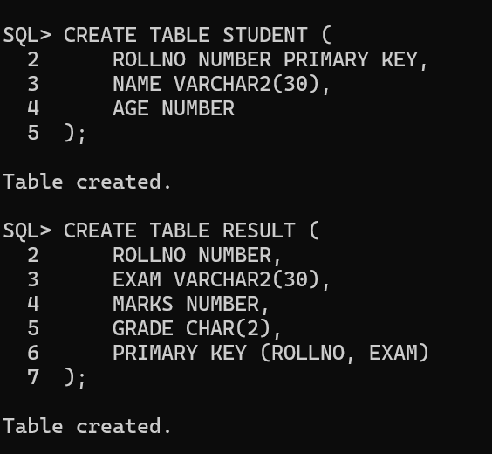

Observe the structure of the given EMPLOYEE table and suggest what kind of problem this table has and how to solve the problem.
EMPLOYEE (EMPNO, PROJECT_NO, NO_OF_DAYS, CUSTOMERNAME)
In the above table, EMPNO and PROJECT_NO together form a composite primary key. Explain what normalization issue exists and how to convert the table into the next normal form.
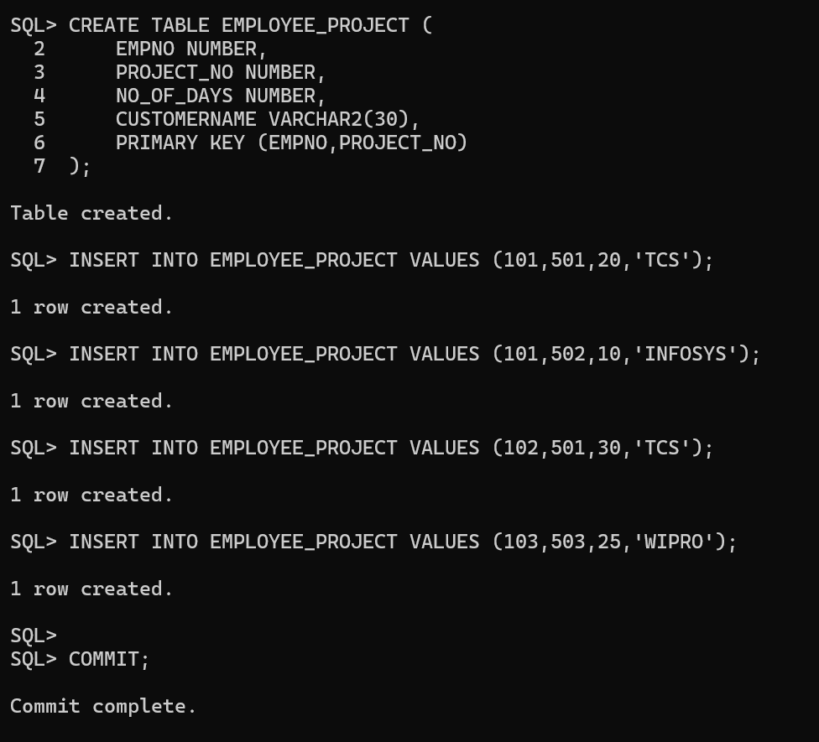

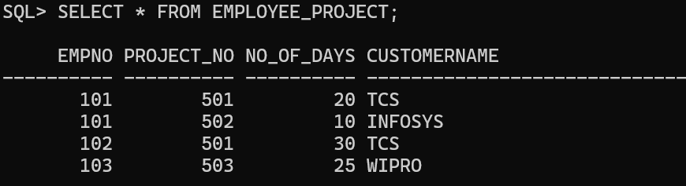

Convert to 2NF
