Name – Niraj Deepak Pawar

Roll no. - 106

Practical no. – 1

Title – Set up a GitHub account and send an email message to friend telling to your friend about the account.

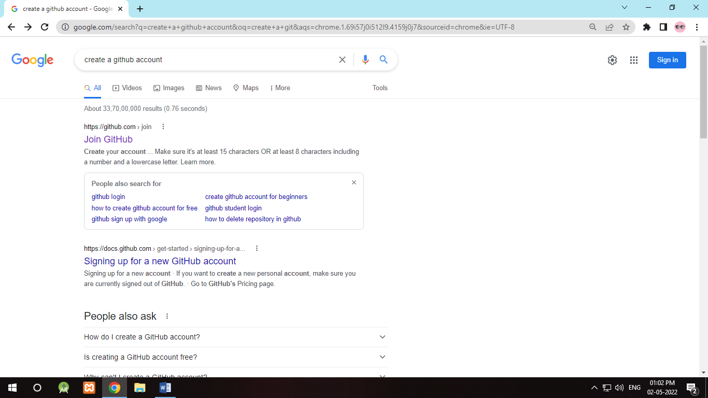

Screenshot 1 – Looking for official webpage of GitHub

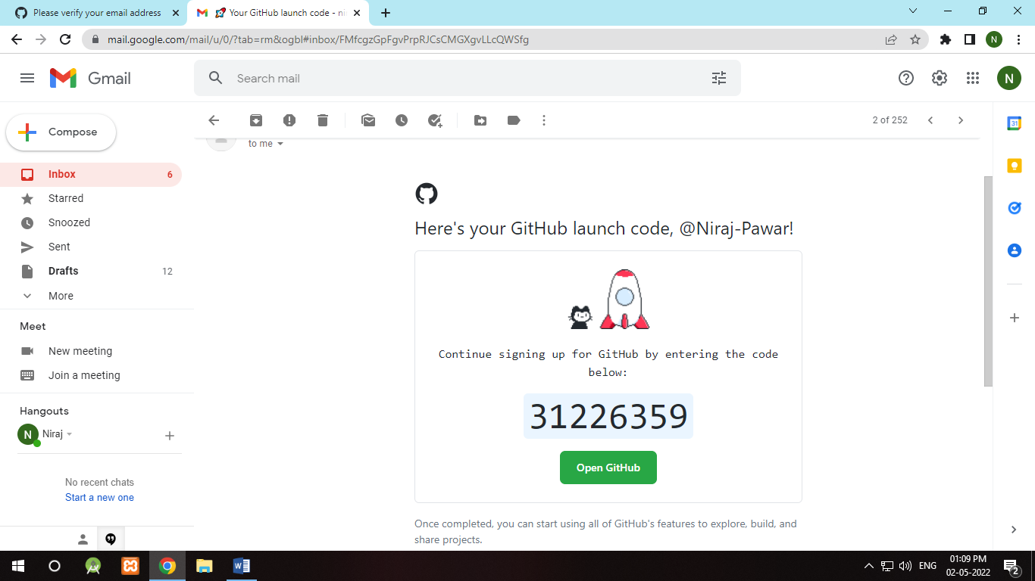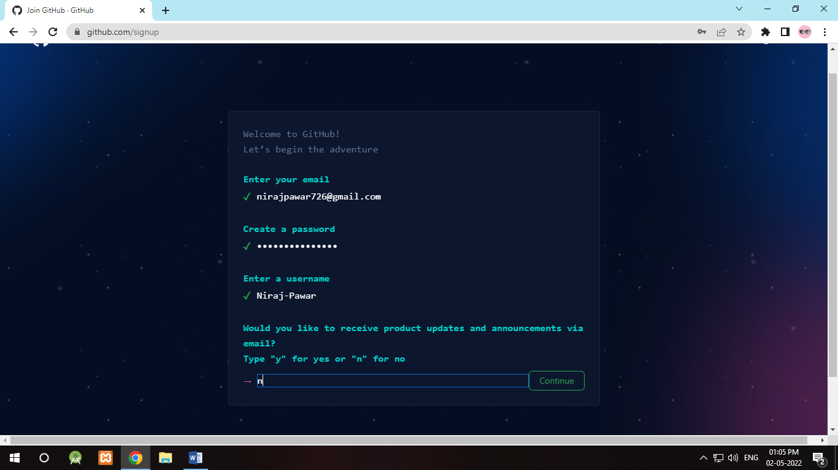

Screenshot 3 – Get an unlock code on registered mail

Screenshot 2 - Creating account on GitHub

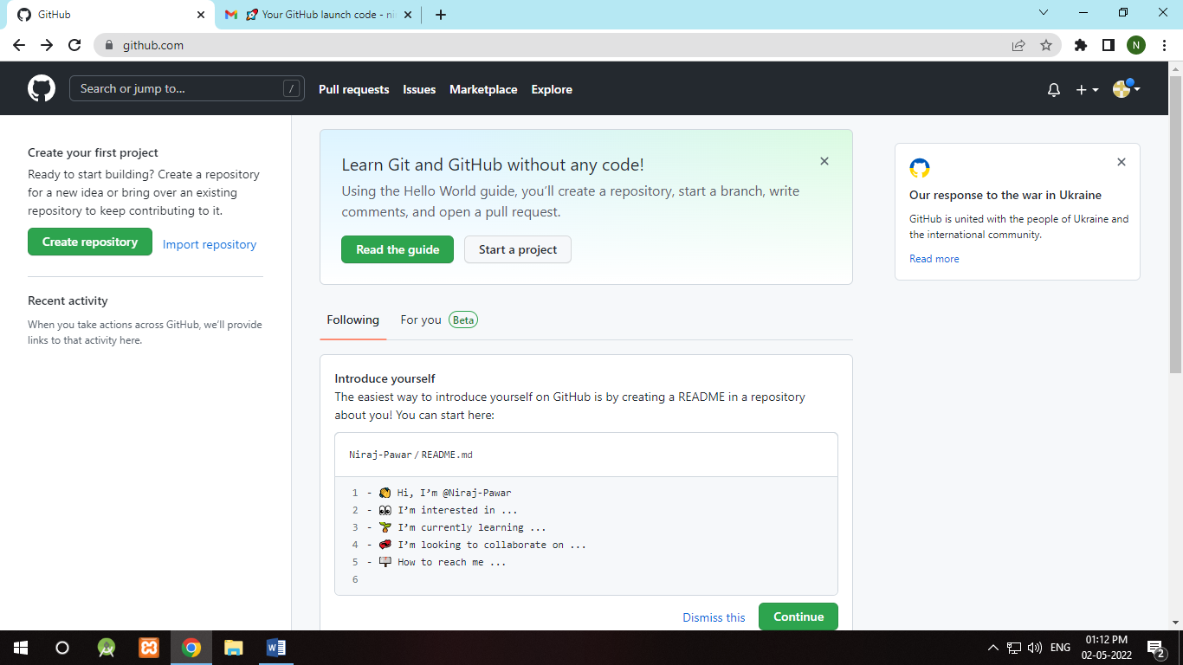

Screenshot 4 – Congratulations! Account has been created

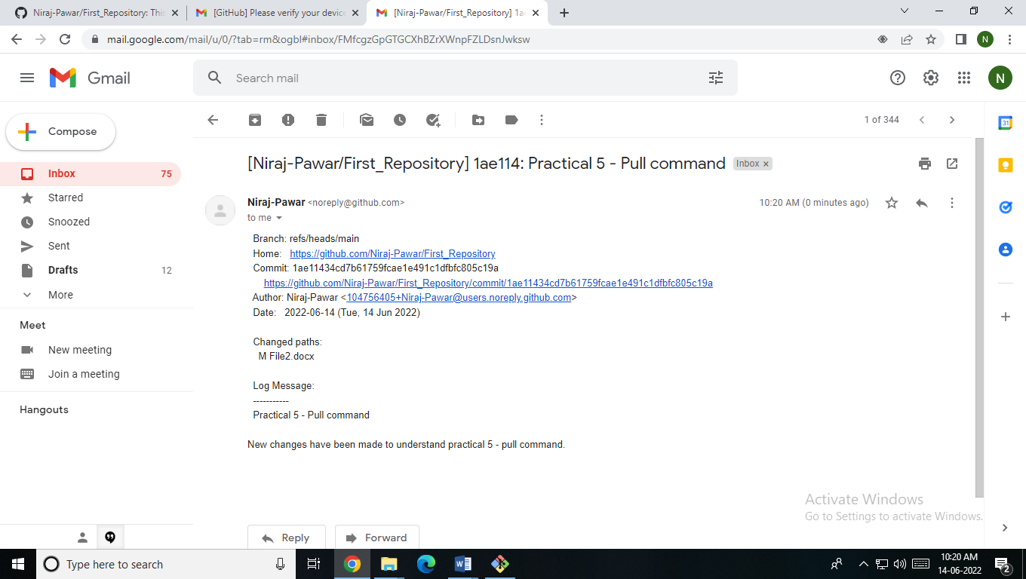

Screenshot 5 – A mail to notify yourself about the changes through GitHub