**

**CSIS 4175**

**Mobile Application ||**

**Winter 2025**

**Classwork 6**

**Popular Movies App**

**Student Name: Pukar Ojha**

**Student Id: 300392983**

**Instructor: Abbasi, Reza**

**Due Date: Feb 14th , 2025**  **Submission: Feb 14th, 2025**

**Note:**

I am confirming that I have completed this classwork assignment completely based on the requirements and it is working and fully functional.

Codes:

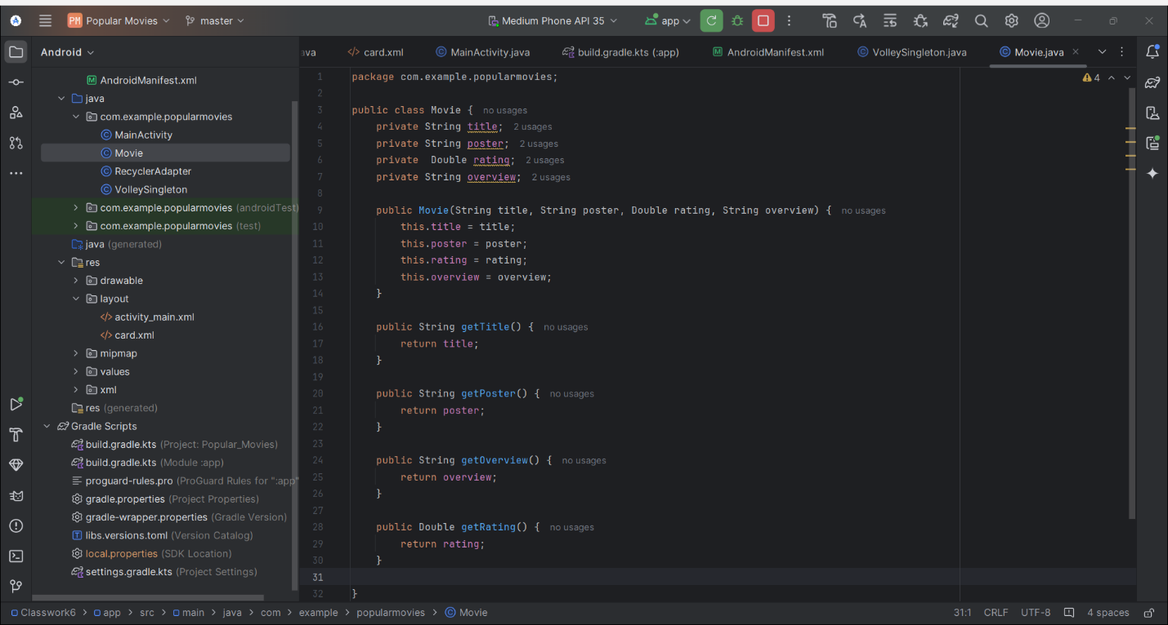

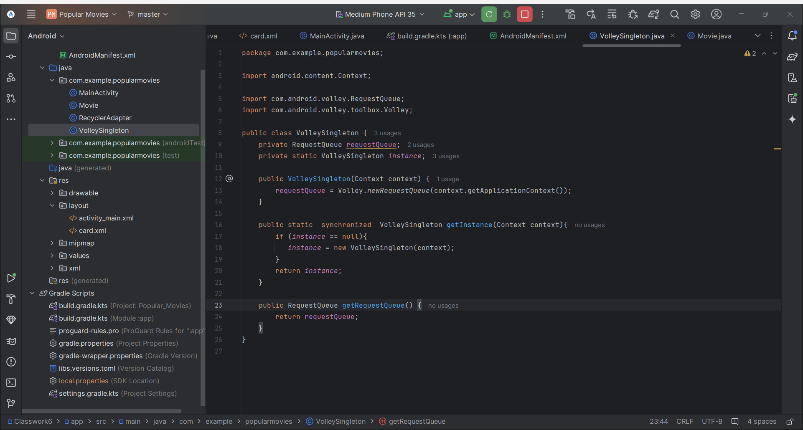

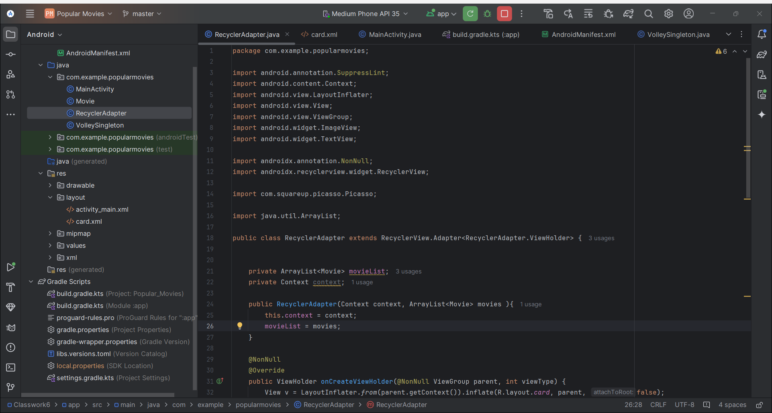

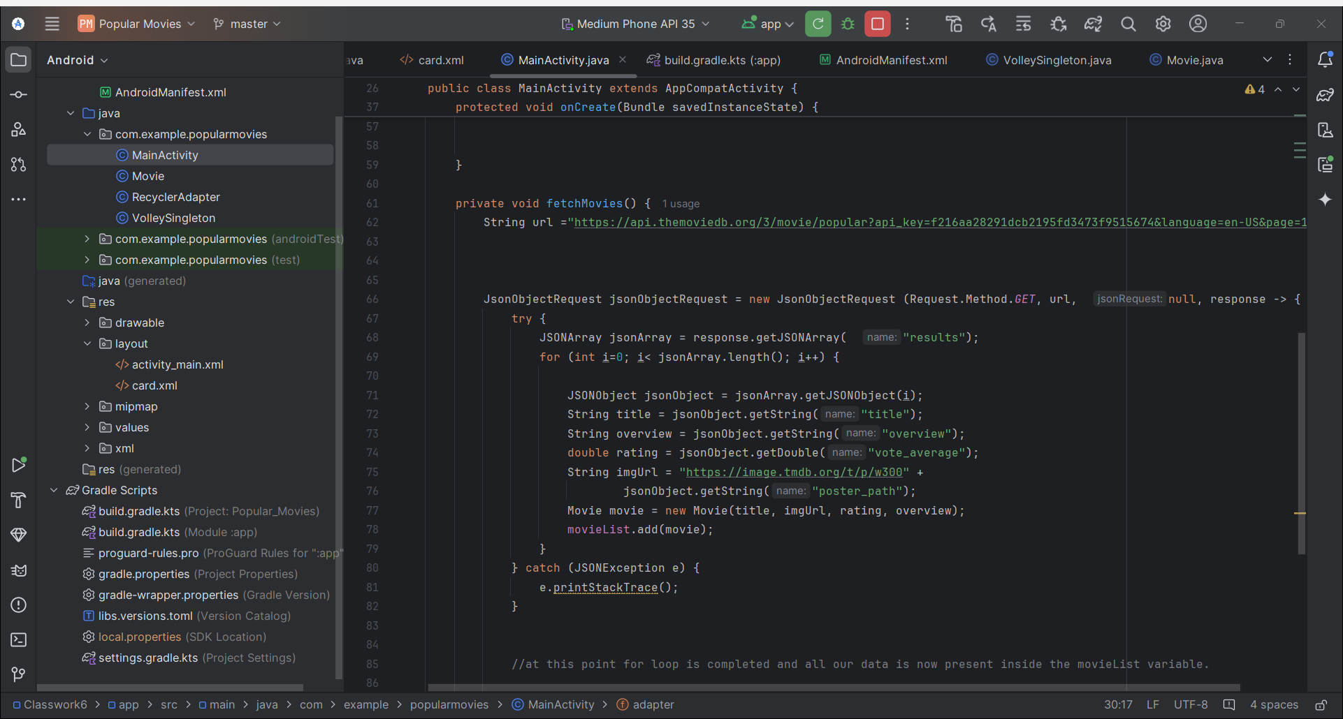

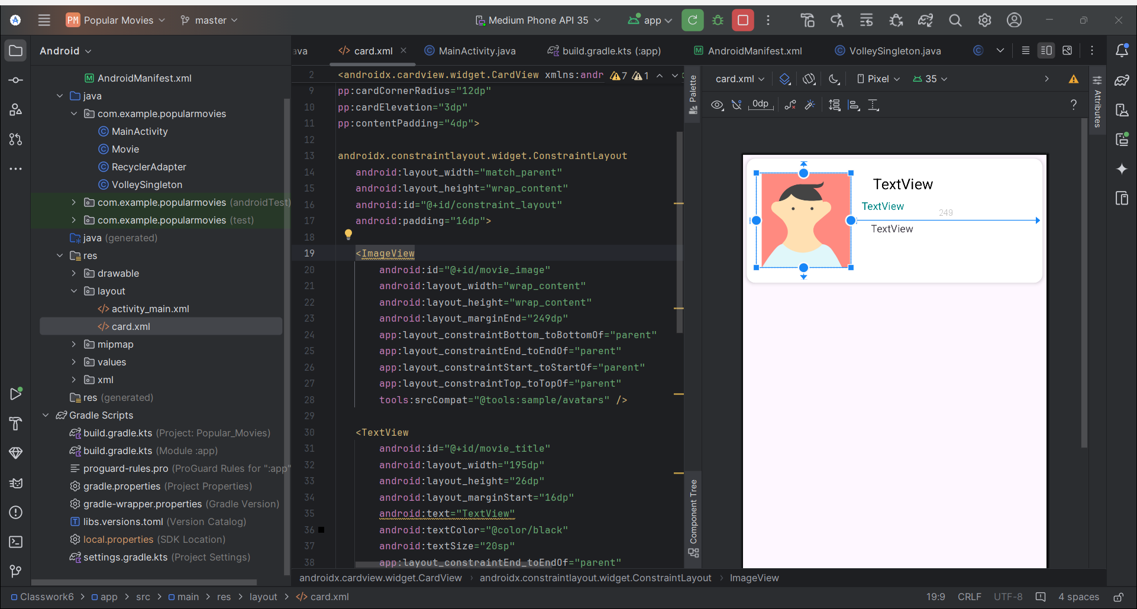

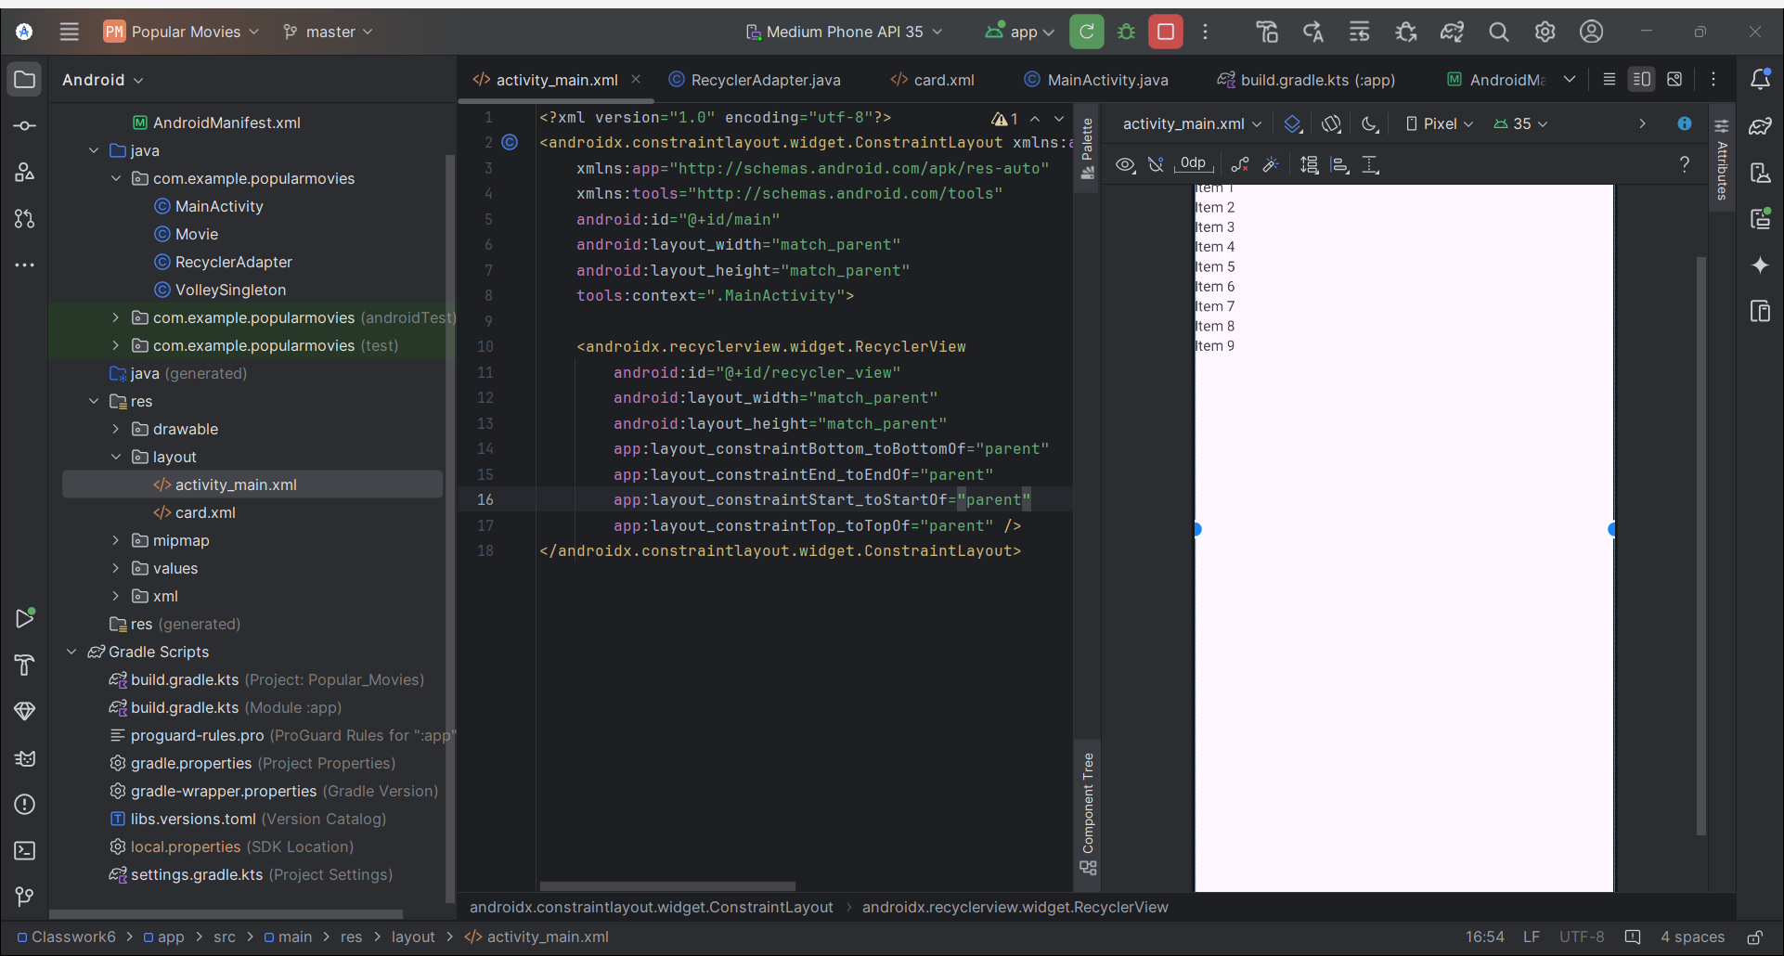

Output:

