**Sentimental Analysis of Social Media**

Kundan Malviya  
Student   
Department of AI&DSPrestige Institute of Engineering Management and Research

Pukhraj Garasiya  
Student   
Department of AI&DSPrestige Institute of Engineering Management and Research

Rohit Thakur  
Student   
Department of AI&DSPrestige Institute of Engineering Management and Research

Rohit Kumar  
Student   
Department of AI&DSPrestige Institute of Engineering Management and Research

Dr. Dipti Chauhan

Professor

Department of AI&DS Prestige Institute of Engineering Management and

Research

**Abstract**

***Social media platforms have become integral to modern communication, providing a vast and dynamic landscape for expressing opinions and emotions. Sentiment analysis, the automated extraction of sentiment from text, plays a crucial role in understanding the mood and opinions of social media users. This paper presents a comprehensive review and analysis of sentiment analysis techniques applied to social media data.***

***The study begins by exploring the unique challenges posed by social media text, including the use of informal language, abbreviations, emojis, and contextual nuances. Various natural language processing (NLP) and machine learning (ML) approaches are then examined, highlighting their strengths and limitations in capturing the complexity of sentiment in social media content.***

***Furthermore, the paper delves into the evolving nature of sentiment on social media platforms, considering factors such as temporal trends, user demographics, and cultural influences. The impact of social media sentiment on public opinion, brand perception, and crisis management is also discussed, emphasizing the practical implications of sentiment analysis in real-world scenarios.***

***Additionally, the paper investigates the ethical considerations surrounding sentiment analysis in the social media context, addressing issues such as privacy, bias, and the responsible use of user-generated content. The role of explainability and transparency in sentiment analysis models is explored to enhance the trustworthiness of automated systems.***

**Keyword-** Sentimental Analysis

**1. Introduction**

People make judgments about the world around them when they are living in the society. They make positive and negative attitudes about people, products, places and events. These types of attitudes can be considered as sentiments. Sentiment analysis is the study of automated techniques for extracting sentiments from written languages. Growth of social media has resulted in an explosion of publicly available, user generated text on the World Wide Web. These data and information can potentially be utilized to provide real-time insights into the sentiments of people [1]

Sentiment analysis of social media is a powerful computational technique that involves the use of natural language processing, text analysis, and computational linguistics to systematically identify, extract, quantify, and study subjective information from textual data. With the explosion of user-generated content on various social media platforms, sentiment analysis has become an invaluable tool for understanding and analyzing public opinion, attitudes, and emotions expressed by individuals or groups online.

By employing machine learning and deep learning algorithms, sentiment analysis can effectively categorize text into positive, negative, or neutral sentiment categories, enabling businesses, organizations, and researchers to gain valuable insights into customer preferences, public opinion, and brand perception. This process not only helps in understanding customer satisfaction and feedback but also aids in

monitoring brand reputation, conducting market research, and making data-driven

decisions for improved customer engagement and product development.

Moreover, sentiment analysis of social media has proven to be instrumental in monitoring and analyzing trends, public sentiment shifts, and emerging issues, thus

enabling proactive crisis management and timely response to potential PR challenges. By harnessing the power of sentiment analysis, companies can adapt their marketing strategies, tailor their products and services to meet customer needs, and enhance overall customer experience,

ultimately leading to improved brand loyalty and increased market competitiveness.

Overall, the application of sentiment analysis in social media has transformed the way businesses and researchers interpret and leverage vast amounts of textual data, enabling them to stay ahead of market trends, understand consumer behavior, and make informed decisions that drive business success and foster meaningful connections with their target audience.

**2. LITERATURE REVIEW**

This section illustrates other similar work related to analyzing sentiments. Most of these approaches analyse sentiments as positive and negative while some approaches are in research level and few more are commercially available.

2.1 Adobe Social Analytics

Adobe Social Analytics basically measures the impact of social media on businesses by understanding how conversations on social networks and online communities influence marketing performance. After capturing and understanding the conversations going on, it correlates the impact of those conversations with key business matrices such as revenue and brand value. Other than that it measures the interactions that businesses have with their customers in social media including how Facebook posts drive site visitors and purchase behaviours . Adobe Social Analytics uses a natural language processing algorithm to implement sentiment analysis.[11]

2.2 Brandwatch Sentiment Analysis

Brandwatch is also a sentiment analysis tool developed by a team of PhD qualifiers in the United Kingdom; this is also commercially available currently. Through this tool they are trying to access whether a sentiment is positive, negative or neutral.[12]

2.3 TweetFeel

TweetFeel is also a web tool that analyzes sentiments of the given input through the twitter social media. This gathers real time data on Twitter, about the search items and evaluates those tweets into positive and negative categories in real time. This uses machine learning based sentiment analysis which enables to get much clearer feeling about sentiments.

2.4 Social Mention

Social Mention is a social media search and analysis platform which analyses user sentiments through social media. This is

also an online tool that allows tracking what people are saying about a particular brand, product or topic in real time. This tool allows the user to define a time period in which to analyze user sentiments.[1]

2.5 Sentiment140

This is an online tool for analyzing sentiments of Twitter social network. This tool allows discovering the sentiment of a brand, product or topic on Twitter. This was created by three Computer Science graduate students at Stanford University and their main focus is analyzing the languages English and Spanish. Sentiment140 basically states whether the specified brand, product or topic is positive, negative or neutral.[13]

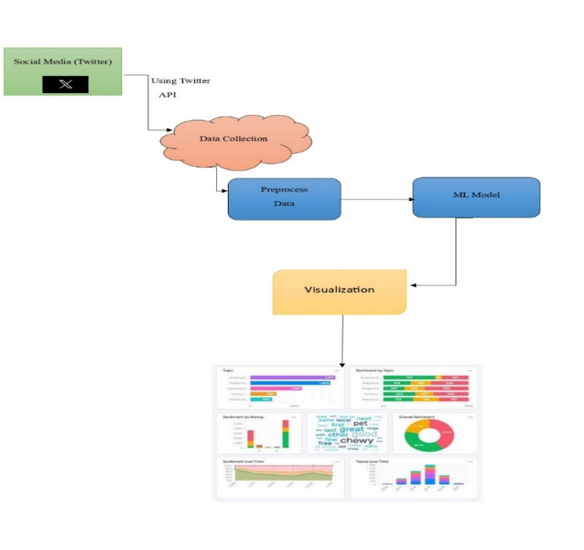**3. SYSTEM ARCHITECTUR**

Figure. 1

The flowchart provides an overview of the model's design, which is integrated into our website. When a user visits the website, they can analyze the retweets of various users. This analysis is leveraged to predict the potential future outcome of a product based on the reviews and sentiments expressed in those retweets.

**4. METHODOLOGY**

4.1. Data Collection:

Collect social media data from Twitter, including comments or tweets related to the product or topic of interest.

4.2. Data Preprocessing:

Clean and preprocess the collected data. This may involve removing irrelevant information, handling special characters, and tokenizing the text.

4.3. Sentiment Analysis:

Apply a pre-trained NLTK model for sentiment analysis. This model will classify the text into positive, negative, or neutral sentiments based on the content.

4.4. Visualization:

Visualize the sentiment analysis results. Categorize and present the comments as positive, negative, or neutral, allowing users to easily interpret the sentiment of each comment.

4.5. Website Integration:

Integrate the sentiment analysis tool into a website or web application, ensuring it is user-friendly and accessible to visitors.

4.6. User Interaction:

Enable users to interact with the integrated tool on the website. Users can input different comments or tweets for analysis.

**5. Experiment**

In this section, the results for the analysis of the collected tweets are discussed.

5.1 Results

We retrieved around 14000 tweets from dataset. We grouped the collected tweets to attributes (e.g. collected tweets are as “tweet”, “tweet-id”, Postivite tweets as “pos”, Negative tweets as “neg”, Neutral tweets as “neu” etc.). We have filtered out many tweets that include some of the search keywords in for example (e.g. 'https:','@','#','$','&' etc).

In the analysis of tweets, positive polarity score ranges from 0 to 1, negative polarity score ranges from 0 to -1 and the overall polarity score ranges from -1 to 1. Subjectivity in sentiment analysis is the amount of personal opinion in a text. It's a float value between 0 and 1, where 0 is objective and 1 is highly subjective. A higher subjectivity means the text contains more personal opinion than factual information.

Figure 2 In this section, we are retraving the tweets of specific user by there user name and analyz that tweets and display the visualization of screen.

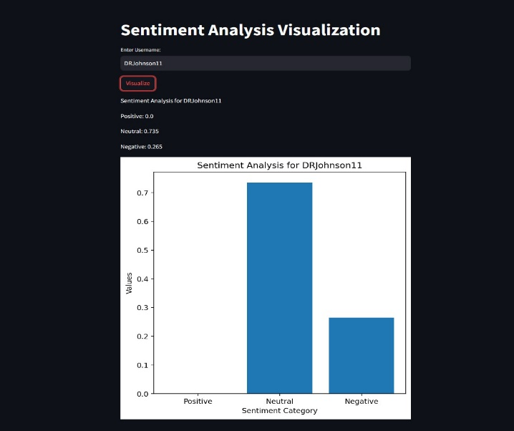

Figure. 2

Figure 3 In this section, we are analyzing the text and visualize polarity and subjectivity score.

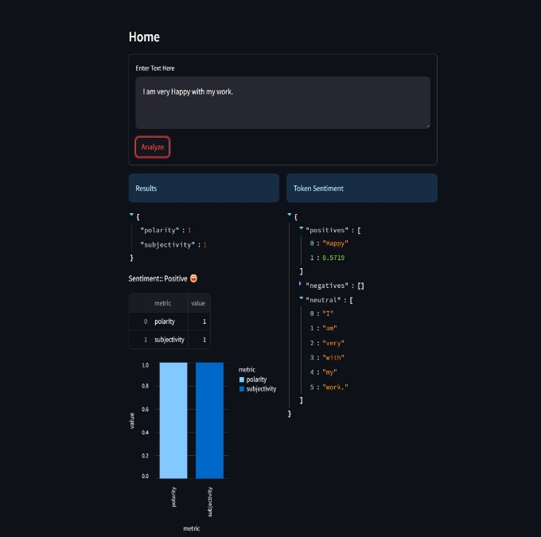

Figure. 3

**6. CONSTRAINTS AND PROBLEMS FACED**

5.1. Data Retrieval Issues: We encountered difficulties in fetching data through the Twitter API, mainly due to the evolving nature of Twitter's API versions. Different API versions come with varying functionalities and limitations, which at times posed challenges in retrieving comprehensive and up-to-date data.

5.2. Data Quality and Authenticity: Ensuring the quality and authenticity of the data used for training the model and for analysis proved to be a significant challenge. Social media platforms often contain a mix of genuine user reviews and content generated by bots or spam accounts. The presence of inauthentic reviews can significantly impact the model's accuracy, as it may inadvertently learn from biased or irrelevant data.

**7. CONCLUSION**

It is a very important fact to analyze how people think in different context about different things. This becomes more important when it comes to the business world because business is dependent on their customers and they always try to make products or services in order to fulfill customer requirements. So knowing what they want, what they think and talk about existing products, services and brands is more useful for businesses to make decisions such as identifying competitors and analyzing trends. Both because people express their ideas on social media and it can access those data, it has been enabled in some way to do the above mentioned things by using those data. The project, Sentiment Analysis for Social Media does that.

From the view at the top level of the project, we get data from social media sites to extract sentiments out of them and keep record of those sentiments with the information of the users who stated those sentiments in order to be used later. Finally it does data mining with the extracted sentiments so that it can be used in product profiling, trend analysis and forecasting.

After developing, the main challenge that was to be addressed was, how to decide whether a given sentence was positive or negative or neutral. The first thing that was found to address this challenge was a lexical data source which is called SentiWordNet, in that it has positive and negative score for each word. Though there are positive and negative scores for almost all words in English language, when it comes to sentences, it differs the overall polarity of a sentence with other words and according to the context. Other than that, it cannot analyze words with short terms which in returns reduce the accuracy and sometimes it makes the result incorrect. Moreover, it sometimes did not give correct polarity values for sentences which includes terms like ‘not good’, ‘not bad’.

During the implementation of the sentiment module we had to consider several issues such as, the comment by the user of a product or a brand can be not only in English but also mix with other language (Sinhala/Tamil), with emotional symbols etc., the comment may not completely match with what exactly user need to express about the product or brand, identifying the entity, identifying the relation of a particular comment with previous comments, ambiguity of words of the comment, human language is noisy and chaotic and the users may use different jargon or slang communications. But with the implementation machine learning techniques, it could achieve more accurate results after building classifiers training on large labeled data sets but still there are some issues of processing natural language.

Finally, using the sentiment scores for sentiments regarding particular product or service with the user’s information, it could successfully profile the products, analyze trends and forecasting. So, as overall, the system is capable of saying that how a set of people of a particular age range, a particular area with a particular profession think about a particular product or service and how it will change it the future which are most useful information when it comes to business world.

**8. REFERENCES**

1). David Osimo and Francesco Mureddu, "Research challenge on Opinion Mining and Sentiment Analysis"

2).Adobe® SocialAnalytics, powered by Omniture®.

3).Brandwatch.[Online].http://www.brandwatch.com/

4).Sentiment140.[Online]. http://www.sentiment140.com