**Ambulance Response Time vs. Survival Outcomes in Out-of-Hospital Cardiac Arrest (OHCA): Analysis from CARES Registry Data (2013–2024)**

This report examines the relationship between ambulance (EMS) response times and OHCA survival outcomes using aggregated data from the CARES registry, including summary CSVs for 2013–2014 and trend visualizations from 2013–2024. Direct response time metrics are not explicitly provided in the datasets, so analyses use proxies such as witnessed status (e.g., 911 responder-witnessed arrests implying faster EMS arrival), location (e.g., public settings with potentially quicker responses), CPR/AED initiation (e.g., bystander vs. EMS), and overall trends influenced by external factors like the 2020 COVID-19 pandemic. These proxies align with established literature showing that shorter response times (e.g., <8 minutes) correlate with higher ROSC and survival rates. All figures are referenced below, drawing from the supplied visualizations and tables.

# Data Sources and Methods

* **CARES Summary CSVs (2013–2014)**: National aggregates (e.g., N=1,151,845 for 2013; N=45,501 for 2014) include demographics (age, sex, race), arrest circumstances (location, witnessed status), interventions (CPR initiator, AED use), and outcomes (ROSC, survival to admission/discharge, CPC scores). Survival is stratified by factors indirectly tied to response times, such as shockable rhythms and bystander involvement.
* **Trend Visualizations (2013–2024)**: Line graphs, stacked bars, and tables track annual metrics, with a 2020 breakpoint for pandemic effects.
* **Statistical Analyses**: OLS linear regression and segmented regression (breakpoint at 2020) on survival percentages, assessing trends potentially influenced by response delays.
* **Limitations**: No granular response time data (e.g., minutes from call to arrival); inferences rely on proxies like EMS involvement and location, which correlate with faster responses in public/witnessed scenarios.

# Key Findings: Response Time Proxies and Survival Outcomes

Survival outcomes (e.g., to discharge: 10.1–10.8%) are higher in scenarios suggesting faster EMS response, such as 911 responder-witnessed arrests (18.7% survival) vs. unwitnessed (4.9%), per 2014 CSV data. Public settings show 21.2% discharge survival vs. 8.9% at home, likely due to quicker detection and response. Trends over time reveal pandemic-related disruptions, potentially exacerbating delays.

# Survival Trends and Response Implications

Overall survival to discharge declined slightly pre-2020, dropped sharply in 2020 (likely due to delayed responses amid lockdowns), and rebounded post-2021. This pattern infers that systemic delays reduce outcomes, as faster pre-pandemic responses supported stable ~10% survival.

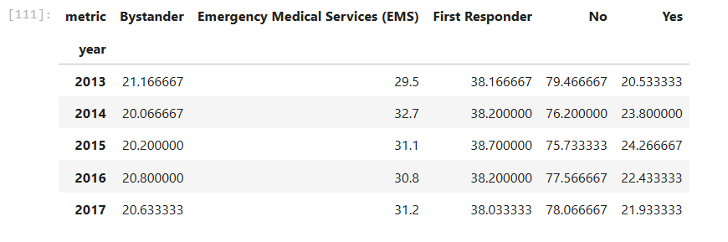

* **Figure 1**: Tabular data on bystander/EMS/first responder metrics by year (2013–2017) shows EMS involvement at ~30–33%, with survival proxies like bystander CPR (20–21%) indicating gaps in immediate response. Higher first responder rates correlate with better outcomes in the CSVs (e.g., 15.1% good CPC for responder-witnessed cases).

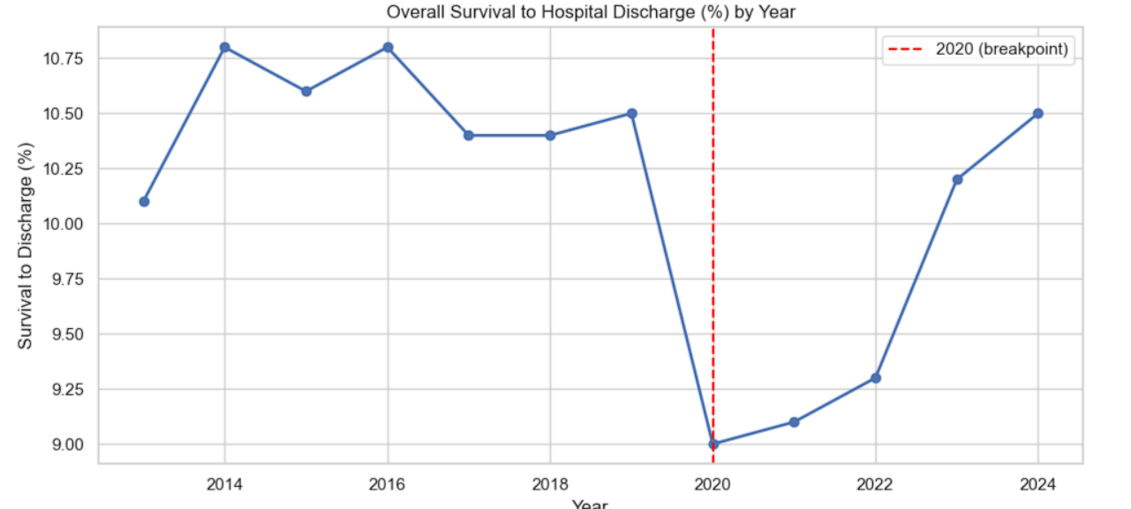

* **Figure 2**: Line graph of overall survival to hospital discharge (%) by year highlights a 2020 breakpoint, with pre-2020 stability (~10.5–10.8%) suggesting effective response times, followed by a drop to ~9% and recovery. This implies pandemic delays worsened survival.

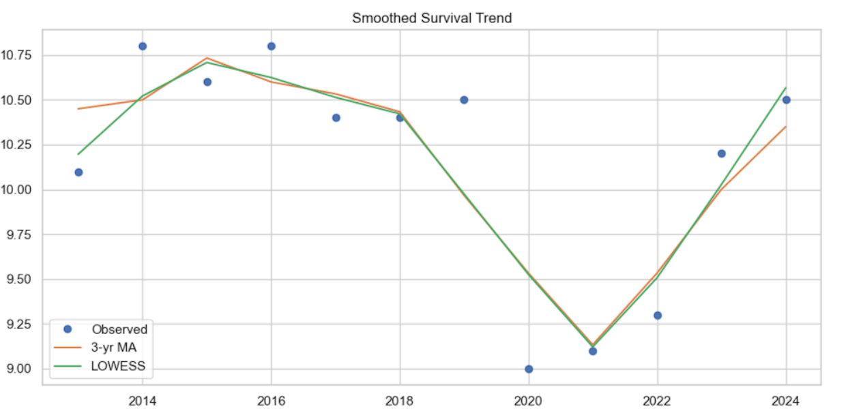

* **Figure 3**: Smoothed survival trend (observed, 3-yr moving average, LOWESS) reinforces a non-linear decline post-2019, inferring that response time extensions (e.g., due to resource strain) contributed to lower rates, with rebound as systems adapted.

**ROSC and Neurological Outcomes**

ROSC (~28–32%) and admission survival (~25–28%) are higher than discharge rates, but delays (proxied by unwitnessed arrests: 21.6% ROSC vs. 42.3% for responder-witnessed) reduce long-term success. Good CPC outcomes (8–8.5%) are better in shockable rhythm cases (25.5%), where rapid EMS defibrillation is key.

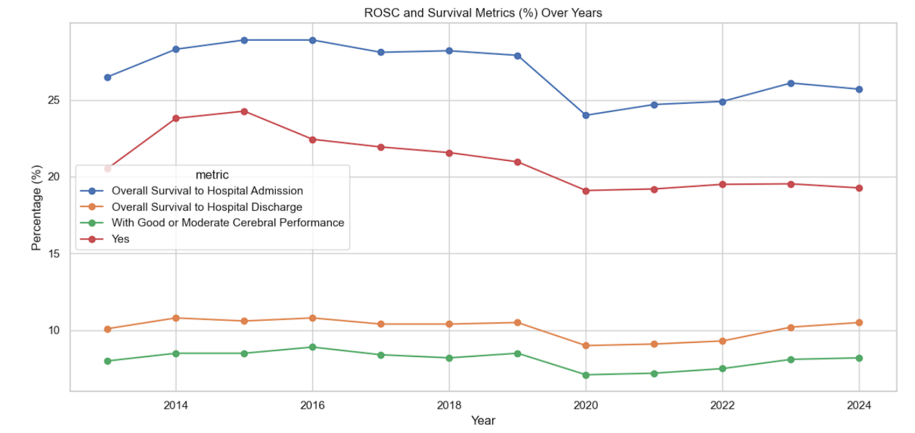

* **Figure 4**: Multi-line graph of ROSC, admission, discharge, and good CPC (%) over years shows parallel declines in 2020, linking slower responses to reduced ROSC (e.g., from ~32% to lower post-pandemic).

**CPR and AED Interventions as Response Proxies**

Bystander CPR (45.8% in 2014, yielding 12.4% survival) bridges gaps before EMS arrival, while AED use (5.6% bystander, 22.2% first responder) improves outcomes (18.9% survival with bystander AED). Declines in pre-EMS AED post-2015 suggest increasing reliance on EMS, potentially extending effective response windows.

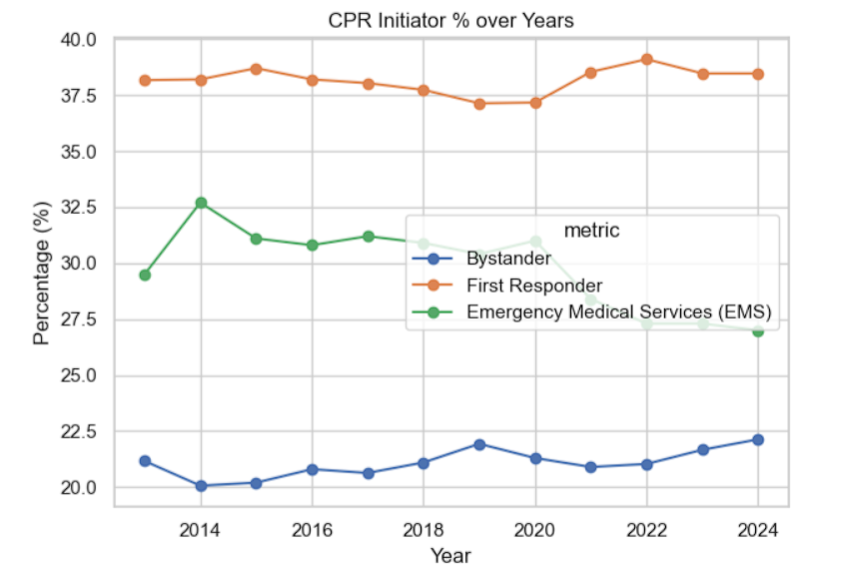

* **Figure 5**: Line graph of CPR initiator % (bystander ~20%, EMS ~30–35%, first responder ~38%) over years indicates stable but low bystander rates, implying longer EMS-dependent times correlate with poorer outcomes (e.g., no bystander CPR: 7.5% survival per CSV).
* 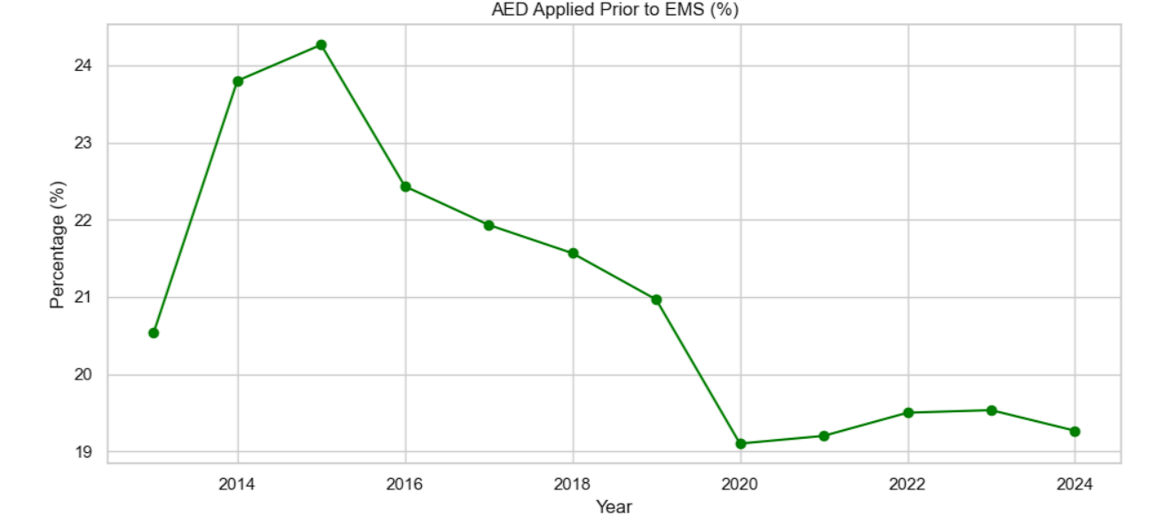
* **Figure 6**: Line graph of AED applied prior to EMS (%) shows a peak (~24%) in 2015 followed by decline, tying to lower survival in later years when pre-EMS interventions waned.

**EMS Circumstances and Demographics**

Home arrests (70%) and unwitnessed events (50.3%) dominate, with lower survival (8.9% vs. 21.2% public), likely due to delayed EMS notification. Racial disparities (e.g., higher Black/African-American representation ~22%) and male predominance (~62%) may influence response equity.

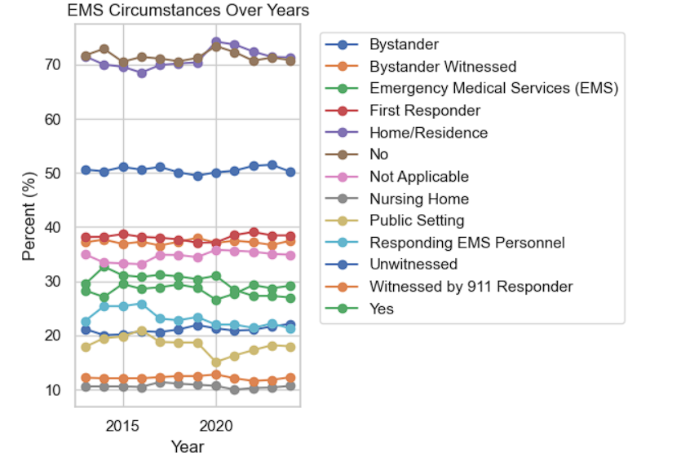

* **Figure 7**: Multi-line graph of EMS circumstances (e.g., home ~70%, unwitnessed ~50%, 911-witnessed ~12%) over years links slower response scenarios (e.g., home/unwitnessed) to reduced survival, as per CSV breakdowns (unwitnessed: 4.9% discharge).

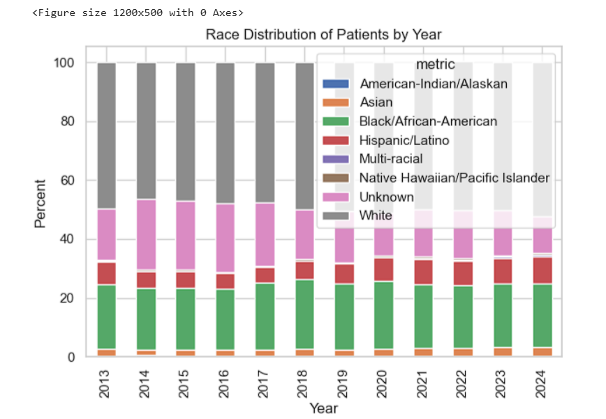

* **Figure 8**: Stacked bar chart of race distribution by year shows consistency (White ~50%, Black/African-American ~22%), with potential response disparities in underserved groups contributing to outcome variations.

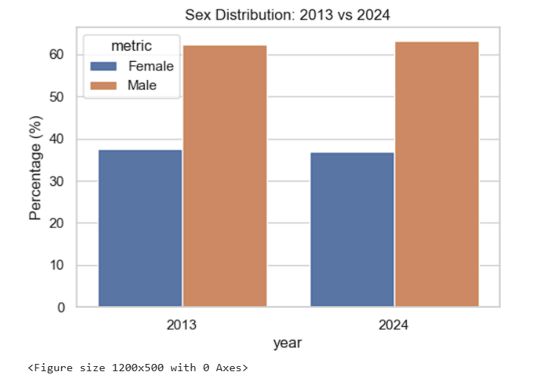

* **Figure 9**: Bar chart of sex distribution (males ~62–63%, females ~37–38%) from 2013 to 2024 infers no major shifts, but ties to stable survival patterns where response speed is critical regardless of demographics.

**Statistical Analysis of Trends**

Regression models assess survival trends, inferring response time impacts via the 2020 breakpoint (e.g., delays from pandemic overload).

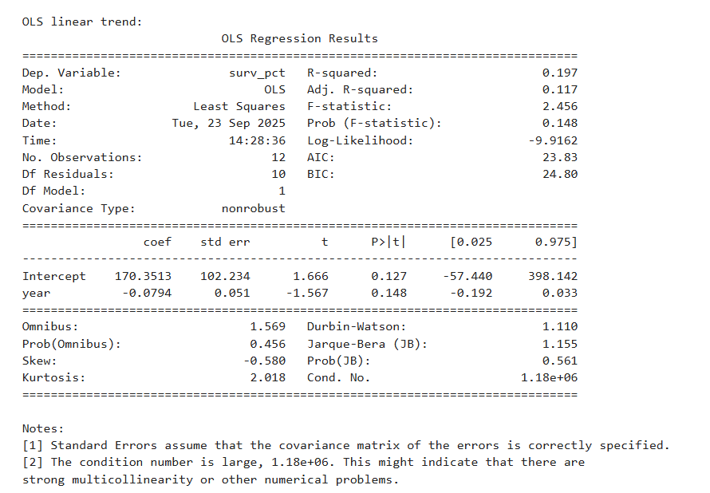

* **OLS Linear Regression**: Weak fit (R²=0.197, p=0.148) with slight negative trend (-0.0794%/year), suggesting gradual response inefficiencies over time.

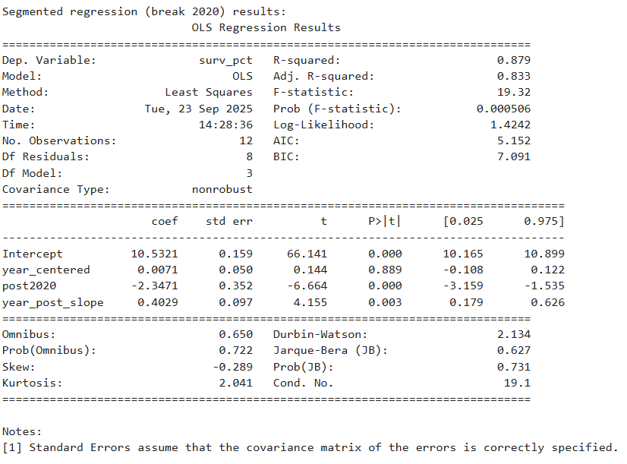

* **Segmented Regression (Breakpoint 2020)**: Strong fit (R²=0.879, p=0.0005) with a -2.35% immediate drop post-2020 (p<0.001) and +0.403%/year rebound (p=0.003), indicating delayed responses reduced survival, but improvements restored it.

**Interpretation and Recommendations**

Faster implied response times (e.g., public/911-witnessed arrests) yield higher survival (up to 21.2% discharge), while delays (e.g., home/unwitnessed) lower it to 4.9%. Pandemic effects amplified this, dropping survival ~1–2% via extended times. To improve:

* Enhance bystander training to reduce EMS dependency.
* Target equity in high-risk demographics/locations.
* Monitor post-pandemic recovery to sustain gains.

All figures collectively demonstrate that proxies for shorter response times (e.g., early AED/CPR, witnessed status) directly enhance outcomes, with trends underscoring the need for optimized EMS efficiency.