Does higher Level of Education reduces risk of developing Multiple Chronic Condition (MCC) – A Study
Pulak Debnath
Colorado State University – Global Campus
5th Oct, 2019
Does higher Level of Education reduces risk of developing Multiple Chronic Condition (MCC) – A Study

Background
Any condition which lasts for a year or more and needs ongoing treatment and/or limits daily activities is known as Chronic Conditions. This includes conditions such as diabetes, hypertension, heart disease, respiratory disease, arthritis, cancer, dementia, etc. Around half of the American populations suffer from chronic illness. The striking fact is that one in four Americans is actually suffering from multiple chronic conditions (MCCs). People with MCCs more often experience adverse drug effects, unnecessary hospitalization, conflicting medical advice, duplicative tests and poor health outcomes. The population with MCCs also adds substantial financial burden on the healthcare spending. 95% of the Medicare spending is consumed by the MCCs population, and two-third of it is accounted for people with more than five chronic illnesses.

Objective
The objective of this study is to find out if there is any correlation between level of education of a member and risk of development of multiple chronic illness (MCCs), i.e. if a person with higher level of education is at lower risk of developing MCCs and vice versa. If a correlation can be established, it could help the healthcare industry in few ways:
- The care network can assess the risk factor of a member of developing MCCs early enough to plan for future care and educate member of self-care.
- Early intervention to battel MCCs may reduce overall healthcare cost by reducing prescription medication cost, fewer provider visit and/or hospitalizations.
- Health Insurance cost can be adjusted according to the risk factor where level of education can be considered as a factor too.

Method
To conduct the study, I am going to follow the most part of a typical Data Analytics project lifecycle. In the discovery phase, I will conduct some research about Multiple Chronic Conditions to gain some knowledge about its characteristics. Next I am going to download the data from national database [US Department of Health & Human Services] and prepare for analysis. Finally, I will build few statistical models to draw the inference of my study. I will use SAS for this study.

Data Preparation:
For this study, I chose to use the Medical Expenditure Panel Survey data - MEPS HC-201: 2017 Full Year Consolidated Data File. Since, the level of education is the independent variable, I have filtered out all records where level of education data couldn’t be acquired. The following chronic conditions are considered for this study:
High Blood Pressure
Chronic and other Heart Disease
Angina
High Cholesterol
Diabetes
Arthritis
Asthma

The data has been classified by age group and by level of education for visualization purpose.

Hypothesis:
H₀: People with higher level of education do not have a lower risk of MCCs.
H₁: People with higher level of education have a lower risk of MCCs.

Data Visualization:
Execute the following SAS code to see the distribution of population with at least one chronic disease between the age groups.
SAS Code (1):
proc sgplot data=WORK.MCCDATA (WHERE=(CHRONIC_COUNT GT 0));
vbar AGEGROUP / group=CHRONIC_COUNT groupdisplay=stack datalabel stat=percent;
yaxis grid;
run;

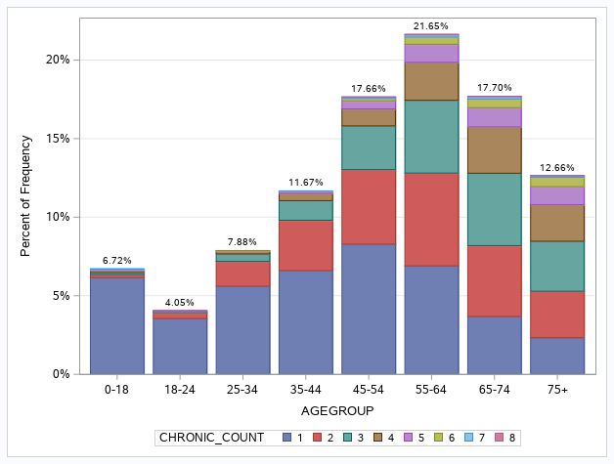
Figure-1: Distribution of Chronic Illness within Age Group

SAS Code (2):
proc sgplot data=WORK.MCCDATA (WHERE=(CHRONIC_COUNT GT 0));
vbar EDUCATION / group=CHRONIC_COUNT groupdisplay=stack datalabel stat=percent;
yaxis grid;
run;

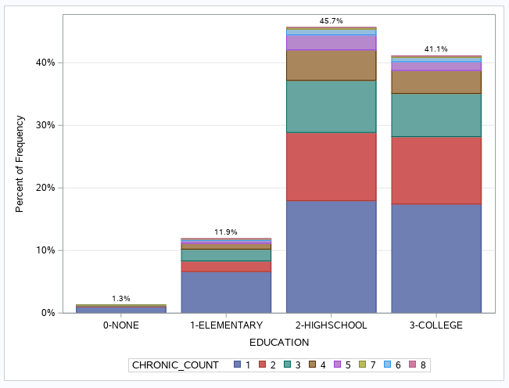
Figure-2: Distribution of Chronic Illness with Education Level

Model Preparation:
I have fitted a Logistic Regression Model where the dependent variable is IS_MCC and independent variables are taken as AGE17X (the age of member on 12/31/2017) and EDUCYR (years of education). Both independent variables are continuous variables.
SAS code (3):
proc logistic data=WORK.MCCDATA ;
model IS_MCC(event='1')=AGE17X EDUCYR / link=logit technique=fisher;
run;

The result following result shows that both Age and Education is a predictor of MCC.
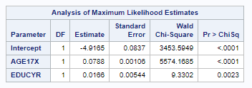
Figure-3: Logistics Regression Analysis – coefficient estimate
The Odds Ratio shows that the chances of IS_MCC=1, i.e. the chances of developing Multiple Chronic Conditions increases with the unit increase in Age and Education level.

Figure-4: Odds Ration of the independent variables
I have readjusted the SAS code to measure the goodness-of-fit.
SAS Code (4):
proc logistic data=WORK.MCCDATA;
model IS_MCC(event='1')=AGE17X EDUCYR / link=logit lackfit ctable
technique=fisher;
run;

The examining the Chi-square (high) and the corresponding p-value (very low) of the Hosmer and Lemeshow Test, it shows that the model doesn’t fit well.
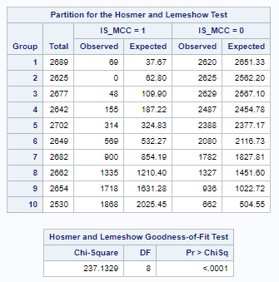
Figure-5: Result of Goodness-of-fir test of the model
Examining the ROC curve with AUC value of 0.8681 shows a relatively okay fit of the model.
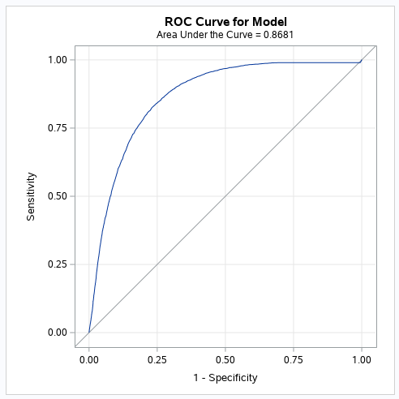
Figure-6: ROC Curve for the model

Result:
The test result is semi-encouraging. The logistics regression model which was developed, showed a mixed result. The fitted logistics regresion model returned coefficients for Age, Education and intercept with very low p-value, suggesting a good model. However the goodness-of-fit test showed low confidence on the model. On the other hand, the coefficient of education level turned out to be a positive value, and the Odd Ratio of 1.017 (which is greater than 0), tells us that the odds of developing MCCs will increase with the increase of level of education. This contradicts our hypothesis.

Conclusion
Using the visualization of the available survey data, it provided the impression that the null hypothesis (People with higher level of education do not have a lower risk of MCCs.) would fail. But, after conducting the statistical tests, it appears that the null hypothesis cannot be rejected. Even though the logistic regression model is not the best fit for the data, the ROC curve shows some confidence. Considering all evidences, it wouldn’t be very prudent to draw a conclusion as the model must be analyzed and corrected.
References
Benjamin, R. M. (2010). Multiple Chronic Conditions: A Public Health Challenge. Public Health Reports, 125(5), 626–627. https://doi.org/10.1177/003335491012500502
Mary L. Adams, Joseph Grandpre, David L. Katz, Douglas Shenson, Linear association between number of modifiable risk factors and multiple chronic conditions: Results from the Behavioral Risk Factor Surveillance System, Preventive Medicine, Volume 105, 2017, Pages 169-175, ISSN 0091-7435, https://doi.org/10.1016/j.ypmed.2017.09.013.

GitHub repository: https://github.com/PulakDebnath/CSUGlobal.git

