01.

CODE -

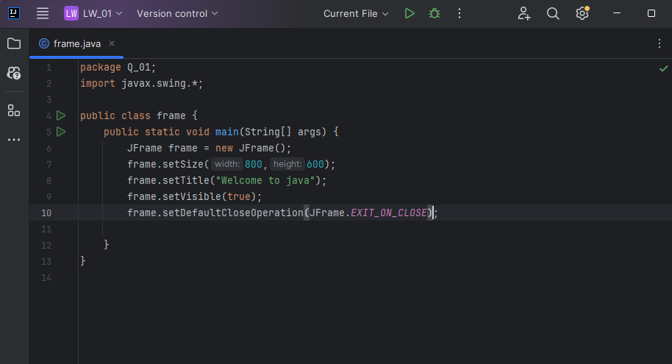

OUTPUT –

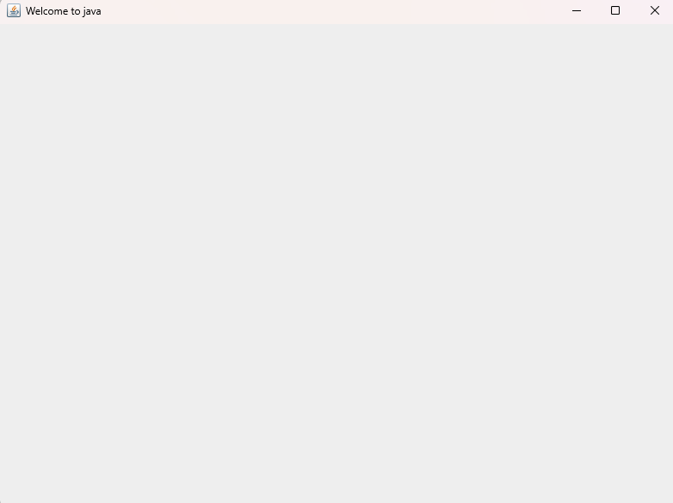

02.

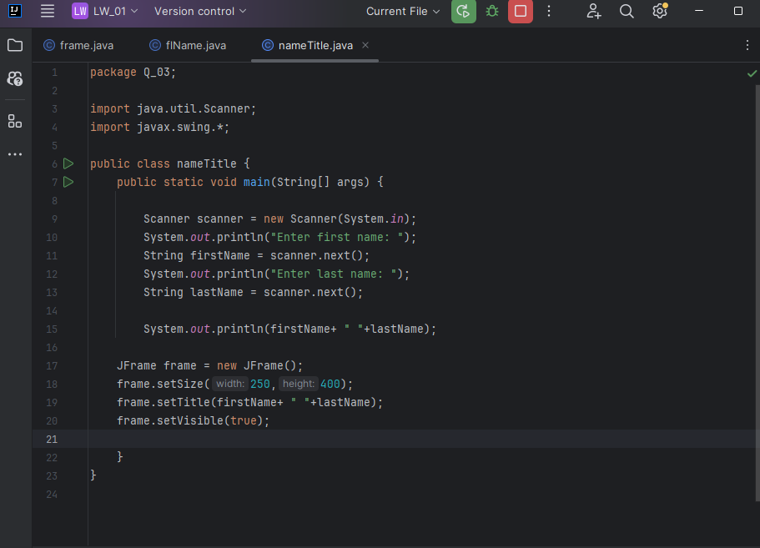CODE –

OUTPUT-

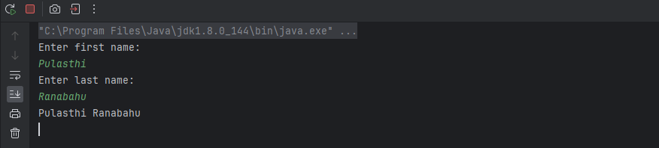

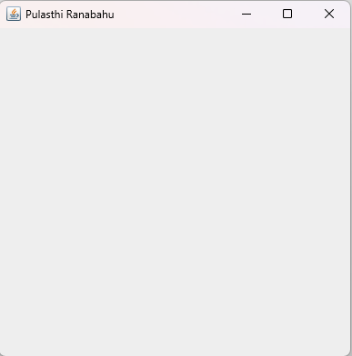

03.

CODE-

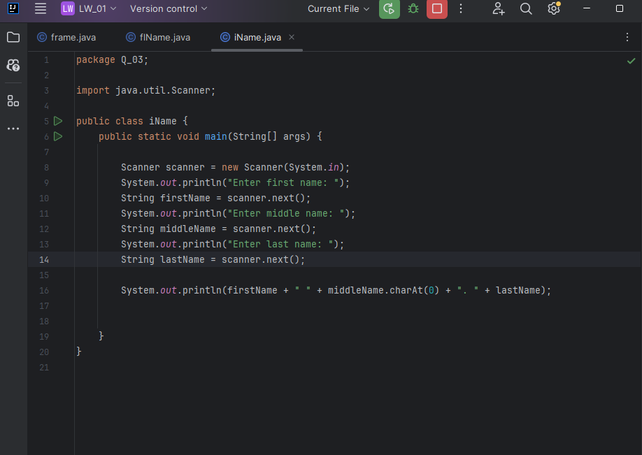

OUTPUT-

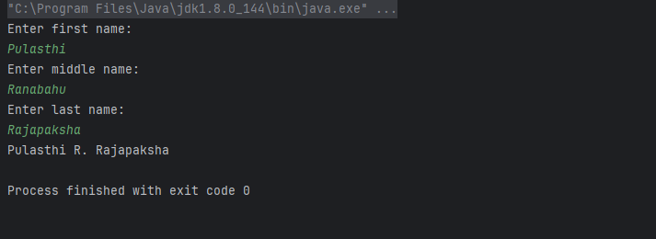

04.

CODE-

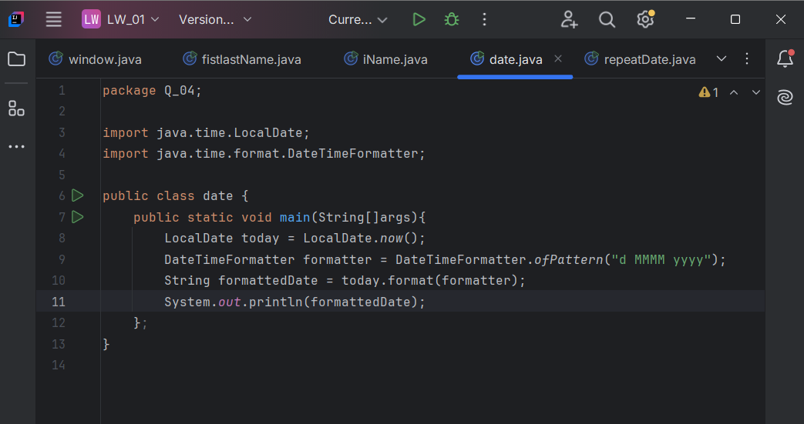

OUTPUT-

05.

CODE –

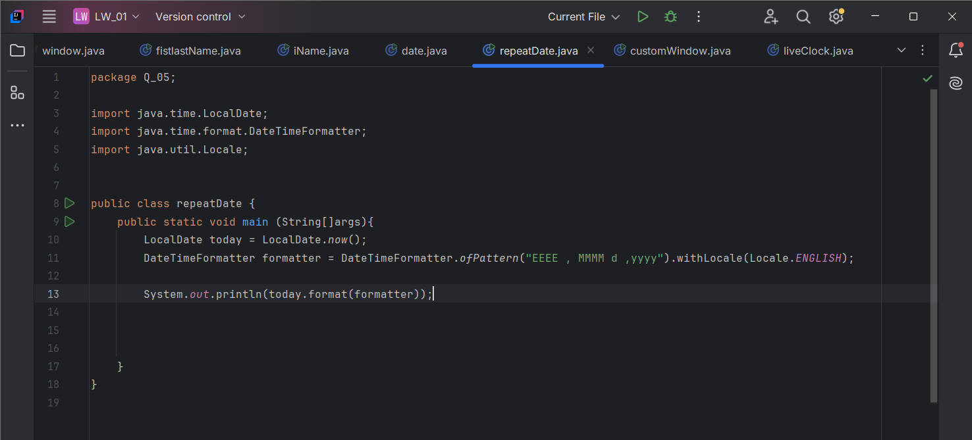

OUTPUT-

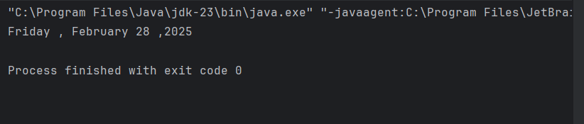

06.

CODE-

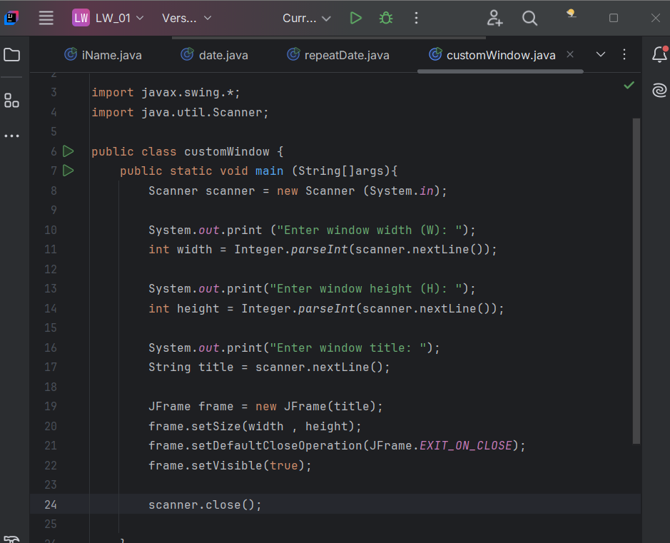

OUTPUT-

07.

CODE-

OUTPUT-

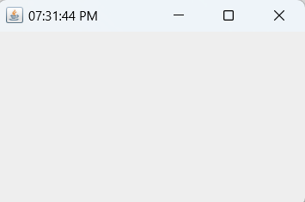

08.

CODE-

OUTPUT-

09.

CODE-

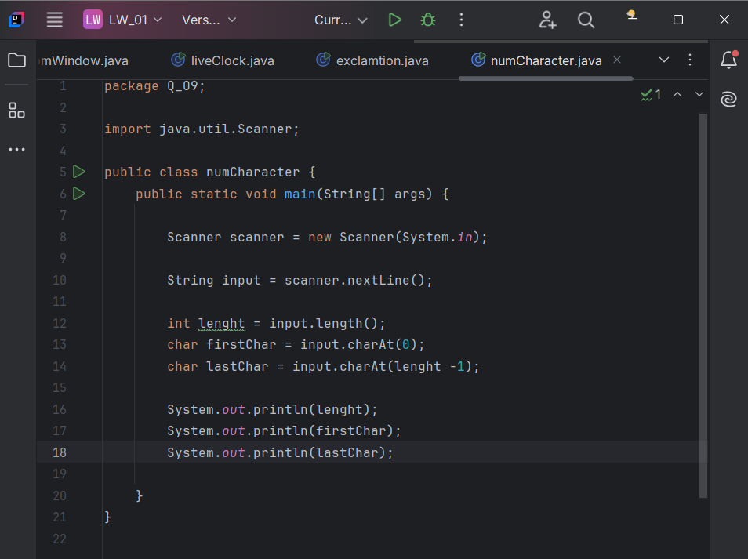

OUTPUT-

10.

CODE-

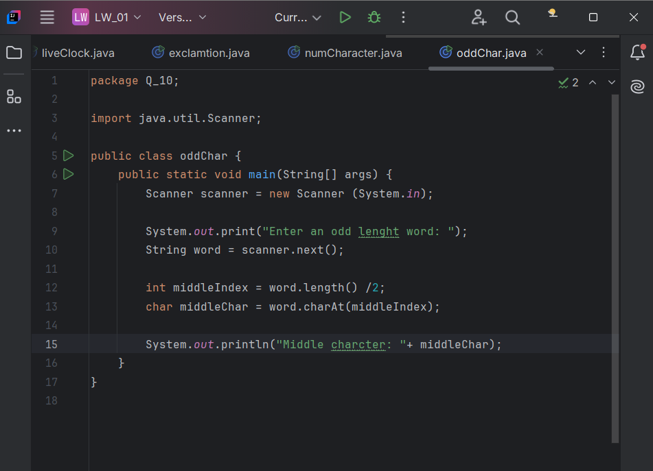

OUTPUT-

11.

CODE-

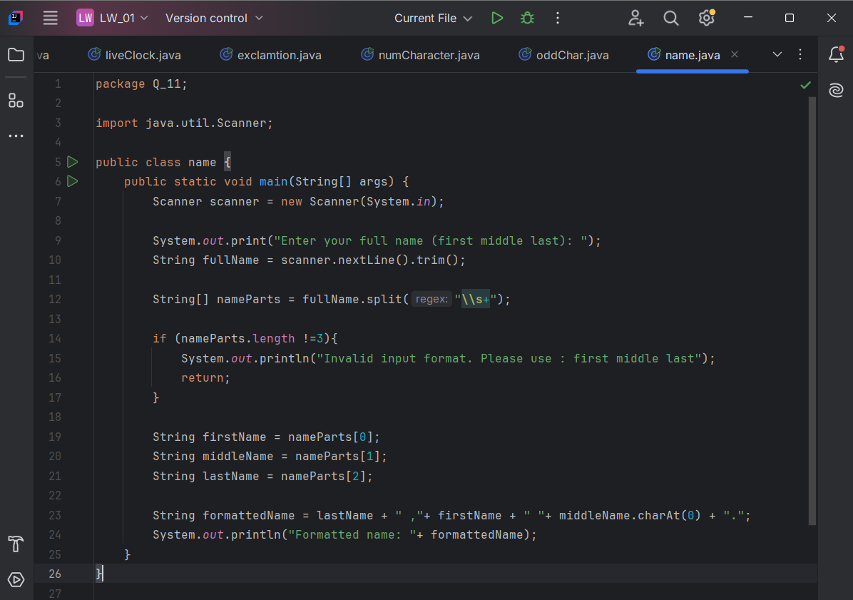

OUTPUT-

12.

CODE-

OUTPUT-

