**CREATING MULTI-COLORED LIGHT USING ARDUINO**

A Major Project Report Submitted   
In partial fulfillment of the requirements for the award of the degree of

## Bachelor of Technology

**in**

**Computer Science and Engineering**

**by**

## P. Manoj Kumar 21N31A05J9

## P. Yugeshwar 21N31A05J8

## N. Abhinav 21N31A05F7

Under the esteemed guidance of

**Mrs. R. Sujatha**

**Assistant Professor**



**Department of Computer Science and Engineering**

**Malla Reddy College of Engineering & Technology**

(Autonomous Institution- UGC, Govt. of India)

(Affiliated to JNTUH, Hyderabad, Approved by AICTE, NBA &NAAC with ‘A’ Grade)

Maisammaguda, Kompally, Dhulapally, Secunderabad – 500100  
website: www.mrcet.ac.in

2024-2025



**Malla Reddy College of Engineering & Technology**

(Autonomous Institution- UGC, Govt. of India)

(Affiliated to JNTUH, Hyderabad, Approved by AICTE, NBA &NAAC with ‘A’ Grade)

Maisammaguda, Kompally, Dhulapally, Secunderabad – 500100  
website: www.mrcet.ac.in

**CERTIFICATE**

This is to certify that this is the Bonafide record of the project entitled **“Creating multi-colored light using Arduino,”** submitted by **P. Manoj Kumar (21N31A05J9), P. Yugeshwar (21N31A05J8) and N. Abhinav (21N31A05F7)** of B. Tech in the partial fulfillment of the requirements for the degree of Bachelor of Technology in Computer Science and Engineering, Department of CSE during the year 2024-2025. The results embodied in this project report have not been submitted to any other university or institute for the award of any degree or diploma.

**Internal Guide Head of the Department**

**Mrs. R. Sujatha Dr. S. Shanthi**

**Assistant Professor Professor**

**External Examiner**

**DECLARATION**

## We hereby declare that the project titled “Creating multi-colored light using Arduino” submitted to Malla Reddy College of Engineering and Technology (UGC Autonomous), affiliated to Jawaharlal Nehru Technological University Hyderabad (JNTUH) for the award of the degree of Bachelor of Technology in Computer Science and Engineering is a result of original research carried-out in this thesis. It is further declared that the project report or any part thereof has not been previously submitted to any University or Institute for the award of degree or diploma.

**P. MANOJ KUMAR (21N31A05J9)**

**P. YUGESHWAR (21N31A05J8)**

**N. ABHINAV (21N31A05F7)**

# ACKNOWLEDGEMENT

We feel ourselves honored and privileged to place our warm salutation to our college Malla Reddy College of Engineering and Technology (UGC-Autonomous) and our Director **Dr. V. S. K Reddy** and our Principal **Dr. S. Srinivasa Rao,** who gave us the opportunity to have experience in engineering and profound technical knowledge.

We express our heartiest thanks to our Head of the Department **Dr. S. Shanthi** for encouraging us in every aspect of our project and helping us realize our full potential.

We would like to thank our internal guide and Project Coordinator **Ms. R. Sujatha** for her regular guidance and constant encouragement. We are extremely grateful to her valuable suggestions and unflinching co-operation throughout project work.

We would like to thank our class in charge **Ms. R. Sujatha** who despite being busy with his duties took time to guide and keep us on the correct path.

We would also like to thank all the supporting staff of the Department of CSE and all other departments who have been helpful directly or indirectly in making our project a success.

We are extremely grateful to our parents for their blessings and prayers for the completion of our project that gave us strength to do our project.

with regards and gratitude

## P. MANOJ KUMAR – 21N31A05J9

## P. YUGESHWAR – 21N31A05J8

## N. ABHINAV – 21N31A05F7

**ABSTRACT**

The project "Creating Multi-colored Lights using RGB LED and Arduino" explores the integration of micro-controller technology with RGB LED systems to produce a versatile and cost-effective lighting solution. By leveraging the Arduino platform, this project demonstrates how precise control of red, green, and blue light-emitting diodes can generate a vast spectrum of colors through additive color mixing. The Arduino microcontroller enables dynamic programming of LED behavior, including color transitions, intensity modulation, and interactive features, making it ideal for applications ranging from decorative lighting to educational demonstrations. Additionally, this project incorporates various lighting effects such as color gradients, breathing effects, strobe flashes, and dynamic chasing patterns to enhance visual appeal. Advanced features like a rainbow effect, disco mode with random color changes, and a fire flicker simulation add realism and creativity to the system. Furthermore, a user-input mode allows manual selection of colors via a keyboard, offering customization and interactivity. An additional feature allows users to view the color of a star based on its surface temperature using scientifically mapped RGB values.

Keywords: Arduino UNO Board, RGB LED, Demonstration, Arduino C++ Programming Language, Resistors and jumper wires.

**TABLE OF CONTENTS**

|  |  |  |
| --- | --- | --- |
| **S.NO** | **TITLE** | **PG.NO** |
| **1** | **INTRODUCTION**  1.1 Purpose, Aim And Objectives  1.2 Background Of Project  1.3 Scope Of Project  1.4 Modules Description | **01**  02  06  07  08 |
| **2** | **LITERATURE SURVEY** | **11** |
| **3** | **SYSTEM ANALYSIS**  3.1 Hardware And Software Requirements  3.2 Software Requirement Specification | **13**  13  13 |
| **4** | **TECHNOLOGIES USED**  4.1 Arduino UNO  4.2 Common Anode RGB LED  4.3 Serial Communication (UART)  4.4 Arduino IDE  4.5 C++ Programming Language | **18**  18  19  20  21  21 |
| **5** | **SYSTEM DESIGN & UML DIAGRAMS**  5.1 Software Design  5.2 Architecture  5.3 UML Diagrams | **23**  23  24  25 |
| **6** | **IMPLEMENTATION**  6.1 Sample Code  6.2 Output Screens | **30**  30  39 |
| **7** | **CONCLUSION & FUTURE SCOPE** | **42** |
| **8** | **BIBLIOGRAPHY** | **44** |

**LIST OF FIGURES**

|  |  |  |
| --- | --- | --- |
| **FIGURE.NO** | **NAME** | **PG.NO** |
| **5.2** | **System Architecture** | **24** |
| **5.3.1** | **Data Flow Diagram** | **26** |
| **5.3.2** | **Use Case Diagram** | **27** |
| **5.3.3** | **Class Diagram** | **28** |
| **5.3.4** | **Sequence Diagram** | **29** |
| **6.2.1** | **RED Light LED** | **39** |
| **6.2.2** | **GREEN Light LED** | **40** |
| **6.2.3** | **BLUE Light LED** | **41** |

# INTRODUCTION

Lighting has always played a crucial role in both aesthetics and functionality, and with modern technology, it has become more interactive and customizable. The "Multi-Colored Light Using Arduino" project explores the use of RGB LEDs controlled by an Arduino microcontroller to create dynamic lighting effects. By adjusting the intensity of the red, green, and blue components, this project can generate a vast spectrum of colors. The ability to program lighting patterns makes it ideal for various applications such as home automation, decorative lighting, mood lighting, and interactive installations.

At the heart of this project is the Arduino board, which processes programmed instructions to control the RGB LED. The interactive elements like sensors, buttons, or mobile app integration can be incorporated to enhance the project, making it more versatile and engaging. For instance, users can create a breathing light effect, strobe lights, or even sound-reactive lighting based on external inputs.

This project is a fantastic opportunity for beginners to gain hands-on experience with electronics, circuit design, and programming. By experimenting with different color patterns and effects, users can develop a deeper understanding of microcontroller-based control systems. Whether for learning, innovation, or simply creating visually appealing lighting, this project serves as a foundation for exploring more advanced smart lighting solutions.

An additional feature integrated into the RGB LED control code is the "temperature to star color" mode, which allows users to visualize the color of a star based on its surface temperature in Kelvin. By inputting a temperature value through the Serial Monitor, the program determines the corresponding spectral class of the star—ranging from cool red stars (Class M) to hot blue stars (Class O)—and adjusts the RGB LED to display the appropriate color. This feature not only adds an educational aspect to the project by linking astrophysics with electronics, but also enhances the interactivity and versatility of the LED system, making it a fun and informative tool for learning about stellar classifications.

## PURPOSE, AIM AND OBJECTIVES

The purpose of this project is to provide a flexible and customizable RGB LED lighting system that can be controlled via Arduino. By allowing users to manipulate the color and lighting effects, the system serves as an engaging visual tool for various applications, including home decoration, entertainment setups, and creative projects. The system’s ability to implement dynamic effects such as color transitions, strobe patterns, and user-defined color inputs ensures that it can be adapted to a wide range of environments and user preferences.

Another key purpose of the project is to integrate scientific education with interactive lighting. By enabling users to input the surface temperature of a star, the system can visually represent star colors based on their classification, creating an educational tool for understanding stellar temperatures and classifications. This scientific application not only enhances the functionality of the RGB LED system but also bridges the gap between technology and learning, providing users with a practical demonstration of scientific concepts in an intuitive and visually appealing way.

**AIM**

The aim of this project is to develop an interactive and dynamic RGB LED lighting system controlled by an Arduino. The primary goal is to create a versatile lighting solution that offers a wide range of colors and lighting effects, including color gradients, strobe lights, breathing effects, and more. By using a common anode RGB LED and Arduino, the system allows users to customize their lighting experience through a simple interface, enabling both predefined and user-defined modes.

Additionally, the project aims to incorporate innovative features like star temperature visualization, where the system can display colors corresponding to the surface temperature of stars based on their spectral class. This feature adds a scientific dimension to the project, demonstrating the relationship between temperature and color in a visually appealing way.

**OBJECTIVES**

1. **Color Control and Mixing**

The first objective of the project is to develop precise control over the color output of the RGB LED by manipulating the intensity of the individual red, green, and blue channels. This allows the system to produce a wide spectrum of colors by adjusting the brightness levels of each LED color. By varying these intensities, users can create any desired color, enabling custom ambient lighting for various applications. The implementation of PWM (Pulse Width Modulation) for each color channel ensures smooth transitions and accurate color mixing, providing vivid and customizable lighting effects.

1. **Dynamic Lighting Effects**

Another key objective is to design and implement dynamic lighting effects, which enhance the visual appeal and interactivity of the RGB LED system. These effects include color transitions, fading, flashing lights, and predefined patterns like rainbow cycles, strobe lights, and chasing sequences. Each effect is programmed to offer different lighting behaviors, such as smooth color gradients, rhythmic flashing, or moving light patterns. These dynamic effects will be user-controlled, allowing users to switch between them easily, creating an engaging and vibrant visual experience suitable for various environments.

1. **User Interaction**

A major focus of the project is user interactivity, ensuring that users can easily modify the lighting system to their preferences. This involves providing multiple input options for users to control the system, including serial input via a connected computer, buttons, sensors, or even mobile applications.

1. **Microcontroller Programming**

The heart of the project lies in the development of the Arduino code that automates the control and behavior of the RGB LED system. The programming involves controlling the timing, intensity, and color transitions to create the desired effects. The code must be optimized for the limited resources available in microcontrollers, ensuring that the system runs efficiently and without lag. By utilizing simple control structures, modular functions for different lighting effects, and direct manipulation of hardware components, the program automates lighting transitions and enables seamless user control.

1. **Power Efficiency**

An essential aspect of this project is optimizing the design for power efficiency while maintaining bright and vibrant lighting effects. Since RGB LEDs consume a significant amount of power, especially when running multiple colors at high intensities, it is critical to implement energy-efficient coding practices. The system must be designed to minimize energy usage, ensuring that the lighting remains sustainable for long periods. This can be achieved by incorporating low-power states, adjusting brightness levels when needed, and utilizing efficient PWM control to manage the LED’s power consumption without compromising on visual quality.

1. **Application in Smart Systems**

As part of the future scope, this project aims to explore the integration of the RGB LED system into smart systems such as home automation, lighting control systems, or interactive environments. The goal is to expand the system’s functionality by enabling remote control via mobile apps, voice assistants, or integration with IoT devices. Such integration will allow users to automate lighting patterns based on time, environmental factors (like temperature or ambient light), or user-specific preferences, making the system adaptable for smart homes, offices, or entertainment setups.

1. **Scientific Visualization**

A novel objective of this project is to use the RGB LED system for scientific visualization, particularly in demonstrating stellar classification based on the surface temperature of stars. The system will allow users to input the temperature of a star (in Kelvin), and the RGB LED will display the corresponding color based on the star's spectral class (e.g., blue for hot stars and red for cooler stars).

## BACKGROUND OF PROJECT

Lighting plays a crucial role in human life, serving both functional and aesthetic purposes. Traditional lighting systems have evolved significantly with advancements in technology, moving from basic incandescent bulbs to energy-efficient **LEDs (Light Emitting Diodes).** Among these, **RGB LEDs** stand out for their ability to produce a **wide range of colours** by adjusting the intensities of **red, green, and blue** light sources. This capability has paved the way for **dynamic and programmable lighting solutions**, widely used in **home automation, entertainment, mood lighting, and artistic displays.** With the rise of microcontrollers, such as **Arduino**, controlling RGB LEDs has become more accessible, allowing users to create **customized and interactive lighting effects.**

The **Arduino platform** provides an easy-to-use and flexible environment for **developing smart lighting systems.** Unlike traditional electrical circuits that rely on simple switches and dimmers, Arduino enables **precise digital control** over LED colours and behaviour. Through **programming**, users can define how the LEDs change over time, respond to **external inputs**, and execute **predefined lighting patterns**. The open-source nature of Arduino, combined with its affordability and wide community support, makes it an ideal choice for **hobbyists, students, and professionals** looking to experiment with multi-coloured lighting projects.

This project, **"Multi-Coloured Light Using Arduino,"** aims to explore the practical application of Arduino-controlled RGB LEDs to **create a customizable and interactive lighting system.** By using simple components such as an **Arduino board, an RGB LED, and control interfaces like buttons or mobile apps,** users can manipulate the **colour output** to suit different needs. This system can be expanded to include **various effects,** such as **colour transitions, flashing patterns, and sensor-based lighting control,** making it a versatile solution for **both learning and real-world applications.**

With the increasing demand for **smart and energy-efficient lighting solutions**, Arduino-based RGB lighting offers a **cost-effective and innovative** approach. It enables creative lighting implementations in **homes, events, gaming setups, and artistic projects.**

## SCOPE OF PROJECT

The scope of this project revolves around designing and implementing an Arduino-controlled multi-color LED system with various lighting effects. The project enables users to control an RGB LED using predefined lighting modes, allowing dynamic and visually appealing color changes. With a simple serial input interface, users can select different modes to create effects such as color gradients, breathing effects, strobes, chasing patterns, and even fire flicker simulations. This system is ideal for decorative lighting, interactive displays, and educational demonstrations. Future enhancements could include additional lighting patterns, user-defined effects, and integration with external sensors for automation. Here's a breakdown of the project's scope:

1. **Interactive Lighting Effects:** The project enables users to select from multiple predefined lighting modes such as color gradient, breathing effect, strobe, chasing, rainbow, disco, fire flicker, and user-defined colors. Each mode provides a unique visual experience, making the system suitable for decorative and interactive applications.
2. **Custom User Input for Colors:** Users can manually input specific color names via the serial monitor, allowing personalized lighting customization. This feature enhances user engagement by providing flexibility in color selection beyond predefined effects.
3. **Application in Decorative and Ambient Lighting:** The system can be used for home decor, mood lighting, event decorations, and creative installations where dynamic color effects are desired. The ability to cycle through different colors and patterns makes it an ideal choice for aesthetic lighting solutions.
4. **Expandability and Future Enhancements:** The project has room for expansion, including adding more complex lighting effects, integrating with external sensors (such as sound or motion sensors for automated responses), and developing a mobile or IoT-based interface for wireless control.

## MODULE DESCRIPTION

The project is divided into multiple functional modules, each responsible for specific tasks related to controlling the RGB LED and processing user inputs. Below is a detailed description of each module:

**1. User Input Module**

The User Input Module is a critical component in interactive systems like the RGB LED lighting project. Its main function is to collect data or commands from the user, allowing them to control and customize the behavior of the system. In the context of the Arduino-based RGB lighting project, this module is implemented through serial communication, where the user inputs commands via the serial monitor on the Arduino IDE or a connected terminal. The Arduino then processes these commands to trigger specific lighting effects, such as color gradients, breathing, strobe, and others. The simplicity and ease of interaction with this input method make it ideal for prototypes or hobbyist projects, while also offering flexibility for future enhancements.

In this system, the user input is received through the serial port, where the Arduino listens for incoming commands. The input is processed line by line using the Serial.readStringUntil() function, which captures the user’s command (such as "color_gradient", "breathing", or "strobe") and stores it in a string variable. This string is then checked against predefined modes, and depending on the mode selected, the system activates the corresponding lighting effect. This modular approach makes it easy for users to interact with the system and switch between different modes in real-time.

The serial input method used in the User Input Module also allows for custom color input from the user. For instance, the userColor() function prompts the user to enter a color name, such as "red", "green", or "blue", which is then mapped to specific RGB values and applied to the LED. This interactivity provides a simple yet effective way for users to control their lighting experience, offering more personalized and dynamic results. The flexibility of the system also extends to more advanced modes, like "temperatureToColor", where the user can enter the temperature of a star, and the system will display a corresponding color based on that temperature.

Although the current implementation uses the Arduino IDE’s serial monitor for user input, the system can be easily adapted for other input methods such as Bluetooth or Wi-Fi through the integration of additional modules (like HC-05 for Bluetooth or ESP8266 for Wi-Fi). These additions would allow for wireless communication between the user’s smartphone or computer and the Arduino, providing even greater convenience and flexibility. The adaptability of the User Input Module ensures that the system can evolve with future technological advancements, supporting a range of input devices beyond just a wired connection.

**2. Mode Selection and Execution Module**

The Mode Selection and Execution Module is a core component of the RGB LED lighting system, responsible for managing the selection of various lighting effects. In this module, the system listens for user input through a serial interface, where commands are received in real-time. The commands correspond to different predefined lighting effects, such as color gradient, strobe, breathing, and others. The system checks the input for validity and maps it to the appropriate effect function, ensuring that the user’s request is executed accurately. The module also provides feedback to the user by displaying the selected mode, allowing for intuitive interaction and easy troubleshooting.

One of the key features of this module is its ability to handle dynamic user input and instantly trigger corresponding lighting effects. Upon receiving a valid mode command, the system processes the input, and an effect function is executed. For instance, if the user selects "breathing," the system invokes the breathingEffect() function, which smoothly adjusts the brightness of the RGB LED. This method of mode selection and execution enables the creation of real-time interactive lighting experiences where the user can easily switch between different effects during runtime, providing flexibility and control.

The module is designed to be extensible, allowing for the addition of new modes with minimal changes to the core logic. By following a structured pattern for handling different modes, developers can quickly introduce new lighting effects without disrupting existing functionality.

Additionally, the Mode Selection and Execution Module contributes to the overall user experience by providing error handling and feedback. If an invalid mode is entered, the system responds with an error message, prompting the user to try again. This ensures that the system remains user-friendly and robust, even in the face of incorrect input. The module’s ability to handle errors gracefully and provide meaningful feedback enhances the reliability and usability of the RGB LED system, making it suitable for both hobbyists and more advanced users who may want to experiment with different modes and customization options.

**3. Color Control and LED Output Module**

The Color Control and LED Output Module is a crucial component in any RGB LED lighting system, responsible for managing the display of colors and controlling the output to the LED components. In the context of an Arduino-based project, this module handles the conversion of digital input (user commands or automated effects) into the appropriate signals that control the color output of the LED. The module uses Pulse Width Modulation (PWM) to adjust the brightness levels of the red, green, and blue channels in an RGB LED, resulting in a wide spectrum of colors. By varying the duty cycle of the PWM signal, different intensities of red, green, and blue light are mixed to create the desired color.

Within the Color Control and LED Output Module, each color channel (red, green, and blue) is controlled through a dedicated pin on the Arduino. These pins are connected to the corresponding channels of the common anode RGB LED. The Arduino's PWM functionality is used to adjust the brightness of each color channel in real time. The module can accept user input for color selection, enabling the user to set specific colors or choose from pre-defined lighting effects. The flexibility of PWM allows for smooth transitions between colors and effects, such as fading or breathing, where the brightness of each color gradually increases and decreases over time.

One of the key features of this module is its ability to handle multiple lighting modes simultaneously. In projects such as the RGB LED lighting system, this module is used to implement various lighting effects like color gradient, strobe, chasing, and rainbow modes. Furthermore, the Color Control and LED Output Module is designed with modularity in mind, allowing for easy expansion and customization. New effects can be added by modifying the logic that controls the RGB values or by incorporating additional control structures, such as user input for custom colors. This modularity is particularly useful for adapting the system to different applications.

For example, the system could be modified to integrate sensors that change the LED colors based on environmental data, such as light or temperature. The use of this module in the RGB LED lighting system ensures that it remains both flexible and scalable, making it an ideal solution for decorative, interactive, and ambient lighting applications.

**4. Lighting Effects Module**

The Lighting Effects Module is a core component of the RGB LED system, responsible for generating and controlling various lighting effects based on user inputs or predefined settings. This module encapsulates the logic and timing for different visual effects, ensuring smooth transitions between colors and patterns. It provides a dynamic user experience by allowing multiple lighting effects, such as color gradients, breathing, strobe, chasing, rainbow, disco, and fire flicker, to be triggered based on the mode selected by the user through the serial interface. Each effect is specifically designed to create engaging and visually appealing transitions that enhance the ambiance of a space or application.

One key feature of the Lighting Effects Module is its ability to handle color transitions. Effects like the color gradient and rainbow utilize interpolation algorithms to smoothly transition from one color to another. The module dynamically calculates intermediate color values and applies them to the RGB LED in real-time. This ensures that the user experiences seamless and fluid color changes, avoiding harsh, jarring transitions. For instance, in the color gradient effect, the LED smoothly shifts between two user-defined colors by gradually adjusting the red, green, and blue channels according to a set number of steps, creating a visually pleasing gradual blend.

# LITERATURE SURVEY

The use of microcontrollers like the Arduino Uno in controlling LED lights has been widely explored in both academic research and hobbyist projects. The Arduino Uno, a popular open-source microcontroller board based on the ATmega328P, has gained significant attention due to its affordability, ease of use, and flexible programming environment (Banzi & Shiloh, 2024). It has become a key platform for prototyping in electronics, especially in projects involving lighting effects.

One of the common applications of Arduino Uno is in controlling RGB (Red, Green, Blue) LEDs to produce a variety of colors through mixing techniques. RGB LEDs can be of two types: common cathode and common anode. In a common anode RGB LED, the anode is connected to the positive voltage, and each color channel is activated by grounding its cathode through a resistor. By varying the voltage or current to each of the RGB pins using Pulse Width Modulation (PWM), a wide spectrum of colors can be achieved (Monk, 2022).

Several studies and projects have demonstrated the effectiveness of using PWM signals for generating smooth color transitions and effects such as fading, breathing, strobe, and color chasing. According to Kumar and Gupta (2021), the Arduino’s analogWrite() function provides a simple interface for PWM, which can be used to simulate analog voltage levels across the RGB channels. This makes it possible to create complex lighting effects with minimal hardware.

In addition to manual programming, some works have explored dynamic control methods for RGB LEDs using sensors or remote communication modules. For example, Khan et al. (2021) implemented a Bluetooth-based color control system where users could set LED colors using a smartphone. This type of integration enhances the interactivity and flexibility of the lighting system, aligning with current trends in smart home automation.

Moreover, advancements in web-based interfaces and mobile applications have extended the control of Arduino-based lighting systems to IoT (Internet of Things) environments. Research by Singh and Verma (2019) shows that by using ESP modules with Arduino, users can remotely access and change lighting settings through a webpage or app, opening up opportunities for real-time user input.

In conclusion, literature on Arduino-controlled RGB lighting emphasizes the ease and versatility of using Arduino Uno to produce and manipulate multi-colored lights. With the growing availability of online resources, libraries, and open-source tools, the development of interactive and visually appealing LED lighting systems has become increasingly accessible. This review supports the feasibility of developing a project that allows users to create and control multi-colored lighting effects using an Arduino Uno and a common anode RGB LED, possibly with user inputs via web or mobile platforms.

# 3. SYSTEM ANALYSIS

The system analysis of the "Hand Sign Detection Using Computer Vision in Python" project focuses on the architecture and workflow of the system. It processes real-time video input from a webcam, applying image preprocessing techniques like background subtraction and contour detection to isolate hand gestures.

## HARDWARE AND SOFTWARE REQUIREMENTS

#### Hardware Requirements

#### Microcontroller

#### LED Module

#### Power Supply

#### Resistors

#### Jumping wires

#### Software Requirements

* IDE
* Programming Language
* Libraries
* Operating System
* Firmware

## SOFTWARE REQUIREMENT SPECIFICATION

* + 1. **SRS:**

The Software Requirements Specification (SRS) for "Arduino-Based Multi-Color LED Effects System" defines the necessary hardware and software components, along with the functional requirements of the system. This project utilizes an Arduino board for microcontroller-based control, a common anode RGB LED, and user input through the Serial Monitor. The system must run on Windows, macOS, or Linux with the Arduino IDE for programming and uploading the code. The lighting effects are programmed using C++ (Arduino programming language) and executed through the microcontroller.

## Role of SRS:

The purpose of the Software Requirements Specification (SRS) is to clearly define the project's objectives, ensuring a mutual understanding between developers and end-users. It helps in minimizing misunderstandings and provides a structured guideline for implementing the LED control system. The SRS outlines the key functionalities, expected outcomes, and system limitations to ensure smooth development and future enhancements.

#### Functional Requirements

1. **User Input Handling**
   * The system must receive user input through the **Serial Monitor** to select lighting effects.
   * Users should be able to specify custom colors and adjust effect parameters.
2. **LED Control and Colour Management**
   * The system must control an **RGB LED** with varying intensity to create different lighting effects.
   * Color values should be **adjustable** to support different modes.
3. **Predefined Lighting Effects**
   * The system must support multiple lighting effects, including:
     + **Color Gradient** (smooth transition between colors)
     + **Breathing Effect** (fading in and out smoothly)
     + **Strobe Effect** (flashing LED)
     + **Chasing Effect** (cycling through colors)
     + **Rainbow Effect** (continuous color change)
     + **Disco Mode** (randomized flashing colors)
     + **Fire Flicker Effect** (mimicking real fire flickering)
4. **Real-Time Execution**
   * The system must run lighting effects in real time with **low latency**.
   * Users should experience smooth transitions and seamless effect changes.
5. **Customization of Colours**
   * Users should be able to enter **custom RGB values** or predefined color names.
   * The system should validate the input and display an error message if an invalid color is provided.
6. **Power and Voltage Management**
   * The system must operate within the voltage requirements of the **Arduino board (5V or 3.3V).**
   * LED brightness and current must be managed efficiently to prevent overheating or excessive power consumption.
7. **Error Handling and Recovery**
   * The system should detect **invalid inputs** (e.g., unrecognized mode names) and prompt the user to retry.
   * It should recover from errors without requiring a system restart.
8. **User Interface and Feedback**
   * The system must provide real-time **text feedback** on the Serial Monitor, including:
     + Current mode selection
     + Active colors and effects
     + Error messages if necessary
9. **Integration with Additional Hardware**
   * The system should be expandable to **additional LEDs or hardware components** like:
     + **Multiple LED strips**
     + **External sensors** for dynamic effects based on environmental changes
10. **Scalability and Future Enhancements**
    * **More complex lighting effects**
    * **Wireless control using Bluetooth or Wi-Fi**
    * **Mobile app integration for user-friendly control**

## SCOPE:

The scope of the Arduino-Based Multi-Colour LED Effects System encompasses a wide range of applications, from decorative lighting to interactive displays. This project aims to provide a versatile and customizable LED lighting system that supports multiple dynamic effects, such as colour gradients, breathing effects, strobe lighting, and fire flicker simulations. By leveraging an Arduinomicrocontroller, users can control and modify lighting patterns through serial input commands, allowing for easy customization. The system is designed to be energy-efficient, cost-effective, and scalable, making it suitable for home automation, artistic installations, and entertainment setups.

Additionally, the project can be extended to integratewithexternalsensors, such as sound or motion detectors, enabling responsive lighting effects. Future enhancements may include BluetoothorWi-Ficonnectivity, allowing remote control via mobile applications. This project not only enhances the aesthetics of environments but also serves as a foundation for learning embedded systems and real-time control applications.

## EXISTING SYSTEM:

In the current landscape of multi-color LED lighting control, traditional systems often rely on basic microcontroller programming or manual hardware-based circuits. These systems typically use simple resistor-based LED drivers, basic switch-based control, or predefined lighting sequences with limited flexibility. Some existing solutions involve PWM (Pulse Width Modulation) control to adjust brightness and colors, but they often lack dynamic and customizable effects. Additionally, some advanced setups use external ICs (like WS2812B LEDs) for addressable LED control, but these require specialized configurations and are not as adaptable for general use.

## Drawbacks of Existing System:

Despite their functionality, existing LED control systems have several limitations that restrict their usability and efficiency. Manualcircuit-basedsystems lack customizability, requiring physical modifications to change colors or effects. BasicPWM-basedsolutions often fail to provide smooth transitions or advanced effects like color gradients, breathing, or fire flickering. Furthermore, many traditional systems are not user-friendly, requiring in-depth knowledge of microcontroller programming to modify lighting patterns. Existing solutions also lack integration capabilities with modern technologies like Bluetooth, Wi-Fi, or IoT, limiting

* + 1. **PROPOSED SYSTEM:**

The proposed system introduces a versatile and customizable RGB LED control mechanism using an Arduino and a common anode RGB LED. Unlike traditional systems, this approach allows users to select different lighting effects dynamically via serial input, including color gradients, breathing effects, strobe lighting, chasing effects, rainbow transitions, disco mode, fire flicker effects, and user-defined colors. The system eliminates the need for manual hardware adjustments by enabling real-time color selection and effect customization through simple serial commands, making it more flexible and user-friendly.

* + 1. **Advantages of Proposed System:**

The proposed system offers greater flexibility and user control compared to existing systems. It enables smooth and visually appealing lighting transitions without requiring additional complex circuitry. The ability to change modes and colors dynamically through serial communication enhances usability and eliminates the need for physical reconfiguration. Additionally, the system is cost-effective, requiring only an Arduino, an RGB LED, and a few resistors, making it an efficient solution for decorative lighting, mood lighting, or interactive applications.

**4. TECHNOLOGIES USED**

The project utilizes various hardware and software technologies to achieve RGB LED control and lighting effects using Arduino and serial communication. Below is a detailed breakdown of the technologies used:

**4.1. ARDUINO UNO**

Arduino Uno is a widely-used open-source microcontroller board based on the ATmega328P microchip. It is part of the Arduino family, known for its ease of use and accessibility to beginners and hobbyists in the world of electronics and embedded systems. The Uno model provides a simple, flexible platform for prototyping interactive hardware projects and is often considered the standard or go-to board for entry-level development due to its affordability, reliable performance, and rich documentation.

The board includes 14 digital input/output pins, six of which can provide Pulse Width Modulation (PWM) output, and 6 analog inputs. It operates at 5V with a 16 MHz quartz crystal oscillator, which provides the timing necessary for precise control over digital and analog signals. Additionally, it has a USB interface for programming and serial communication, along with a DC power jack, an ICSP header, and a reset button. These features make the Arduino Uno suitable for a wide variety of hardware interfaces, including sensors, motors, LEDs, and displays.

One of the key reasons for Arduino Uno’s popularity is its support through the Arduino IDE (Integrated Development Environment). This software allows developers to write code in a simplified version of C/C++, upload it directly to the board, and monitor the system in real-time using the Serial Monitor. The IDE and Arduino's extensive open-source libraries allow rapid development and testing of code, even for complex applications like lighting control, robotics, or IoT integration.

In the context of this project, the Arduino Uno acts as the central processing unit, managing serial input from the user and translating it into PWM signals that control the RGB LED’s colors and lighting effects. Its efficient and real-time processing capabilities allow smooth transitions between different modes such as strobe, breathing, rainbow, and others. The Uno’s ability to handle multiple tasks with minimal delay, along with its modular design and compatibility with external modules (Bluetooth, Wi-Fi, sensors), makes it an ideal platform for developing scalable and interactive lighting systems.

**4.2. COMMON ANODE RGB LED**

A Common Anode RGB LED is a type of light-emitting diode that combines red, green, and blue LEDs into a single package, allowing for the generation of a wide spectrum of colors through color mixing. In this configuration, all three LEDs share a common positive (anode) terminal, which is connected to a constant voltage, typically +5V from the Arduino. Each individual LED color (red, green, and blue) is controlled by connecting its cathode (negative terminal) to ground through a current-limiting resistor and a microcontroller pin. This structure enables users to control each color channel independently using Pulse Width Modulation (PWM).

Unlike common cathode RGB LEDs, where the cathodes are all tied to ground and the anodes are individually powered, the common anode setup requires the control signals to sink current rather than source it. This means that to illuminate a particular color, the corresponding control pin on the microcontroller must be set to a lower voltage (typically via analogWrite) than the common anode’s supply voltage. The brightness of each LED is managed by varying the duty cycle of the PWM signal, allowing for smooth transitions and combinations of colors.

One of the primary benefits of using a common anode RGB LED is circuit simplicity when paired with microcontrollers, especially in projects where the positive rail is shared among components. It also provides a convenient way to manage LED brightness since the control lines are active-low, offering precise control for visual effects. This makes common anode LEDs ideal for DIY electronics projects, ambient lighting systems, and decorative displays.

In the context of this Arduino-based lighting project, the common anode RGB LED plays a central role. It enables the display of various lighting effects such as gradients, breathing, and color transitions by carefully manipulating the intensity of each color channel. Its compatibility with Arduino’s PWM functionality ensures smooth and flicker-free animations, making it an excellent choice for creating interactive and visually appealing light-based applications.

**4.3. SERIAL COMMUNICATION (UART)**

Serial Communication (UART) is a fundamental method of data transmission commonly used in embedded systems and microcontrollers like the Arduino. UART stands for Universal Asynchronous Receiver/Transmitter, and it is responsible for sending and receiving serial data one bit at a time over a single communication line. Unlike parallel communication, which sends multiple bits simultaneously, UART is more efficient for long-distance communication and requires fewer pins, making it ideal for small-scale devices with limited I/O availability.

In the context of Arduino, UART is used through the Serial Monitor, which provides a simple interface for communication between the Arduino and a computer. The Serial.begin() function initializes the UART with a specified baud rate (e.g., 9600 bps), determining the speed of data exchange. When the user enters commands through the Serial Monitor, these are received by the Arduino via UART, parsed, and then used to trigger specific actions such as changing lighting modes in this project. Likewise, Arduino can send feedback or messages back to the user, enhancing interaction and debugging.

One of the key features of UART is that it operates asynchronously, meaning it does not require a shared clock signal between the transmitter and receiver. Instead, both devices must agree on the baud rate beforehand. The communication typically includes a start bit, the data bits (usually 8), an optional parity bit for error checking, and a stop bit. This structure ensures that each byte of data is properly framed and interpreted, even without synchronization via a clock line, which simplifies wiring and reduces complexity.

In this RGB LED lighting project, UART serves as the primary user interface, allowing commands to be entered in real time to control various lighting effects. This not only simplifies user interaction but also provides a scalable and test-friendly approach during development. As future enhancements like Bluetooth or Wi-Fi modules are added, UART will continue to play a critical role as the underlying protocol for communication between the Arduino and external devices, either directly or through serial bridges. Its simplicity, reliability, and widespread support make UART an essential communication standard in embedded electronics.

**4.4. ARDUINO IDE**

The **Arduino Integrated Development Environment (IDE)** is the primary software used for writing, compiling, and uploading code to Arduino microcontroller boards. It provides a user-friendly interface that simplifies the programming process for beginners while offering advanced features suitable for experienced developers. The IDE supports the Arduino programming language, which is based on C/C++, and comes with built-in functions tailored for microcontroller tasks like reading sensors or controlling LEDs, making hardware programming more accessible.

One of the standout features of the Arduino IDE is its **cross-platform compatibility**. It is available for Windows, macOS, and Linux, ensuring that users can develop Arduino projects on virtually any system. The installation process is straightforward, and the interface is designed to be clean and intuitive. The editor highlights syntax, provides error messages during compilation, and allows users to open or manage multiple sketches (Arduino projects) easily. This simplicity makes it a popular choice in educational environments and for hobbyists.

The IDE includes a **serial monitor and plotter**, which are powerful tools for debugging and data visualization. The serial monitor allows users to send and receive messages from the Arduino board, making it invaluable for monitoring sensor values, debugging logic, or reading user input.

In addition to supporting the official Arduino boards, the IDE is **extensible** through the use of libraries and board manager support. Users can install third-party libraries for specific components, such as LED drivers, Wi-Fi modules, or sensors, greatly speeding up development. The Board Manager allows easy integration of new boards, such as ESP8266 or ESP32, expanding the platform's capabilities beyond standard Arduino hardware. Overall, the Arduino IDE remains a vital and versatile tool in embedded systems and electronics prototyping.

**4.5. C++ PROGRAMMING LANGUAGE (EMBEDDED C FOR ARDUINO)**

The C++ programming language is at the heart of Arduino development, enabling the creation of efficient and scalable embedded systems. While C++ itself is a high-level, object-oriented language, its usage in embedded systems like Arduino focuses on low-level hardware manipulation, making it suitable for controlling sensors, actuators, and various other peripherals. Arduino programming typically utilizes a simplified version of C++ that is often referred to as "Embedded C."

In the context of Arduino, Embedded C combines the flexibility of C++ with the direct hardware access provided by the Arduino platform. The Arduino IDE simplifies the process of coding with an easy-to-use interface and a set of libraries that abstract many of the complexities involved in hardware communication. For instance, in Arduino projects like the RGB LED lighting system, embedded C is used to manage I/O operations, handle serial communication, and execute time-based functions.

One of the key advantages of using C++ (Embedded C) in Arduino is its efficiency. Unlike high-level programming languages that may require heavy processing and memory usage, C++ allows for fine-grained control over the hardware, ensuring that the program runs smoothly within the limited memory and processing power of microcontrollers.

The object-oriented nature of C++ also introduces modularity and reusability in code development. For example, a developer can create classes to represent sensors, actuators, or even custom lighting effects, making the code easier to manage and extend. In projects like the RGB LED system, this modular approach allows for the easy addition of new lighting effects or changes in control logic without altering the core system.

# 5. SYSTEM DESIGN &UML DIAGRAMS

## SOFTWARE DESIGN

Designing software for a hand sign detection project using computer vision involves multiple layers, from capturing the input images to classifying the detected hand signs accurately. The first component in the design is the image acquisition and preprocessing module. Here, the system captures images or frames from a live video feed using a camera, ensuring high-quality and consistent image inputs. Preprocessing techniques such as resizing, grayscale conversion, and noise reduction are applied to standardize the images, making them easier for the system to process. Additionally, hand segmentation and background subtraction techniques are utilized to isolate the hand from the background. This helps to reduce computational complexity and improves detection accuracy. OpenCV is a popular library for these steps, as it provides robust methods for image processing tasks.

The next major component is the feature extraction and classification module. This step involves using a machine learning or deep learning model to recognize specific hand signs based on key features of the hand’s position, shape, and gesture. Techniques such as Convolutional Neural Networks (CNNs) are well-suited for this, as they can automatically learn spatial hierarchies and patterns within the images. A custom dataset of hand signs can be created, or pre-existing datasets can be used to train the model. Once trained, the classifier is integrated with the preprocessing module, enabling real-time prediction. The final design may include a user interface for displaying the recognized hand sign and additional options for retraining the model if new signs need to be added. This modular approach ensures flexibility, accuracy, and scalability for future enhancements in the hand sign detection project.

## ARCHITECTURE

This concept is like discussions regarding machine learning and its algorithms. For generalization and to examine its specifics, neural networks are primarily used.

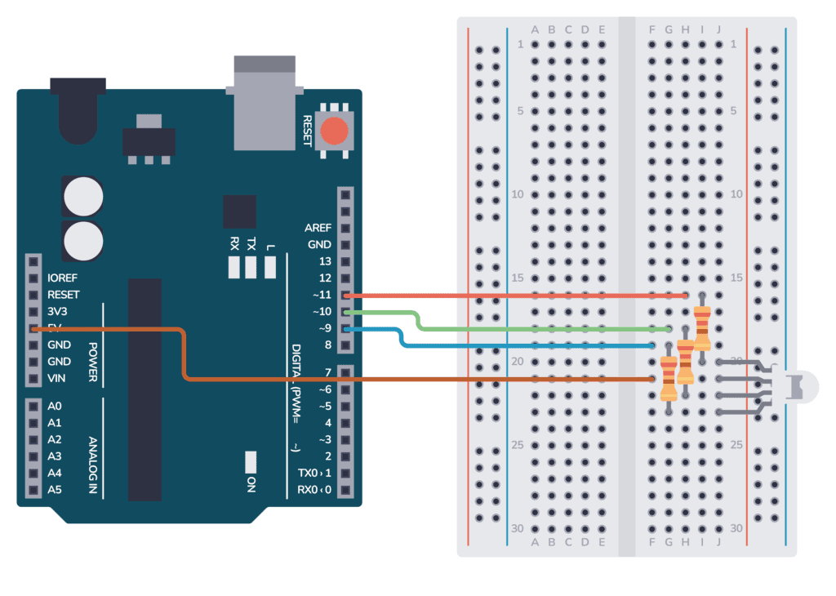

**Fig 5.2** **– System Architecture**

## UML DIAGRAMS

Unified Modeling Language (UML) diagrams are graphical representations used in software engineering to visualize the structure, behavior, and interactions of a system. These diagrams help in understanding, designing, and communicating the system's architecture and functionality among stakeholders.

UML diagrams can be categorized into several types, including structural diagrams such as class diagrams, object diagrams, and component diagrams, which depict the static structure of the system, including classes, objects, and their relationships. On the other hand, behavioral diagrams such as sequence diagrams, activity diagrams, and state diagrams illustrate the dynamic behavior and interactions within the system, showcasing how components collaborate to achieve specific functionalities.

A UML diagram is a way to visualize systems and software using Unified Modeling Language (UML). Software engineers create UML diagrams to understand the designs, code architecture, and proposed implementation of complex software systems. UML diagrams are also used to model workflows and business processes.

Additionally, deployment diagrams depict the physical deployment of software components across hardware nodes, while use case diagrams provide a high-level view of the system's functionalities from the user's perspective. Each UML diagram serves a specific purpose in capturing different aspects of the system, and collectively they offer a comprehensive representation of the system's architecture, behavior, and interactions.

### Data Flow Diagram

A data-flow diagram is a visual representation of how data moves through a system or a process (usually an information system). The data flow diagram also shows the inputs and outputs of each entity as well as the process itself. A data-flow diagram lacks control flow, loops, and decision- making processes. With a flowchart, certain operations based on the data can be depicted. The flowchart can be used to understand how the data flows in this project. A video clip from a PTZ camera is used as the input in this case, and the number of frames on which the algorithm operates will later be converted. The result will be a picture in which a drone is recognized and shown using a rectangle frame around it.

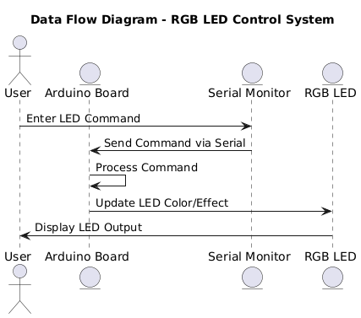

**Fig. 5.3.1 Data Flow Diagram**

### Use Case Diagram

To depict a system's dynamic behavior, use case diagrams are often employed. Using use cases, actors, and their interactions, it captures the functionality of the system. A system or subsystem of an application's necessary duties, services, and operations are modelled. It shows a system's high- level functionality as well as how a user interacts with that system.

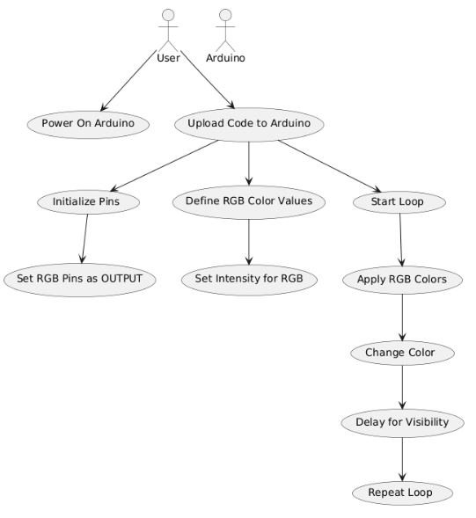

**Fig. 5.3.2 Use Case Diagram**

### Class Diagram

Class diagrams are the main building block of any object-oriented solution. It displays a system's classes, along with each class's properties, operations, and relationships to other classes. Most modelling tools include three elements to a class. Name is at the top, followed by attributes, then operations or methods, and finally, methods. Classes are linked together to generate class diagrams in a complex system with numerous related classes. Various sorts of arrows represent different relationships between classes.

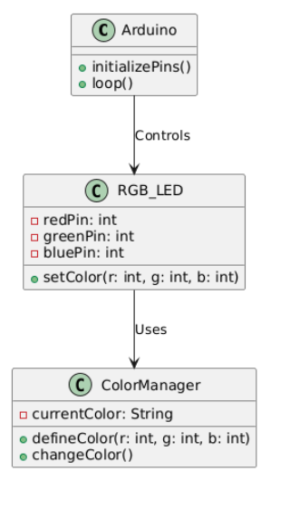

**Fig. 5.3.3 Class Diagram**

### Sequence Diagram

In UML, sequence diagrams display how and in what order certain items interact with one another. It's crucial to remember that they depict the interactions for a certain circumstance. The interactions are depicted as arrows, while the processes are portrayed vertically. The objective of sequence diagrams and their fundamentals are explained in this article. To understand more about sequence diagrams, you may also look at this comprehensive tutorial.

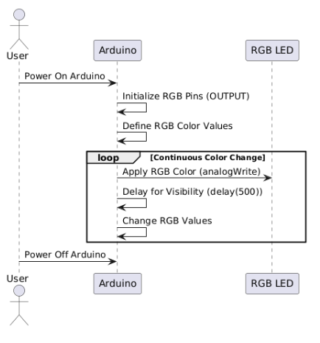

**Fig. 5.3.4 Sequence Diagram**

# 6. IMPLEMENTATION

## 6.1 SAMPLE CODE:

##### RGB.INO

#define RED_PIN 9

#define GREEN_PIN 10

#define BLUE_PIN 11

String mode = "";  // Variable to store the selected mode

void setup() {

  pinMode(RED_PIN, OUTPUT);

  pinMode(GREEN_PIN, OUTPUT);

  pinMode(BLUE_PIN, OUTPUT);

  Serial.begin(9600);

  Serial.println("Enter mode: color_gradient, breathing, strobe, chasing, rainbow, disco, fire_flicker, colors, or temp");

}

void loop() {

  if (Serial.available()) {

    mode = Serial.readStringUntil('\n');

    mode.trim(); // Remove any extra spaces or newline characters

    Serial.print("Selected mode: ");

    Serial.println(mode);

    if (mode == "color_gradient") {

      colorGradient(255, 0, 0, 0, 255, 0, 20);

    }

    else if (mode == "breathing") {

      breathingEffect(255, 0, 0, 20);  // Red breathing effect

    }

    else if (mode == "strobe") {

      strobeEffect(5, 100);  // White strobe effect

    }

    else if (mode == "chasing") {

      chasingEffect(200);  // Chasing colors

    }

    else if (mode == "rainbow") {

      rainbowEffect(20);  // Rainbow color change

    }

    else if (mode == "disco") {

      discoMode(100);  // Random color changes (disco mode)

    }

    else if (mode == "fire_flicker") {

      fireFlickerEffect(50);  // Fire flicker effect

    }

    else if (mode == "colors") {

      userColor();  // Let user input custom colors

    }

    else if (mode == "temp") {

      temperatureToColor();  // Determine color based on star temperature

    }

    else {

      Serial.println("Invalid mode, try again.");

    }

  }

}

// Color Gradient Effect

void colorGradient(int r1, int g1, int b1, int r2, int g2, int b2, int steps) {

  for(int i = 0; i < 8; i++) {

    for (int i = 0; i <= steps; i++) {

      int r = r1 + ((r2 - r1) * i) / steps;

      int g = g1 + ((g2 - g1) * i) / steps;

      int b = b1 + ((b2 - b1) * i) / steps;

      setColor(r, g, b);

      delay(50);

    }

  }

}

// Breathing Effect

void breathingEffect(int r, int g, int b, int delayTime) {

  for (int j = 0; j < 2; j++) {

    for (int i = 0; i <= 255; i += 3) {

      setColor(r * i / 255, g * i / 255, b * i / 255);

      delay(delayTime);

    }

    for (int i = 255; i >= 0; i--) {

      setColor(r * i / 255, g * i / 255, b * i / 255);

      delay(delayTime);

    }

  }

}

// Strobe Effect

void strobeEffect(int flashes, int delayTime) {

  for (int i = 0; i < flashes; i++) {

    setColor(255, 255, 255);

    delay(delayTime);

    setColor(0, 0, 0);

    delay(delayTime);

  }

}

// Chasing Effect

void chasingEffect(int delayTime) {

  for (int i = 0; i < 8; i++) {

    setColor(255, 0, 0);

    delay(delayTime);

    setColor(0, 255, 0);

    delay(delayTime);

    setColor(0, 0, 255);

    delay(delayTime);

  }

}

// Rainbow Effect

void rainbowEffect(int delayTime) {

  for (int i = 0; i < 256; i += 3) {

    setColor(255, i, 0);

    delay(delayTime);

  }

  for (int i = 255; i >= 0; i--) {

    setColor(i, 255, 0);

    delay(delayTime);

  }

  for (int i = 0; i < 256; i++) {

    setColor(0, 255, i);

    delay(delayTime);

  }

  for (int i = 255; i >= 0; i--) {

    setColor(0, i, 255);

    delay(delayTime);

  }

  for (int i = 0; i < 256; i++) {

    setColor(i, 0, 255);

    delay(delayTime);

  }

  for (int i = 255; i >= 0; i--) {

    setColor(255, 0, i);

    delay(delayTime);

  }

}

// Disco Mode

void discoMode(int delayTime) {

  for (int i = 0; i < 30; i++) {

    int r = random(0, 256);

    int g = random(0, 256);

    int b = random(0, 256);

    setColor(r, g, b);

    delay(delayTime);

  }

}

// Fire Flicker Effect

void fireFlickerEffect(int delayTime) {

  for (int i = 0; i < 30; i++) {

    int r = random(200, 255);

    int g = random(100, 150);

    int b = random(0, 50);

    setColor(r, g, b);

    delay(delayTime);

  }

}

// Star Temperature to Color

void temperatureToColor() {

  Serial.println("Enter surface temperature of the star in Kelvin:");

  while (Serial.available() == 0) {}

  int temp = Serial.parseInt();

  String color = "";

  if (temp >= 30000) {

    color = "Blue (Class O)";

    setColor(0, 0, 255);

  } else if (temp >= 10000) {

    color = "Blue-white (Class B)";

    setColor(135, 206, 235);

  } else if (temp >= 7500) {

    color = "White (Class A)";

    setColor(255, 255, 255);

  } else if (temp >= 6000) {

    color = "Yellow-white (Class F)";

    setColor(255, 255, 224);

  } else if (temp >= 5200) {

    color = "Yellow (Class G)";

    setColor(255, 255, 0);

  } else if (temp >= 3700) {

    color = "Orange (Class K)";

    setColor(255, 165, 0);

  } else if (temp >= 2400) {

    color = "Red (Class M)";

    setColor(255, 0, 0);

  } else {

    color = "Temperature too low or invalid.";

  }

  Serial.print("Star color: ");

  Serial.println(color);

}

// User Color Input

void userColor() {

  Serial.println("Enter a color name: red, green, blue, yellow, cyan, magenta, white, pink, brown, purple, violet, orange");

  while (Serial.available() == 0) {}

  String color = Serial.readStringUntil('\n');

  color.trim();

  if (color == "red") {

    setColor(255, 0, 0);

  } else if (color == "green") {

    setColor(0, 255, 0);

  } else if (color == "blue") {

    setColor(0, 0, 255);

  } else if (color == "yellow") {

    setColor(255, 255, 0);

  } else if (color == "cyan") {

    setColor(0, 255, 255);

  } else if (color == "magenta") {

    setColor(255, 0, 255);

  } else if (color == "white") {

    setColor(255, 255, 255);

  } else if (color == "pink") {

    setColor(255, 192, 203);

  } else if (color == "brown") {

    setColor(139, 69, 19);

  } else if (color == "purple") {

    setColor(128, 0, 128);

  } else if (color == "violet") {

    setColor(238, 130, 238);

  } else if (color == "orange") {

    setColor(255, 165, 0);

  } else {

    Serial.println("Given color is not available, try again.");

  }

// Set RGB LED Color for Common Anode

void setColor(int r, int g, int b) {

  analogWrite(RED_PIN, 255 - r);

  analogWrite(GREEN_PIN, 255 - g);

  analogWrite(BLUE_PIN, 255 - b);

}

## 6.2 OUTPUT SCREENS

**OUTPUT 1**

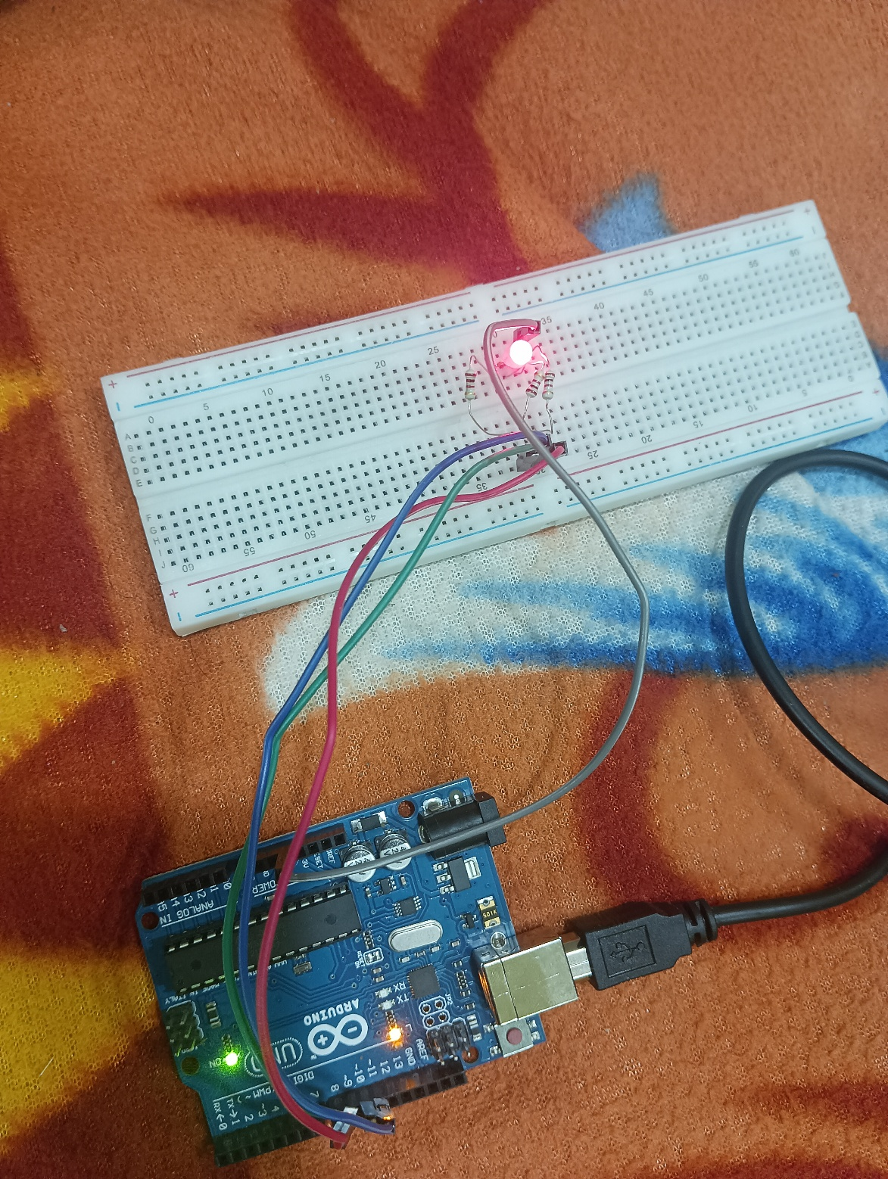

**Fig. 6.2.1 RED Light LED**

In the serial monitor when the user gives the input as colors > red, then the Arduino board gives the signal to the red input wire and therefore we get to see the red light on the RGB LED.

**OUTPUT 2**

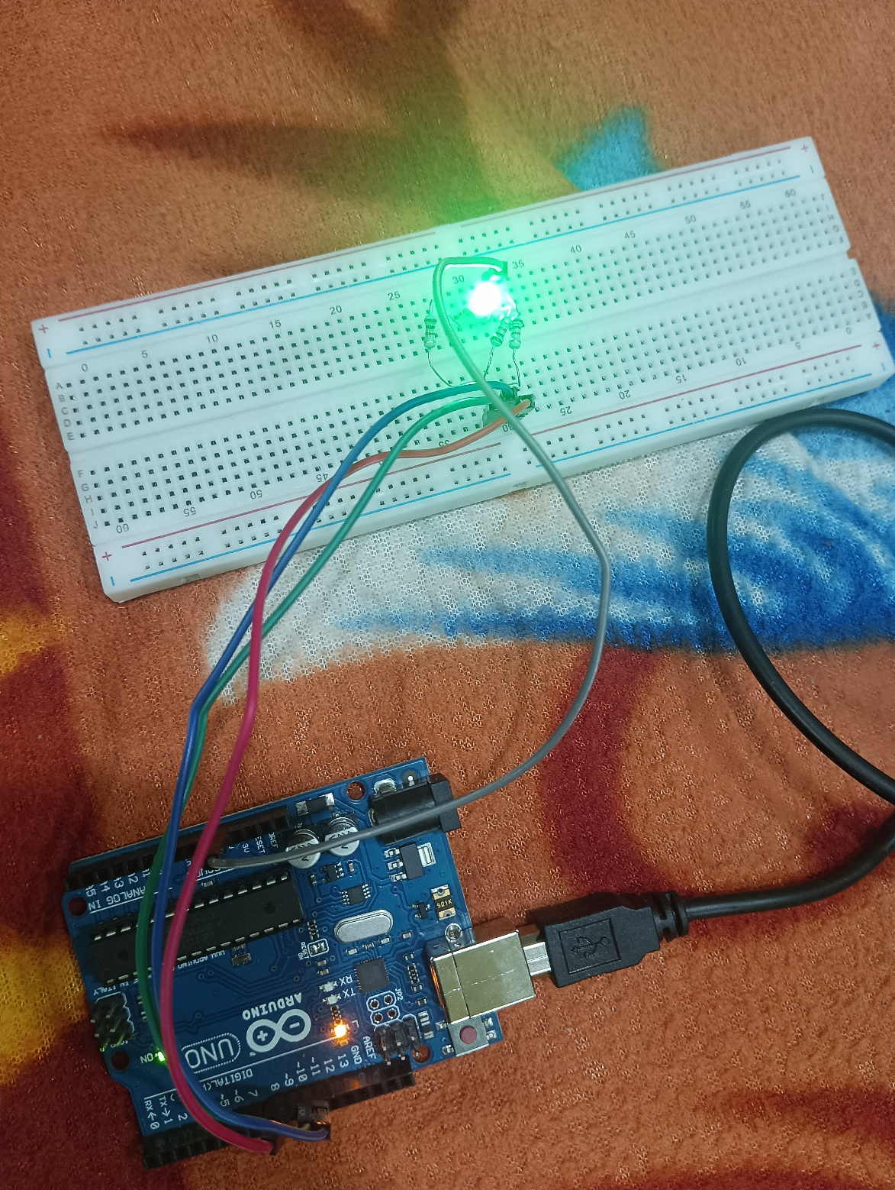

**Fig. 6.2.2 GREEN Light LED**

In the serial monitor when the user gives the input as colors > green, then the Arduino board gives the signal to the green input wire and therefore we get to see the green light on the RGB LED.

**OUTPUT 3**

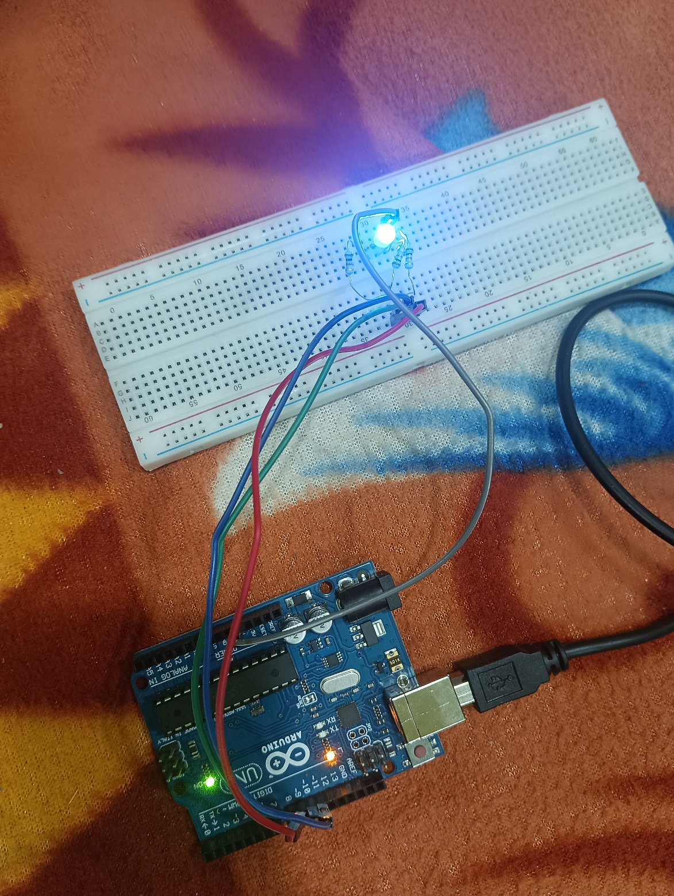

**Fig. 6.2.3 BLUE Light LED**

In the serial monitor when the user gives the input as colors > blue, then the Arduino board gives the signal to the blue input wire and therefore we get to see the blue light on the RGB LED.

# 7. CONCLUSION & FUTURE SCOPE

**CONCLUSION:**

The RGB LED lighting system built using Arduino and a common anode LED effectively demonstrates how interactive and dynamic lighting effects can be achieved with minimal hardware. With modes like color gradient, breathing, strobe, chasing, and rainbow, the project showcases the versatility of LED control through precise PWM manipulation. Each effect is implemented in a modular fashion, making it easy to navigate, customize, or extend. The serial communication approach ensures a user-friendly interface that allows real-time selection and switching of lighting modes, contributing to a highly engaging user experience.

The project architecture is thoughtfully organized, with clear separation of logic for each lighting mode. Functions like colorGradient(), breathingEffect(), and fireFlickerEffect() encapsulate their behaviors cleanly, encouraging code readability and maintainability. The inclusion of both pre-defined and user-input modes — such as userColor() and temperatureToColor() — adds interactivity, enabling users to personalize the experience. Moreover, the use of analog PWM control with inverted values properly addresses the behavior of the common anode RGB LED, ensuring accurate color rendering.

Scalability is a core strength of this design. Developers or hobbyists can easily introduce new effects or modify existing ones without altering the underlying control logic. The use of a centralized input handling structure allows seamless expansion of command options. Additionally, the adaptability of the system makes it suitable for a wide range of applications including home ambiance, gaming setups, and educational demonstrations. Integrating external modules like Bluetooth or Wi-Fi in the future could further extend its usability in remote or automated environments.

Overall, this project stands out as a cost-effective, customizable, and beginner-friendly solution for RGB lighting control. By combining efficient software structure with creative visual outputs, it proves the potential of Arduino in producing polished and interactive electronic systems.

**FUTURE SCOPE:**

The current implementation lays a solid foundation for various future improvements and technological integrations. One promising direction is the addition of wireless connectivity using modules like Bluetooth (HC-05) or Wi-Fi (ESP8266/ESP32). This would enable remote control of lighting effects via smartphone apps or web interfaces, eliminating the dependency on serial input and making the system more user-friendly and flexible for smart home environments.

Another area for expansion is the integration of sensors to create responsive lighting based on external stimuli. For instance, motion sensors could trigger specific effects, sound sensors could sync lights to music (creating a real-time visualizer), or ambient light sensors could adjust brightness automatically. These additions would significantly enhance the interactivity and usability of the system in dynamic environments such as parties, gaming setups, or exhibitions.

The system can also be expanded to support multiple RGB LEDs or LED strips, allowing synchronized effects across larger spaces or complex installations. This would involve implementing additional control logic and possibly using shift registers or driver ICs to manage power and timing effectively. Advanced animations, transitions, and timing sequences could be programmed to offer a more immersive lighting experience, suitable for stage lighting or decorative art installations.

Lastly, incorporating user customization and memory features could elevate the experience. For example, storing user preferences in EEPROM would allow the device to remember the last selected mode or custom colors even after being powered off. Adding a simple display or menu system via an LCD or OLED screen could also provide visual feedback and control without requiring a PC connection. These enhancements would make the project more practical, autonomous, and appealing for real-world deployment in both hobby and commercial settings.

# 8. BIBLIOGRAPHY

# WEBSITES

# [1] RGB LED Serial Control Arduino.

# Available at: <https://www.instructables.com/RGB-LED-Serial-Control-Arduino>

# [2] Interfacing RGB LED with Arduino.

# Available at: <https://projecthub.arduino.cc/semsemharaz/interfacing-rgb-led-with-arduino-b59902>

# [3] RGB LED with Serial Monitor - Arduino Forum.

# Available at: <https://forum.arduino.cc/t/rgb-led-withserial-monitor/858907>

# [4] Arduino RGB LED Guide: Easy Setup and Code Examples. Available at: <https://www.build-electronic-circuits.com/arduino-rgb-led>

# [5] How to Use an RGB LED - Arduino Tutorial.

# Available at: <https://www.instructables.com/How-to-use-an-RGB-LED-Arduino-tutorial>

# [6] RGB LED Interfacing With Arduino. Available at: <https://www.instructables.com/RGB-LED-Interfacing-With-Arduino/>

# [7] How to Use an RGB LED with Arduino | Tutorial. Available at: <https://howtomechatronics.com/tutorials/arduino/how-to-use-a-rgb-led-with-arduino/>

# [8] Arduino - RGB LED Tutorial. Available at: <https://arduinogetstarted.com/tutorials/arduino-rgb-led>

# [9] Interfacing Arduino Uno with RGB LED. Available at: <https://projecthub.arduino.cc/electronicsfan123/interfacing-arduino-uno-with-rgb-led-69d4fa>

# [10] RGB LED Color Mixing With Arduino in Tinkercad. Available at: <https://www.instructables.com/RGB-LED-Color-Mixing-With-Arduino-in-Tinkercad/>

# REFERENCES

# A tutorial on using serial input to control an RGB LED with an Arduino, allowing real-time color changes via the Serial Monitor.

# A beginner-friendly project that explains how to connect and control an RGB LED using Arduino code and basic components.

# A forum discussion with user-shared solutions and code snippets for controlling RGB LEDs through the Arduino Serial Monitor.

# A detailed guide explaining RGB LED wiring, common anode vs. cathode types, and example Arduino code for different colors.

# A step-by-step tutorial for using RGB LEDs with Arduino, including simple circuit diagrams and sample code.

# An instructable covering RGB LED interfacing, with diagrams, explanations, and control methods.

# A comprehensive tutorial explaining how RGB LEDs work, how to connect them to Arduino, and how to control them using code.

# A concise Arduino tutorial providing clear instructions, code examples, and troubleshooting tips for RGB LED control.