HAND SIGN DETECTION USING COMPUTER VISION AND ML ALGORITHMS

P. Manoj Kumar, P. Yugeshwar,
N. Abhinav
Department of Computer Science Engineering, UG Student,
Malla Reddy College of Engineering and Technology,
Hyderabad,India
tarunivadapalli@gmail.com

S.Shanthi
Assistant Professor,Department of Computer Science Engineering,
Malla Reddy College of Engineering and Technology,
Hyderabad,India
santhis015@gmail.com

Abstract— Hand sign detection is a fascinating area of computer vision that involves recognizing and interpreting human hand gestures through images. This technology has numerous applications, ranging from human-computer interaction and augmented reality till sign language translation and robotics. Few of its components are Image Acquisition, Preprocessing, Hand Segmentation, Feature Extraction, Gesture Recognition, Post-Processing and Output. Tools and Libraries used in it are OpenCV, MediaPipe, Tensorflow, Numpy Keras. Few of its Applications are Sign Language Interpretation, Human-Computer Interaction, Virtual Reality and Robotics. The system is designed with modular components, including image acquisition, preprocessing, feature extraction, and classification. A convolutional neural network (CNN) model, trained on a diverse dataset of hand sign images, serves as the core classifier, enabling robust recognition of signs despite variations in hand positioning, lighting, and background. With this approach, the system provides a reliable and adaptable solution for recognizing hand signs in real-time.
Keywords— Hand Gesture Recognition, Computer Vision, Real-Time Detection, Assistive Technology, Machine Learning

Introduction
The project "Hand Sign Detection Using Computer Vision in Python" aims to create an innovative and interactive system that can recognize and classify hand gestures in real-time using computer vision techniques. With the rise of natural user interfaces and the growing need for intuitive interaction methods, this project leverages Python’s extensive libraries such as OpenCV and TensorFlow to build a system that processes hand movements from live video input and interprets them into meaningful actions or commands. The system's primary goal is to bridge the gap between humans and machines, allowing for touchless interaction in various applications.
This project’s significance lies in its wide range of applications, from accessibility tools for the differently-abled to gesture-based controls in gaming, virtual reality, and smart home environments. The ability to recognize hand gestures in real-time also has practical implications for industries such as robotics, healthcare, and education, where touchless and gesture-based control can enhance user experience and functionality. By employing advanced image processing and deep learning models, the system can accurately detect hand signs in diverse conditions, making it adaptable and reliable for real-world scenarios.
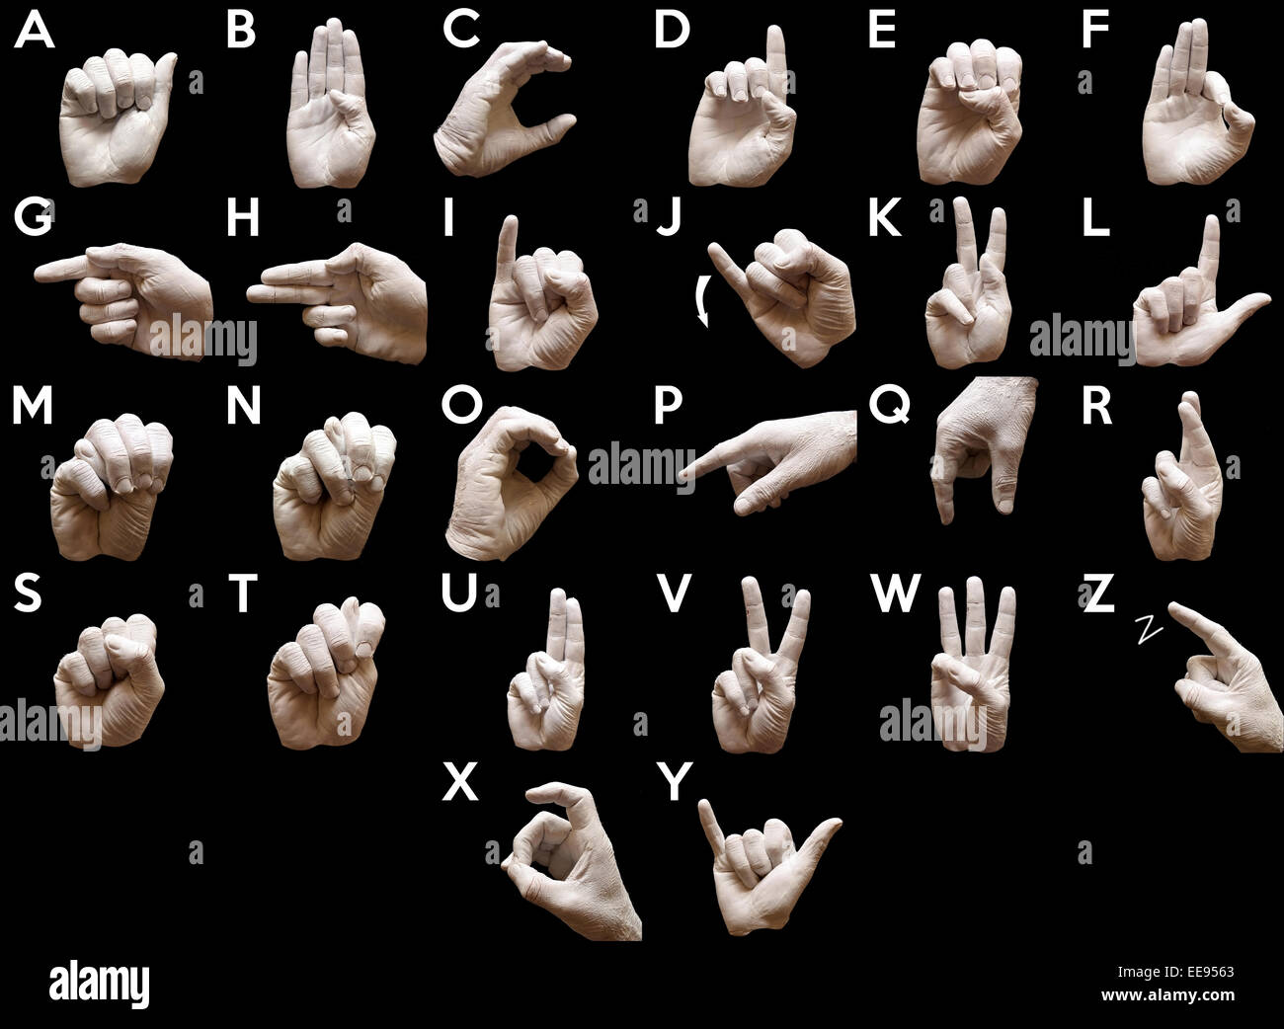
Fig 1. American Standard Hand Sign Language Gestures .

The technical foundation of this project revolves around the integration of computer vision and machine learning techniques, enabling the system to learn and improve gesture recognition over time. The use of Python provides flexibility and access to a wide array of libraries that facilitate tasks such as video capture, image preprocessing, and neural network training. As a result, this project offers a scalable solution that can be implemented on different platforms and devices, opening the door to future enhancements and extensions, such as expanding gesture libraries or integrating with external systems like IoT or robotic platforms.

Literature Survey
Hand sign detection has been an active area of research within computer vision and machine learning, driven by the potential to improve human-computer interaction, accessibility, and assistive technology. Early work in gesture recognition primarily relied on hardware-intensive methods such as sensors and specialized gloves to capture hand movements accurately. While these systems achieved reasonable accuracy, they were costly and limited by the necessity of wearing or handling physical devices, making them less practical for everyday users.

The advancement of computer vision algorithms, particularly with the emergence of convolutional neural networks (CNNs), significantly transformed hand gesture recognition. Researchers began exploring image-based approaches, leveraging traditional computer vision techniques like edge detection, contour analysis, and feature extraction. These methods provided a foundation for detecting static hand poses by analyzing the shape and position of the fingers and palm. However, these rule-based systems faced challenges in maintaining high accuracy across diverse users, backgrounds, and lighting conditions, limiting their adaptability and robustness.

Recent literature emphasizes deep learning as a powerful approach for enhancing the robustness and adaptability of hand sign detection systems. Convolutional neural networks (CNNs) have proven effective in automatically learning spatial hierarchies and complex patterns from images, reducing the need for manual feature extraction. Studies demonstrate that CNNs achieve impressive accuracy in recognizing hand signs and gestures across diverse datasets, showing resilience against background variation and slight hand movements. Data augmentation techniques, such as flipping, rotating, and varying brightness in hand images, have also contributed to increased model generalization, making deep learning models applicable to real-world scenarios where hand positions and lighting vary.

Real-time performance has also become a focus of recent studies, as practical applications demand systems that can quickly process video input and respond with minimal latency. Some research integrates lightweight CNN architectures and optimization techniques, allowing hand sign recognition models to run efficiently on mobile and embedded devices. This shift enables applications in areas like mobile accessibility for people with disabilities, gesture-based interfaces in public spaces, and remote control of IoT devices through simple hand gestures. Furthermore, the development of real-time hand tracking techniques has provided another layer of accuracy and responsiveness by focusing processing resources on hand regions within video frames.

Another important theme in the literature is the design of datasets that reflect the wide diversity in hand shapes, skin tones, and cultural variations in hand gestures. Datasets like the American Sign Language (ASL) dataset and custom collections from various projects have been widely used for training and testing purposes, supporting models that recognize gestures across different contexts. Such datasets contribute to building robust models that are not only accurate but also inclusive. Research indicates that diversity in training data is essential for the model’s capacity to generalize across users with different backgrounds, which is crucial for developing accessible hand sign recognition systems for public use.

Current studies also discuss the integration of gesture recognition systems with smart devices and the Internet of Things (IoT), expanding the potential applications of hand sign detection in smart homes, workplaces, and healthcare. For instance, researchers have successfully implemented gesture control for smart home devices, where users can turn lights on or off, adjust temperatures, or control entertainment systems through hand gestures. In healthcare, hand gesture recognition can provide assistive solutions for individuals with limited mobility or communication difficulties, enabling greater independence and engagement.

In summary, the literature on hand sign detection highlights a progression from hardware-dependent systems to sophisticated, deep learning-based computer vision models that offer accurate, real-time recognition. Modern hand gesture recognition leverages advancements in CNN architectures, dataset diversity, and optimization techniques, expanding applications beyond traditional domains and offering transformative possibilities in assistive technology, human-computer interaction, and IoT integration. The field continues to evolve with a focus on improving real-time capabilities, robustness across diverse environments, and accessibility for a wide range of users.

Methodology
1. Data Collection and Preprocessing
The first step in the methodology involves collecting a comprehensive dataset of hand signs for model training and testing. The dataset should contain various hand poses representing different signs, with images captured from different angles, lighting conditions, and backgrounds to enhance model generalization. Sources for the dataset can include publicly available sign language datasets, or it may be necessary to create a custom dataset by capturing images or video sequences of hand signs in diverse environments.

To prepare the data for the model, several preprocessing techniques are applied. Images are resized to a uniform dimension suitable for the CNN model, and color normalization helps mitigate variations in lighting. Data augmentation, such as rotating, flipping, and adjusting brightness, is also applied to increase the diversity of training samples. This augmentation helps the model learn to recognize signs under various conditions, improving its robustness in real-world scenarios.

2. Hand Detection and Segmentation
After preprocessing, the next step is to detect and segment the hand from the background. This phase isolates the hand region from each image or video frame, enhancing the model’s focus on relevant features for sign recognition. A popular approach is to use color-based segmentation, where color thresholds (like skin color) help differentiate the hand from the background. Alternatively, advanced models like the YOLO (You Only Look Once) object detection model can detect and isolate hands effectively.

The segmentation process might include techniques like morphological transformations, contour detection, and background subtraction. These techniques refine the hand region and filter out noise, allowing the model to receive a clean and consistent input. By ensuring high-quality segmentation, the system improves its accuracy and responsiveness in classifying hand signs.

3. Feature Extraction
Feature extraction is essential for capturing meaningful details from the segmented hand region. For this, key points and shapes of fingers, palm position, and hand contours are analyzed. Convolutional neural networks (CNNs) automatically handle feature extraction by learning spatial hierarchies and patterns from the segmented hand images, capturing intricate details without manual intervention.

CNNs are particularly effective because they can identify complex features across different layers, such as edges in lower layers and shapes in higher layers. Using pre-trained CNNs like VGG, ResNet, or MobileNet can accelerate this process by transferring learned features to the new hand sign recognition task. This transfer learning approach speeds up training and reduces the need for large datasets, making it highly suitable for real-time applications.

4. Model Training and Algorithm Selection
The heart of the system is the machine learning model, which is trained to classify hand signs based on extracted features. CNNs are the preferred choice for image-based classification tasks due to their high accuracy and efficiency in capturing spatial information. The training process involves feeding the CNN with labeled hand images, allowing it to learn the associations between image features and corresponding signs.

For this project, a CNN-based architecture is trained using a backpropagation algorithm with an optimization technique like Adam or SGD (Stochastic Gradient Descent). The model undergoes multiple epochs of training to adjust its weights and biases, minimizing the classification error. Training hyperparameters such as learning rate, batch size, and number of epochs are tuned to balance accuracy and computational efficiency. Once trained, the model can generalize to detect unseen hand signs accurately.

5. Real-Time Implementation and Model Integration
After training, the model is integrated into an application that captures live video input, applies preprocessing and segmentation, and performs real-time classification. This implementation involves setting up a pipeline where video frames are processed in sequence, with each frame passed through the segmentation, feature extraction, and classification stages.

To enable real-time performance, lightweight model architectures, such as MobileNet, may be chosen for faster inference, particularly on devices with limited resources. Additionally, optimization techniques such as quantization and pruning are applied to reduce the model size and enhance computational efficiency. The final system processes video input continuously, displaying the detected sign or triggering specific actions based on the classification output, ensuring a smooth and responsive user experience.

6. Testing and Evaluation
Once the model is implemented, rigorous testing and evaluation are conducted to assess its accuracy, robustness, and performance. Testing involves using separate validation and test datasets that were not part of the training process to ensure unbiased evaluation. Key performance metrics include accuracy, precision, recall, and F1-score, which provide a comprehensive view of the model’s classification capability.

Result and Discussion

The results and discussion section of the Brain Tumor Detector project is critical for assessing the model's performance, discussing the implications of findings, and evaluating the effectiveness of the implemented methodology. This section encompasses a detailed examination of the input and output screens, along with an analysis of the achieved result.

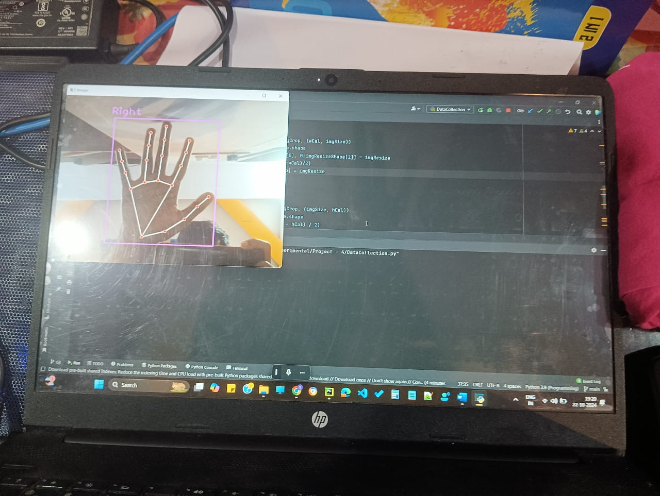
Fig 1. Machine detecting Right Hand

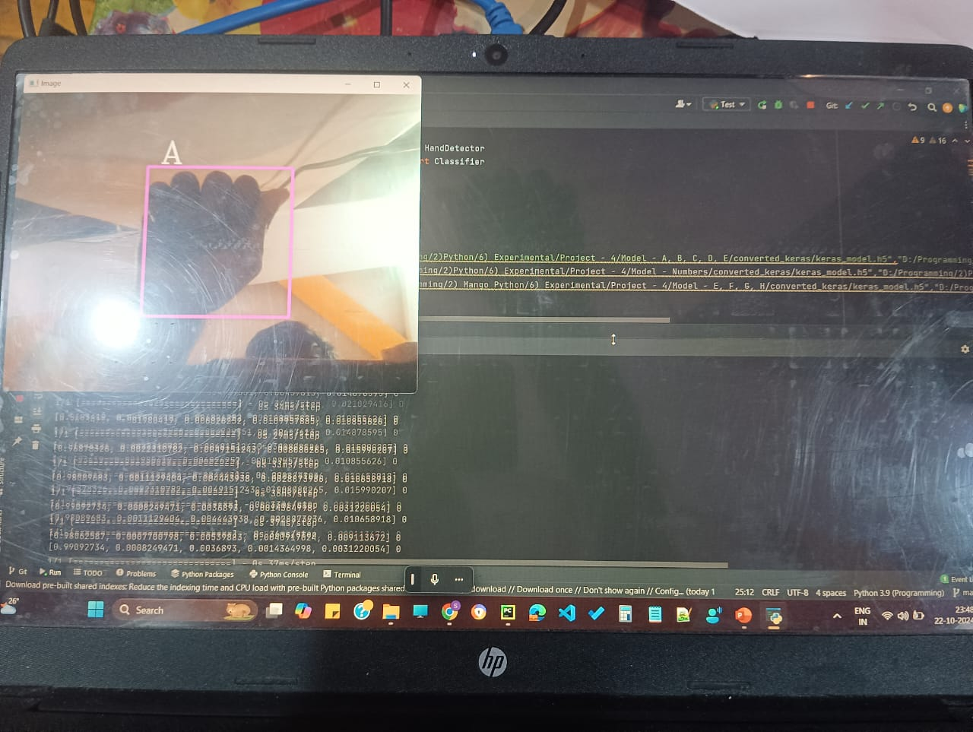
Fig 2. Machine detecting letter ‘A’ hand gesture.

Input Screen: The input screen provides the user interface where the hand sign detection system captures live video or image input from the user. This screen is designed for easy setup, allowing users to position their hand within a designated frame or guideline to ensure optimal visibility and accuracy. The system processes each frame in real-time, preparing it for subsequent stages of detection and classification. The simplicity of the input screen layout ensures that users can quickly adjust their hand position and background conditions to achieve consistent results across various settings.
Output Screen: The output screen displays the real-time classification results of detected hand signs, providing immediate feedback to users. When a hand sign is recognized, the system overlays the detected sign label on the screen, enabling the user to confirm the correctness of the detection. Additionally, the output screen may highlight the hand region, visually demonstrating which parts are actively contributing to the classification. This clear and informative layout enhances the user experience by delivering instantaneous and accurate recognition results, helping users understand how their gestures are being interpreted.
Model Robustness: Model robustness in hand sign detection refers to the system's ability to maintain accuracy across varied conditions such as lighting changes, background complexity, and differences in hand sizes and shapes. To achieve robustness, the model undergoes training with diverse datasets and data augmentation techniques, which help it generalize better to real-world scenarios. A robust model is essential for the system's reliability, ensuring it can perform consistently and accurately regardless of minor environmental or user-based variations. This characteristic is crucial for practical applications where users may operate in uncontrolled settings.
User Interaction and Education: User interaction and education focus on empowering users to effectively engage with the hand sign detection system. This involves providing clear instructions on positioning their hand within the camera's view, optimal lighting, and minimizing background distractions. Additionally, a user guide or tutorial is offered, explaining how to interpret output results and common issues that may arise. Educating users helps them optimize their interactions with the system, ensuring a smoother experience and higher recognition accuracy, which is particularly valuable for individuals new to gesture-based interfaces.
Continuous Refinement and Optimization: Continuous refinement and optimization are essential for maintaining and improving the hand sign detection system's performance. This includes periodic retraining of the model with new data to adapt to changing usage patterns, as well as implementing model optimization techniques like pruning and quantization to enhance computational efficiency. Regular updates ensure that the system remains accurate, responsive, and effective in real-time applications. This process of ongoing improvement also allows for integrating user feedback and addressing emerging issues, making the system more robust and user-friendly over time.
Ethical Considerations: Ethical considerations in hand sign detection involve ensuring privacy, inclusivity, and fairness in the system's design and usage. As the system captures real-time video input, protecting user data and respecting privacy rights are paramount. Inclusivity is another focus, with the model trained on diverse datasets to avoid biases related to skin tone, hand size, or background. Additionally, ethical considerations address the system's transparency, with clear explanations of data usage and limitations. Prioritizing ethical design ensures a fair, inclusive, and trustworthy tool for all users.
Future Directions: Future directions for hand sign detection involve expanding the system's capabilities and improving accessibility. Potential enhancements include adding support for a broader range of hand gestures, enabling multi-sign sequences for more complex interactions, and incorporating speech or sound feedback for increased accessibility. Integrating with Internet of Things (IoT) devices could allow users to control various smart devices through hand gestures, extending the application’s usability. Further research may also focus on improving model accuracy and efficiency, ensuring the system can run effectively on low-resource devices and diverse environments.

Conclusion

In conclusion, this project represents a promising step toward advancing human-computer interaction through gesture-based control. The potential applications of hand sign detection are vast, and as technology continues to evolve, we can expect to see even more sophisticated and user-friendly systems. The success of this project paves the way for further research and development, making it a valuable contribution to the fields of computer vision, machine learning, and interactive system design.

References

[1] J Imaging. 2020 Jul 23;6(8):73. doi: 10.3390/jimaging6080073 Hand Gesture Recognition Based on Computer Vision: A Review of Techniques Munir Oudah 1, Ali Al-Naji 1,2, *, Javaan Chahl 2 Copyright and License information PMCID: PMC8321080 PMID: 34460688
[2] Hand Gesture Recognition: A Literature Review August 2012 International Journal of Artificial Intelligence & Applications 3(4):161-174 DOI:10.5121/ijaia.2012.3412
[3] Hand Gesture Recognition Based on Computer Vision: A Review of Techniques Munir Oudah 1, Ali Al-Naji 1,2, *, Javaan Chahl 2
[4] Hand Gesture Recognition System Based in Computer Vision and Machine Learning October 2013 DOI:10.1007/978-3-319-13407-9 21I.Ravi Prakash Reddy, “Trust Rate based Cooperative Neighbor Selection for Reliable Data Transmission in Mobile Adhoc Networks”, International Journal of Research, ISSN No:2236- 6124, IJR Journal, Vol-VII, Issue-X, October-2018.

