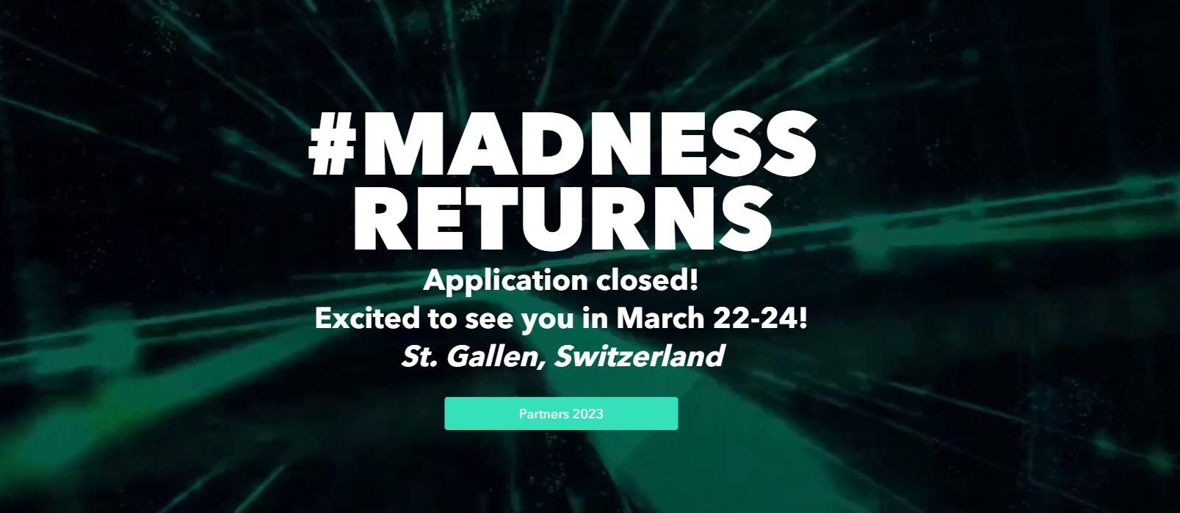

***BELL FOOD GROUP CASE***

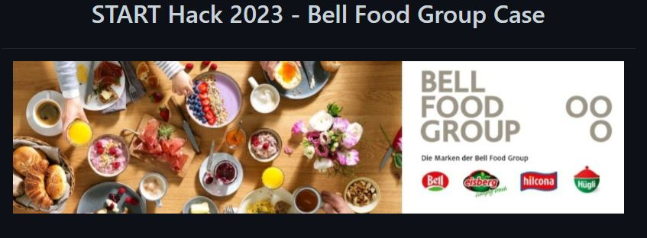

***MORPHEUSERS***

***HOME***

For the first time you will enter with your account’s token provided by the company and then you’ll have to answer some questions about your lifestyle.

The main components are:

* The personal pie chart that shows information about your impact
* Different cards for each category, each of them showing the percentage of success in that branch.
* Claim box where you can get your daily bonus and you’ll be kept up with all your latest earnings/purchases for each level there’s an increasing daily bonus. This pushes users to open the app everyday.
* Navbar (for each page) that allows you to go through the different pages.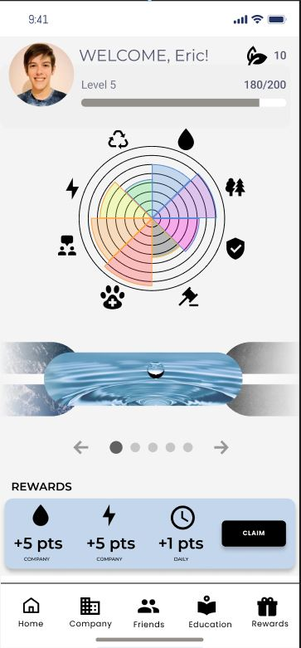

***COMPANY***

In this screen there will be information about the company.

The main components are:

* A list of achievements for each category
* A list of goals to achieve in a certain period. When an achievement is completed every employee will receive some eco-points. This helps all the users to feel a part of the company improving the safety and health in the workplace.

***FRIENDS***

In the friends section you can interact with other users.

The main components are:

* search-bar that allows you to search people by token and add them to your friends
* Scoreboard sorted by the users’ scores, in this way there can be a sustainable competition and employees will try to improve their rank to appear on top.
* Private chat between players.

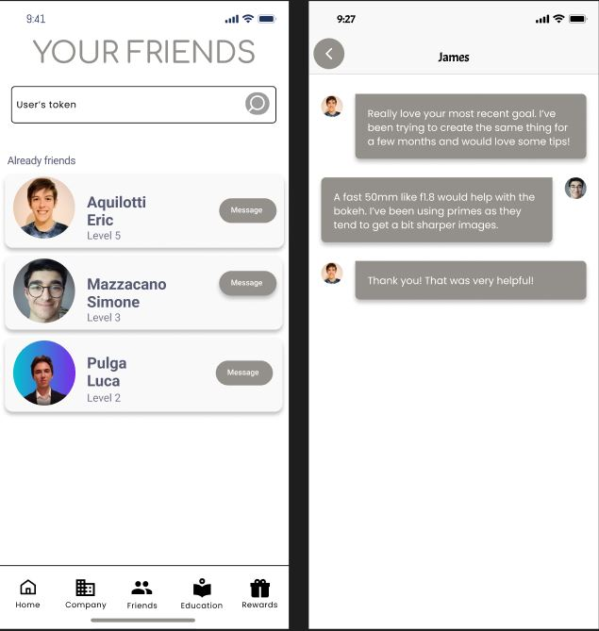

***EDUCATION***

In this page you will find:

* Advices about how to improve your score
* Events promoted from the company such as planting tree days or cleaning parks. Each event will have an impact on the score and will reward the participants with eco-points.
* Info pills to improve the environmental culture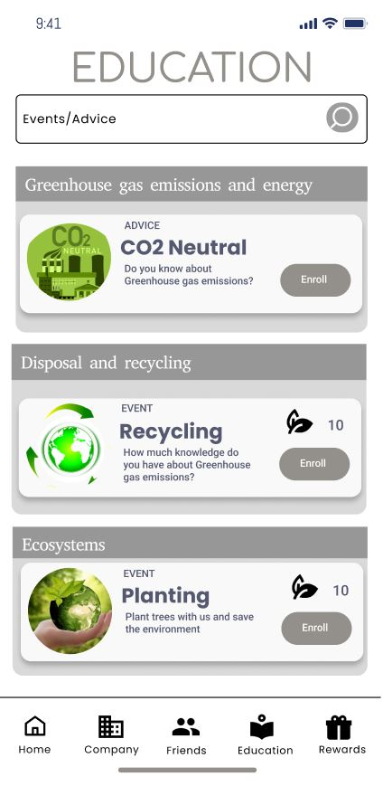

***REWARDS***

In this page you’ll be informed about the claimable rewards.

There is a list of rewards whose claimability is based on the level and the eco-points of the user. To claim the rewards you use the qr-code that’s in the profile page. For example if you want to claim a free coffee you go to the company bar or an affiliate bar and the barman will scan your code and the eco-points will be updated automatically.

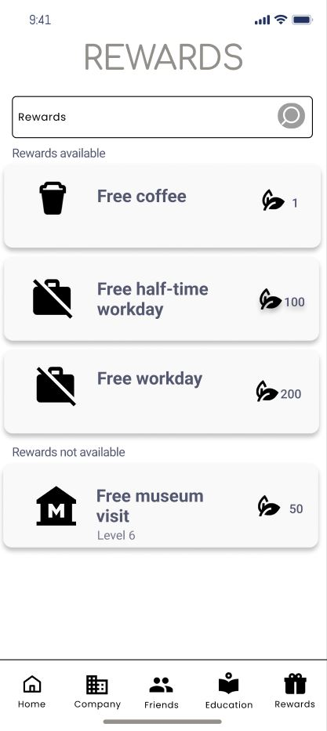

***PROFILE***

In the profile settings there is information about the user such as the score, the level, the eco-points, the goal achieved and the qr-code used to claim the rewards.

