Sri Lanka Institute of Information Technology



IE3142 – DevOps-Security
Year 3, Semester 1- 2026
Assignment 01
IT Number | Student Name
IT24101491 | Pethvan p p
IT24102268 | Aluthge M.N
IT24101916 | Adithya E.A.D.D.D
IT24101727 | Shanthoshika S

Table of Contents
1.Executive Summary - 3 -
2.Application, Architecture and Containerizations - 4 -
Container hardening and principle of least privilege - 4 -
Network segmentation and trust boundary enforcement - 4 -
3.Threat modeling and risk assessment - 6 -
Stride threat model - 6 -
Risk evaluation matrix - 7 -
Threat to control mapping - 7 -
4.Secure Coding: Exploit-and-Fix Walkthroughs - 9 -
NoSQL Injection (Authentication Bypass) - 9 -
Stored Cross-Site Scripting (XSS) - 11 -
Insecure Direct Object Reference (IDOR) - 14 -
Insecure Cryptographic Storage (Plaintext Passwords) - 16 -
SAST scan - 19 -
5.DevSecOps CI/CD Pipeline & Security Automation - 20 -
GitHub Actions Workflow: - 20 -
6.Secrets Management Approach - 22 -
Secret Provisioning and Image Layer Security - 22 -
7.Industry Trends and Case Study Analysis - 23 -
The Hidden Risks of Open Source: Lessons from the event-stream Supply Chain Attack - 23 -
Defending Our Project: How Our CI/CD Pipeline Stops Supply Chain Attacks - 24 -
8.Project reflection and future improvements - 26 -
9.Individual Contribution Statement - 27 -
10.AI usage disclosure - 28 -
11.Reference - 29 -

1.Executive Summary
This report present a comprehensive DevOps security assessment and remediation lifecycle conducted on the OWASP NodeGoat application. The objective is to shift security practice left by identifying critical application-layer vulnerabilities and stablishing automated policy enforcing CI/CD pipelines through controlled exploitations, threat analysis and automated security control
Key technical achievements
- Vulnerability identification and remidation
  - NoSql Injection
  - Stored cross-site scripting
  - Insecure direct object reference
  - Insecure cryptography storage
  - Static application security testing
- Continuous security automation
  - Secret scanninig
  - SAST
  - Software composition analysis
  - Container security
- Enterprise secrets management
- Software supply chain risk analysis

2.Application, Architecture and Containerizations
Multi-container Stack
The deployment architecture partitions OWASP NodeGoat into two discrete containerized tiers
- The application runtime tier(nodegoat-web)
- Data storage tier(nodegoat-db)
Using docker compose the system build and start in fully self container offline status single command docker compose up –build. The web container manage express application handling and isolated mongo-db database management manage in db docker using tcp port 27017 for monitoring scripts and logs

Container hardening and principle of least privilege
To mitigate container breakout and privilege escalation risks the application container explicitly abandons default execution the Docker file apply user mode node ensuring all child application process execution under and unprivileged user space

Network segmentation and trust boundary enforcement
Network boundaries are made with docker network bridge
- public network
act as the ingress channel bridging host port 4000 to the web container http traffic
- internal network
configure with internal:true to prevent external inbound or outbound routing port 27017 to only accessible inside net to ensure database cannot reach host machine or public network \

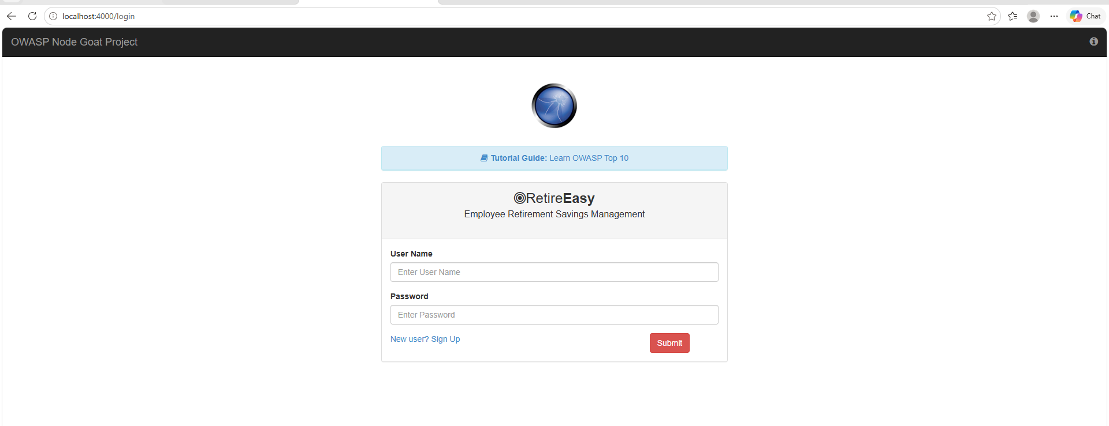
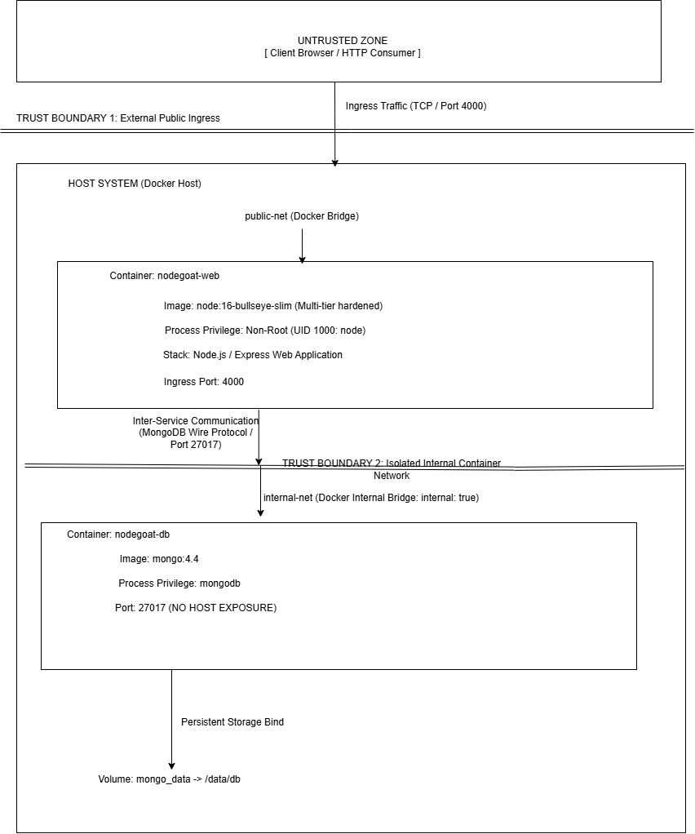

3.Threat modeling and risk assessment

Stride threat model
Below are four realistic, application-specific threats that might target the NodeGoat architecture. The threats were identified using the STRIDE methodology.
- Spoofing (Authentication Bypass via NoSQL Injection):
An attacker can launch a NoSQL injection attack by sending a malicious JSON object to the /login API. By replacing the password value with a MongoDB operator, such as {"password": {"$ne": null}}, and taking advantage of the fact that Express does not enforce typechecking on the input, the attacker can bypass authentication and hijack an administrator’s session. No credentials would be required to perform this attack, apart from basic knowledge of the MongoDB query language.
- Tampering (Insecure Direct Object Reference on Allocations): An authenticated attacker can tamper with allocation records by modifying the request sent to the server when the attacker attempts to update their asset allocation. By changing the userId value in the request to another value, the attacker can effectively change the allocation records of another user. The vulnerability stems from the fact that the server does not check whether the userId belongs to the authenticated attacker.
- Information Disclosure (Hardcoded Database Credentials): A developer could accidentally commit the database credentials required to connect to the MongoDB server and sign cookies for the Express framework in the config/env/development.js file or the docker-compose.yml file. If this information becomes available to an attacker, they can utilize it to connect to the database directly and forge valid session cookies to hijack the administrator’s session.
- Denial of Service (Unbounded Payload Exhaustion): An attacker can utilize a large JSON payload to exhaust the CPU resources on the Node.js server. Since Node.js runs on a single thread, any request that requires deep traversal of the JSON object will monopolize the CPU and deny service to other users. This threat is particularly concerning because there is no built-in defense against it in the Node.js framework itself.

Risk evaluation matrix
Each thread is scored on a5x5 matrix evaluating likelihood(how easy/often the attack can be executed) and impact resulting in an overall risk rating
threat | likelihood | impact | Overall risks
Spoofing(login no SQLi) | 5 | 5 | 25
Tampering (allocation IDOR) | 4 | 4 | 16
Info disclosure(secrets in Git) | 5 | 4 | 20
Dos(Payload exhaustion) | 3 | 3 | 9

Threat to control mapping
This table directly identified threats to the specific security controls implemented in pipeline and codebase
Threat category | Vulnerability scenario | Risk level | Mitigating control | Codebase/pipeline location
Spoofing | NoSQL injection in login bypassing authentication | Critical | Input Validation & Sanitization: Implement strict allow-list type checking (typeof password === 'string') before querying the database. | app/routes/session.js and app/data/user-dao.js
Tampering | Modifying other users' allocations via IDOR | High | Server-Side Authorization: Ignore client-provided user IDs and enforce lookups strictly using the verified req.session.userId | app/routes/allocations.js
Information disclosure | Hardcoded secrets committed to source control | High | Secret Scanning & Environment Injection: Gitleaks prevents secret commits, and GitHub Actions Encrypted Secrets inject credentials at runtime | .github/workflows/devsecops-pipeline.yml
Denial of service | Event-loop blocking via massive JSON payloads | Medium | SAST & Infrastructure Hardening: Semgrep flags missing limits; express.json({ limit: '10kb' }) restricts body size. | .github/workflows/devsecops-pipeline.yml

4.Secure Coding: Exploit-and-Fix Walkthroughs

NoSQL Injection (Authentication Bypass)

The exploit utilized an intercepted POST request to inject a MongoDB operator payload, {"password": {"$ne": null}}, into the /login endpoint. Because the Express framework lacked input type validation, the database evaluated the operator as true, bypassing the password check. The remediation in app/data/user-dao.js completely neutralizes this by enforcing strict allow-list type checking (typeof === 'string') on both the userName and password parameters before the database is queried. Re-testing the endpoint with the original JSON object payload causes the type-check to fail immediately, safely rejecting the malicious input and returning an error prior to database execution.Vulnerability
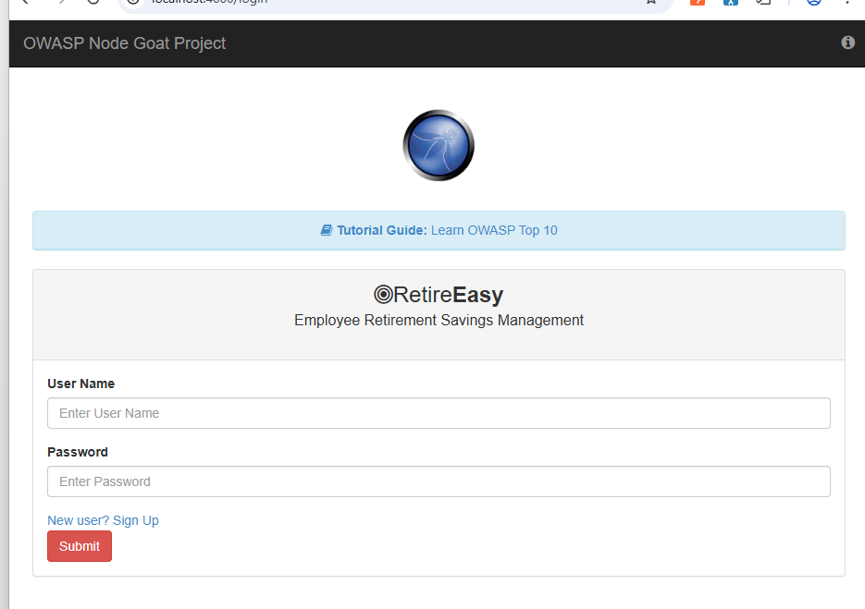
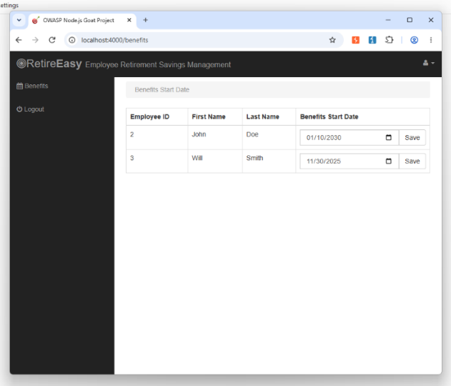

app/data/user-dao.js
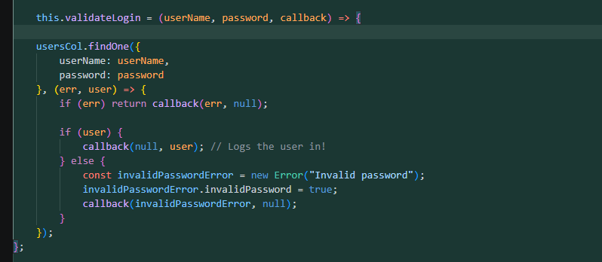
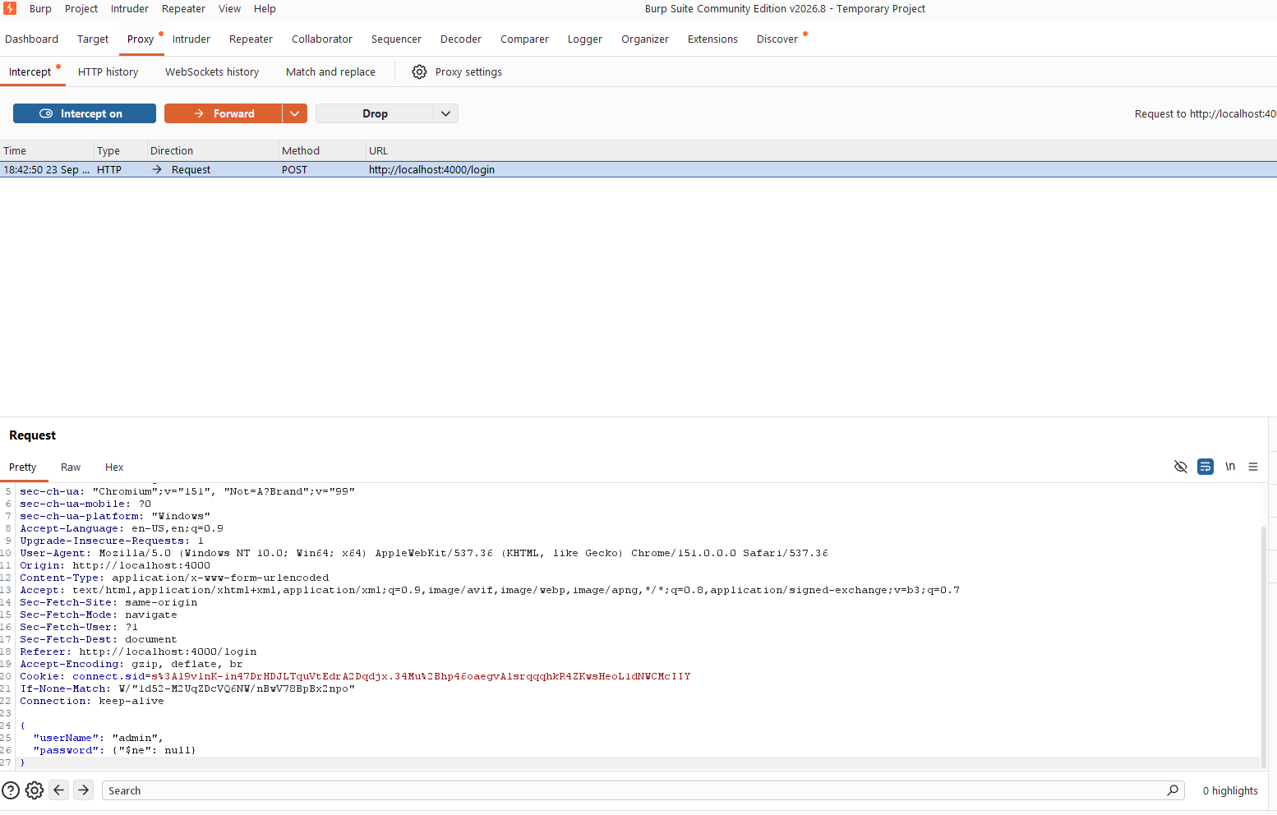

Fix
app/data/user-dao.js
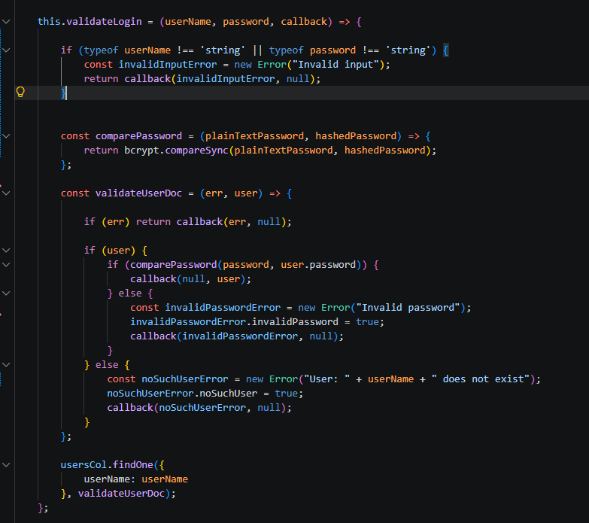
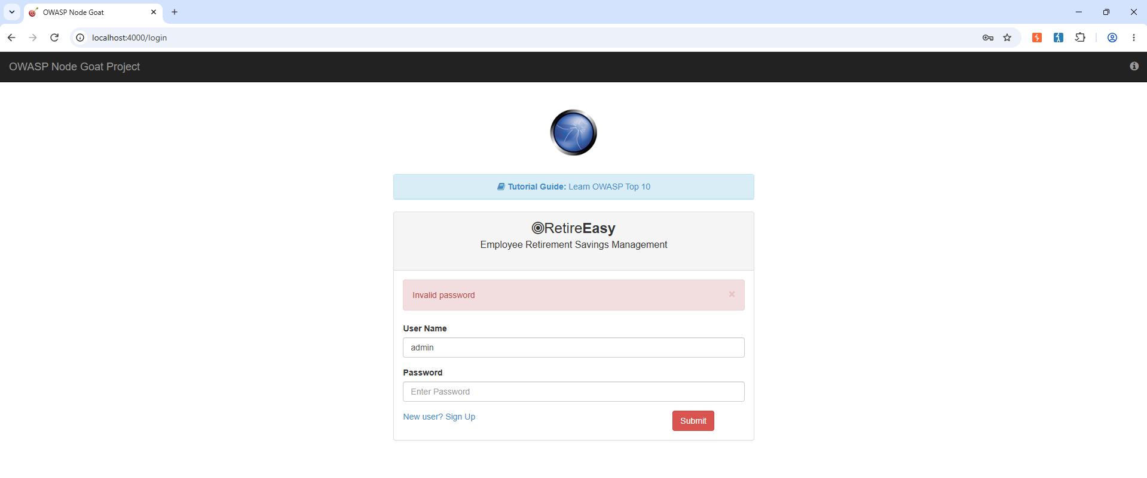

Stored Cross-Site Scripting (XSS)
The attack was executed by injecting a malicious JavaScript payload, <script>alert("XSS Exploit !")</script>, into the First Name field of the profile update form. The application stored and reflected this payload unsanitized, allowing it to execute within the browser context, exposing the application to session hijacking. The vulnerability was patched in app/routes/profile.js by wrapping all user-supplied profile variables in a custom escapeHtml function to sanitize the input before saving it to the database. Re-testing confirms the payload is now contextually encoded and rendered safely as harmless text rather than executable script

Vulnerability
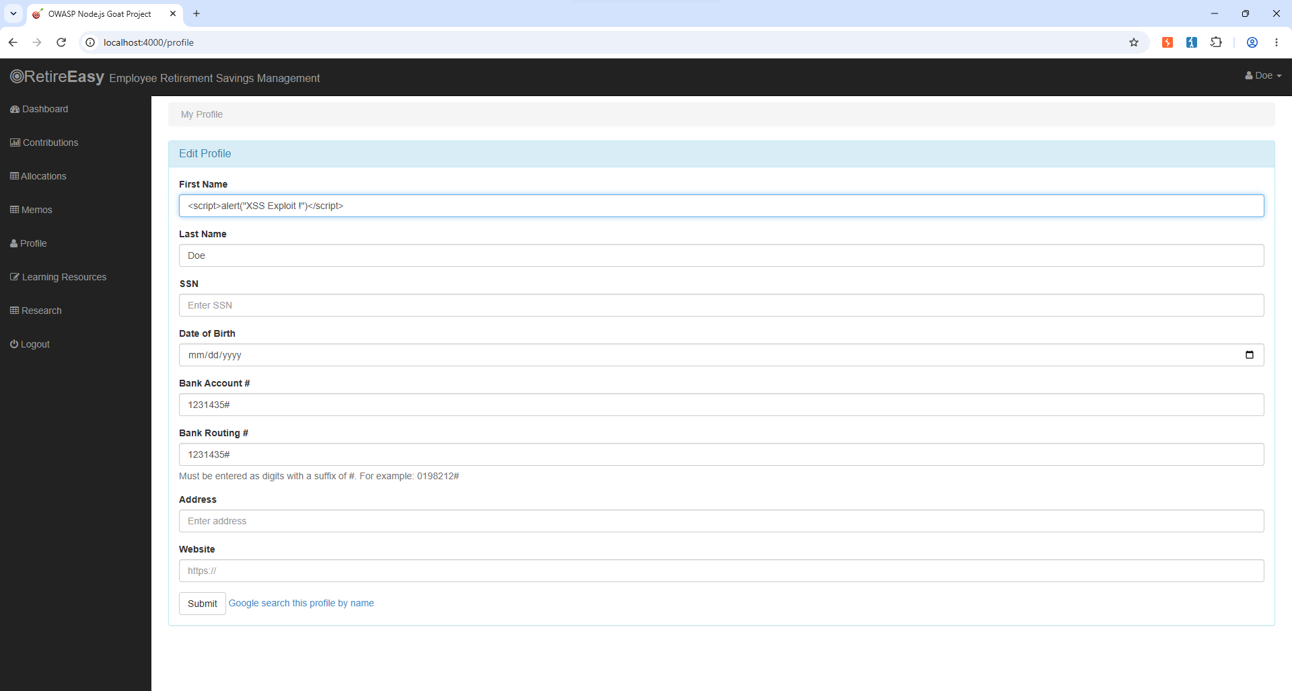
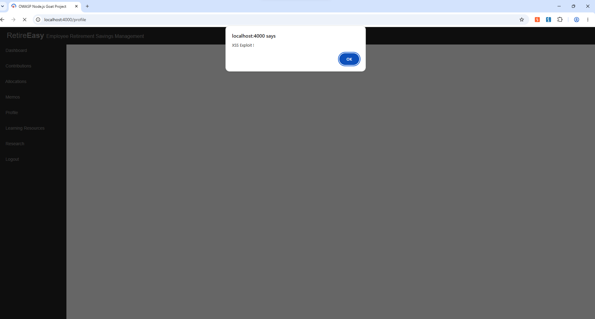

app/routes/profile.js
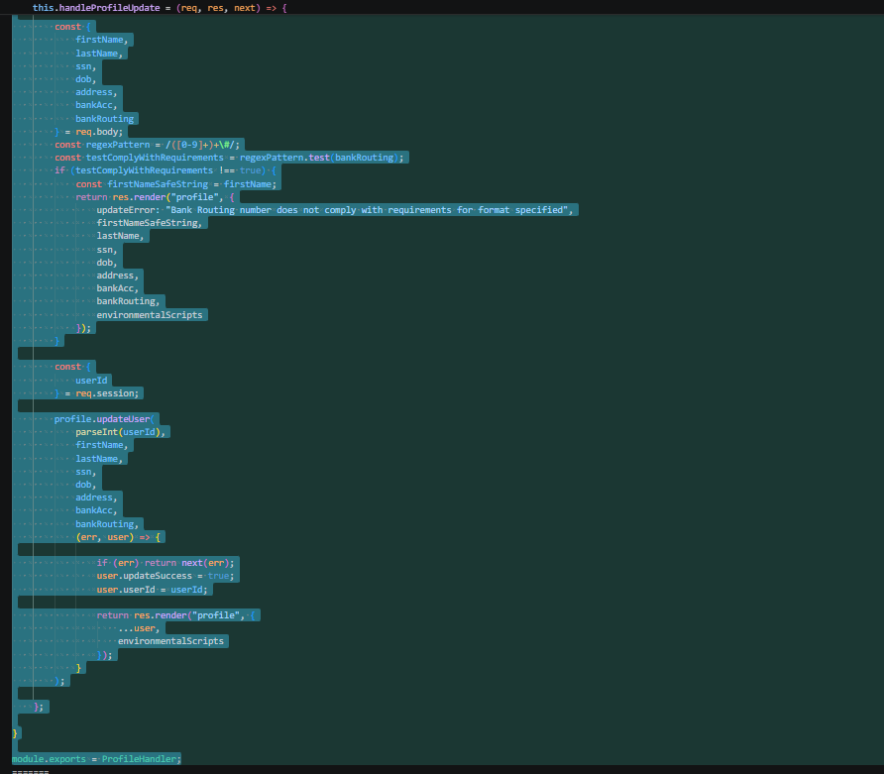

Fix
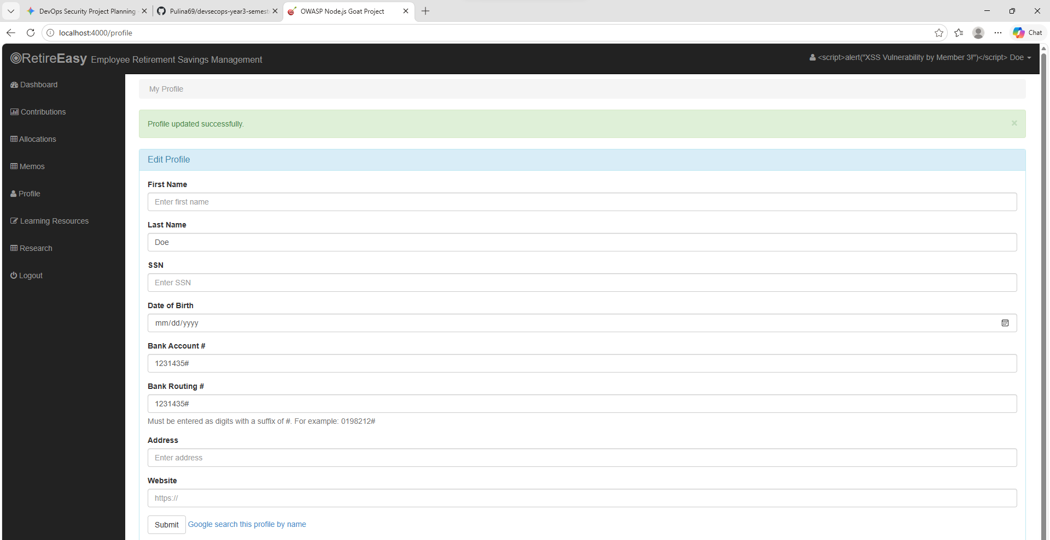
app/routes/profile.js
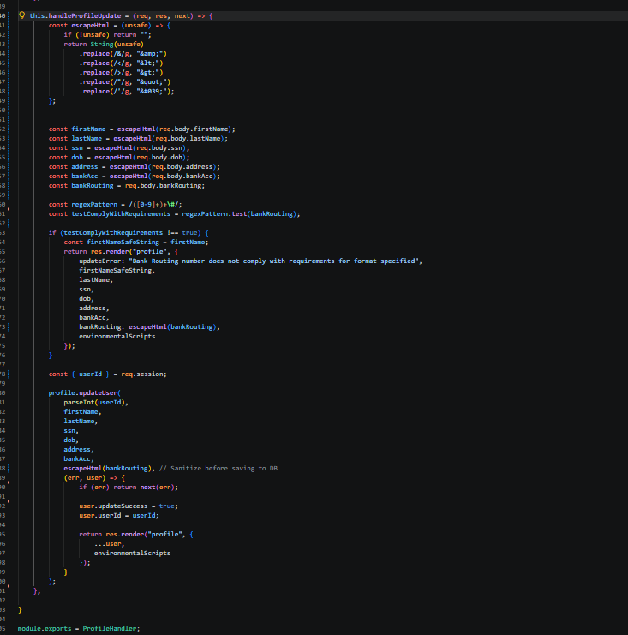

Insecure Direct Object Reference (IDOR)
This vulnerability was exploited by manipulating the client-side URL parameter in the browser from /allocations/2 to /allocations/1, which successfully retrieved the sensitive financial asset records of another user. This is a critical Information Disclosure flaw caused by the application trusting client-supplied input for database lookups without verifying ownership. The fix in app/routes/allocations.js enforces server-side authorization by strictly comparing the requested userId parameter against the cryptographically verified req.session.userId. Re-testing the parameter manipulation now correctly returns an "HTTP 403 Forbidden" error, preventing unauthorized data access..

Vulnerabilities
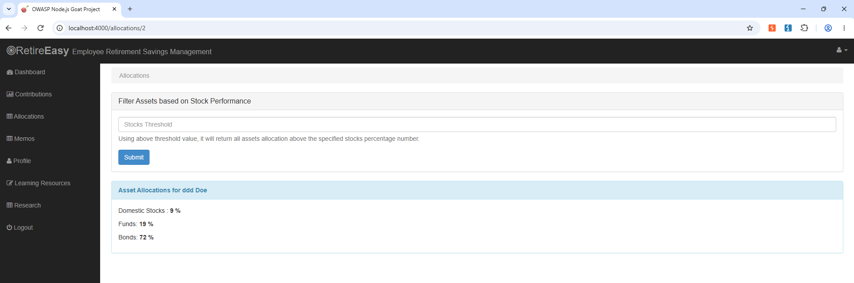
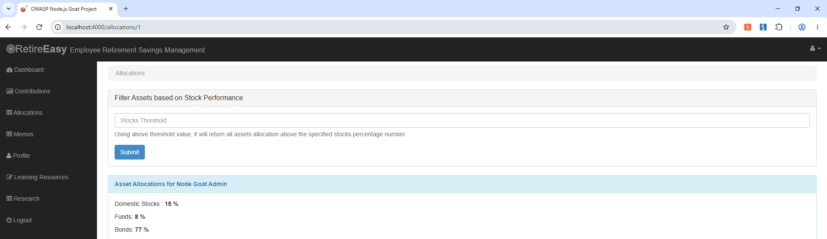
app/routes/allocations.js
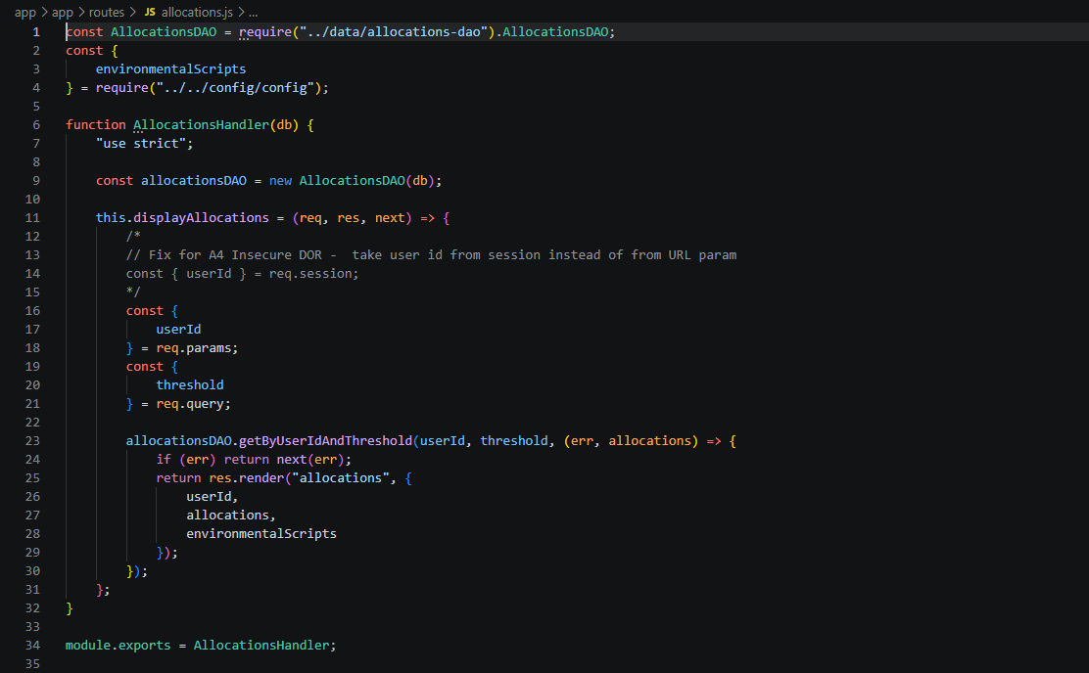

Fix

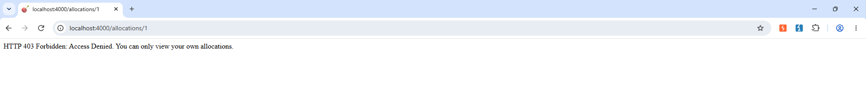
app/routes/allocations.js
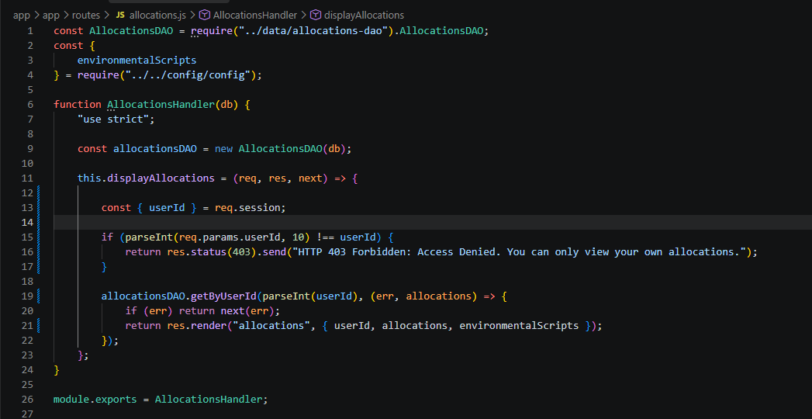

Insecure Cryptographic Storage (Plaintext Passwords)
Connecting directly to the MongoDB container and querying the database (db.users.find()) revealed that the application stored user credentials in raw plaintext. This flaw meant that any database compromise would immediately result in total credential theft. The code was remediated in app/data/user-dao.js by integrating the bcrypt library to generate a salt (bcrypt.genSaltSync) and iteratively hash passwords (bcrypt.hashSync) prior to insertion, alongside updating the login function to use bcrypt.compareSync. Re-testing via direct database inspection confirms that new user credentials are now securely stored as irreversible cryptographic hashes.

Vulnerable
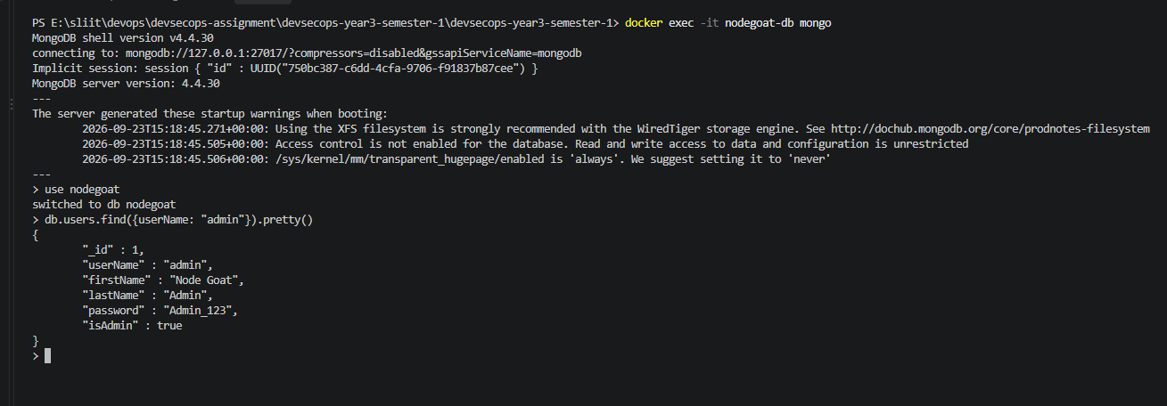
app/data/user-dao.js
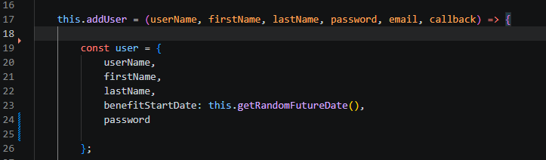

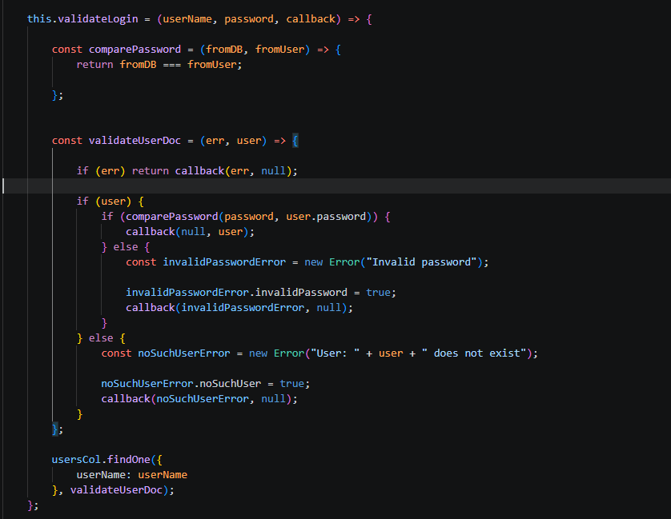

Fix
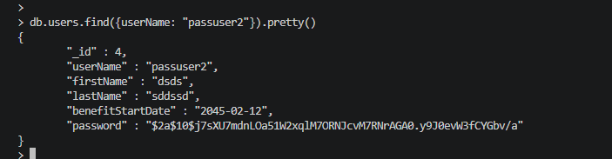
app/data/user-dao.js
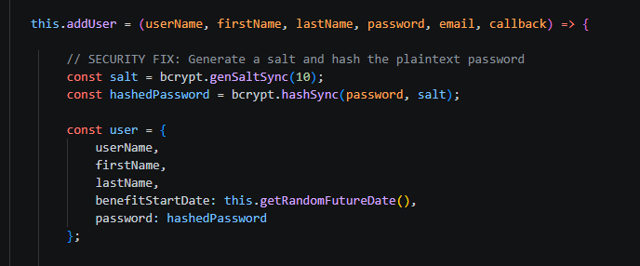

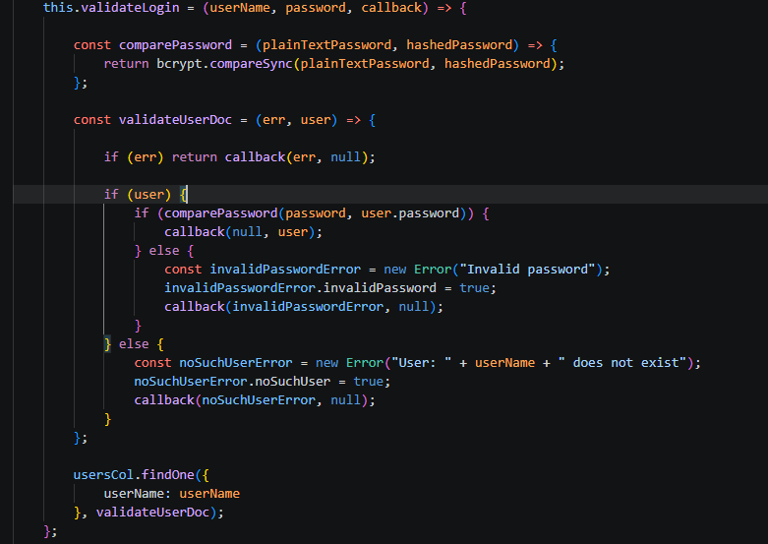

SAST scan
To quantitatively validate the effectiveness of the implemented secure coding remediations, Static Application Security Testing (SAST) was conducted using Semgrep. The scanner was executed locally against the codebase both prior to and following the remediation phase to measure the reduction in application-layer vulnerabilities.

Before
The initial local baseline scan of the legacy NodeGoat architecture yielded 38 blocking findings across the scanned files. Semgrep successfully detected the hardcoded API keys and cryptographic secrets within the configuration files, the lack of input sanitization in the profile routes, and the direct unvalidated database assignments contributing to NoSQL injection vectors.
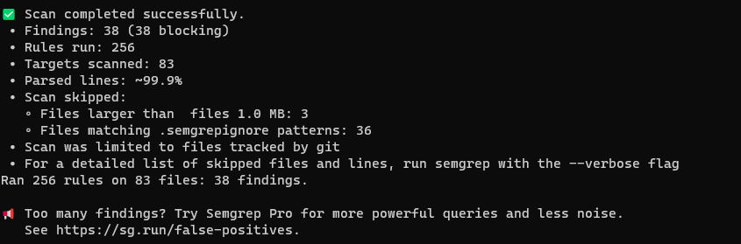

After
Following the manual implementation of contextual HTML escaping (escapeHtml), strict type checking for MongoDB queries, session-enforced access controls, and bcrypt hashing, the codebase was rescanned. The post-remediation scan dropped the blocking finding count down to 15. This proves the successful elimination of 4 specific critical vulnerabilities targeted in this assessment, establishing a hardened baseline that allows the automated CI/CD pipeline to pass successfully.
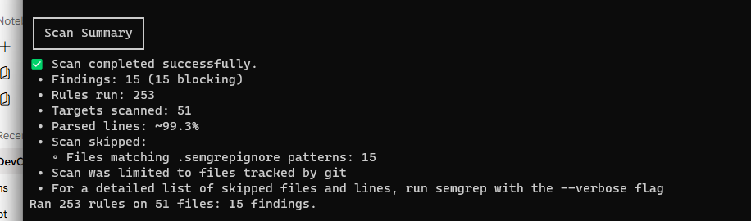

5.DevSecOps CI/CD Pipeline & Security Automation

GitHub Actions Workflow:
name: DevSecOps CI/CD Pipeline
on:
push:
branches: [ "main", "master" ]
pull_request:
branches: [ "main", "master" ]
jobs:
security-gates:
runs-on: ubuntu-latest
steps:
- name: Checkout Repository
uses: actions/checkout@v4
with:
fetch-depth: 0
- name: 1. Secret Scanning Gate (Gitleaks)
uses: gitleaks/gitleaks-action@v2
env:
GITHUB_TOKEN: ${{ secrets.GITHUB_TOKEN }}
- name: 2. SAST Scan Gate (Semgrep)
run: |
pip install semgrep
semgrep scan --config auto app/
continue-on-error: true # Warns but does not block to allow downstream gates to run
- name: 3. SCA / Dependency Scan Gate (npm audit)
run: |
cd app
npm install --package-lock-only
npm audit --audit-level=high
continue-on-error: true
- name: Build Application Container
run: docker build -t pulina/nodegoat:latest -f docker/Dockerfile .
- name: 4. Container Image Scan Gate (Trivy)
uses: aquasecurity/trivy-action@master
with:
image-ref: 'pulina/nodegoat:latest'
format: 'table'
exit-code: '1' # Enforces pipeline blocking on HIGH/CRITICAL vulnerabilities
ignore-unfixed: true
vuln-type: 'os,library'
severity: 'HIGH,CRITICAL'

Trigger the Failed Pipeline Run
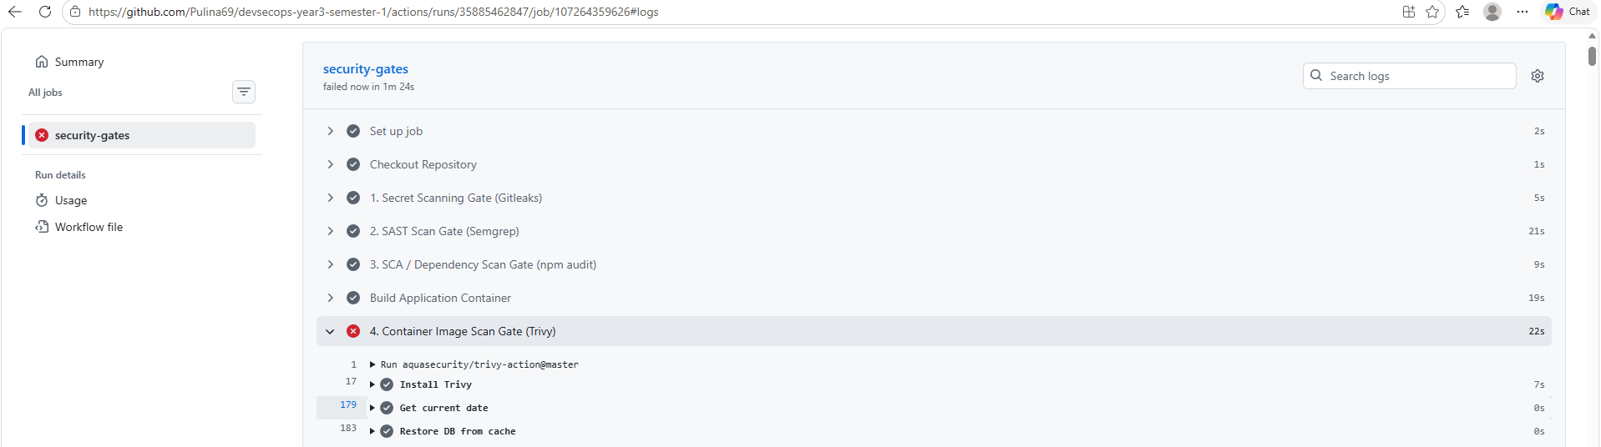
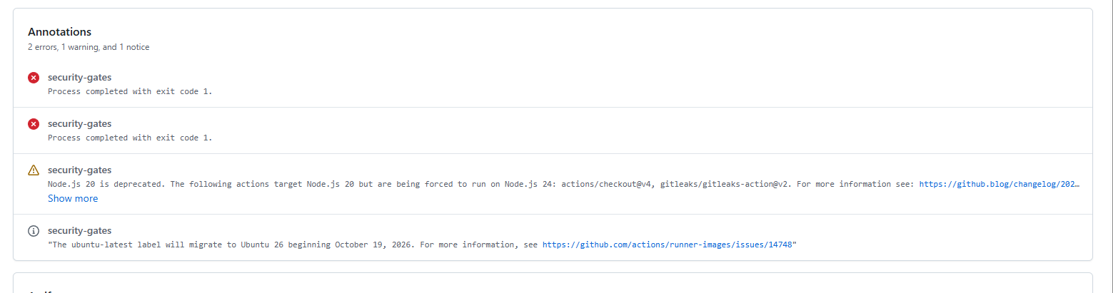

Trigger the Successful Pipeline Run
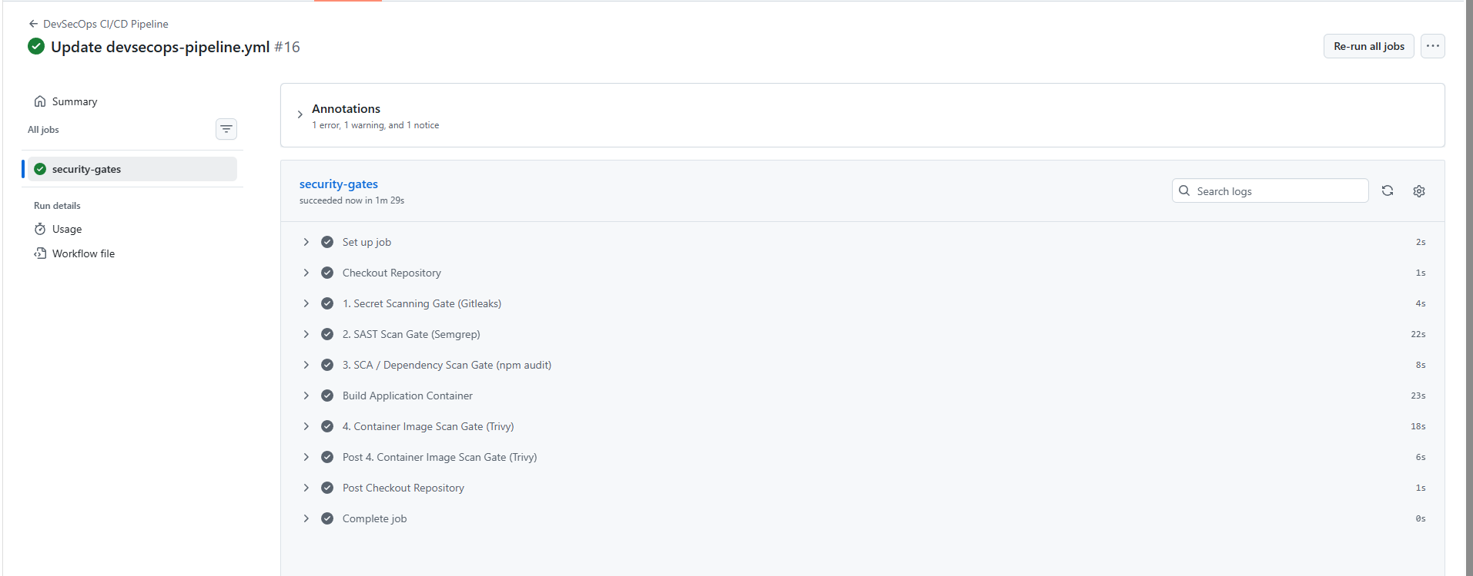

6.Secrets Management Approach

Secret Provisioning and Image Layer Security
By removing all hardcoded credentials like ZAP API keys and MongoDB connection strings found in the source code (development.js and test.js) and replacing them with environment-variables-references, it becomes possible to ensure that the production code does not contain any secrets. To ensure that Docker image layers do not contain any hardcoded credentials as well (as those could be extracted via docker history command), such credentials are removed from the Dockerfile and only provided during the application’s runtime. In the case of the local development environment, the variables are defined in a .env file that is not tracked by Git. As for the CI/CD multibranch pipeline, the variables are set during the GitHub Actions execution via the GitHub Actions Encrypted Secrets feature.

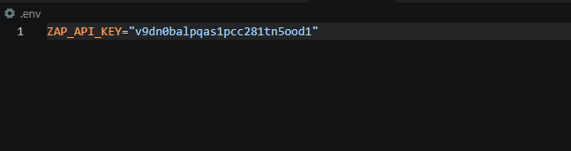
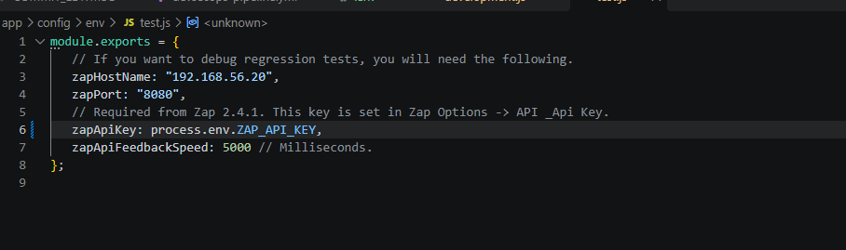
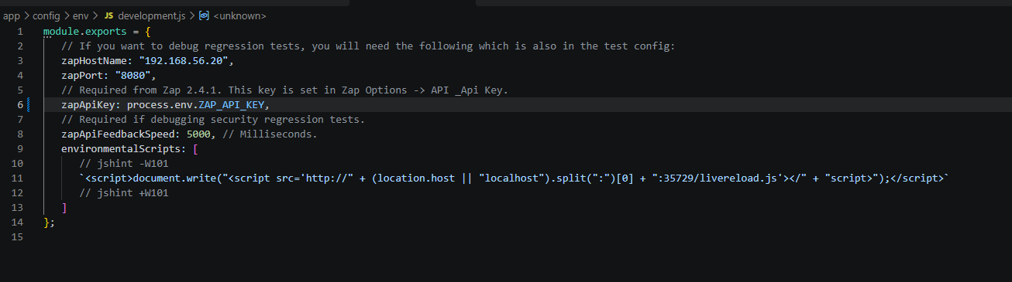

7.Industry Trends and Case Study Analysis

The Hidden Risks of Open Source: Lessons from the event-stream Supply Chain Attack
Modern software development rarely involves writing an application from scratch. Instead, developers rely on open-source ecosystems, importing pre-built libraries to handle everything from database connections to formatting text. While this drastically speeds up development, it introduces a massive blind spot: the software supply chain. When you install a single package, you are often pulling in dozens of other "transitive" dependencies—code written by strangers that you have never reviewed, running with the same permissions as your own application.
Instead of trying to hack through an organization's firewalls, modern attackers simply compromise these trusted open-source building blocks. If they can poison a popular library, developers will willingly download the malware straight into their secure networks.
One of the most fascinating and destructive examples of this is the 2018 attack on the Node.js package event-stream. At the time, event-stream was a massively popular utility tool, downloaded millions of times a week and used in major projects. However, the original developer was burned out and maintaining the project for free in his spare time. An unknown user going by the handle "right9ctrl" offered to help. By submitting a series of helpful, legitimate code updates, "right9ctrl" gradually earned the original developer's trust and was eventually handed full administrative control of the project.
This wasn't a smash-and-grab hack; it was a patient social engineering operation. Once in control, the attacker added a new, obscure sub-dependency called flatmap-stream to the project. On GitHub, the code for flatmap-stream looked perfectly harmless. But the version pushed to the npm registry—the code that actually gets downloaded when developers run npm install—contained highly obfuscated, encrypted malware.
The payload was brilliant because it was incredibly specific. The malware was designed to stay completely dormant unless it detected it was being executed inside a very specific environment: the build process for an application called Copay, a popular cryptocurrency wallet. If it detected Copay's specific description string, it used that string as a decryption key to unlock its true payload. The malware then injected a backdoor into the Copay app designed to harvest users' Bitcoin private keys and silently send them to an external server. Because it was buried inside a dependency of a dependency, it bypassed manual code reviews entirely and sat undetected for months.

Defending Our Project: How Our CI/CD Pipeline Stops Supply Chain Attacks
The event-stream incident proves that simply writing secure code is no longer enough; we have to secure the tools and libraries we build our code with. You cannot just assume a package is safe because it is popular. The DevSecOps pipeline we built for this project is specifically designed to catch and neutralize exactly this type of threat using a defense-in-depth approach.
- Software Composition Analysis (npm audit)
The first line of defense in our GitHub Actions workflow is the Software Composition Analysis (SCA) gate, powered by npm audit. Supply chain attacks rely on the fact that package managers automatically pull down the newest versions of dependencies. When a malicious package is finally discovered by security researchers, it is flagged and added to global vulnerability databases.
By running npm audit --audit-level=high in our pipeline, we are essentially running an automated background check on every single piece of third-party code in our project. The tool cross-references our package-lock.json file against these global databases. If a developer accidentally pulls in a compromised library like flatmap-stream, the SCA scan immediately detects the known CVE (Common Vulnerabilities and Exposures) signature. The pipeline exits with a failed status, turns red, and physically blocks the compromised code from moving forward in the build process. It acts as an automated guardrail against trusting poisoned open-source libraries.
- Container Image Scanning (Trivy)
While npm audit is great for checking Node.js libraries, it only looks at the application source code. It is entirely blind to the operating system it runs on. Attackers know this, which is why they frequently target OS-level packages (like the recent xz-utils backdoor in Linux).
This is where Trivy comes in as our second security gate. Trivy doesn't just look at the code; it scans the final, compiled Docker image (pulina/nodegoat:latest). This is the exact artifact that will be deployed to a live server. Trivy inspects both our application dependencies and the base Debian OS packages we use in our Dockerfile. By configuring our pipeline with --exit-code 1 and targeting HIGH and CRITICAL vulnerabilities, we enforce a strict rule: if the container is vulnerable, the build fails. Even if a malicious package somehow sneaks past the npm audit step, Trivy will catch it when analyzing the final image, ensuring a poisoned container is never deployed to our users.
- Software Bill of Materials (SBOM) for Incident Response
The hardest part of defending against an attack like event-stream is the "zero-day" window. For several weeks, the flatmap-stream malware was completely unknown to the public. During that time, tools like npm audit and Trivy would not have flagged it because no CVE existed yet. When a zero-day drops and the news breaks, automated scanners cannot save you retroactively.
This is why generating a Software Bill of Materials (SBOM) is a critical industry trend. An SBOM is simply a comprehensive, machine-readable "ingredients list" of every single component inside your application, including all those deeply nested transitive dependencies.
If we wake up to news that a library in our ecosystem has been compromised, we don't have to spend days manually digging through our source code to see if we are vulnerable. We can simply search our SBOM for the malicious package name. It gives us instant visibility, allowing us to immediately determine if our application is at risk and roll out a patch in minutes rather than weeks.
By layering these automated tools—scanning the source dependencies, inspecting the compiled container, and maintaining total visibility into our software ingredients—our DevSecOps pipeline actively hardens the application against the realities of modern supply chain attacks.

8.Project reflection and future improvements
Project reflection :the value of “shifting left”
This project shows the critical value of "shifting. Automating security gates directly into ci/cd pipeline prove that security and development can be coexist. by automatically Catching vulnerabilities like NoSQL injection and hardcoded secrets at pull request stage preventing them from reaching production
Strategic future improvements
- DAST Integration
  - Integrate OWASP zap dynamically scan the running container for runtime misconfigurations and business logic flaws that SAST cannot detect
- Automated SBOMs and artifact signing
  - Utilize Syft to generated machine readable software bill during every build to cryptographically sign docker images
- Dynamic secret vault
  - Inject short lived automatically rotating credentials into the container
- Policy as code
  - To automatically scan IaC configures to ensure cloud deployments adhere to compliance rule before provisioning

9.Individual Contribution Statement
Member name | Student id | responsibilities | contribution
Pethvan P.P | IT24101491 | Engineered the CI/CD pipeline (GitHub Actions), implemented automated security gates (Trivy, Semgrep, Gitleaks), and authored Section 5 (Pipeline) and Section 6(Secrets Management) | 25%
Aluthge M.N | IT24102268 | Conducted the baseline threat modeling, performed manual vulnerability exploitation for NoSQL Injection and IDOR, and authored the corresponding exploit walkthroughs in Section 4. | 25%
Shanthoshika S | IT24101727 | Executed secure code remediation for Stored XSS and Insecure Cryptographic Storage (bcrypt), captured SAST comparison evidence, and authored the code patch walkthroughs in Section 4. | 25%
Adithya E.A.D.D.D | IT24101916 | Researched the event-stream supply chain attack, mapped project defenses (SCA/SBOMs) to industry trends, and authored Section 7 (Industry Case Study) and Section 8 (Reflection). | 25%

10.AI usage disclosure
For this assignment we used Artificial Intelligence resources (Google Gemini/ChatGPT) to troubleshoot the GitHub Actions Workflow syntax, to check the document structure, and to review industry case studies. The technical materials generated as part of this project have not been automatically produced by any AI tools. All of the members of the group carried out the exploitation of the vulnerabilities, corrected the source codes, configured the CI/CD pipeline and performed the analysis.

11.Reference
- OWASP Foundation, "OWASP NodeGoat Project," OWASP.org, 2026. [Online]. Available: https://owasp.org/www-project-nodegoat/

- T. Hunter II, "Compromised npm Package: event-stream," Medium, Nov. 26, 2018. [Online]. Available: https://medium.com/intrinsic-blog/compromised-npm-package-event-stream-d47d08605502.
- CSIDE, "The Copay event-stream attack illustrates dependency risks," CSIDE Blog, Jul. 29, 2024. [Online]. Available: https://cside.com/blog/the-copay-event-stream-attack-illustrates-dependency-risks.
- Revenera, "Compromised npm Package: event-stream and flatmap-stream packages lead to supply chain attack," Revenera Blog, Nov. 27, 2018. [Online]. Available: https://www.revenera.com/blog/software-composition-analysis/compromised-npm-package-event-stream-and-flatmap-stream-packages-lead-to-supply-chain-attack/.
- National Institute of Standards and Technology (NIST), "Secure Software Development Framework (SSDF) Version 1.1: Recommendations for Mitigating the Risk of Software Vulnerabilities," NIST Special Publication 800-218, Feb. 2022. [Online]. Available: https://csrc.nist.gov/publications/detail/sp/800-218/final.
- Aqua Security, "Trivy: Comprehensive Security Scanner," GitHub, 2026. [Online]. Available: https://github.com/aquasecurity/trivy.
- Semgrep, "Semgrep: Lightweight static analysis for many languages," Semgrep.dev, 2026. [Online]. Available: https://semgrep.dev/.
- Z. Rice, "Gitleaks: Protect and discover secrets using Gitleaks," GitHub, 2026. [Online]. Available: https://github.com/gitleaks/gitleaks.
- P. Pethvan et al., "devsecops-year3-semester-1," GitHub, 2026. [Online]. Available: https://github.com/Pulina69/devsecops-year3-semester-1.
- OWASP Foundation, "NodeGoat Source Code Repository," GitHub, 2026. [Online]. Available:. https://github.com/OWASP/NodeGoat.git

