- Doctor AI: AI-Powered Diagnostic Systems, SHAP-based Explainability
1st Akanksha  Department of Computer Science  KIET Group of Institutions  Delhi-NCR, Ghaziabad, India akanksha.cs@kiet.edu  4th Raghav Mishra  Department of Computer Science  KIET Group of Institutions  Delhi-NCR, Ghaziabad, India raghav.2226cseml1055@kiet.edu | 2nd Pulkit  Department of Computer Science  KIET Group of Institutions  Delhi-NCR, Ghaziabad, India pulkit.2226cseml1051@kiet.edu  5th Gautam Pandey  Department of Computer Science  KIET Group of Institutions  Delhi-NCR, Ghaziabad, India gautam.2226cseml1044@kiet.edu | 3rd Nikhil Kaul  Department of Computer Science  KIET Group of Institutions  Delhi-NCR, Ghaziabad, India nikhil.2226cseml1006@kiet.edu

Abstract— Artificial intelligence and its applications are everywhere around us and affect every industry, including healthcare. Advancements in artificial intelligence make digital healthcare more effective by providing the possibility of early diagnosis and makes sure it is accessible by everyone at zero cost. In this paper we propose one such medical system, Doctor AI, a predictive model which can diagnosis the users disease based on the few symptoms. In Doctor AI we leverage ensemble techniques to achieve 100% test accuracy when trained on dataset of 41 disease spread across 4290 samples. We also integrate SHAP (SHapley Additive exPlanations) based explainability to make the results more interpretable by the professionals. We aim to show how enhancing the interpretability can increase trust in digital healthcare.
Keywords— Artificial Intelligence, Explainable AI, SHAP,
Deep Learning, Healthcare Diagnosis, Ensemble Learning

I. INTRODUCTION
The advancement of artificial intelligence in recent years has really prompted the use of AI in healthcare systems, which has created the possibility for early diagnosis and personalized treatment which could also be accessible to everyone. In this work we propose the design and development of Doctor AI, a smart web based medical assistant that uses an ensemble model to try and predict the disease based on symptoms reported by users.
This system uses a trained ensembled model combining Support Vector Classifier (SVC) and Deep neural network (DNN) to analyze user input and predict what is likely the medical condition. We also offer various detailed insights such as disease descriptions and prevention tips along with suggested medications, dietary advice, and exercise routines tailored to each condition.
The application is built with a Python Flask backend and we used HTML/CSS/JavaScript for the frontend, featuring Bootstrap and animations which may enhance the user experience. For further ease of use it also contains pdf report generation and voice recognition. We believe the platform can also be hosted on the cloud for possibly better accessibility and scalability.
In this paper we discuss the technical details and implementation of Doctor AI which includes everything from model training to the final evaluation. Here we also attempt to compare its benefits to traditional symptom checking methods. Traditional diagnostic tools may lack the flexibility and predictive power needed for medical diagnosis, while AI technologies like deep neural networks may provide strong predictive accuracy but can also raise issues related to interpretability and trust due to their complex nature. Our system aims to address these factors of disease prediction by combining SVM and DNN models along with SHAP to potentially enhance transparency. We focus on the supervised classification problem where the user provides symptoms and the model predicts outcomes. We think the study shows how AI might be effectively integrated into digital health solutions to help raise awareness and possibly reduce diagnostic delays for non-critical cases.
II. LITERATURE REVIEW
In [1], Shortliffe et al. created MYCIN, one of the first computer programs used to help doctors identify medical problems. It was used to identify bacterial infections and suggest the preventive measures.
In [2], Myers and Miller created Internist-l, a medical diagnosis system that uses experts knowledge to analyse complex patient information. It was quite accurate, but it has to be entered manually.
In [3], WebMD Corporation created the WebMD Symptom Checker, a web-based platform allowing users to manually input symptoms and receive potential causes. It is proprietary, lacks transparency in its algorithms, and does not offer medical customisation or PDF outputs.
In [4], Ada Health GmbH developed the Ada Health app, an AI-based tool that helps users to check their symptoms and get possible prevention suggestions and an interactive interface.
In [5], Khan et al. presented a machine learning system that used Naïve Bayes and Decision Trees to predict diseases based on symptoms. The results improved when the data was cleaned and useful features were selected. However, did not include user-friendly elements such as voice input or automatic report generation.
In [6], S. Patel et al. showed that adding speech recognition to medical AI systems can make them more efficient and accessible, especially for people in rural areas or individuals with special needs. However, it does not include a full frontend or provide guidance as medicine or diet suggestions.
In [7], Kumar and Verma worked on creating medical summaries and PDF reports from diagnosis results using NLP and HTML to PDF tools.
In [8], K. Dey et al. (2021) used machine learning to study how disease can be predicted from patient symptoms.
In [9], Chaddad et al. (2023) reviewed different Explainable AI(XAI) methods used in healthcare. They highlighted that medical AI systems must be transparent so that doctors and patients can trust them, and ensure that technology is used ethically in clinical settings.
In [10], the paper "Optimising Healthcare Decisions Using Explainable AI for Enhanced Predictions" (2024) shows that XAI models can improve clinical decision-making by giving understandable predictions and reducing diagnostic errors in complex medical data.
In [11], Van der Velden et al. (2022) focused on the roles of XAI in deep learning-based medical image analysis. Their findings show that adding explainability to image models increases diagnostic reliability and confidence.

In [12], Wu et al. (2023) suggested an understandable machine learning method that makes use of LIME. Their study displays how explainability helps maintain transparency in prediction findings.
In [13], Saraswat et al. (2022) study the concept of healthcare 5.0 and how Explainable AI can transform it. They discussed its benefits and problems of using XAI in healthcare, such as interpretability, scalability, and ethical considerations.
In [14], Pawar et al. (2020) highlighted the importance of using XAI in healthcare analytics to support clinical decision-making. It is mainly focused on making AI-based healthcare systems.
In [15], Mujawar et al. (2024) compared SHAP and LIME methods for explaining cancer prediction models. They found that SHAP gives more consistency across datasets, while LIME offers better interpretability for individuals.
In[16], the Scikit-learn documentation supports the implementation of the web framework for systems.
In [17], the flask documentation supported the implementation of the web framework for deploying the systems.
In [18], the WHO illness guidelines were used to get disease information and medical recommendations.

III. METHODOLOGY
Overview - The proposed system, employs an end to end trained and intelligent pipeline that combines statistical learning and neural computation in an attempt to increase predictive power while explainable AI (SHAP powered) provides interpretable results. It is designed to process user-input symptoms in order to predict potential diseases and then justify its decision using transparent and data-driven explanations.
3.1. System Architecture
The architecture of Doctor AI follows a multilayered, modular approach comprising the following key stages:
- Input Layer: Through our web interface the user provides symptoms in text format as the input for the system. These symptoms are then mapped to a 132-dimensional binary symptom vector, in this vector each index represents the presence or absence of a symptom.
- Feature Engineering Layer: We transform input symptoms into a structured numerical format here which is compatible with both our traditional and deep learning models. We try to make sure models ignore missing or unrecognized values to hopefully ensure robust performance.
- Modelling Layer: This layer contains two models — a Support Vector Machine (SVM) and a Deep Neural Network (DNN) which we trained independently to learn the disease symptom associations.
Decision Fusion; Here outputs from the individual models are integrated using soft voting. We used this to form a balanced ensemble that may possibly enhance prediction reliability.
- Explainability Layer: We integrated the SHAP (SHapley Additive exPlanations) framework here to try to interpret model behaviour and visualize influential features contributing to each prediction.
- Output Generation: Finally the system generates a web based output which contains the predicted disease and SHAP visualization along with various other features such as medical recommendations and a downloadable pdf report.
This modular architecture may help in ensuring the interpretability and scalability for new data and additional disease categories as well.
Fig. 1. Shows the basic architecture and flow of Doctor AI
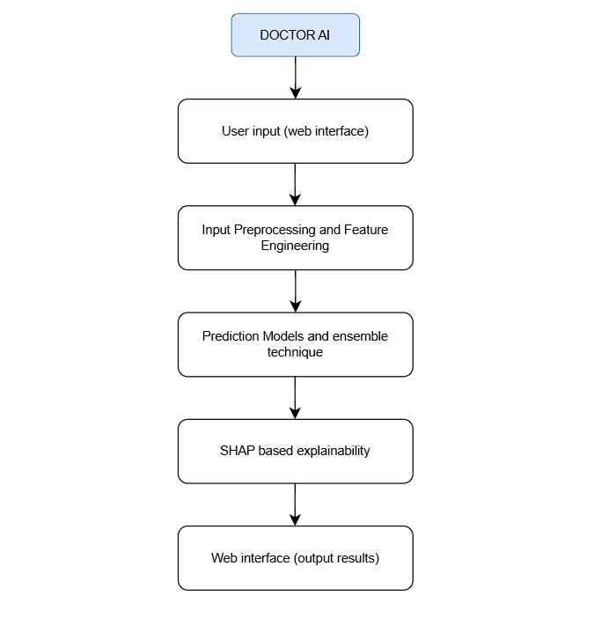
Fig. 1.

  - Dataset and Preprocessing
For the training and evaluation of the model, we used a dataset that contains 4,920 patient records with 132 distinct symptom features mapped to 41 disease categories.
We ensured each sample is a vectorised binary encoding of the presence or absence of the symptom. We believe this facilitates compatibility with both linear and nonlinear models effectively.
Key preprocessing steps include:
  - Feature Normalisation: Ensures consistent scaling for the DNN.
  - Label Encoding: Diseases are encoded numerically using a Label Encoder stored as label_encoder.joblib.
  - Train-Test Split: Data is divided into 80:20 ratio for training and evaluation.
  - Sanitization Pipeline: Prevents injection of invalid or malformed user inputs in the Flask-based frontend.
  - Ensemble Model
To achieve optimal predictions, Doctor AI employs a soft voting ensemble combining SVM and DNN probability outputs
- Support Vector Machine (SVM):
  - Implemented using scikit-learn’s SVC with a linear kernel and probability=True for calibrated and probabilistic outputs.
  - The SVM captures linear relationships between symptom vectors and disease classes. The model is then stored as svc.pkl, a pickle file.
Implementation notes:
  - Preprocessing: standardise numerical features, use encoding with care.
  - Hyperparameters: kernal=’rbf’, use class_weight=’balanced’
Fig. 2 illustrates the training and validation accuracy of the SVC model. Both accuracy converge and stabilize near 100% suggesting that the model generalizes well.
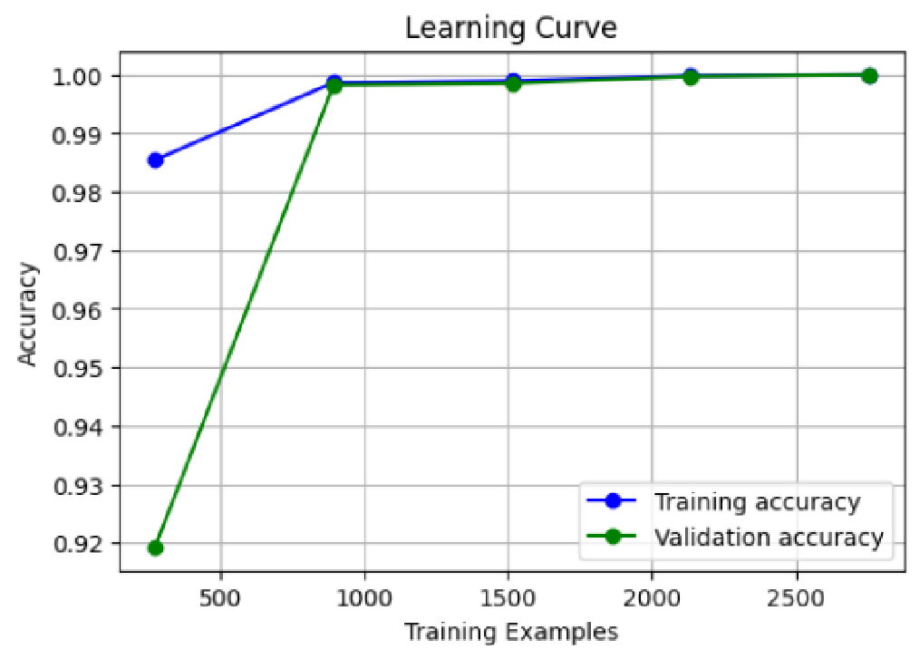

Fig. 2. Learning curve of SVM
- Deep Neural Network (DNN):
• Implemented in TensorFlow/Keras, the DNN architecture is defined as:
Input (132) → Dense (128) → Batch Normalization → Dropout (0.3) →Dense (64) → Batch Normalization → Dropout (0.3) → Dense (32) → Output (softmax)
Layer-by-Layer description:
- Input layer
Receives pre-processed feature vector. Missing values are imputed, and features will be standardised.
- Dense(128)
First high-capacity layer to learn nonlinear feature interactions.
- Batch Normalisation
Stabilises learning, reduces internal covariate shift, and often allows higher learning rates.
- Dropout (0.3)
Regularisation to reduce overfitting.
- Dense (64)
Intermediate representation; layer depth helps in hierarchical feature extraction.
- Dense (32)
Compact representation before the final decision layer; helps the model focus on compact predictive signals.
This design ensures robust nonlinear mapping, which helps the model in generalising well and prevents overfitting.
Fig. 3 illustrates the training and validation accuracy and loss of the DNN model.

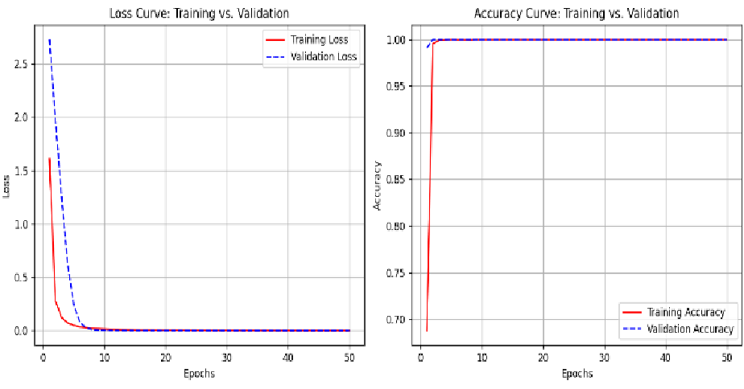
Fig. 3. Learning curves of DNN
- Soft Voting:
The ensemble combines model probabilities as:
PFINAL = W_{DNN} ⋅ P_{DNN} + W_{SVM} ⋅ P_{SVM} where, …(1)
WDNN = WSVM = 0.5 ……(2)
The final disease class is determined as:
ypred = argmax(PFINAL)
This balanced fusion ensures the performance and robustness of DNN and the simplicity and interpretability of SVM.

  - Explainable AI Integration
To enhance clinical trust and transparency, SHAP (SHapley Additive exPlanations) is integrated for local, individual prediction interpretability.
- Use of XAI in healthcare
  - Trust & adoption: Clinicians must understand why a system recommended a diagnosis before incorporating it into care.
  - Debugging and bias discovery: Explanations help identify spurious correlations or dataset artefacts.
  - Patient communication: Transparency helps in explaining the recommendations to patients.

- SHAP Workflow:
  - The SHAP explainer computes feature contributions for each symptom in the input vector.
  - Top contributing symptoms are visualised in a bar chart, allowing medical professionals or users to understand why a specific disease was predicted.
- Visualization:
The system dynamically generates and saves SHAP plots as images, which are then embedded into the web interface for each prediction. This transparency aligns the model’s decision with medical reasoning, improving user trust.

- Practical considerations when using SHAP
  - Background dataset selection: SHAP requires a background distribution to compute the expected value. Use a representative sample of the training data.
  - Explainer choice: Use DeepExplainer or GradientExplainer for neural networks if compatible
  - Performance: KernelExplainer is computationally expensive;use a small representative subset for analysis.

  - Web Application Deployment
The trained models are deployed within a Flask web framework integrated with Flask-CORS.
The web interface enables:
    - Interactive symptoms input
    - Real-time disease prediction
    - Downloadable PDF medical report via xhtml2pdf

IV. RESULTS
The accuracy of the model is calculated as the Accuracy Classification Score. A value between 0 and 1 is returned by the function. The higher the number better the accuracy score.
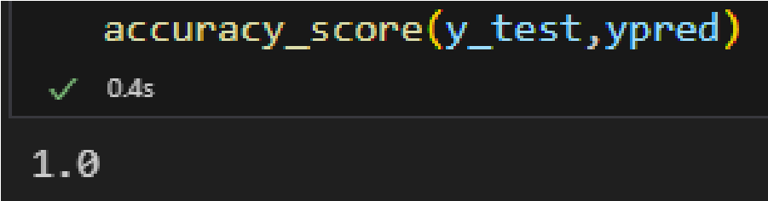
Fig. 4. Accuracy of SVM
From Fig. 4, the accuracy of the SVM model individually is 100%.
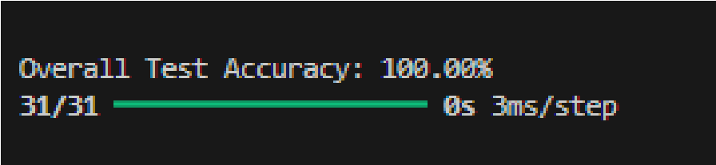
Fig. 5. Accuracy of DNN
From Fig. 5, the accuracy of the DNN model individually is 100%.
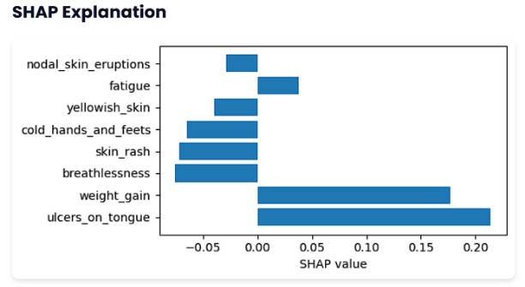
Fig. 6. Sample SHAP plot
Fig. 6 shows a sample SHAP plot obtained in the browser when input symptoms = itching.
Interpretation: The bar plot visualises the magnitude and direction of the most impactful features. (in this case, 8 features)
- A positive SHAP value indicates the feature that makes the diagnosis more likely. Eg. weight_gain
- A negative SHAP value indicates the feature that makes the diagnosis less likely. Eg. skin_rash
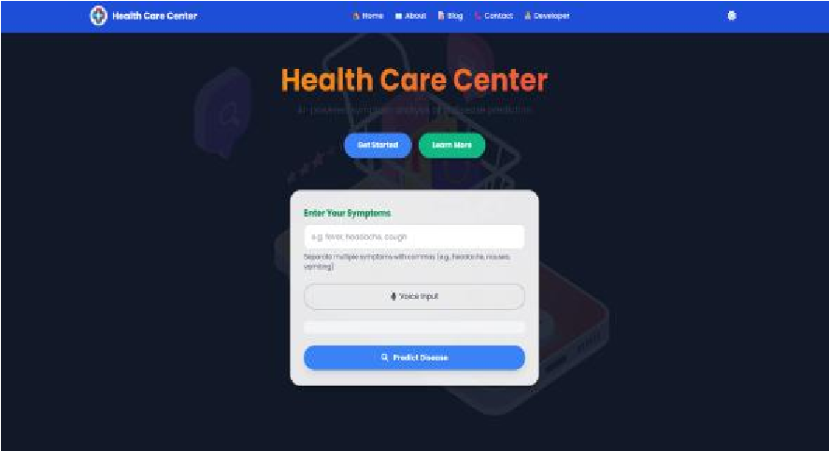
Fig. 7. Web interface of the Home page, running on Localhost

Fig. 7. Shows the user interface of our website, designed for simplicity and user friendliness.
Once we enter the symptoms and click the Predict Disease button our application generates the results which will be displayed as shown in Fig. 8.
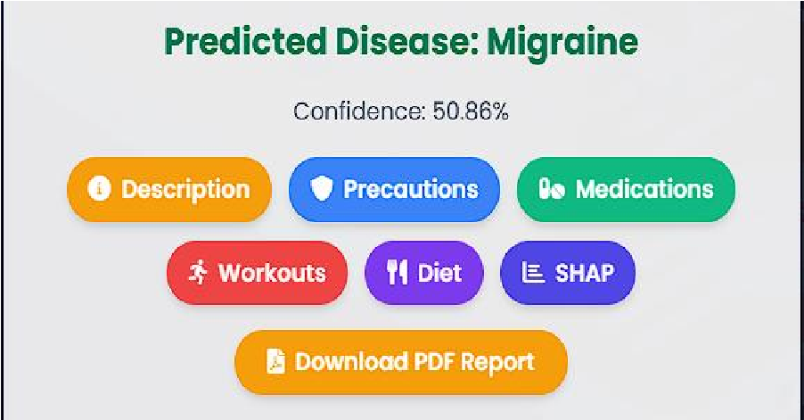
Fig. 8 results based on entered symptoms
Fig. 8 shows the various options and recommendation our system generates based on the entered symptoms. Every button is clickable and provides details about the specific aspect in clear bullet points. A pdf report can also be downloaded which includes all the recommendations and the description.

Comparison between features and functionalities of Doctor AI and few other research papers is discussed in Table 1.

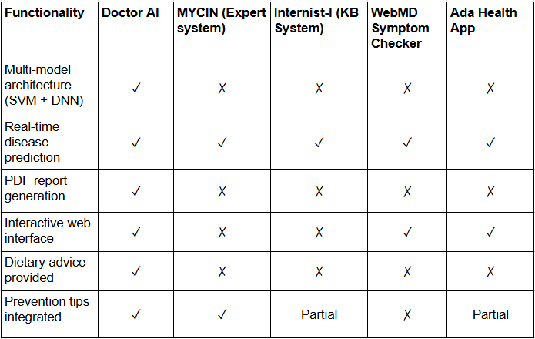

Table 1. Comparison Table

V. CONCLUSION

Doctor AI presented an explainable diagnostic assistant that combines an SVM baseline and a TensorFlow DNN through soft-voting ensemble methods and SHAP explanations to make model decisions interpretable. Our solution demonstrates a comprehensive pipeline for symptom-based disease prediction, including preprocessing, model creation, and an integrated web interface with downloadable results.

The experimental results on a dataset of 4,920 records and 41 disease categories consistently demonstrate high predictive accuracy, confirming the feasibility of combining classical and deep learning methods with explainable AI for accessible and web-based healthcare support. While our current evaluations are only limited to an internal dataset, the framework is designed to scale toward a larger and more diverse clinical data. Future development in Doctor AI might focus on extending and improving the dataset and also optimizing SHAP computations for faster and computationally lightweight results.

With the continued refinement and improvement of Doctor AI it may potentially evolve from just a research prototype into a dependable clinical tool. We think it can assist in non-critical cases and may also help to possibly enhance trust in AI-assisted healthcare.

REFERENCES
- E. H. Shortliffe, “Computer-Based Medical Consultations: MYCIN,” Elsevier, 1976.
- J. D. Myers and R. A. Miller, “The Internist-I Computer-Based Diagnostic Tool: History and Current Status,” MD Computing, vol. 1, no. 5, pp. 29–36, 1984.
- WebMD Corporation, “WebMD Symptom Checker,” [Online]. Available: https://symptoms.webmd.com (dated on : 11 Sep 2025)
- Ada Health GmbH, “Ada - Check Your Health Symptoms,” [Online]. Available: https://ada.com (dated on : 19 Sep 2025)
- R. Khan, A. Ahmad, and S. Khan, “Disease Prediction System Using Machine Learning Techniques,” International Journal of Advanced Research in Computer Science, vol. 10, no. 5, pp. 45–50, 2019.
- S. Patel, N. Shah, and K. Dave, “AI-based Disease Prediction Using Speech Recognition,” International Research Journal of Engineering and Technology (IRJET), vol. 7, no. 5, pp. 231–234, 2020.
- A. Kumar and P. Verma, “Automated PDF Report Generation for Health Diagnosis Using Flask and NLP,” International Journal of Scientific & Engineering Research (IJSER), vol. 11, no. 12, pp. 142–147, 2021.
- K. Dey et al., "Predicting Medical Conditions Using Symptoms", Journal of Biomedical Informatics, 2021.
- Chaddad A, Peng J, Xu J, Bouridane A. Survey of Explainable AI
Techniques in Healthcare. Sensors (Basel). 2023 Jan 5;23(2):634. doi: 10.3390/s23020634. PMID: 36679430; PMCID: PMC9862413.
- “Optimizing Healthcare Decisions Using Explainable AI for Enhanced Predictions”, Int. J. CIM, vol. 4, no. 1, pp. 17–27, Jun. 2024, doi: 10.54489/ijcim.v4i1.389.
- van der Velden BHM, Kuijf HJ, Gilhuijs KGA, Viergever MA. Explainable artificial intelligence (XAI) in deep learning-based medical image analysis. Med Image Anal. 2022;79:102470. doi:10.1016/j.media.2022.102470.
- Wu Y, Zhang L, Bhatti UA, Huang M. Interpretable Machine Learning for Personalized Medical Recommendations: A LIME-Based Approach. Diagnostics (Basel). 2023 Aug 15;13(16):2681. doi: 10.3390/diagnostics13162681. PMID: 37627940; PMCID: PMC10453635.
- D. Saraswat et al., "Explainable AI for Healthcare 5.0: Opportunities and Challenges," in IEEE Access, vol. 10, pp. 84486-84517, 2022, doi: 10.1109/ACCESS.2022.3197671.
- U. Pawar, D. O’Shea, S. Rea and R. O’Reilly, "Explainable AI in Healthcare," 2020 International Conference on Cyber Situational Awareness, Data Analytics and Assessment (CyberSA), Dublin, Ireland, 2020, pp. 1-2, doi: 10.1109/CyberSA49311.2020.9139655.
- S. Mujawar, M. Sayed and A. Chaware, "Empowering Decision Making in Healthcare - A Comparative Analysis of eXplainable AI Techniques Using SHAP and LIME for Cancer Patients Data," 2024 3rd Edition of IEEE Delhi Section Flagship Conference (DELCON), New Delhi, India, 2024, pp. 1-5, doi: 10.1109/DELCON64804.2024.10867049.
- Scikit-learn Documentation – https://scikit-learn.org (Dated on: 16 Sep 2025)
- Flask Documentation – https://flask.palletsprojects.com (dated on: 23 sept 2025)
- WHO Disease Guidelines – https://www.who.int (dated on: 23 Sept 2025)

