

**INT301: OPEN-SOURCE TECHNOLOGIES**

**CA-2**

**Assignment:** Techno Technical Aspect

**(**Filling Copyright form Online)

Name :- Pulkit Mishra

Reg. No. :- 11913340

Roll no. :- KE022B63

**Diary number :- 8472/2023-CO/L**

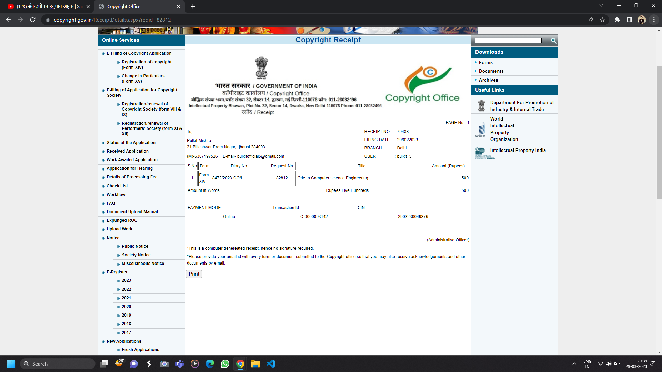

Submitted by

|  |  |  |  |
| --- | --- | --- | --- |
| Name | Reg. No. | Roll no. |  |
| Pulkit Mishra | 11913340 | 63 | Prime Applicant |
| Yash Vardhan  Srivastava | 11906337 | 21 | Co-Prime Applicant |
| Divyansh Pradip  Bawankar | 11909765 | 58 | Co-Prime applicant |