Configure OSPF routing

**Assignment#10**

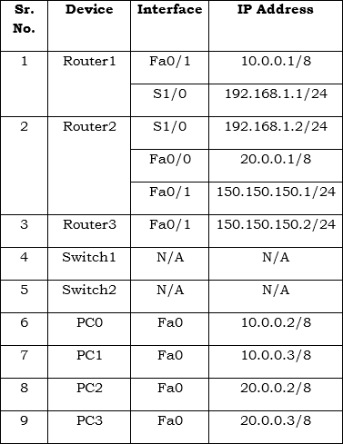

Syntax

Router(config)#router ospf <process id 1 -65535>

Router(config-router)network <network address> <wild card mask> area <0-4294967295>

1. Move on to **Router1** and execute the following commands to specify the OSPF network and area.
2. Router1(config)#router ospf 200

3. Router1(config-router)#network 10.0.0.0 0.255.255.255

area 0

4. Router1(config-router)#network 192.168.1.0 0.0.0.255 area 0.0.0.0

Router1(config-router)#exit

To verify and test the OSPF configuration, execute the following commands on any router and review the output of each command.

To view the OSPF neighbor routers, execute the following command.

Router#show ip ospf neighbor

To view the OSPF border routers, execute the following command.

Router#show ip ospf border-routers

