**LAB: Assignment 11**

**Objective: Configure a Routing Internet Protocol (RIP) Using GNS.**

## Instructions: The instructor is required to discuss the following questions with the students.

**Students are required to make solution and check connectivity using PING command.**

Procedure:

# Create a topology as shown in the figure.

1. Configure all the routers.

# Implement RIP protocols in the router to configure the network.

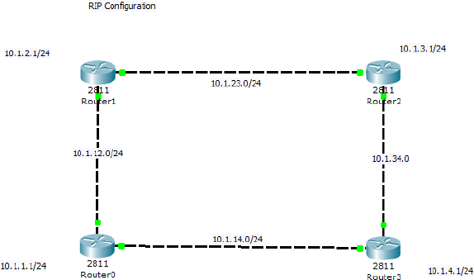

### Configuration for Router 0:

R0>en R0#conf t

R0(config)#int lo0 //loopback interface R0(config-if)#ip add 10.1.1.1 255.255.255.0

R0(config-if)#no shut

R0(config-if)#int s0/0

R0(config-if)#ip address 10.1.12.1 255.255.255.0 R0(config-if)#no shut

R0(config-if)#int s0/1

R0(config-if)#ip address 10.1.14.1 255.255.255.0 R0(config-if)#no shut

R0(config-if)#end R0#wr

### RIP Configuration Commands for R0:

R0>en R0#conf t

R0(config)#router rip R0(config-router)#net 10.0.0.0 R0(config-router)#

R0(config-router)#end R0#show ip route

**Configuration for R1:**

R1>en R1#conf t

R1(config)#int lo0 //loopback interface R1(config-if)#ip add 10.1.2.1 255.255.255.0

R1(config-if)#no shut

R1(config-if)#int s0/1

R1(config-if)#ip address 10.1.23.1 255.255.255.0 R1(config-if)#no shut

R1(config-if)#int s0/0

R1(config-if)#ip address 10.1.12.2 255.255.255.0 R1(config-if)#no shut

R1(config-if)#end R1#wr

### RIP Configuration Commands for R1:

R1>en R1#conf t

R1(config)#router rip R1(config-router)#net 10.0.0.0 R1(config-router)#

R1(config-router)#end R1#show ip route

## Configuration for R2:

R2>en R2#conf t

R2(config)#int lo0 //loopback interface R2(config-if)#ip add 10.1.3.1 255.255.255.0

R2(config-if)#no shut

R2(config-if)#int s0/0

R2(config-if)#ip address 10.1.23.2 255.255.255.0 R2(config-if)#no shut

R2(config-if)#int s0/1

R2(config-if)#ip address 10.1.34.1 255.255.255.0 R2(config-if)#no shut

R2(config-if)#end R2#wr

R2#en

R2#sh ip route

### RIP Configuration Commands for R2:

R2>en R2#conf t

R2(config)#router rip R2(config-router)#net 10.0.0.0 R2(config-router)#

R2(config-router)#end R2#show ip route

## Configuration for R3:

R3>en R3#conf t

R3(config)#int lo0 //loopback interface R3(config-if)#int s0/0

R3(config-if)#ip add 10.1.34.2 255.255.255.0 R3(config-if)#no shut

R3(config-if)#int s0/1

R3(config-if)#ip address 10.1.14.2 255.255.255.0 R3(config-if)#no shut

R3(config-if)#end R3#wr

R3#show ip route

### RIP Configuration Commands for R3:

R3>en R3#conf t

R3(config)#router rip R3(config-router)#net 10.0.0.0 R3(config-router)#

R3(config-router)#end R3#show ip route

