**Assignment 9**

**Objective: Configure Static Route in GNS3**

* Static route tells the device exactly where to send traffic, no matter what.
* Static route is often used when your network **has only a few routers** or **there is only one route from a source to a destination**.

**Syntax of Static route:**

# ip route destination-network-address subnet-mask {next-hop-IP-address | exit-interface}

Where,

1. **destination-network-address:** destination network address of the remote network
2. **subnet mask:** subnet mask of the destination network
3. **next-hop-IP-address:** the IP address of the receiving interface on the next-hop router
4. **exit-interface:** the local interface of this router where the packets will go out

# Scenario

* + Suppose that your company has **2 branches** located in **Tehran** and **Shiraz**.
  + As the administrator of the network, you are tasked to connect them so that employees in the two LANs **can communicate with each other**.
  + After careful consideration you decided to connect them via **static route**.

# Physical Topology

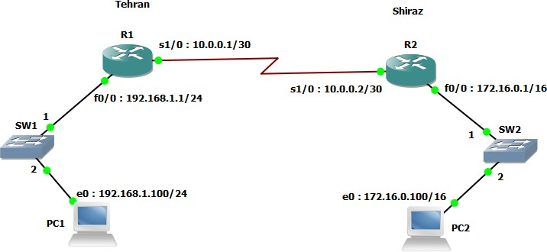

1. **Configuring interfaces on R1**

R1#configure terminal R1(config)#interface fastEthernet 0/0

R1(config-if)#ip address 192.168.1.1 255.255.255.0 R1(config-if)#no shut

R1(config-if)#exit R1(config)#interface serial 1/0

R1(config-if)#ip address 10.0.0.1 255.255.255.252 R1(config-if)#no shut

R1(config-if)#clock rate 64000 (now can’t send more thatn 64kbps)

# Configuring interfaces on R2

R2#configure terminal R2(config)#interface serial 1/0

R2(config-if)#ip address 10.0.0.2 255.255.255.252 R2(config-if)#no shut

R2(config-if)#exit R2(config)#interface fastEthernet 0/0

R2(config-if)#ip address 172.16.0.1 255.255.0.0 R2(config-if)#no shut

R2(config-if)#exit

# Show ip route command

R1#show ip route R2#show ip route

# Configuring static route on R1

R1(config)#ip route 172.16.0.0 255.255.0.0 10.0.0.2

R1(config)#exit R1#show ip route

# Configuring static route on R2

R2(config)#ip route 192.168.1.0 255.255.255.0 10.0.0.1

R2(config)#exit R2#show ip route

# Manually set an IP on PC1

PC1> ip 192.168.1.100 255.255.255.0 192.168.1.1

# Manually set an IP on PC2

PC2> ip 172.16.0.100 255.255.0.0 172.16.0.1

# Try to ping each far end network

PC2> ping 192.168.1.100

