Algo Fox – Strategy Development

(1) Exchange:- NFO/BFO

(2) Underlying :- INDEX SPOT

(3) Script selection :- NIFTY/BANKNIFTY/FINNIFTY/MIDNIFTY/SENSEX/BANKEX

(4) Strike Price :- OTM /ATM/ITM.

(5) Expiry Date :- …………..

(6) Order Types:- Normal/MIS

(7) Combine profit in Amount :-…………….

(8) Combine Loss in Amount :- ………………..

(9) Profit Trails in Amount :- (a) Reach at………… (b) Lock at & Square off ………….

(10) EVERY TRADE STOPLOSS IN %

(11) EVERY TRADE TARGET IN %

(12)FIX Lot size:-……………..

(13) New Cycle Stop Time :- ……….. don’t start new cycle after end of time here,

\*WHAT’S CYCLE?

ONE CYCLE IS DONE HERE, WHEN ANY HIT OF BELOW OPTIONS,

{ Combine profit in Amount /Combine Loss in Amount /Profit Trails in Amount }

(14) Directional Average in Points :-….50 points…..

(15) Reverse Direction in Points :-….100 points….

supposed I given input here, 50 in Direction average, and given 100 values in reverse Direction average. Then below scenario I can see, trade will execute by below pattern for Directional trade type,  
 suppose nifty start from 22000, then order should be placed like this,  
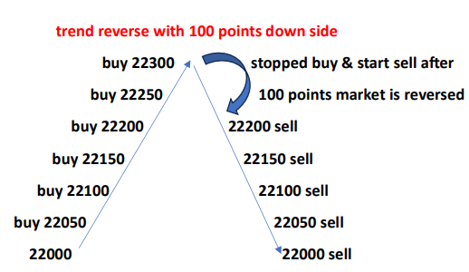  
Similar likes followed every 100 points reversed and start reverse direction trades by followed every 50 points distances.

For Opposite trade types become here opposite pattern, when market goes down side 50 points then start every 50 points buying order and when reversed from 100 points than start selling by every 50 points. Likes, do for until hit profit or hit loss.

(16) Trade Types :- Directional/Opposite.

If, I selected here Directional than it’s followed below scenario,

Suppose, nifty is open at 9:15 am at 22000 and I given Directional Average in points value is 50 points (wait for first entry in points) than here we can assume two possibilities. Either nifty goes up side or goes downside, if goes up side and touched 22050 then order should be placed immediately for bullish (ATM PUT SELL AND OTM PUT BUY OF CHOOSEN STRIKE PRICE) order, similar if nifty goes downside and touched 21950 then order should be placed immediately for bearish (ATM CALL SELL AND OTM CALL BUY OF CHOOSEN STRIKE PRICE) order. Here,

In shorts, It’s called trending strategy.