**CNN based Disease Detection Approach on Potato Leaves**

Name – Pulkit Garg

Roll No. – 102115006

Course Code – UEC642

Course Name – Deep Learning and Applications

Submission Date – 13th November, 2024



DEPARTMENT OF ELECTRONICS AND COMMUNICATION ENGINEERING

THAPAR INSTITUTE OF ENGINEERING & TECHNOLOGY PATIALA

November 2024

**Introduction**

Potatoes are a globally essential food crop and play a vital role in the economies of many countries. In Bangladesh, an agricultural hub, potato farming is crucial, occupying nearly 500,000 hectares of land annually and yielding between 0.70 and 1.09 crore tonnes, according to the Department of Agricultural Extension (DAE). As the world’s 7th largest potato producer, Bangladesh depends heavily on this crop, both for domestic consumption and export. However, in recent years, potato production has faced setbacks due to diseases affecting potato leaves, which impact both yield and quality, hampering the country's agricultural balance and export capabilities.

The efficient detection and management of these diseases are vital to ensuring food security and minimizing economic losses. Advanced detection techniques involving machine learning and computer vision provide promising approaches to early disease identification, enabling timely intervention. With the increasing adoption of these technologies, we can improve disease control practices and enhance the sustainability of potato farming. This study proposes a novel approach for detecting leaf diseases in potato crops using advanced image processing and machine learning methods. By leveraging recent advancements in deep learning, the proposed approach aims to provide accurate and real-time disease detection with minimal manual intervention.

Common potato leaf diseases like early blight, late blight, brown spot, bacterial wilt, and septoria blight pose serious challenges to production. These diseases present specific symptoms: early blight shows small black lesions, late blight appears as blistered areas that rot over time, while bacterial wilt affects all parts of the plant, and septoria leaf spot has grey centres with dark margins on leaves. Visual identification of these diseases can be challenging for farmers, yet critical for timely intervention.

To address these challenges, a deep-learning model for potato leaf disease detection is proposed. This model will classify potato leaves as healthy or diseased, with specific distinctions for early blight and late blight based on leaf images. This approach focuses on image-based detection, requiring a robust dataset of labelled images for training and testing. Images will be divided, with around 80% allocated for training, 10% for validation and the remainder for testing, to ensure high model accuracy.

By implementing this model, farmers will be able to easily identify diseases early, preventing the spread and boosting potato yield. This report presents the methodology, objectives, and results of this innovative study, contributing new perspectives to agricultural disease management through technological solutions.

**Problem Formulation**

The primary challenge addressed in this study is the early and accurate detection of potato leaf diseases. Traditional methods rely on manual inspection, which is labour-intensive, time-consuming, and often inaccurate due to human error. The focus of this research is to develop an automated, efficient, and scalable system that can detect and classify common potato leaf diseases using digital images. This problem is crucial as it can enable rapid response to disease outbreaks and reduce yield losses by facilitating timely intervention.

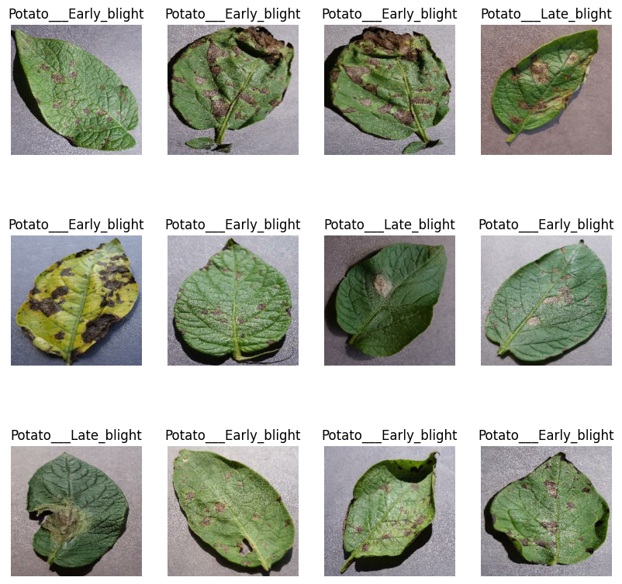

Fig 1.1 : Potato leaves with Early Blight and Late Blight

**Novelty Statement**

This study provides a novel approach by utilizing a customized CNN architecture optimized for distinguishing multiple types of potato leaf diseases. This work’s uniqueness lies in its application of deep learning to create a specialized, accurate tool for crop disease detection, potentially supporting large-scale agricultural disease monitoring.

**Objective**

* To develop an automated system for detecting common potato leaf diseases with high accuracy.
* To minimize the need for human intervention in disease detection by leveraging deep learning models.
* To design a system that can be integrated into mobile applications for real-time field use.

**Methodology**

The methodology for this project includes several essential steps, represented in the following flow:

1. **Data Collection and Preprocessing:** The dataset consists of images of potato leaves categorized by disease type. Images are resized, normalized, and augmented to improve model robustness and prevent overfitting.
2. **Model Architecture Selection:** A convolutional neural network (CNN) is chosen for its strong performance in image classification tasks. Layers and parameters are fine-tuned based on performance metrics.
3. **Training and Validation:** The dataset is split into training and validation sets. The model is trained on the training data, with hyperparameter tuning applied to optimize classification accuracy.
4. **Evaluation:** The model’s performance is evaluated on the validation set, using metrics such as accuracy, precision and recall. Further optimizations may be made based on the results.

An editable figure to illustrate this methodology might include steps like data collection, preprocessing, model selection, training, and evaluation, visually representing each part of the workflow.

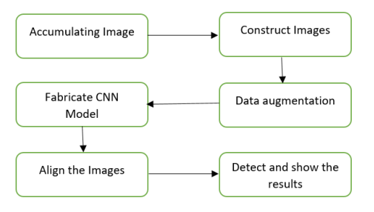

Fig 1.2 Block Diagram

**Code**

Drive link of google colab notebook :

<https://drive.google.com/file/d/1uoMt5jKcYrqmgIDfdqnr_mV4Iq8S3TDk/view?usp=drive_link>

**Results with description**

The model achieved an impressive accuracy of **96.24%** on the validation set, indicating a high level of proficiency in identifying and classifying potato leaf diseases. The training process involved optimizing the model to achieve strong performance metrics, and the results reflect the model's capacity for generalizing well on unseen data.

The graphs above show the **Training and Validation Accuracy** (left) and **Training and Validation Loss** (right) across 50 epochs. The accuracy graph reveals that the training accuracy increased steadily, eventually stabilizing close to 100%. The validation accuracy also shows an upward trend with minor fluctuations, leveling off around 96%, demonstrating consistent performance and minimal overfitting.

In the **Loss** graph, the training loss decreased sharply in the initial epochs and continued to fall gradually as training progressed, indicating that the model effectively learned from the data. The validation loss fluctuated more than the training loss, reflecting possible minor overfitting or sensitivity to certain validation samples, but overall, it stabilized at a low value, complementing the high validation accuracy.

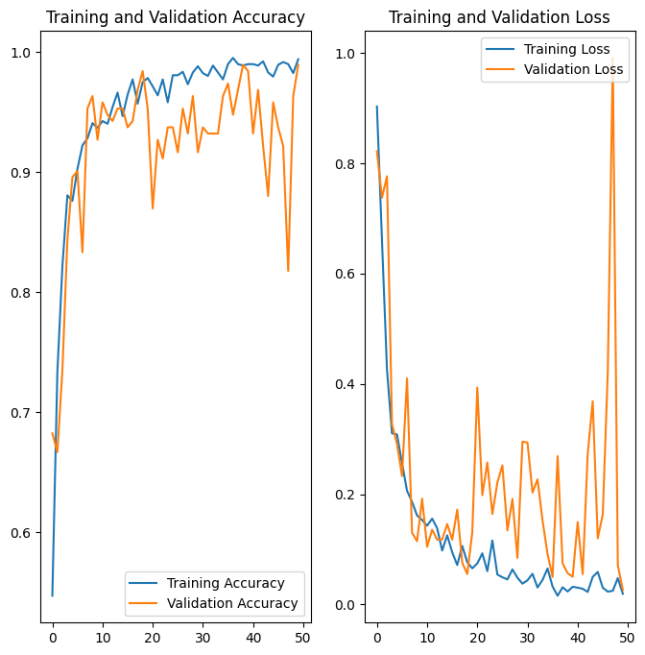

Fig 1.3 Training & Validation Accuracy and Training & Validation Loss

**References**

1. <https://www.kaggle.com/datasets/arjuntejaswi/plant-village>
2. <https://www.tensorflow.org/api_docs/python/tf/keras/preprocessing/image_dataset_from_directory>
3. <https://www.tensorflow.org/api_docs/python/tf/keras/callbacks/History>
4. <https://www.geeksforgeeks.org/convolutional-neural-network-cnn-in-machine-learning/>
5. Mahum, Rabbia, et al. "A novel framework for potato leaf disease detection using an efficient deep learning model." *Human and Ecological Risk Assessment: An International Journal* 29.2 (2023): 303-326.
6. Asif, Md Khalid Rayhan, Md Asfaqur Rahman, and Most Hasna Hena. "CNN based disease detection approach on potato leaves." *2020 3rd International conference on intelligent sustainable systems (ICISS)*. IEEE, 2020.