Minor project

Solar radiation prediction

Algorithm: MLPRegressor

Accuracy: 87.61987753102567 percent

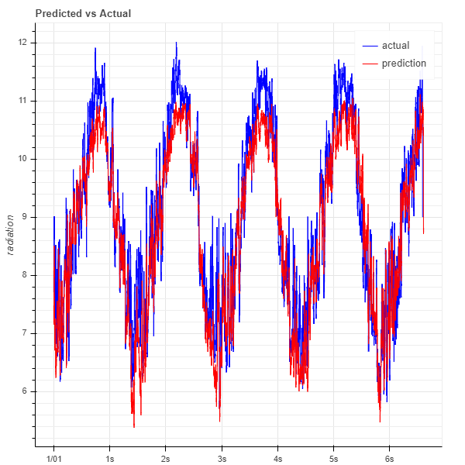

Algorithm: RandomForestRegressor

Accuracy: 96.4761933328811 percent

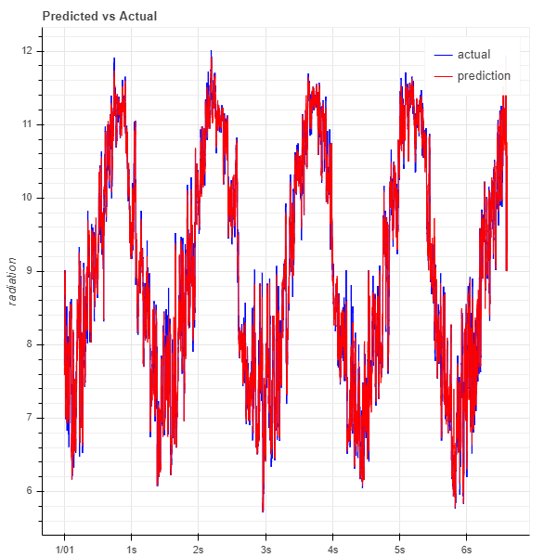

Algorithm: LinearRegression

Accuracy: 91.33480042728067 percent

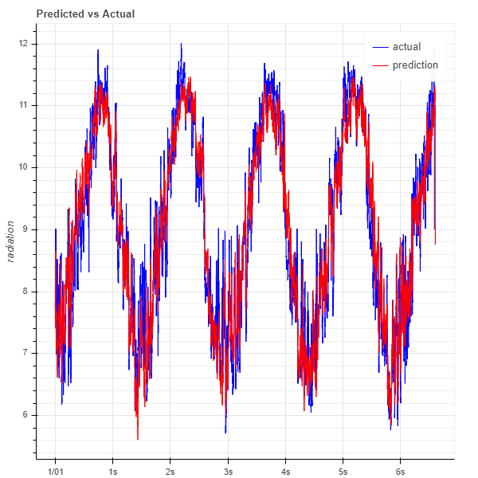

Correlation Matrix

