Name: Pulkit M. Jeph Class: B.Tech(III) CSE

Enrollment No.: 17114060 Subject Code: CSN-361

Batch:CS-2

Assignment L2

1. **Write a socket program in C to connect two nodes on a network to communicate with each other, where one socket listens on a particular port at an IP, while other socket reaches out to the other to form a connection.**

Data Structures used: 1. Struct sockaddr_in

2. Character array

Snapshot of running code:

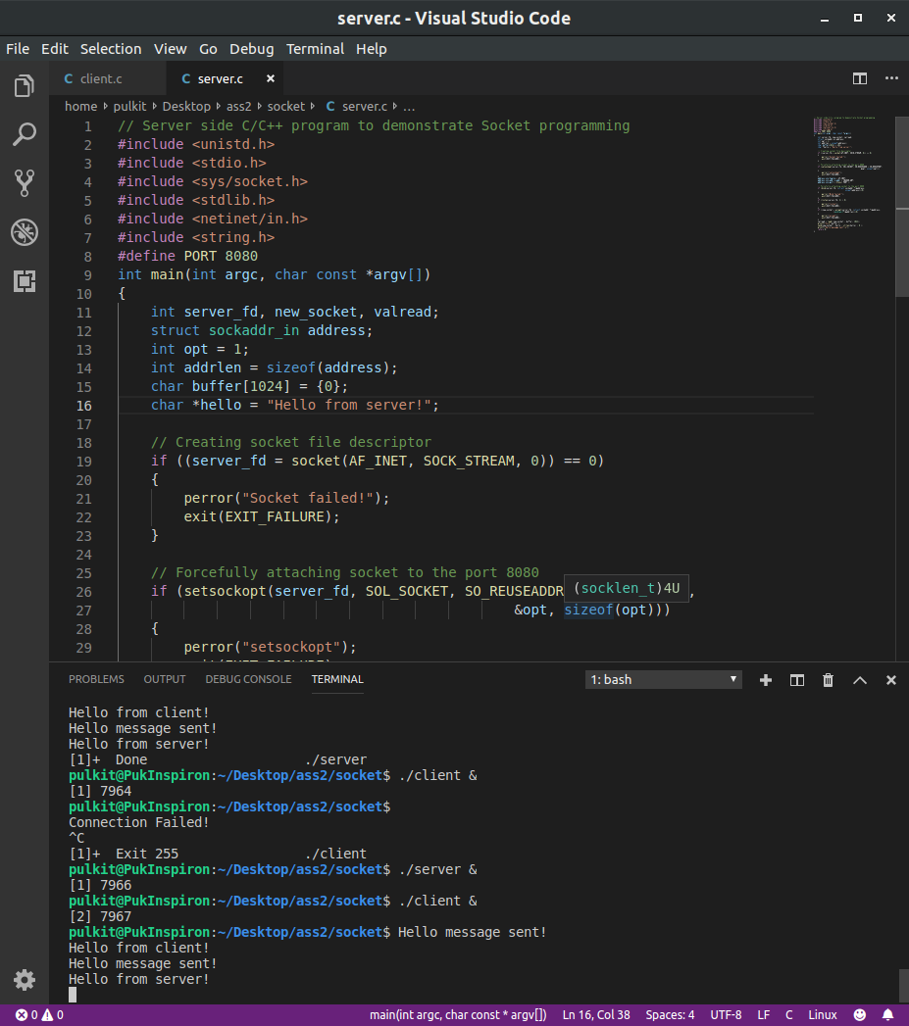

**2. Write a C program to demonstrate both Zombie and Orphan process.**

Snapshot of running code:

