Name: Pulkit M. Jeph Class: B.Tech(III) CSE

Enrollment No.: 17114060 Subject Code: CSN-361

Batch:CS-2

Assignment L3

1. **Write a socket program in C to determine class, Network and Host ID of an IPv4 address.**

**Input: 1.4.5.5**

**Output:**

**Given IP address belongs to Class A**

**Network ID is 1**

**Host ID is 4.5.5**

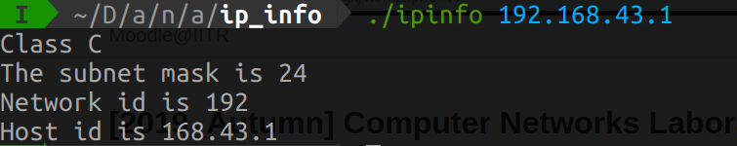

**2. Write a C program to demonstrate File Transfer using UDP.**

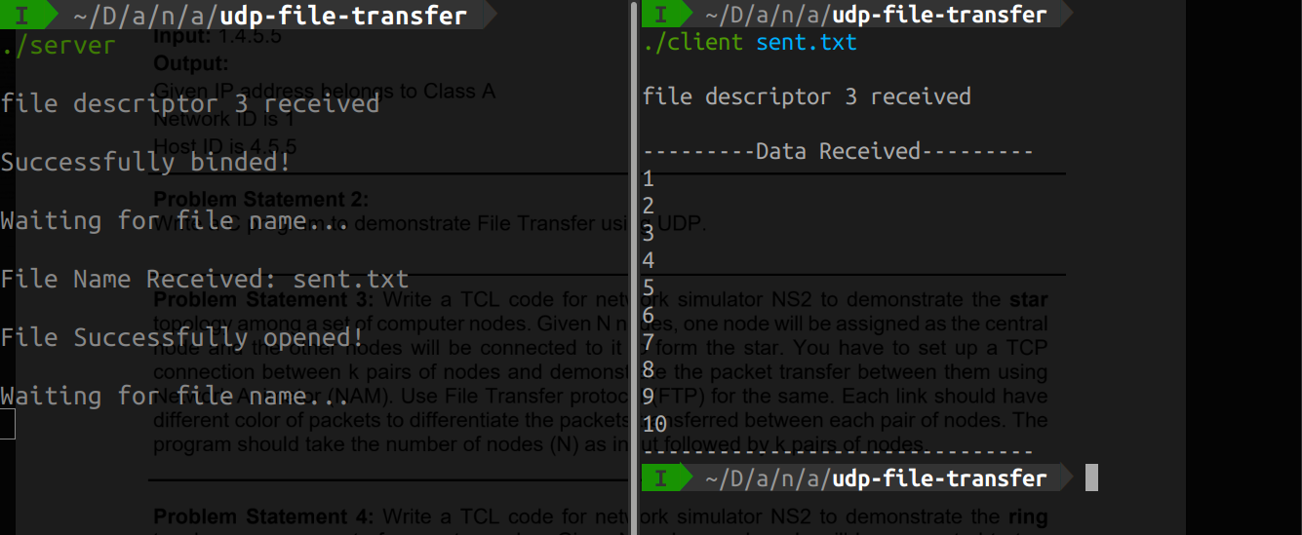

**3. Write a TCL code for network simulator NS2 to demonstrate the star topology among a set of computer nodes. Given N nodes, one node will be assigned as the central node and the other nodes will be connected to it to form the star. You have to set up a TCP connection between k pairs of nodes and demonstrate the packet transfer between them using Network Animator (NAM). Use File Transfer protocol (FTP) for the same. Each link should have different color of packets to differentiate the packets transferred between each pair of nodes. The program should take the number of nodes (N) as input followed by k pairs of nodes.**

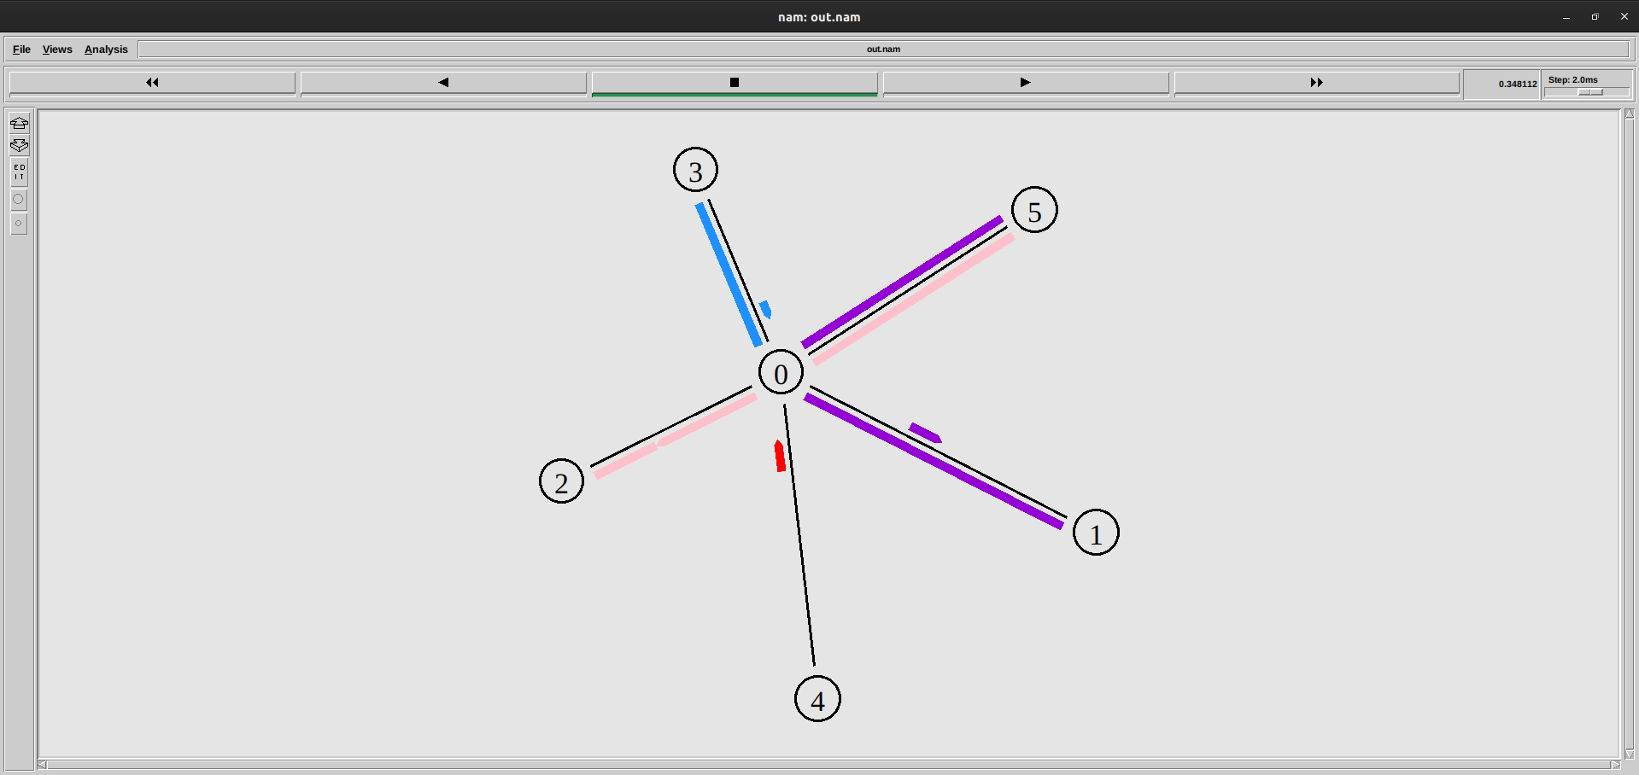

**4. Write a TCL code for network simulator NS2 to demonstrate the ring topology among a set of computer nodes. Given N nodes, each node will be connected to two other nodes in the form of a ring. You have to set up a TCP connection between k pairs of nodes and demonstrate packet transfer between them using Network Animator (NAM). Use File Transfer protocol (FTP) for the same. Each link should have different color of packets to differentiate the packets transferred between each pair of nodes. The program should take the number of nodes (N) as input followed by k pairs of nodes.**

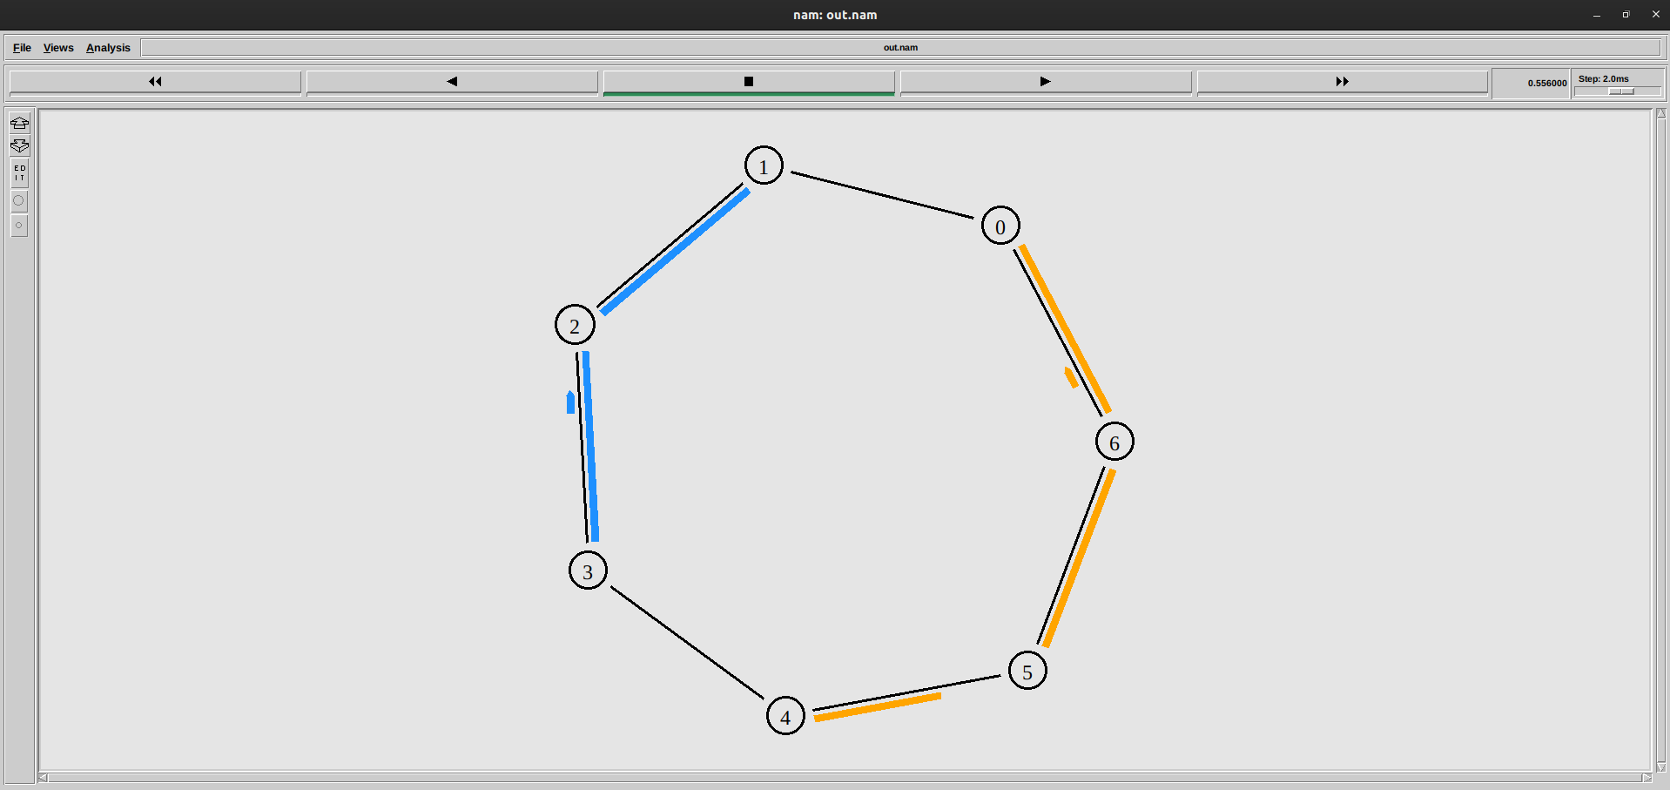

**5. Write a TCL code for network simulator NS2 to demonstrate the bus topology among a set of computer nodes. Given N nodes, each node will be connected to a common link. You have to set up a TCP connection between k pairs of nodes and demonstrate packet transfer between them using Network Animator (NAM). Use File Transfer protocol (FTP) for the same. Each link should have different color of packets to differentiate the packets transferred between each pair of nodes. The program should take the number of nodes (N) as input followed by k pairs of nodes.**

