Com S 227: Summer 2024
Homework 2 Part A and B 150 points
Due Date: June 15th at 11:59pm.

General information
This assignment is to be done on your own. See the Academic Dishonesty policy in the syllabus, for details.
If you need help, see the instructor or TAs. Help is also available through the Discord discussions.

Overview
In this homework, you will have a chance to practice writing loops and conditionals, work with arrays and lists, read files, and put together a small system built from several interacting classes. Part A is to simply read this document. Part B is to implement the methods provided in the skeleton files. The submission procedure will be as described in the last section of this document.
The result will be a working (but simplified) version of the game “Wheel of Fortune”. In this assignment you will implement the backend code, that is, the game logic and state. Code for two sample user interfaces will be provided for you.
Wheel of Fortune is a word-guessing game like hangman. It is best known for the TV version on which this assignment is loosely based. Naturally, you can learn more than you ever wanted to know from the Wikipedia page: http://en.wikipedia.org/wiki/Wheel_of_Fortune_(U.S._game_show)
However, please bear in mind that for this assignment we are dramatically simplifying the rules, so you should follow this spec, not what you see on TV!
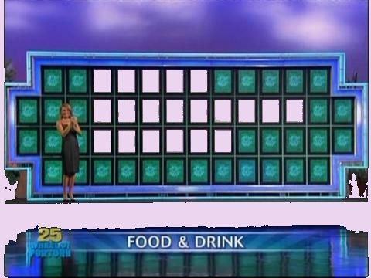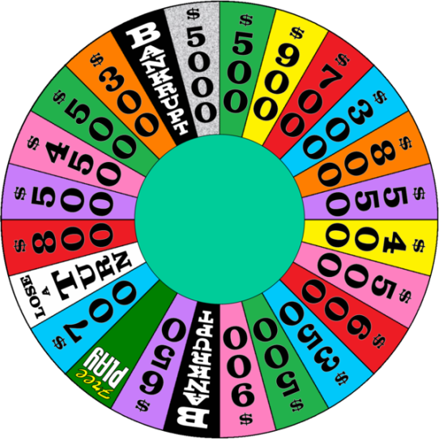
A secret phrase or word is initially displayed with all the letters hidden.
Each player initially has a round balance of zero for the round, representing that player’s potential winnings for the current round. A player also has a game balance, the player's total winnings over all rounds of the game. The round balance is only added to the player's overall game balance if he or she wins the round, described below.
A player’s turn always begins by spinning a wheel that is divided into segments as shown in the picture above. The possibilities are that:
- Stops at “Bankrupt”, in which case the player loses all potential winnings accumulated in this round and the next player gets a turn,
- Stops at “Lose a Turn”, in which case the next player gets a turn,
- Stops with a dollar amount (where "free play" represents zero for us). In this case, the player can go on to do one of the following:
- Guess a consonant. If the letter occurs in the phrase, all occurrences are revealed; then the number of occurrences times the dollar amount from the wheel is added to the player’s winnings, and it remains the player’s turn and they spin the wheel again. If the letter does not occur, the next player takes a turn. For example, after guessing ‘C’, the board might look like this:
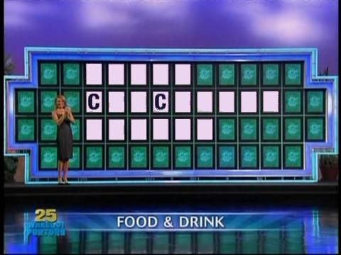
- Buy a vowel. This requires that the player has a balance of at least $250 for this round, and $250 is deducted from the player’s balance. The player can then guess a vowel. If the vowel occurs in the phrase, it remains that player’s turn (but nothing is added to his or her balance) and he or she spins the wheel again. If the vowel does not occur, the next player takes a turn.
- Solve the puzzle, that is, guess the entire word or phrase. If incorrect, the next player takes a turn. If correct, the player wins the round. The dollar amount on the wheel, times the number of consonants still hidden, is added to the player's round balance, and the player's winnings for the round are added to his or her overall total for the game. The losing players lose their potential winnings for that round. The completed phrase is displayed. To guess, the phrase must exactly match, commas included.
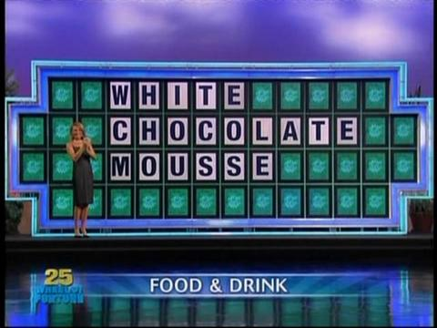

Project overview
There are five classes for you to implement. All the game state and game logic are encapsulated in the class Game. Within the Game, the wheel is represented by an instance of the Wheel class, and the hidden phrase is represented by an instance of the class HiddenText, and the players are represented by an array of Player objects. In addition, there is a class PhraseList that stores a list of possible words or phrases, which can be used by clients.
The GOAL of this assignment is to:
- Have you look up and understand information about the wheel of fortune game.
- We are providing our design and the public API that you are to implement, in part B.
The responsibilities of each of these five classes is discussed in more detail in the next few sections.
The class Game
This class encapsulates the game state and logic. This state consists of:
- an array of Player objects (which includes each player's winnings)
- which player's turn it is
- whether the player whose turn it is needs to spin the wheel
- whether the round is over
- the hidden text, represented by an instance of HiddenText
- the wheel, represented by an instance of Wheel
All operations on a newly created Game are undefined until the startRound() method is called. The startRound() method takes two arguments:
public void startRound(int whoseTurn, HiddenText secretPhrase)
The start method initiates a new round that will use the given HiddenText. The first argument is the index of the player who is to have the first turn. At the beginning of a round, each player starts with a round balance of zero. A round ends when one of the players successfully calls guessPhrase(). (Note: even if all letters have been guessed and are displayed, the round doesn’t end until guessPhrase() is called. This may seem odd, but this fact keeps the code simpler.)
After a round ends, the winning player’s balance for the round can be obtained from the getRoundBalance() method. (The losing players' round balances will be zero.) Each player's total winnings for all rounds that have been played can be obtained from getGameBalance(). Another round can be started with a call to startRound(), and each player again starts with a round balance of zero.
It is important to note that the details about the hidden text such as keeping track of which letters should be displayed, checking whether the phrase contains a guessed letter, and so on, are NOT performed in the Game class. These responsibilities are delegated to the HiddenText class, an instance of which is always provided to the game when the startRound() method is called. (Only a couple of loops are needed at all in the Game class, to iterate over the array of players.) Likewise, details about the wheel state are delegated to Wheel, and details about each player's winnings are delegated to Player.
The class HiddenText
The HiddenText class encapsulates a string containing the secret phrase along with a “displayed” form of the string in which only some of the letters are revealed. The displayed form of the string is an array of char in which, on construction, every alphabetic character is replaced by the ‘*’ (asterisk) character. The method update() is used to indicate that a character should be revealed. For example, if you wrote a test that executed the following two lines,
HiddenText hidden = new HiddenText("HELLO, WORLD!");
char[] displayed = hidden.getDisplayedText();
System.out.println(new String(displayed));
the output should be
*****, *****!
Then after these three lines,
hidden.update('L');
displayed = hidden.getDisplayedText();
System.out.println(new String(displayed));
the output should be
**LL*, ***L*!
You’ll write additional methods for determining how many times a given character occurs, how many characters are left to guess, and so on.
The class Wheel
The Wheel class encapsulates the position of the wheel and contains information about the dollar amounts associated with the segments. These numbers are based on the specific values shown on the picture of the wheel in this document, with special constants standing for "bankrupt" and "lose a turn". The wheel's position at any point is the number of degrees of counterclockwise rotation, and the selected segment is at the top. Each segment of the wheel is 15 degrees. Specifically, for a rotation of 0 through 14 degrees, the segment value is 500; for 15 through 29 degrees, the segment value is 900, for 30 through 44 it's 700, and so on. (In practice, the rotation won't ever be an exact multiple of 15 degrees; see the javadoc for details.)
The class PhraseList
The PhraseList is just a list of phrases that is initialized from a text file. The file format is one phrase per line of the file. This class is not referenced directly by the Game class but may be used by other applications such as the user interface code.

User interfaces
There are two examples of user interfaces provided for you. One is a simple text-based UI. You are strongly encouraged to read and understand the code for the text-based UI, since doing so will help you understand the classes you are to implement. When you are first trying out and debugging your system, it is probably a good idea to use the text-based version. This version has three players, but you can change that by editing the array of names in the main method.
The other user interface is a more sophisticated graphical UI built on the Java Swing libraries. The code is complex and specialized, and you are not expected to understand all the details of how it works (though you might find it interesting to explore). It is restricted to two players only.
Please note that both UIs are functional, but not polished. They are provided to you for fun and so you can see how the backend classes you create can be integrated into a more complete application. We do not claim that the UI classes are free of errors, and you should not rely on the UIs for testing your code.
You can edit the main method of either UI to change the names of the players or the name of the phrase file. If you want to experiment with modifications of the UI code, you should probably do so in a separate project, to ensure that your five required classes still work with the original UIs.
Notes
1. All code you write should be in the package hw2.
2. For methods of Game that require a player index, such as getRoundBalance, it is the caller's responsibility to ensure that the index is in the required range (0 <= index < getNumPlayers()). You do not have to error-check the index and you can simply allow the appropriate exception (usually IndexOutOfBoundsException) to be thrown by the runtime.
3. None of the classes that you implement should directly read input or print output. All input and output are performed by the user interface classes.

Testing on Gradescope
Unlike the previous assignment, we will not be providing a specchecker that performs functional tests for you. It is up to you to write tests for your code. You will save a lot of time by writing at least a few simple tests for everything you code, especially if you do so before you write the code. For example, you might say to yourself,
"for a HiddenText initialized with HELLO, WORLD!, countHiddenConsonants should initially return 7"
Which leads to a simple test such as
@Test
public void testTextInitial()
{
HiddenText t = new HiddenText("HELLO, WORLD!");
assertEquals(7, t.countHiddenConsonants());
}
Similarly,
"for a new Wheel, after a spin of 46 degrees the rotation should be 44"
@Test
public void testWheelOneSpin()
{
Wheel w = new Wheel();
w.spin(46);
assertEquals(44, w.getRotation());
}
Since no test code is to be turned in for this assignment, you are encouraged to discuss your test cases and post your tests on Piazza for others to comment on and try out.
To some extent, you can see whether your code is working by trying it out in one of the user interfaces. However, you will find that this is an extremely slow and unreliable way to test. You should note that when we evaluate and grade your work, we are NOT going to run either of the user interfaces, we are going to check whether each class behaves according to its specification.
A simple specchecker will be provided later on Gradescope to help you to ensure you haven't accidentally modified any of the public APIs.

Importing the sample code
The file hw2.zip is a complete Eclipse project that you will normally be able to import as follows:
- Download the zip file to somewhere you can find it. You don't need to unzip it.
- Select File -> Import
- In the Import dialog, under General, select Existing Projects into Workspace and click Next
- In the next dialog, click the radio button for Select Archive File
- Browse to hw2.zip
- Under Projects in the dialog, check the box next to the hw2 project (if it is greyed out, that means you already have a project called hw2 in your workspace)
- Click Finish
- Please make sure to read all the javadocs under the doc directory in doc/index.html. This defines exactly what each method is supposed to do.
If there are problems after importing, it is possible there are some incompatibilities with the project settings. The simplest solution is to go ahead and create the project from scratch, unzip the zip file, and drag the hw2 directory into your project's src folder.

Getting started
Remember: Read the spec first. Work incrementally. Test early, test often!
- Skeleton code for the five required classes is provided, see "Importing the sample code" above. The code should compile, but it will fail spectacularly if you try to run either of the UIs, however.
- The Wheel and Player classes are pretty easy to start with and do not depend on anything else.
- PhraseList is pretty easy too and can be done independently. Be sure you have done lab 7. (The first checkpoint of Lab 8 is helpful too.) If you are having trouble with reading a text file, you can continue testing other things by providing a hardcoded return value for getPhrase (e.g. always return "HELLO, WORLD!" or something and return 1 from getSize). You'll need to have the file (such as "phrases.txt" though you can create your own) in your project directory in order to read it.
- You can work independently on HiddenText, which also does not depend on anything else. Refer to the example test code shown in the notes above. Write some more test cases.
- The class Game depends on having a HiddenText instance to function correctly, but you can still get a lot of work done independently on Game. Most of the methods are extremely simple. Define instance variables representing the various aspects of the game state. Think through what happens in each method: for example, when a player guesses a letter, use the HiddenText to find out how many times the letter appears in the phrase. If the answer is none, increment the current player to the next player. Otherwise, add the appropriate amount to the current player’s balance, and indicate that the wheel needs spinning again. And so on.
- If you are unsure about how the game works, read the text UI and see how it is being used. Refer to the online documentation for details.

Style and documentation
Roughly 15% of the points will be for documentation and code style. Here are some general guidelines to follow:
- Each class, method, constructor and instance variable, whether public or private, must have a meaningful and complete Javadoc comment. Class javadoc must include the @author tag, and method javadoc must include @param and @return tags as appropriate.
  - You can copy and paste from the method descriptions online if you wish!
  - Run the javadoc tool and see what your documentation looks like! You do not have to turn in the generated html, but at least it provides some satisfaction :)
- All variable names must be meaningful (i.e., named for the value they store).
- Use instance variables only for the “permanent” state of the object, use local variables for temporary calculations within methods.
  - You will lose points for redundant instance variables
  - As you add instance variables to your class, immediately document exactly what each one represents.
  - All instance variables should be private.
- Internal (//-style) comments are normally used inside of method bodies to explain how something works, while the Javadoc comments explain what a method does. (A good rule of thumb is: if you had to think for a few minutes to figure out how something works, you should probably include a comment explaining how it works.)
  - Internal comments always precede the code they describe and are indented to the same level.
- Use a consistent style for indentation and formatting.
  - Note that you can set up Eclipse with the formatting style you prefer and then use Ctrl-Shift-F to format your code. To play with the formatting preferences, go to Window->Preferences->Java->Code Style->Formatter and click the New button to create your own “profile” for formatting.
- Unless explicitly specified, NONE of your code should not be producing console output. We often add println statements when debugging, but you need to remove them before submitting the code.
- Use the defined constants (e.g. VOWEL_COST).

If you have questions
For questions, please see the Piazza Q & A pages and click on the folder assignment2. If you don’t find your question answered, then create a new post with your question. Try to state the question or topic clearly in the title of your post, and attach the tag assignment2. But remember, do not post any source code for the classes that are to be turned in. It is fine to post source code for general Java examples that are not being turned in, and for this assignment you are welcome to post and discuss test code. (In the Piazza editor, use the button labeled “pre” to have Java code formatted the way you typed it.)
If you have a question that absolutely cannot be asked without showing part of your source code, make the post “private” so that only the instructors and TAs can see it. Be sure you have stated a specific question; vague requests of the form “read all my code and tell me what’s wrong with it” will generally be ignored.
Of course, the instructors and TAs are always available to help you. See the Office Hours section of the syllabus to find a time that is convenient for you. We do our best to answer every question carefully, short of actually writing your code for you, but it would be unfair for the staff to fully review your assignment in detail before it is turned in.
Any posts from the instructors on Piazza that are labeled “Official Clarification” are considered to be part of the spec, and you may lose points if you ignore them. Such posts will always be placed in the Announcements section of the course page in addition to the Q&A page. (We promise that no official clarifications will be posted within 24 hours of the due date.)

What to turn in
Please submit, on Gradescope, the following five files:
Game.java
PhraseList.java
HiddenText.java
Wheel.java
Player.java
All of them should be in the package hw2. Do not upload the class files or the UI package.
Submit the five files to Gradescope using the Assignment 2 submission link.

