DNS

An application layer protocol defines how the application processes running on different systems, pass the messages to each other.

* DNS stands for Domain Name System.
* DNS is a directory service that provides a mapping between the name of a host on the network and its numerical address.
* DNS is required for the functioning of the internet.
* Each node in a tree has a domain name, and a full domain name is a sequence of symbols specified by dots.
* DNS is a service that translates the domain name into IP addresses. This allows the users of networks to utilize user-friendly names when looking for other hosts instead of remembering the IP addresses.
* For example, suppose the FTP site at EduSoft had an IP address of 132.147.165.50, most people would reach this site by specifying ftp.EduSoft.com. Therefore, the domain name is more reliable than IP address.

DNS is a TCP/IP protocol used on different platforms. The domain name space is divided into three different sections: generic domains, country domains, and inverse domain.

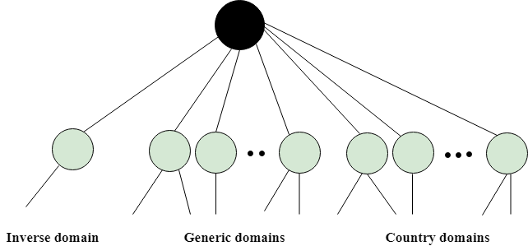

Generic Domains

* It defines the registered hosts according to their generic behavior.
* Each node in a tree defines the domain name, which is an index to the DNS database.
* It uses three-character labels, and these labels describe the organization type.

|  |  |
| --- | --- |
| **Label** | **Description** |
| aero | Airlines and aerospace companies |
| biz | Businesses or firms |
| com | Commercial Organizations |
| coop | Cooperative business Organizations |
| edu | Educational institutions |
| gov | Government institutions |
| info | Information service providers |
| int | International Organizations |
| mil | Military groups |
| museum | Museum & other nonprofit organizations |
| name | Personal names |
| net | Network Support centers |
| org | Nonprofit Organizations |
| pro | Professional individual Organizations |

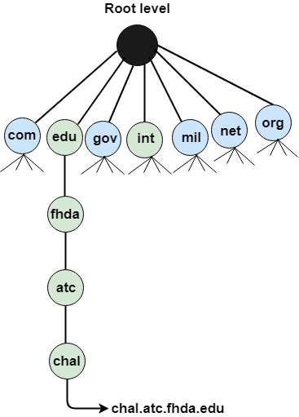

# TCP vs UDP

## What is the TCP?

The TCP stands for **Transmission Control Protocol**. If we want the communication between two computers and communication should be good and reliable. For example, we want to view a web page, then we expect that nothing should be missing on the page, or we want to download a file, then we require a complete file, i.e., nothing should be missing either it could be a text or an image. This can only be possible due to the TCP. It is one of the most widely used protocols over the [TCP/IP](https://www.javatpoint.com/tcp-ip-full-form) network.

### **Features of TCP**

**The following are the features of the TCP:**

* **Data delivery**  
  TCP protocol ensures that the data is received correctly, no data is missing and in order. If TCP protocol is not used, then the incorrect data can be received or out of order. For example, if we try to view the web page or download a file without using TCP, then some data or images could be missing.
* **Protocol**  
  TCP is a connection-oriented protocol. Through the word **connection-oriented,** we understand that the computers first establish a connection and then do the communication. This is done by using a three-way handshake. In a **three-way handshake,** the first sender sends the SYN message to the receiver then the receiver sends back the SYN ACK message to confirm that the message has been received. After receiving the **SYN ACK** message, the sender sends the acknowledgment message to the receiver. In this way, the connection is established between the computers. Once the connection is established, the data will be delivered. This protocol guarantees the data delivery means that if the data is not received then the TCP will resend the data.

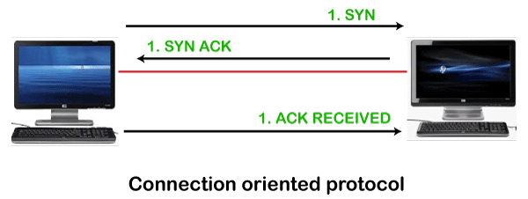

## What is UDP?

The UDP stands for **User Datagram Protocol**. Its working is similar to the TCP as it is also used for sending and receiving the message. The main difference is that UDP is a connectionless protocol. Here, connectionless means that no connection establishes prior to communication. It also does not guarantee the delivery of data packets. It does not even care whether the data has been received on the receiver's end or not, so it is also known as the "fire-and-forget" protocol. It is also known as the **"fire-and-forget"** protocol as it sends the data and does not care whether the data is received or not. UDP is faster than TCP as it does not provide the assurance for the delivery of the packets.

## Differences between the TCP and UDP

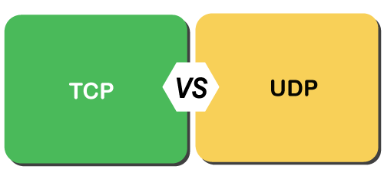

* **Type of protocol**  
  Both the protocols, i.e., TCP and UDP, are the transport layer protocol. TCP is a connection-oriented protocol, whereas UDP is a connectionless protocol. It means that TCP requires connection prior to the communication, but the UDP does not require any connection.
* **Reliability**  
  TCP is a reliable protocol as it provides assurance for the delivery of the data. It follows the acknowledgment mechanism. In this mechanism, the sender receives the acknowledgment from the receiver and checks whether the acknowledgment is positive or negative. If the ACK is positive means, the data has been received successfully. If ACK is negative, then TCP will resend the data. It also follows the flow and error control mechanism.  
  UDP is an unreliable protocol as it does not ensure the delivery of the data.
* **Flow Control**  
  TCP follows the flow control mechanism that ensures a large number of packets are not sent to the receiver at the same time, while UDP does not follow the flow control mechanism.
* **Ordering**  
  TCP uses ordering and sequencing techniques to ensure that the data packets are received in the same order in which they are sent. On the other hand, UDP does not follow any ordering and sequencing technique; i.e., data can be sent in any sequence.
* **Speed**  
  Since TCP establishes a connection between a sender and receiver, performs error checking, and also guarantees the delivery of data packets while UDP neither creates a connection nor it guarantees the delivery of data packets, so UDP is faster than TCP.
* **Flow of data**  
  In TCP, data can flow in both directions means that it provides the full-duplex service. On the other hand, UDP is mainly suitable for the unidirectional flow of data.