DOCUGUARD LITE

Healthcare Policy and
Compliance Intelligence Platform
DBMS Mini Project Report
Course Title | Database Management System
Course Code | UE24CS351A
Project Title | DocuGuard Lite - Healthcare Policy and Compliance Intelligence Platform
Student 1 | Pulla Jagadeeshwar Reddy SRN: PES1UG24CS347
Student 2 | Pushkar S Kulkarni SRN: PES1UG24CS350
Submission Date | 09/11/2026

Report guide
This report describes the implemented DocuGuard Lite system and its verified database and API behavior. The title-page course and student details are complete; review the final submission checklist and screenshot captions before submission.
- 1. Abstract and project scope
- 2. Technology stack and justification
- 3. System architecture and data flow
- 4. ER model and relational schema
- 5. SQL commands and DBMS concepts
- 6. NoSQL commands and content operations
- 7. Next.js interface and project tree
- 8. Authentication and authorization
- 9. Verification results
- 10. Screenshot evidence
- 11. Rubric completion status
- 12. Setup and demo guide
- 13. Team contribution and finalization checklist

1. Abstract and project scope
DocuGuard Lite is a local policy-document and reading-compliance application for a fictional hospital. It provides a role-aware policy library, version approval, acknowledgments, time-limited emergency access, audit logging and a summary dashboard. The project demonstrates relational modeling, constraints, SQL functions and triggers, joins and recursive queries, MongoDB document storage and aggregation, and integration through Express and Next.js.
PostgreSQL is authoritative for people, roles, document metadata, version state, access grants, acknowledgments, emergency overrides and audit events. MongoDB stores extracted policy text and metadata. Original PDF and DOCX files are kept in a private local upload directory. Express is the only application component that connects to either database.
The simplified design has eleven relational tables. Vector embeddings, semantic search, regulatory coverage, notifications and document dependency mapping are outside this Lite implementation.

Objectives
- Model the approved 11-entity design with keys, constraints and delete rules.
- Demonstrate maker-checker approval, version history and version-specific acknowledgments.
- Enforce roles and per-document access through Express routes and SQL predicates.
- Maintain an append-only SHA-256 access-log chain with non-persisting verification.
- Use MongoDB for extracted content, indexes and aggregation.
- Present workflows through a Next.js App Router interface.

2. Technology stack and justification
Layer | Technology | Reason
Web | Next.js App Router 16, React 19, TypeScript, Tailwind 4 | Typed route-based interface with role-aware navigation.
API | Express 5, TypeScript, Zod | Centralizes authentication, validation and data access.
Relational | PostgreSQL 16, pg driver, handwritten SQL, pgcrypto | Shows constraints, transactions, functions, triggers, views and SHA-256.
Document store | MongoDB 7 and official Node driver | Flexible extracted pages/metadata and aggregation.
Security | bcrypt, HTTP-only JWT cookie, Helmet, CORS, rate limiting | Credential and session protection.
UI libraries | React Hook Form, Zod, Recharts | Typed forms and dashboard charts.
Local services | Docker Compose | Runs isolated Lite databases with separate names and ports.

No PostgreSQL ORM is used. Parameterized pg queries keep SQL visible. Lite uses MongoDB as its NoSQL store; vector storage and vector search are not implemented.

3. System architecture and data flow
Step | Component | Responsibility
1 | Browser and Next.js | Renders pages and forwards same-origin API requests.
2 | Express API | Validates input, authenticates users, checks roles and runs transactions.
3 | PostgreSQL | Stores relational state and enforces constraints, triggers, views and audit chain.
4 | MongoDB | Stores extracted policy content and provides aggregation inputs.
5 | Private upload folder | Stores original files outside the public web directory.

Upload flow: Express validates a PDF or DOCX, extracts text and writes it to MongoDB. A PostgreSQL transaction creates document/version metadata and links the Mongo record. If SQL fails, the API attempts compensating deletion; an orphan sweeper handles old unlinked records.
Approval flow: a different Admin approves a pending version. A database check enforces maker-checker, and a trigger updates the current-version pointer and supersedes the previous version.
Acknowledgments are stored only when completed; pending users are derived by anti-join. Emergency access creates an expiring override and flagged access log in one transaction, followed by review from a different Admin.

Architecture diagram
[Browser] -> [Next.js] -> [Express API]
| |
v v
[PostgreSQL] [MongoDB]
11 tables document_contents
SQL rules extracted content
|
v
[Private upload folder]

4. ER model and relational schema
The simplified ER model is in docs/inputs/docuguard_er_diagram.mermaid, with a Chen diagram beside it. The eleven relations are:
Subject | Relations
Identity | departments, roles, users
Policy | document_categories, documents, document_versions, document_permissions
Audit and emergency | access_logs, access_overrides
Reading compliance | policy_assignments, acknowledgments

Relationships and constraints
- Users reference one role and optionally one department.
- Documents reference a category and owner and have many versions; current_version_id points to one version.
- The current-version FK is added after both tables exist to resolve the circular reference.
- Document permissions join documents to roles and record access level and grantor.
- Access logs reference actor/document and optionally version/override.
- Assignments target a role, department, or both; acknowledgments identify the exact version.
- Overrides have a requester, document and optional distinct reviewer.
Rule | Enforcement
Domains and identity | CHECK statuses/roles/actions; NOT NULL/UNIQUE email and foreign keys.
Versioning | Positive version; unique document/version pair; maker-checker check; approval timestamp consistency.
Permissions | Allowed access levels and unique document/role/access tuple.
Emergency access | Justification >= 20 chars; expiry > grant and <= 24 hours; reviewer differs from requester.
Assignments/acks | At least one target; due-date check; unique assignment/user/version acknowledgment.
Audit log | Required hashes; unique row hash; break-glass consistency; immutable trigger and restricted runtime grants.

Representative DDL
CREATE TABLE document_versions (
version_id SERIAL PRIMARY KEY,
document_id INT NOT NULL REFERENCES documents(document_id)
ON DELETE CASCADE,
version_number INT NOT NULL CHECK (version_number > 0),
mongo_content_id VARCHAR(64) NOT NULL UNIQUE,
uploaded_by INT NOT NULL REFERENCES users(user_id),
approved_by INT REFERENCES users(user_id),
effective_date DATE NOT NULL,
expiry_date DATE CHECK (expiry_date > effective_date),
version_status VARCHAR(20) NOT NULL DEFAULT 'pending_review',
UNIQUE (document_id, version_number),
CHECK (approved_by <> uploaded_by)
);
ALTER TABLE documents
ADD CONSTRAINT fk_documents_current_version
FOREIGN KEY (current_version_id)
REFERENCES document_versions(version_id);
The complete data dictionary is docs/inputs/docuguard_data_dictionary.md. Executable DDL is under database/postgres/01a_schema_core.sql, 01b_schema_reading.sql and 02_alter.sql.

5. SQL commands and DBMS concepts

Local setup commands
docker compose up -d
npm install
npm run db:rebuild
npm run db:auth
npm run db:mongo:indexes
npm run db:mongo:seed
npm run dev
Lite uses PostgreSQL host port 55432, MongoDB 27018, API 4010 and frontend 3010. db:rebuild resets the Lite database; never point it at the archived full project's database.

DML and important queries
PostgreSQL seed scripts add personnel, categories, synthetic policies, versions, permissions, assignments, acknowledgments and emergency examples. Express uses parameterized SQL for workflow changes.
-- Join document, category and current version.
SELECT d.document_id, d.title, c.category_name,
v.version_number, v.version_status
FROM documents d
JOIN document_categories c ON c.category_id=d.category_id
LEFT JOIN document_versions v
ON v.version_id=d.current_version_id
ORDER BY d.title;
-- Correlated permission predicate.
SELECT d.document_id, d.title
FROM documents d
WHERE EXISTS (
SELECT 1 FROM document_permissions p
JOIN users u ON u.role_id=p.role_id
WHERE u.user_id=$1 AND u.account_status='active'
AND p.document_id=d.document_id AND p.revoked_at IS NULL
);
-- Derive pending acknowledgments for the current version.
SELECT pa.assignment_id, u.user_id, d.title, v.version_number
FROM policy_assignments pa
JOIN documents d ON d.document_id=pa.document_id
JOIN document_versions v ON v.version_id=d.current_version_id
JOIN users u ON u.account_status='active'
LEFT JOIN acknowledgments a ON a.assignment_id=pa.assignment_id
AND a.user_id=u.user_id AND a.version_id=v.version_id
WHERE a.ack_id IS NULL AND d.document_status='active'
AND v.version_status='approved';
-- Recursive history uses existing document_id/version_number fields.
WITH RECURSIVE history(document_id, version_number, depth, path) AS (
SELECT document_id, version_number, 1, ARRAY[version_number]
FROM document_versions WHERE version_id=$1
UNION ALL
SELECT prior.document_id, prior.version_number,
current.depth+1, current.path||prior.version_number
FROM history current JOIN document_versions prior
ON prior.document_id=current.document_id
AND prior.version_number=current.version_number-1
WHERE NOT prior.version_number=ANY(current.path)
)
SELECT document_id, version_number, depth
FROM history ORDER BY version_number;
docs/QUERIES.md also covers GROUP BY/HAVING and window functions.

Functions, triggers and views
Object | Purpose
fn_accessible_document_ids | Returns role-granted or active-override document ids.
fn_access_log_hash | Calculates SHA-256 from prior hash and log fields.
fn_audit_chain_before_insert | Uses advisory transaction lock; sets prev_hash and row_hash.
verify_audit_chain | Returns first broken log id or NULL; does not store a check record.
fn_expire_overrides / fn_expiry_sweep | Expire elapsed overrides and versions.
fn_assignment_completion | Calculates eligible-user completion for the current version.
trg_version_approved | Switches current version and supersedes the former version transactionally.
trg_validate_acknowledgment | Requires the assignment's current approved version.
trg_audit_immutable | Rejects audit log UPDATE and DELETE.

Audit chain design
The BEFORE INSERT trigger serializes writers with pg_advisory_xact_lock, reads the last row_hash, assigns prev_hash and computes row_hash with pgcrypto.digest(..., 'sha256'). Another trigger rejects update/delete, and docuguard_runtime lacks those grants. SQL tests tamper with a row as database owner, verify detection, and roll back.
Views summarize document status, expirations, access activity, emergency review and acknowledgment completion. Negative SQL tests prove database-side rejection.

6. NoSQL database commands and operations
MongoDB 7 stores one document_contents record per uploaded version, including extracted pages, sections, keywords and word count. PostgreSQL remains authoritative for document state and access.

Collection and indexes
db.createCollection("document_contents");
db.document_contents.createIndex({versionId:1}, {
unique:true,
partialFilterExpression:{versionId:{$type:"number"}}
});
db.document_contents.createIndex({documentId:1,category:1});
db.document_contents.createIndex({"extracted.keywords":1});
The scripts are database/mongo/indexes.js and seed.js. Setup uses npm run db:mongo:indexes and npm run db:mongo:seed.

Content CRUD and aggregation
db.document_contents.insertOne({
_id:"content-uuid", documentId:42, versionId:null,
category:"Patient Safety", fileName:"sample-policy.pdf",
pages:[{n:1,text:"Illustrative policy text"}],
extracted:{keywords:["transfer","safety"],wordCount:3}
});
db.document_contents.updateOne(
{_id:"content-uuid"},
{$set:{documentId:42,versionId:103}}
);
db.document_contents.deleteOne({_id:"content-uuid"});
db.document_contents.aggregate([
{$match:{versionId:{$in:[103,104]}}},
{$unwind:"$extracted.keywords"},
{$group:{_id:{category:"$category",keyword:"$extracted.keywords"},
uses:{$sum:1}}},
{$sort:{uses:-1}}, {$limit:10}
]);
Admin analytics obtains eligible current version ids from PostgreSQL before filtering Mongo results. Mongo is not an authorization source.

Vector scope
The simplified design removes document_chunks, embeddings, similar_documents and vector_id. Lite has no vector column, HNSW index, embedding model, semantic-search endpoint or vector database commands. MongoDB supplies the project's NoSQL evidence.

7. Next.js interface and project tree
The frontend is a Next.js App Router application. The interface includes authentication, a dashboard, policy browsing and detail, upload/version approval, My Policies, acknowledgments, emergency access and administration screens. The browser calls Express API routes; it has no direct PostgreSQL or MongoDB connection.

Selected project tree
frontend/
src/app/
login/page.tsx
(protected)/layout.tsx
(protected)/dashboard/page.tsx
(protected)/documents/page.tsx
(protected)/documents/new/page.tsx
(protected)/documents/[id]/page.tsx
(protected)/my-policies/page.tsx
(protected)/break-glass/page.tsx
(protected)/admin/users/page.tsx
(protected)/admin/acknowledgments/page.tsx
(protected)/admin/break-glass/page.tsx
(protected)/admin/audit/page.tsx
backend/src/
routes/ services/ middleware/
database/
postgres/ mongo/
docs/
inputs/ QUERIES.md RELATIONAL_SCHEMA.md
This selected tree is a navigation aid, not a complete file listing. Every path shown was checked against the current Lite repository on 2026-11-09.

8. Authentication, authorization and request flow
- The user submits credentials in the Next.js login form; Express validates input and checks the account and password hash.
- On success, Express issues a signed JWT in an HTTP-only cookie. The frontend does not receive or store the password hash.
- Protected requests pass through authentication and role middleware. Express obtains authorized data using parameterized SQL and document-permission checks.
- For upload, Express stores extracted content in MongoDB and coordinates PostgreSQL metadata/version changes, including compensation if the relational transaction fails.
- Document reads/downloads and sensitive actions create access-log rows. A PostgreSQL trigger appends each row to a SHA-256 hash chain.
- Acknowledgments, emergency overrides, review actions and dashboard summaries are handled through Express and the relevant PostgreSQL tables/views; MongoDB aggregation supports content analytics.
Roles are Admin, Doctor, Nurse and Staff. Authorization is implemented in the application using PostgreSQL role/document-permission data and Express checks. This project does not claim PostgreSQL row-level security or separate database login roles per application user.

9. Verification record
Final verification was rerun on 2026-11-09. These results are from the current Lite branch and disposable validation databases.
Check | Recorded result
npm install | Passed; 554 packages installed. npm audit reported 19 advisories (3 low, 16 moderate); production-only audit reported 0.
npm run lint | Passed (recorded 2026-11-09).
npm run build | Passed (recorded 2026-11-09).
npm run db:rebuild-test | Passed against disposable Lite test database (recorded 2026-11-09).
Jest / Supertest | 7 suites, 11 tests passed (recorded 2026-11-09).
SQL constraint and trigger tests | Passed, including maker-checker, constraints and audit tamper checks (recorded 2026-11-09).
Endpoint smoke coverage | Login, upload/approval, acknowledgment, break-glass, audit verification and dashboard covered by recorded integration tests; no new manual browser walkthrough is claimed here.

Before submission
- The verification results above were recorded on 2026-11-09. Repeat the setup locally if you need to confirm the demonstration environment before presenting.
- The README lists synthetic demo accounts; use them only in the local Lite environment and do not include real personal credentials in the report.
- Capture any remaining screenshots from the running Lite instance, with sensitive local details hidden. S7 and S15 remain pending as noted in their captions and rubric evidence.

10. Screenshot evidence
The report includes the available screenshot evidence. Captions identify the visible state and call out any remaining capture needed.

Application screenshots
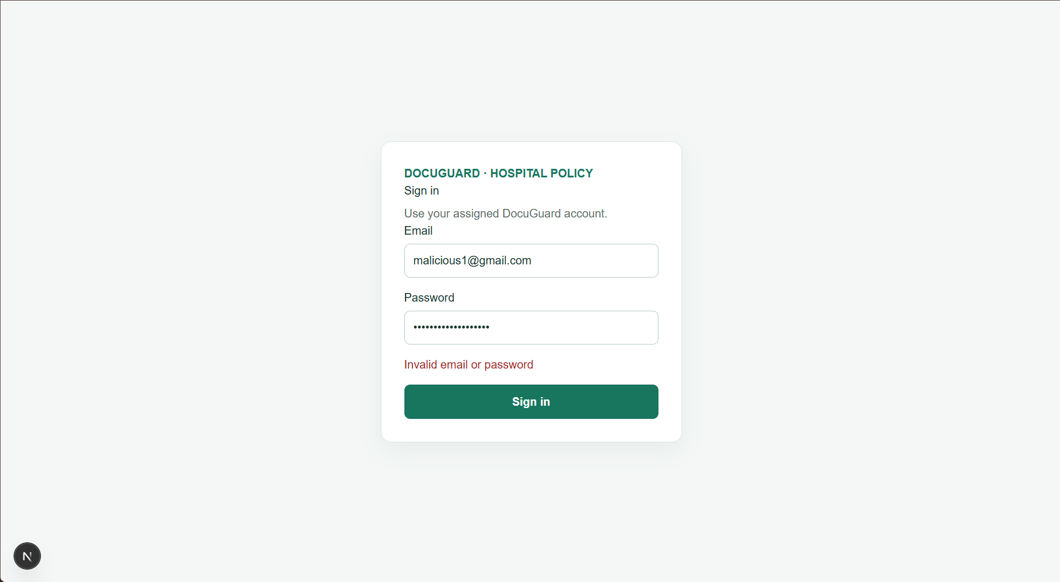
S1. Login validation
Login page showing required-field or invalid-credentials feedback.

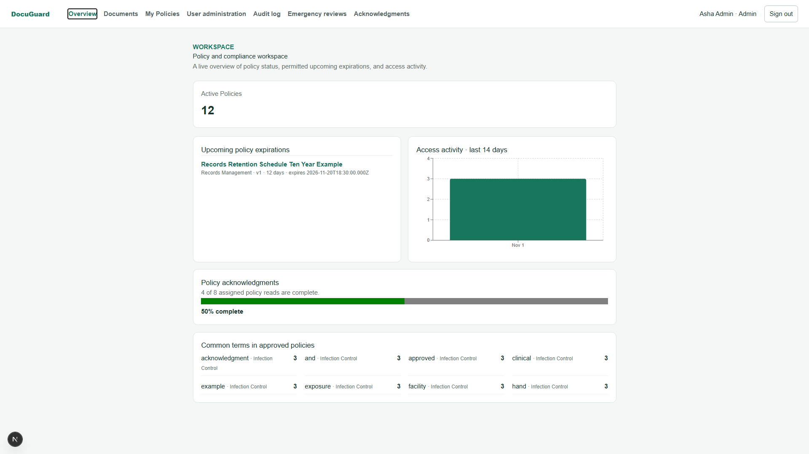
S2. Admin dashboard
Admin landing dashboard with current summary metrics.

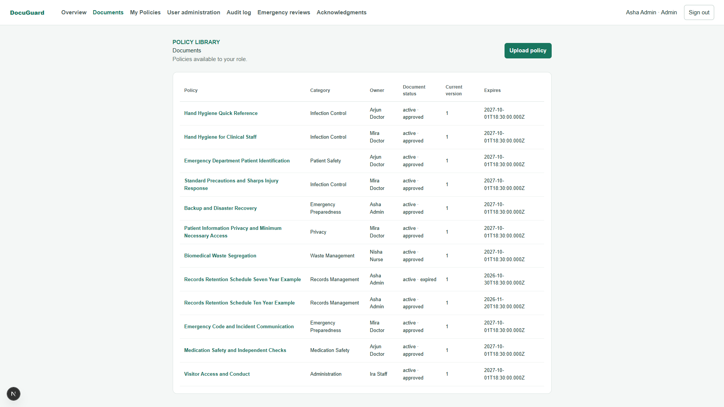
S3. Admin policy list
Policy list as Admin, showing available policy records.

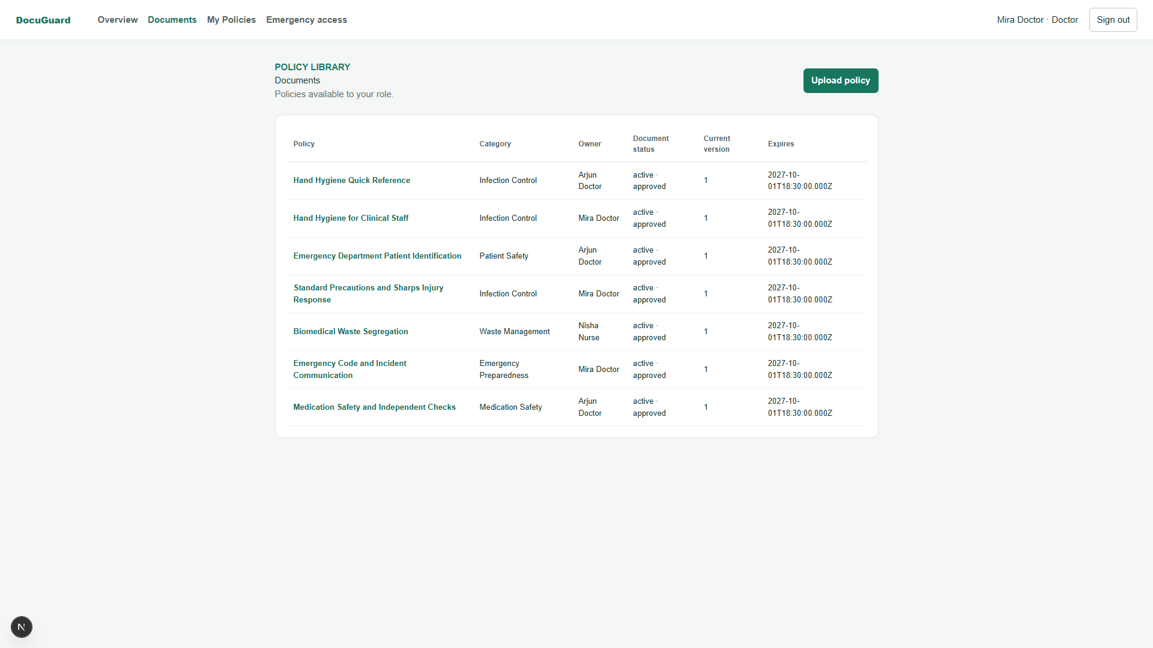
S4. Doctor or Nurse policy list
Role-scoped policy list demonstrating permissions.

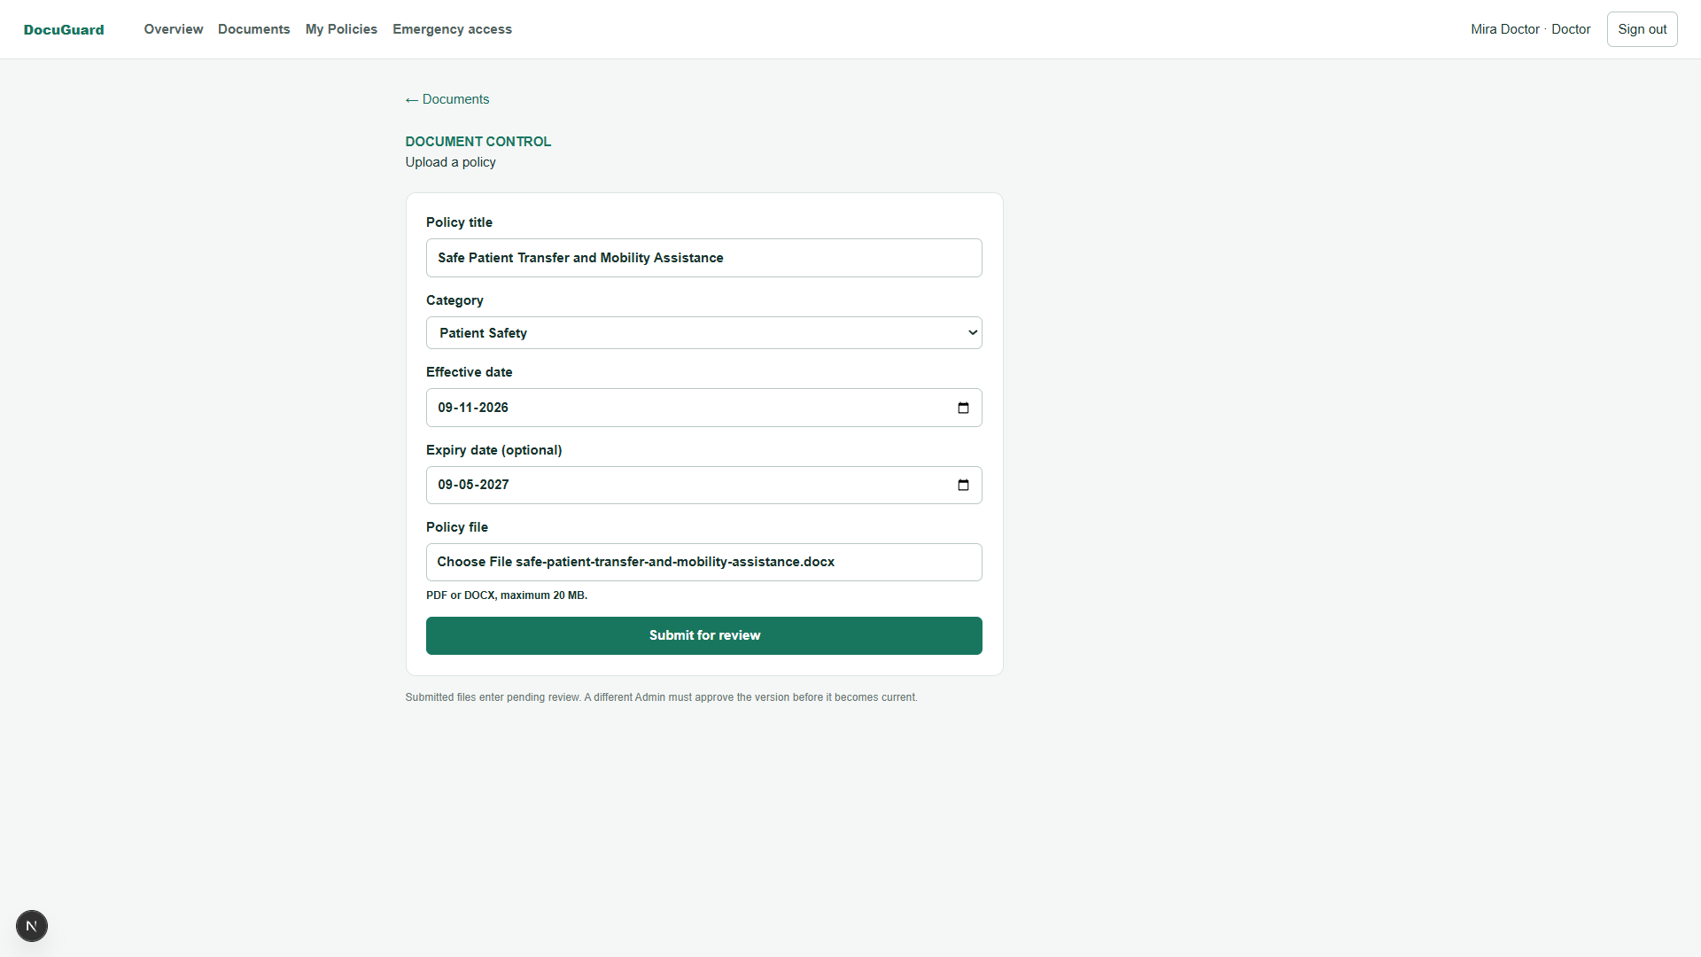
S5. Upload policy
Upload form with title/category/file and version details.

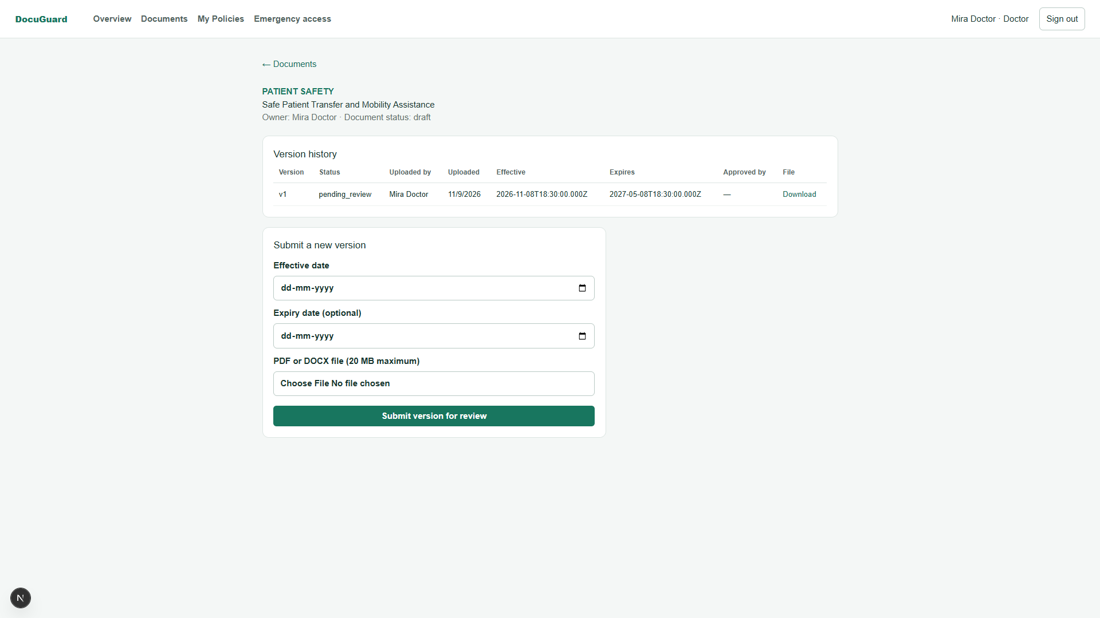
S6. Pending approval
Document detail showing a submitted version awaiting review.

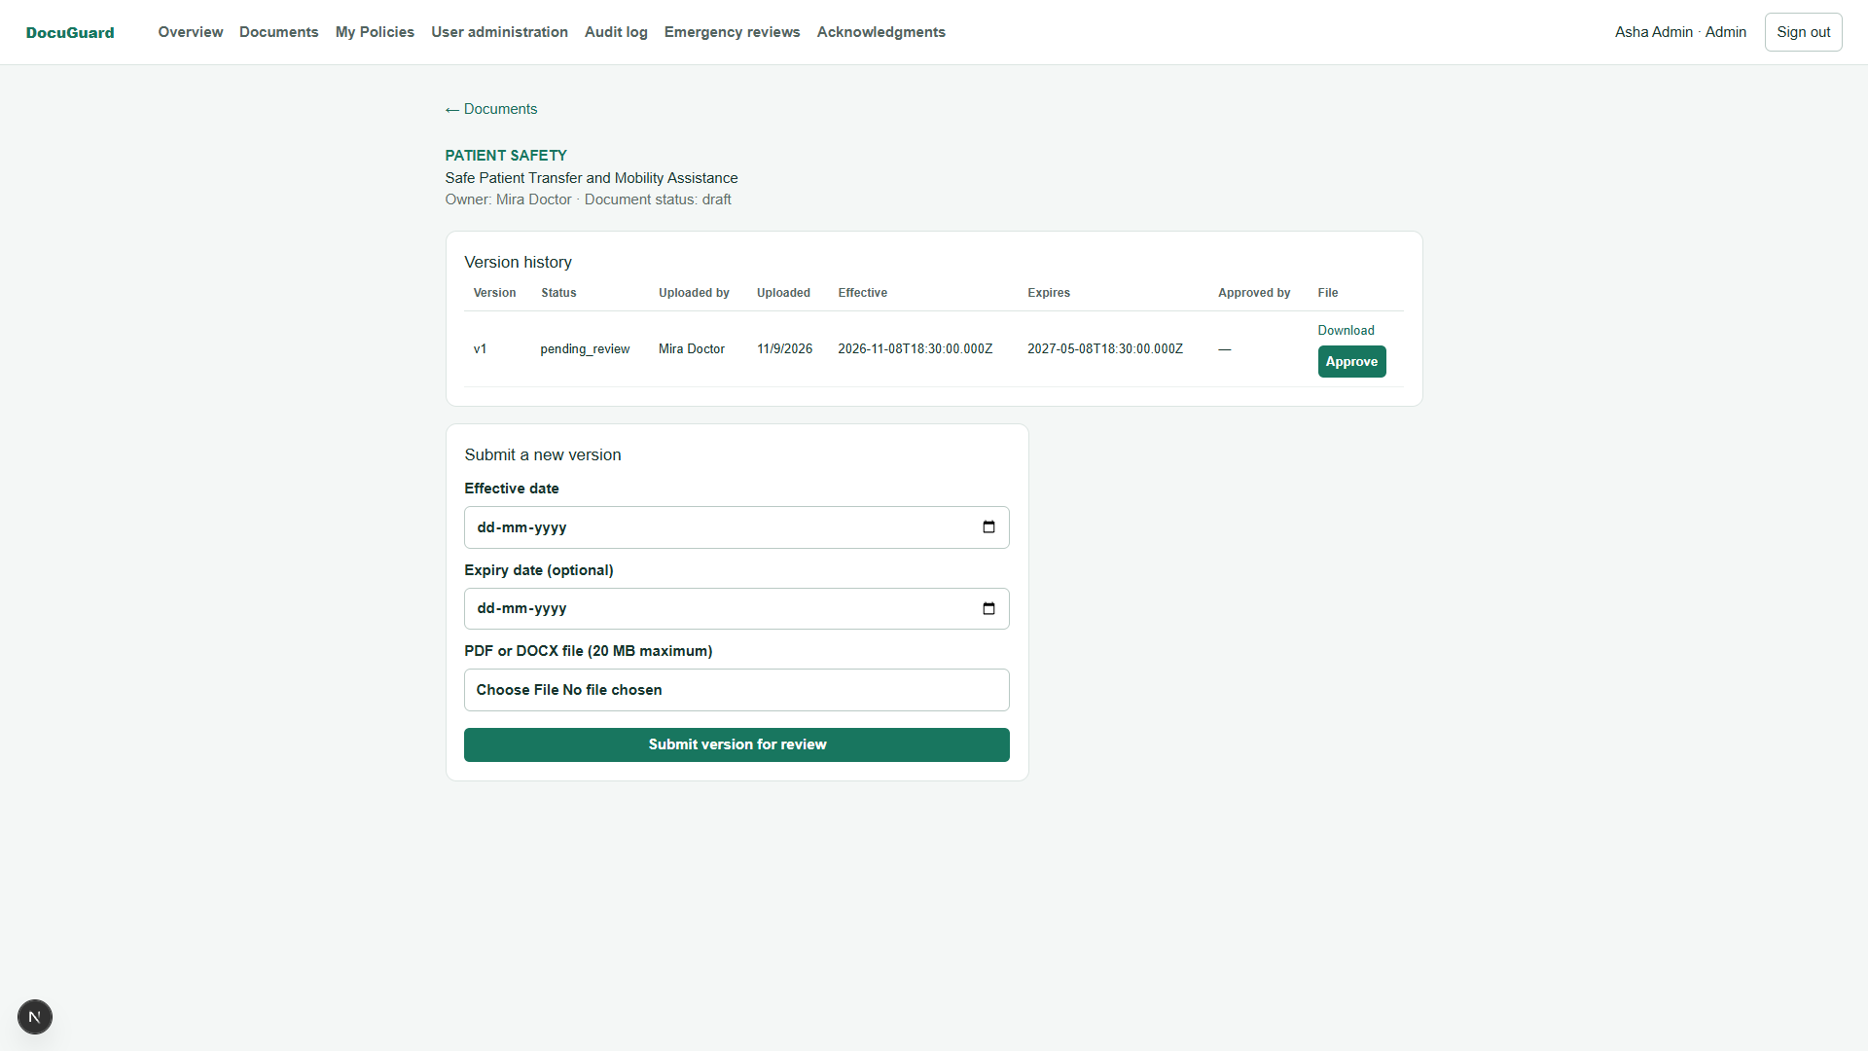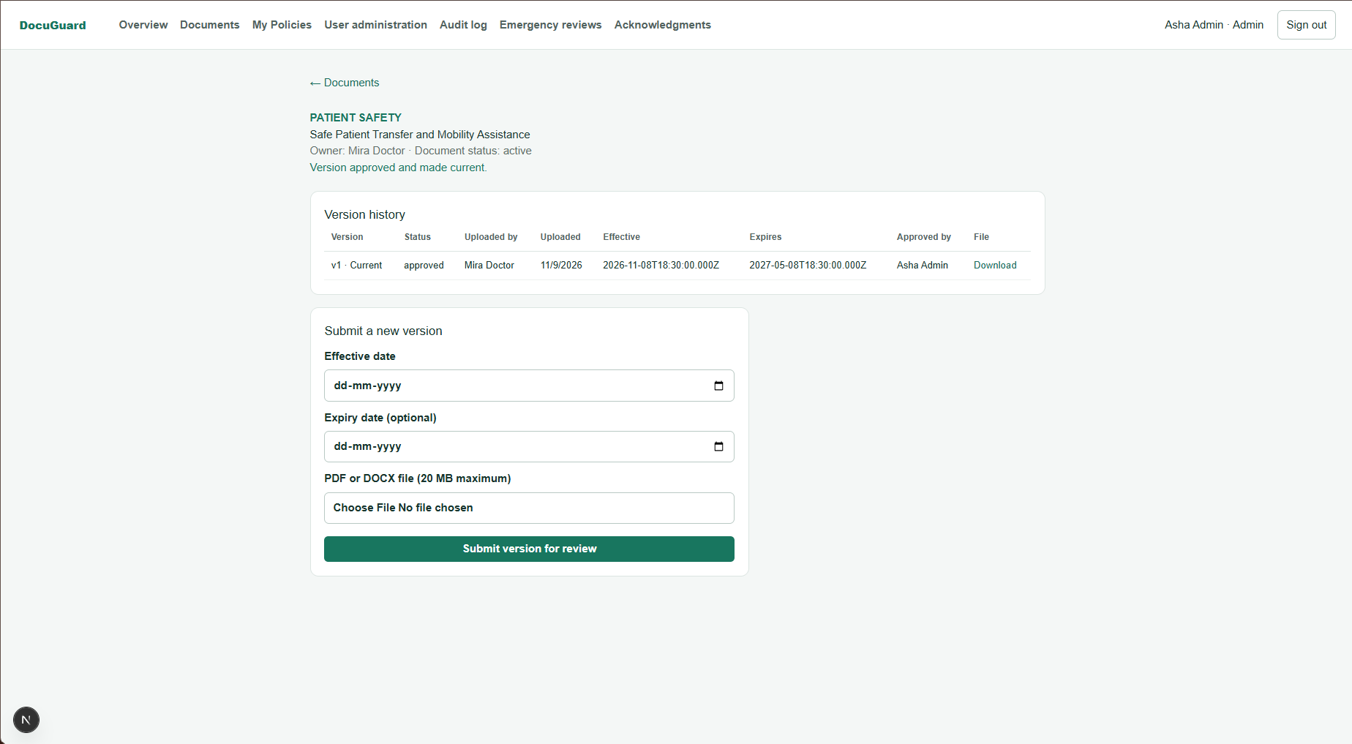
S7. Version awaiting approval
The capture shows the pending version and approval action; add the post-approval history state.

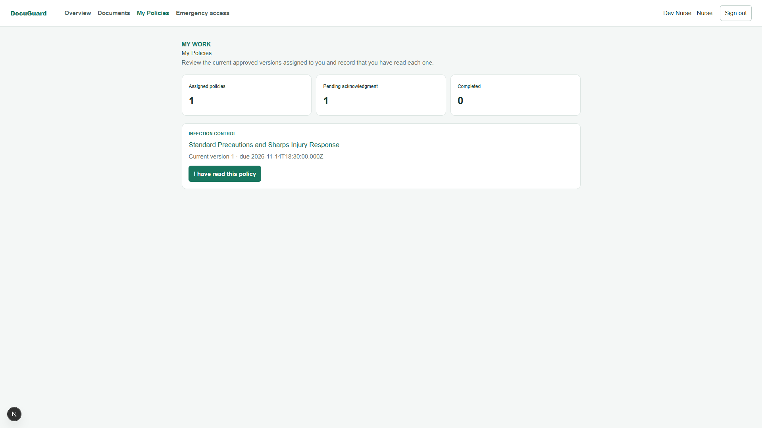
S8a. My Policies before acknowledgment
Assigned policy shown as pending for the signed-in user.

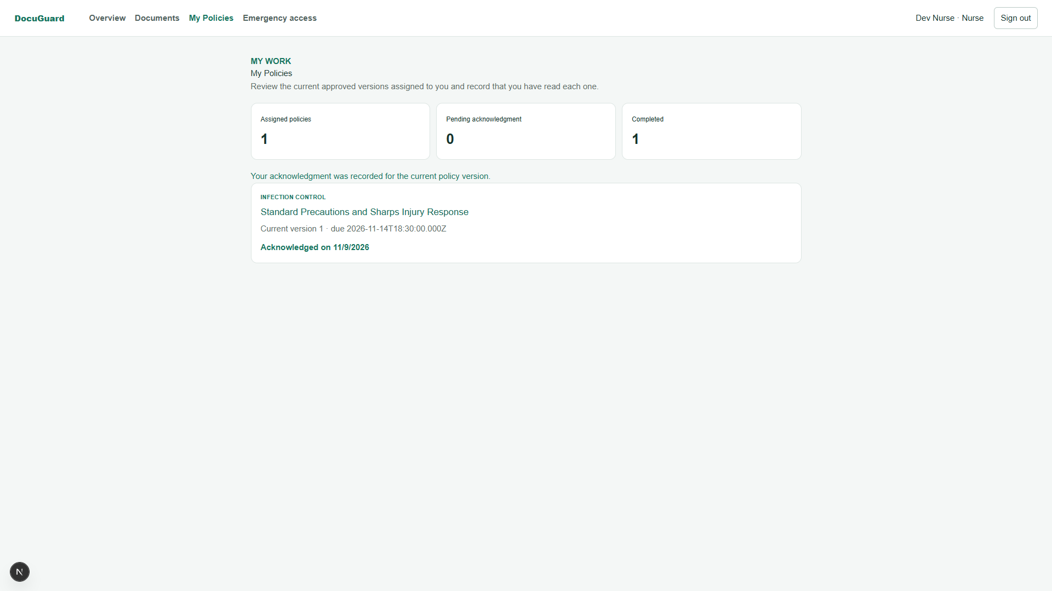
S8b. My Policies after acknowledgment
Same assignment shown as acknowledged/compliant.

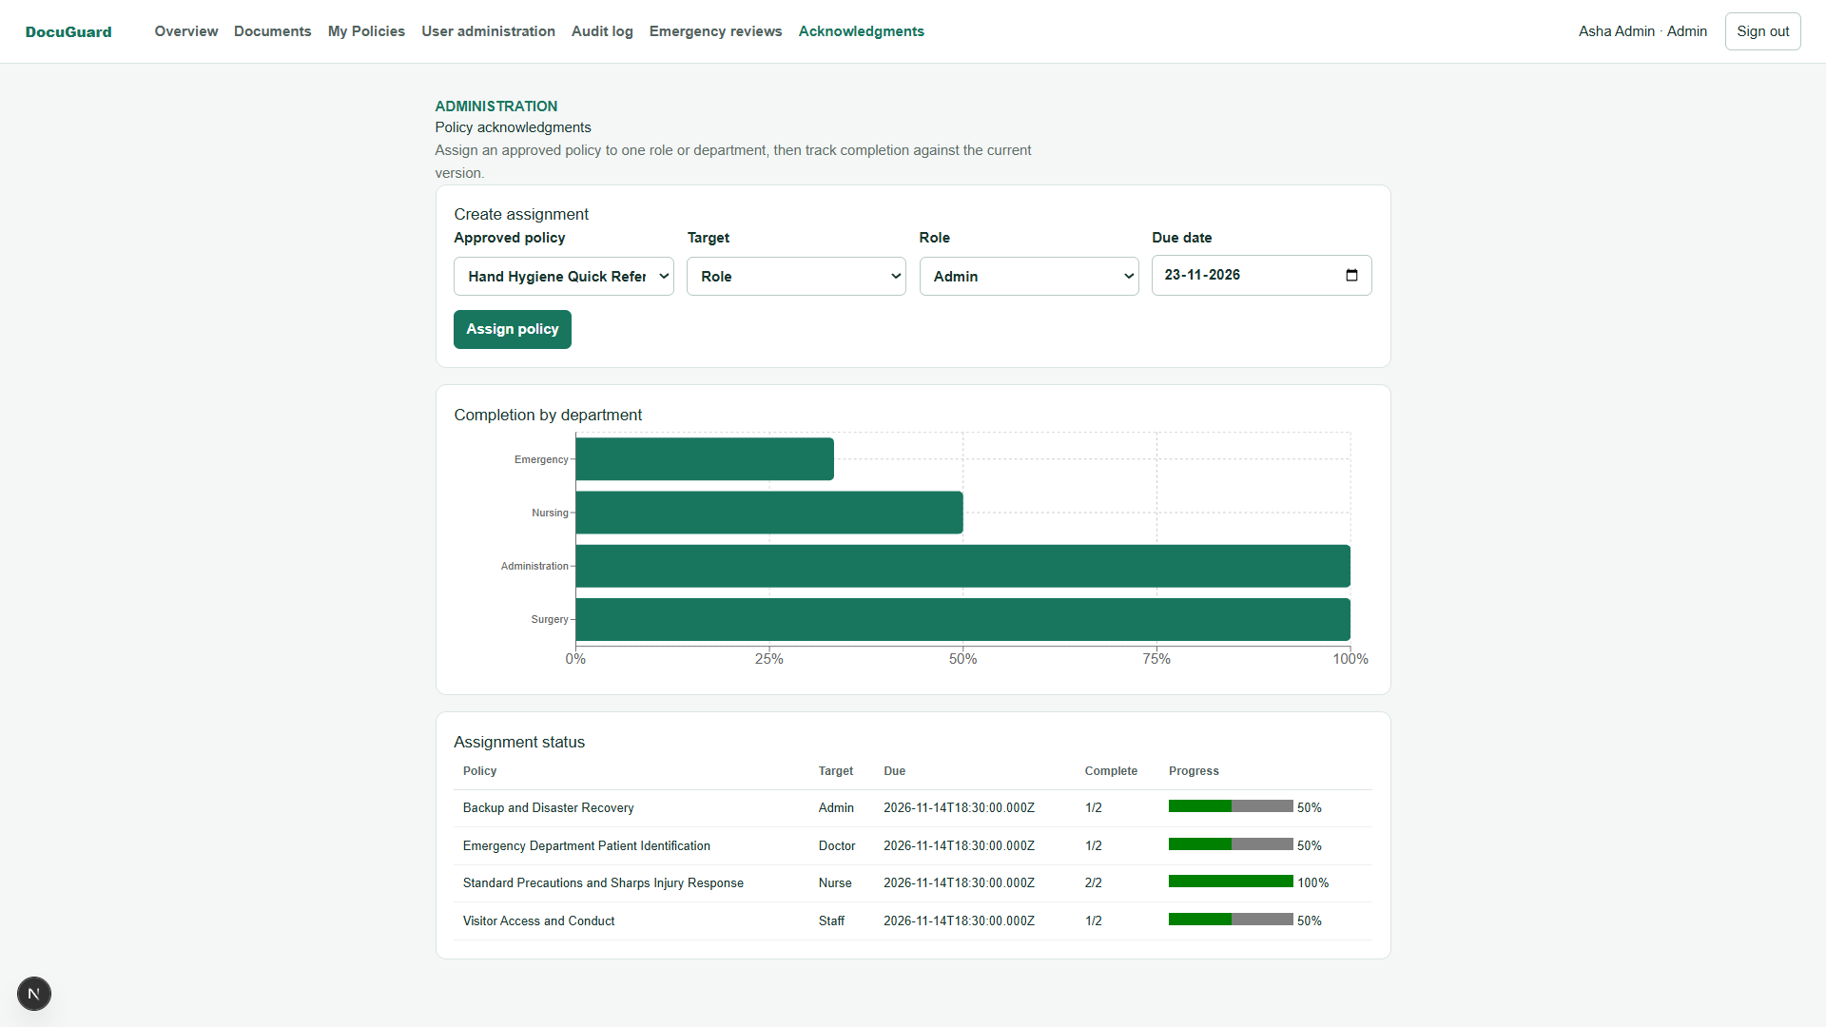
S9. Admin acknowledgments
Acknowledgment summary or department compliance view.

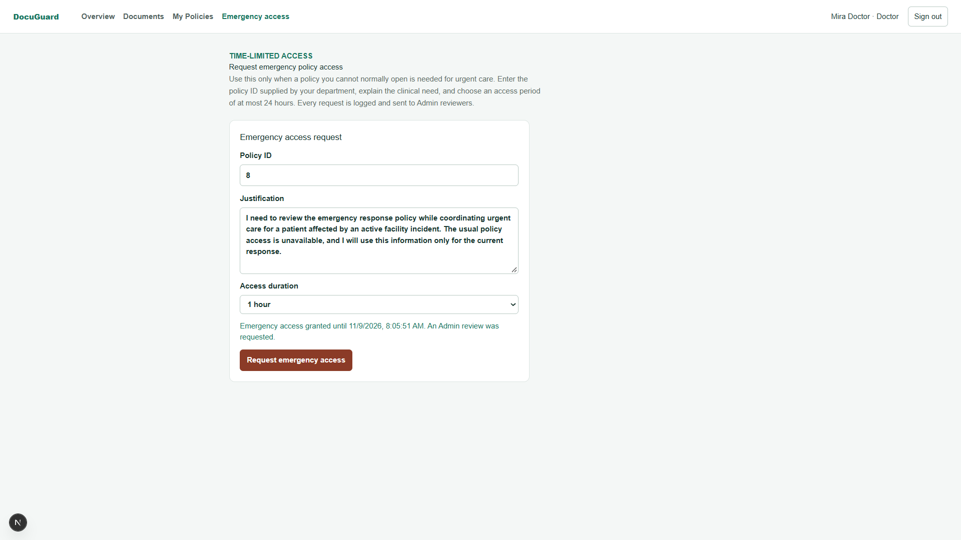
S10. Emergency access request
Doctor request form with required justification.

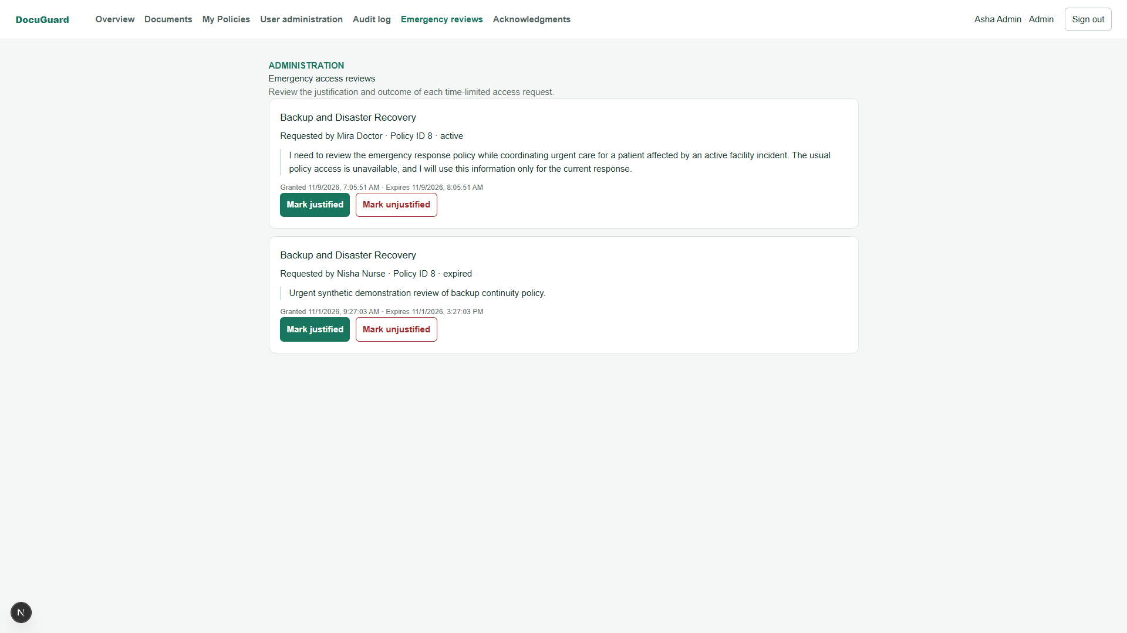
S11. Emergency review queue
Admin view showing pending break-glass review.

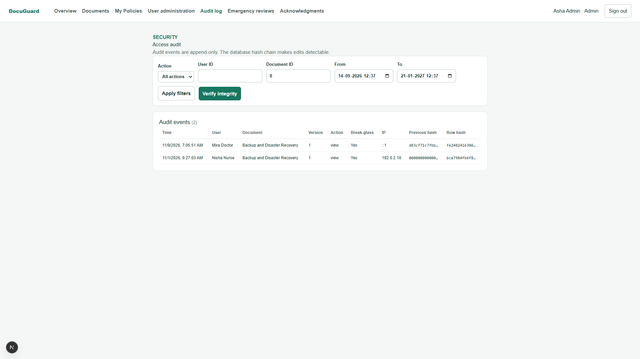
S12. Audit integrity
Audit page showing a successful chain verification result.

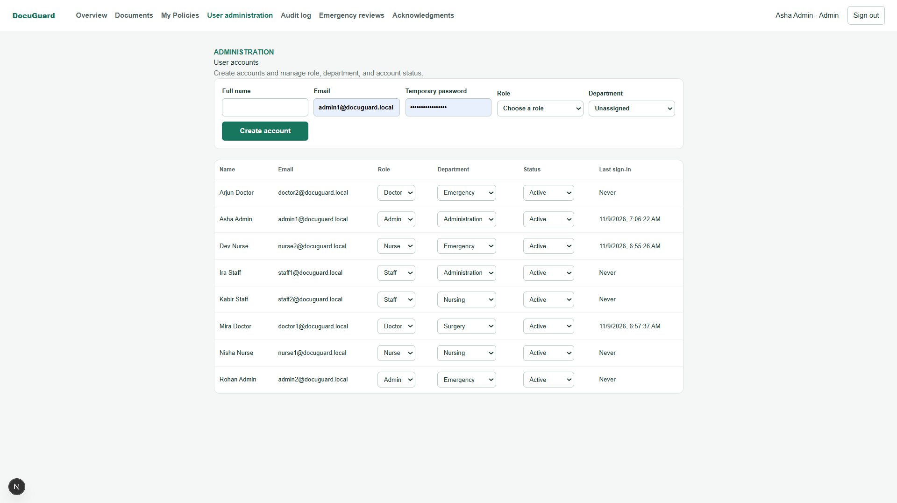
S13. User administration
Admin user list/status controls.

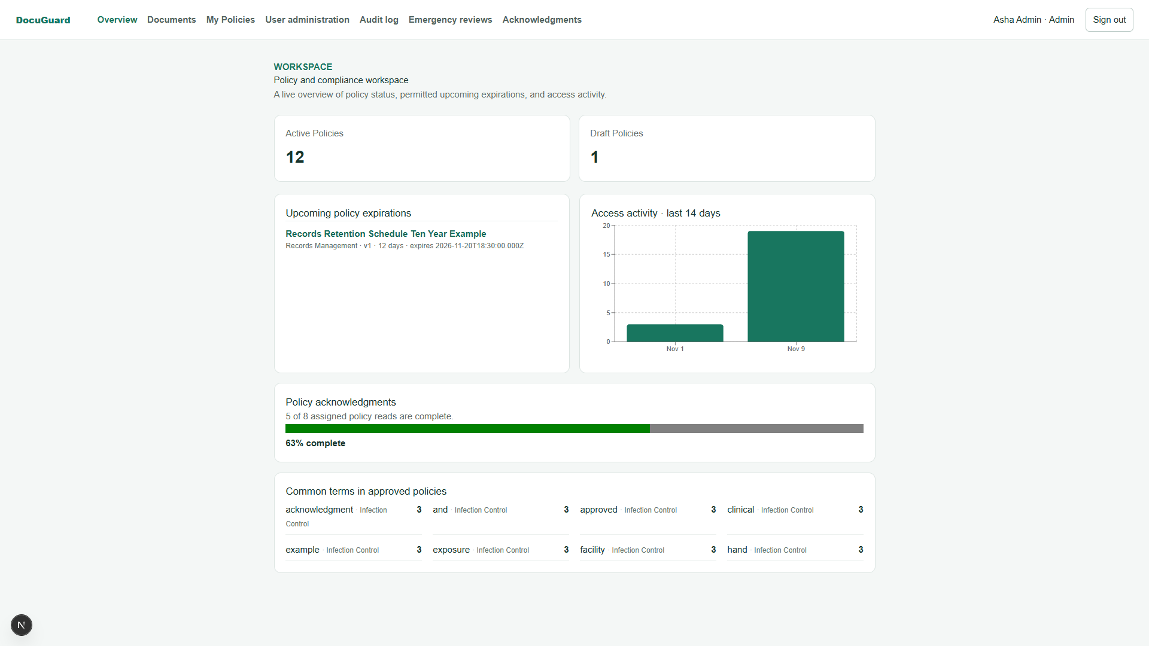
S14. Dashboard content analytics
Dashboard or analytics state backed by Mongo content aggregation.

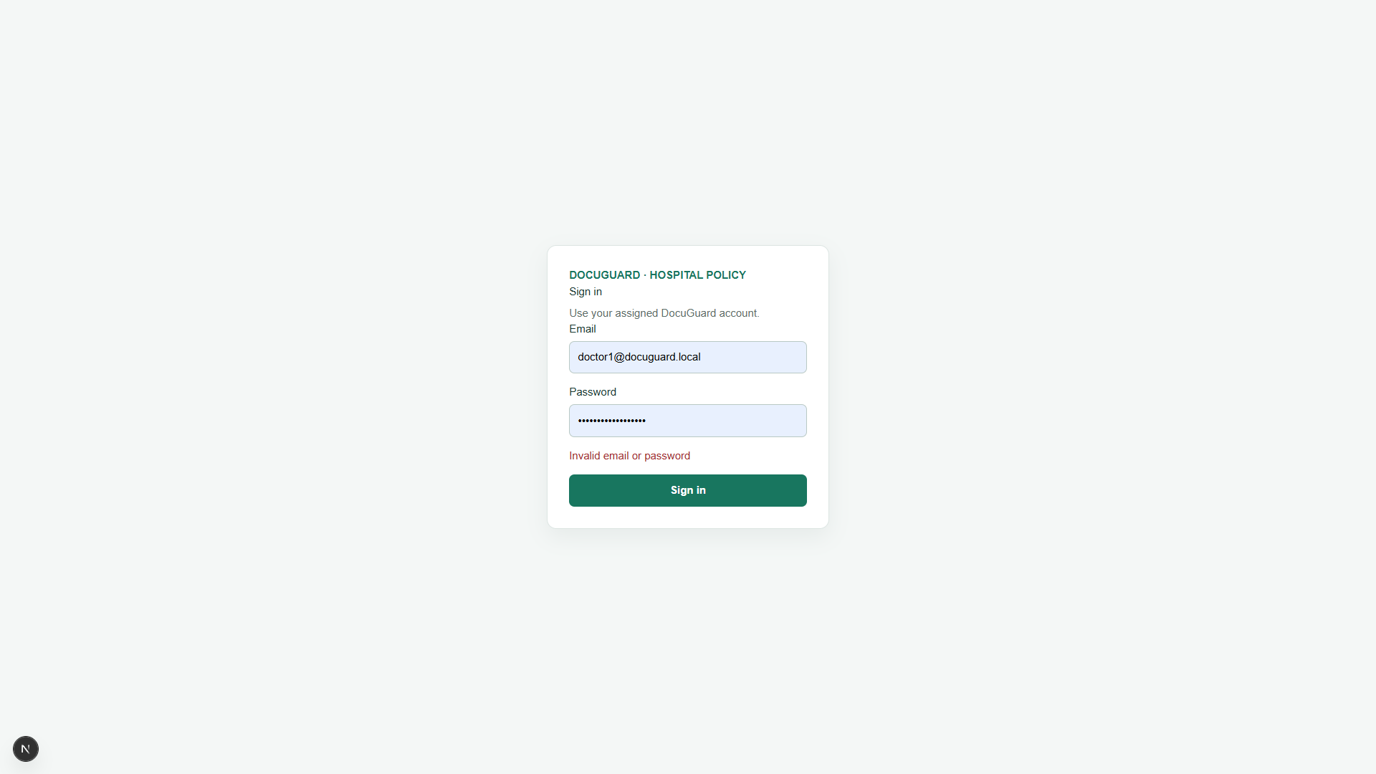
S15. Login authentication error
Sign-in page showing the generic invalid-credentials response.

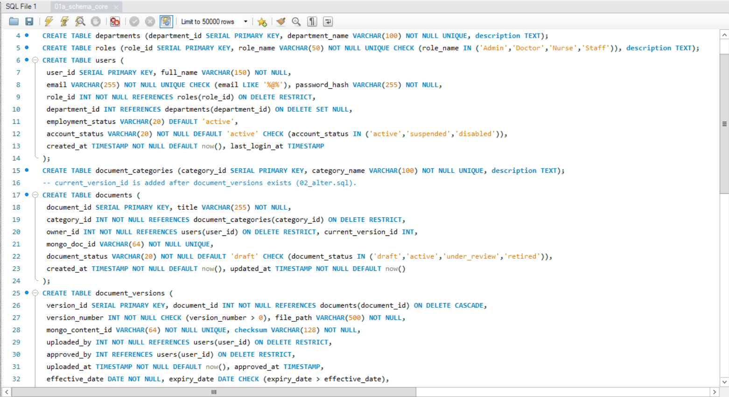
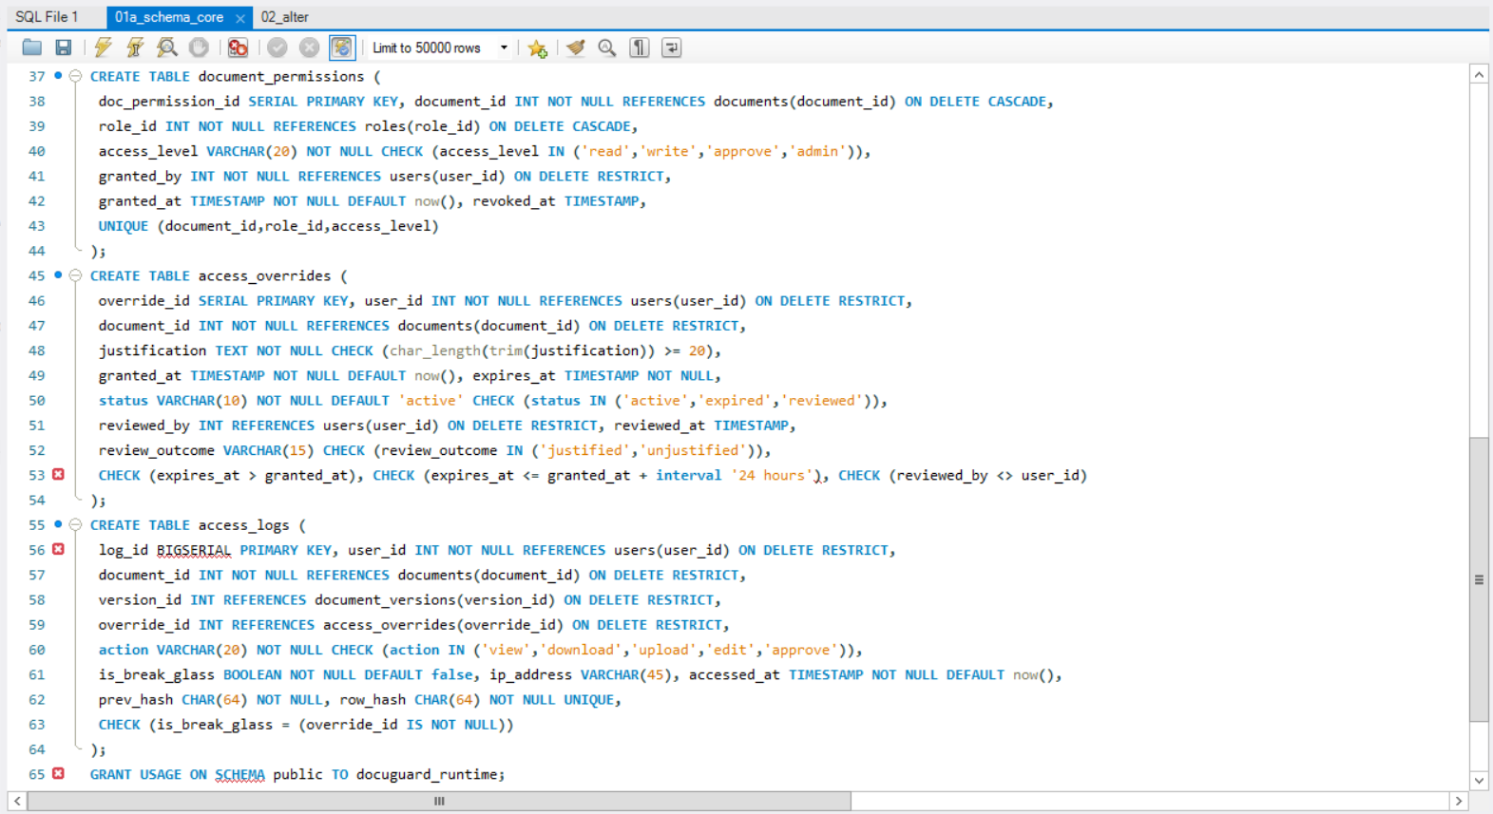
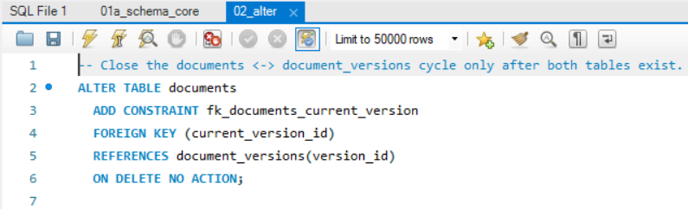

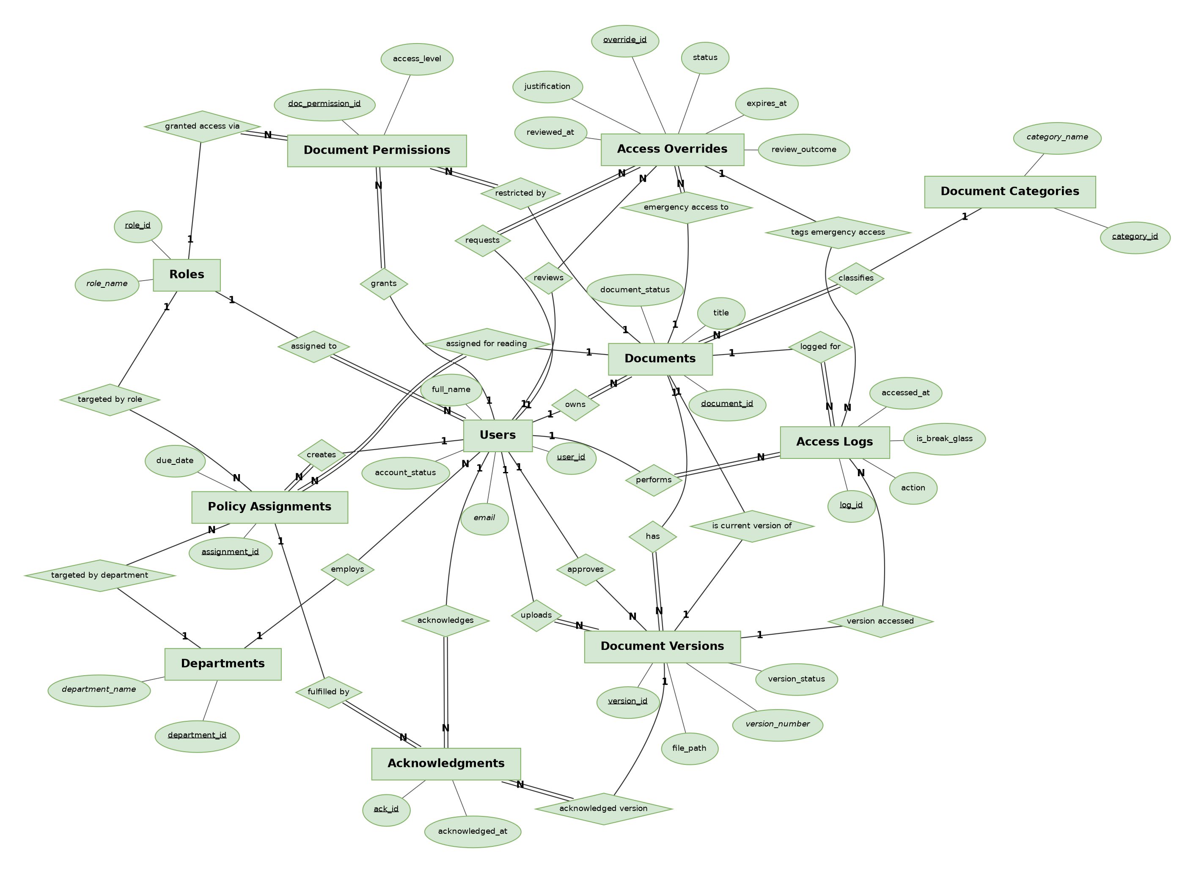
C1. Schema DDL and ER diagram
PostgreSQL table/constraint captures and the simplified ER diagram.

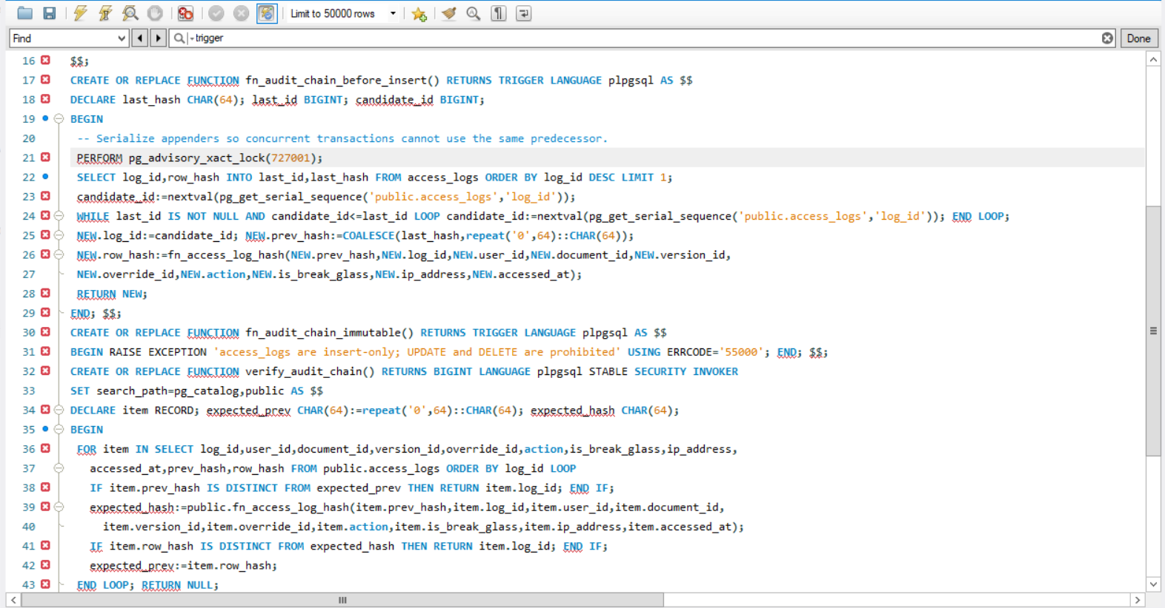
C2. Audit function and trigger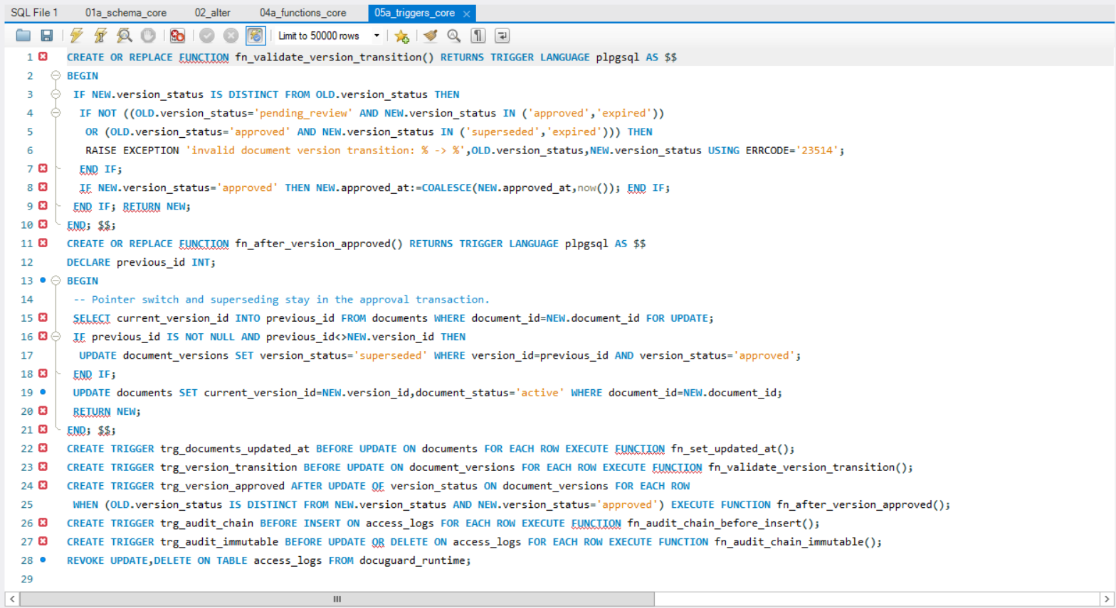
Hash-chain SQL captures; the recursive version-history CTE is printed in Section 5.

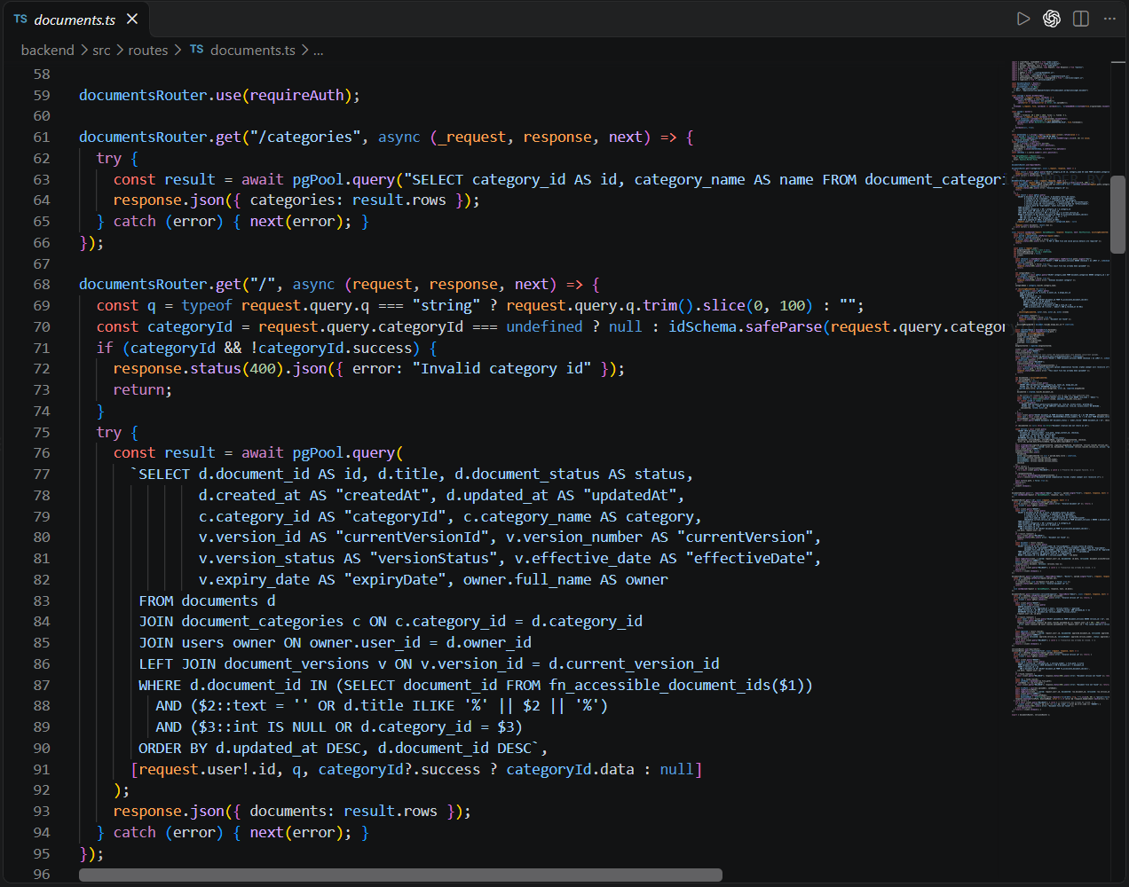
C3. Express API and permission-aware SQL
Parameterized document query and its authorization predicate.

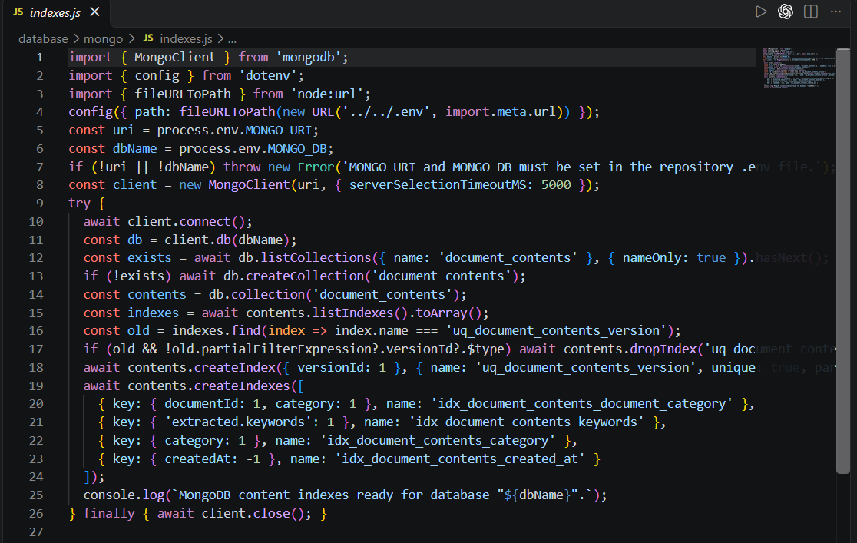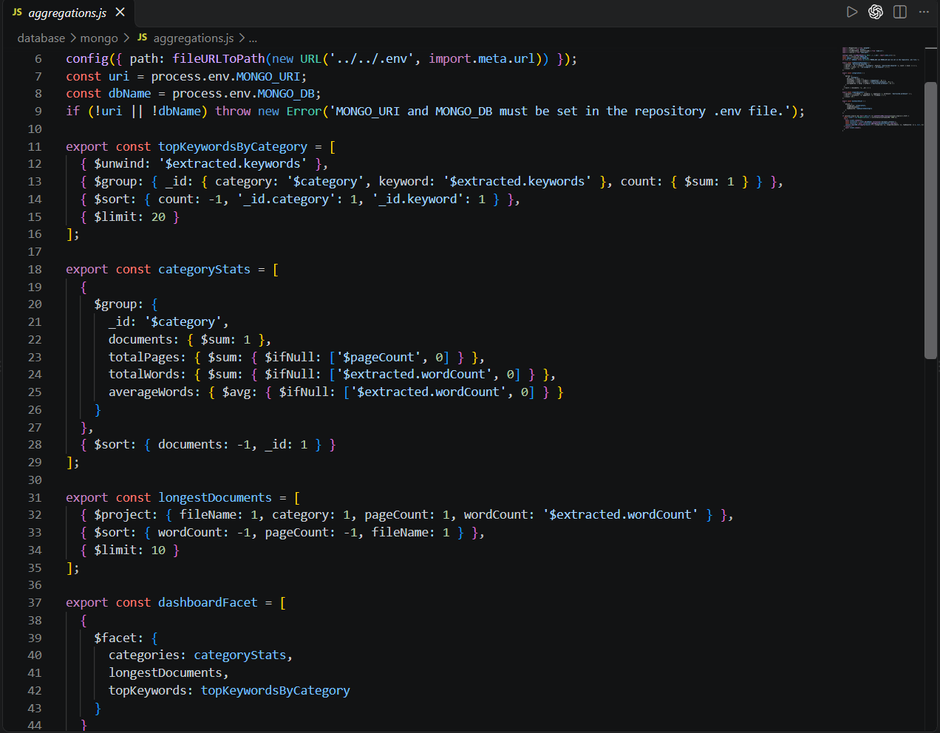
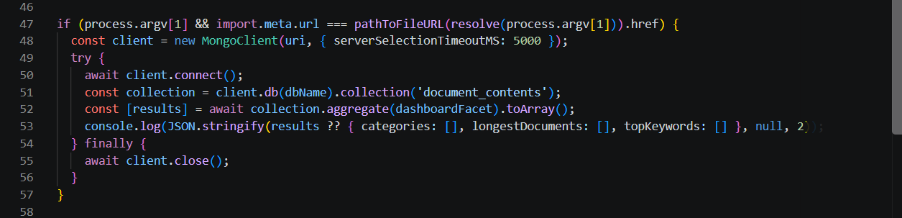 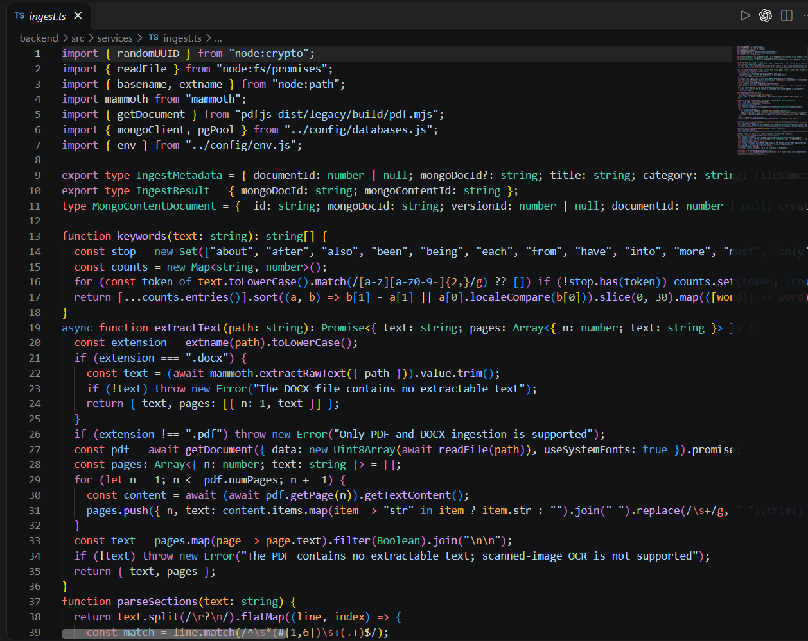
C4. MongoDB content CRUD and aggregation
document_contents collection/index and aggregation pipeline.

11. Evaluation rubric completion status
This is an evidence checklist, not a mark prediction. Total rubric weight: 50 marks. The instructor awards marks.
Evaluation metric | Marks | Status | Evidence / remaining work
ER diagram | 2 | Present | Mermaid target model and Chen image.
Relational schema with keys, relationships, constraints | 3 | Present | 11-table schema, dictionary, keys/FKs and constraints.
SQL DDL with constraints | 4 | Present | Numbered migrations and negative constraint/trigger tests.
NoSQL/Vector database creation | 4 | Met via NoSQL | MongoDB 7, document_contents collection and indexes; no vector schema.
Technology justification | 1 | Present | Architecture and NoSQL documentation explain component roles.
DML operations | 4 | Present | PostgreSQL seed/API CRUD and MongoDB content CRUD.
Nested/correlated/recursive/join queries | 4 | Present | JOIN, EXISTS, anti-join, GROUP BY/HAVING, window query and recursive history.
Functions, triggers, CTE | 6 | Present | Audit chain, approval/ack triggers, views and recursive CTE.
NoSQL/Vector feature and CRUD | 7 | Met via NoSQL | MongoDB insert/read/update/delete and aggregation; no vector feature.
Next.js interface | 3 | Implemented; 2 captures pending | Replace S7 with post-approval state; replace S15 with a real denial state if required.
Backend/API and database integration | 2 | Present | Express connects PostgreSQL/MongoDB; Next.js calls Express.
Authentication and database-backed role access | 4 | Implemented with qualification | JWT/bcrypt and four DB roles/document grants; Express/SQL enforces them. No PostgreSQL RLS/per-user DB roles.
Documentation, Git/GitHub | 2 | Present; contributor evidence pending | Lite branch is pushed to DockGuardLite; add/verify teammate access and PR evidence.
Originality, individual contribution, modification/viva | 4 | Team evidence pending | Teammate needs genuine Lite commits under their identity; both students should explain their work.
The rubric says NoSQL/Vector; this report follows the NoSQL alternative through MongoDB. Lite has no vector column or vector-search feature in its approved model.

12. Setup and demonstration guide
Follow the Lite README. Its Compose project, ports, databases and volumes are isolated from the archived full version.
Copy-Item .env.example .env
docker compose up -d
npm install
npm run db:rebuild
npm run db:auth
npm run db:mongo:indexes
npm run db:mongo:seed
npm run dev
Frontend: http://localhost:3010/login | API health: http://localhost:4010/health

Appendix A. Core database objects
Relational tables: departments, roles, users, document_categories, documents, document_versions, document_permissions, access_logs, access_overrides, policy_assignments and acknowledgments.
MongoDB collection: document_contents. PostgreSQL extension: pgcrypto. Lite uses MongoDB as its NoSQL store and has no vector search.

Appendix B. Project references
- README.md - setup and demo accounts.
- docs/inputs/docuguard_er_diagram.mermaid and docs/inputs/docuguard_data_dictionary.md - model and constraints.
- docs/RELATIONAL_SCHEMA.md and docs/QUERIES.md - schema/query explanation.
- docs/NOSQL_VECTOR.md - MongoDB model and aggregation.
- docs/TESTING.md - dated test results.
- docs/RUBRIC_CHECKLIST.md, docs/OWNERSHIP.md and docs/DEMO_GUIDE.md - rubric, team and presentation evidence.

