Software Architecture and Design Specification
Project: Collaborative Study Material & Quiz Platform
Version: 1.0
Authors: Project Team : Jagadeesh, Alifiya, Pushkar
Date: 03-10-2026
Status: Final

Revision History
Version | Date | Author | Change Summary
1.0 | 03-10-2026 | Project Team | Integrated final architecture and design specification for all project features (Account Management, Material Sharing, Question Bank & Quizzes, Performance & Collaboration) and the security architecture. Includes the component diagram, component descriptions, team-wide requirements traceability, STRIDE security architecture, seven UML sequence diagrams, integrated API design, error handling, logging and monitoring, UX design and appendices.

Approvals
Role | Name | Signature/Date
Project guide | ___________________ | ____________________

1. Introduction
1.1 Purpose
This document specifies the architecture and design of the Collaborative Study Material & Quiz Platform, a web application for sharing study material, building a question bank, taking auto-graded quizzes and analysing performance. It is a single integrated team specification covering every feature of the platform.
1.2 Scope
This document covers the complete architecture and design of the platform. In scope:
- Account Management: registration, authentication, session handling, logout and profile management.
- Material Sharing: upload, viewing and listing, download, sharing, update, removal and revocation of access to study material.
- Question Bank & Quizzes: question management, quiz creation and publication, timed attempts and automatic grading, results and quiz submissions.
- Performance & Collaboration: personal, topic-wise and class performance analysis, study groups and Admin moderation of collaborative content.
- Security architecture: the controls, applied across all four areas, that realise the security objectives and security requirements of the SRS.
Requirements, use cases and security objectives are those defined in the SRS; this document does not change them.
1.3 Audience
Developers, QA engineers, security reviewers, instructors, and maintenance teams.
1.4 Definitions
SRS (Software Requirements Specification), STP (Software Test Plan), RTM (Requirements Traceability Matrix), UML, UC (use case), REQ / SEC / NFR (functional, security and non-functional requirement identifiers of the SRS), SO (security objective, SO-01 to SO-06), REST, JWT (JSON Web Token), RBAC (Role-Based Access Control), TLS, MERN (MongoDB, Express.js, React, Node.js), ODM (object-document mapper), SPA (single-page application), STRIDE (threat-classification model), ADR (Architecture Decision Record), MCQ (multiple-choice question). Further architecture terms are in Appendix 5.1.

2. Document Overview
2.1 How to use this document
Provides the architectural deliverables: component diagram, component descriptions, architecture pattern, technology stack, risks, requirements traceability, STRIDE security architecture, UML sequence diagrams, API design, error handling, UX design and open issues.
Section 3 (Architecture) describes the system as a whole: 3.3 and 3.4 give the component diagram and descriptions, 3.8 traces every SRS requirement group to the architecture and 3.9 describes the security architecture. Section 4 (Design) describes the detailed design: 4.2 gives the sequence diagrams of the main flows, 4.3 the single integrated API and 4.4 the error handling, logging and monitoring for the whole platform. Section 5 contains the glossary, references and tools.
2.2 Related Documents
SRS (Collaborative Study Material & Quiz Platform, Version 1.0): source of all requirement IDs, use cases and the security objectives SO-01 to SO-06.
STP (Software Test Plan): test cases that verify the requirements traced in Section 3.8.
RTM (Requirements Traceability Matrix, Appendix C of the SRS): requirement-to-test traceability; Section 3.8 of this document adds requirement-to-architecture traceability.

3. Architecture
3.1 Goals & Constraints
Goals:
(1) secure – meet security objectives SO-01 to SO-06 of the SRS;
(2) responsive – login within 2 seconds, quiz results available within 2 seconds of submission as specified by REQ-QZ-12, and material sharing or access revocation within 2 seconds as specified by NFR-PERF-03, and page loads within 3 seconds for 95% of requests with 200 concurrent users as specified by NFR-PERF-01 and NFR-PERF-02;
(3) reliable – a submitted quiz attempt is never lost or altered and material operations do not expose a partially completed state;
(4) modular and testable, so that three developers can build and test their features independently;
(5) usable from modern desktop and mobile browsers.
Constraints: MERN stack (MongoDB, Express.js, React, Node.js); TLS 1.2 or higher for all communication; passwords stored only as salted bcrypt hashes; study materials limited to PDF, DOCX, PPTX and PNG files up to 25 MB; three-member team and one-semester schedule.
3.2 Stakeholders & Concerns
Students: usability, fast and fair quizzes, confidentiality of their materials and results.
Faculty: control over questions and quizzes, integrity of results.
Administrators: ability to moderate content and manage users.
Developers: modularity, clear interfaces, testability.
Instructors/evaluators: traceability to the SRS and quality of documentation.
Security reviewers: access control and protection of data.

3.3 Component (UML) Diagram

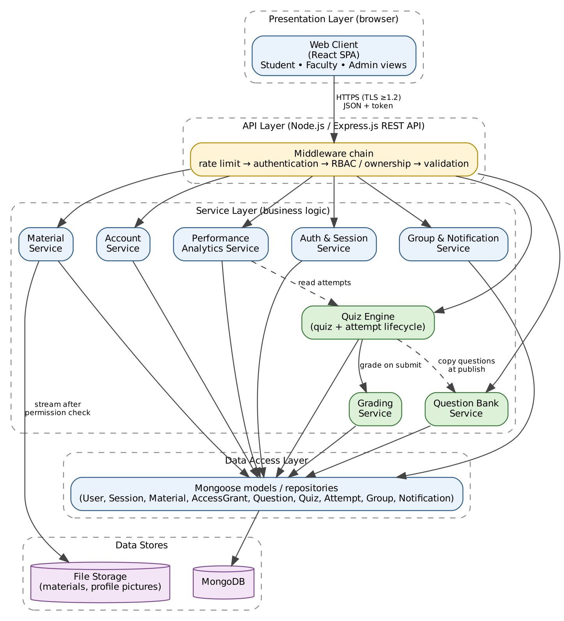
Figure 3.1: Component diagram (layered architecture): Web Client → API Layer (middleware chain) → Service Layer → Data Access Layer → MongoDB / File Storage. Green = Question Bank & Quizzes components. TLS 1.2+ is terminated by the Nginx reverse proxy in front of the API Layer.

3.4 Component Descriptions
Every component shown in Figure 3.1 is described below. The Group & Notification Service of the figure is the service for study groups and collaborative-content moderation (also called the Study Group & Collaboration Service in the sequence diagram of Figure 4.7).
Web Client (React SPA)
Responsibility: user interface for Students, Faculty and Admin; navigation, forms, quiz screens, performance charts and group screens; shows the quiz countdown for display only.
Inputs / outputs: in: user input; out: HTTPS/JSON requests with the session token, rendered pages and field-level error messages.
Security / access checks: holds no secrets and never receives quiz answer keys; hides controls the role may not use, but all enforcement is on the server.
SRS requirements: NFR-PERF-01, NFR-QUAL-01, NFR-QUAL-04, SEC-QZ-02.
API Layer (Express.js) and middleware chain
Responsibility: routes requests through rate limiting, authentication (token and session check), role and ownership authorization and input validation before the controller is called; central error handler; builds Student-facing projections without answer keys.
Inputs / outputs: in: HTTP requests; out: controller calls, standard {error: {code, message}} responses.
Security / access checks: deny by default; RBAC and ownership middleware; express-validator and express-mongo-sanitize; upload type and size limits; rate limiting.
SRS requirements: REQ-ACC-10, REQ-MAT-10, REQ-QB-07, REQ-QZ-17, REQ-QZ-18, SEC-ACC-01 to SEC-ACC-06, SEC-MAT-01 to SEC-MAT-04, SEC-QZ-01 to SEC-QZ-05, NFR-PERF-02, NFR-QUAL-03.
Nginx reverse proxy (deployment element)
Responsibility: terminates TLS in front of the API Layer, serves the React build and restarts with the Docker deployment.
Inputs / outputs: in: HTTPS traffic; out: plain HTTP to Express.
Security / access checks: TLS 1.2 or higher only.
SRS requirements: SEC-COM-01, NFR-QUAL-02, NFR-PERF-01, NFR-PERF-02.
Auth & Session Service
Responsibility: registration, login with bcrypt comparison, failed-login counter and lock-out after 5 failures for 15 minutes, creation of the server-side session record and signed token, 30-minute inactivity expiry, logout and token invalidation.
Inputs / outputs: in: registration data, credentials; out: token with expiresIn 1800, session status.
Security / access checks: passwords stored only as salted bcrypt hashes; identical message for unknown e-mail and wrong password; a token is valid only while its session record is valid; security events audited.
SRS requirements: REQ-ACC-01 to REQ-ACC-07, REQ-ACC-10, SEC-ACC-01 to SEC-ACC-06.
Account Service
Responsibility: viewing and updating the permitted profile fields (full name, institution, profile picture).
Inputs / outputs: in: profile data (multipart/form-data when a picture is sent); out: profile data.
Security / access checks: users can access only their own profile; e-mail address and role cannot be changed; picture validated for type and size.
SRS requirements: REQ-ACC-08, REQ-ACC-09, REQ-ACC-10, SEC-ACC-01 to SEC-ACC-06.
Material Service
Responsibility: upload with type and size checks, ownership, listing and viewing, download, update, removal, sharing and revoking access through AccessGrant records; SHA-256 checksum at upload; blocks access before deleting a file.
Inputs / outputs: in: metadata and file (multipart), recipient user ID; out: material data, file stream, grant records.
Security / access checks: ownership or AccessGrant checked before every view or download; only the owner may update, remove, share or revoke; permission read from the database on every request.
SRS requirements: REQ-MAT-01 to REQ-MAT-11, SEC-MAT-01 to SEC-MAT-04, NFR-PERF-03, NFR-SAFE-02, NFR-SAFE-03.
File Storage
Responsibility: stores uploaded files (materials and profile pictures) on server disk outside the web root; can be replaced by object storage.
Inputs / outputs: in: file from the Material or Account Service; out: file stream to the Material Service only.
Security / access checks: no public URL; streamed only after the permission check; scheduled copy for backup.
SRS requirements: REQ-MAT-01, REQ-MAT-06, REQ-MAT-08, REQ-MAT-11, SEC-MAT-01, NFR-SAFE-01 to NFR-SAFE-03.
Question Bank Service
Responsibility: adding, searching/filtering, editing and removing questions; verifies that question IDs exist when a quiz is created.
Inputs / outputs: in: question data, search parameters; out: question data (including the answer key, to Faculty only).
Security / access checks: Faculty only; only the owner may edit or remove; Students receive 403.
SRS requirements: REQ-QB-01 to REQ-QB-07, NFR-PERF-05.
Quiz Engine
Responsibility: quiz life cycle (Draft → Published), copy of questions at publication, availability window, listing, attempt start with server-side deadline, answer saving, submission, auto-submit when time expires, own results and quiz submissions.
Inputs / outputs: in: quiz data, answers; out: quiz and attempt data (questions without correct options while the attempt is open).
Security / access checks: Faculty owner for management and submissions; Student for attempts; server clock only; one attempt per Student per quiz; submitted attempts immutable.
SRS requirements: REQ-QZ-01 to REQ-QZ-18 (except grading detail in Grading Service), SEC-QZ-01 to SEC-QZ-05, NFR-PERF-06.
Grading Service
Responsibility: compares the submitted answers with the answer keys held in the quiz copy and computes score, percentage and per-question correctness.
Inputs / outputs: in: attempt and quiz copy; out: stored result.
Security / access checks: runs only on the server; result stored with the immutable attempt; answer keys never logged.
SRS requirements: REQ-QZ-11, REQ-QZ-12, REQ-QZ-14, SEC-QZ-02, SEC-QZ-05, NFR-PERF-04.
Performance Analytics Service
Responsibility: retrieves completed attempts and aggregates them into personal, topic-wise and class performance statistics.
Inputs / outputs: in: user or quiz identifier; out: attempt lists and statistics.
Security / access checks: Student sees only own data; Faculty sees only quizzes they own; others receive 403.
SRS requirements: REQ-PA-01 to REQ-PA-06.
Group & Notification Service
Responsibility: creates and manages study groups, maintains group membership (duplicate membership rejected), stores group-related notification records and performs Admin-only moderation of collaborative content.
Inputs / outputs: in: group data, join and moderation requests; out: group and membership data. Push notifications to external devices are a future enhancement.
Security / access checks: Student role for creating and joining groups; Admin role for moderation; unavailable items return 404 without details.
SRS requirements: REQ-COL-01 to REQ-COL-07.
Data Access Layer (Mongoose)
Responsibility: models and repositories for User, Session, Material, AccessGrant, Question, Quiz, Attempt, Group, GroupMember, Notification and collaborative-content data; indexes and connection pool.
Inputs / outputs: in: repository calls from services; out: documents.
Security / access checks: the only code that touches the database; sanitised queries; no business rules.
SRS requirements: REQ-MAT-03, REQ-QB-04, NFR-PERF-01, NFR-PERF-02, NFR-SAFE-02.
MongoDB
Responsibility: persistent store for all application data.
Inputs / outputs: in/out: documents via Mongoose.
Security / access checks: access only from the server network; daily backup.
SRS requirements: NFR-SAFE-01, NFR-PERF-02.

3.5 Chosen Architecture Pattern and Rationale
Layered architecture implemented as a modular monolith: Presentation (React) → API / middleware (Express routes and middleware chain) → Service layer (business logic) → Data access layer (Mongoose) → Database / file storage (MongoDB and File Storage).
Rationale: clear separation of concerns; security checks are enforced in one place (middleware and service layer) for every feature; each service can be developed and unit-tested independently; one deployable unit is simple to build and demonstrate; grading runs in-process, which easily meets the 2-second target; it fits the MERN constraint.
Rejected alternatives: microservices – unnecessary operational complexity and distributed transactions for an expected load of a few hundred users; client-side grading – insecure, since answer keys and scores would be exposed and changeable (SEC-QZ-02, SEC-QZ-05).
Key decisions (ADR summary): ADR-1 layered modular monolith. ADR-2 MongoDB document store; quiz questions are copied into the quiz when it is published, so a published quiz and its attempts are self-contained. ADR-3 signed token plus a server-side session record, so that logout and 30-minute inactivity can invalidate a token. ADR-4 grading and the quiz timer run only on the server.

3.6 Technology Stack & Data Stores
Client: React 18, React Router, Axios, Chart.js for performance charts.
Server: Node.js 20 LTS, Express.js 4, Mongoose ODM; jsonwebtoken for tokens, bcrypt for password hashing, helmet (security headers), express-rate-limit, express-validator (input validation), express-mongo-sanitize (NoSQL injection protection), multer (uploads).
Data stores: MongoDB 7 with collections users, sessions, materials, accessGrants, questions, quizzes (with embedded question copies), attempts (with embedded answers and result), groups, groupMembers, collaborativeContent; file storage on server disk outside the web root (can be replaced by object storage).
Communication and deployment: HTTPS with TLS 1.2 or higher through an Nginx reverse proxy; REST/JSON.
Quality tools: Jest and Supertest for tests, ESLint, Git/GitHub.
Consistency with the SRS: all technologies stay within the MERN constraint; no additional runtime platform or database is introduced, and password hashing (bcrypt) and TLS 1.2+ match the SRS security requirements.

3.7 Risks & Mitigations
Risk: browser or connection fails during a quiz and answers are lost → Mitigation: each answer is saved to the server when selected; the Student can resume the attempt; at the deadline the server auto-submits the answers saved so far.
Risk: many Students submit requests concurrently and processing becomes slow → Mitigation: grading is a simple in-memory comparison of at most 50 answers; indexes are maintained on attempt and quiz identifiers; load testing shall include 200 concurrent users in accordance with NFR-PERF-01 and NFR-PERF-02, including quiz submission and grading activity; if grading fails, the submission is retained and grading is retried.
Risk: a Student changes the device clock or tampers with the timer → Mitigation: start time, deadline and acceptance of answers use the server clock only (SEC-QZ-04).
Risk: answer keys leak to the client → Mitigation: Student-facing responses are built from a projection that excludes correct options and explanations until submission (SEC-QZ-02); tested explicitly.
Risk: direct download of material files by URL → Mitigation: files are stored outside the web root and served only after an ownership or grant check (SEC-MAT-01).
Risk: password guessing → Mitigation: lock-out after 5 failed logins for 15 minutes and rate limiting.
Risk: the single server is a single point of failure → Mitigation: daily database backups and a reproducible deployment (Docker) so the system can be restored quickly.
Risk: team members change shared data models and break each other's code → Mitigation: shared Mongoose models follow the ER model in the SRS; changes are agreed in the group and covered by tests.

3.8 Traceability to Requirements
Every requirement group of the SRS is mapped below to the architecture component(s) that implement it and to the design section or diagram that shows it. Requirement IDs are unchanged from the SRS.
Requirement(s) | Architecture component(s) | Design reference
Account Management
REQ-ACC-01 to REQ-ACC-07 (registration, authentication, session) | Auth & Session Service | 4.1; Fig 4.3; 4.3 /auth/*; 4.4
REQ-ACC-08, REQ-ACC-09 (profile) | Account Service | 4.1; 4.3 /account/profile
REQ-ACC-10 | API Layer, Auth & Session Service, Account Service | 3.9; 4.3 conventions; 4.4 (401)
SEC-ACC-01 to SEC-ACC-06 | API Layer, Auth & Session Service, Account Service | 3.9; Fig 4.3
Material Sharing
REQ-MAT-01 | Material Service, File Storage | Fig 4.4; 4.3 POST /materials
REQ-MAT-02 | Material Service | 4.1; 4.3 /materials
REQ-MAT-03 | Material Service, Data Access Layer | 4.3 GET /materials, /materials/:id
REQ-MAT-04, REQ-MAT-05, REQ-MAT-09 | Material Service, AccessGrant (Data Access Layer) | Fig 4.4; 4.3 share and access endpoints
REQ-MAT-06, REQ-MAT-08, REQ-MAT-11 | Material Service, File Storage | 4.1; 4.3 download, update, delete
REQ-MAT-07 | Material Service | 4.3 /materials/:id
REQ-MAT-10 | API Layer, Material Service | 3.9; 4.3; 4.4
SEC-MAT-01 to SEC-MAT-04 | API Layer, Material Service, AccessGrant, File Storage | 3.9; Fig 4.4
Common security
SEC-COM-01 | Nginx reverse proxy (TLS 1.2+) | 3.6; 3.9
Question Bank
REQ-QB-01 to REQ-QB-03, REQ-QB-05 (add, edit, owner, validation) | Question Bank Service | 4.3 /questions
REQ-QB-04 (search and filter) | Question Bank Service, Data Access Layer (indexes) | 4.3 GET /questions
REQ-QB-06 (remove; published quizzes unchanged) | Question Bank Service, Quiz Engine (question copy) | 4.1 quiz design; 4.3 DELETE /questions/:id
REQ-QB-07 | API Layer (RBAC and ownership middleware) | 3.9; 4.3; 4.4
Quizzes
REQ-QZ-01 to REQ-QZ-05 (create, validate, draft, copy at publication, edit/delete) | Quiz Engine | Fig 4.1; 4.3 quiz management
REQ-QZ-06, REQ-QZ-07 (list, start rules) | Quiz Engine | Fig 4.2; 4.3 GET /quizzes, POST /quizzes/:id/attempts
REQ-QZ-08 to REQ-QZ-10 (timer, answers, auto-submit) | Quiz Engine, API Layer | Fig 4.2; 4.3 attempts
REQ-QZ-11, REQ-QZ-12, REQ-QZ-14 (grading, 2-second result, immutability) | Grading Service, Quiz Engine | Fig 4.2; 4.3 submit
REQ-QZ-13, REQ-QZ-15, REQ-QZ-16 (results, own attempts, quiz submissions) | Quiz Engine, Data Access Layer | 4.3 results and submissions
REQ-QZ-17 | API Layer (RBAC and ownership middleware) | 3.9; 4.3; 4.4
REQ-QZ-18 (unavailable item) | API Layer (central error handler) | 4.4
SEC-QZ-01 to SEC-QZ-05 | API Layer (RBAC, Student projection), Quiz Engine (server clock, immutability), Grading Service (server-side scoring) | 3.9; Fig 4.1, 4.2
Performance & Collaboration
REQ-PA-01, REQ-PA-02 | Performance Analytics Service, Data Access Layer | Fig 4.5; 4.3 /performance/personal
REQ-PA-03 | Performance Analytics Service, Data Access Layer | Fig 4.6; 4.3 /performance/topics
REQ-PA-04, REQ-PA-05, REQ-PA-06 | Performance Analytics Service, API Layer (RBAC and ownership), Data Access Layer | Fig 4.6; 4.3 /performance/class/:quizId; 4.4
REQ-COL-01 to REQ-COL-04 | Group & Notification Service, Data Access Layer | Fig 4.7; 4.3 /groups
REQ-COL-05 to REQ-COL-07 | Group & Notification Service, API Layer (RBAC, error handling), Data Access Layer | Fig 4.7; 4.3 moderation; 4.4
Non-functional requirements
NFR-PERF-01 (95% of page loads within 3 s, 200 users) | Web Client (SPA), API Layer (pagination), Data Access Layer (indexes), Nginx | 3.1; 3.6; 4.4 monitoring
NFR-PERF-02 (200 concurrent users, under 1% failed requests) | API Layer (rate limiting), Nginx, Data Access Layer (connection pool, indexes), MongoDB | 3.7; 4.4 monitoring
NFR-PERF-03 (share and revocation within 2 s) | Material Service, AccessGrant (permission read on every request) | 4.1; 4.3
NFR-PERF-04 to NFR-PERF-06 (grading, bank search, quiz start) | Grading Service, Question Bank Service, Quiz Engine, Data Access Layer (indexes) | Fig 4.2; 4.4 monitoring
NFR-SAFE-01 (daily backup, restore within 24 h) | MongoDB (scheduled dump), File Storage (scheduled copy), Docker deployment | 3.7; 4.4
NFR-SAFE-02 (interrupted operations keep previous state) | Material Service, File Storage, Data Access Layer | 4.1; 4.4
NFR-SAFE-03 (downloaded file identical to upload) | Material Service (SHA-256 checksum), File Storage | 4.1; 4.3 download
NFR-QUAL-01 (usability) | Web Client (consistent navigation, inline field errors) | 4.5
NFR-QUAL-02 (99% availability) | Nginx, Docker deployment (automatic restart), monitoring, daily backups | 3.7; 4.4
NFR-QUAL-03 (robustness) | API Layer (validation, sanitisation, upload limits, central error handler) | 3.9; 4.4
NFR-QUAL-04 (browser portability) | Web Client (React SPA, responsive layout) | 4.5
NFR-QUAL-05 (modular, independently testable) | Layered modular monolith with separate services | 3.5; 4.1
NFR-QUAL-06 (traceability to test cases) | This section, the RTM (Appendix C of the SRS) and the Test Plan | 3.8; 2.2
Coverage: REQ-ACC-01 to 10, REQ-MAT-01 to 11, SEC-ACC-01 to 06, SEC-MAT-01 to 04, SEC-COM-01, REQ-QB-01 to 07, REQ-QZ-01 to 18, SEC-QZ-01 to 05, REQ-PA-01 to 06, REQ-COL-01 to 07, NFR-PERF-01 to 06, NFR-SAFE-01 to 03 and NFR-QUAL-01 to 06 are all traced above.

3.9 Security Architecture
Security controls by layer: TLS 1.2+ for all traffic (Nginx); authentication with a signed token that is checked against a server-side session record (30-minute inactivity, invalidated on logout); role-based and ownership-based authorization in middleware and again in the service layer (deny by default); input validation and NoSQL-injection sanitisation on every request; bcrypt hashing for passwords; Student-facing quiz responses built by projection without answer keys; files outside the web root; audit logging of security events without sensitive data.
Threat Modeling (STRIDE):
Spoofing → bcrypt-hashed credentials, lock-out after 5 failures, signed token plus session record, TLS (SEC-ACC-02, 03, 06).
Tampering → ownership checks on materials, questions and quizzes (SEC-MAT-03, SEC-QZ-01); scores computed only on the server and submitted attempts immutable (SEC-QZ-05); input validation and sanitisation.
Repudiation → audit log of login, logout, material sharing, quiz publication, attempt start and submission, with server timestamps.
Information disclosure → TLS (SEC-COM-01); no answer keys or explanations sent before submission (SEC-QZ-02); results visible only to the attempt owner and submissions only to the quiz owner (SEC-QZ-03); material access only for owner and authorized users (SEC-MAT-01); no passwords or tokens in logs.
Denial of service → rate limiting, 25 MB upload limit, pagination, at most 50 questions per quiz, one attempt per Student per quiz.
Elevation of privilege → RBAC middleware for Student, Faculty and Admin; Students cannot reach question-bank or quiz-management endpoints (REQ-QB-07, REQ-QZ-17); ownership checked on every update, delete and view-submissions call.
Security controls and the SRS requirements they implement (together they realise security objectives SO-01 to SO-06 of the SRS):
Security control | Implemented by | SRS requirements
TLS 1.2+ for all traffic | Nginx reverse proxy | SEC-COM-01
Authentication; bcrypt-hashed passwords; lock-out after 5 failed logins (15 min) | Auth & Session Service | SEC-ACC-01 to SEC-ACC-06
Server-side sessions: signed token checked against a session record; 30-minute inactivity timeout; token invalidated on logout | Auth & Session Service, API Layer authentication middleware | SEC-ACC-01 to SEC-ACC-06, REQ-ACC-10
RBAC (Student, Faculty, Admin) and ownership checks, in middleware and again in services | API Layer, all services | REQ-QB-07, REQ-QZ-17, REQ-MAT-10, SEC-MAT-03, SEC-QZ-01
Input validation and NoSQL-injection sanitisation on every request | API Layer (express-validator, express-mongo-sanitize) | NFR-QUAL-03
Protected file storage outside the web root; streaming only after permission check; SHA-256 checksum | Material Service, File Storage | SEC-MAT-01 to SEC-MAT-04, NFR-SAFE-03
Answer-key protection: Student responses built by projection without correct options or explanations until submission | API Layer, Quiz Engine | SEC-QZ-02
Server-side grading and server-clock timer | Grading Service, Quiz Engine | SEC-QZ-04, SEC-QZ-05, REQ-QZ-11
Immutable submitted attempts; one attempt per Student per quiz | Quiz Engine, Data Access Layer | SEC-QZ-05, REQ-QZ-14
Result and submission visibility limited to attempt owner and quiz owner | Quiz Engine, API Layer | SEC-QZ-03
Audit logging of security events with server timestamps, without sensitive data | Logger used by all services (see 4.4) | Repudiation control of the STRIDE model
Rate limiting, upload limit (25 MB), pagination, at most 50 questions per quiz | API Layer | NFR-PERF-02, NFR-QUAL-03

4. Design

4.1 Design Overview
The platform is designed as layered modules. A request passes through the middleware chain (rate limit, authentication, authorization, validation), then a controller, a service, the data access layer and finally storage (MongoDB or File Storage). The request flow is: rate limit → authentication → authorization → validation → controller → service → data access → storage. Controllers contain no business rules; services contain the rules of the SRS; models only access MongoDB.
Suggested code structure: server/{routes, controllers, services, models, middleware}, client/{pages, components, api}.
Quiz design: a quiz is Draft until published; at publication the selected questions (text, options, correct option, explanation) are copied into the quiz, so later changes to the bank do not affect it. An attempt moves In Progress → Submitted → Graded. The attempt stores the server start time and deadline, the selected answers, and after grading the score, percentage and per-question correctness. A Student can have only one attempt per quiz.
Account management design: Account Management is implemented through the Auth & Session Service and Account Service. Registration and authentication requests pass through the API Layer, where input validation and authentication controls are applied. Passwords are compared using bcrypt and are stored only as salted bcrypt hashes. After successful authentication, the Auth & Session Service creates a server-side session record and issues a signed token. The token is accepted only while the corresponding session is valid. The Auth & Session Service maintains the failed-login counter and locks an account for 15 minutes after five consecutive failed login attempts. A session expires after 30 minutes of inactivity or when the user logs out, and the associated session record is invalidated. The Account Service handles viewing and updating permitted profile information and prevents modification of protected fields such as email address and role.
Material sharing design: Material Sharing is implemented through the Material Service, AccessGrant records, File Storage and the Data Access Layer. During upload, the Material Service validates the title, subject, description, file type and file size before storing the material. Supported files are PDF, DOCX, PPTX and PNG, with a maximum size of 25 MB. The authenticated uploader is recorded as the material owner. Material files are stored outside the web root and are streamed only through the Material Service after an ownership or access-grant check. Sharing creates an AccessGrant for the selected registered user. Revoking access removes or invalidates the corresponding grant so that the next access request is denied. Update and removal operations require ownership authorization. Material access checks are performed before viewing or downloading the file. To keep operations safe, the Material Service writes an uploaded file to temporary storage, computes and stores its SHA-256 checksum, and creates or updates the database record only after the file has been stored. If any step fails or is interrupted, the previous state is kept and no success response is returned. Removal blocks access first and deletes the file afterwards.
Performance & Collaboration design: Performance Analytics is implemented through the Performance Analytics Service and the Data Access Layer. The service retrieves completed quiz attempts and uses the stored score, percentage, submission date and quiz information to generate personal performance and topic-wise analysis for Students. Faculty performance views are restricted to quizzes owned by the requesting Faculty member and contain the performance information of Students who submitted attempts for the selected quiz.
Study group functionality is implemented through the Group & Notification Service and the Data Access Layer. An authenticated Student can create a study group or join an existing study group. Group membership is stored separately so that duplicate membership can be detected and rejected. Students can retrieve the groups to which they belong.
Collaborative-content moderation is restricted to authenticated Admin users. The API Layer performs authentication and role checks, and the Group & Notification Service performs the corresponding business operation. Requests from non-Admin users are rejected with an access-denied response. If a requested study group or collaborative content is unavailable, the system returns an appropriate unavailable response without exposing details of the unavailable item.

4.2 UML Sequence Diagrams
This section contains seven project-specific UML sequence diagrams covering all four feature areas. Each shows its actors and components, the messages of the success flow and, where relevant, the validation or error branch, and is tied to use cases (UC) and requirements (REQ/SEC) of the SRS.
Figure | Flow | Use case(s) | Requirements | Error / validation branch
4.1 | Create and publish a quiz | UC-QZ-01, UC-QZ-02 | REQ-QZ-01 to REQ-QZ-05, REQ-QZ-17, SEC-QZ-01 | 401/403 (not Faculty), 400 invalid fields
4.2 | Attempt a quiz and automatic grading | UC-QZ-04, UC-QZ-05 | REQ-QZ-06 to REQ-QZ-16, SEC-QZ-02 to SEC-QZ-05 | 403 QUIZ_NOT_OPEN / QUIZ_CLOSED, 409 ALREADY_ATTEMPTED, deadline auto-submit
4.3 | Authenticate user | UC-ACC-02 | REQ-ACC-04 to REQ-ACC-06, SEC-ACC-01, 02, 06 | 401 invalid credentials, 423 account locked
4.4 | Upload and share material | UC-MAT-01, UC-MAT-03 | REQ-MAT-01 to REQ-MAT-05, SEC-MAT-01, 02 | 400 invalid field or unsupported file
4.5 | View personal performance | UC-PA-01 | REQ-PA-01, REQ-PA-02 | 401 not authenticated (4.4)
4.6 | View class and topic-wise performance | UC-PA-02, UC-PA-03 | REQ-PA-03 to REQ-PA-06 | 403 not quiz owner
4.7 | Create or join study group; moderate content | UC-COL-01, UC-COL-02 | REQ-COL-01 to REQ-COL-07 | 409 already a member, 403 non-Admin

Sequence diagram 1: Create and publish a quiz (UC-QZ-01, UC-QZ-02)
Figure 4.1: Sequence diagram – Create and publish a quiz (UC-QZ-01, UC-QZ-02)
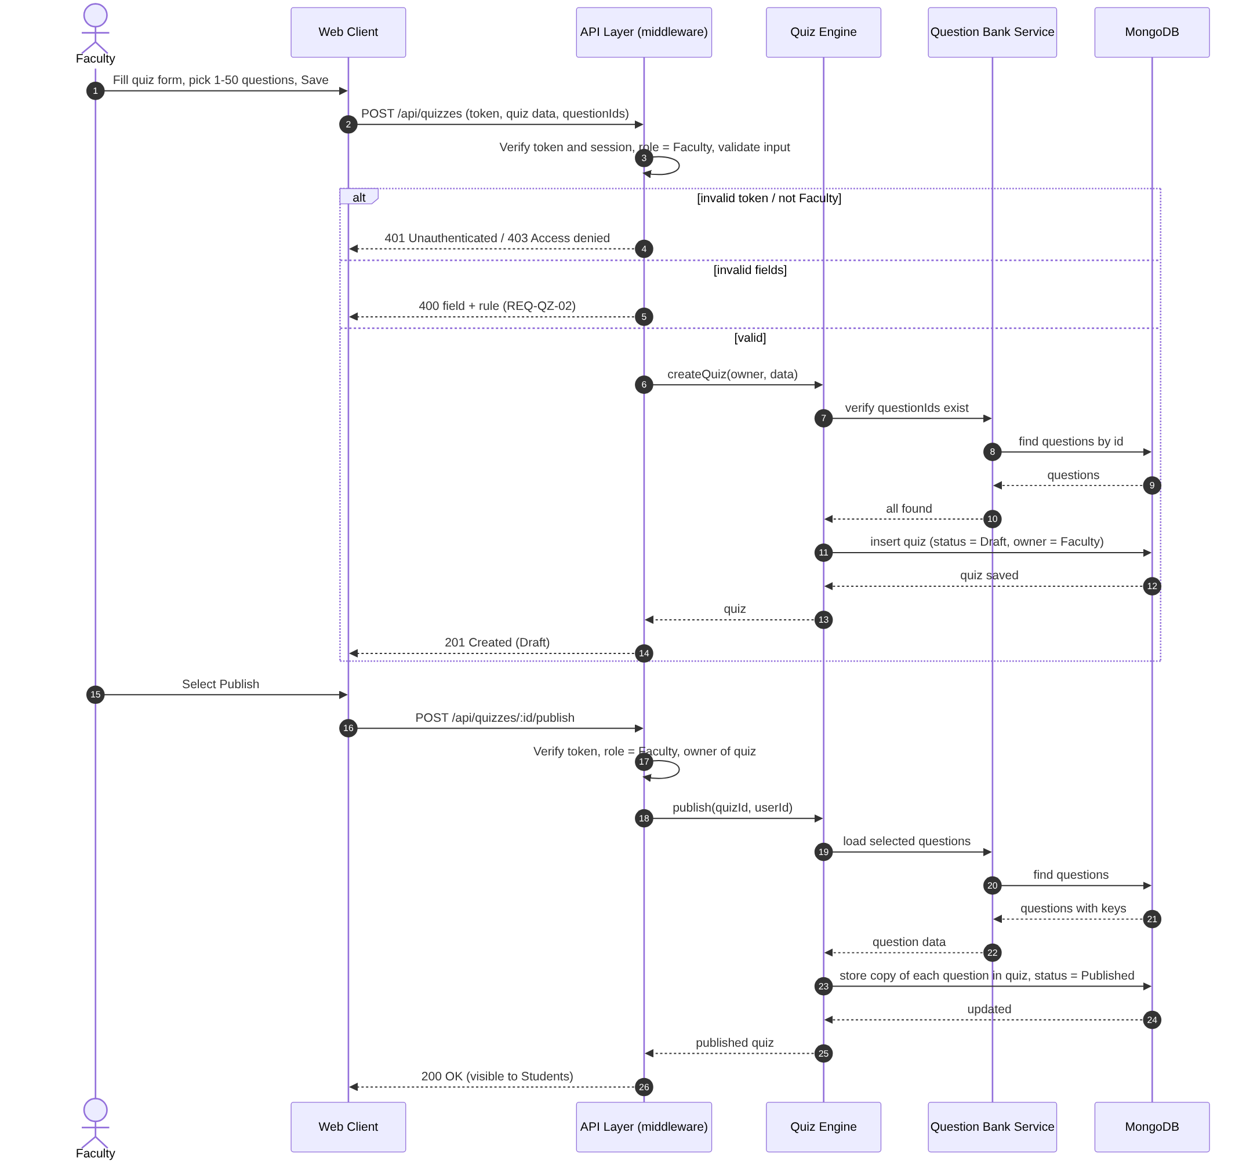
Sequence diagram 2: Attempt a quiz and automatic grading (UC-QZ-04, UC-QZ-05)
Figure 4.2: Sequence diagram – Attempt a quiz and automatic grading (UC-QZ-04, UC-QZ-05)
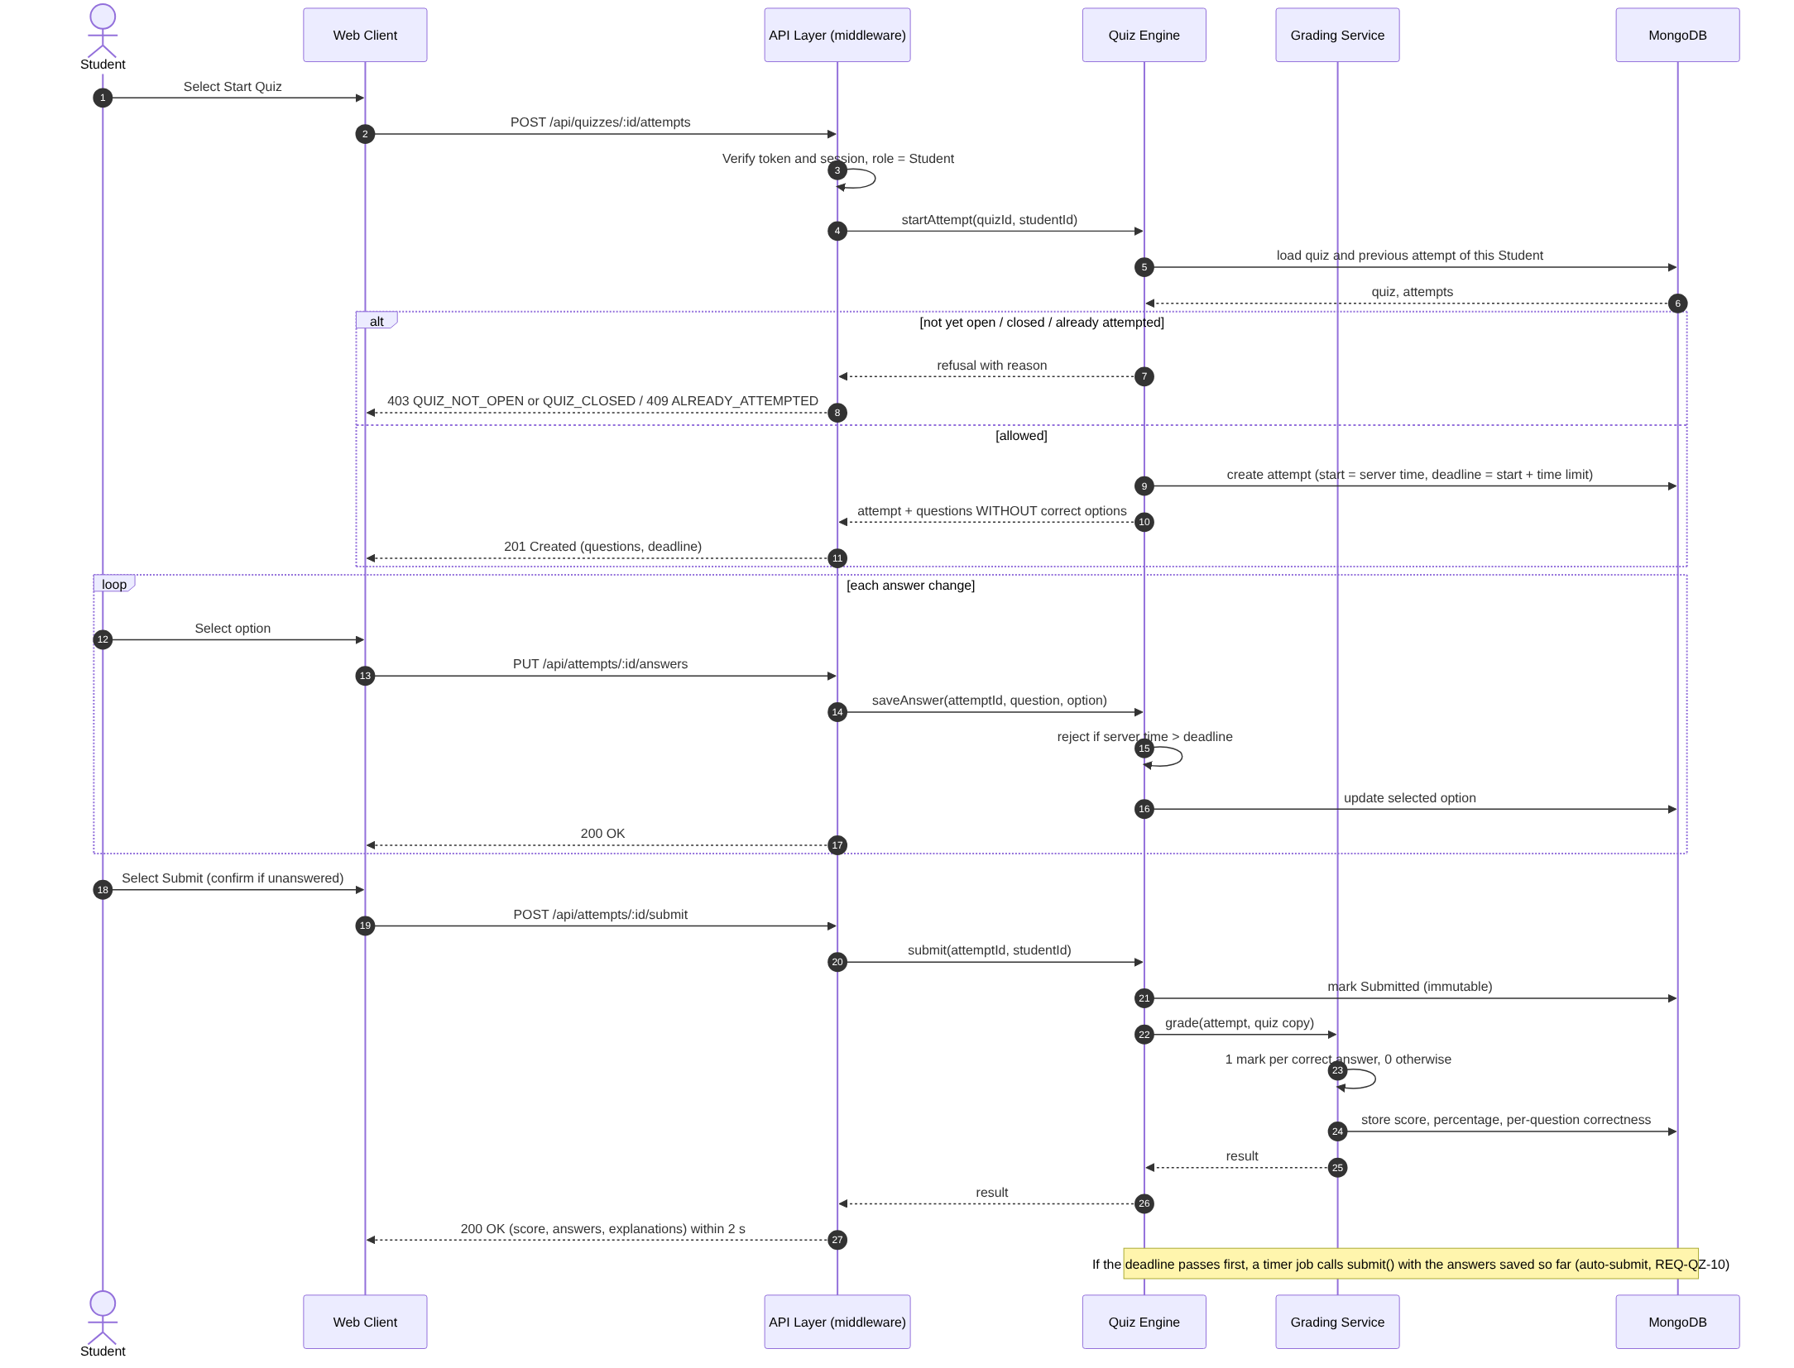
Sequence diagram 3: Authenticate User
Use Case: UC-ACC-02 Authenticate User
Requirements: REQ-ACC-04, REQ-ACC-05, REQ-ACC-06, SEC-ACC-01, SEC-ACC-02, SEC-ACC-06
Figure 4.3: Sequence diagram – Authenticate User (UC-ACC-02)
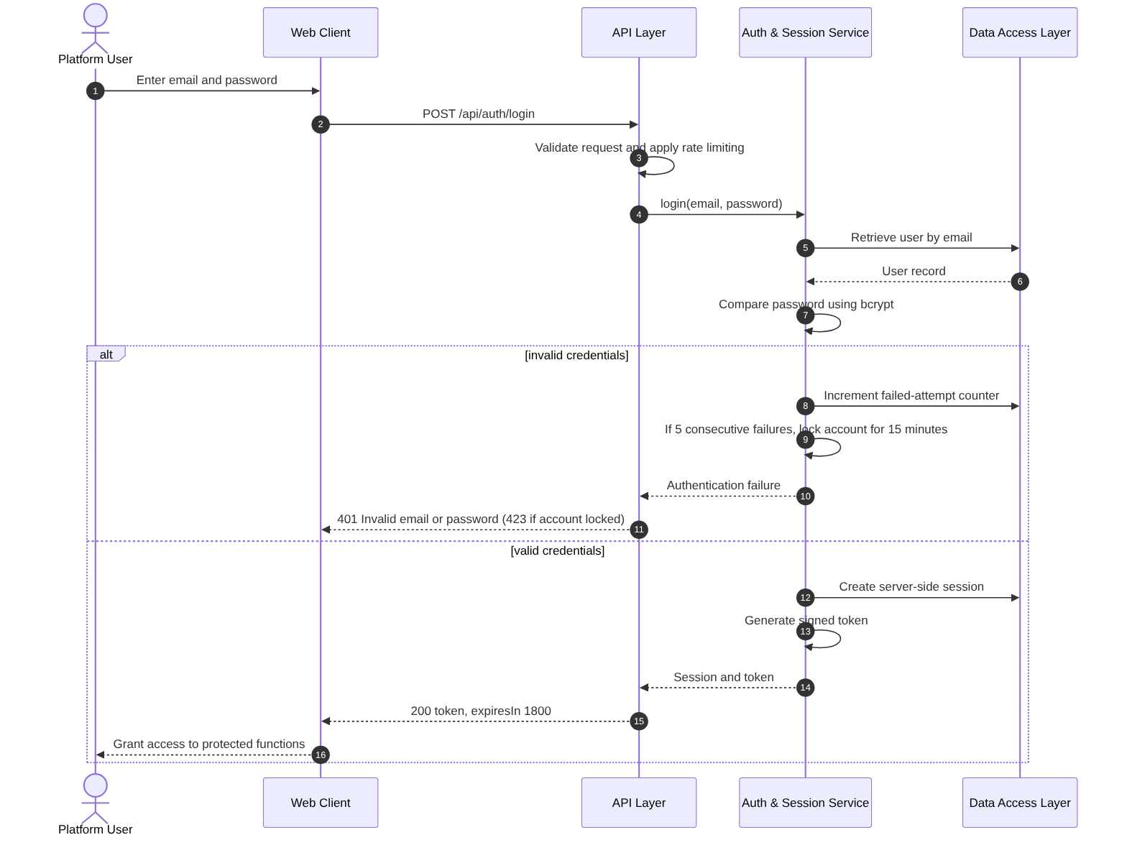
Sequence diagram 4: Upload and Share Material
Use Cases: UC-MAT-01 Upload Material, UC-MAT-03 Share Material
Requirements: REQ-MAT-01 to REQ-MAT-05, SEC-MAT-01, SEC-MAT-02
Figure 4.4: Sequence diagram – Upload and Share Material (UC-MAT-01, UC-MAT-03)
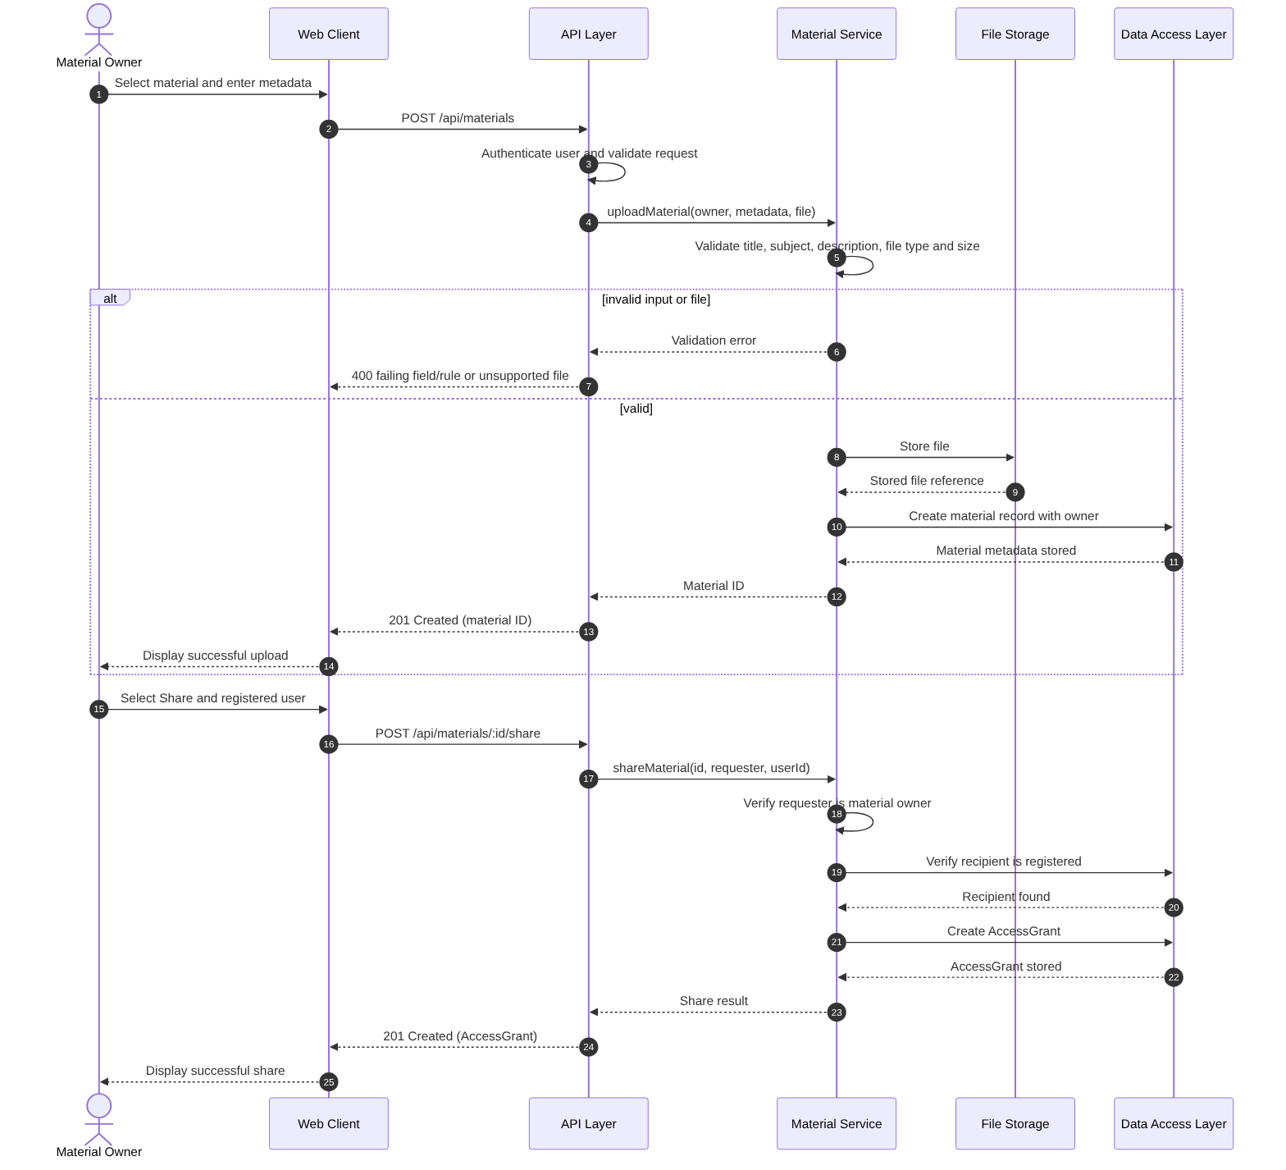
Sequence diagram 5: View Personal Performance
Use Case: UC-PA-01 View Personal Performance
Requirements: REQ-PA-01, REQ-PA-02
Figure 4.5: Sequence diagram – View Personal Performance (UC-PA-01)
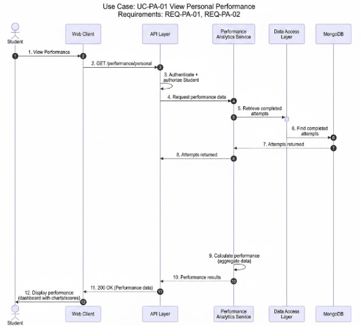
Sequence diagram 6: View Class and Topic-wise Performance
Use Cases: UC-PA-02 View Class Performance, UC-PA-03 View Topic-wise Analysis
Requirements: REQ-PA-03 to REQ-PA-06
Figure 4.6: Sequence diagram – View Class and Topic-wise Performance (UC-PA-02, UC-PA-03)
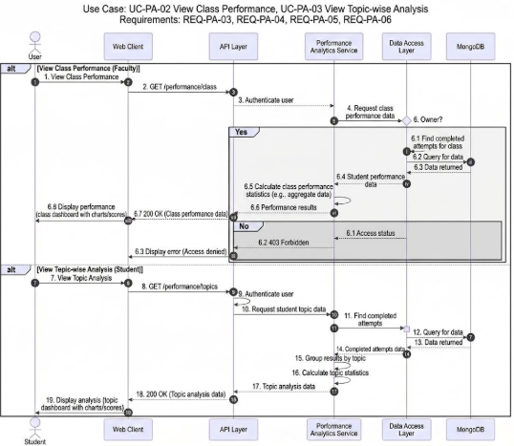
Sequence diagram 7: Create or Join Study Group and Moderate Content
Use Cases: UC-COL-01 Create or Join Study Group, UC-COL-02 Moderate Content
Requirements: REQ-COL-01 to REQ-COL-07
Figure 4.7: Sequence diagram – Create or Join Study Group and Moderate Content (UC-COL-01, UC-COL-02)
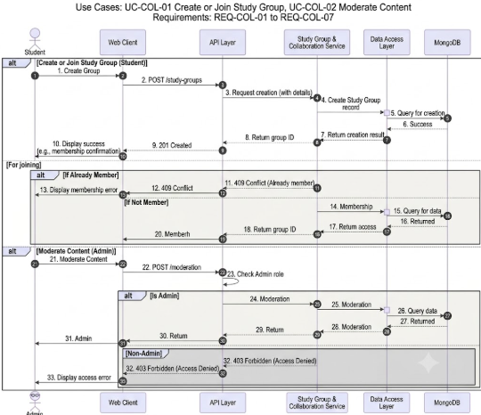
Note on Figures 4.5 to 4.7: endpoint labels inside the figures are abbreviated. The normative endpoints are those of Section 4.3 (GET /performance/personal, GET /performance/topics, GET /performance/class/:quizId, POST /groups, POST /groups/:id/join, DELETE /collaboration/content/:id). The Study Group & Collaboration Service of Figure 4.7 is the Group & Notification Service of Figure 3.1.

4.3 API Design
Interface definition for all components of the platform in one integrated API.
All endpoint paths below are relative to the /api base path (for example /auth/login is served at /api/auth/login).
Conventions
Format: requests and responses are JSON (application/json) except where multipart/form-data is stated.
Authentication: every endpoint except POST /auth/register and POST /auth/login requires the header Authorization: Bearer <token>. The token is issued by /auth/login and is accepted only while its server-side session record is valid (30 minutes of inactivity; invalidated on logout). A missing, expired or invalidated token returns 401.
Authorization: role and ownership checks are enforced on the server by the API Layer middleware and again in the service layer; client-side checks are for display only.
File uploads: supported material types are PDF, DOCX, PPTX and PNG, with a maximum size of 25 MB; other types or larger files return 400. The limit is enforced before the file is stored.
Lists: list endpoints accept optional page and limit query parameters.
Errors: every error uses the structure {error: {code, message}}; validation errors also name the failing field and rule (see 4.4). 429 RATE_LIMITED may be returned by any endpoint when the rate limit is exceeded.
Component: Auth & Session Service (Account Management)
Endpoint: /auth/register
Method: POST
Authorization: Public
Request: {fullName, email, password, role: "Student"|"Faculty"}
Response: 201 {id, email, role}
Errors: 400 validation error identifying the failing field and rule
Endpoint: /auth/login
Method: POST
Authorization: Public
Request: {email, password}
Response: 200 {token, expiresIn: 1800}
Errors: 400 validation error, 401 INVALID_CREDENTIALS ("Invalid email or password"), 423 ACCOUNT_LOCKED (15 minutes after 5 consecutive failures)
Endpoint: /auth/logout
Method: POST
Authorization: Authenticated user
Request: –
Response: 204 (session record invalidated; the token is rejected afterwards)
Errors: 401 not authenticated
Component: Account Service (Account Management)
Endpoint: /account/profile
Method: GET
Authorization: Authenticated user (own profile)
Request: –
Response: 200 {fullName, institution, profilePicture, email, role}
Errors: 401 not authenticated
Endpoint: /account/profile
Method: PUT
Authorization: Authenticated user (own profile)
Request: multipart/form-data {fullName?, institution?, profilePicture? (image file)}; plain JSON is accepted when no picture is sent
Response: 200 {id, fullName, institution, profilePicture}
Errors: 400 validation error (field and rule, unsupported picture type or size, or an attempt to change e-mail or role), 401 not authenticated
Note: The profile picture is stored in File Storage and is subject to the same server-side type and size validation as other uploads; e-mail address and role are not editable.
Component: Material Service (Material Sharing)
Endpoint: /materials
Method: POST
Authorization: Authenticated Student or Faculty
Request: multipart/form-data {title, subject, description, file (PDF, DOCX, PPTX or PNG, max 25 MB)}
Response: 201 {id, owner, title, subject}
Errors: 400 failing field and rule or unsupported file type/size, 401 not authenticated, 403 Access denied (other roles), 500 storage failure (nothing is created)
Endpoint: /materials
Method: GET
Authorization: Authenticated user
Request: query: page?, limit?
Response: 200 {materials[{id, title, subject, owner}], total} – materials owned by or shared with the user
Errors: 401 not authenticated
Endpoint: /materials/:id
Method: GET
Authorization: Material owner or user with an AccessGrant
Request: –
Response: 200 {id, title, subject, description, owner}
Errors: 401 not authenticated, 403 Access denied, 404 material unavailable
Endpoint: /materials/:id/download
Method: GET
Authorization: Material owner or user with an AccessGrant
Request: –
Response: 200 file stream (identical to the uploaded file)
Errors: 401 not authenticated, 403 Access denied, 404 material unavailable
Endpoint: /materials/:id
Method: PUT
Authorization: Material owner
Request: multipart/form-data with any permitted updated fields {title?, subject?, description?, file?}
Response: 200 {id, updatedAt}
Errors: 400 failing field and rule or unsupported file type/size, 401, 403 Access denied, 404 material unavailable, 500 (previous state kept)
Endpoint: /materials/:id
Method: DELETE
Authorization: Material owner
Request: –
Response: 204
Errors: 401 not authenticated, 403 Access denied, 404 material unavailable
Endpoint: /materials/:id/share
Method: POST
Authorization: Material owner
Request: {userId: registeredUserId}
Response: 201 {materialId, userId, grantedAt}
Errors: 400 recipient validation error, 401, 403 Access denied, 404 material or user unavailable
Endpoint: /materials/:id/access/:userId
Method: DELETE
Authorization: Material owner (revoke access)
Request: –
Response: 204 (the next access request by that user is denied)
Errors: 401, 403 Access denied, 404 material or access grant unavailable
Component: Question Bank Service (Question Bank)
Endpoint: /questions
Method: POST
Authorization: Faculty
Request: {text, options[4], correctOption, topic, difficulty, explanation?}
Response: 201 {id, owner, createdAt}
Errors: 400 failing field and rule, 401, 403 Access denied
Endpoint: /questions?q=&topic=&difficulty=
Method: GET
Authorization: Faculty
Request: query parameters (optional page, limit)
Response: 200 {questions[{id, text, topic, difficulty, owner}], total}
Errors: 401, 403 Access denied (Students)
Endpoint: /questions/:id
Method: PUT
Authorization: Faculty owner of the question
Request: any question field
Response: 200 {id, updatedAt}
Errors: 400 failing field and rule, 401, 403 Access denied (not owner), 404 question unavailable
Endpoint: /questions/:id
Method: DELETE
Authorization: Faculty owner of the question
Request: –
Response: 204 (published quizzes keep their own copy)
Errors: 401, 403 Access denied, 404 question unavailable
Component: Quiz Engine – quiz management (Quizzes)
Endpoint: /quizzes
Method: POST
Authorization: Faculty
Request: {title, description?, timeLimitMinutes, availableFrom, availableUntil, questionIds[1..50]}
Response: 201 {id, status: "Draft"}
Errors: 400 failing field and rule, 401, 403 Access denied, 404 question unavailable
Endpoint: /quizzes/:id
Method: PUT
Authorization: Faculty owner (Draft only)
Request: quiz fields
Response: 200 {id}
Errors: 400 failing field and rule, 401, 403 Access denied, 404 quiz unavailable, 409 quiz already attempted or no longer Draft
Endpoint: /quizzes/:id
Method: DELETE
Authorization: Faculty owner
Request: –
Response: 204
Errors: 401, 403 Access denied, 404 quiz unavailable, 409 quiz already attempted
Endpoint: /quizzes/:id/publish
Method: POST
Authorization: Faculty owner
Request: –
Response: 200 {id, status: "Published"} (selected questions copied into the quiz)
Errors: 400 availability end already passed, 401, 403 Access denied, 404 quiz unavailable
Endpoint: /quizzes
Method: GET
Authorization: Student
Request: –
Response: 200 {quizzes[{id, title, questionCount, timeLimitMinutes, availableFrom, availableUntil, attempted}]} (no questions or answers)
Errors: 401, 403 Access denied
Endpoint: /quizzes/:id/submissions
Method: GET
Authorization: Faculty owner
Request: –
Response: 200 {submissions[{studentName, score, percentage, submittedAt}]}
Errors: 401, 403 Access denied, 404 quiz unavailable
Component: Quiz Engine and Grading Service – attempts and grading (Quizzes)
Endpoint: /quizzes/:id/attempts
Method: POST
Authorization: Student
Request: –
Response: 201 {attemptId, deadline, questions[{position, text, options[4]}]} (no correct options)
Errors: 401, 403 Access denied, 403 QUIZ_NOT_OPEN or QUIZ_CLOSED, 404 quiz unavailable, 409 ALREADY_ATTEMPTED
Endpoint: /attempts/:id/answers
Method: PUT
Authorization: Student attempt owner
Request: {position, selectedOption}
Response: 200
Errors: 400 invalid position or option, 401, 403 Access denied, 404 attempt unavailable, 409 already submitted, 410 TIME_EXPIRED
Endpoint: /attempts/:id/submit
Method: POST
Authorization: Student attempt owner
Request: –
Response: 200 {score, total, percentage, questions[{yourAnswer, correctOption, correct, explanation}]} within 2 seconds
Errors: 401, 403 Access denied, 404 attempt unavailable, 409 already submitted
Endpoint: /attempts/mine
Method: GET
Authorization: Student (own attempts)
Request: –
Response: 200 {attempts[{quizTitle, score, percentage, submittedAt}]}
Errors: 401 not authenticated
Endpoint: /attempts/:id/result
Method: GET
Authorization: Student attempt owner
Request: –
Response: 200 detailed result as for submit
Errors: 401, 403 Access denied, 404 attempt unavailable
Component: Performance Analytics Service (Performance)
Endpoint: /performance/personal
Method: GET
Authorization: Authenticated Student
Request: –
Response: 200 {attempts[{quizTitle, score, percentage, submittedAt}]}
Errors: 401 not authenticated, 403 Access denied (other roles)
Endpoint: /performance/topics
Method: GET
Authorization: Authenticated Student
Request: –
Response: 200 {topics[{topic, attempts, averagePercentage}]}
Errors: 401 not authenticated, 403 Access denied (other roles)
Endpoint: /performance/class/:quizId
Method: GET
Authorization: Faculty owner of the quiz
Request: –
Response: 200 {submissions[{studentName, score, percentage, submittedAt}]}
Errors: 401 not authenticated, 403 Access denied, 404 quiz unavailable
Component: Group & Notification Service (Collaboration)
Endpoint: /groups
Method: POST
Authorization: Authenticated Student
Request: {name, description?}
Response: 201 {id, name, description, createdBy}
Errors: 400 validation error, 401 not authenticated, 403 Access denied
Endpoint: /groups/:id/join
Method: POST
Authorization: Authenticated Student
Request: –
Response: 201 {groupId, userId, joinedAt}
Errors: 401, 403 Access denied, 404 group unavailable, 409 ALREADY_MEMBER
Endpoint: /groups
Method: GET
Authorization: Authenticated Student (own groups)
Request: –
Response: 200 {groups[{id, name, description, createdBy}]}
Errors: 401 not authenticated, 403 Access denied
Endpoint: /collaboration/content/:id
Method: DELETE
Authorization: Authenticated Admin (moderation)
Request: –
Response: 204
Errors: 401 not authenticated, 403 Access denied (non-Admin), 404 content unavailable

4.4 Error Handling, Logging & Monitoring
Error handling. All errors use the format {error: {code, message}} defined in 4.3; validation errors also carry the name of the failing field. A central Express error handler converts exceptions into this format, so stack traces and internal details never reach the client. Validation runs in the middleware chain before the controller, and a rejected request changes no data.
Error codes
HTTP | Error code | Meaning
400 | VALIDATION_ERROR | Input failed validation; the message names the failing field and rule. No data is changed.
401 | NOT_AUTHENTICATED / INVALID_CREDENTIALS | Token missing, invalid, expired or logged out; or wrong e-mail or password ("Invalid email or password").
403 | ACCESS_DENIED, QUIZ_NOT_OPEN, QUIZ_CLOSED | Role or ownership check failed ("Access denied"); quiz not yet open or already closed.
404 | NOT_FOUND | Item removed or unavailable; no details of the item are returned.
409 | ALREADY_ATTEMPTED, ALREADY_SUBMITTED, ALREADY_MEMBER, QUIZ_ALREADY_ATTEMPTED | Conflict with the current state of the item.
410 | TIME_EXPIRED | Operation arrived after its deadline (answer saved after the attempt deadline).
423 | ACCOUNT_LOCKED | Account locked for 15 minutes after 5 consecutive failed logins.
429 | RATE_LIMITED | Rate limit exceeded.
500 | INTERNAL_ERROR | Unexpected server error; generic message returned, details logged.

Errors by feature area
Account Management: 400 invalid registration or profile data (including unsupported picture type or size and attempts to change e-mail or role); 401 invalid credentials or invalid/expired/logged-out token; 423 account locked.
Material Sharing: 400 invalid metadata, unsupported file type or file above 25 MB, invalid recipient; 403 user is neither owner nor grantee, or is not the owner for update, remove, share or revoke; 404 material, user or grant unavailable; 500 storage failure.
Question Bank: 400 invalid question; 403 Students, or Faculty who do not own the question; 404 question unavailable.
Quizzes: 400 invalid quiz data or availability end already passed at publication; 403 not the quiz owner, or QUIZ_NOT_OPEN / QUIZ_CLOSED; 404 quiz, question or attempt unavailable; 409 ALREADY_ATTEMPTED, already submitted, or quiz already attempted (cannot be edited or deleted); 410 TIME_EXPIRED for an answer after the deadline (the server auto-submits the answers saved so far); 500 grading failure (the submission is retained and grading is retried).
Performance: 401 unauthenticated; 403 role not permitted or Faculty requesting a quiz they do not own; 404 quiz unavailable, without details.
Collaboration: 400 invalid group data; 403 non-Student creating or joining, or non-Admin moderating; 404 group or content unavailable; 409 ALREADY_MEMBER.
Failed operations. A failed or interrupted upload, update or removal leaves the previous state unchanged and returns no success response (NFR-SAFE-02). Messages never contain answer keys, passwords or tokens.
Logging. The server writes structured log entries with timestamp, event type, user ID, resource ID and outcome.
Logged: each request (method, path, status, user ID), and security events with server timestamps – successful and failed logins, account lock-out, logout and session expiry, access denials (403), material upload, sharing, revocation and removal, upload failures, quiz publication, attempt start and submission, grading failures, and Admin moderation actions.
Never logged: passwords, session tokens, quiz answer keys, and sensitive personal data beyond the user ID needed for audit.
Monitoring. The following are monitored and raise an alert when the target is exceeded or when the rate rises above the operational threshold set at deployment:
Monitored item | Target / alert condition | Requirement
Failed-login rate and authentication failures | abnormal rise (possible password guessing); lock-outs counted | SEC-ACC-01 to SEC-ACC-06
API error rate (4xx/5xx) and failed requests | below 1% failed requests at 200 concurrent users | NFR-PERF-02
Upload failures | any rise in failed or rejected uploads | NFR-SAFE-02, REQ-MAT-01
Material access denials (403) | abnormal rise (possible probing of other users' material) | SEC-MAT-01
Quiz submission and grading latency | result within 2 seconds of submission | REQ-QZ-12, NFR-PERF-04
Page-load and concurrent-user performance | 95% of page loads within 3 s with 200 users | NFR-PERF-01, NFR-PERF-02
Share and revocation latency | effective within 2 seconds | NFR-PERF-03
Availability | at least 99%; automatic restart on failure | NFR-QUAL-02
Server and resource health; daily backups | CPU, memory, disk and database connections; backup success | NFR-SAFE-01

4.5 UX Design
Platform-wide design. Responsive React interface that works on desktop and mobile browsers (NFR-QUAL-04), with consistent navigation, logout and help on every screen (NFR-QUAL-01). Navigation shows only the options allowed for the user's role. Validation errors are shown next to the field with the failing rule. Accessibility: keyboard-operable controls, sufficient colour contrast, text labels for all form fields and charts accompanied by tabular values.
Account screens. Registration, login and profile screens with inline validation; the profile screen shows the e-mail address and role as read-only. Session expiry after 30 minutes of inactivity redirects the user to the login screen with a clear message.
Material screens. Upload form with title, subject, description and a file picker that states the allowed types (PDF, DOCX, PPTX, PNG) and the 25 MB limit; list of own and shared materials; view and download; owner actions to edit, remove, share with a registered user and revoke access, each with a confirmation prompt for removal and revocation.
Question bank and quiz screens (Faculty). Question form with four options and the correct option, search and filter by topic and difficulty, quiz builder for selecting 1 to 50 questions, availability window and time limit, publish action and list of submissions.
Responsive React interface with consistent navigation, logout and help on every screen; errors shown next to the field. Quiz screens: a visible countdown, one-question-per-view navigation with an answered/unanswered indicator, a confirmation prompt before submission when questions are unanswered, keyboard-operable options, sufficient colour contrast, and a result page that shows the score first and then the per-question review.
Performance screens: Personal performance displays completed quiz attempts with score, percentage and submission date. Topic-wise analysis groups performance information by topic. Faculty class-performance views display Student performance for quizzes owned by the Faculty member.
Collaboration screens: Study group screens provide controls for creating and joining groups and display the groups to which the Student belongs. Moderation controls are available only to Admin users. Access-denied and unavailable-resource messages are displayed without exposing restricted or removed content.
Security-related user messages. "Invalid email or password" for any failed login without revealing which part was wrong; "Account locked, try again in 15 minutes"; "Session expired, please log in again"; "Access denied" for forbidden actions; a generic "not available" message for removed or unavailable items; "Quiz already attempted" and "Time expired" during quizzes. Messages never reveal answer keys, other users' data or internal details.

4.6 Open Issues & Next Steps
Decisions taken (resolved).
- Questions are single-correct multiple choice only; quizzes are open to every registered Student and are not limited to study-group members.
- Performance Analytics consumes the attempt fields quizId, score, percentage, submittedAt and the quiz/question topic information; the exact database field names follow the shared Mongoose data model derived from the ER model of the SRS.
- The collaboration service is named Group & Notification Service in the component diagram; notification records are in-application, and push notifications are out of scope for this release.
- Material files are stored on server disk outside the web root; moving them to object storage is a deployment option that does not change the Material Service interface.
Implementation decisions (made during development, within the architecture). Concrete alert thresholds for monitoring, log retention period and index tuning are set during deployment and load testing against the targets of NFR-PERF-01 to NFR-PERF-06.
Next steps. Implement the services per Section 4.1, execute the Test Plan against the traced requirements and keep the RTM synchronised with Section 3.8.
Future enhancements. Push notifications, multi-select and descriptive questions, question images, negative marking, quizzes restricted to study groups, caching with Redis.

5. Appendices
5.1 Glossary
SRS, STP, RTM, UML, UC, SO, REST, JWT, RBAC, TLS, MERN, ODM, SPA, STRIDE, ADR, MCQ: as in Section 1.4.
Layered architecture – structure in which each layer calls only the layer below it (Presentation → API/middleware → Service → Data Access → Database/File Storage).
Modular monolith – one deployable application made of separate, independently testable modules (services).
API Layer – Express.js routes and middleware chain (rate limit, authentication, authorization, validation).
Middleware chain – ordered request checks executed before the controller.
Controller – thin handler that calls a service; contains no business rules.
Service – component holding the business rules of one feature area.
Data Access Layer – Mongoose models and repositories; the only code that accesses MongoDB.
File Storage – server disk store outside the web root for uploaded files.
Auth & Session Service – registration, login, lock-out, sessions and logout.
Server-side session – session record that must be valid for a token to be accepted.
Ownership check – verification that the requesting user owns the resource.
AccessGrant – record that gives a registered user access to a shared material.
Quiz Engine – component that manages quizzes and attempts.
Grading Service – component that scores submitted attempts on the server.
Question copy – snapshot of a bank question stored in a published quiz.
Projection – response shape that omits fields such as correct options.
Performance Analytics Service – personal, topic-wise and class statistics.
Group & Notification Service – study groups, membership, notifications and moderation (also called Study Group & Collaboration Service).
NoSQL injection – attack that alters database queries through crafted input; countered by sanitisation.
bcrypt – salted password-hashing function.
SHA-256 checksum – digest stored at upload to verify file integrity.
Rate limiting – restriction on the number of requests per client in a time window.
Audit log – timestamped record of security events.
Immutable attempt – submitted attempt that can no longer be changed.
5.2 References
IEEE 42010; OWASP Application Security Verification Standard; NIST SP 800-160; MongoDB, Express, React and Node.js documentation; Software Requirements Specification (SRS), Collaborative Study Material & Quiz Platform, Version 1.0 (including the RTM, Appendix C); Software Test Plan (STP); official SAD template.
5.3 Tools
Graphviz, Mermaid, draw.io (diagrams); Jest, Supertest (testing); ESLint; Git/GitHub; Docker; Nginx.

