Software Architecture and Design Specification
Project: Collaborative Study Material & Quiz Platform
Version: 1.0
Authors: Group [__] – Member 1 (Jagadeesh), Member 2 [name], Member 3 [name]
Date: 03-10-2026
Status: Draft

Revision History
Version | Date | Author | Change Summary
1.0 | 03-10-2026 | Member 1, Member 2 | Draft of Sections 1–5: architecture, traceability, security architecture, sequence diagrams, API design, error handling, logging and monitoring.

Approvals
Role | Name | Signature/Date
Project guide | [name] | [signature/date]

1. Introduction
1.1 Purpose
This document specifies the architecture and design of the Collaborative Study Material & Quiz Platform, a web application for sharing study material, building a question bank, taking auto-graded quizzes and analysing performance.
1.2 Scope
Covers account management, material sharing, question bank and quizzes (quiz creation, timed attempts, automatic grading), performance analysis and collaboration study groups and collaborative-content moderation), and the security architecture that applies to all of them, as specified in the SRS.
1.3 Audience
Developers, QA engineers, security reviewers, instructors, and maintenance teams.
1.4 Definitions
SRS (Software Requirements Specification), STP (Software Test Plan), RTM (Requirements Traceability Matrix), UML, REST, JWT (JSON Web Token), RBAC (Role-Based Access Control), TLS, MERN (MongoDB, Express.js, React, Node.js), ODM (object-document mapper), STRIDE (threat-classification model), ADR (Architecture Decision Record), MCQ.

2. Document Overview
2.1 How to use this document
Provides the architectural deliverables: component diagram, architecture decisions, STRIDE threat model, UML sequence diagrams and API design. Section 3 describes the system as a whole; Section 4 describes the detailed design and the flows of each feature.
2.2 Related Documents
SRS (Collaborative Study Material & Quiz Platform, Version 1.0), STP (Software Test Plan), RTM (Appendix C of the SRS).

3. Architecture
3.1 Goals & Constraints
Goals:
(1) secure – meet security objectives SO-01 to SO-06 of the SRS;
(2) responsive – login within 2 seconds, quiz results available within 2 seconds of submission as specified by REQ-QZ-12, and material sharing or access revocation within 2 seconds as specified by NFR-PERF-03;
(3) reliable – a submitted quiz attempt is never lost or altered and material operations do not expose a partially completed state;
(4) modular and testable, so that three developers can build and test their features independently;
(5) usable from modern desktop and mobile browsers.
Constraints: MERN stack (MongoDB, Express.js, React, Node.js); TLS 1.2 or higher for all communication; passwords stored only as salted bcrypt hashes; study materials limited to PDF, DOCX, PPTX and PNG files up to 25 MB; three-member team and one-semester schedule.
3.2 Stakeholders & Concerns
Students: usability, fast and fair quizzes, confidentiality of their materials and results.
Faculty: control over questions and quizzes, integrity of results.
Administrators: ability to moderate content and manage users.
Developers: modularity, clear interfaces, testability.
Instructors/evaluators: traceability to the SRS and quality of documentation.
Security reviewers: access control and protection of data.

3.3 Component (UML) Diagram

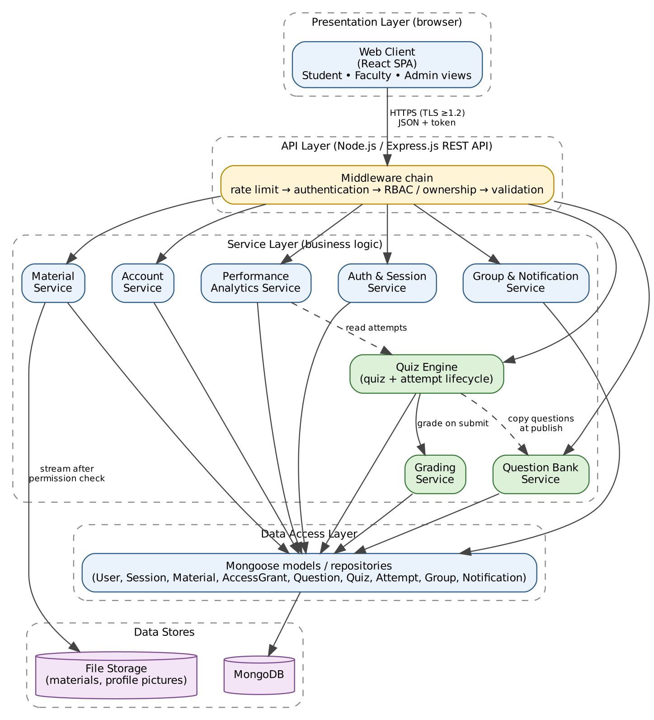
Figure 3.1: Component diagram (layered architecture). Green = Question Bank & Quizzes components.

3.4 Component Descriptions
- Web Client (React SPA): user interface for Students, Faculty and Admin; calls the REST API over HTTPS; holds no secrets and never receives quiz answer keys; shows the countdown timer for display only.
- API Layer (Express.js): routes requests through a middleware chain – rate limiting, authentication (token and session check), role and ownership authorization, input validation – before the controller is called.
- Auth & Session Service: registration, login with bcrypt comparison, lock-out after 5 failed attempts, session creation, 30-minute inactivity expiry, logout and token invalidation.
- Account Service: view and update profile.
- Material Service: upload with type and size checks, ownership, sharing and revoking access, download after permission check.
- File Storage: stores uploaded files outside the web root; files are streamed only by the Material Service after a permission check.
- Question Bank Service: add, search/filter, edit and remove questions; enforces Faculty-only access and question ownership.
- Quiz Engine: quiz life cycle (Draft → Published), copy of questions at publication, availability window, attempt start with server-side deadline, answer saving, submission and auto-submit when time expires.
- Grading Service: compares submitted answers with the answer keys held in the quiz copy and computes score and percentage on the server.
- Performance Analytics Service: retrieves completed quiz attempts and aggregates them into personal, topic-wise and class performance statistics. It applies Student/Faculty access rules before returning performance information.
- Study Group & Collaboration Service: creates and manages study groups, maintains group membership, supports Students in creating or joining groups, and provides Admin-only moderation of collaborative content.
- Data Access Layer (Mongoose): models and repositories for User, Session, Material, AccessGrant, Question, Quiz, Attempt, Group, GroupMember and collaborative-content data.
- MongoDB: persistent store for all application data.

3.5 Chosen Architecture Pattern and Rationale
Layered (three-tier) architecture implemented as a modular monolith: Presentation (React) → API layer (Express routes and middleware) → Service layer (business logic) → Data access layer (Mongoose) → MongoDB.
Rationale: clear separation of concerns; security checks are enforced in one place (middleware and service layer) for every feature; each member owns services that can be developed and unit-tested independently; one deployable unit is simple to build and demonstrate; grading runs in-process, which easily meets the 2-second target; it fits the MERN constraint.
Rejected alternatives: microservices – unnecessary operational complexity and distributed transactions for an expected load of a few hundred users; client-side grading – insecure, since answer keys and scores would be exposed and changeable (SEC-QZ-02, SEC-QZ-05).
Key decisions (ADR summary): ADR-1 layered modular monolith. ADR-2 MongoDB document store; quiz questions are copied into the quiz when it is published, so a published quiz and its attempts are self-contained. ADR-3 signed token plus a server-side session record, so that logout and 30-minute inactivity can invalidate a token. ADR-4 grading and the quiz timer run only on the server.

3.6 Technology Stack & Data Stores
Client: React 18, React Router, Axios, Chart.js for performance charts.
Server: Node.js 20 LTS, Express.js 4, Mongoose ODM; jsonwebtoken for tokens, bcrypt for password hashing, helmet (security headers), express-rate-limit, express-validator (input validation), express-mongo-sanitize (NoSQL injection protection), multer (uploads).
Data stores: MongoDB 7 with collections users, sessions, materials, accessGrants, questions, quizzes (with embedded question copies), attempts (with embedded answers and result), groups, groupMembers, collaborativeContent; file storage on server disk outside the web root (can be replaced by object storage).
Communication and deployment: HTTPS with TLS 1.2 or higher through an Nginx reverse proxy; REST/JSON.
Quality tools: Jest and Supertest for tests, ESLint, Git/GitHub.

3.7 Risks & Mitigations
Risk: browser or connection fails during a quiz and answers are lost → Mitigation: each answer is saved to the server when selected; the Student can resume the attempt; at the deadline the server auto-submits the answers saved so far.
Risk: many Students submit requests concurrently and processing becomes slow → Mitigation: grading is a simple in-memory comparison of at most 50 answers; indexes are maintained on attempt and quiz identifiers; load testing shall include 200 concurrent users in accordance with NFR-PERF-01 and NFR-PERF-02, including quiz submission and grading activity; if grading fails, the submission is retained and grading is retried.
Risk: a Student changes the device clock or tampers with the timer → Mitigation: start time, deadline and acceptance of answers use the server clock only (SEC-QZ-04).
Risk: answer keys leak to the client → Mitigation: Student-facing responses are built from a projection that excludes correct options and explanations until submission (SEC-QZ-02); tested explicitly.
Risk: direct download of material files by URL → Mitigation: files are stored outside the web root and served only after an ownership or grant check (SEC-MAT-01).
Risk: password guessing → Mitigation: lock-out after 5 failed logins for 15 minutes and rate limiting.
Risk: the single server is a single point of failure → Mitigation: daily database backups and a reproducible deployment (Docker) so the system can be restored quickly.
Risk: members change shared data models and break each other's code → Mitigation: shared Mongoose models follow the ER model in the SRS; changes are agreed in the group and covered by tests.

3.8 Traceability to Requirements
Question Bank & Quizzes
REQ-QB-01 to 03, 05 (add/edit question, owner, validation) → Question Bank Service
REQ-QB-04 (search and filter) → Question Bank Service, Data Access Layer (indexes)
REQ-QB-06 (remove question; published quizzes unchanged) → Question Bank Service, Quiz Engine (question copy)
REQ-QB-07, REQ-QZ-17 (role and ownership checks) → API Layer (RBAC and ownership middleware)
REQ-QZ-01 to 05 (create, validate, draft, copy at publication, edit/delete) → Quiz Engine
REQ-QZ-06, 07 (list quizzes, start rules) → Quiz Engine
REQ-QZ-08 to 10 (timer, answers, auto-submit) → Quiz Engine, API Layer
REQ-QZ-11, 12, 14 (grading, 2-second result, immutability) → Grading Service, Quiz Engine
REQ-QZ-13, 15, 16 (results, own attempts, quiz submissions) → Quiz Engine, Data Access Layer
REQ-QZ-18 (unavailable item) → API Layer (error handling)
SEC-QZ-01 to 05 → API Layer (RBAC, projection of Student responses), Quiz Engine (server clock, immutability), Grading Service (server-side scoring)
NFR-PERF-04 to 06 → Grading Service, Question Bank Service, Quiz Engine, Data Access Layer (indexes)
Account Management
REQ-ACC-01 to 07 → Auth & Session Service
REQ-ACC-08, 09 → Account Service
REQ-ACC-10 → API Layer, Auth & Session Service, Account Service
Material Sharing
REQ-MAT-01 → Material Service, File Storage
REQ-MAT-02 → Material Service
REQ-MAT-03 → Material Service, Data Access Layer
REQ-MAT-04, 05, 09 → Material Service, AccessGrant
REQ-MAT-06 → Material Service, File Storage
REQ-MAT-07 → Material Service
REQ-MAT-08 → Material Service, File Storage
REQ-MAT-10 → API Layer, Material Service
REQ-MAT-11 → Material Service, File Storage
Performance & Collaboration
REQ-PA-01, REQ-PA-02 → Performance Analytics Service, Data Access Layer
REQ-PA-03 → Performance Analytics Service, Data Access Layer
REQ-PA-04, REQ-PA-05, REQ-PA-06 → Performance Analytics Service, API Layer (RBAC and ownership authorization), Data Access Layer
REQ-COL-01, REQ-COL-02, REQ-COL-03, REQ-COL-04 → Study Group & Collaboration Service, Data Access Layer
REQ-COL-05, REQ-COL-06, REQ-COL-07 → Study Group & Collaboration Service, API Layer (RBAC and error handling), Data Access Layer
Account and Material Security
SEC-ACC-01 to SEC-ACC-06 → API Layer, Auth & Session Service, Account Service
SEC-MAT-01 to SEC-MAT-04 → API Layer, Material Service, AccessGrant
SEC-COM-01 → Nginx reverse proxy, HTTPS/TLS 1.2+
Non-Functional Requirements
NFR-PERF-01 (95% of page loads within 3 s with 200 users) → Web Client (single-page app), API Layer (pagination), Data Access Layer (indexes), Nginx reverse proxy
NFR-PERF-02 (200 concurrent users, under 1% failed requests) → API Layer (rate limiting), Nginx reverse proxy, Data Access Layer (connection pool, indexes), MongoDB
NFR-PERF-03 (share and revocation effective within 2 s) → Material Service, AccessGrant (permission read from the database on every request)
NFR-PERF-04 to 06 (grading, bank search, quiz start) → Grading Service, Question Bank Service, Quiz Engine, Data Access Layer (indexes)
NFR-SAFE-01 (daily backup, restore within 24 hours) → MongoDB (scheduled dump), File Storage (scheduled copy), Docker deployment
NFR-SAFE-02 (interrupted operations leave the previous state unchanged) → Material Service, File Storage, Data Access Layer
NFR-SAFE-03 (downloaded file identical to the upload) → Material Service (SHA-256 checksum stored at upload), File Storage (file streamed unmodified)
NFR-QUAL-01 (usability) → Web Client (consistent navigation, inline field errors; see 4.5)
NFR-QUAL-02 (99% availability) → Nginx reverse proxy, Docker deployment (automatic restart), monitoring (4.4), daily backups
NFR-QUAL-03 (robustness) → API Layer (validation middleware, input sanitisation, upload limits, central error handler)
NFR-QUAL-04 (browser portability) → Web Client (React SPA, responsive layout)
NFR-QUAL-05 (modular, independently testable) → layered modular monolith with separate services (3.5, 4.1)
NFR-QUAL-06 (traceability to test cases) → this section, the SRS Requirement Traceability Matrix and the Test Plan traceability tables

3.9 Security Architecture
Security controls by layer: TLS 1.2+ for all traffic (Nginx); authentication with a signed token that is checked against a server-side session record (30-minute inactivity, invalidated on logout); role-based and ownership-based authorization in middleware and again in the service layer (deny by default); input validation and NoSQL-injection sanitisation on every request; bcrypt hashing for passwords; Student-facing quiz responses built by projection without answer keys; files outside the web root; audit logging of security events without sensitive data.
Threat Modeling (STRIDE):
Spoofing → bcrypt-hashed credentials, lock-out after 5 failures, signed token plus session record, TLS (SEC-ACC-02, 03, 06).
Tampering → ownership checks on materials, questions and quizzes (SEC-MAT-03, SEC-QZ-01); scores computed only on the server and submitted attempts immutable (SEC-QZ-05); input validation and sanitisation.
Repudiation → audit log of login, logout, material sharing, quiz publication, attempt start and submission, with server timestamps.
Information disclosure → TLS (SEC-COM-01); no answer keys or explanations sent before submission (SEC-QZ-02); results visible only to the attempt owner and submissions only to the quiz owner (SEC-QZ-03); material access only for owner and authorized users (SEC-MAT-01); no passwords or tokens in logs.
Denial of service → rate limiting, 25 MB upload limit, pagination, at most 50 questions per quiz, one attempt per Student per quiz.
Elevation of privilege → RBAC middleware for Student, Faculty and Admin; Students cannot reach question-bank or quiz-management endpoints (REQ-QB-07, REQ-QZ-17); ownership checked on every update, delete and view-submissions call.

4. Design

4.1 Design Overview
The platform is designed as layered modules. A request passes through the middleware chain (rate limit, authentication, authorization, validation), then a controller, a service and the data access layer. Controllers contain no business rules; services contain the rules of the SRS; models only access MongoDB.
Suggested code structure: server/{routes, controllers, services, models, middleware}, client/{pages, components, api}.
Quiz design: a quiz is Draft until published; at publication the selected questions (text, options, correct option, explanation) are copied into the quiz, so later changes to the bank do not affect it. An attempt moves In Progress → Submitted → Graded. The attempt stores the server start time and deadline, the selected answers, and after grading the score, percentage and per-question correctness. A Student can have only one attempt per quiz.
Account management design: Account Management is implemented through the Auth & Session Service and Account Service. Registration and authentication requests pass through the API Layer, where input validation and authentication controls are applied. Passwords are compared using bcrypt and are stored only as salted bcrypt hashes. After successful authentication, the Auth & Session Service creates a server-side session record and issues a signed token. The token is accepted only while the corresponding session is valid. The Auth & Session Service maintains the failed-login counter and locks an account for 15 minutes after five consecutive failed login attempts. A session expires after 30 minutes of inactivity or when the user logs out, and the associated session record is invalidated. The Account Service handles viewing and updating permitted profile information and prevents modification of protected fields such as email address and role.
Material sharing design: Material Sharing is implemented through the Material Service, AccessGrant records, File Storage and the Data Access Layer. During upload, the Material Service validates the title, subject, description, file type and file size before storing the material. Supported files are PDF, DOCX, PPTX and PNG, with a maximum size of 25 MB. The authenticated uploader is recorded as the material owner. Material files are stored outside the web root and are streamed only through the Material Service after an ownership or access-grant check. Sharing creates an AccessGrant for the selected registered user. Revoking access removes or invalidates the corresponding grant so that the next access request is denied. Update and removal operations require ownership authorization. Material access checks are performed before viewing or downloading the file. To keep operations safe, the Material Service writes an uploaded file to temporary storage, computes and stores its SHA-256 checksum, and creates or updates the database record only after the file has been stored. If any step fails or is interrupted, the previous state is kept and no success response is returned. Removal blocks access first and deletes the file afterwards.
Performance & Collaboration design: Performance Analytics is implemented through the Performance Analytics Service and the Data Access Layer. The service retrieves completed quiz attempts and uses the stored score, percentage, submission date and quiz information to generate personal performance and topic-wise analysis for Students. Faculty performance views are restricted to quizzes owned by the requesting Faculty member and contain the performance information of Students who submitted attempts for the selected quiz.
Study group functionality is implemented through the Study Group & Collaboration Service and the Data Access Layer. An authenticated Student can create a study group or join an existing study group. Group membership is stored separately so that duplicate membership can be detected and rejected. Students can retrieve the groups to which they belong.
Collaborative-content moderation is restricted to authenticated Admin users. The API Layer performs authentication and role checks, and the Collaboration Service performs the corresponding business operation. Requests from non-Admin users are rejected with an access-denied response. If a requested study group or collaborative content is unavailable, the system returns an appropriate unavailable response without exposing details of the unavailable item.

4.2 UML Sequence Diagrams
Question Bank & Quizzes and Account Management / Material Sharing. At least two diagrams specific to the project are provided for each area.

Sequence diagram 1: Create and publish a quiz (UC-QZ-01, UC-QZ-02)
Figure 4.1: Sequence diagram – Create and publish a quiz (UC-QZ-01, UC-QZ-02)
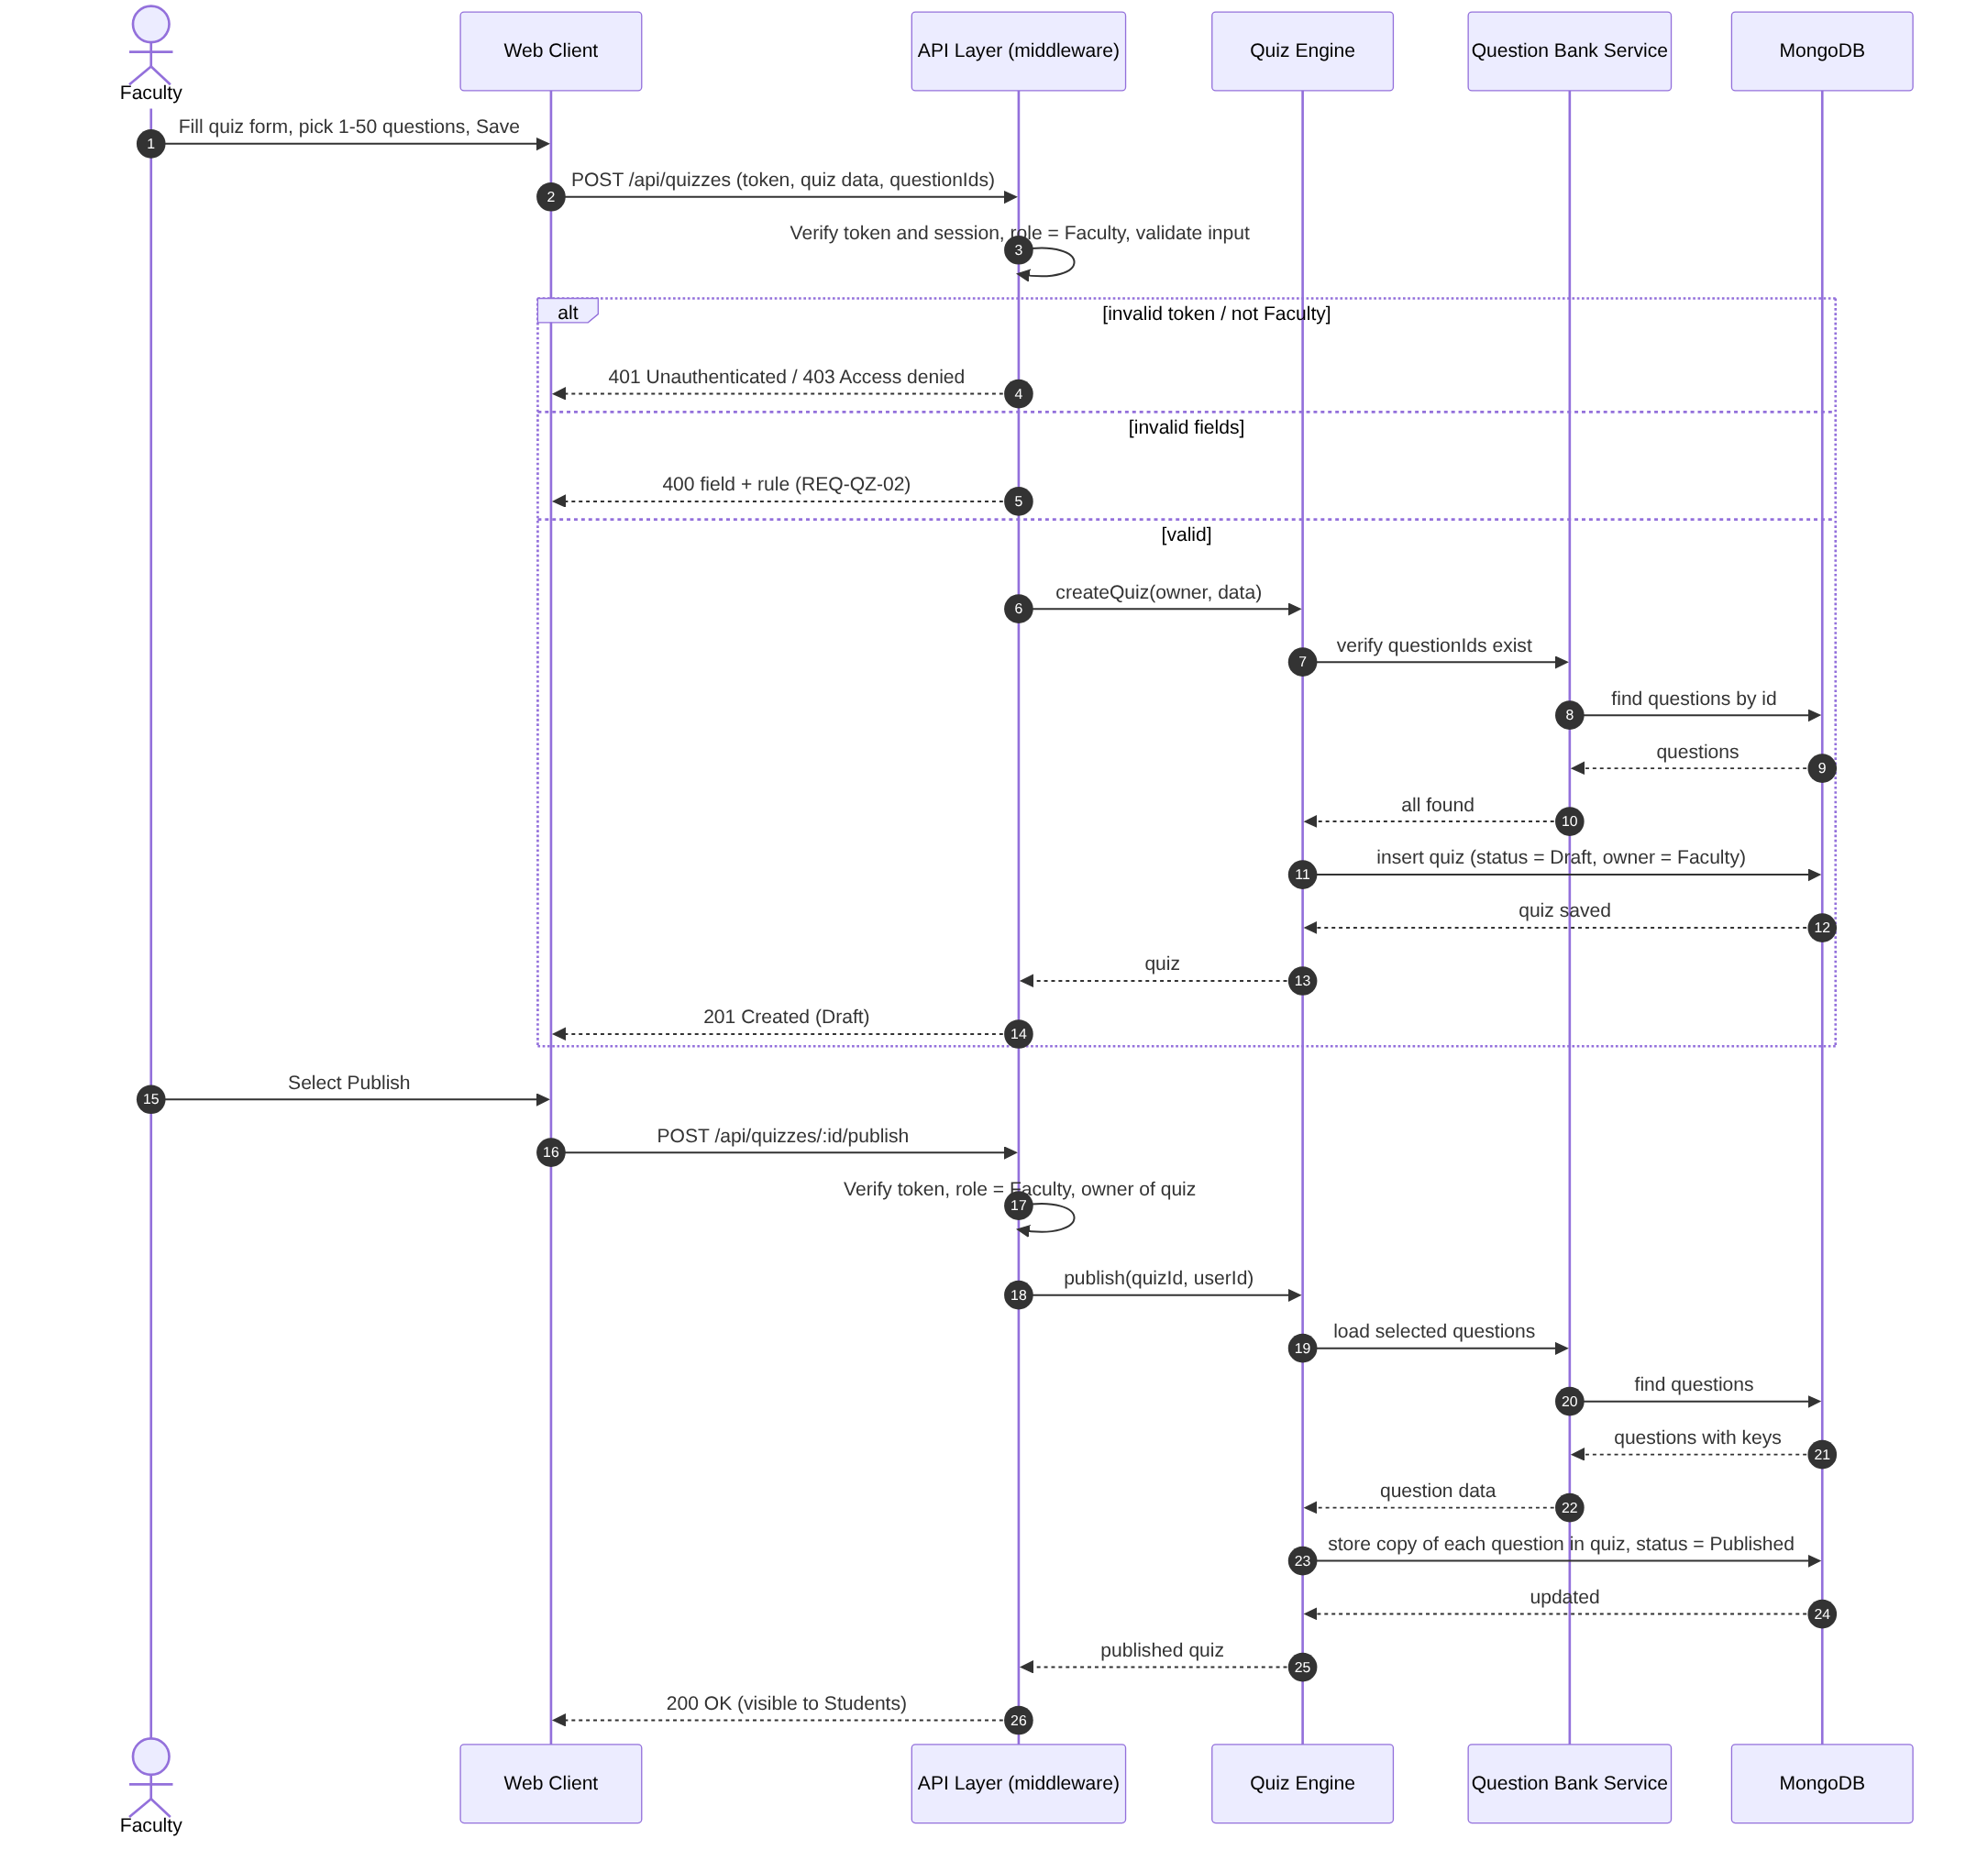
Sequence diagram 2: Attempt a quiz and automatic grading (UC-QZ-04, UC-QZ-05)
Figure 4.2: Sequence diagram – Attempt a quiz and automatic grading (UC-QZ-04, UC-QZ-05)
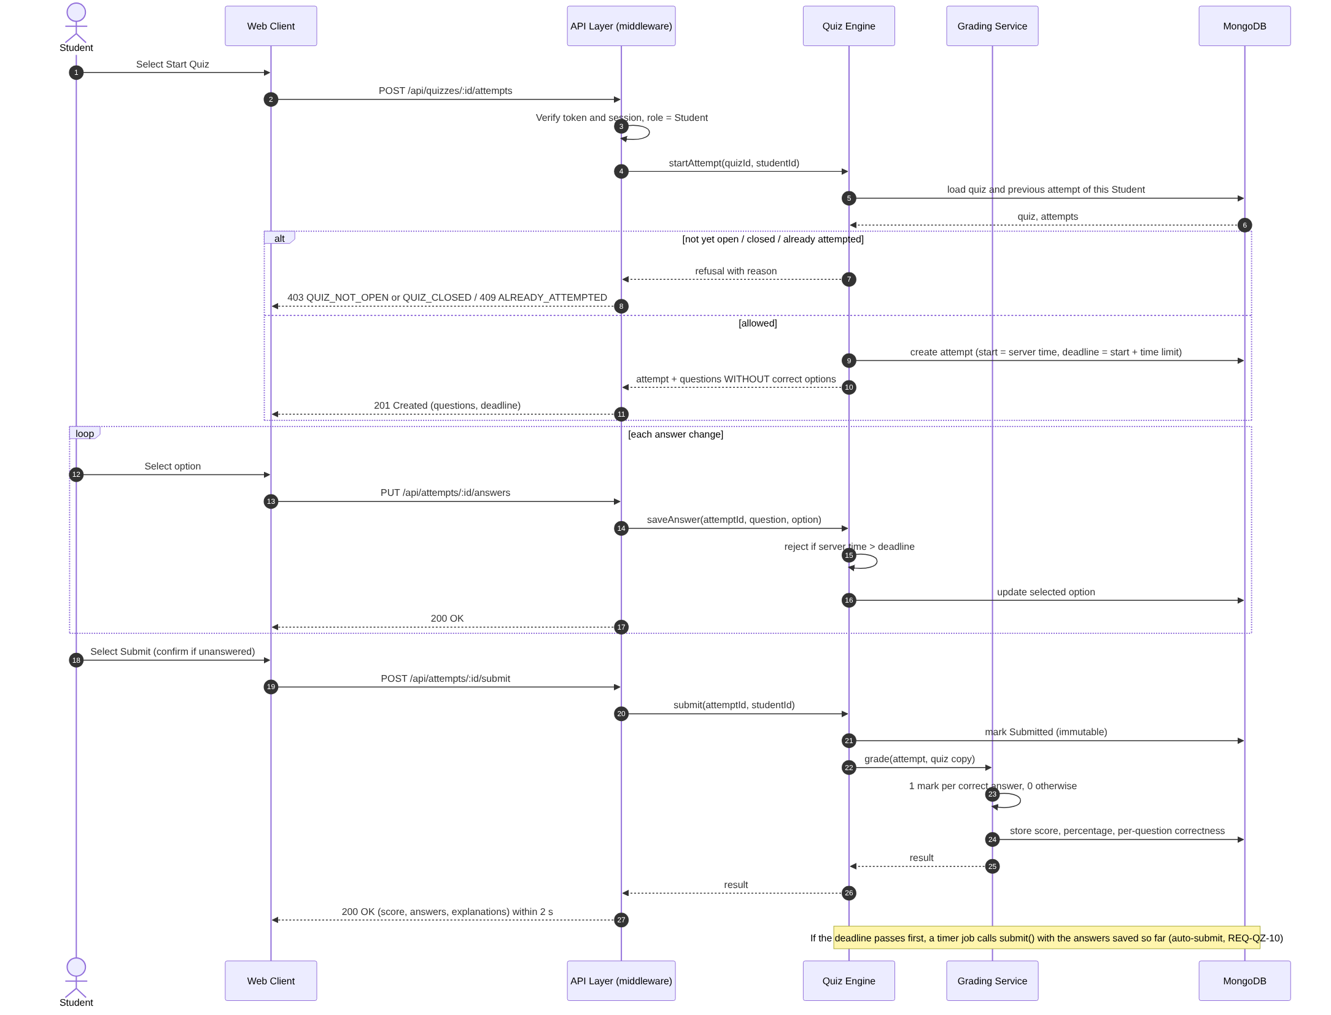
Sequence diagram 3: Authenticate User
Use Case: UC-ACC-02 Authenticate User
Requirements: REQ-ACC-04, REQ-ACC-05, REQ-ACC-06, SEC-ACC-01, SEC-ACC-02, SEC-ACC-06
Figure 4.3: Sequence diagram – Authenticate User (UC-ACC-02)
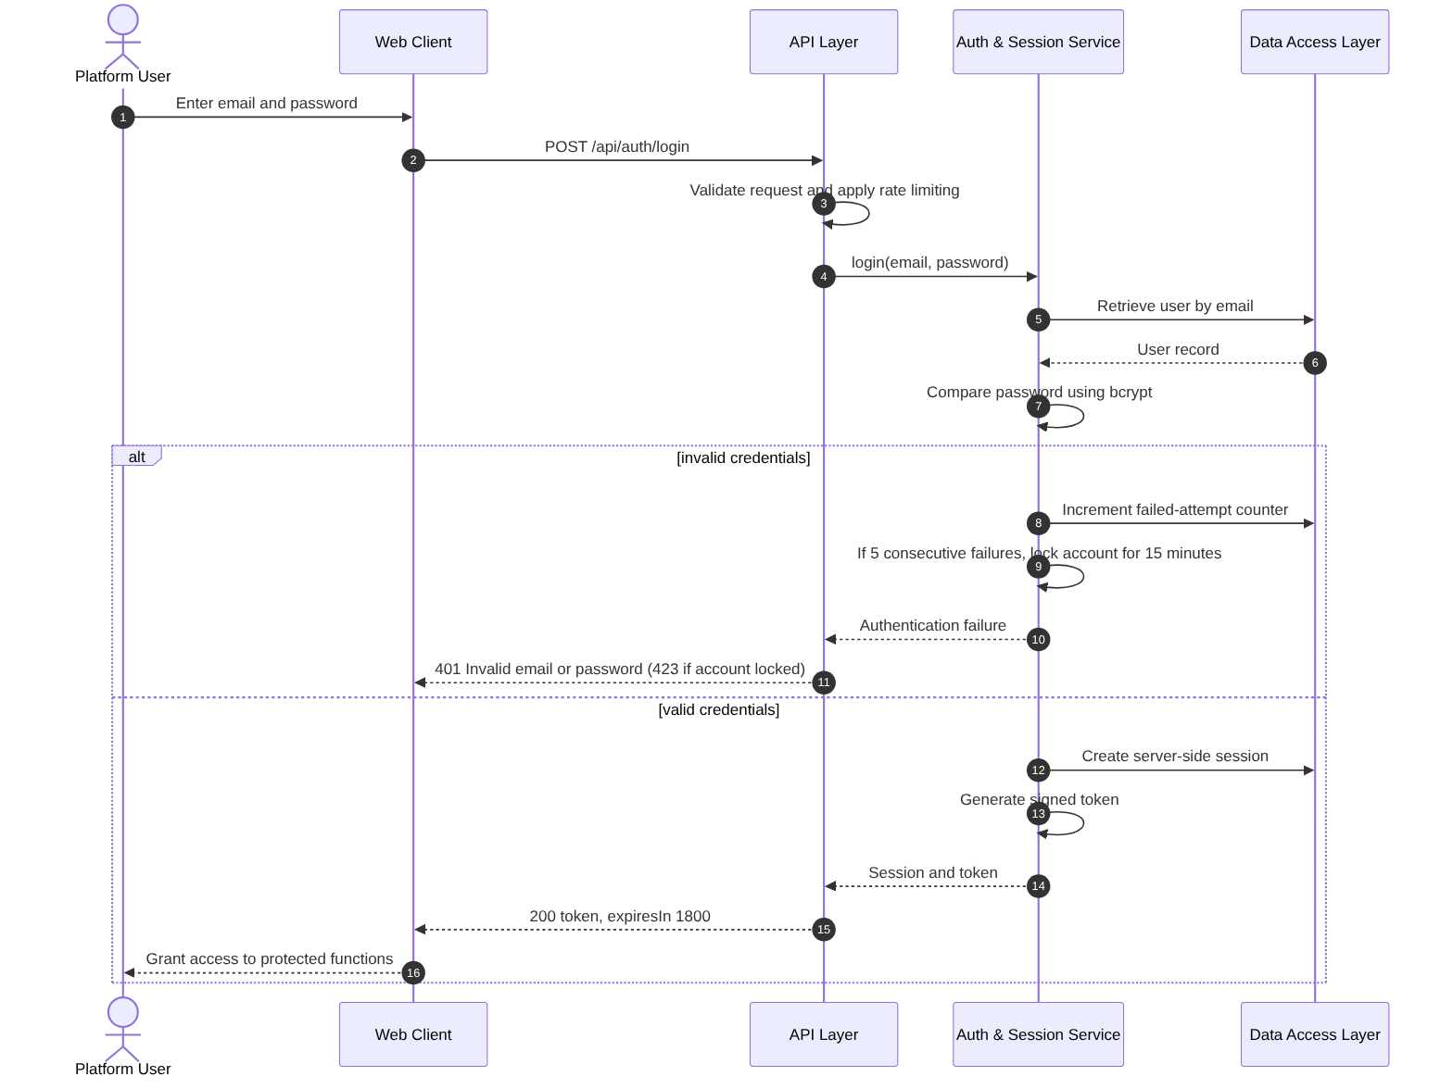
Sequence diagram 4: Upload and Share Material
Use Cases: UC-MAT-01 Upload Material, UC-MAT-03 Share Material
Requirements: REQ-MAT-01 to REQ-MAT-05, SEC-MAT-01, SEC-MAT-02
Figure 4.4: Sequence diagram – Upload and Share Material (UC-MAT-01, UC-MAT-03)
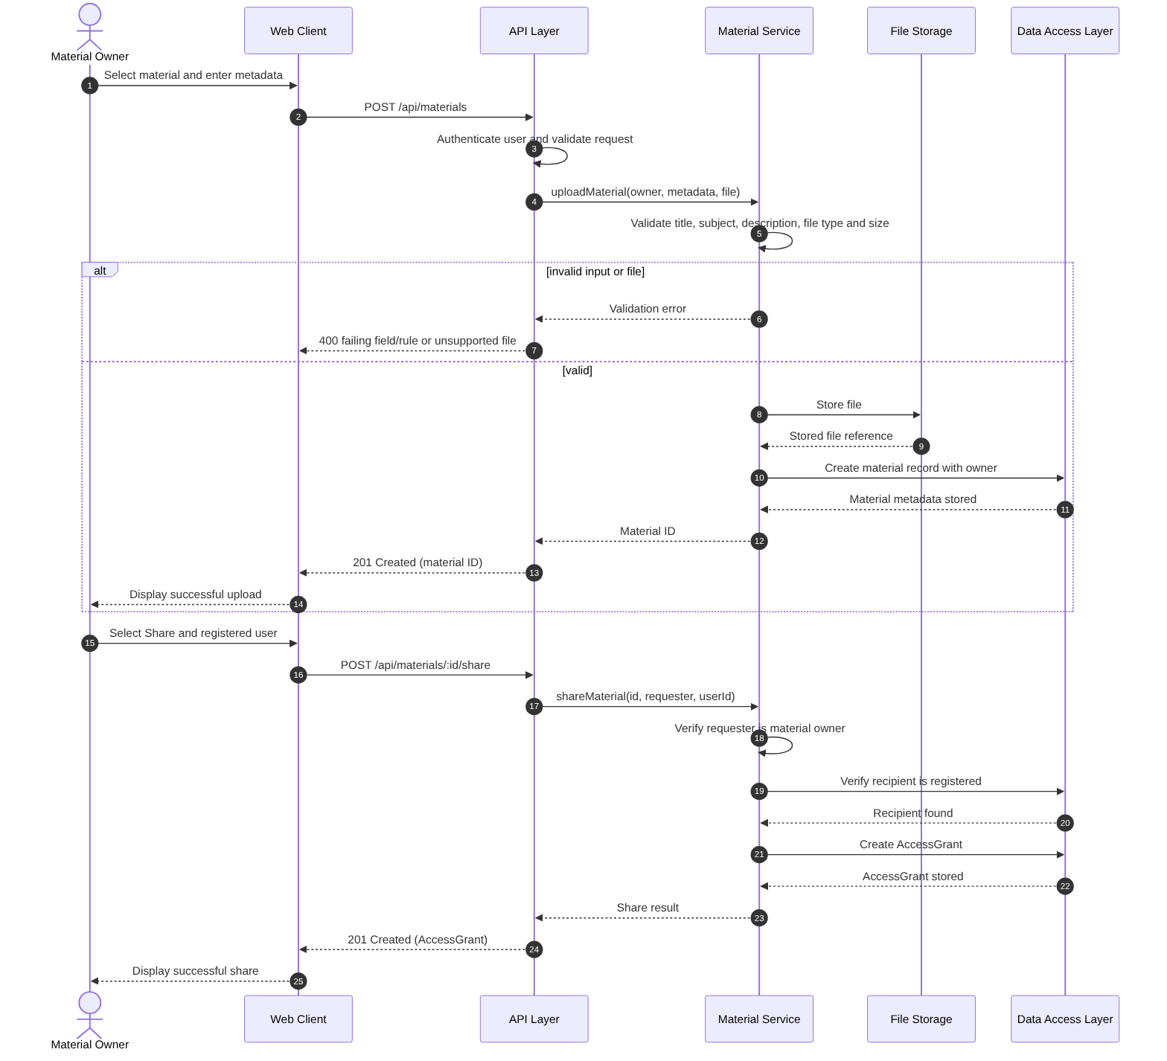
Figure 4.5: Sequence diagram – View Personal Performance (UC-PA-01)
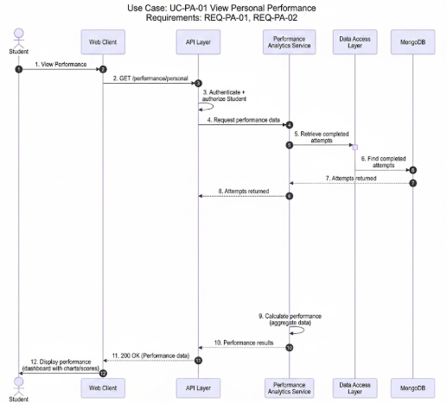
Figure 4.6: Sequence diagram – View Class and Topic-wise Performance (UC-PA-02, UC-PA-03)

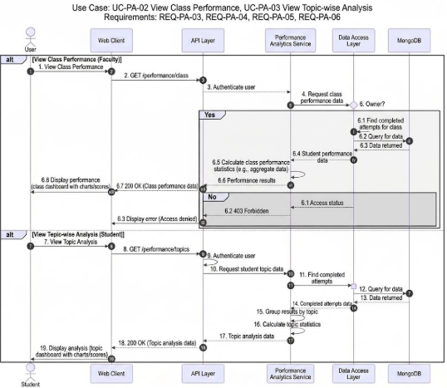
Figure 4.7: Sequence diagram – Create or Join Study Group and Moderate Content (UC-COL-01, UC-COL-02)
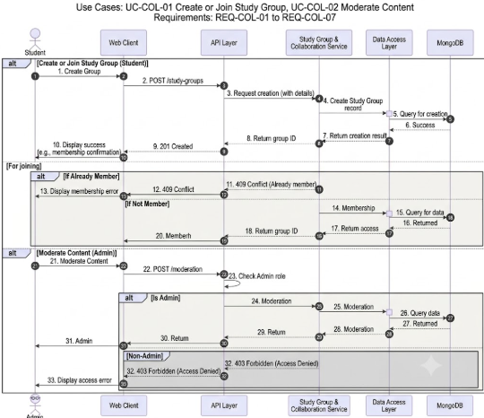

4.3 API Design
Interface definition for Account Management and Material Sharing, and for the Question Bank Service and the Quiz Engine. All endpoints are under /api, use JSON, and require the header Authorization: Bearer <token>. Errors are returned as {error: {code, message}}. Account and Material endpoints use JSON, except where a file is uploaded or replaced (multipart form data).
Component: Auth & Session Service
Endpoint: /auth/register
Method: POST
Authorization: Public
Request: {fullName, email, password, role: "Student"|"Faculty"}
Response: 201 {id, email, role}
Errors: 400 validation error identifying the failing field and rule
Endpoint: /auth/login
Method: POST
Authorization: Public
Request: {email, password}
Response: 200 {token, expiresIn: 1800}
Errors: 401 Invalid email or password, 423 account locked
Endpoint: /auth/logout
Method: POST
Authorization: Authenticated user
Request: –
Response: 204
Errors: 401 not authenticated
Component: Account Service
Endpoint: /account/profile
Method: GET
Authorization: Authenticated user
Request: –
Response: 200 {fullName, institution, profilePicture, email, role: "Student"|"Faculty"|"Admin"}
Errors: 401 not authenticated
Endpoint: /account/profile
Method: PUT
Authorization: Authenticated user
Request: {fullName, institution, profilePicture (file/reference)}
Response: 200 {id, fullName, institution, profilePicture}
Errors: 400 validation error identifying the failing field and rule, 401 not authenticated
Note: Email address and role are not editable through this endpoint.
Component: Material Service
Endpoint: /materials
Method: POST
Authorization: Authenticated Student or Faculty
Request: multipart form data {title, subject, description, file}
Response: 201 {id, owner, title, subject}
Errors: 400 failing field and rule or unsupported file type/size, 401 not authenticated
Endpoint: /materials/:id
Method: GET
Authorization: Authenticated user with ownership or granted access
Request: –
Response: 200 {id, title, subject, description, owner}
Errors: 401 not authenticated, 403 Access denied, 404 material unavailable
Endpoint: /materials/:id/download
Method: GET
Authorization: Authenticated user with ownership or granted access
Request: –
Response: 200 file stream
Errors: 401 not authenticated, 403 Access denied, 404 material unavailable
Endpoint: /materials/:id
Method: PUT
Authorization: Material owner
Request: multipart form data with any permitted updated fields {title?, subject?, description?, file?}
Response: 200 {id, updatedAt}
Errors: 400 failing field and rule or unsupported file type/size, 401 not authenticated, 403 Access denied, 404 material unavailable
Endpoint: /materials/:id
Method: DELETE
Authorization: Material owner
Request: –
Response: 204
Errors: 401 not authenticated, 403 Access denied, 404 material unavailable
Endpoint: /materials/:id/share
Method: POST
Authorization: Material owner
Request: {userId: registeredUserId}
Response: 201 {materialId, userId, grantedAt}
Errors: 400 recipient validation error, 401 not authenticated, 403 Access denied, 404 material or user unavailable
Endpoint: /materials/:id/access/:userId
Method: DELETE
Authorization: Material owner
Request: –
Response: 204
Errors: 401 not authenticated, 403 Access denied, 404 material or access grant unavailable
Component: Question Bank Service
Endpoint: /questions
Method: POST (Faculty)
Request: {text, options[4], correctOption, topic, difficulty, explanation?}
Response: 201 {id, owner, createdAt}
Errors: 400 failing field and rule, 401 not authenticated, 403 Access denied
Endpoint: /questions?q=&topic=&difficulty=
Method: GET (Faculty)
Request: query parameters
Response: 200 {questions[{id, text, topic, difficulty, owner}], total}
Errors: 401, 403 Access denied (Students)
Endpoint: /questions/:id
Method: PUT (owner)
Request: any question field
Response: 200 {id, updatedAt}
Errors: 400, 401, 403 Access denied (not owner), 404 question unavailable
Endpoint: /questions/:id
Method: DELETE (owner)
Request: –
Response: 204
Errors: 401, 403 Access denied, 404
Component: Quiz Engine – quiz management
Endpoint: /quizzes
Method: POST (Faculty)
Request: {title, description?, timeLimitMinutes, availableFrom, availableUntil, questionIds[1..50]}
Response: 201 {id, status: "Draft"}
Errors: 400 failing field and rule, 401, 403, 404 question unavailable
Endpoint: /quizzes/:id
Method: PUT (owner, Draft only) | DELETE (owner)
Request: quiz fields (PUT)
Response: 200 {id} | 204
Errors: 400, 403 Access denied, 404, 409 quiz already attempted
Endpoint: /quizzes/:id/publish
Method: POST (owner)
Request: –
Response: 200 {id, status: "Published"}
Errors: 400 availability end already passed, 403, 404
Endpoint: /quizzes
Method: GET (Student)
Request: –
Response: 200 {quizzes[{id, title, questionCount, timeLimitMinutes, availableFrom, availableUntil, attempted}]} (no questions or answers)
Errors: 401, 403
Endpoint: /quizzes/:id/submissions
Method: GET (owner)
Request: –
Response: 200 {submissions[{studentName, score, percentage, submittedAt}]}
Errors: 401, 403 Access denied, 404
Component: Quiz Engine – attempts and grading
Endpoint: /quizzes/:id/attempts
Method: POST (Student)
Request: –
Response: 201 {attemptId, deadline, questions[{position, text, options[4]}]} (no correct options)
Errors: 401, 403 QUIZ_NOT_OPEN or QUIZ_CLOSED, 404 quiz unavailable, 409 ALREADY_ATTEMPTED
Endpoint: /attempts/:id/answers
Method: PUT (attempt owner)
Request: {position, selectedOption}
Response: 200
Errors: 403 Access denied, 404, 410 TIME_EXPIRED, 409 already submitted
Endpoint: /attempts/:id/submit
Method: POST (attempt owner)
Request: –
Response: 200 {score, total, percentage, questions[{yourAnswer, correctOption, correct, explanation}]} within 2 seconds
Errors: 403 Access denied, 404, 409 already submitted
Endpoint: /attempts/mine and /attempts/:id/result
Method: GET (attempt owner)
Request: –
Response: 200 list of own attempts {quizTitle, score, percentage, submittedAt} | detailed result as above
Errors: 401, 403 Access denied, 404
Component: Performance Analytics Service
Endpoint: /performance/personal
Method: GET
Authorization: Authenticated Student
Request: –
Response: 200 {attempts[{quizTitle, score, percentage, submittedAt}]}
Errors: 401 not authenticated
Endpoint: /performance/topics
Method: GET
Authorization: Authenticated Student
Request: –
Response: 200 {topics[{topic, attempts, averagePercentage}]}
Errors: 401 not authenticated
Endpoint: /performance/class/:quizId
Method: GET
Authorization: Faculty owner of the quiz
Request: –
Response: 200 {submissions[{studentName, score, percentage, submittedAt}]}
Errors: 401 not authenticated, 403 Access denied, 404 quiz unavailable

Component: Study Group & Collaboration Service
Endpoint: /groups
Method: POST
Authorization: Authenticated Student
Request: {name, description?}
Response: 201 {id, name, description, createdBy}
Errors: 400 validation error, 401 not authenticated
Endpoint: /groups/:id/join
Method: POST
Authorization: Authenticated Student
Request: –
Response: 201 {groupId, userId, joinedAt}
Errors: 401 not authenticated, 404 group unavailable, 409 already a member
Endpoint: /groups
Method: GET
Authorization: Authenticated Student
Request: –
Response: 200 {groups[{id, name, description, createdBy}]}
Errors: 401 not authenticated

Moderation endpoint
Endpoint: /collaboration/content/:id
Method: DELETE
Authorization: Authenticated Admin
Request: –
Response: 204
Errors: 401 not authenticated, 403 Access denied, 404 content unavailable

4.4 Error Handling, Logging & Monitoring
Error handling. All errors use the format {error: {code, message}} defined in 4.3; validation errors also carry the name of the failing field. A central Express error handler converts exceptions into this format, so stack traces and internal details never reach the client. Validation runs in the middleware chain before the controller, and a rejected request changes no data.
Error codes
400 – validation failure; the message names the failing field and rule.
401 – not authenticated, or invalid credentials ("Invalid email or password").
403 – not authorized ("Access denied"); also QUIZ_NOT_OPEN and QUIZ_CLOSED.
404 – item removed or unavailable; no details of the item are returned.
409 – conflict, such as ALREADY_ATTEMPTED, already submitted or quiz already attempted.
410 – TIME_EXPIRED for an attempt past its deadline.
423 – account locked for 15 minutes after 5 consecutive failed logins.
500 – unexpected server error; a generic message is returned and the details are logged.
Failed operations. A failed or interrupted upload, update or removal leaves the previous state unchanged and returns no success response (NFR-SAFE-02). Messages never contain answer keys, passwords or tokens.
Logging. The server logs each request (method, path, status, user ID, timestamp) and the audit events listed in the STRIDE model in 3.9: login, logout, material sharing, quiz publication, attempt start and submission. Passwords, tokens and quiz answer keys are never written to the logs.
Monitoring. The following are monitored and raise an alert when a threshold is exceeded: API error rate and login failure rate; grading time against the 2-second target (NFR-PERF-04); upload failures; availability against the 99% target (NFR-QUAL-02); and the success of the daily backups (NFR-SAFE-01).
Performance & Collaboration errors:
Performance requests from unauthenticated users return 401. Faculty requests for quizzes not owned by the requesting Faculty member return 403 Access denied. Requests for unavailable quizzes, study groups or collaborative content return 404 without exposing details of the unavailable item. Attempts to join a study group in which the Student is already a member return 409 ALREADY_MEMBER. Moderation requests from non-Admin users return 403 Access denied.

4.5 UX Design
Responsive React interface with consistent navigation, logout and help on every screen; errors shown next to the field. Quiz screens: a visible countdown, one-question-per-view navigation with an answered/unanswered indicator, a confirmation prompt before submission when questions are unanswered, keyboard-operable options, sufficient colour contrast, and a result page that shows the score first and then the per-question review.
Performance screens: Personal performance displays completed quiz attempts with score, percentage and submission date. Topic-wise analysis groups performance information by topic. Faculty class-performance views display Student performance for quizzes owned by the Faculty member.
Collaboration screens: Study group screens provide controls for creating and joining groups and display the groups to which the Student belongs. Moderation controls are available only to Admin users. Access-denied and unavailable-resource messages are displayed without exposing restricted or removed content.

4.6 Open Issues & Next Steps
Decisions taken: questions are single-correct multiple choice only; quizzes are open to every registered Student and are not limited to study-group members.
Resolved: Performance Analytics consumes the attempt fields quizId, score, percentage, submittedAt and the quiz/question topic information required for topic-wise aggregation. The exact database field names shall follow the shared Mongoose data model. Future enhancements: push notifications, multi-select and descriptive questions, question images, negative marking, quizzes restricted to study groups, caching with Redis.

5. Appendices
5.1 Glossary: SRS, STP, RTM, UML, REST, JWT, RBAC, TLS, MERN, ODM, STRIDE, ADR, MCQ as in Section 1.4; Quiz Engine – component that manages quizzes and attempts; Question copy – snapshot of a bank question stored in a published quiz.
5.2 References: IEEE 42010; OWASP Application Security Verification Standard; NIST SP 800-160; MongoDB, Express, React and Node.js documentation; the project SRS.
5.3 Tools: Graphviz, Mermaid, draw.io.

