1.OpenShift is a Kubernetes-based platform with added functions

**Prerequisites**

**1.2Docker**

**2.OpenShift account:**

**3.OpenShift CLI**

Verify OpenShift CLI is installation with the following command:

***oc version***

Sample OP :

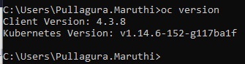

**Login to OpenShift by using the CLI**

1.Navigate to the online web console by following the [username] > Copy Login Command > Display Token > Log in with this token path.

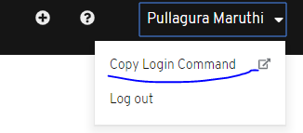

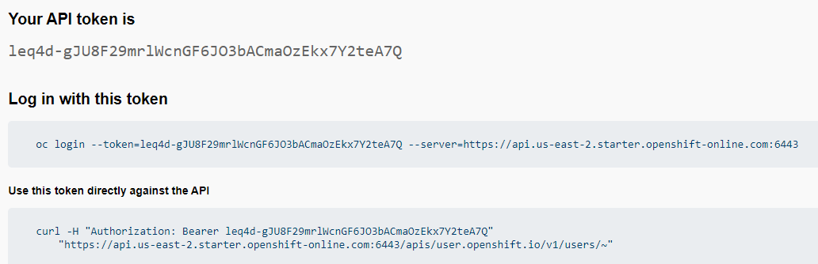

**Syntax :**

2. oc login --token=[your-token] --server=https://api.[region].online-starter.openshift.com:[port]

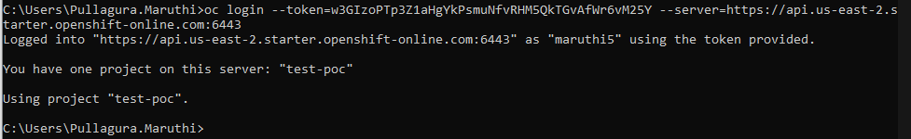

**To create the project**

Syntax:

***oc new-project [project-name]***

Before deploying micro services to OpenShift first we have to create the docker images.

**Creating the docker images**

1. docker build -t system:1.0-SNAPSHOT system/.

2.docker build -t inventory:1.0-SNAPSHOT inventory/.

Check the docker images with the following command:

Syntax to list the docker images:

$ docker images

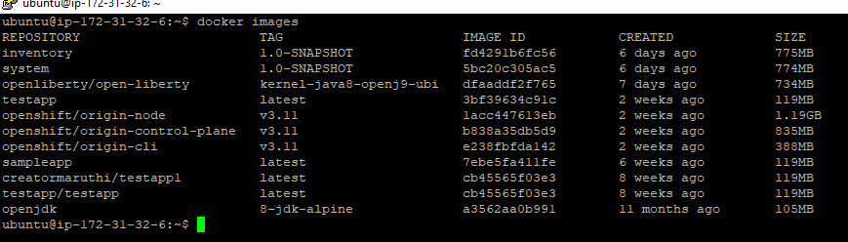

After images created we have to push the images to OpenShift’s internal registry.

First, you must authenticate your Docker client to your OCR. Start by running the login command:

***oc registry login***

***oc whoami***

***oc whoami -t***

***oc registry info***

***echo $(oc whoami -t) | docker login -u developer --password-stdin $(oc registry info)***

***docker tag system:1.0-SNAPSHOT $(oc registry info)/$(oc project -q)/system:1.0-SNAPSHOT***

***docker tag inventory:1.0-SNAPSHOT $(oc registry info)/$(oc project -q)/inventory:1.0-SNAPSHOT***

***docker push $(oc registry info)/$(oc project -q)/system:1.0-SNAPSHOT***

***docker push $(oc registry info)/$(oc project -q)/inventory:1.0-SNAPSHOT***

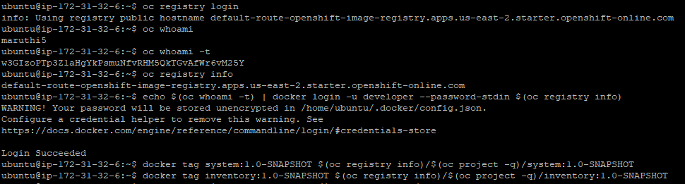

***oc get imagestream***



**Deploying the microservices**

Now that your container images are built, deploy them by using a Kubernetes object configuration file.

Kubernetes objects can be configured in a YAML file that contains a description of all your deployments, services, or any other objects that you want to deploy. All objects can also be deleted from the cluster by using the same YAML file that you used to deploy them.

Run the following commands to deploy the objects as defined in kubernetes.yaml file:

***oc apply -f kubernetes.yaml***

When the apps are deployed, run the following command to check the status of your pods:

***oc get pods***

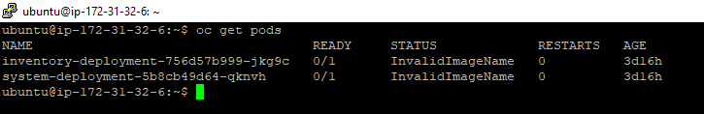

## Making requests to the microservices

To access the services and the application, use a route. A route in OpenShift exposes a service at a hostname such as www.your-web-app.com so external users can access the application.

Your microservices can now be accessed through the hostnames that you can find by running the following command:

***oc get routes***



They can also be found in the web console by following the Networking > Routes > Location path. Hostnames are in the inventory-route-[project-name].apps.[region].starter.openshift-online.com format.

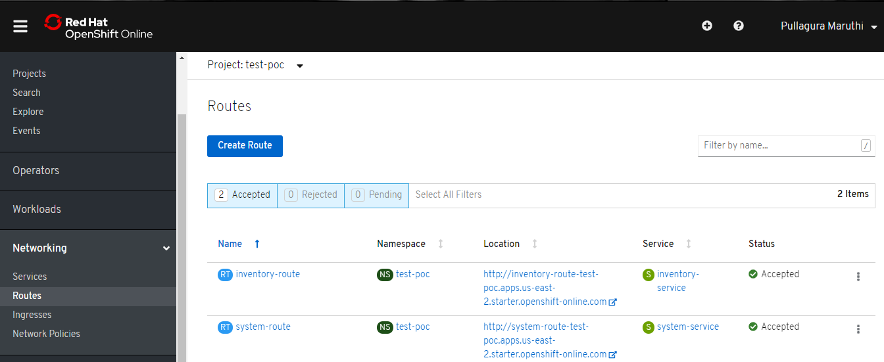

## Tearing down the environment

When you no longer need your deployed microservices, you can delete the Kubernetes deployments, services, and routes by running the following command:

***oc delete -f kubernetes.yaml***

***oc delete imagestream/inventory***

***oc delete imagestream/system***

Finally, you can delete the project by running the following command: