**EXPERIMENT – 1**

**INTRODUCTION TO JAVA ENVIRONMENT**

1. **Explore and understand the role of the JDK, JRE, and JVM.**

* **JDK (Java Development Kit):**A comprehensive software development kit containing tools for writing, compiling, and executing Java programs. It includes the JRE, compiler, debugger, and other essential tools.
* **JRE (Java Runtime Environment):**A subset of the JDK designed specifically for running Java applications. It contains the JVM, core Java libraries, and other essential runtime components.
* **JVM (Java Virtual Machine):**An abstract machine that interprets and executes Java bytecode. It provides platform independence, meaning Java programs can run on any operating system that has a compatible JVM.
* Developers use the **JDK** to write and compile Java code.
* The compiled code (bytecode) is then executed by the **JVM** within the JRE.
* The JVM interacts with the underlying operating system to access resources and execute the program.

1. 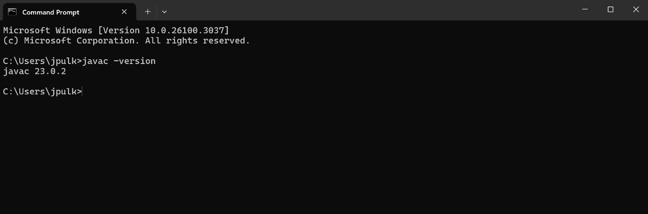**INSTALL LATEST JDK AND VERIFY THE ENVIRONMENT.**
2. **Create a Sample Hello World Program and execute it using command prompt.**
3. 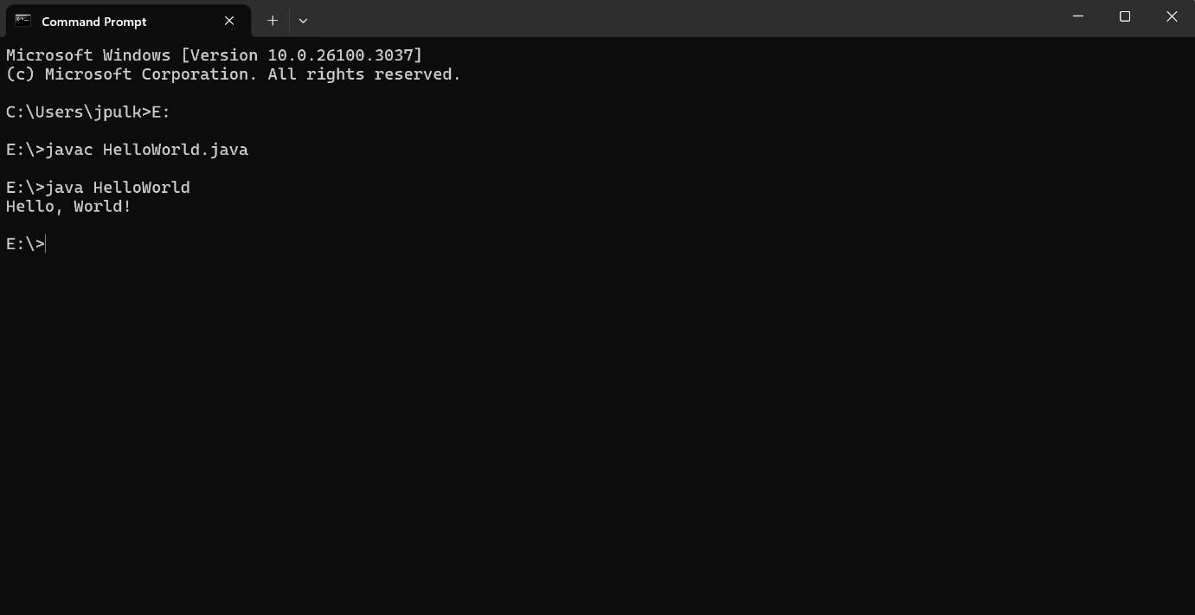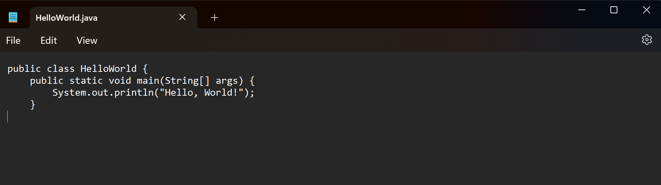**Display your name and complete address in different lines.**

