DECISION BRIEF
Clinical Document Generation v2
A controlled rebuild for complete, consistent, Word-ready clinical documents
RECOMMENDATION Approve a clean rebuild around one public workflow and six production Python modules. AI remains responsible for scoped clinical narrative; deterministic code controls facts, formatting, validation, and release.

How the proposed skill works
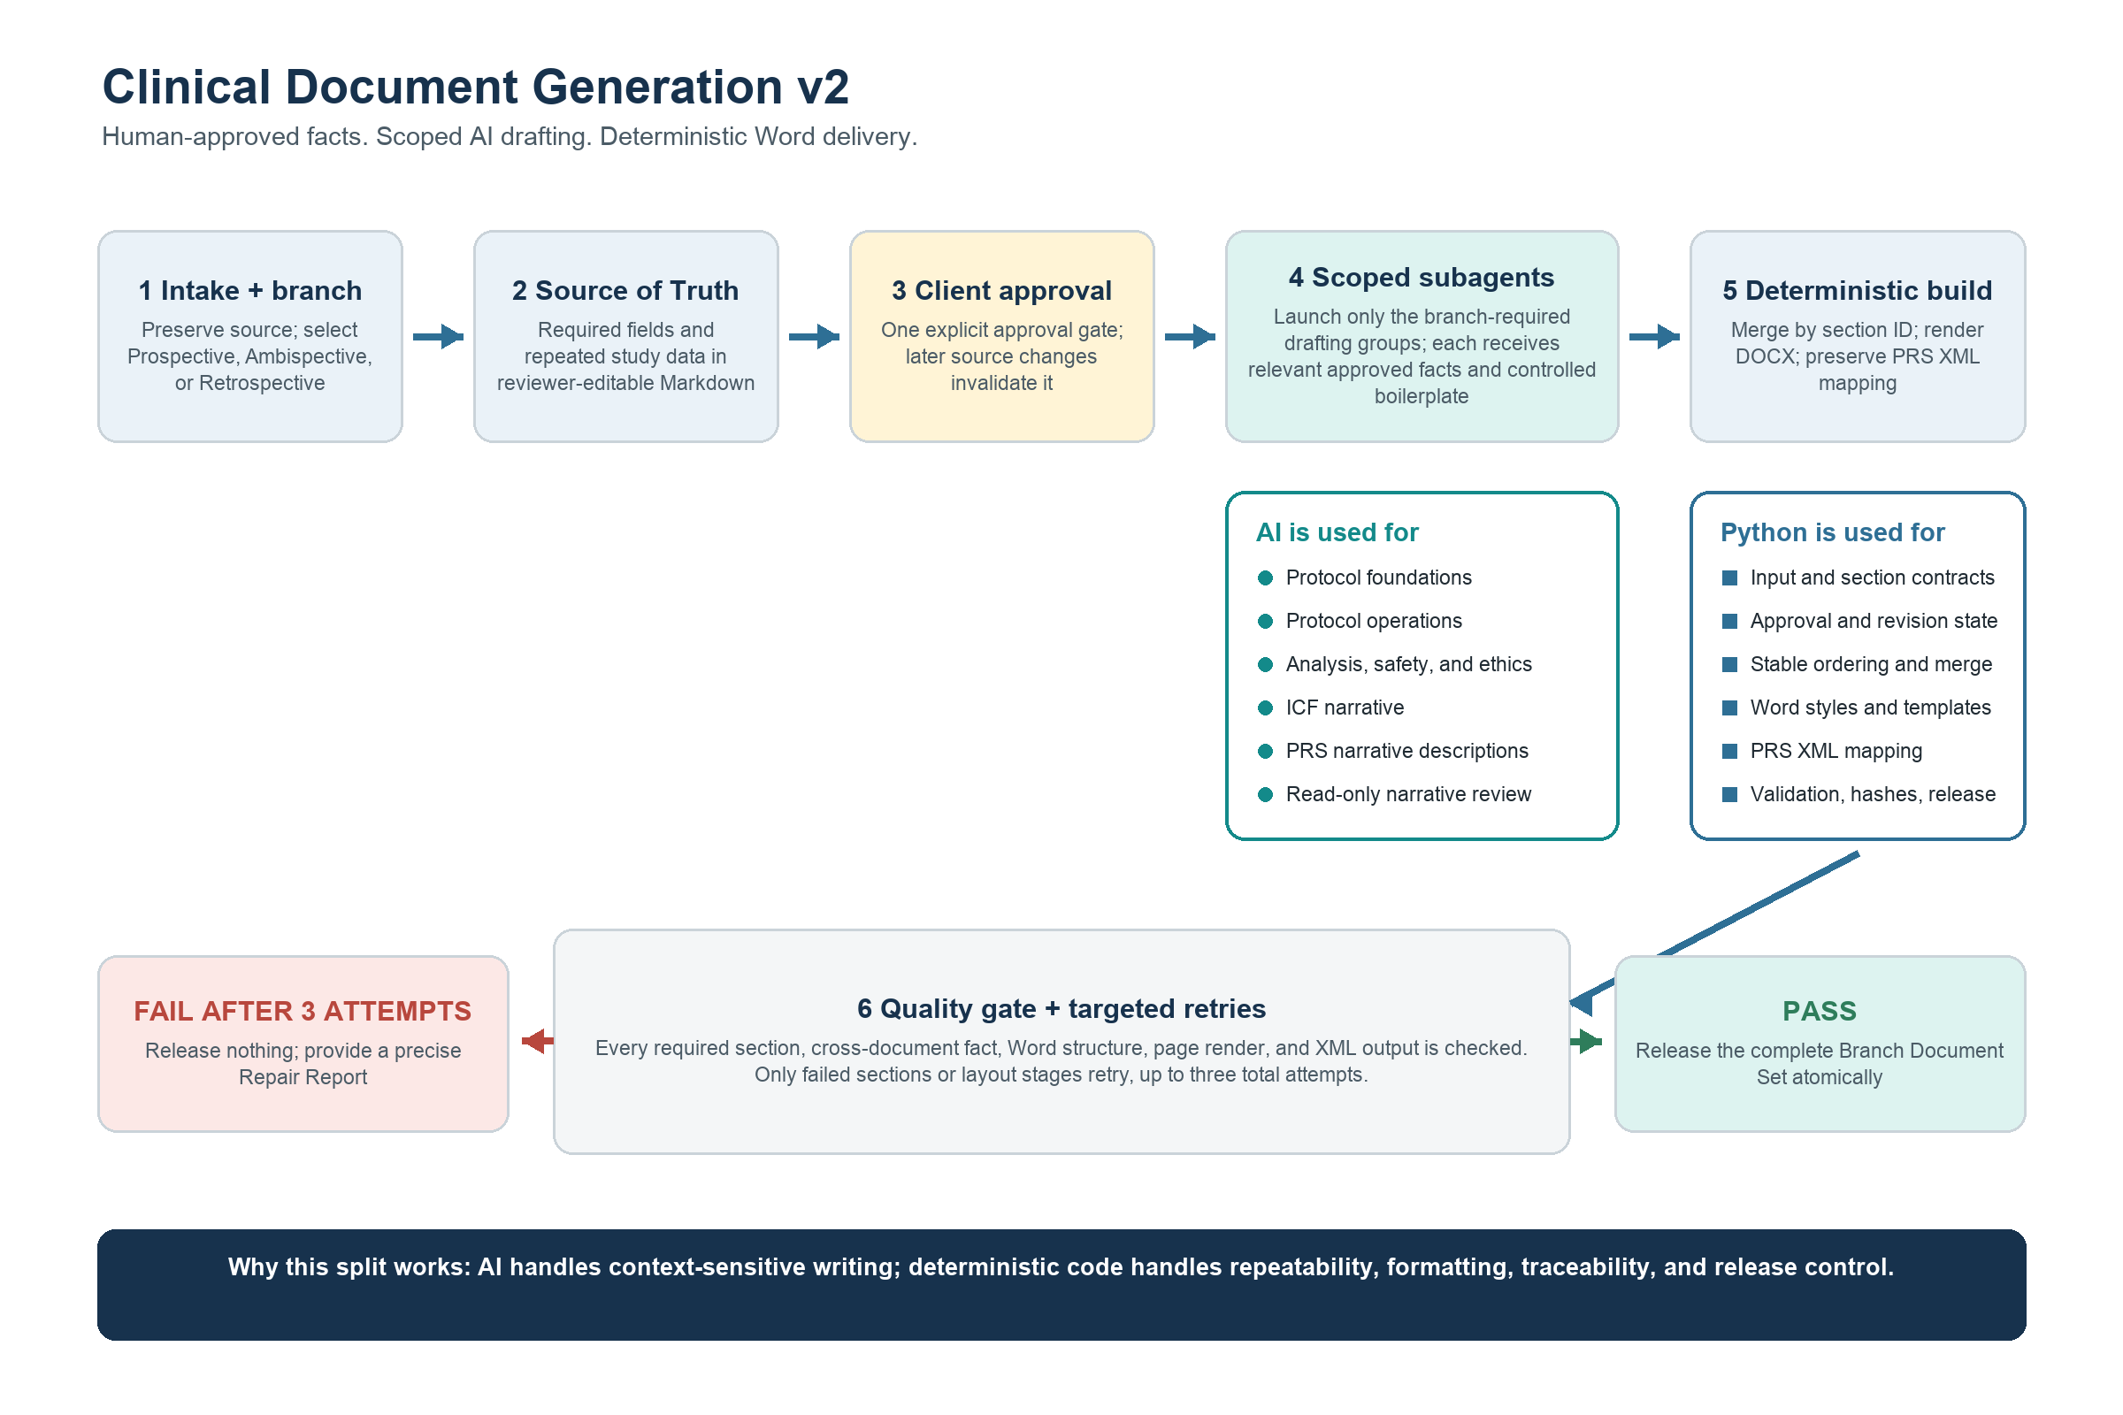
No partial delivery: the complete branch package passes together, or the client receives a Repair Report.

Where subagents are used - and where they are not
The design deliberately uses AI only where clinical language requires judgment. Everything that must be repeatable, auditable, and formatting-stable remains deterministic.
Decision area | Subagents | Deterministic Python
When | After the Source of Truth is explicitly approved. | From intake through approval, and again for assembly, QA, and delivery.
What | Draft narrative sections and perform read-only narrative or visual review. | Validate inputs, enforce contracts, merge sections, render DOCX, map PRS XML, record evidence, and release.
Inputs | Only the approved fields relevant to assigned section IDs, plus controlled boilerplate. | The full approved source, versioned contracts, templates, and accepted drafts.
Authority | Propose text and findings. They cannot approve facts or release files. | Owns pass/fail decisions, retry targets, artifact hashes, and atomic handoff.
Failure behavior | Retry only failed sections, up to three total attempts. | Block release after the retry limit and produce a classified Repair Report.

Five available drafting groups - only the branch-required groups run
- Protocol foundations - rationale, objectives, population, and study design.
- Protocol operations - procedures, visits, measurements, and schedules.
- Protocol analysis and oversight - endpoints, statistics, safety, ethics, and risks.
- ICF narrative - client-template language adapted only with approved study facts.
- PRS narrative - brief and detailed descriptions while preserving the existing XML mapping.
Prospective and Ambispective studies use all five groups. Retrospective studies use the three Protocol groups and do not launch ICF or PRS drafting.

Why this division makes sense
- Better writing. Specialized agents can focus on one clinical concern instead of juggling the whole package.
- Lower invention risk. Each agent sees only relevant approved facts and controlled clinical boilerplate, not raw or unrelated material.
- Faster, safer retries. A failed section is redrafted in isolation; accepted sections are reused rather than rewritten.
- Stable output. Code, not AI, controls section order, Word styles, tables, fields, headers, footers, XML, and file release.
KEY CONTROL Subagents may select, adapt, and connect approved boilerplate, but they may not invent study-specific procedures, risks, benefits, safety obligations, or regulatory claims.

A manageable six-module production architecture
Production module | Single responsibility
workflow.py | Only public entrypoint: prepare, approve, validate, and generate.
contracts.py | Branch input requirements and document section contracts.
drafting.py | Subagent assignments, structured section drafts, targeted retries, and deterministic merge.
rendering.py | Protocol and ICF DOCX generation using contracted client templates.
quality.py | Content, cross-document, structure, renderer, visual, evidence, and release gates.
prs_xml.py | Preserved PRS XML mapping and validation behavior.

Branch deliverables
Study branch | Required client package
Prospective | Protocol DOCX + ICF DOCX + PRS XML
Ambispective | Protocol DOCX + ICF DOCX + PRS XML
Retrospective | Protocol DOCX

Word compatibility without requiring Word on every machine
- Output standard. The skill generates standards-compliant DOCX files designed for Microsoft Word.
- Active renderer. For visual QA it uses Microsoft Word when available, then LibreOffice, then Apple Pages, and records which renderer produced the evidence.
- Honest certification. If no renderer exists, structural checks may run, but the package is not reported as visually passed.
- Template guarantee. Only bundled, contracted templates are supported until a new template completes onboarding and acceptance testing.
PORTABILITY The client can open and update the final DOCX in Microsoft Word even when the development machine used LibreOffice or Pages for visual QA.

Release controls and approval criteria
Current risk | New control | Evidence before release
Empty or weak sections | Versioned section contract checks evidence and substance, not just non-empty text. | Every required leaf section passes; container headings may group children.
Unsupported clinical details | Agents receive approved facts plus controlled boilerplate; cross-document checks compare shared facts. | No unsupported study-specific claim or contradiction.
Formatting quirks | Word-native styles, fields, tables, headers, footers, and per-page visual inspection. | No clipping, overlap, blank pages, orphan headings, split rows, or style drift.
False-positive delivery | Atomic branch release tied to artifact hashes and renderer evidence. | Every required file passes together; later mutation invalidates certification.
Unmaintainable scripts | One public workflow and six focused production modules. | Acceptance tests exercise the full workflow rather than private script chains.

Acceptance corpus
- Sparse-complete and rich-complete studies for each of the three branches (at least six canonical studies).
- Current failing Prospective and Ambispective cases converted into regression tests, plus a complete Retrospective end-to-end case.
- Whole-workflow tests using real bundled templates, accepted section drafts, final rendering, quality gates, and atomic handoff.
- Golden regression protection for the existing PRS XML output and full-corpus reruns after contract or boilerplate changes.
APPROVAL REQUESTED Authorize the clean rebuild and replacement of the current script chain, subject to the six-module boundary, the human Source-of-Truth approval gate, scoped subagent use, three-attempt retry policy, preserved PRS XML behavior, and the release criteria above.

Definition of done: with all obligatory inputs complete, every required section is substantive, every branch deliverable passes its contract, and the complete package renders cleanly before client release.

