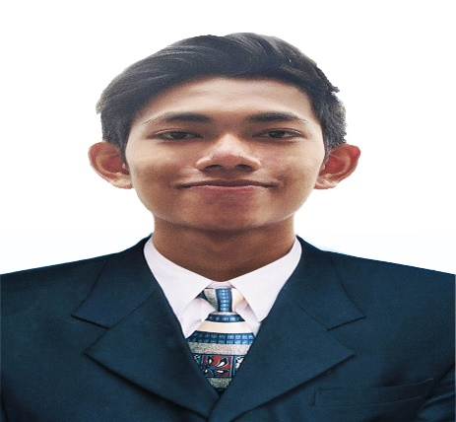

I’m an aspiring web developer. I have the perseverance to improve my skills and my knowledge in every sectors of development. I am passionate and ready to showcase my skillset to your organization.

**EDUCATION**

2015-2019

University of Caloocan City

BS Information System

**ADDRESS**:

4941 Lanzones St. San Vicente Ferrer Brgy. 178 Camarin Caloocan

**CONTACT NUMBER:**

+639977265410

**EMAIL ADDRESS:** [delapenapaulandrei12@gmail.com](mailto:delapenapaulandrei12@gmail.com)

**WEBSITE PORTFOLIO:**

<https://www.paul-myport.cf>

<https://paulportfolio.herokuapp.com/>

**GITHUB:**

https://www**.**github.com/Pulpaul

**LINKEDIN:** https://www.linkedin.com/in/paul-andrei-034660182

* I have sills in Front end and Back end development. I’m knowledgeable in HTML, CSS, BOOTSTRAP, MATERIALIZE DESIGNS for front end development. For back end development I can do LARAVEL PHP FRAMEWORK, PHP, JAVASCRIPT, AJAX, JSON, JQUERY. I also know Wordpress.
* For other development skills I’m knowledgeable in Search Engine Optimization, MVC Design Pattern, Machine Learning AI Chatbot using Dialogflow, Dynamic Mappings with functions of geolocation, and p2p routings. I also have knowledge in Adobe Photoshop, Microsoft Office Apps, Hardware Troubleshooting, Network Troubleshooting, and I have basic knowledge in C++ and c# programming.
* English and Filipino Literate.

**REFERENCE**

Sir Gener Salentes

CITS Officer In Charge

+639399333750

Ma’m Astrea Ivy Ricabar

Accenture HR Personnel

+639493315757

Sir Kim Monjardin

Radio Veritas Web Developer +639397246707

* I finished 400 hours of On the Job Training at Competitive I.T. Solutions Inc. My task are Web Developer, Technical and Network Support.
* I attended some talks and seminars including Data Science, UX Crash Course, Timeless Art: Typography, Search Engine Optimization, Ethical hacking, VM Ware, Github, and Corel Draw.
* I have experience in creating quality web projects.

1. CITS Technical Support System

Link: <https://www.citstechsup.ml>

GIT­­: <https://github.com/Pulpaul/CITSTECH>

1. G-café Post Event System

Link: <http://g-cafe.gearhostpreview.com/>

GIT: <https://github.com/Pulpaul/G-cafe-PES>

**EXPERIENCE**

**SKILLS**

**OBJECTIVE**

**PROFILE**

**PAUL ANDREI T. DELA PEÑA**

WEB DEVELOPER