
neo:XMR Designed for BINARY by Pulse-Eight Control 4 Driver

version V18

INTRODUCTION
Our products are designed to communicate with a variety of control systems. Most of the control systems have their software which require a driver to run our products.
This driver has been designed to allow a Control4 system to communicate with the neo:XMR Designed for BINARY video matrix to allow brief monitoring, configuration, and maintenance.
While the majority of this setup process is common with the standard Pulse-Eight edition of video matrix products, there are two important differences:
- The IR setup of the Designed for BINARY edition is incompatible with the standard edition matrix. The Designed for BINARY edition operates an IR signal natively at 12V, making it compatible with Episode IR Receivers (EE-IR-RCVR-SM and EE-IR-RCVR-TT) and Episode IR flashers (IRF-1 and IRF-2), available from Snap One.
Please note that the Made for BINARY edition is not compatible with 5V IR flashers.
- The Designed for BINARY edition features the IR Blasting technology, allowing Control4 systems to generate and transmit IR signals to any Input and Output devices.

PRE-REQUIREMENTS

Installer ID
During the installation process, you will be required to enter your 4-digit Pulse-Eight Installer Id.
If you do not already have an Installer Id then you will need to register for a new account. Please contact your Snap One representative or visit monitoring.pulse-eight.com/Account/Register
Cloud Monitoring Service
Once you have an Installer ID, you will be able to gain access to the Cloud Monitoring Service which allows you to monitor all of your Pulse-Eight installations remotely in one place, as well as downloading the latest drivers and other documentation.
Web Interface
When setting up the neo:XMR matrix and before configuring the driver, it is important that the installer can access the admin menu on the Web Interface to configure the matrix according to their requirements. The Web Interface can be accessed using a computer connected to same router/network as the matrix and visiting www.gotomymatrix.com in your web browser. Navigate to the Cloud Connection tab and click on “Admin” at the bottom of the page and enter the default password “admin” to access all options.
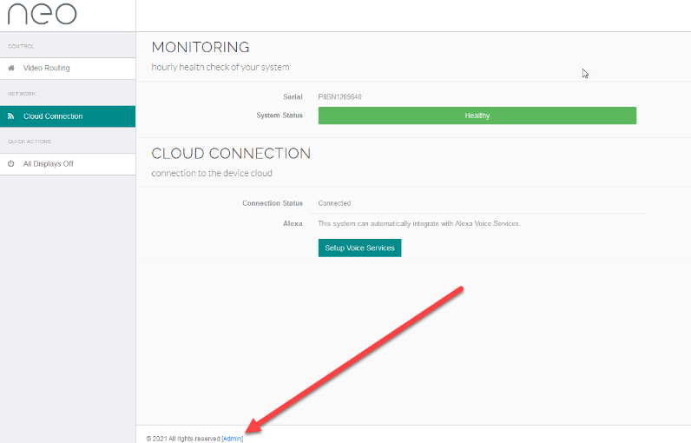
For more information on how to navigate in the admin menu and setup options available (e.g. adjusting HDMI input EDIDs, setting audio modes, HDBaseT link quality tests, etc) then please refer to “Web Interface Setup” section in the latest installation manual found at docs.pulse-eight.com.

CONFIGURE neoXMR DRIVER

Automatic Discovery (recommended)

- The driver is available through the Control4 online driver database.
- Add the device by going to the Discovered tab on the right-hand side under Items. Right click on the device and select ‘Add to Project’.
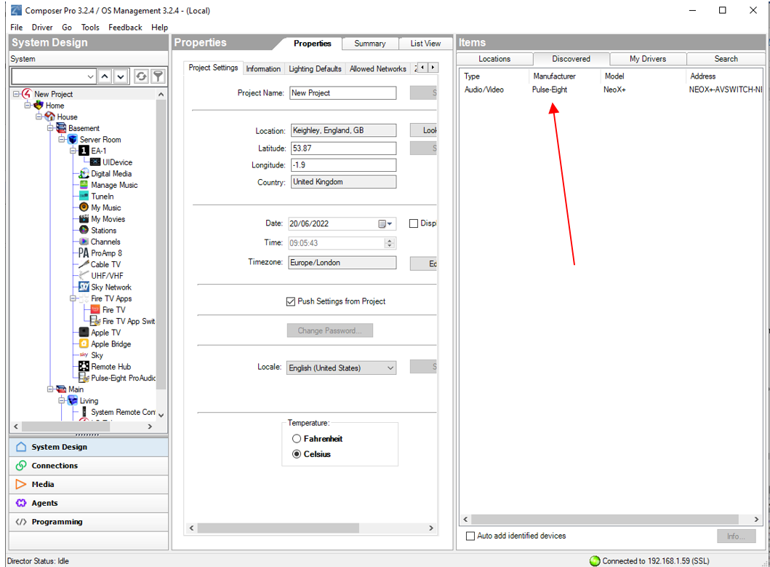
3. (Orange) Device IP address: If Discovery was successful then the IP of the matrix should appear here after a few seconds.
Note: If discovery is unsuccessful, please continue to the Manual Discovery (fallback) section.
(Green) Installer ID: Enter your 4-digit Pulse-Eight Installer Id here and click set. This value will register this system to your monitoring account and allow you to monitor and support the system remotely.
(Blue) Auto Sync: By default, the matrix driver has enabled two-way feedback, to maintain state information with attached navigators (such as SR260) if you don’t require this feature, you can disable it here.
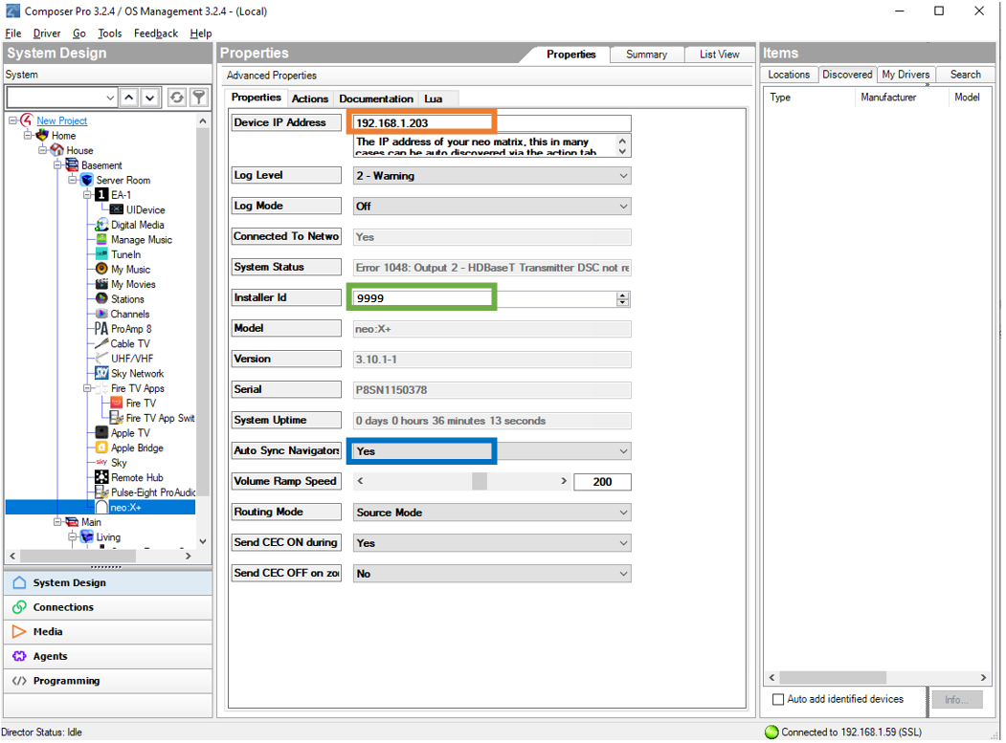

5. Click on the Connections tab (Green) in Composer, select the matrix driver from the list on the Control/AV tab (Red).
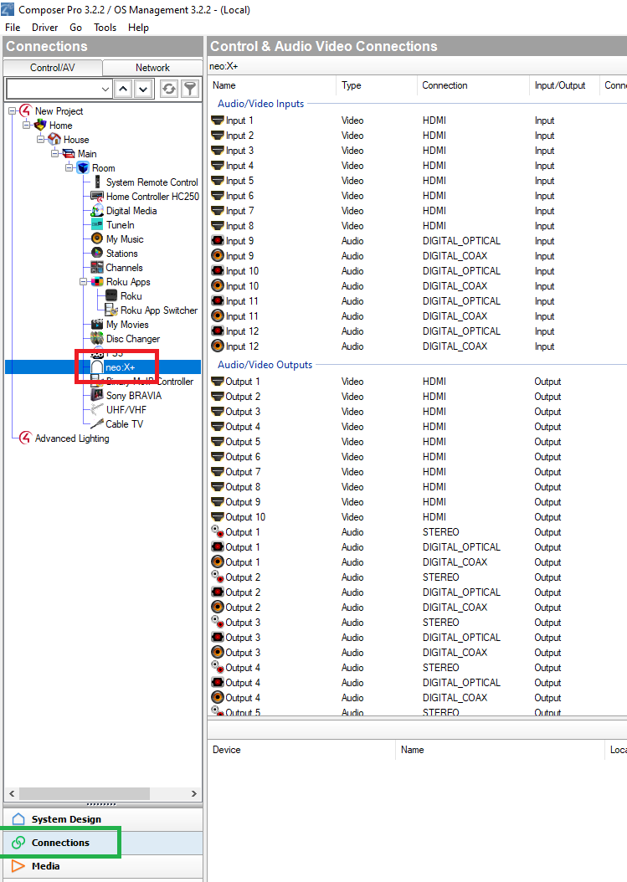

6. Setting the connections is no different than any other driver; however, ensure that the Inputs and Outputs match the physical wiring as per the matrix, as labelled
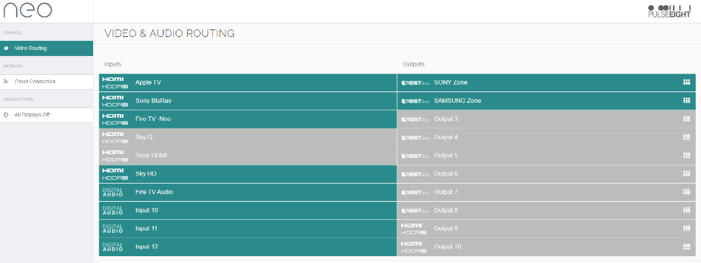
7. Setup is now complete. You may need to restart the director for all the changes to be applied correctly. However, this is not commonly required.
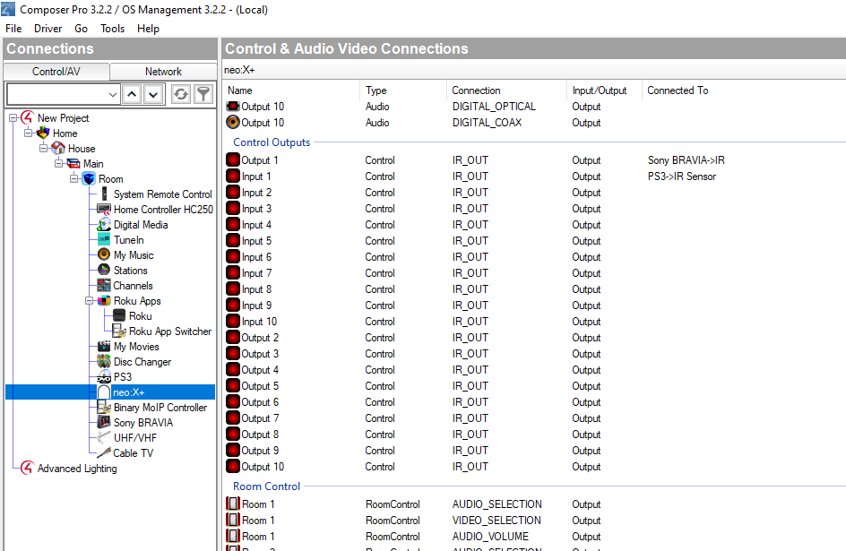

Manual Discovery (fallback)

- Add the drivers by clicking on ‘Driver’ at the top, and then ‘Add or Update Driver’.
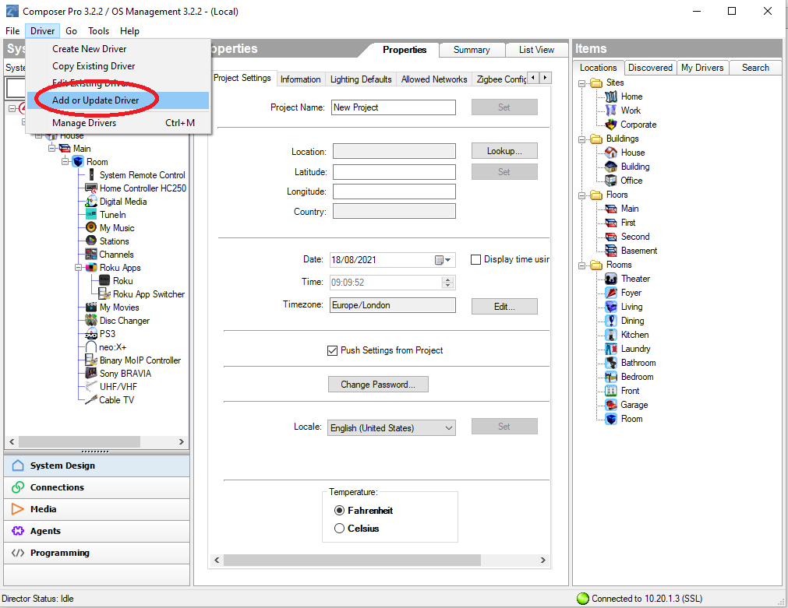
2. Click the Search tab on the right-hand side and search for the driver by the name, drag the driver from the Search window into the correct Room location.

3. Click the Action tab in the matrix driver (Red). Then click the Discover button (Green), then click back to the Properties tab.

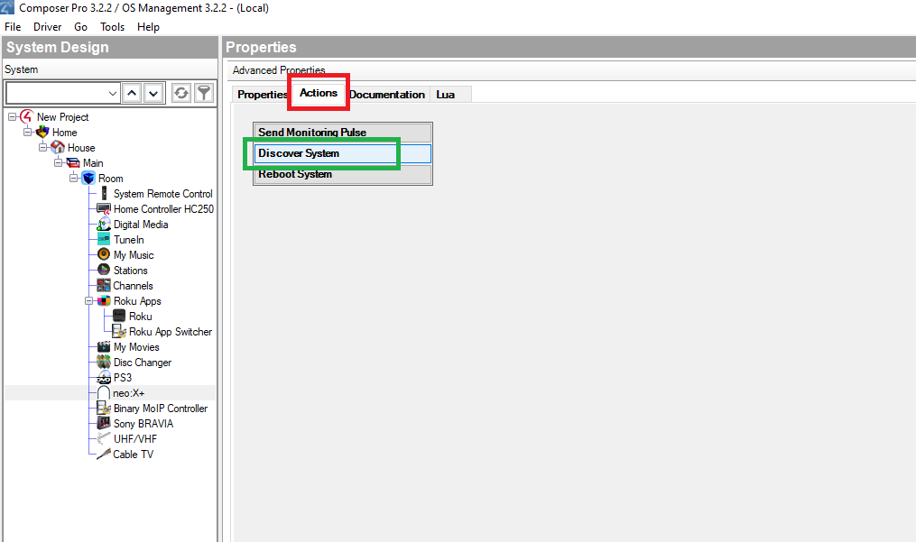

4. If discovery is successful, go to step 3 in Automatic Discovery section and continue.
If not, follow the steps in the new help window to complete IP address configuration.

PROPERTIES
On the properties tab you can examine various core values about the system, these are read only and automatically updated every few seconds.
If something is not working correctly you can enable Log Mode, set this option to Print and the Log Level to 5 – Debug for maximum information.

ACTIONS
There are currently three buttons available in ComposerPro for this driver:
- Reboot System: Restarts the system immediately, doing so will interrupt video routing briefly
- Discover System: Used to automatically discover the Device IP Address of the system where possible
  - Send Monitoring Pulse: Triggers for an immediate monitoring pulse to be sent, allowing for the current system health data to be viewed at the Cloud Monitoring Service.
CONFIGURING AUDIO
There are two audio modes of operation: Source Mode and Sink Mode. By default, when you first install the matrix, the unit is set to Sink Mode in passive.

Sink Mode is the preferred method when setting up the neo:XMR in an installation that does not have a dedicated audio matrix switch.
Sink Modes offers two sub-modes of operation:
- Passive mode allows for audio routing from any input to any of the audio output zones, which by default is intended to match the video routing. Passive mode does not support HDMI-ARC.
- Active mode offers the same capabilities as passive mode, but it will also enable the following features:
  - Audio delay and volume control of the stereo outputs
  - ARC (HDMI). When feature is enabled, the matrix will automatically manage when audio is coming directly from the TV, over the HDMI Audio Return Channel (ARC), and output over the respective audio zone output.

Source Mode is the legacy routing where the audio outputs zones A to F are locked to HDMI inputs 1 to 6 respectively, and with audio output zones G and H linked to audio inputs 7 and 8. Digital audio inputs 9 and 10 are not operational in Source mode. This mode is generally used in larger installations where the input audio is being fed directly to one or more dedicated audio matrices.
Note: if audio outputs are connected to stereo/phono jacks on the audio output zones, the video matrix will automatically downmix multichannel audio (including Dolby 5.1) to stereo (2 ch).

For further information on the Audio Modes and how to change between Sink Mode and Source Mode, please refer to the latest installation manual found at docs.pulse-eight.com
Note: Some changes require the reboot of the system in order for the changes to take effect.

IR Blasting
The neo:XMR Made for BINARY has the unique capability of being able to blast IR commands through any of the IR Flashers plugged into the matrix without the need to have cable connection between an EA controller and the matrix. As long as the EA controller and the matrix are on the same network, then the driver can be configured so that a virtual command from the Control4 system is generated as IR message and blasted to the relevant HDMI Source or Display.

As an example, if you wanted to be able control an HDMI Sources (e.g. Xbox, Sky Plus) connected to the matrix Input 1 and Input 2, respectively, then you must make a binding connection (Blue) in Composer with Inputs <IR OUT> and Sources <IR Sensor>.
If you also want to be able to control the Displays (e.g. LG Television, Television) in a remote room then you must make a binding connection (red) between Outputs <IR OUT> and Displays <IR Sensor>.

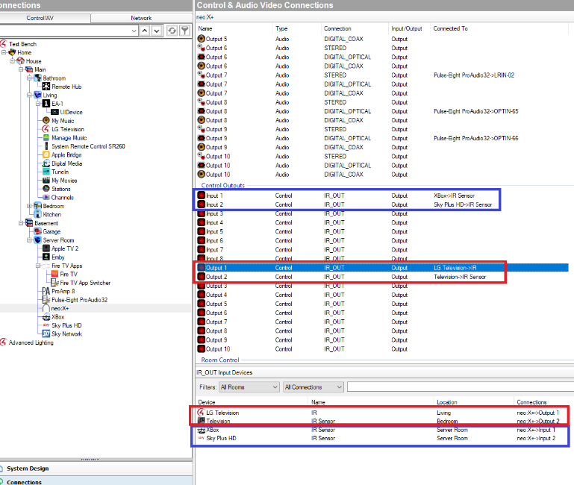

CONFIGURING CEC
Send CEC ON during route change: By default, the matrix will send a CEC <power ON> command to the output when a zone is routed. If it is preferred to switch output devices on using their control4 drivers, then this can be disabled using this setting.
Send CEC OFF on zone off: By default, the matrix will not send a CEC <power OFF> command to the output when a zone is disconnected. However, the driver can send a power off on zone disconnection by simply enabling this setting.

VERSION HISTORY
V18: Improve driver response under network load
CEC + CEC Source Switching options can now be changed from Composer
V17: Internal release
V16: Corrected port numbering for IR blasting
V15: Changed documentation version number to match driver version.
Updated “CONFIGURE neoXMR DRIVER” section to include Automatic and Manual Discovery.
V1.03: Updated Source/Sink mode + CEC Documentation
V1.02: Updated Documentation
V1.01: Updated Documentation
V1.00: Initial Release.

SUPPORT
For further assistance please contact support@pulse-eight.com

