_________________________________________________________________
neo:8a by Pulse-Eight
Control4 Driver
_________________________________________________________________
V19

INTRODUCTION
Our products are designed to communicate with a variety of control systems. Most of the control systems have their software which require a driver to run our products.

This driver has been designed to allow a Control4 system to communicate with the neo:8a video matrix to allow brief monitoring, configuration, and maintenance.

PRE-REQUIREMENT
1. Installer ID
During the installation process, it is recommended to enter your 4-digit Pulse-Eight Installer ID. This process is optional (not mandatory) to enable to access to the Cloud Monitoring Service.
If you do not already have an Installer ID then you will need to register for a new account. Please contact Customer Support at Pulse-Eight (cs@pulse-eight.com).

2. Cloud Monitoring Service
Once you have an Installer ID, you will be able to gain access to the Cloud Monitoring Service which allows you to monitor all of your Pulse-Eight installations remotely in one place, as well as downloading the latest drivers and other documentation.
3. Web Interface
When setting up the neo:8a matrix and before configuring the driver, it is important that the installer can access the admin menu on the Web Interface to configure the matrix according to their requirements. The Web Interface can be accessed using a computer connected to same router/network as the matrix and visiting www.gotomymatrix.com in your web browser. Navigate to the Cloud Connection tab and click on “Admin” at the bottom of the page and enter the default password “admin” to access all options.

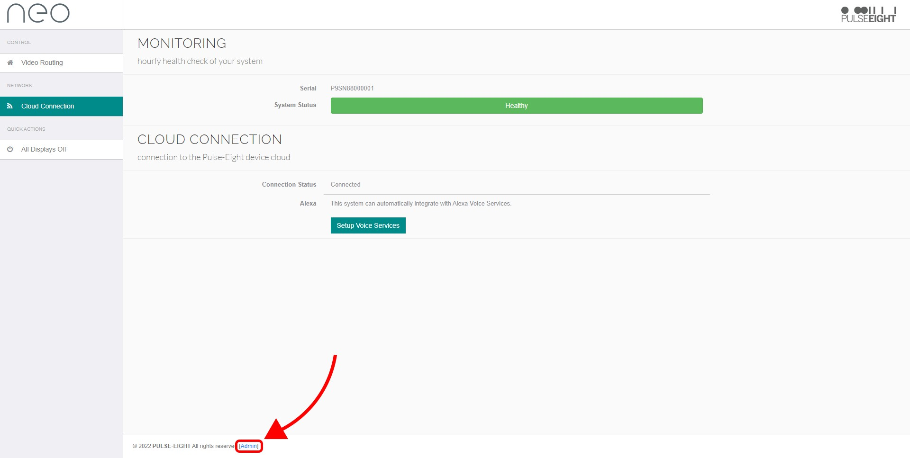

For more information on how to navigate in the admin menu and setup options available (e.g. adjusting HDMI input EDIDs, setting audio modes, HDBaseT link quality tests, etc) then please refer to “Web Interface Setup” section in the latest installation manual found at docs.pulse-eight.com.

CONFIGURE neo:8a DRIVER
1. Add the drivers by clicking on ‘Driver’ at the top, and then ‘Add or Update Driver’
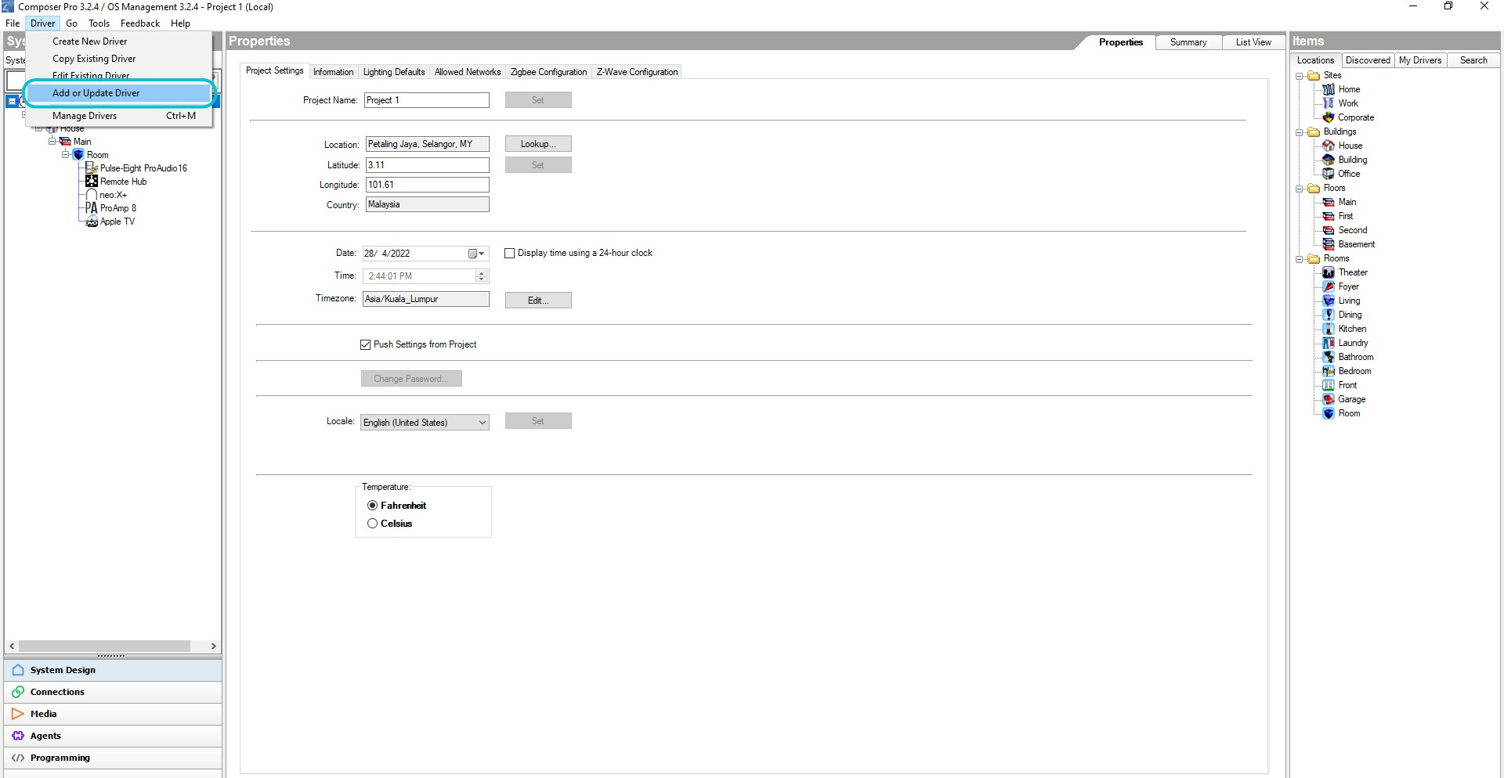

2. Click the Search tab on the right-hand side and search for the driver by the name, drag the driver from the Search window into the correct Room location.
3. Click the Action tab in the matrix driver (A). Then click the Discover button (B), then click back to the Properties tab.
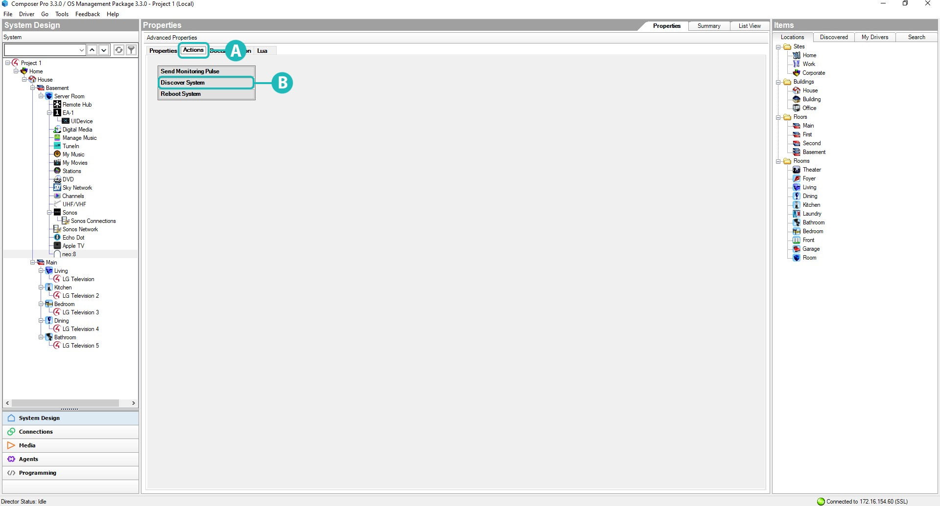
4. (C) If Discovery was successful then the IP of the matrix should appear here. If not follow the steps in the new help window to complete IP address configuration.

(D) You can set your Installer ID here, instead of navigating back to the matrixes web interface to do this. Before you complete your installation, it is important that you set your Installer ID. This value is used to register this system to your monitoring account so you can monitor and support the system remotely.
On the properties tab enter your 4-digit Installer ID and click set. Setting this value will also trigger a Monitoring Pulse to be sent so it should appear in your account immediately.
(E) By default the matrix driver has enabled two-way feedback, to maintain state information with attached navigators (such as SR260) if you don’t require this feature, you can disable it here.
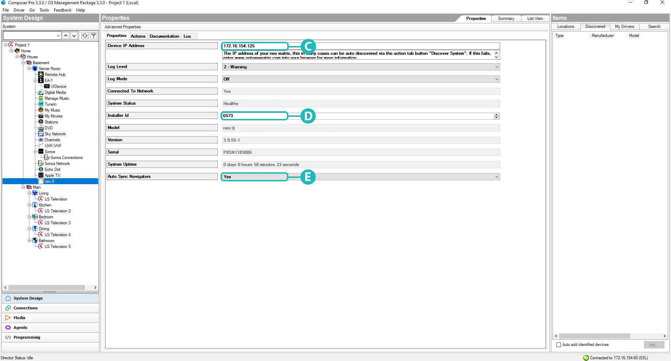

5. Click on the Connections tab (F) in Composer, select the matrix driver from the list on the Control/AV tab (G). To set up the matrix, drag and drop the matrix input/output connection at the top part to the device connection at the bottom part (H).
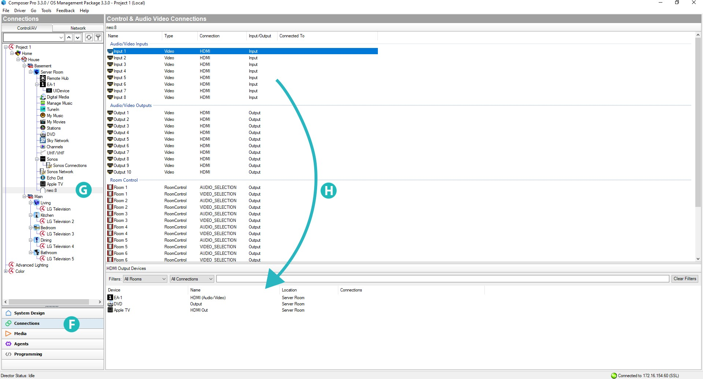

6. Setting the connections is no different than any other driver; however, ensure that the Inputs and Outputs match the physical wiring as per the matrix.
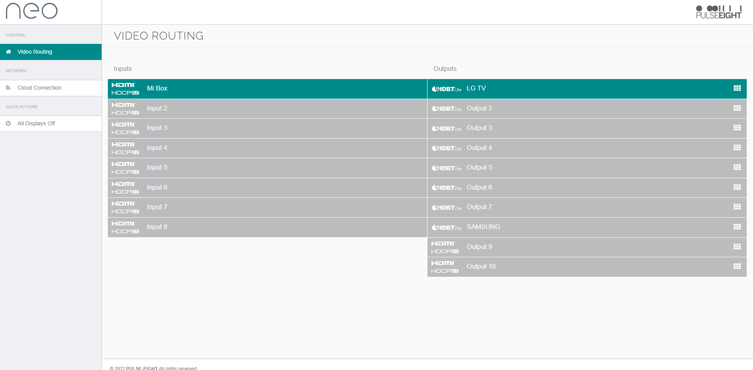

7. Setup is now complete. You may need to restart the director for all the changes to be applied correctly.However, this is not commonly required.
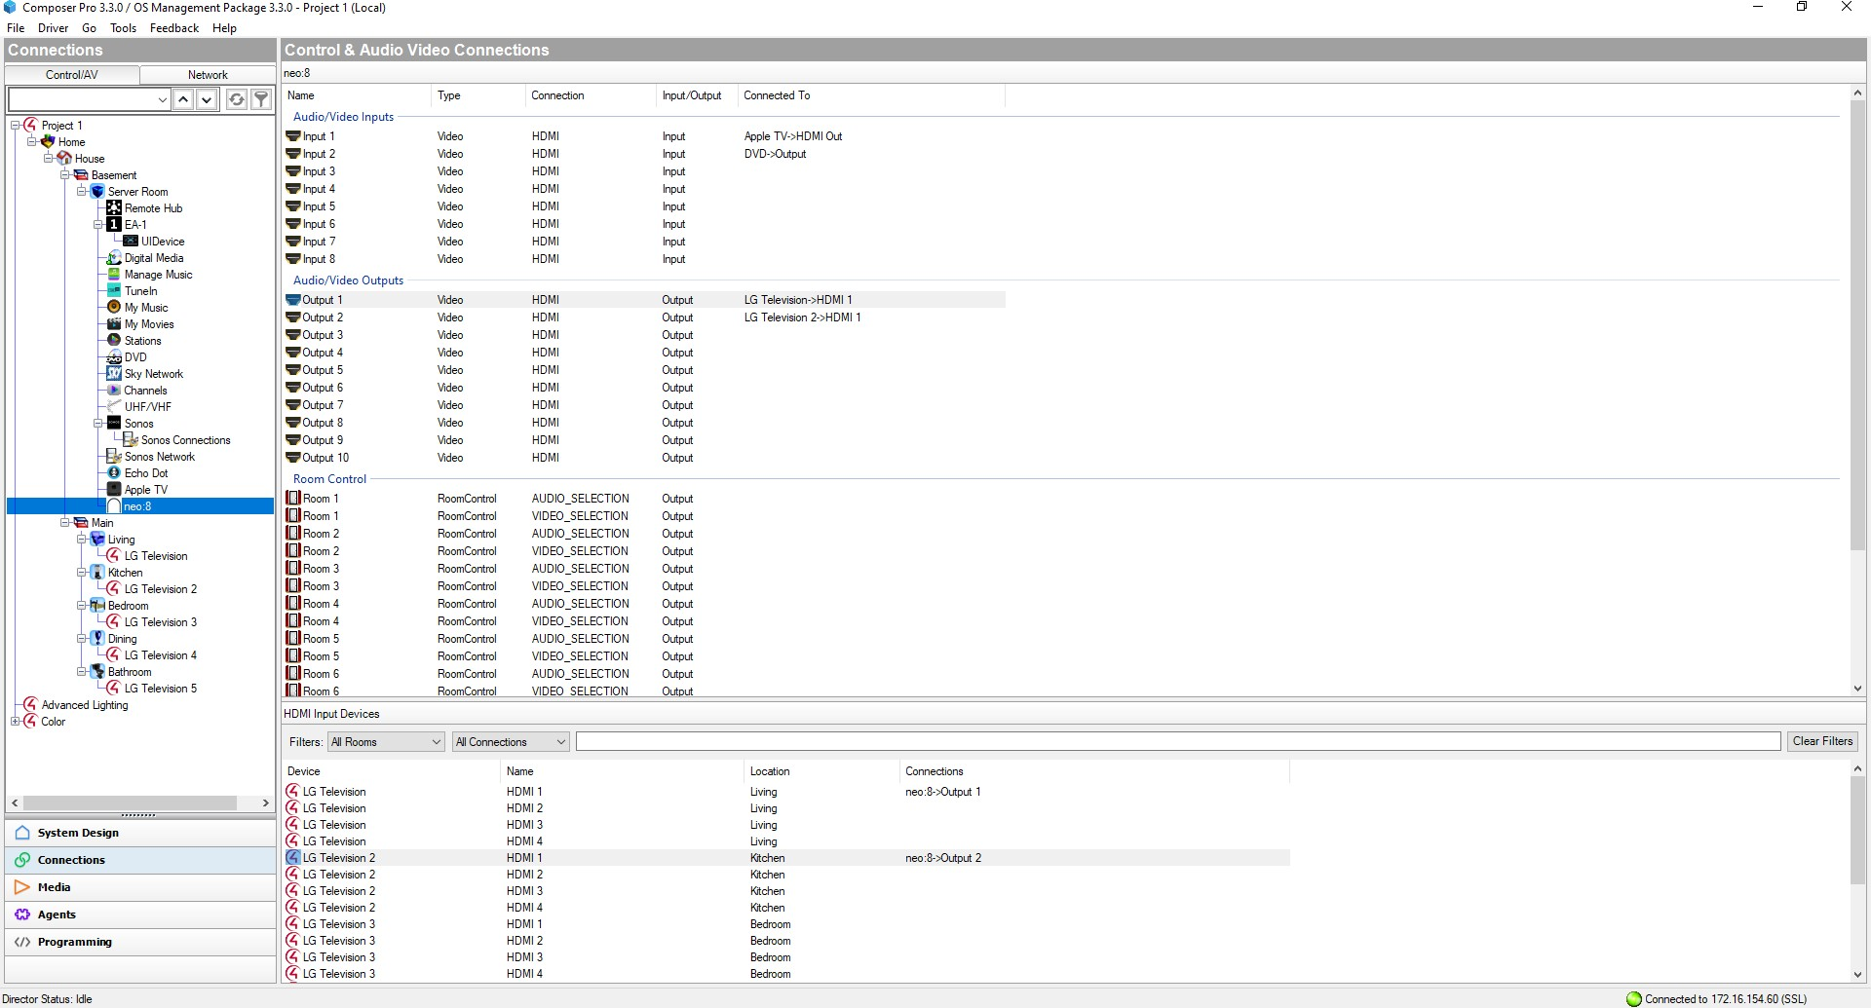

PROPERTIES
On the properties tab you can examine various core values about the system, these are read only and automatically updated every few seconds.
If something is not working correctly you can enable Log Mode, set this option to Print and the Log Level to 5 – Debug for maximum information.
ACTIONS
There are currently three buttons available in ComposerPro for this driver:
- Reboot System
Restarts the system immediately, doing so will interrupt video routing briefly
- Discover System
Used to automatically discover the Device IP Address of the system where possible
- Send Monitoring Pulse
Triggers an immediate monitoring pulse to be sent, returning current system health data to monitoring.pulse-eight.com

CONFIGURING CEC
Send CEC ON during route change: By default, the matrix will send a CEC <power ON> command to the output when a zone is routed. If it is preferred to switch output devices on using their control4 drivers, then this can be disabled using this setting.
Send CEC OFF on zone off: By default, the matrix will not send a CEC <power OFF> command to the output when a zone is disconnected. However, the driver can send a power off on zone disconnection by simply enabling this setting.

VERSION HISTORY
V19: Minor update to driver manual document only.
V18: Improve driver response under network load. CEC + CEC Source Switching options can now be changed from Composer.
V17: Internal release.
V16: Corrected port numbering for IR blasting.
V15: Changed documentation version number to match driver version. Updated “CONFIGURE neo:8a DRIVER” section to include Automatic and Manual Discovery.
V1.03: Updated Source/Sink mode + CEC Documentation
V1.02: Updated Documentation
V1.01: Updated Documentation
V1.00: Initial Release.

SUPPORT
For further assistance please contact support@pulse-eight.com

