_________________________________________________________________
ProAudio Control4 Driver
_________________________________________________________________
V 3.03

This driver installation manual is applicable to:
P8-PROAUDIO8
P8-PROAUDIO16
P8-PROAUDIO1632
P8-PROAUDIO32
P8-PROAUDIO3248

INTRODUCTION
Our products are designed to communicate with a variety of control systems. Most of the control systems have their software which require a driver to run our products.

This driver has been designed to allow a Control4 system to communicate with the ProAudio audio matrix to allow brief monitoring, configuration, and maintenance.

PRE-REQUIREMENT
1. Dealer Portal Credential
During the installation process, you will be required to enter your Control4 dealer portal credential to download the Composer Pro Installer.

2. Composer Pro
Once you have an Installer ID, you will be able to gain access to the Control4 Composer Pro. Log in to the dealer. control4.com portal. Find the required version of Composer Pro in Support > Software Downloads and click on the correct OS version number, for example, OS 3. Click on the Download Composer Pro button. When the file has finished downloading, open it to begin the installation process.
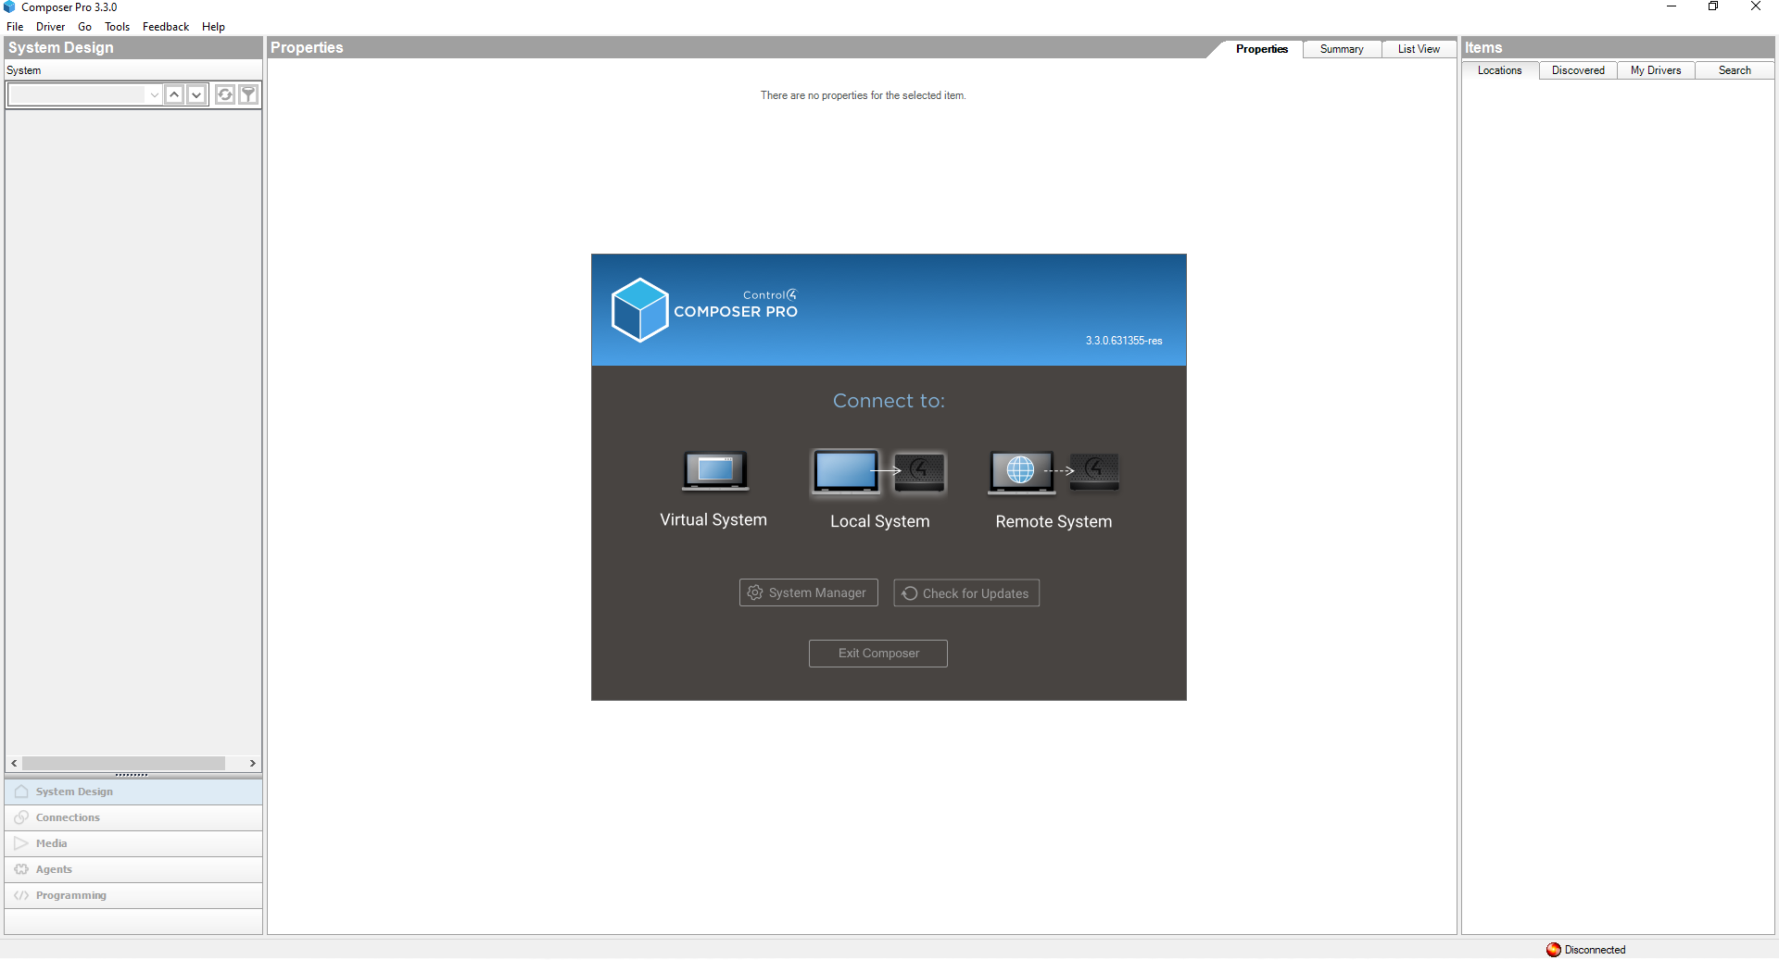

GETTING STARTED WITH COMPOSER PRO

1. When you launch Composer Pro for the first time, the software should display the screen below. Since ProAudio is connecting to the local router, select Local System.

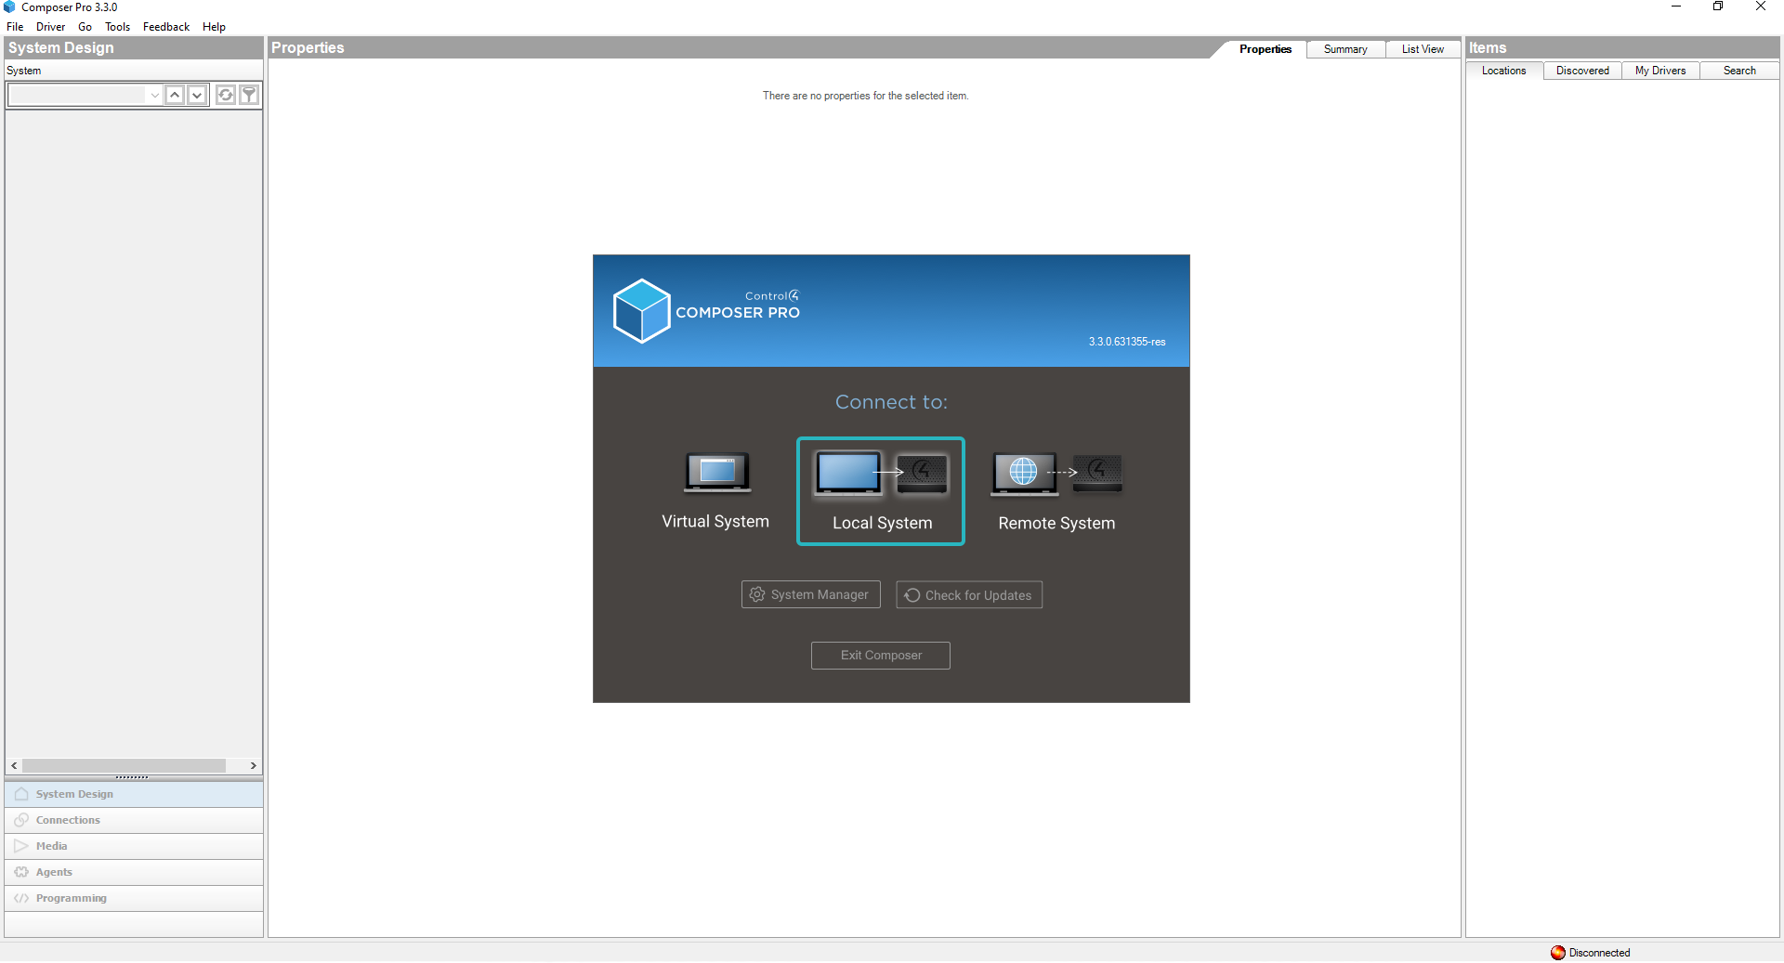

Note: On this screen, you can select between a real controller (local or remote) and a virtual controller, which can be used to create a setup before downloading it to a real controller.

2. Here shows all the Control4 controller that has been detected by the Composer Pro.

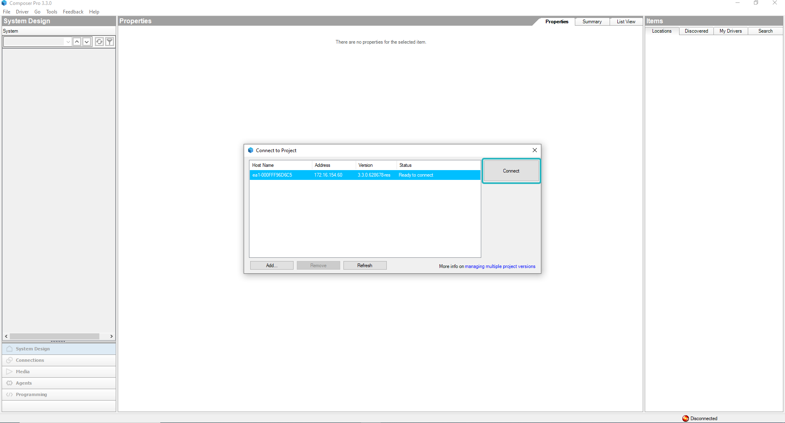

Note: On this screen, you can select your Control4 “Director(s)” (the controllers). You are not currently selecting the ProAudio driver; rather, you are selecting which Control4 controller to controller.

CONFIGURE PROAUDIO DRIVER

1. The driver is available through the Control4 online driver database.
2. Add the device by going to the Discovered tab under Items on the right-hand side. Right-click the device and choose ‘Add to Project’ or double-click it.

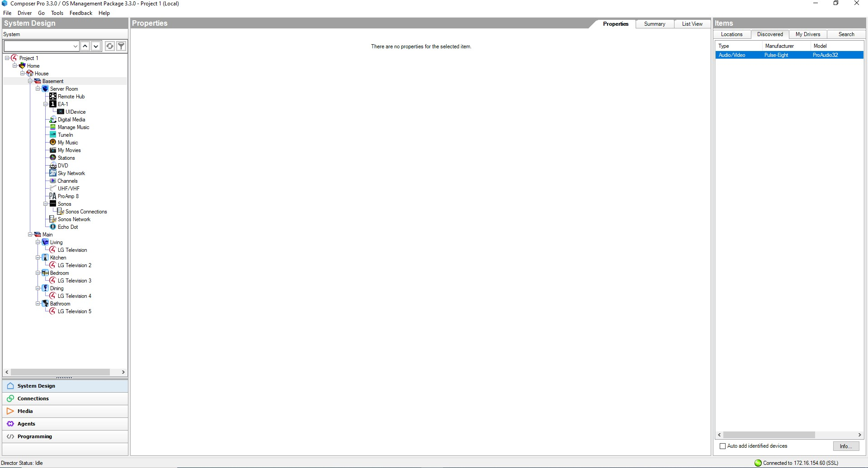

Note: It will assumed that drivers for other devices (including audio sources, amplifiers and speakers) in this
Control4 project have already been installed.

3. If the Discovery was successful, the ProAudio’s Model and Firmware Version should appear here after a few seconds.

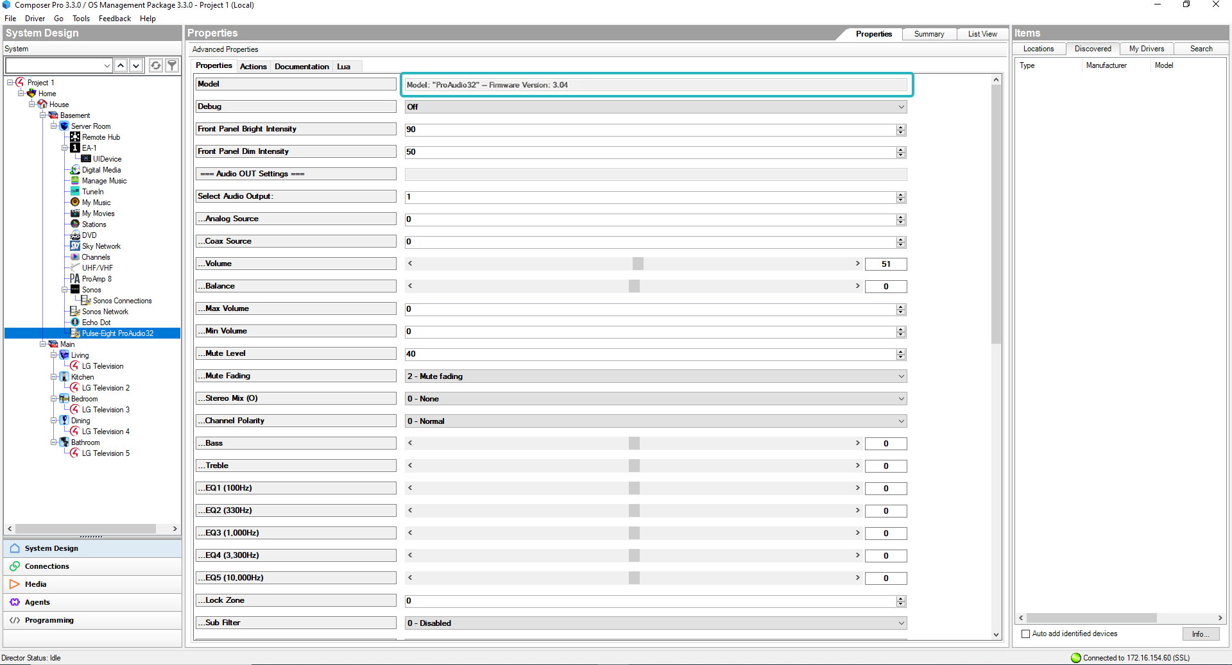

4. In Composer, go to the Connections tab (A), and then select the ProAudio driver from the list on the Control/ AV tab (B). Drag and drop the ProAudio Input connection at the top to the device connection at the bottom to configure the ProAudio (C). In this example, stereo input 1 of the ProAudio is wired to an Echo Dot (audio source device).

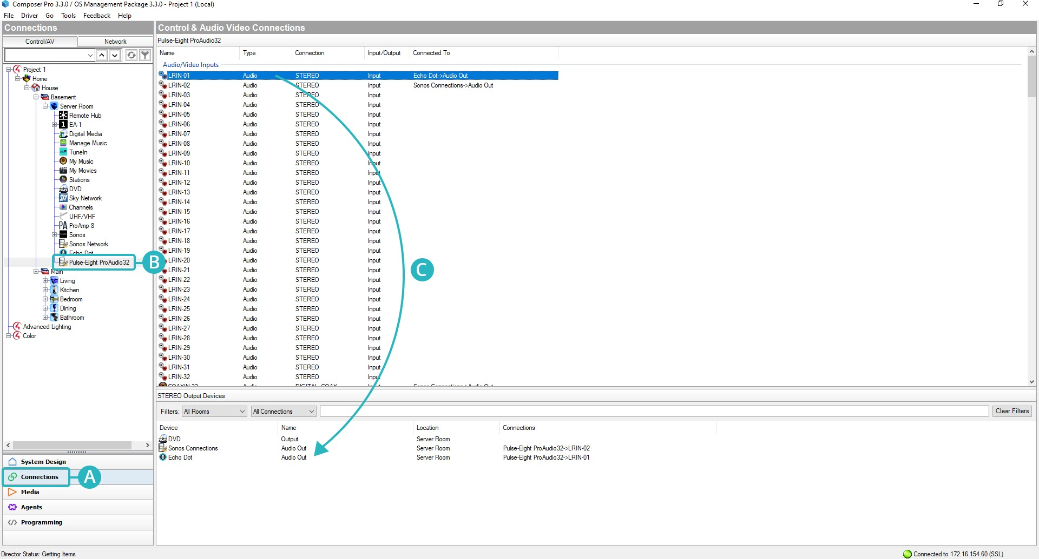

5. Then, configure the ProAudio Output by dragging and dropping the ProAudio Output connection from the top to the device connection from the bottom (D). In this example, the stereo output 4 of the ProAudio32 is wired to input 4 of an amplifier (ProAmp8).
6. Repeat the same steps 4 and 5 for all connected devices to the ProAudio’s audio inputs and outputs.
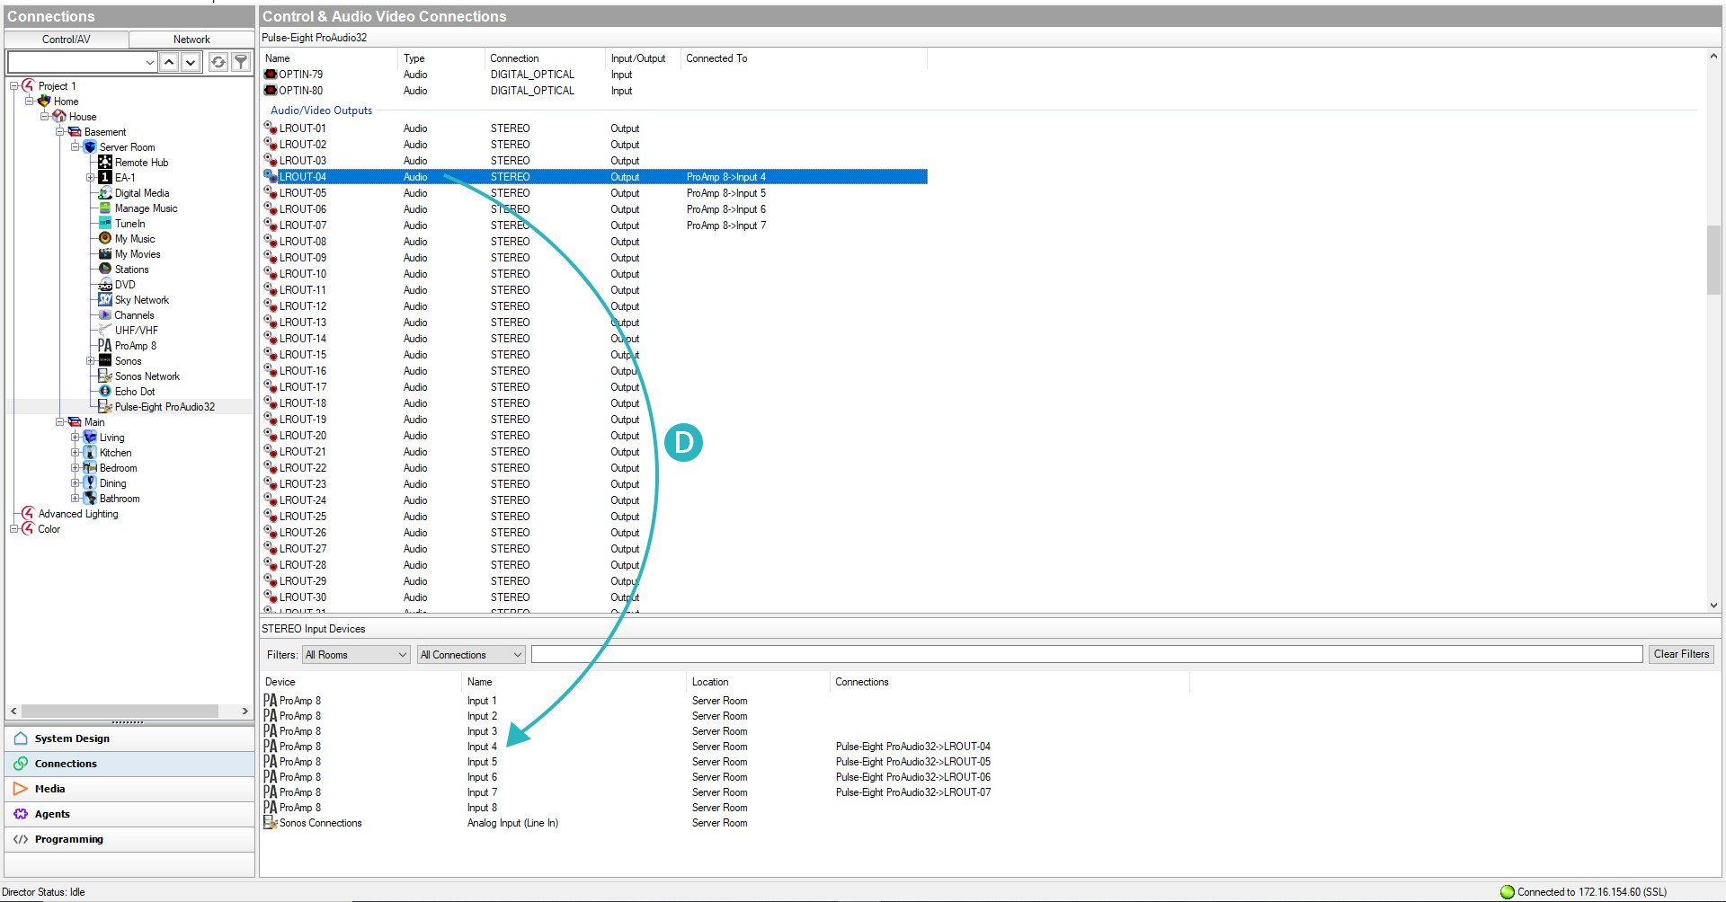

Note: If a previous version of the driver has been installed, then sometimes (a very rare occurrence) the new driver version might not appear on the composer - i.e. it still shows the previous version. If this is the case, then it might be necessary to turn OFF and then back ON the C4 processor, and refresh the composer after a few seconds. The new driver version should now appear.

INITIAL PROPERTIES CONFIGURATION

There are several standard settings for controlling the ProAudio in the driver’s Properties tab. Here are the settings you can use to get the most out of your ProAudio:

- Debug: Set to Off (recommended) or at the different levels of debugging when troubleshooting.

  - Front Panel Bright Intensity: The intensity of the front panel at full brightness.
  - Front Panel Dim Intensity: The intensity of the front panel when fully dimmed.

CONFIGURE PROAUDIO OUTPUTS

These parameters are output specific, and will therefore only modify the selected output, and therefore the process will need to be repeated for every output port.
To adjust these settings, please select the output by changing the “Select Audio Output” parameter. As an example, if you set this parameter to ‘1’ then you will now be able to change the settings for analog output 1 and coaxial output 1.
When changed, the driver will refresh the parameters to the values of the selected output by reading the switch’s current settings. All changes will only be applied to the newly selected output.

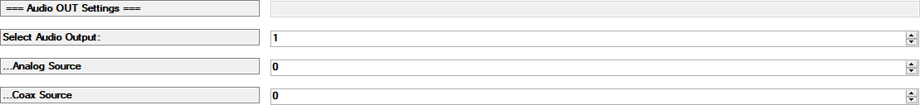
  - Analog Source: Current audio input being routed to the selected analog output.
    - Coax Source: Current audio input being routed to the selected coaxial output (applies only when the “coax audio” setting below is set to “switched independent of analog”).

The following DSP parameters apply to the analog output only:
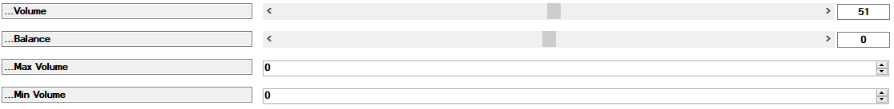
  - Volume: Each step is a percentage of the range: MinVolume - MaxVolume. 0=No audio, 1=MinVolume, 100=MaxVolume.
  - Balance: Each step = 0.5dB and the range is: -200 (full left) to +200 (full right).
  - Minimum volume setting: Each step = 0.5dB and the range is: -199 to MaxVolume-99 (-99.5dB to MaxVolume-49.5dB).
  - Maximum volume setting: Each step = 0.5dB and the range is: MinVolume+99 to +48 (MinVolume+49.5dB to 24dB).

  - Mute Level: The mute level features allows you to mute a level by a specific amount instead of a full mute. Each step = 0.5dB and the range is: 0 to 248 (full mute).
  - Mute Fading: The audio can be set to mute fading or no fading.

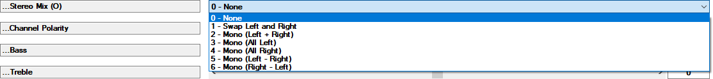
  - Stereo mix: The stereo outputs can be mixed in a number of ways:-
0. None - Audio is passed with no changes.
1. Swap Left and Right - Left and right channels are swapped.
2. Mono (Left+Right) - Mono out mix is done by adding the left and right channels.
3. Mono (All Left) - Both channels output the left channel.
4. Mono (All Right) - Both channels output the right channel.
5. Mono (Left-Right) - Mono out mix is done by subtracting the right channel from the left.
6. Mono (Right-Left) - Mono out mix is done by subtracting the left channel from the right.

  - Channel Polarity: The audio outputs can be inverted to improves the sound, it is recommended to mix in MONO.
0. Normal - Audio is passed with no changes.
1. Invert right channel - Right channels are inverted.
2. Invert left channel - Left channels are inverted.
3. Invert left and right - Both channels output are inverted.

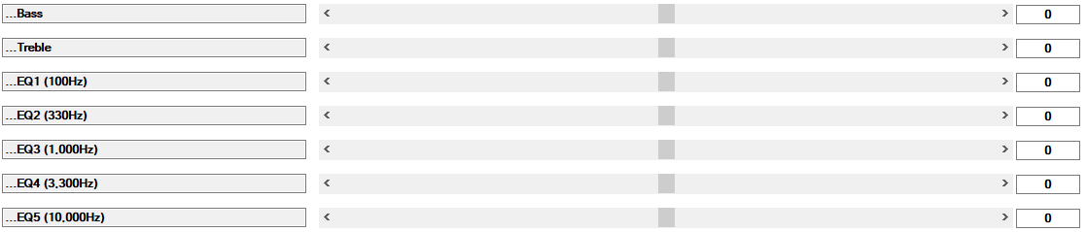
  - Bass: Each step = 0.5dB and the range is: -40 to +40 (-20dB to +20dB)
  - Treble: Each step = 0.5dB and the range is: -40 to +40 (-20dB to +20dB)
  - EQ1: Each step = 0.5dB and the range is: -40 to +40 (-20dB to +20dB)
  - EQ2: Each step = 0.5dB and the range is: -40 to +40 (-20dB to +20dB)
  - EQ3: Each step = 0.5dB and the range is: -40 to +40 (-20dB to +20dB)
  - EQ4: Each step = 0.5dB and the range is: -40 to +40 (-20dB to +20dB)
  - EQ5: Each step = 0.5dB and the range is: -40 to +40 (-20dB to +20dB)

Note: When adding Equalizer and Tone settings, the overall boost/cut can never exceed the +/- 20dB range. For example, a Bass setting of +10dB and a EQ1 setting of +15dB will be limited to an overall gain of +20dB.

  - Lock Zone: Set the selected audio output to be locked to another zone.
Note: Please see the LOCK ZONE section of the ProAudio manual for more information.

  - Sub Filter: Set the crossover filter level to 12dB or 24dB. The subwoofer output should be set to Low-Pass and Speaker output set to High-Pass.

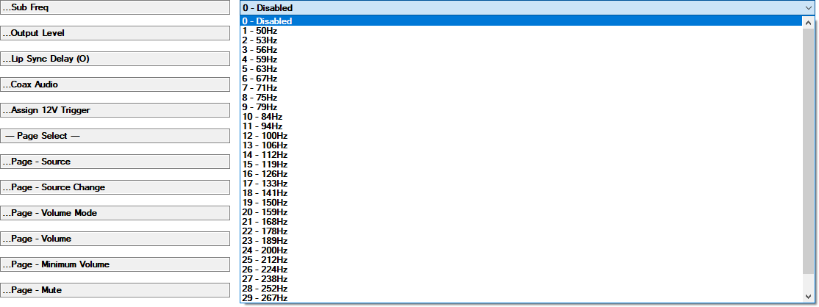
- Sub Freq: The Set the crossover frequency for the subwoofer and speakers. This value can be set to anything between 50-300Hz. If unsure, then set the crossover frequency for stereo and subwoofer speakers to 119 Hz, as this tends to be a good default value.
Note: Please refer to the SETTING UP A SUBWOOFER section in the ProAudio manual.

  - Output Level: Match the volume levels of the audio output to the sensitivity of the amplifiers filter level to -24dB to 24dB. Each step = 0.5dB and the range is: 0 to 48.
  - Lip Sync Delay: Each step = 1/48 mS and to range is: 0 to 8191 (0-170.65mS)

    - Coax Source: Allows mirroring the analog outputs to the corresponding associated coax output. E.g.
      - Coax output 1 switches independent of analog output 1
      - Coax output 1 mirrors analog output 1
      - Coax output 1 mirrors analog output 1 when audio present only.
    - 12V Trigger: Set the “12V Trigger” port (1, 2, …12) associated with the selected output port. Whenever there is audio present on the selected analog output, the corresponding 12V Trigger port will be enabled accordingly. If you do not want a 12V trigger port associated with the selected output, then set parameter to ‘0’.
Note: This option is not available for ProAudio16 or ProAudio8.

If you need paging for the output, then please refer to the CONFIGURE PROAUDIO PAGING SYSTEM section for further details.

AUDIO IN SETTINGS
These These properties are input (source) specific, and will therefore only modify the selected input.
To adjust these settings, first select the input to be adjusted by changing the “Select Input” property.
As an example, if you set this parameter to ‘1’ then you will now be able to change the settings for analog input 1 only.
When changed, the driver will refresh the parameters to the values of the selected input by reading the switch’s current settings. All changes will only be applied to the newly selected input.

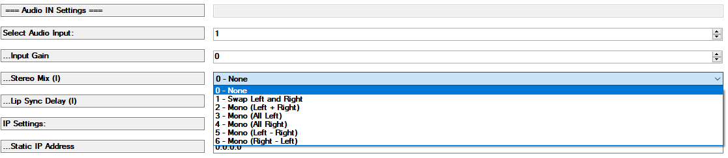

  - Gain: Input gain adjustment. Each step = 0.5dB and the range is: -24dB to +24dB (-48 to +48).
  - Stereo mix: The stereo inputs can be mixed in a number of ways:-
0. None - Audio is passed with no changes.
1. Swap Left and Right - Left and right channels are swapped.
2. Mono (Left+Right) - Mono out mix is done by adding the left and right channels.
3. Mono (All Left) - Both channels output the left channel.
4. Mono (All Right) - Both channels output the right channel.
5. Mono (Left-Right) - Mono out mix is done by subtracting the right channel from the left.
6. Mono (Right-Left) - Mono out mix is done by subtracting the left channel from the right.

  - Lip Sync Delay: Each step = 1/48 mS and to range is: 0 to 170.65 mS (0-8191).

IMPORTANT NOTES
1. Overall input gain is limited to +24dB. If the combined settings (input gain + master volume + volume) add up to more than +24dB, then +24dB will be used. However, the output gains are added to the input gains. So an input gain of 24dB + an output gain of 24dB adds up to a full 48dB of gain. That’s a lot of gain! This means you can drive nearly any level of input to distortion, this is something to be aware of as gain adjustments are being made.
2. The Gain set for a Digital input (OPT or COAX) only affects PCM audio; Non-PCM (Dolby 5.1) audio is always passed unchanged.
3. When using lip sync delays, the combined input/output delay will not exceed 170.65 mS. For example, when an input delay of 100 ms is combined with an output delay of 100 ms, the delay will not be 200 ms, but will be limited to 170.65 ms.

IP SETTINGS
These settings should not be required or changed when the ProAudio has been successfully discovered (automatic configuration) and added to your Control4 project, according to the steps followed in the CONFIGURE PROAUDIO DRIVER section.
For reference, the IP settings should appear here:
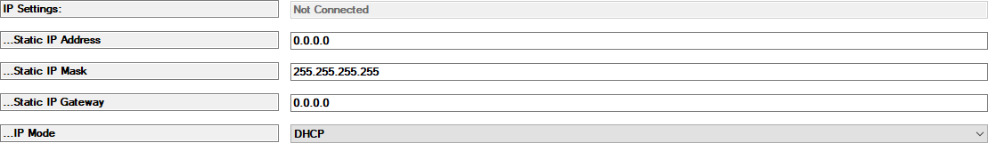

CONFIGURE PROAUDIO PAGING SYSTEM

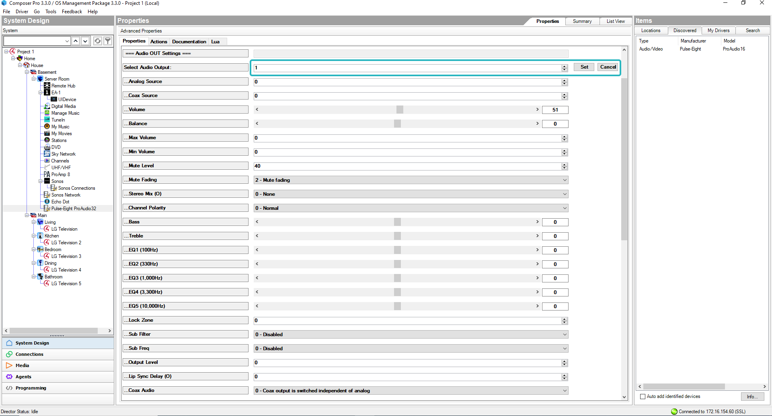

When a page or doorbell is triggered (from now on referred to simply as a “page”), all zones switch to a predetermined source and volume. When the page is completed, all zones are returned to normal operation.
There are two page settings, each with its own configuration. For example, page ‘1’ could be used for the front door and page ‘2’ for the back door, and if you have two different sound generators, you could have a different sound for the two doorbells and connect the pages to two different sources.
All of the actions that each zone should take when a page is triggered need to be pre-programmed in the Control4 Composer’s Properties tab.

Note: After changing these settings, backup them in case of a power outage by going to Composer’s Action Tab and clicking the “Backup Paging Settings” button.
Please ensure to read the PAGING AND DOORBELL section in the ProAudio User Manual, for more information on the wiring connections for either dry closures or other voltage triggers.
Because each zone can have its own settings, and therefore each zone must be configured separately. To begin, the zone must be chosen and set as shown in the figure above.

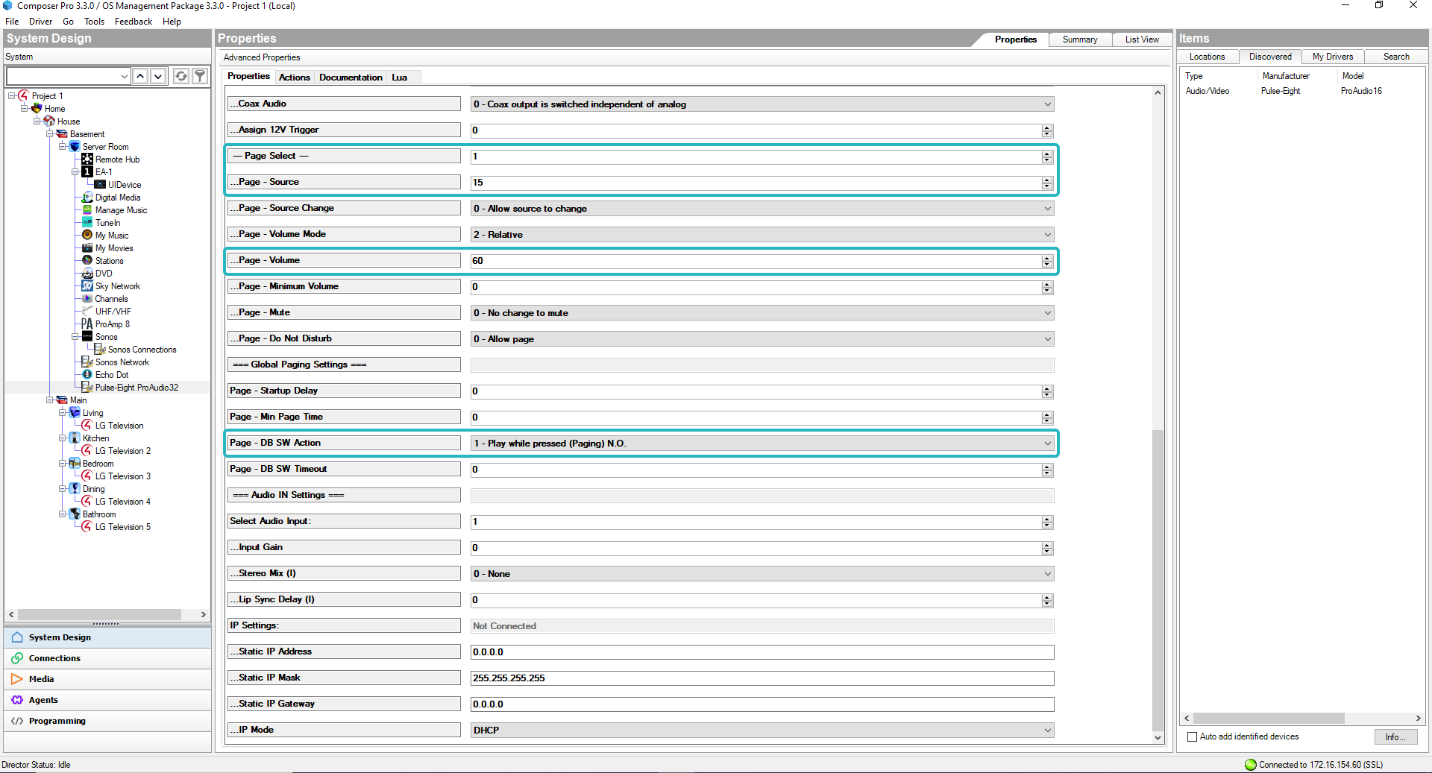
Once a zone is selected, the zone’s current parameters will fill in.
Next select the paging number under “-- Page Select --” there are two page settings for each zone (‘1’ or ‘2’), for things like front door, back door, etc.
The above settings are a good general test of the paging system, assuming the doorbell sound generator is connected to source 15. Also assumes a relay or switch is wired to the DB-1 connection on the back of the switch as follows:

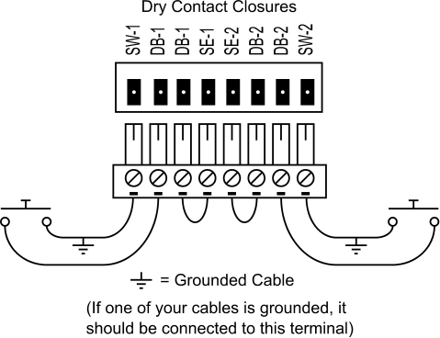
These settings are a good way to see if paging is functioning properly. When the DB-1 switch is pressed, the zone should switch to source 15, set itself to 60% volume, and then return to normal.
Page Select ‘1’ is triggered by DB-1 and Page Select ‘2’ would be triggered by DB-2.

VERSION HISTORY
Version 3.03 - Update documentation + repackage
Version 3.02 - Handle multiple error codes correctly
Version 3.01 - Skipped
Version 3.00 - Initial Release.

SUPPORT
For further assistance please contact support@pulse-eight.com

