PulseFitness.ai · MODService Portal
A secure digital control layer for MOD PTE service delivery
MODService is the single, secure environment that connects the Authority, MOD site personnel, the Pulse Fitness service team, engineers, suppliers and every individual piece of physical training equipment across the estate. It replaces email trails and phone chasing with live visibility, asset-level evidence and auditable control — so the right information reaches the right people the moment a machine needs attention.
AT A GLANCE
• Secure, role-controlled access built specifically for MOD sites and Service Personnel
• One live asset register per site — manufacturer, model, serial, warranty and supplier
• QR-enabled fault reporting and maintenance checks from the gym floor
• AI-assisted risk assessments that keep professional judgement with the assessor
• Lifecycle, CAPEX and Beyond-Economic-Repair evidence drawn from real service data
• Centralised ASER equipment-safety and personal-incident reporting in one audit trail

SECURE, MOD-READY ACCESS
One platform. Three Services. Always ready.
MODService opens with secure, monitored sign-in designed for Army, Royal Navy and Royal Air Force sites. Personnel log in with unit-issued credentials or a shared site code for kiosk use, access is recorded, and fault reporting and equipment registers are available from day one — with no email-led administration to set up.
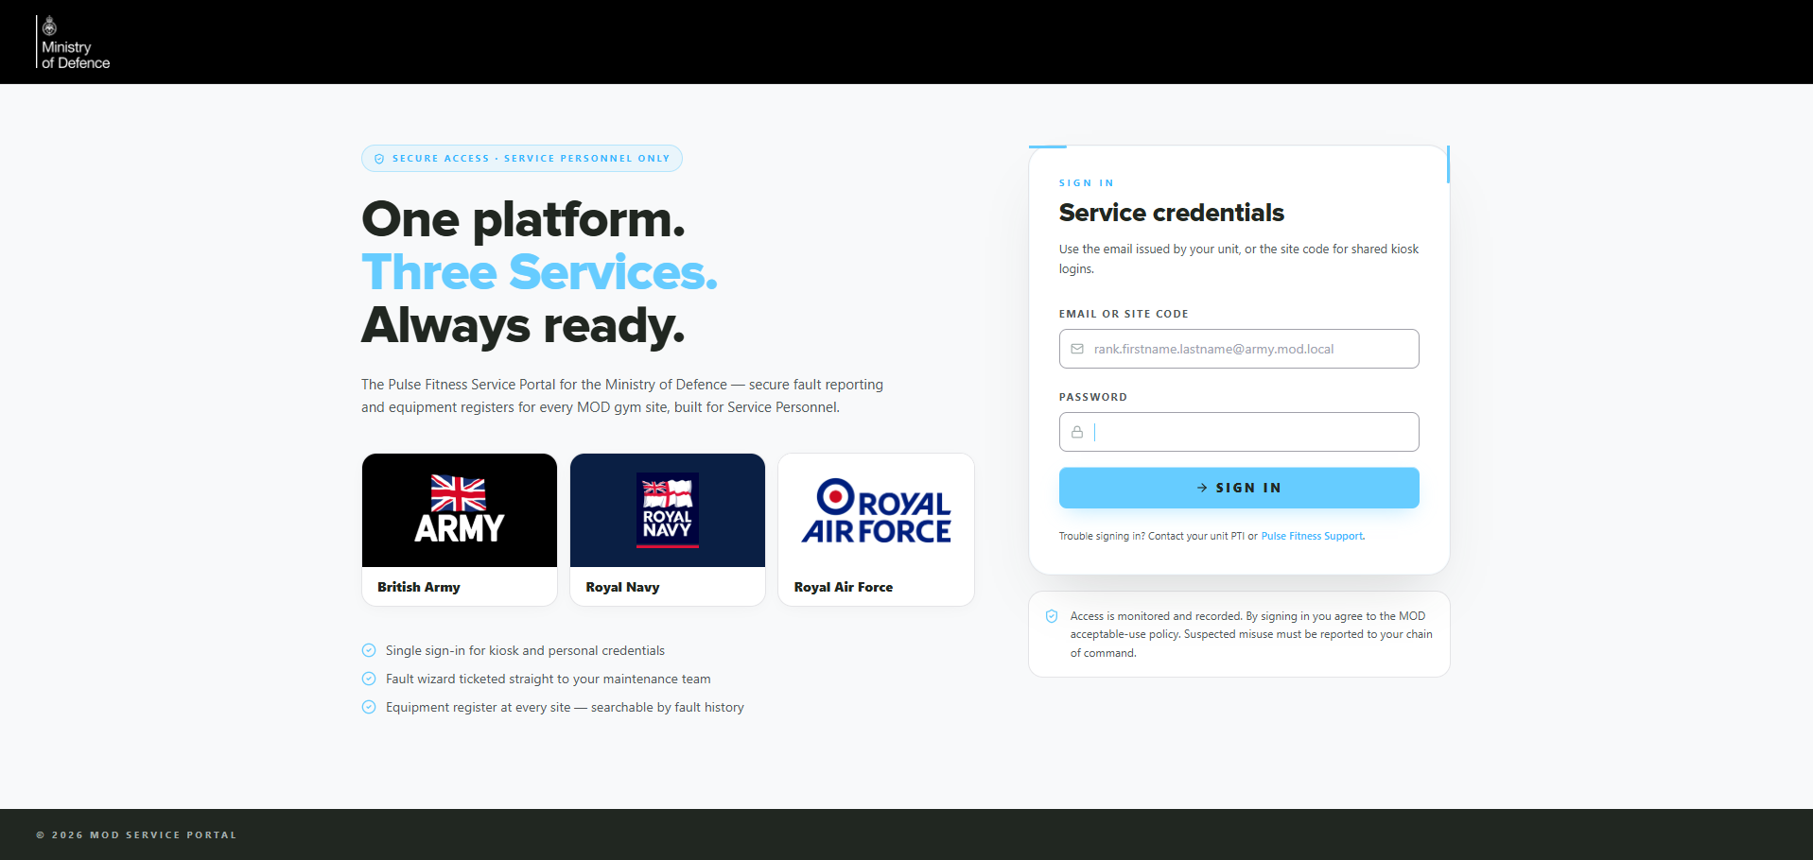
Secure sign-in for authorised Service Personnel — access monitored and recorded.
LIVE ESTATE VISIBILITY
A current view of every site — without waiting for a report
The command dashboard gives site personnel and managers a real-time read of equipment availability, fault status and overall site health. A live gym-health score summarises the position at a glance, with full drill-down into the detail behind it.
- Total machines and current operational status
- Open faults, recent resolutions and audits logged
- Supplier allocation and current exceptions
- A live gym-health score with drill-down context
Why it matters — MOD sites no longer chase updates by phone or email. The portal provides a consistent, evidence-based view of service activity and where intervention is required.
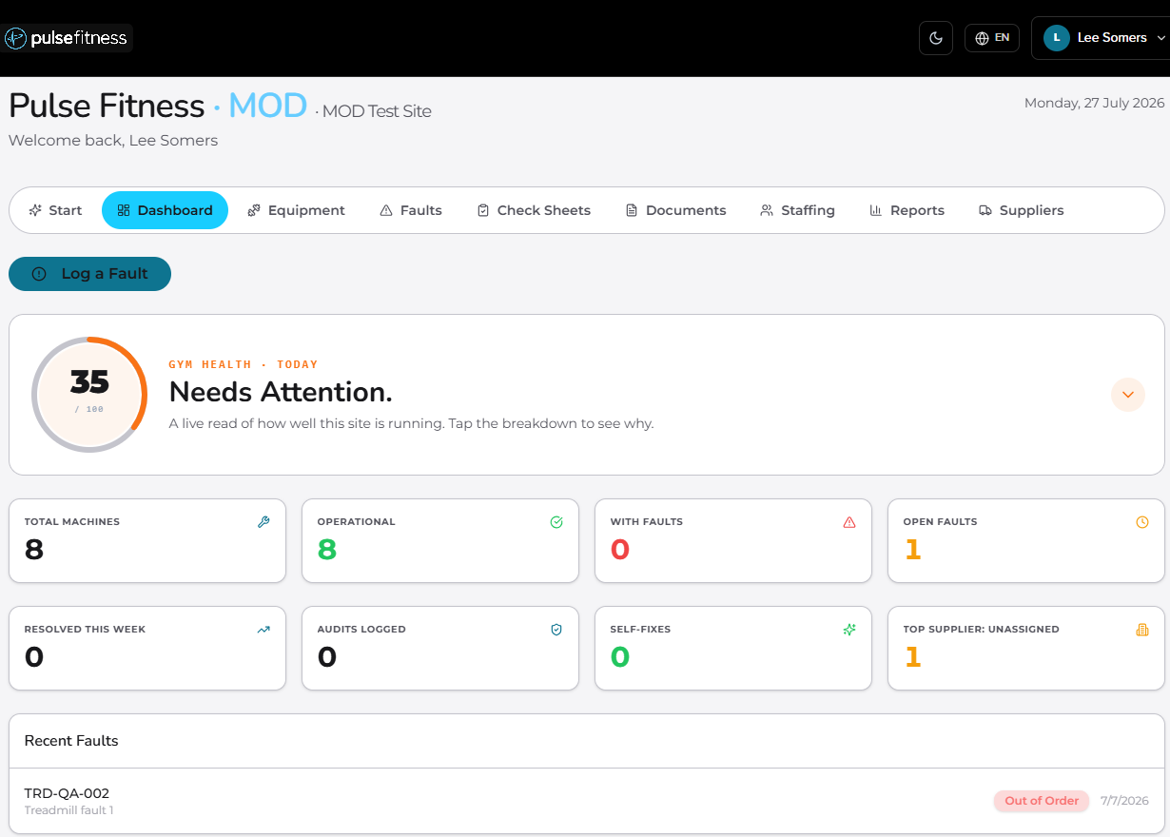
Site dashboard — gym-health score, machine status and recent faults in one view.
A SINGLE SOURCE OF TRUTH
One digital asset register for every site
Each asset is recorded by manufacturer, model and serial number, with warranty, contract and supplier visibility attached. The register removes ambiguity across similar machines, while each individual record holds the detail needed for repair, warranty decisions and future support.
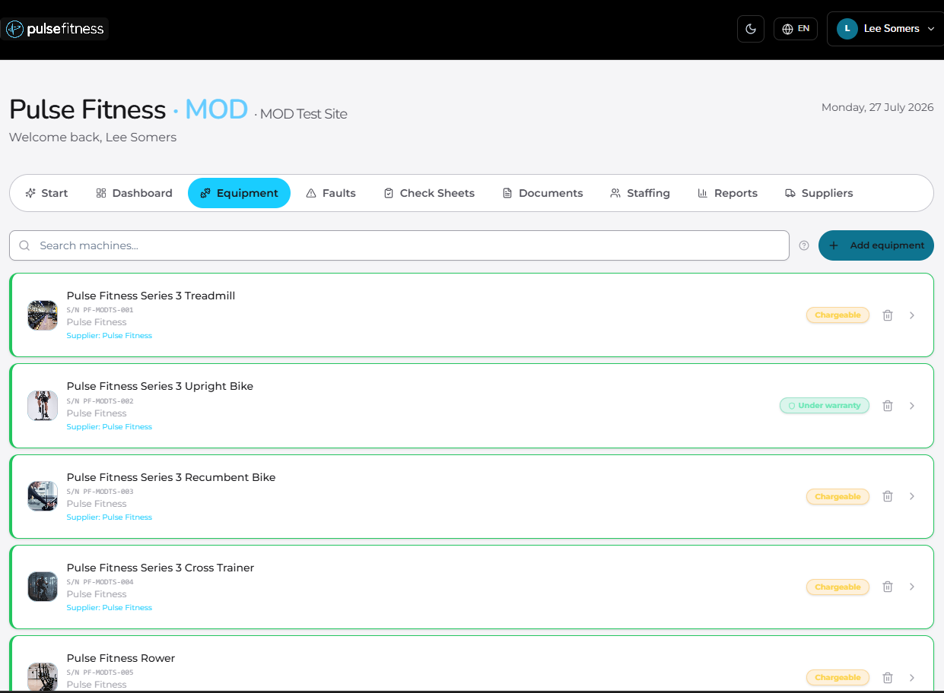
Searchable equipment register — every machine identified by serial, warranty and supplier.
THE COMPLETE MACHINE RECORD
Warranty, contract, history and QR — all in one place
Open any asset to see its type, serial number, manufacturer, location and supplier, its live warranty and service-contract status, its full fault history and attached documents — plus a machine-specific QR label ready to print and fix to the equipment.
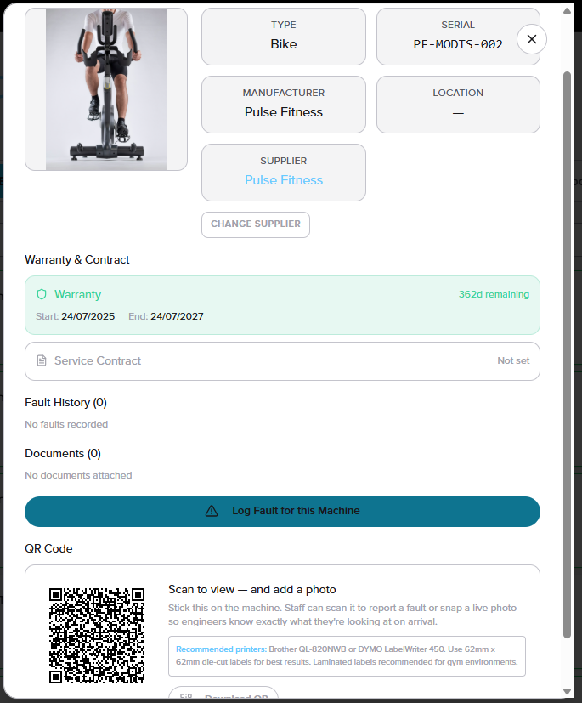
Individual asset record with warranty, contract, fault history and printable QR label.
REPORTING AT THE MACHINE
Scan, check and report from the gym floor
Service personnel scan the QR label fixed to a machine, open the exact asset record on a mobile device and either complete a maintenance check or report a fault with photos in seconds. Faults are logged against the actual machine — never a generic email trail.
- Scan the QR label to open the correct asset instantly
- Complete a structured maintenance check
- Report a fault with photographs and steps already tried
- Review warranty and contract details on the spot
Operational benefit — Engineers arrive with the correct asset, site, serial number, history and evidence already in hand. From scan to service record in seconds.
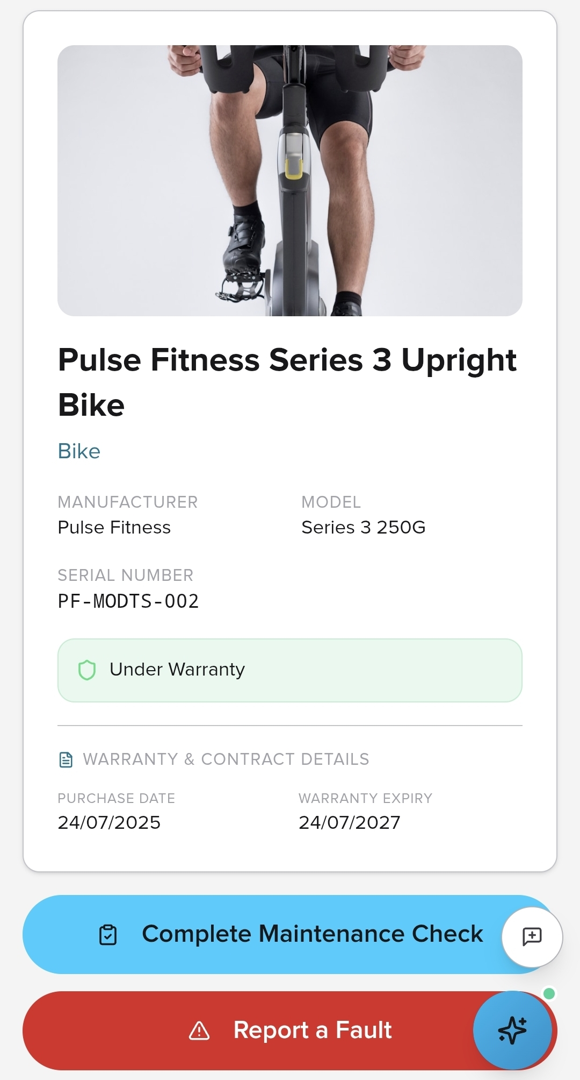
Mobile asset view — maintenance check and fault reporting built for the gym floor.
STRUCTURED SERVICE EVIDENCE
Faults become clean, accountable job cards
MODService turns every fault into an asset-level record that supports triage, engineer allocation, parts identification and supplier coordination. Each job links the exact site, asset, serial number, photographs, warranty status, service history and supplier — giving Pulse Fitness a clean job card, reducing repeat questions and supporting accountable resolution.
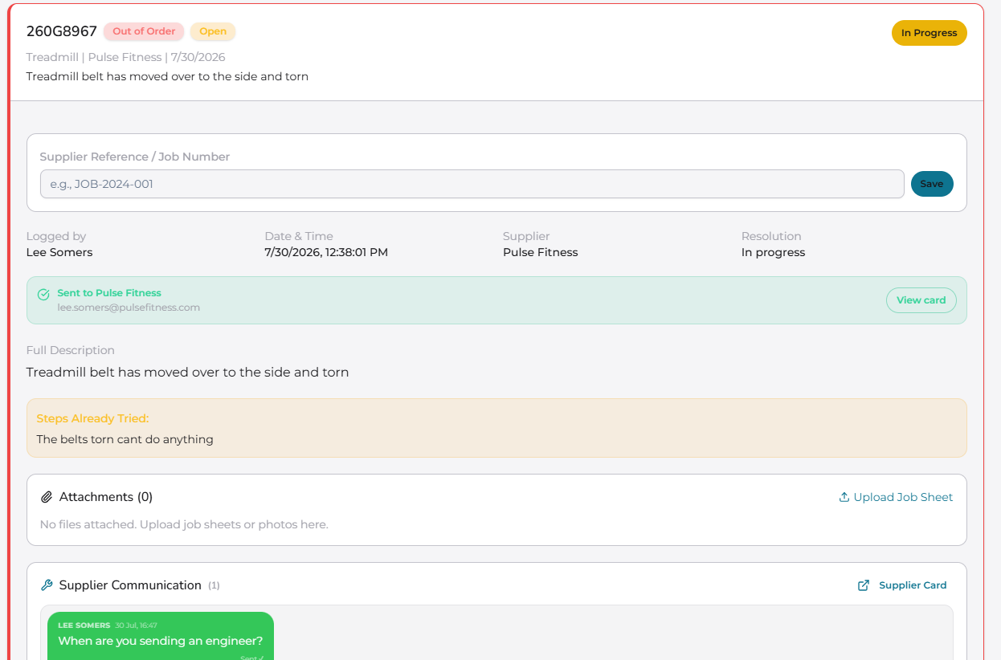
Fault job card — supplier reference, communication trail and full context in one place.
SAFETY CONTROLS INSIDE THE WORKFLOW
AI-assisted risk assessments, controlled by the assessor
The portal supports consistent risk assessment while keeping professional judgement and sign-off firmly with the user. Assessments are equipment- or area-specific, capture the assessor, site and date, and score probability, severity and residual risk.
- PLR, PSR and residual-risk (RRN) scoring built in
- AI-generated hazard suggestions and photo analysis
- Manual hazard entry and assessor override at every step
- Submitted records stored for audit
Tender value — A consistent framework for identifying, recording and controlling equipment-related hazards across the MOD estate — without replacing human review.
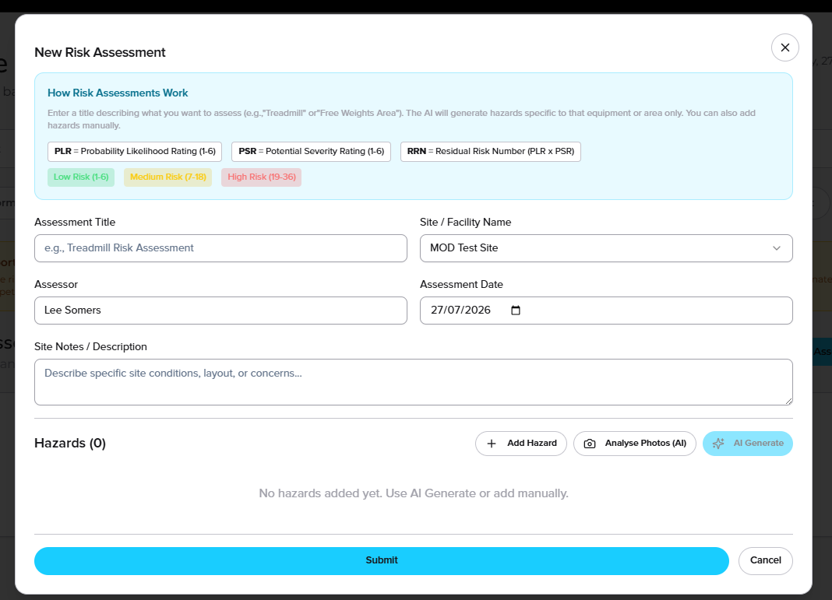
Risk assessment workflow — AI assistance with assessor control and full audit capture.
ACCESS & HANDOVER GOVERNANCE
Controlled staffing and personnel movement, built around MOD use
MODService is designed for the realities of MOD operation: secure sign-in, service-specific context, site restrictions and auditable activity. Where personnel rotate between authorised sites, controlled transfer workflows move staff cleanly — and cross-force transfers are blocked by design.
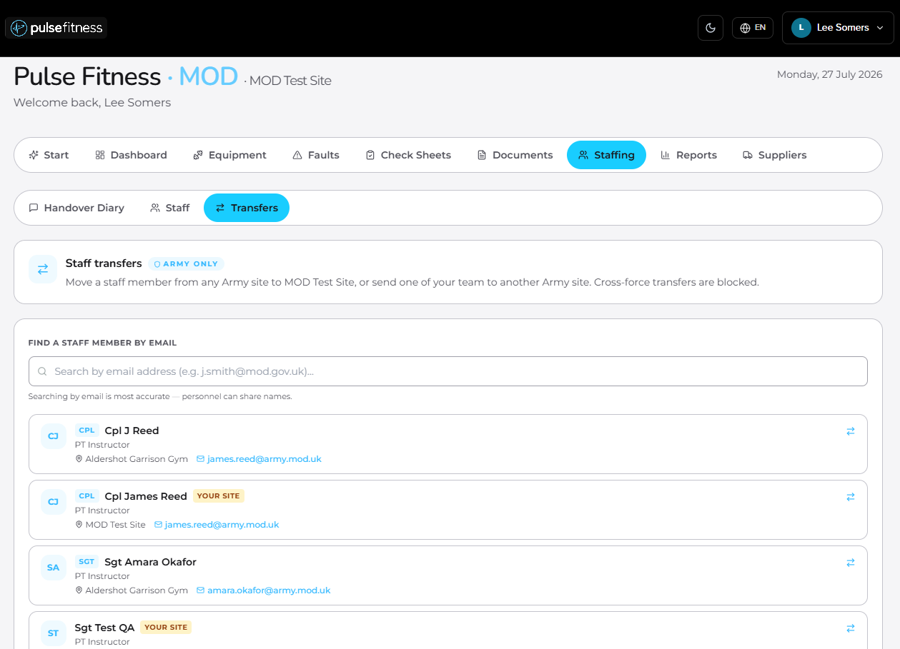
Staffing and transfers — controlled movement between authorised sites, fully auditable.
EVIDENCE-LED INVESTMENT
Lifecycle, CAPEX and BER reporting from real service data
The portal helps the Authority evidence when equipment should be maintained, monitored or replaced — using recorded faults, downtime and safety risk rather than opinion.
- Lifecycle-stage and condition-score distribution
- Safety-risk trend across the fleet
- Beyond Economic Repair (BER) status
- 6-month versus 12-month spend comparison with worsening / improving indicators
Decision-maker impact — CAPEX discussions are supported by service evidence, giving the Authority a transparent basis for prioritising replacement investment.
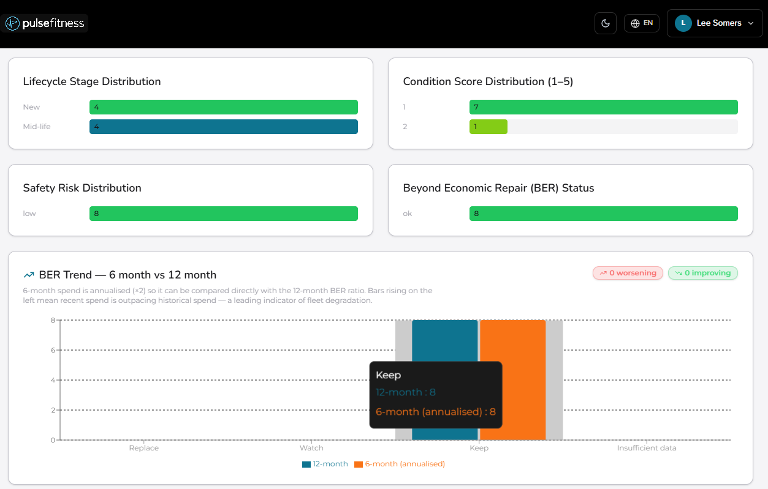
Lifecycle and BER analytics — replacement decisions backed by real service data.
MODSERVICE REPORTS
Centralised safety reporting — all in one place
MODService brings equipment-safety events and personal-incident reporting into one secure, auditable workflow — while keeping the two pathways properly separated.
ASER — Activity Safety Events Register
- Logs PTE risks, near misses and repeated failures against the exact asset
- Records impact on rehab delivery, group programmes and clinical output
- Builds evidence for service escalation, repair history and CAPEX replacement
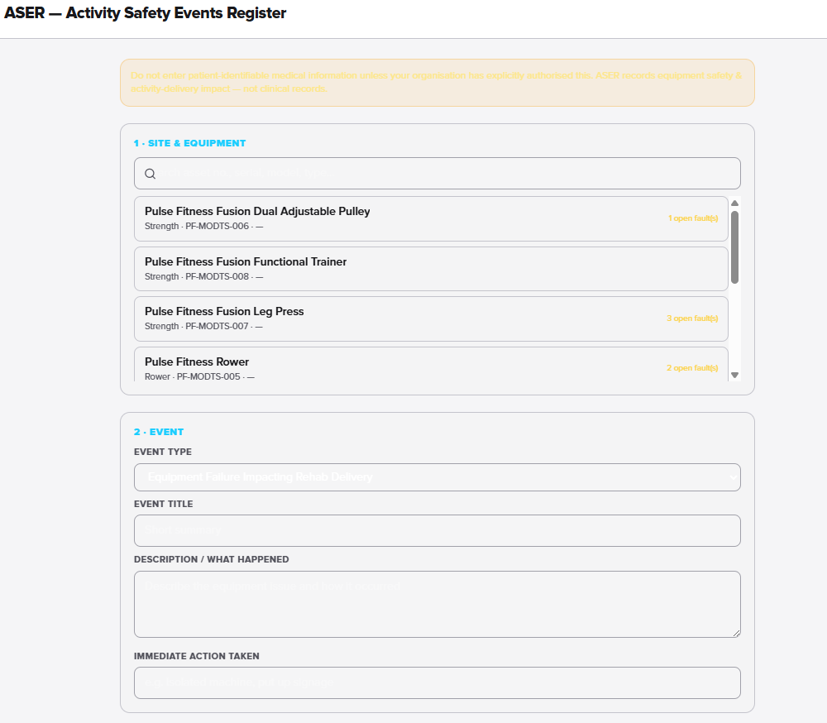
ASER — asset-linked evidence of PTE impact and recurring risk.
Personal Incident — dedicated injury pathway
- Separate workflow for incidents involving injury to a person
- Captures category, severity, reporter details and a factual description
- Keeps equipment-only faults out of injury reporting while retaining visibility
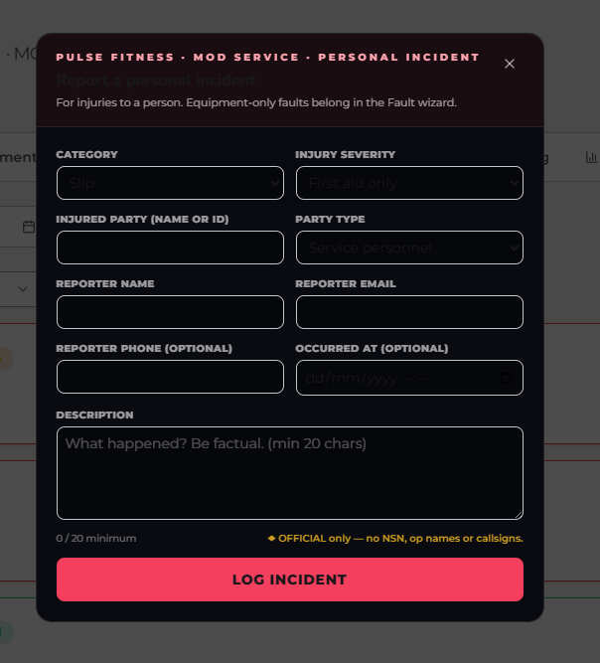
Personal Incident — a controlled, OFFICIAL-only route for injury reporting.
THE SERVICE PROMISE
MODService is the control layer behind the service
It connects the Authority, MOD site personnel, the Pulse Fitness service team, engineers, suppliers and each individual asset through one secure, evidence-led environment.
- Faster triage — faults, photos and serials sit against the correct machine from the start
- Better engineer preparation — asset history, warranty, documents and site notes travel with the job
- Stronger contract control — open faults, response risk and service performance visible in real time
- Evidence-led replacement — CAPEX and BER reporting use service data to justify action

